 CHEMICAL ENGINEERING TRANSACTIONS  VOL. xxx, 2026 | A publication of  
The Italian Association
of Chemical Engineering
Online at www.cetjournal.it

Guest Editors: Flavio Manenti, Botir Usmonov, Alessandro Di Pretoro
Copyright © 2026, AIDIC Servizi S.r.l.
ISBN 979-12-81206-xx-x; ISSN 2283-9216

A Computationally Efficient Data-driven Approach
for Sustainable Process Scheduling
Alessandro Di Pretoro^{a,}*, Ludovic Montastrucª
ªLaboratoire de Génie Chimique, Université de Toulouse, CNRS/INP/UPS, Toulouse, France
alessandro.dipretoro@ensiacet.fr
Given the international goals in terms of reduced CO₂ emissions, the transition of the chemical industry towards more sustainable production policies is facing the need of substantial reconfiguration of process operation management. In particular, in order to mitigate the mismatch between the sustained market demand and the unstable nature of renewable energies and bio-sourced feedstocks, the future generations of chemical processes are required to meet high standards in terms of operation flexibility and equipment modularity. As a direct consequence, steady-state simulations are going to be progressively replaced by the dynamic ones to account for the modulation of operating parameters in response to external variations. However, dynamic simulations of chemical processes are much more computationally demanding and, thus, some effective solutions should be conceived to deal with such a higher complexity. Hence, this research presents a derivative-based surrogate modelling approach for dynamic systems that is able to reduce the simulation time for complex chemical processes. To prove the general validity of the methodology, the surrogate modelling data-driven strategy was tested on a biogas-to-methanol process plant under sustained fluctuation of the operating conditions. The characteristic parameters of a second order differential pseudo-response function were obtained by minimizing the relative error and provided results within a 99% accuracy range. In terms of computational time, the calculation takes 70000 times lower than the conventional dynamic simulation for a 24hours plant scheduling problem. The proposed approach exhibits relevant potential and meets the expected goal of reducing computational effort without significant accuracy losses. This work could then represent a starting point for future studies dealing with more unstable operations and for applications in other domains than chemical processes.
  - Introduction
Given the increasing amount of industrial data to be treated and the availability of powerful computational tools, including those related to the use of Artificial Intelligence, the conventional approach for process modeling based on the phenomenological characterization is progressively losing its predominance with respect to data-driven solutions. Most of these techniques, also known as surrogate modeling, are currently being used for process feasibility analysis and optimization in the field of chemical engineering (Bhosekar and Ierapetritou, 2018) with promising perspectives for the description of systems whose detailed behaviour in terms of phenomena characterization is difficult to describe. However, despite the established effectiveness of these approaches, it is sometimes unclear how the fields of Chemical and Process Engineering could actually benefit of mitigated computational times for a steady-state simulation that only takes few seconds to converge and that mainly needs to be run during the design phase. On the contrary, both new and existing plants need continuous updates and verification in terms of process operation scheduling, control and optimization. For this reason, during the last years, the number of scientific studies addressing the topic of dynamic surrogate models for chemical processes has been showing an increasing trend (McBride and Sundmacher, 2019). With regard to the process system size, both examples on unit operations, e.g. chemical reactors (Shokry et al., 2020) or distillation columns (Mousa et al. 2025), and entire chemical plant sections (Di Pretoro et al., 2022) can be found in recent literature with good results in terms of prediction accuracy. Hence, the identification of practical applications whose computational effort can benefit from such techniques could be interesting from both an academic and an industrial point of view.
In the perspective of the sustainable transition and the environmental-friendly retrofitting of chemical processes, the main technological challenge chemical plants are dealing with is represented by the much more unsteady and fluctuating nature of renewable energy sources with respect to fossil fuels. In particular, while the Demand-Side Management has been for years the methodology used to optimize the process operation scheduling according with the cost of the energy (Panda et al., 2023), a new emissions-oriented fashion of this approach is now gaining attention with the aim of maximizing the exploitation of renewables on the utility side, i.e. minimizing carbon emissions due to fossil fuels (Mawassi et al., 2025). However, since power sources such as solar or wind exhibit a daily and seasonal variation respectively, the renewables-assisted chemical plant of the future cannot even operate under steady-state for a single day. Thus, if optimal operations with respect to the utility side fluctuations need be ensured on a daily basis, the simulation-based scheduling optimization should be almost continuously performed. The computational effort required by an optimization algorithm including the execution of a dynamic simulation for each iteration is extremely high and it could represent an excellent use case for a data-driven model replacement.
Based on these premises, this study explores the possibility of providing a good prediction of the dynamic behaviour of a chemical plant by means of a non-phenomenological model. In particular, in order to know the analytic form of the correlation between the manipulated and controlled variables, a differential equation is used as surrogate model and its coefficients are optimized with respect to a preliminary dataset taken from simulation. The description of the biogas-to-methanol application that was used to prove the effectiveness of such approach is therefore provided in the next section followed by the methodology description.
  - The biogas-to-methanol case study
Among the sustainable routes conceived to replace the conventional fossil-based processes for chemicals production, one of the most interesting applications can be identified in the methanol plant (Silvetti et al., 2023). Methanol can indeed be used both as intermediate chemical for further conversion into higher added value molecules and energy vector to store and delocalize renewables energies. In the light of those market studies who report an annual demand that have recently hit 90 million tons (Tabibian and Sharifzadeh, 2023), the green route for this process provides a huge potential in terms of industrial decarbonization in case of optimal exploitation of renewables for its production or, even better, direct synthesis from carbon dioxide. However, in order to be able to maximize the use of carbon-free energy for power-to-X technologies, the productivity of the chemical plant should be able to match the variable profile of renewable sources over time, i.e. the conventional steady-state approach cannot fit the purpose. On the other hand, coupling the scheduling optimization with a dynamic simulation results in a bi-level algorithm whose calculation time could potentially achieve more than 10 hours. For the aforementioned reason, this process system has been selected as perfect candidate for the replacement of the dynamic simulation with a derivative-based data-driven model with the final purpose of substantially reducing the required computational effort.
In a previous study, the authors already proposed an emissions-oriented scheduling of such a plant by means of a dynamic simulation carried out on the Aspen Dynamics® software package (Mawassi et al. 2025). As explained in the next section, the same simulation was used to generate the training dataset for the data-driven model. The layout of the corresponding biogas-to-methanol plant section is reported in Figure 1.

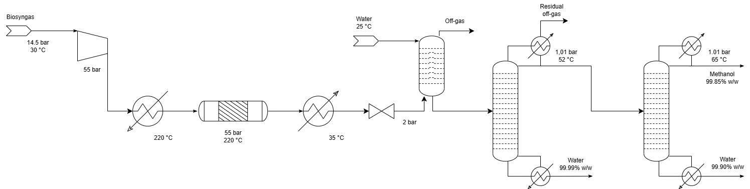
Figure 1: PFD of biomethanol production

As it can be noticed, the simulation focuses on the syngas-to-methanol conversion and it comprises the methanol reaction section followed by a preliminary washing column and then a train of separation units. The inlet syngas comes from the upstream steam reforming unit after preliminary water removal and the final targeted product purity is set to grade AA, i.e. 99.85% mass fraction. The feed properties and the main specifications for each process unit are listed in Table 1.
Table 1: Process parameters and specifications for the biogas-to-methanol plant
Unit operation | Property | Value | Unit | Min value | Max value
Feed | Flowrate | 1600 | kg/h | 600 | 3000
 | CH₄ fraction | 0.0104 | mol/mol
 | CO₂ fraction | 0.1051 | mol/mol
 | H₂O fraction | 0.0008 | mol/mol
 | H₂ fraction | 0.6230 | mol/mol
 | CO fraction | 0.2607 | mol/mol
Reactor | Pressure | 55 | bar
 | Temperature | 220 | °C
Scrubber | Pressure | 2 | bar
 | Temperature | 25.8 | °C
 | Water/Feed | 3.8 | kg/kg
1st column | Top pressure | 1.01 | bar
 | Number of stages (feed) | 35 (3) | -
 | Methanol loss in bottom | 0.0005 | kg/kg
 | Water recovery in bottom | 0.996 | kg/kg
2nd column | Top pressure | 1.01 | bar
 | Number of stages (feed) | 35 (27) | -
 | Methanol purity | 0.9985 | kg/kg
 | Methanol recovery | 0.9999 | kg/kg

Some remarks concerning the feed flowrate value are nevertheless required. In fact, since the process capacity corresponds to the manipulated to be adjusted according with the renewable energy availability, the value provided in the table corresponds to the target productivity under steady-state conditions. However, because of the flowrate modulation, the important values for the modeling phase are represented by the lower and upper boundaries of the operating window. These values, which are constrained by feasibility limitations (Mawassi et al., 2025), correspond also to the domain for dataset generation as better explained in the following section.
  - Derivative-based surrogate model strategy
Regardless of the specific domain, the term surrogate modeling usually includes diverse strategies based on methodologies that substantially differ among themselves in terms of optimization algorithms. Some of the most common examples are given by Kriging, Artificial Neural Networks, Radial Basis Functions or Support Vector Machines (McBride and Sundmacher, 2019). One of the most common criteria for the categorization of such type of approaches is given by the output nature; in fact, some methods allow to obtain the analytic form of the final model while others just provide reliable values that approximate the original dataset. When dealing with dynamic profiles, the former case could be more interesting since it allows to exploit the model in control loops and optimization algorithms. For this reason, in the presented, a second order differential equation is used as basis function for the dataset regression in order to allow the user to operate with both the implicit and the explicit function equation according to their needs. Before presenting the final results, the procedure for the sample generation phase and the derivative-based model regression are respectively explained in the following subsections.
    - Sample generation
The very first step of the procedure is given by the generation of either experimental or calculated values to be used to optimize the analytical form and the characteristic parameters of the differential model. As previously discussed, due to the difficulty of having experimental data for innovative industrial plants, simulated points were used in this case (Mawassi et al., 2025). The sample dynamic profile over a 24 hours simulation run was generated by resetting the manipulated variable with a step variation at the beginning of every simulation hour. The 24 target values are generated within the operating window provided in Table 1, i.e. 600-3000 kg/h, by following the Latin Hypercube Sampling strategy (McKay et al., 1979) , which ensures a good domain filling with a homogeneous discretization. This method is based on the partition of the domain into n x n equal sub-spaces and on the random selection of one of the n points per each of them, as shown by the simplified example in Figure 2a. Hence, the resulting input profile over the 24 hours is obtained as reported in Figure 2b and the dynamic simulation is run accordingly. Based on these values, the surrogate modelling step could be then carried out according to the approach detailed in the following subsection.
a)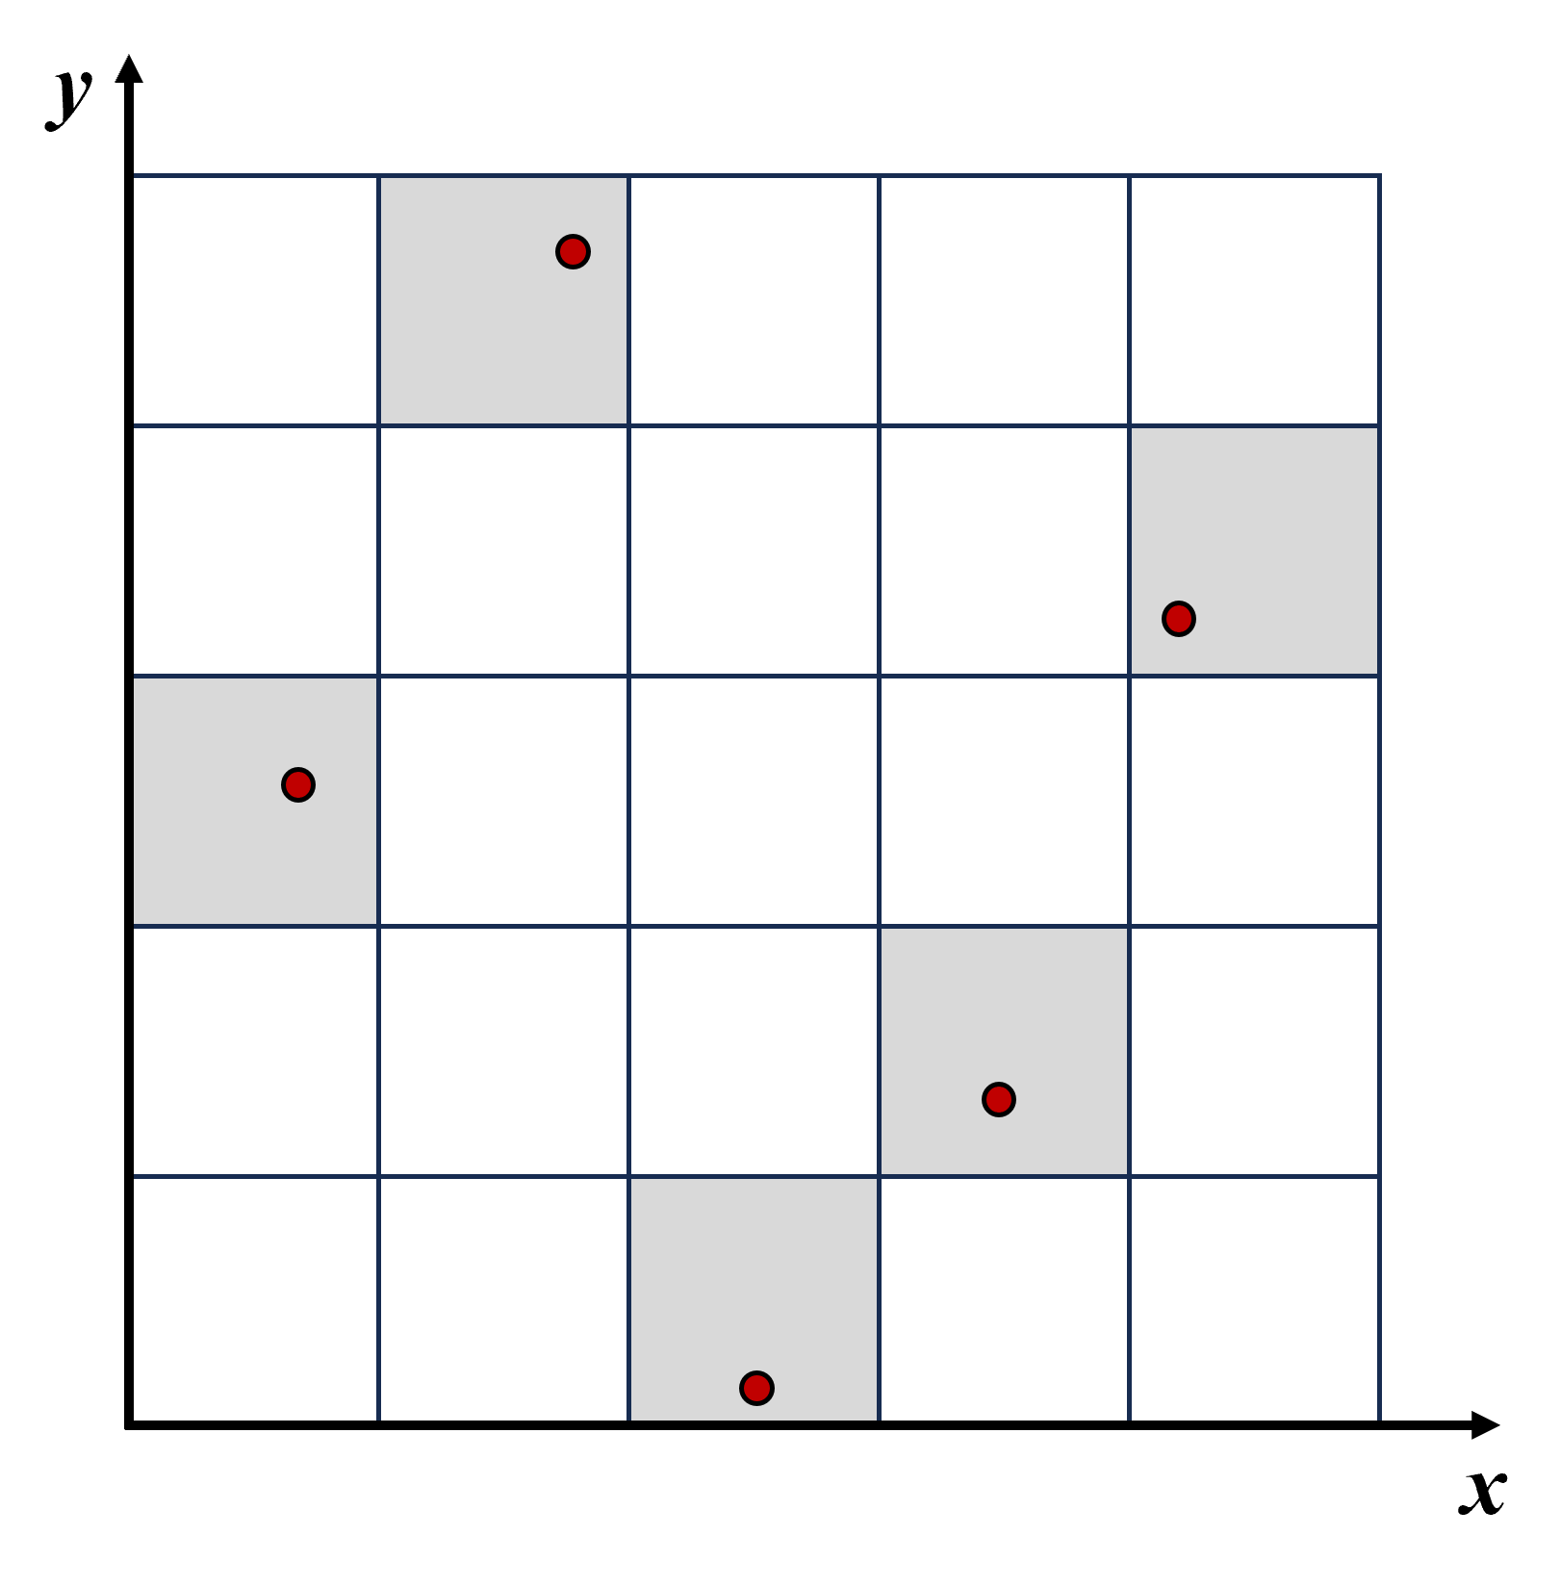 b) 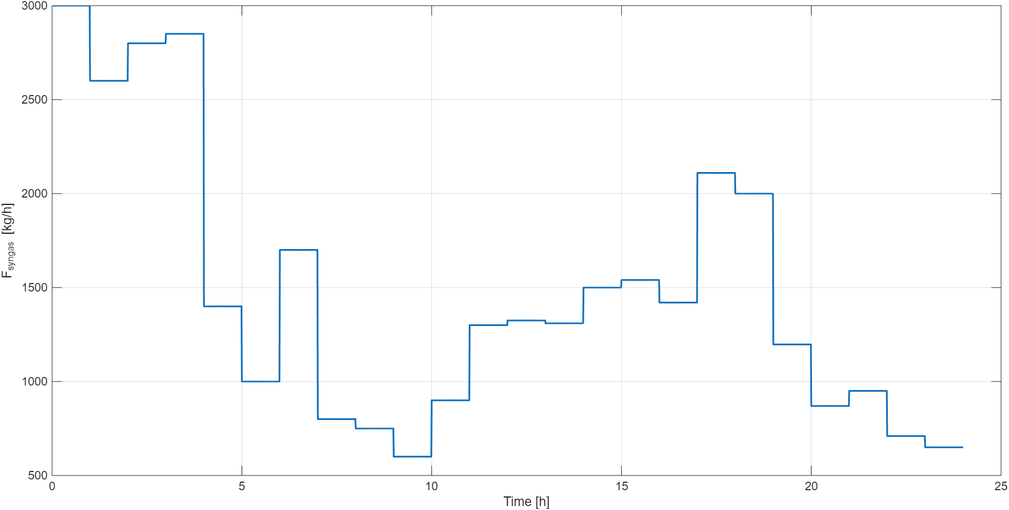
Figure 2: a) Example of Latin Hypercube Sampling - b) Input variable profile for dataset generation

    - Modeling strategy
The second part of the surrogate modeling procedure presented in this work refers to the model derivation. The main innovation of this research is the use of a differential equation as analytic function to be regressed; this choice approximates a pseudo-transfer function approach by exploiting the derivative form of the model equation. The theoretical fundamental that makes the strategy possible is given by the fact that all dynamic systems whose order is higher than two can be approximated as a pseudo-second order system (Stephanopoulos 1984). This means that the correlation between the input and output variable of the dynamic system can be described by the following characteristic equation :
$$\frac{1}{ω^{2}} ⋅\frac{d^{2}y}{dt^{2}}+\frac{2⋅ξ}{ω}⋅\frac{dy}{dt}+f(y,u)=0$$ | (1)
where y is the dependent variable (output), u is the manipulated variable (input), ω is the characteristic frequency of the system and ξ is the damping ratio. The value of the latter term, that can be higher, lower or equal to 1, determines whether the behaviour of the system is overdamped, underdamped or critically damped respectively. The final goal of the modeling optimization algorithm is then to identify the coefficients of the equation, including the k_{i} coefficients of the function f(y,u), that minimize the mismatch between the dataset and the calculated values. The resulting surrogate modeling problem formulation can then be written as :
$$\min_{ω,ξ,\tilde{k}}{F_{obj}}{=\min_{ω,ξ,\tilde{k}}\left(\frac{y^{sim}-y^{mod}}{y^{sim}}\right)}^{2}$$ | (2)
Therefore, the expected result of the modeling problem is a single differential equation whose integration, either numerical or analytical, is able to provide the dependent variable profile over time according to the variation of the manipulated one, that is represented inside the f(y,u) function. For the specific biogas-to-methanol plant, the final goal is then to obtain the methanol productivity trend over the daily scheduling profile according with the biosyngas flowrate adjustment. The results for both the modeling problem and the methanol plant scheduling are therefore discussed in the following section.
  - Results
The surrogate modelling optimization problem described in the previous section was then solved by means of the fmincon function available in Matlab 2025b. A discretization of 100 points per hour was used and the model optimization took about 8 seconds for the 24 hours simulation modelling on a laptop with Windows 11 operating system, a 13th Gen. i9 - 2.60 GHz processor and 64 GB RAM. As final result of the procedure, the following differential equation is obtained :
$$\frac{1}{ω^{2}} ⋅\frac{d^{2}F_{MetOH}}{dt^{2}}+\frac{2⋅ξ}{ω}⋅\frac{dF_{MetOH}}{dt}-ΔF_{syngas}(t)=0$$ | (3)
with ω and ξ that are equal to 60 1/h and 1.6 respectively.
The graphical comparison between the model trajectory and the dynamic simulation data is then reported in Figure 3. As it can be noticed, the overlap accuracy is very high for each of the input step deviations. In those regions where the operation profile shows a stable trend, i.e. pseudo-steady state conditions, the mismatch is practically absent while minor deviations can be observed in the proximity of the setpoint step variations. However, even in this case, the incongruencies are visible only for very large step variations, they do not exceed 5 kg/h error and in most of cases they only last for a few minutes, as it can be noticed at hours 4, 6, 7 and 17.

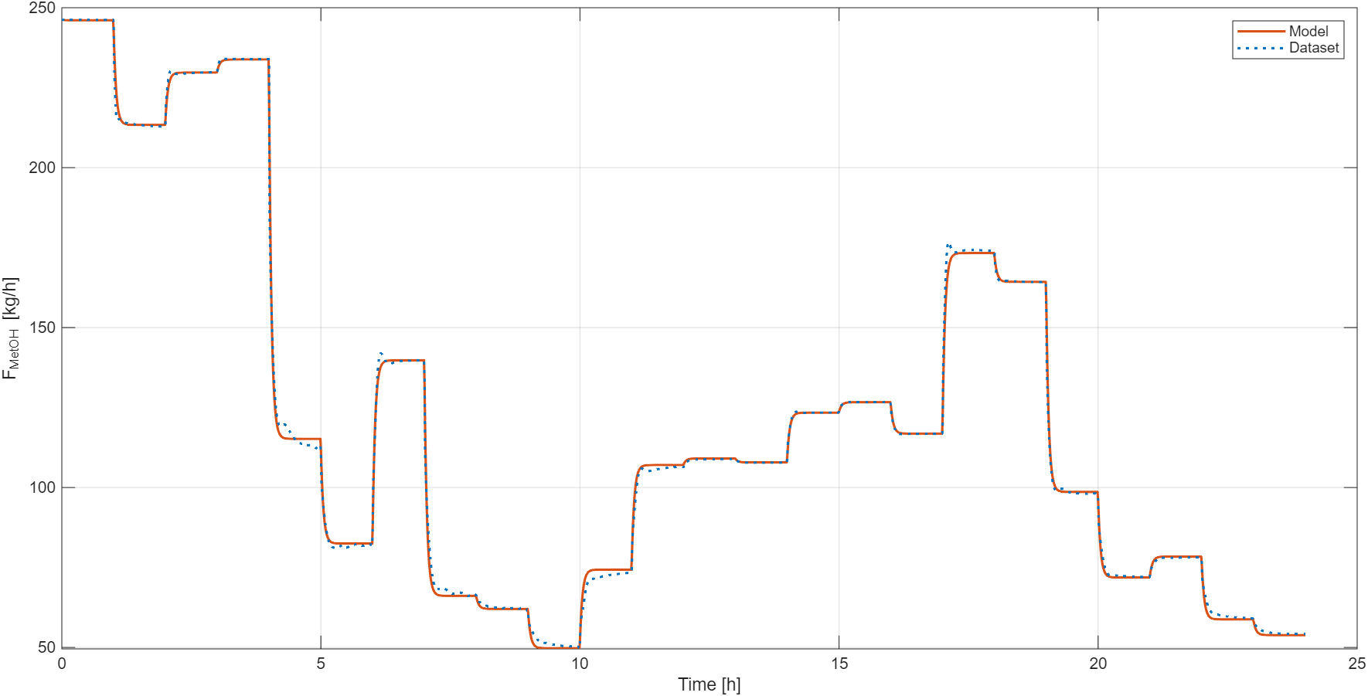
Figure 3: Methanol production : comparison between dynamic simulation and surrogate model profiles

Finally, concerning the model accuracy and the computational performance, the most relevant indicators are reported in Table 2. Beside simulation and dynamic model data, the linear correlation corresponding to the steady-state estimation of the system response was included in the analysis for further benchmarking. As it can be noticed, the calculation time required to generate the dynamic profile over 24 hours (that is different from the optimization computational time) drastically drops when moving from phenomenological to data-driven models. In particular, the integration of the second-order differential equation approximately takes three times more than the linear steady-state value while both of them provide results within a time span that is reduced by a factor of about 10⁵ with respect to the Aspen Dynamics® simulation.
Beside that, both the minimum and the average accuracy were assessed by computing the Maximum (MAE) and the mean (mre) relative errors. As already pointed out from the graphics, the second-order dynamic surrogate model exhibits an average error lower than 1%, that is an excellent approximation of the real plant behavior. In terms of mre, also the steady-state estimation shows a good performance with less than 1.78% average mismatch. However, the quality of such approximation is mainly given by the fact that the simulated plant is characterized by short transients, i.e. the stable operating conditions dominate the 24 hours dynamics. In fact, when the maximum error is taken into account instead, the linear model achieves peak values of MRE higher than 60%, which are clearly not acceptable for dynamic simulations.
In addition to the point-wise performance, given the interest of using these models for optimal process scheduling, the overall daily productivity is an important aspect worth a dedicated discussion. The second-order differential model is able to replicate the overall production over 24 hours with almost no error at all (2913.1 vs 2912.9 kg). This level of accuracy is also given by the fact that the some over- and under-estimations are able to compensate each other when the number of decreasing and increasing steps are close. Hence, whether the data-driven model should be used in optimal scheduling problems, the error on the objective function results to be almost negligible with respect to the same algorithm applied to the rigorous simulation.
Table 2: Performance indicators
Indicator | Simulation | Steady-state | 2nd order model
Computational time | 6 min 32 s | 0.0016 s | 0.0056 s
Daily productivity | 2913.1 kg | 2901.8 kg | 2912.9 kg
MRE | reference | 61.12 % | 8.85 %
mre | reference | 1.78 % | 0.87 %
MAE on productivity | reference | 0.39 % | 0.008 %
  - Conclusions
As claimed in the first part of the manuscript, the presented work proves the effectiveness of a simple but rigorous derivative-based approach for data-driven dynamic modelling of chemical processes. In particular, it can be concluded that the use of a pseudo-differential equation to regress dynamic profiles of stable systems is able to reduce the required computational time by four/five orders of magnitude with respect to conventional dynamic simulation packages and, at the same time, to keep high accuracy of the monitored variable even when changing the set of input perturbations. When embedding such a model within an optimization algorithm, the reduction in terms of computational time is obtained for each of the iterations, by completely change the time scale of the optimization problem resolution time. A further advantage of this method is the flexibility of utilization since it doesn’t need the fulfilment of specific hypotheses or constraints and it can be adapted to both open- and closed-loop systems as long as they are well controlled, which is in any case a mandatory requirement for chemical plants. Moreover, the same type of differential-model can be exploited for a multi-scale application since it is suitable for a single unit operation, a combination in parallel or series of multiple units or, as proved in this study, a whole process plant from the inlet to the final product.
Given such a potential, future applications of this methodology will target optimal operation scheduling and model predictive control problems in order to give a substantial boost to their time consuming algorithms and to make these strategies viable on real-time and industrial scales.

Nomenclature
F_{MetOH} – Methanol flowrate, kg/h
F_{syngas} – Bio-syngas flowrate, kg/h
MRE – Maximum Relative Error, %
mre – Mean relative error, %
t – time, h
u – manipulated variable, kg/h
y – dependent variable, kg/h
ξ – characteristic dumping factor, -
ω – characteristic frequency, 1/h

References
Bhosekar A., Ierapetritou M., 2018. Advances in surrogate based modeling, feasibility analysis, and optimization: A review. Computers & Chemical Engineering 108, 250–267.
Di Pretoro A., Bruns B., Negny S., Grünewald M., Riese J., 2022. Demand response scheduling using derivative-based dynamic surrogate models. Computers & Chemical Engineering, 160, 107711.
Di Pretoro A., Silvetti A., Annesini M.C., 2023. Power-to-methanol Process Plant Performances Under Uncertainty: Economic and Environmental Criticalities. Chemical Engineering Transactions, 99, 655-660.
McBride K., Sundmacher K., 2019. Overview of Surrogate Modeling in Chemical Process Engineering. Chemie Ingenieur Technik, 91(3), 228–239.
McKay M.D., Beckman R.J., Conover W.J., 1979. Comparison of three methods for selecting values of input variables in the analysis of output from a computer code, Technometrics 21(2), 239–245.
Mawassi G., Di Pretoro A., Montastruc L., 2025. Exploiting Dynamic Simulation in Sustainability-based Scheduling Optimization for Biomethanol Production. Chemical Engineering Transactions, 199, 337-342.
Mousa J., Negny S., Ouaret R., Di Pretoro A., Montastruc L., 2025. Incorporating Physical Constraints inside Neural Networks to Improve their Accuracy and Physical Reliability for Chemical Engineering Unit Operations Modeling. Computers & Chemical Engineering 199, 109156.
Panda S., Mohanty S., Rout P.K., Sahu B.K., Parida S.M., Samanta I.S., Bajaj M., Piecha M., Blazek V., Prokop L., 2023. A comprehensive review on demand side management and market design for renewable energy support and integration. Energy Reports, 10, 2228–2250.
Shokry A., Baraldi P., Zio E., Espuña A., 2020. Dynamic Surrogate Modeling for Multistep-ahead Prediction of Multivariate Nonlinear Chemical Processes. Industrial and Engineering Chemistry Research, 59(35), 15634–15655.
Stephanopoulos G., 1984, Chemical Process Control: An Introduction to Theory and Practice, Prentice Hall, New Jersey, USA.
Tabibian S. S., Sharifzadeh M., 2023. Statistical and analytical investigation of methanol applications, production technologies, value-chain and economy with a special focus on renewable methanol. Renewable and Sustainable Energy Reviews, 179, 113281.

