 CHEMICAL ENGINEERING TRANSACTIONS  VOL. xxx, 2026 | A publication of  
The Italian Association
of Chemical Engineering
Online at www.cetjournal.it

Guest Editors: Flavio Manenti, Botir Usmonov, Alessandro Di Pretoro
Copyright © 2026, AIDIC Servizi S.r.l.
ISBN 979-12-81206-xx-x; ISSN 2283-9216

Design Of Efficient Visible-Light-Active Photocatalysts Based On Mixed Phthalocyanine/Metal Oxides For Water Treatment
Albert R. Koldarov*, Mastura Kh. Aripova, Odiljon Abdurakhmоnov
Tashkent Institute of Chemical Technology, Navoi Street 32A, Tashkent, Uzbekistan
koldarov95@gmail.com
Traditional semiconductor metal oxide photocatalysts can convert solar energy into chemical energy. However, conventional TiO₂ and ZnO are highly chemically and electrochemically stable but absorb only UV light, which accounts for about 5% of the solar spectrum, resulting in exceptionally low visible-light absorption. Additionally, these materials suffer from rapid electron-hole recombination, which drastically lowers their overall efficiency in photochemical water treatment and hydrogen evolution. The composite photocatalysts were synthesized by combining the zinc phthalocyanine complex (PcZn) with metal oxides (ZnO, TiO₂) derived from the spent catalyst of the Shurtan Gas-Chemical Combine in the Kashkadaryo region, Uzbekistan. Transmission Electron Microscopy (TEM) and Scanning Electron Microscopy with Energy-Dispersive X-Ray Spectroscopy (SEM-EDS) were used to verify the formation of the nanostructure after successful layer deposition. Ultraviolet-visible spectroscopy (UV-Vis) was used to confirm the extension of harvestable solar energy into the visible spectrum and to trace the strong π→π* transitions. The methylene blue degradation experiments and computer simulations showed that the composites exhibited better adsorption/photodegradation properties than pure semiconductor phases, indicating improved photocatalytic performance.
1. Introduction
The structural synergy between organic phthalocyanines and inorganic semiconductors is achieved through various nanoarchitectures. Functionalized TiO₂ and ZnO nanofibers have been used to prepare various nanofibers and porous structures, yielding high-surface-area composites for photodegradation. Additionally, hierarchical porous TiO₂ has been used to embed unsymmetric zinc phthalocyanine sensitizers. Phthalocyanines can be stabilized within TiO₂ frameworks via sol-gel processes for medical applications (Lopez et al., 2010). For sensing, combinatorial arrays of Pc-functionalized TiO₂/ZnO thin films have been developed to improve gas selectivity (Sivalingam et al., 2022). STM studies (Olszowski et al., 2017) showed that Zn-centered phthalocyanines order themselves on TiO₂ (011) surfaces. The anchoring of unsymmetrical Zn-phthalocyanines on nanostructured films has been used to improve interactions with substrates (Pellegrino et al., 2013). The primary goal of these heterostructures is to enable visible-light activity through efficient electron transfer, appropriate electron injection, and recombination rates between TiO₂ nanoparticles and ZnO nanorods when sensitized by Pc (Virkki et al., 2018). The sensitization mechanism involves the transfer of photogenerated carriers in Zn (II) phthalocyanine-sensitized TiO₂ (Li et al., 2010). The formation of heterojunctions offers benefits, as immobilized TiO₂/ZnO heterostructures sensitized with copper(II) phthalocyanine have proven effective at degrading pharmaceuticals such as ibuprofen (Bethel Anucha et al., 2021). Generally, semiconductor composites with organic phthalocyanines have broad applications for environmental remediation. Composites are widely used to degrade dyes such as methyl orange and complex pollutants (Mapukata et al., 2020). Green energy applications include visible-light-induced H₂ production (Tiwari et al., 2018) and the photocatalytic reduction of aqueous carbonate to methanol (Rophael et al., 1990). Some composites exhibit antimicrobial activity (Vallejo et al., 2021), demonstrating that Zn (II)-tetracarboxyphthalocyanine-sensitized TiO₂ is a potent antimicrobial agent under visible irradiation. The composites can be considered solar cell photosensitizers, and symmetrically and unsymmetrically substituted carboxyphthalocyanines have been specifically evaluated as sensitizers for nanoporous ZnO films (Masilela et al., 2010). A significant technical effect is achieved by using phthalocyanines as photosensitizers combined with wide-bandgap semiconductors via a Type-II heterojunction mechanism. When the Pc is excited by visible light, electrons are promoted, and if the Lowest Unoccupied Molecular Orbital (LUMO) of the Pc is more negative than the Conduction Band (CB) of the oxide, the electron is injected into the semiconductor. This efficient separation prevents recombination, leaving holes on the Pc to oxidize pollutants directly. Furthermore, while ZnO/TiO₂ hybrids can be prone to photocorrosion in acidic media, the newly applied Pc coating acts as a protective layer, technically increasing the chemical stability of the ZnO core.
The main goal of this study is to design efficient, visible-light-active hybrid photocatalysts for photochemical water treatment by developing novel composite systems that integrate sustainably sourced metal oxides with phthalocyanines (Pcs) as photosensitizers to suppress recombination and harvest visible and near-infrared light. To achieve this goal, the following sequential tasks were:
1. Fabricate hybrid photocatalysts based on a zinc phthalocyanine complex (PcZn) and ZnO nanoparticles.
2. Create thin layers of PcZn on the surfaces of ZnO and TiO₂ derived from spent catalysts of the oil-and gas industry in Uzbekistan.
3. Optimize the photocatalyst structure based on structure-activity relationships, using a set of spectroscopic data, band-gap measurements, methylene blue degradation tests, and calculated electronic parameters.
While prior literature focuses on the fundamental photochemistry and structural pairing of synthetic and pure oxides, this work introduces a highly sustainable, waste-to-resource approach that uses real industrial by-products to construct active heterojunctions.
2. Materials And Methods
2.1. Synthesis of ZnO and TiO₂ composites
The initial hydrolysis of ZnO(acac)₂ was performed at room temperature, but complete conversion to the crystalline oxide phase required calcination at 400°C.
Zn(C₅H₇O₂)₂ + 2H₂O → Zn(OH)₂ + 2C₅H₈O₂
Zn(OH)₂ → ZnO + H₂O
The composite samples were prepared by mixing with zinc phthalocyanine (PcZn) (Sigma-Aldrich) at a concentration below 1,3% during the hydrolysis step (ZnO(acac)-PcZn). The PcZn acts as a nucleation template that slows and controls hydrolysis, leading to the formation of unique needle-shaped and flower-like crystalline aggregates that optimize the reaction surface area. In addition, deep-coating with the PcZn ethanol solution under sonication (35 kHz, 30 minutes) was performed on metal oxides (ZnO, TiO₂) derived from the spent catalyst of Shurtan Gas-Chemical Combinate, Kashkadaryo region, Uzbekistan (ZnO-PcZn, TiO₂-PcZn). Sonication was used to facilitate the coating and integration of the PcZn layers onto the surfaces of the metal oxide catalysts to achieve surface-adsorbed layers and successful nanostructure formation.
2.2. Characterization
Transmission Electron Microscopy (TEM) (Talos, ThermoFisher, USA) and Scanning Electron Microscopy with Energy-Dispersive Spectroscopy (SEM-EDS) (Jeol, IT200, Japan) were used to characterize surface morphology and elemental composition, and the ChemiSEM was used for simultaneous morphology and elemental mapping (Phenom, ThermoFisher, USA). Diffuse reflectance optical spectra were acquired using a UV-Vis Spectrophotometer (Analytic Jena, Specord 50, Germany). Monte Carlo computer simulations were performed using Adsorption Locator (Biovia 2020 software) at the semiconductor oxide-phthalocyanine interface. The adsorbate consisted of water and methylene blue molecules. Simulation supercells for the ZnO (101), TiO₂ anatase (101), and PcZn (100) planes were generated from CIF files. For all calculations, the COMPASS II forcefield was used with the number of simulated annealing cycles under automated temperature control – 5; steps per cycle – 50,000. Adsorption energy evaluation was based on the principle that a more negative value indicates a spontaneous, stable structure and higher adsorption capacity. Experimental photodegradation was evaluated in an aqueous solution of methylene blue (0.001 mM) under solar irradiation.
3. Results and discussion
SEM images (Figure 1) clearly demonstrate the successful formation of a ZnO-phthalocyanine composite. The images reveal a distinct interaction between the organic macrocycle and the inorganic semiconductor. In the ZnO-PcZn sample, large, elongated rod- or rectangular-shaped crystals of crystalline phthalocyanine macrocycles are visible (Figure 1a). Numerous small, needle-shaped ZnO spent catalyst nanoparticles are distributed throughout the ZnO-PcZn sample. In several regions, the ZnO needles have clustered to form flower-like aggregates, a feature favored in sol-gel synthesis because it provides a high surface area for photocatalytic reactions. Figure 1b (at higher magnification) shows a phthalocyanine crystal almost entirely covered by a dense layer of these ZnO(acac) nanoneedles and aggregates, with strong interfacial bonding between the two components. The coexistence of large organic crystals and small inorganic needles confirms the two-phase nature of the material. The dense ZnO(acac) coverage on the phthalocyanine suggests an efficient heterojunction. This is ideal for visible-light-active photocatalysts, as the phthalocyanine can act as a sensitizer, transferring electrons to the ZnO needles.
a b
Figure 1: ChemiSEM image of synthesized composites (a-ZnO-PcZn; b-ZnOacac-PcZn).
The TEM image (Figure 2a) reveals dense, irregularly shaped clusters of TiO₂-PcZn nanoparticles. The blue (Ti) and green (O) maps show strong spatial correlation, confirming the presence of the titanium dioxide phase within these clusters. The red map (C) shows a relatively uniform distribution of carbon across the scanned area, overlapping with the TiO₂ regions. This indicates that the organic phthalocyanine macrocycle has been successfully coated onto the metal oxide particle surface.
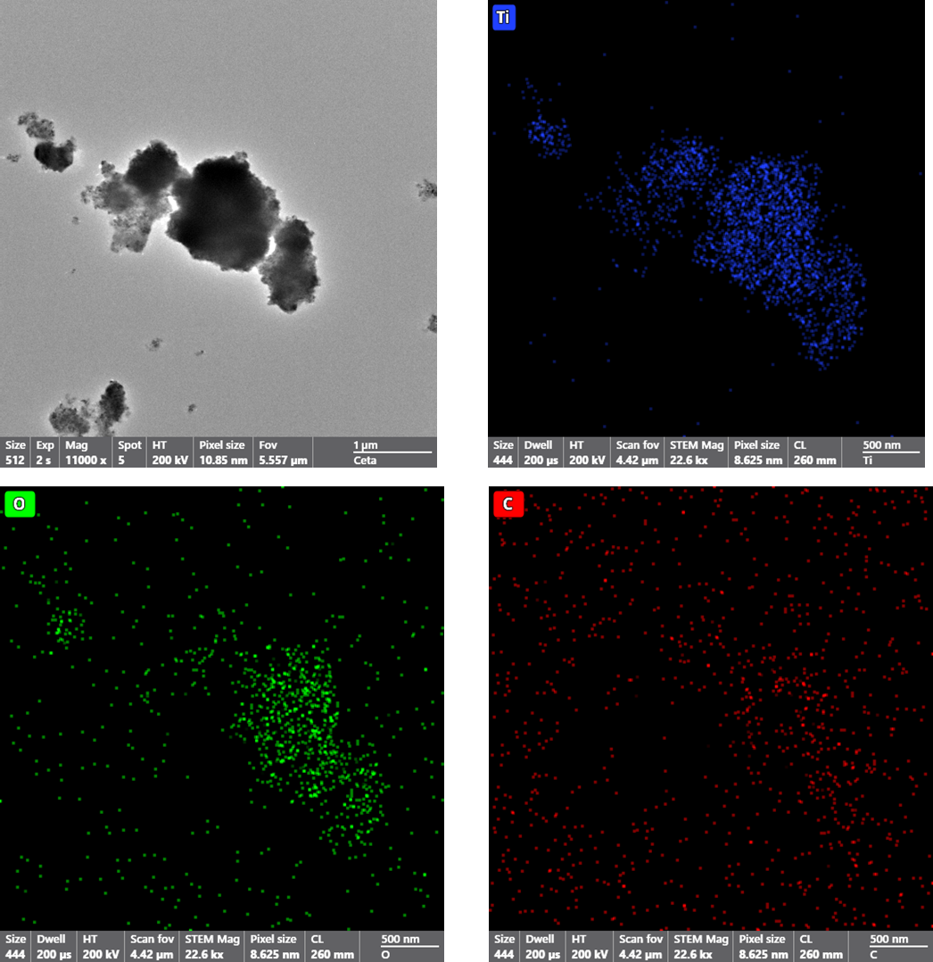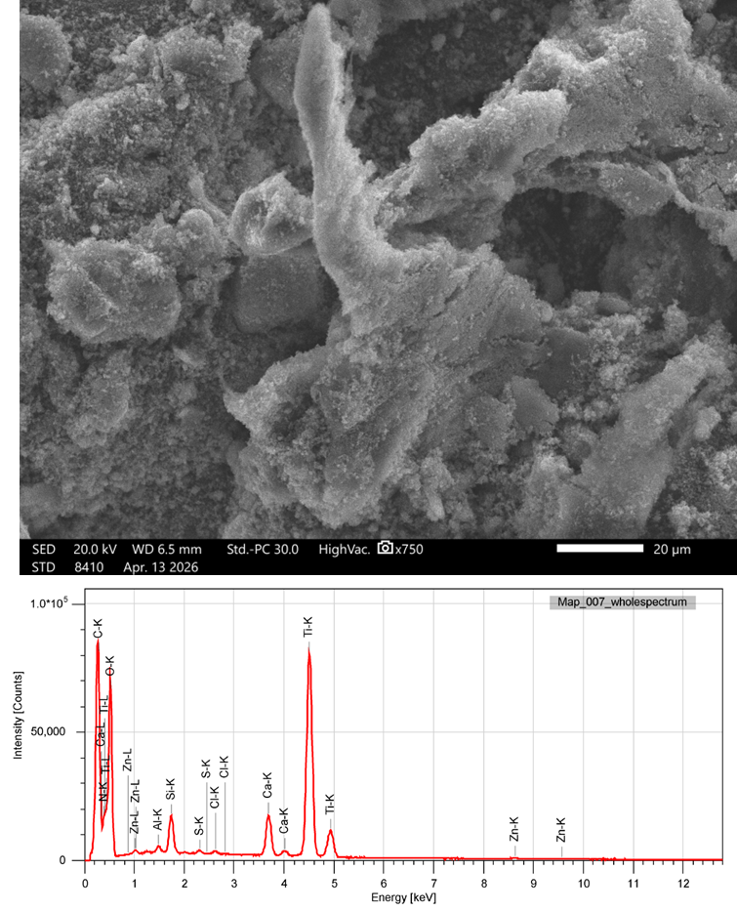
a b
Figure 2: TEM-EDX (a) and SEM-EDX (b) of TiO₂-PcZn.
The SEM image (Figure 2b) shows a highly textured, porous surface with hierarchical features. Large, integrated structures appear to be covered with a dense layer of smaller aggregates, forming a high-surface-area material suitable for photocatalysis. Clear EDS peaks confirm TiO₂ as the primary component. The presence of Zn peaks suggests the use of a zinc-based phthalocyanine. Carbon (C), nitrogen (N), and oxygen (O) peaks correspond to the phthalocyanine structure and the metal oxide. Minor peaks for elements such as silicon (Si), sulfur (S), chlorine (Cl), and calcium (Ca) may be attributed to spent industrial catalysts.
All XRD patterns (Figure 3a) exhibit the characteristic peaks of the hexagonal wurtzite structure of ZnO, with prominent triplets between 30 and 40 ° corresponding to the (100), (002), and (101) planes. The distinct low-angle "fingerprint" peak of the crystalline phthalocyanine macrocycle appears at approximately 7-9°. The ZnO(acac)-PcZn pattern shows significantly sharper and more intense peaks, suggesting that the phthalocyanine is more crystalline or has larger crystallite sizes. Despite the low concentration (less than 3%), the phthalocyanine is clearly detectable due to its high molecular symmetry and crystalline nature. The positions of the ZnO peaks do not show a significant shift, indicating that the phthalocyanine exists as a separate phase or a surface-adsorbed layer. The sharp peaks in the ZnO-PcZn pattern suggest well-defined crystalline domains, typical of needle-like growth along specific axes. Large flower-like aggregates lead to higher peak intensities because the increased volume of ordered material contributes to the diffraction. The primary difference is the increased peak intensity and sharpness, suggesting the composite material is ordered, with the phthalocyanine acting as a template or secondary crystalline phase that promotes the growth of the flower-like and needle-like ZnO structures. The XRD pattern for the TiO₂-PcZn composite (Figure 3b) reveals the most intense peak at 25.3 ° (101), along with subsequent peaks at 37.8, 48.0, 53.9, 55.1, and 62.7 ° of the anatase phase (band gap 3.22 eV). The low-angle, sharp peaks at 2θ < 15 ° indicate a well-ordered PcZn phase within the composite.
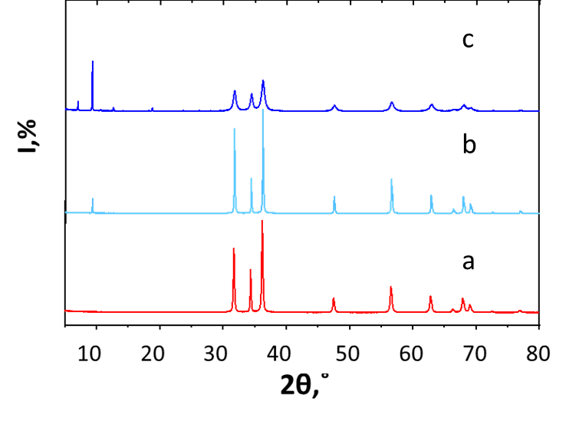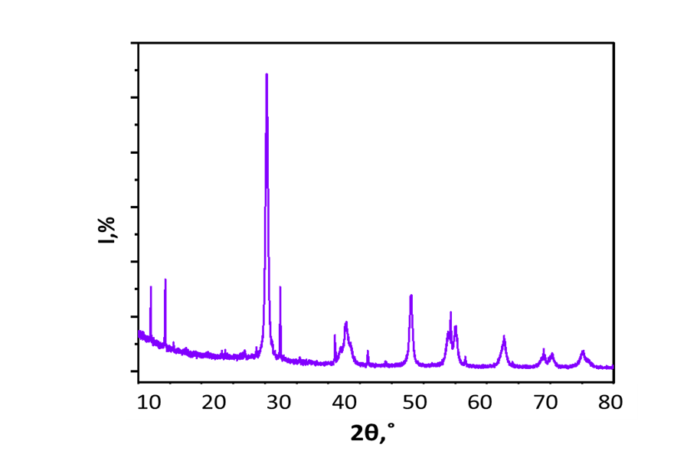
a b
Figure 3: XRD of the synthesized composites: a - (а-ZnO-PcZn; b-ZnOacac-PcZn; c - ZnO-PcZn) and b- TiO₂-PcZn.
Analysis of the Tauc plots for the titanium dioxide (TiO₂) and zinc phthalocyanine (PcZn) composite can be used to define the optical properties of this photocatalytic material (Figure 4). ZnO is a direct band-gap semiconductor (valence band (O2p) to conduction band (Zn4s)). By extrapolating the linear portions of the absorption edges to the baseline, ZnO shows a steep absorption edge around 3.1 eV. This is consistent with the standard bulk value for wurtzite ZnO (~3.3 eV) with a slight redshift. The ZnO(acac)-PcZn composite has a main Eg ~3.18 eV (ZnO semiconductor transition), and the slight shift suggests a marginal narrowing of the ZnO band gap due to surface interaction with the phthalocyanine. The phthalocyanine macrocycle exhibits a broad molecular transition in the visible/NIR region, with a value around 1.40–1.60 eV. Taking into consideration the sharp XRD peaks (indicating high crystallinity) and two distinct absorption edges, it is possible to suggest that the Zn(acac)-PcZn is not merely a physical mixture. Based on the Tauc plots provided for the ZnO-PcZn, the primary (~3.21 eV) and secondary (~1.45 eV) optical band gaps were observed. The band gap of the ZnO component remains relatively stable across the series, ranging from 3.21 eV to 3.23 eV. This confirms that the wurtzite crystal structure of the ZnO remains the dominant electronic framework. The second transition in the visible/near-infrared region, at approximately 1.45–1.50 eV, is associated with the absorption of lower-energy photons. These values indicate successful formation of a composite material with an extended light-harvesting range, combining the UV activity of ZnO with the visible-light sensitivity of the phthalocyanine. Unlike the ZnO-PcZn plots, the TiO₂ UV edge here appears slightly more gradual, possibly due to different grain boundary effects or a different crystallization state. The primary TiO₂ transition is observed at approximately 3.25 eV, which may correspond well with the anatase phase of TiO₂ (typically 3.22 eV). The TiO₂-PcZn shows a very slight shift to lower energy (3.22 eV), which may indicate a synergistic electronic interaction at the TiO₂-PcZn interface. The secondary PcZn transition has a distinct, broad peak and absorption edge in the lower-energy region, starting around 1.45 eV.
The experimental results for the photodegradation of methylene blue aqueous solutions completely confirm the better catalytic activity of the hybrid composite (Figure 4). The rate constants followed pseudo-first order kinetics within the Langmuir-Hinshelwood model (k(ZnO) 0.0083 <k(ZnO-PcZn) 0.0183 <k(ZnO(acac)-PcZn) 0.0289 min⁻¹ and k(TiO₂) 0,0048 <k(TiO₂-PcZn) 0.0223 min⁻¹), indicating an important role of adsorption on the catalyst surface prior to photooxidation. The presence of two distinct band gaps indicates the formation of a composite system with a type II heterojunction. UV light excites electrons from the semiconductor valence band to the conduction band, while visible light excites electrons in the PcZn macrocycle. Electrons can transfer from the PcZn to the conduction band, significantly reducing electron-hole recombination and increasing the efficiency of pollutant degradation (Figure 5a).
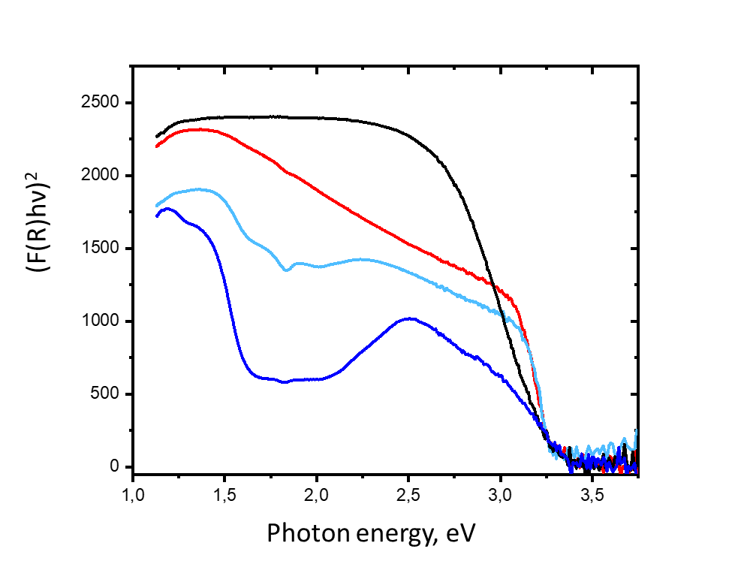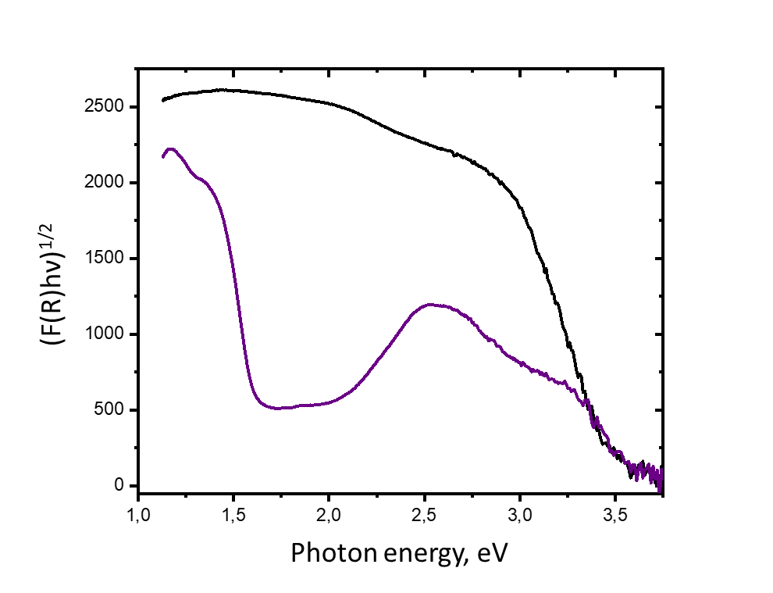
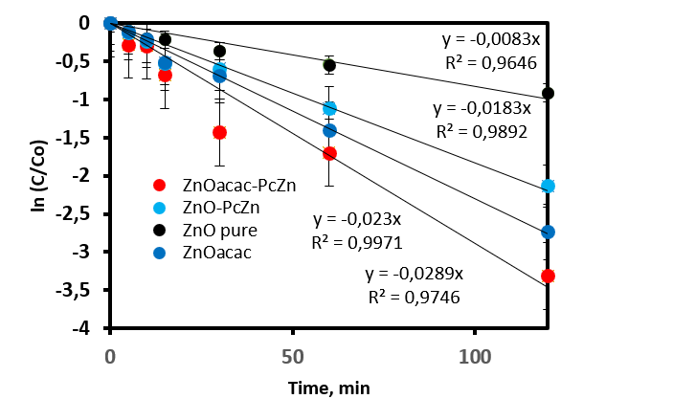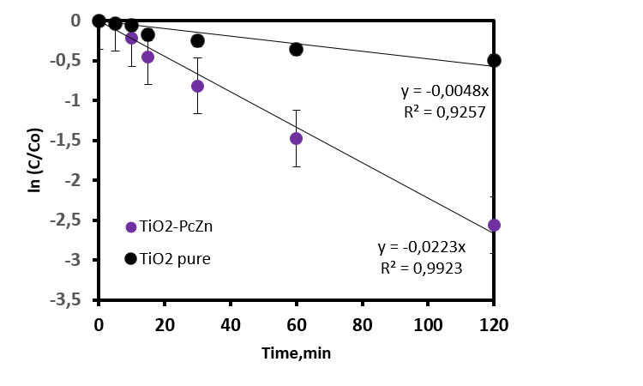
a b
Figure 4: Tauc plot and photodegradation kinetics of the synthesized composites (a) ZnO(spent catalyst) (black); ZnO(acac) (red); ZnO-PcZn (dark-blue); ZnOacac-PcZn (light blue); b- TiO₂ (spent catalyst) (black); TiO₂-PcZn (purple).
The Adsorption Locator computer simulation (Figure 5 b,c) indicates that PcZn retains crystalline stacking on both surfaces, consistent with the XRD data. Figure 5b shows more compact anchoring of methylene blue and water molecules on the PcZn surface in the ZnO-PcZn case, whereas Figure 5c shows more localized water molecules at the junction between TiO₂ and PcZn. Both models confirm that the PcZn macrocycle is positioned to act as a visible-light sensitizer, injecting electrons directly into the conduction bands of the metal oxides.
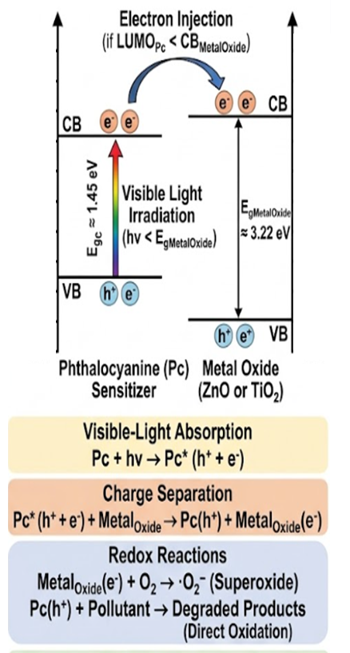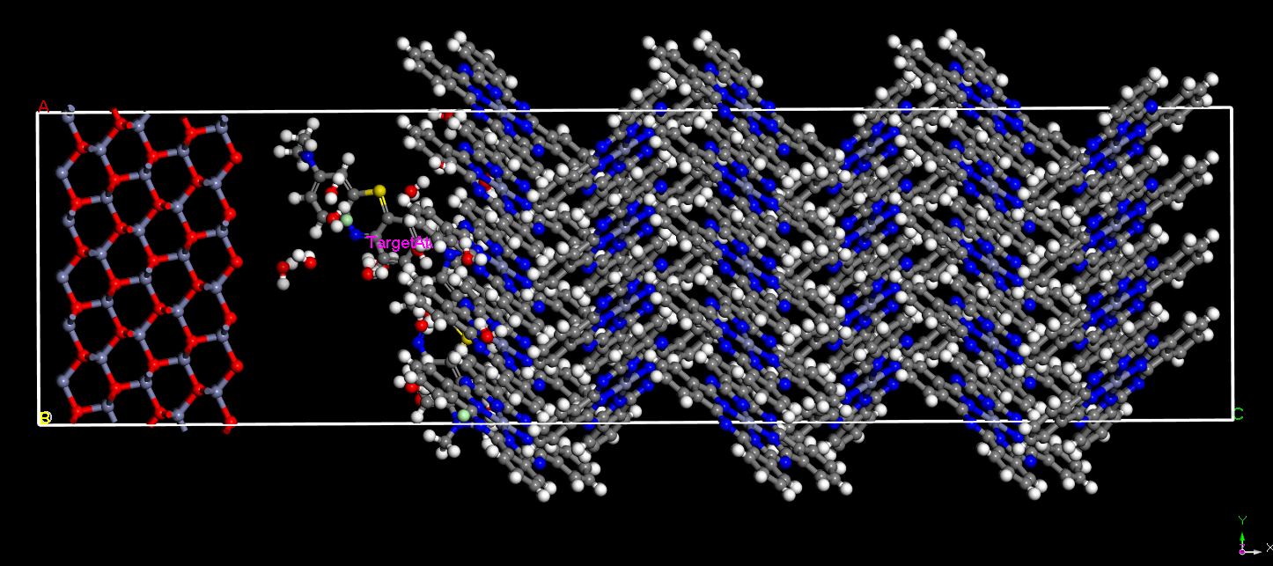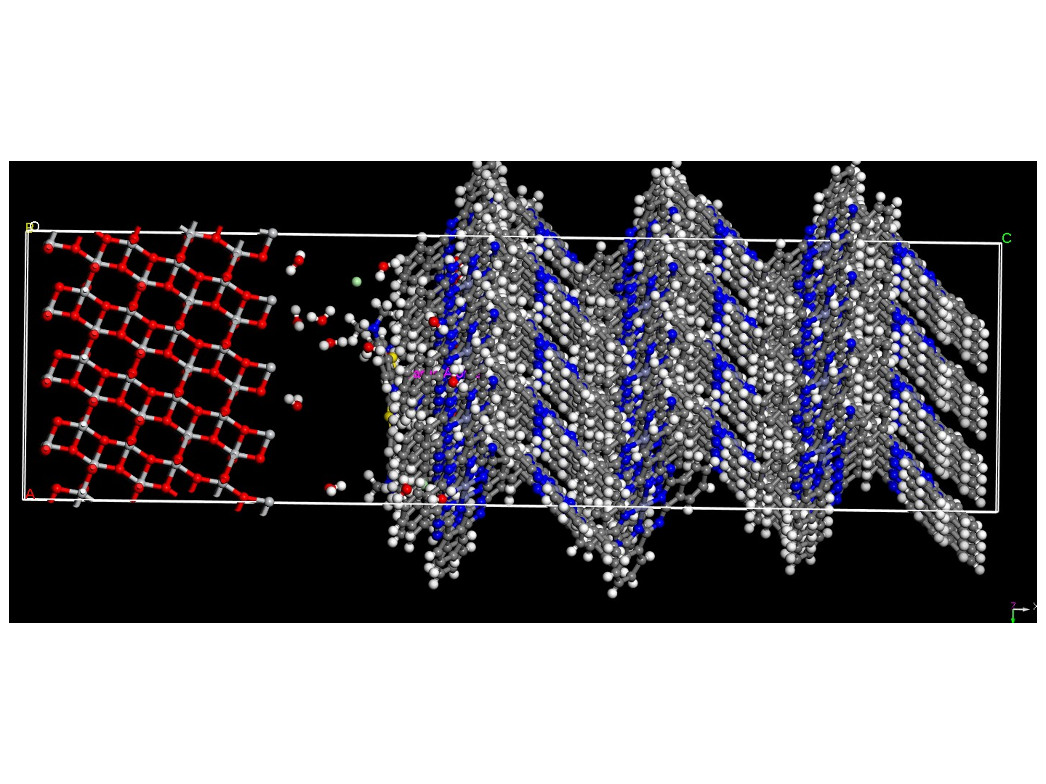
a b c
Figure 5: Photodegradation (a) adsorption mechanism (methylene blue, water) on the interface between PcZn and ZnO (b); TiO₂ (с).
Conclusion
The composite photocatalysts were prepared by integrating the zinc phthalocyanine complex (PcZn) with metal oxides (ZnO, TiO₂) sourced from the used catalyst of the Shurtan Gas-Chemical Combine, Uzbekistan. The TiO₂-PcZn exhibits broader peaks and smaller crystallite sizes than the ZnO needles. Multiple low-angle peaks suggest a more complex crystalline arrangement or multiple orientations of PcZn crystals in TiO₂-PcZn with high-purity anatase. The clear separation of TiO₂ and PcZn peaks confirms that the two distinct transitions in the Tauc plot (~3.22 eV and ~1.45 eV) originate from two crystalline phases. The simultaneous presence of crystalline TiO₂ and ZnO (UV photocatalysts) and crystalline PcZn (a visible-light harvester) suggests a high-surface-area heterojunction. In contrast, the formation of needles and flowers indicates that the hydrolysis of zinc acetylacetonate was slow and controlled in the presence of the phthalocyanine, which served as a nucleation template. Sharp, intense XRD peaks indicate large, highly crystalline needles and flower-like aggregates of ZnO(acac)-PcZn. A single prominent low-angle peak suggests specifically oriented growth or coverage on high-purity wurtzite ZnO needles. The prepared composite structure appears well-suited for water purification or air treatment applications, where high surface-to-volume ratios and enhanced light absorption are critical. The composite photocatalysts offer a highly resource-efficient, circular approach by sustainably deriving the required metal oxides from spent industrial catalysts. This strategy serves as a form of import substitution, reducing reliance on costly chemical precursors by repurposing local industrial waste.
Acknowledgments
The authors express their sincere gratitude to the Uzbekistan-Japan Innovation Center of Youth (UJICY) for providing the laboratory facilities and technical assistance.
References
BethelAnucha C., Altin I., Bacaksiz E., Degirmencioglu I., Kucukomeroglu T., Yılmaz S., Stathopoulos V. N., 2021, Immobilized TiO₂/ZnO sensitized copper (II) phthalocyanine heterostructure for the degradation of ibuprofen under UV irradiation, Separations, 8, 24.
Li L., Xin B. F., 2010, Photogenerated carrier transfer mechanism and photocatalysis properties of TiO₂ sensitized by Zn (II) phthalocyanine, Journal of Central South University of Technology, 17, 218-222.
Lopez T., Ortiz E., Alvarez M., Navarrete J., Odriozola J. A., Martinez-Ortega F., Páez-Mozo E.A., Escobar P., Espinoza K.A., Rivero I. A., 2010, Study of the stabilization of zinc phthalocyanine in sol-gel TiO₂ for photodynamic therapy applications, Nanomedicine: Nanotechnology, Biology and Medicine, 6, 777-785.
Mapukata S., Nyokong T., 2020, Development of phthalocyanine functionalised TiO₂ and ZnO nanofibers for photodegradation of methyl orange, New Journal of Chemistry, 44, 16340-16350.
Masilela N., Nombona N., Loewenstein T., Nyokong T., Schlettwein D., 2010, Symmetrically and unsymmetrically substituted carboxy phthalocyanines as sensitizers for nanoporous ZnO films, Journal of Porphyrins and Phthalocyanines, 14, 985-992.
Olszowski P., Zajac L., Godlewski S., Such B., Pawlak R., Hinaut, A., Jöhr R., Glatzel T., Meyer E., Szymonski, M., 2017, Ordering of Zn-centered porphyrin and phthalocyanine on TiO₂ (011): STM studies, Beilstein journal of nanotechnology, 8, 99-107.
Pellegrino G., Alberti A., Condorelli G. G., Giannazzo F., La Magna A., Paoletti A. M., Pennesi G., Rossi G. Zanotti G., 2013, Study of the anchoring process of tethered unsymmetrical Zn-phthalocyanines on TiO₂ nanostructured thin films, The Journal of Physical Chemistry C, 117, 11176-11185.
Rophael M. W., Khalil L. B., Moawad M. M., 1990, The reduction of aqueous carbonate to methanol, photocatalysed by TiO₂ phthalocyanine, Vacuum, 41, 143-146.
Sivalingam Y., Magna G., Kalidoss R., Murugan S., Chidambaram D., Nutalapati V., Jayaraman S.V., Paolesse R., Di Natale C, 2022, Combinatorial selectivity with an array of phthalocyanines functionalized TiO₂/ZnO heterojunction thin film sensors, Nanotechnology, 33(7), 075503.
Tiwari A., Krishna N. V., Giribabu L., Pal U., 2018, Hierarchical porous TiO₂ embedded unsymmetrical zinc–phthalocyanine sensitizer for visible-light-induced photocatalytic H₂ production, The Journal of Physical Chemistry C, 122, 495-502.
Vallejo W., Navarro K., Díaz-Uribe C., Schott E., Zarate X., Romero E., 2021, Zn (II)-tetracarboxy-phthalocyanine-sensitized TiO₂ thin films as antimicrobial agents under visible irradiation: a combined DFT and experimental study, ACS omega, 6, 13637-13646.
Virkki K., Tervola E., Ince M., Torres T., Tkachenko N. V., 2018, Comparison of electron injection and recombination on TiO₂ nanoparticles and ZnO nanorods photosensitized by phthalocyanine, Royal Society Open Science, 5, 180323.

