 CHEMICAL ENGINEERING TRANSACTIONS  VOL. xxx, 2026 | A publication of  
The Italian Association
of Chemical Engineering
Online at www.cetjournal.it

Guest Editors: Flavio Manenti, Botir Usmonov, Alessandro Di Pretoro
Copyright © 2026, AIDIC Servizi S.r.l.
ISBN 979-12-81206-xx-x; ISSN 2283-9216

Chemical Profiling and Valorization of Liquid By-products from Polyethylene Wax Production: A Combined GC-MS and FT-IR Approach
Eldor E. Mashaev^{a,}*, Jamshid S. Nazirovª, Raxmatulla I. Anarboyevª, Abdurashid B. Sattorovª, Jamshid N. Boymurodovª, Khudoyberdi I. Akhmadov^{b}
ªTashkent Institute of Chemical Technology, Department of Chemical Technology of Oil and Gas Processing, Tashkent, Uzbekistan
^{b}Tashkent Institute of Chemical Technology, Department of High Molecular Compounds and Plastics, Tashkent, Uzbekistan
eldor275@gmail.com

Thermal cracking of high-molecular-weight polyethylene during polyethylene wax production generates liquid by-products with potential for further upgrading. This study investigates the chemical composition and formation pathways of a light fraction obtained from this process. The sample was isolated by fractional distillation and analyzed using Gas Chromatography–Mass Spectrometry and Fourier Transform Infrared spectroscopy. The results show that the identified hydrocarbon fraction is dominated by aliphatic compounds in the C₈–C₁₄ range, with decane and dodecane accounting for 33.58% of the reported GC-MS peak area. The occurrence of alkane–alkene pairs is consistent with radical chain-scission and hydrogen-transfer pathways. Oxygen-containing compounds were also detected; however, because library matching alone does not provide definitive structural confirmation for all oxygenates, particularly the formic-acid assignment, these compounds are treated as tentative assignments requiring confirmation by retention indices and/or authentic standards. FT-IR spectra indicate the predominance of saturated aliphatic structures, while branched compounds identified by GC-MS are consistent with intramolecular hydrogen-transfer and isomerization reactions. The detection of heavier hydrocarbons in the distillate is attributed primarily to entrainment and limited fractionation during distillation. The combined results indicate that the liquid fraction has potential as a feedstock for further upgrading, but application as a fuel, solvent, lubricant, or chemical feedstock requires additional physicochemical characterization and purification.
  - Introduction
The increasing accumulation of polymeric waste and by-products from petrochemical industries has intensified the need for efficient conversion and valorization strategies. Among these, thermal cracking of polyolefins, particularly polyethylene, represents a well-established route for transforming high-molecular-weight polymers into valuable low-molecular-weight hydrocarbons suitable for fuel and chemical applications. Al-Salem et al. (2017) demonstrated that thermal and catalytic pyrolysis of plastics can yield liquid fractions with significant industrial potential, emphasizing the importance of detailed compositional analysis. Polyethylene wax production involves controlled thermal degradation of high-molecular-weight polyethylene (HMWPE), generating a spectrum of by-products with diverse physicochemical properties. These by-products are often underutilized due to insufficient understanding of their chemical composition and reaction origin. Aguado et al. (2008) investigated feedstock recycling of polyethylene via thermal processes and highlighted the formation of complex hydrocarbon mixtures governed by radical mechanisms. The reaction network underlying polyethylene thermal cracking is dominated by free-radical pathways, including random chain scission, β-scission, hydrogen abstraction, and intramolecular isomerization. Bockhorn (1999) provided a comprehensive description of pyrolysis mechanisms, identifying β-scission as the primary pathway leading to the formation of α-olefins and paraffins. Similarly, Onwudili et al. (2009) experimentally studied polyethylene pyrolysis and reported the coexistence of alkane–alkene pairs as direct evidence of competing radical termination reactions.
Product distribution in thermal cracking is strongly affected by temperature, residence time, heating rate, reactor configuration, and secondary reactions. Experimental studies on plastic pyrolysis have shown that changes in degradation temperature and reaction time can substantially alter paraffin, olefin, aromatic, and molecular-weight distributions (Lee and Shin, 2007), while kinetic studies of polyethylene degradation demonstrate the strong temperature dependence of polymer decomposition rates (Bockhorn et al., 1999). In the present study, the exact industrial cracking temperature and residence time were not included in the analytical dataset; therefore, the observed C₁₀–C₁₂ enrichment should not be attributed quantitatively to a single operating parameter. Nevertheless, the coexistence of n-alkanes and 1-alkenes is consistent with primary radical scission followed by hydrogen transfer, β-scission, and termination reactions. Longer residence times and/or higher temperatures can promote secondary cracking and isomerization, which generally shift the product distribution toward lower-molecular-weight and more highly transformed species. Conversely, rapid removal and condensation of primary cracking products can preserve a broader hydrocarbon distribution. Advanced analytical techniques are therefore essential for elucidating the composition of pyrolysis-derived liquids. GC-MS provides molecular-level identification, but library-based peak-area percentages should be regarded primarily as semi-quantitative because detector response factors and co-elution can influence the reported areas (Serras-Malillos et al., 2024). FT-IR complements GC-MS by providing information on hydrocarbon functional groups. Oxygen-containing compounds in plastic-derived liquids may originate from thermo-oxidative degradation, feedstock impurities, additives, or analytical contamination; their origin therefore requires independent confirmation. The balance between linear and branched hydrocarbons is also relevant to potential low-temperature behavior. Despite extensive research on polyethylene pyrolysis, limited attention has been given to liquid by-products generated specifically during polyethylene wax production. Such streams may differ from conventional pyrolysis oils because the production process involves controlled degradation followed by partial fractionation. Detailed chemical and physicochemical characterization are therefore required before selecting an industrial valorization route.
The present study focuses on the comprehensive characterization of a liquid by-product obtained from polyethylene wax production. By combining GC–MS and FT-IR analyses, the work aims to establish a clear relationship between reaction pathways and product distribution, providing insights into the reaction engineering aspects of polymer cracking processes and supporting the development of efficient valorization strategies.
  - Materials and Methods
    - Sample Origin and Preparation
The experimental sample was obtained as a liquid by-product of industrial PE wax production via thermal cracking of high-molecular-weight polyethylene (HMWPE), producing lower-molecular-weight hydrocarbons through polymer-chain scission.
The raw pyrolytic liquid was fractionally distilled in a laboratory-scale setup. The fraction boiling up to 220°C was collected as a transparent, low-viscosity liquid with a sharp oily odor and selected for chemical profiling and evaluation as a potential chemical feedstock or fuel component. The residue boiling above 220°C was reserved for future investigation.
    - Gas Chromatography-Mass Spectrometry (GC-MS)
Chemical identification of volatile and semi-volatile components was performed using an Agilent 5977A GC/MSD system with a 7890B GC and 5977A MSD (Agilent Technologies, USA). The analysis conditions were:
Column: Capillary column, 30 m × 0.25 mm i.d., 0.25 µm film thickness. Injection: Split mode using the “Drugs_SCAN_GAZ_CON_24_avto.M” method. MS: EI mode at 70 eV; ion source and quadrupole temperatures of 230°C and 150°C, respectively; scan range 35–600 amu. Data processing: Compounds were identified by comparison with NIST17.L, NIST11.L, and NIST25.L libraries. A Qual score ≥80 was used as the main identification criterion, while lower scores were considered for selected branched isomers.
    - Fourier Transform Infrared (FT-IR) Spectroscopy
Structural characterization was performed using a Shimadzu IRTracer-100 FT-IR spectrophotometer (Shimadzu, Japan), equipped with a high-energy ceramic source, temperature-controlled DLATGS detector (S/N 60,000:1), sealed Michelson interferometer, and automatic dehumidifier.
The analysis was conducted in transmittance mode (%T) over 4000–400 cm⁻¹ at 4 cm⁻¹ resolution with 10 scans per spectrum and Happ-Genzel apodization. The liquid sample was analyzed in its native state, with an empty-compartment background recorded for correction of ambient moisture and CO₂. Data were processed using LabSolutions IR. C–H stretching (2800–3000 cm⁻¹), C–H bending (1350–1470 cm⁻¹), and CH₂ rocking (720 cm⁻¹) bands were evaluated to characterize the aliphatic backbone.
  - Results and Discussion
The investigation of the by-product from polyethylene (PE) wax production, obtained via thermal cracking of high-molecular-weight PE, allows for a detailed characterization of the chemical composition and physicochemical properties of this complex mixture. The transparent liquid, characterized by a pungent odor and representing the fraction distilled up to 220°C, was subjected to comprehensive analysis using Gas Chromatography-Mass Spectrometry (GC-MS) and Fourier Transform Infrared (FT-IR) spectroscopy. The results demonstrate a predominance of normal and branched aliphatic hydrocarbons, alongside a significant concentration of oxygenated compounds, which determine both the organoleptic properties of the product and its potential pathways for industrial valorization.
    - Chromatographic Profile and Identification of Light Components
The primary analysis of the Total Ion Chromatogram (TIC) reveals a complex multicomponent structure with retention times (RT) ranging from 1.675 to 19.937 minutes Figure 1.
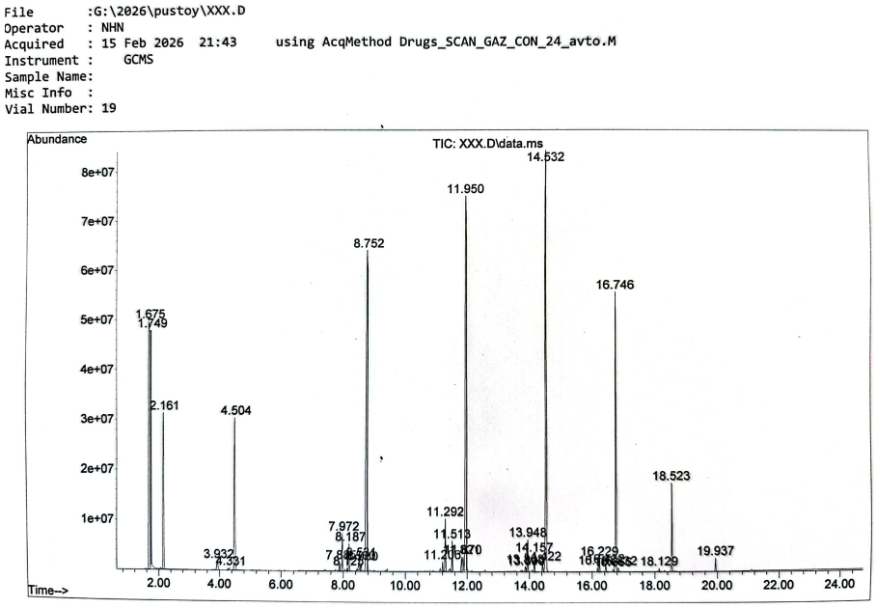
Figure 1: Total Ion Chromatogram (TIC) of the analyzed sample
As shown in Figure 1, the chromatogram exhibits several dominant peaks corresponding to major components, along with numerous minor peaks forming a broad unresolved hump typical of polymer thermal degradation products.
A notable feature of the chromatographic profile is the detection of several early-eluting oxygen-containing compounds. The most significant library assignments are summarized in Table 1. Because GC-MS library matching is a qualitative identification approach and the reported peak areas are not equivalent to calibrated mass concentrations, the oxygenated compounds should be interpreted cautiously. In particular, the formic-acid assignment should be considered a tentative identification until confirmed by retention index, an authentic standard, or an independent analytical method such as GC-FID with standards or ion chromatography.
Table 1: Light fraction components identified using the NIST17.L, NIST11.L, and NIST25.L mass spectral libraries
Peak no. | Retention Time (RT, min) | Identified Compound / Library Assignment | Peak Area (%) | Library Quality (Qual)
1 | 1.675 | Formic acid (CH₂O₂) | 15.67 | 96
2 | 1.749 | Ethanol / methylhydrazine (tentative) | 3.52 | 99
3 | 2.161 | Ethyl acetate (tentative) | 5.19 | 58
4 | 3.932 | 3-Methylheptane (C₈H₁₈) | 0.41 | 94
5 | 4.504 | Octane (C₈H₁₈) | 5.63 | 95

Formic acid was assigned to Peak 1 with a library match of 96 and a peak area of 15.67%. However, this does not establish that it represents 15.67% of the sample mass. The assignment may reflect genuine oxygenated impurities, thermo-oxidative degradation, feedstock contamination, or chromatographic/library effects. Ethyl acetate (Peak 3, Qual 58) and the non-unique Peak 2 assignment (methylhydrazine/ethanol) should therefore be considered tentative. Confirmation of the major oxygenates is recommended before using them to infer reaction pathways or corrosion-related properties.
    - Analysis of Medium-Range Aliphatic Hydrocarbons (С₈-С₁₄)
The major light components are paraffins and olefins in the C₈–C₁₄ range, consistent with random PE chain scission at elevated temperature. Their distribution should be considered alongside the distillation history: the 220°C cut defines the collected fraction, while the actual cracking temperature and vapor residence time govern primary and secondary reactions.
During thermal cracking, C–C bond cleavage generates radicals that undergo β-scission and intra- or intermolecular chain transfer. The process is described by the following reaction:
(1)
Hydrogen abstraction terminates radicals to form n-alkanes, while β-scission and disproportionation can produce 1-alkenes. Their relative abundance depends on the competition among primary C–C cleavage, hydrogen transfer, secondary cracking, and termination. Higher temperature and longer residence time favor secondary transformations, whereas rapid quenching preserves primary products (Lee and Shin, 2007).
Table 2 supports this mechanism through alkane–alkene pairs: 1-decene (RT 8.580) and decane (RT 8.752) for C10, and 1-dodecene (RT 11.821) and dodecane (RT 11.950) for C12. These pairs support radical pathways but do not quantify individual reaction rates because temperature and residence time were not systematically varied.
Table 2: Major hydrocarbons in the C₈–C₁₄ fraction identified by GC-MS
Compound | RT (min) | Area (%) | Role in Composition
Octane (C₈) | 4.504 | 5.63 | Light solvent
Decane (C₁₀) | 8.752 | 15.45 | Major medium fraction component
Dodecane (C₁₂) | 11.950 | 18.13 | Primary component
1-Dodecene (C₁₂) | 11.821 | 0.51 | Unsaturated intermediate

Decane and dodecane account for 15.45% and 18.13% of the reported GC-MS peak area, respectively, giving a combined value of 33.58%. Their presence indicates that a substantial portion of the collected fraction lies in the middle-distillate carbon-number range. However, the data do not by themselves prove that a particular cracking temperature or residence time favored these homologues. Product distribution is governed by the combined effects of reaction severity, secondary cracking, vapor-phase residence time, quenching, and subsequent fractionation. The reported hydrocarbon profile therefore supports the potential of the fraction for further fuel-oriented upgrading, but direct fuel suitability must be established using measured density, viscosity, flash point, distillation characteristics, cold-flow properties, cetane-related parameters, acidity, and stability.
    - Isomerization and Branched Structures
Beyond linear hydrocarbons, GC-MS revealed branched alkanes and other hydrocarbon structures. Compounds such as 4-ethyloctane, 5-methylnonane, 3-methylnonane, and 5-methylundecane are consistent with intramolecular hydrogen-transfer (“back-biting”) and subsequent radical rearrangement. These reactions can alter the distribution of linear and branched hydrocarbons and may affect cold-flow behavior. However, a lower pour point or improved low-temperature performance should not be inferred from molecular identification alone; such claims require direct measurement of cloud point, pour point, and related fuel properties.
    - Experimental FT-IR Spectroscopy Data
As shown in Figure 2, FT-IR analysis was performed using a Shimadzu IRTracer-100 spectrometer in transmittance mode (%T). The recorded spectrum exhibits sharp absorption bands characteristic of saturated aliphatic hydrocarbons with methyl branching, confirming the chemical nature of the product.
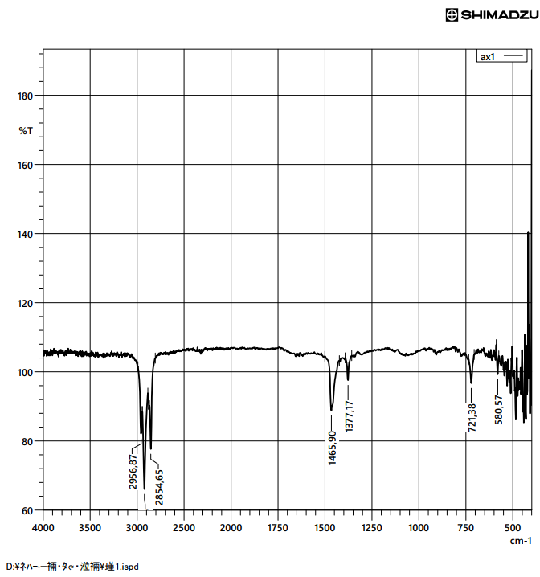
Figure 2: FT-IR spectrum showing characteristic absorption bands of aliphatic hydrocarbons with methyl branching
The main experimental absorption maxima and their interpretations are summarized below.
Table 3: Main FT-IR absorption bands and their interpretation
Wavenumber (cm⁻¹) | Intensity | Vibration Type | Chemical Interpretation
2956.87 | High | υ_{as} (CH₃) stretching | Methyl groups (terminal and branched)
2854.65 | High | υ_{s} (CH₂) stretching | Methylene groups in long aliphatic chains
1465.90 | Medium | δ (CH₂) bending | "Scissoring" mode in PE-like structures
1377.17 | Medium | δ (CH₃) bending | Symmetric CH₃ bending ("umbrella" mode)
721.38 | Weak | ρ (CH₂) rocking | -(CH₂)_{n}- sequence where n≥4
580.57 | Low | Skeletal vibrations | Typical for low-molecular-weight paraffins

The analysis confirms a predominantly aliphatic hydrocarbon matrix. The 1377.17 cm⁻¹ band is consistent with methyl-group deformation and the branched structures observed by GC-MS, but is not a quantitative measure of branching. The 721.38 cm⁻¹ band supports the presence of long-chain linear hydrocarbons. Overall, FT-IR confirms the dominant aliphatic C–H functionalities, while GC-MS provides more specific molecular assignments.
    - Heavy Components and Distillation Anomalies
Despite the 220°C cut-off, GC-MS detected heavier wax-phase hydrocarbons, including n-heneicosane (C₂₁, RT 14.532, 16.46%), n-tetracosane (C₂₄, RT 16.746, 8.02%), and traces of hexacosane (C₂₆). Their boiling points exceed 220°C, indicating non-ideal fractionation rather than equilibrium distillation. Two mechanisms are proposed:
- Entrainment: vapor flow during cracking may carry droplets or aerosolized wax into the distillate.
- Fractionation inefficiency: limited laboratory separation efficiency may allow heavy components into the nominally light fraction.
An azeotropic explanation is not supported by the present data. Improved fractionation and independent boiling-range analysis are needed to distinguish entrainment from other separation effects.
    - Valorization: Industrial Application Pathways
The combined GC-MS and FT-IR results indicate several potential valorization pathways; however, the present data are insufficient to demonstrate compliance with fuel, solvent, or lubricant specifications. Therefore, these applications are considered potential upgrading routes rather than established end uses.
The C₈–C₁₄ and broader C₈–C₂₆ paraffinic fractions make the material a candidate for further fuel evaluation or blending after purification and, if necessary, hydrotreatment. Complementary measurements for the same fraction indicate a cetane number of approximately 42, a cloud point of −16°C, and a pour point of −27°C, supporting further fuel investigation but not confirming diesel-specification compliance. Oxygenated compounds and acidity should also be quantified because they may affect corrosion, stability, and blending behavior.
The high proportion of linear hydrocarbons suggests potential use in catalytic oxidation, olefin functionalization, and other upgrading routes. However, acid number, density, viscosity, elemental composition, flash point, sulfur/nitrogen, water, and oxidation stability should be determined before selecting a specific chemical or surfactant-production route.
The low apparent aromatic content and paraffinic composition suggest potential technical solvent or lubricant-feedstock applications after fractionation and purification. Confirmation requires viscosity, volatility/distillation range, flash point, pour/cloud point, oxidation stability, and compositional data. Thus, the study demonstrates chemical potential for further upgrading rather than a finished commercial product.
  - Conclusions
Comprehensive GC-MS and FT-IR characterization established that the investigated PE-wax by-product is dominated by aliphatic hydrocarbons, with decane and dodecane representing 33.58% of the reported GC-MS peak area and heavier C21–C26 hydrocarbons occurring because of incomplete fractionation or entrainment. The FT-IR spectrum confirms the predominance of aliphatic C–H functionalities and supports the GC-MS evidence for linear and branched hydrocarbon structures. Oxygen-containing compounds were detected by library matching, including a formic-acid assignment of 15.67% peak area; however, these oxygenate assignments should be considered tentative until confirmed by retention indices and independent standards. The relationship between product distribution and cracking severity is consistent with radical chain scission, β-scission, hydrogen transfer, and secondary reactions, but the present study does not contain a systematic variation of cracking temperature or residence time. Therefore, the liquid fraction should be regarded as a promising intermediate feedstock rather than a directly validated fuel, solvent, lubricant, or chemical raw material. Further work should include density, viscosity, acid number, flash point, distillation characteristics, cold-flow properties, cetane-related parameters, elemental composition, and oxidation stability, followed by purification/upgrading trials to establish the most appropriate industrial application.
References
Aguado J., Serrano D.P., Escola J.M., 2008, Fuels from waste plastics by thermal and catalytic processes: A review, Industrial & Engineering Chemistry Research, 47, 7982–7992, doi:10.1021/ie800393w
Al-Salem S.M., Lettieri P., Baeyens J., 2009, Recycling and recovery routes of plastic solid waste (PSW): A review, Waste Management, 29, 2625–2643, doi:10.1016/j.wasman.2009.06.004
Bockhorn H., Hornung A., Hornung U., 1999, Mechanisms and kinetics of thermal decomposition of plastics from isothermal and dynamic measurements, Journal of Analytical and Applied Pyrolysis, 50, 77–101, doi:10.1016/S0165-2370(99)00026-1
Coates J., 2006, Interpretation of infrared spectra, a practical approach, Encyclopedia of Analytical Chemistry, Wiley, doi:10.1002/9780470027318.a5606
Kaminsky W., Predel M., Sadiki A., 2004, Feedstock recycling of polymers by pyrolysis in a fluidised bed, Polymer Degradation and Stability, 85, 1045–1050, doi:10.1016/j.polymdegradstab.2003.05.002
Lee K.-H., Shin D.-H., 2007, Characteristics of liquid product from the pyrolysis of waste plastic mixture at low and high temperatures: Influence of lapse time of reaction, Waste Management, 27, 168–176, doi:10.1016/j.wasman.2005.12.017
Miskolczi N., Angyal A., Bartha L., Valkai I., 2009, Fuels by pyrolysis of waste plastics from agricultural and packaging sectors in a pilot scale reactor, Fuel Processing Technology, 90, 1032–1040, doi:10.1016/j.fuproc.2009.04.019
Onwudili J.A., Insura N., Williams P.T., 2009, Composition of products from the pyrolysis of polyethylene and polystyrene in a closed batch reactor: Effects of temperature and residence time, Journal of Analytical and Applied Pyrolysis, 86, 293–303, doi:10.1016/j.jaap.2009.07.008
Serras-Malillos A., Perez-Martinez B.B., Iriondo A., Acha E., Lopez-Urionabarrenechea A., Caballero B.M., 2024, Quantification of the composition of pyrolysis oils of complex plastic waste by gas chromatography coupled with mass spectrometer detector, RSC Advances, 14, 9892–9911, doi:10.1039/D4RA00226A
Sharuddin S.D.A., Abnisa F., Wan Daud W.M.A., Aroua M.K., 2016, A review on pyrolysis of plastic wastes, Energy Conversion and Management, 115, 308–326, doi:10.1016/j.enconman.2016.02.037
Williams P.T., Williams E.A., 1999, Fluidised bed pyrolysis of low density polyethylene to produce petrochemical
feedstock, Journal of Analytical and Applied Pyrolysis, 51, 107–126, doi.org/10.1016/S0165-2370(99)00011-X

