 CHEMICAL ENGINEERING TRANSACTIONS  VOL. xxx, 2026 | A publication of  
The Italian Association
of Chemical Engineering
Online at www.cetjournal.it

Guest Editors: Flavio Manenti, Botir Usmonov, Alessandro Di Pretoro
Copyright © 2026, AIDIC Servizi S.r.l.
ISBN 979-12-81206-xx-x; ISSN 2283-9216

Two-stage photo-fermentation by Rhodopseudomonas palustris: growth conditions affect pigment content and hydrogen productivity
Matteo Zandolini¹, Veronica Lucato¹, Elena Barbera¹, Robert W. M. Pott², Eleonora Sforza¹*
¹Department of Industrial Engineering, University of Padova, Via Marzolo 9, 35131 Padova, Italy
²Department of Process Engineering, Stellenbosch University, Banghoek Road, 7599, Stellenbosch, South Africa
eleonora.sfroza@unipd.it

Hydrogen is a key low-carbon energy carrier, but its production remains largely fossil-based. Photo-fermentation by purple non-sulfur bacteria, particularly Rhodopseudomonas palustris, could represent a promising biological alternative, requiring high biomass and adequate photosynthetic pigment (i.e., carotenoids and bacteriochlorphyll a) content as a first step, to maximize hydrogen production in a dedicated second step. However, quantitative information on how cultivation conditions affect pigment accumulation is still limited. The aim of this work is therefore to identify cultivation conditions that maximize biomass formation while maintaining an appropriate pigment apparatus, with the broader goal of contributing to an optimization of the biohydrogen process. Cultures differing in pigment content were tested under photo-fermentative conditions, revealing that higher specific pigment levels result in greater hydrogen production. Therefore, preliminary batch experiments were carried out to examine the influence of carbon source and concentration, and oxygen availability on biomass production and pigment retention, using glycerol as a substrate. R. palustris exhibited higher biomass production under aerobic conditions, although oxygen availability caused pigment loss, due to a shift towards chemoheterotrophic metabolism. To investigate this trade-off, a Design of Experiment, combined with response surface methodology, was used to assess the joint effect of oxygen availability and light intensity. Oxygen was confirmed to enhance biomass growth while reducing pigment levels, whereas light intensity had no significant impact. An optimal compromise was identified at an oxygenation time of 3.7 hours per day, which allows for a bacteriochlorophyll a and carotenoid productivity of 0.905 and 0.468 mg L⁻¹ d⁻¹, respectively. These results indicate that pigment retention and biomass formation depend mainly on oxygen availability, rather than on carbon concentration or light intensity, and enable the use of lower substrate concentrations and low-intensity LED lighting, offering a practical route toward reducing the cost of biohydrogen production.
  - Introduction
Hydrogen is widely recognized as a key energy carrier for a low-carbon future due to its ability to store and convert energy without direct greenhouse gas emissions (Kovač et al., 2021). However, current production still relies heavily on fossil fuels, resulting in significant CO₂ emissions (Hermesmann & Müller, 2022). Biological hydrogen production offers a promising, carbon-neutral alternative, also enabling the valorization of organic waste streams (Sharma et al., 2020). Among biological processes, photo-fermentation can reach hydrogen yields up to 3.9 times that of other methods, such as dark fermentation (Hitam & Jalil, 2020; Zhang et al., 2020). It is considered efficient and environmentally friendly, producing high-purity hydrogen at ambient temperature and pressure (Hitam & Jalil, 2020). Photo-fermentation is driven by light and carried out by microorganisms that, under strict anaerobic conditions, convert protons into hydrogen via nitrogenase (Hay et al., 2013). Purple non-sulfur bacteria are considered the most suitable microorganisms for biohydrogen production via photo-fermentation (Morrison & Bose, 2025). Among them, Rhodopseudomonas palustris is the most promising one, due to its metabolic versatility and its ability to generate hydrogen using effluents like those derived from dark-fermentation processes (Rai & Singh, 2016), making it optimal for a two-step integrated dark-photo co-fermentation. A key limitation is that hydrogen production occurs in the late exponential or early stationary phase, when growth has already declined (Dogan-Guner & Koku, 2022). Consequently, production strategies involve a two-step approach: biomass accumulation followed by hydrogen production under anaerobic, nitrogen-depleted conditions. Despite its importance, the biomass production phase remains poorly optimized, while the relationship between pigment content and hydrogen production is unclear. Additionally, most studies rely on halogen lamps, which efficiently excite bacteriochlorophylls but suffer from low energy efficiency, dissipating up to 95% of input energy (Adessi & De Philippis, 2014). LEDs represent a promising alternative, offering higher energy efficiency and improved control over light emission (Singh et al., 2015).
In this work, the effect of pigment content on hydrogen production by R. palustris was first investigated. Subsequently, a Design of Experiments (DoE) approach was applied to systematically evaluate the influence of operational conditions on biomass growth and pigment retention, with the aim of identifying strategies that maximize both cell density and photosynthetic capacity.
  - Materials and methods
    - Microbial culture and maintenance conditions
Rhodopseudomonas palustris ATH 2.1.6 (ATCC 17001) was cultivated in 250 mL Quickfit® Drechsel glass bottles with a diameter of 5 cm, under continuous mixing via a magnetic stirrer in a temperature-controlled incubator at 30°C and exposed to a light intensity of 300 µmol m⁻² s⁻¹. Cultivation was performed under microaerobic conditions in Van Niel’s growth medium, containing (per liter): 10.0 g of yeast extract, 1.0 g of K₂HPO₄, and 0.5 g of MgSO₄·7H₂O. The medium was autoclaved at 121°C for 20 minutes before utilization.
    - Biohydrogen production
The biomass was resuspended in Rhodospirillaceae non-growing medium in a final volume of 150 mL, with sodium acetate as the sole carbon source, at a concentration of 6.2 g L⁻¹. The medium was prepared using (per liter): 1864.0 mg of K₂HPO₄, 571.6 mg of KH₂PO₄, 400.0 mg of NaCl, 200.0 mg of MgSO₄·7H₂O, 160.0 mg of Na₂S₂O₃, 50.0 mg of CaCl₂·2H₂O, 5.5 mg of FeCl₃·6H₂O, 2.0 mg of Para-aminobenzoic acid, 1.0 mg of MnCl₂·4H₂O, 0.2 mg of CoCl₂·6H₂O, 0.07 mg of ZnCl₂, 0.06 mg of H₃BO₃, 0.04 mg of NaMoO₄·2H₂O, 0.02 mg of CuCl₂·2H₂O, 2.5 mg of thiamine HCl, 0.01 mg of cyanocobalamin. The medium was autoclaved before utilization, while sodium acetate was sterilized by filtration with 0.22 µm syringe filters. Anaerobic conditions were reached via argon gas stripping for ten minutes. The bottles were kept at 35°C under continuous illumination with an incandescent halogen lamp at 300 µmol m⁻² s⁻¹. The evolved gas was collected for 7 days in an inverted 100 mL measuring cylinder immersed in a water bath, and the gas volume was monitored using the water-displacement technique. According to the literature, hydrogen accounts for 88-94% of the total gas composition (Bosman et al., 2022).
    - Pigment extraction and analysis
Pigment extraction was performed using an acetone:methanol (7:2 v/v) solution; the supernatant was then collected for quantification. The absorption spectrum of the supernatant was acquired between 900 and 400 nm using a Shimadzu UV-1900 double-beam spectrophotometer. Total carotenoid ($Car)$ and bacteriochlorophyll a ($Bchl a$) concentrations (mg L⁻¹) were calculated using Eq(1) (Spanoghe, 2022) and Eq(2) (Schwerzmann, 1989), respectively.
$[Car]= \frac{A_{max}- A_{850}}{ε_{TC}}∙{MM}_{TC}∙\frac{V_{{acetone}/{methanol}}}{V_{sample}}$ (1)
$\left[Bchl a\right]= \frac{A_{771}- A_{850}}{ε_{BChla}}∙{MM}_{BChla}∙\frac{V_{{acet}/{met}}}{V_{sample}}$ (2)
Where A is the absorbance; ε is the molar extinction coefficient (94 mM⁻¹ cm⁻¹ for carotenoids; 65.3 mM⁻¹ cm⁻¹ for Bchl a), MM is the average molar mass (596.0 g mol⁻¹ for carotenoids, 910.5 g mol⁻¹ for Bchl a). Carotenoid (Car) and Bchl a (Bchl a) content (mg_{pigments} g_{DW}⁻¹) was then calculated by normalizing pigment concentration over biomass dry weight.
    - Biomass production
Biomass productivity ($P_{x}$) and maximum growth rate ($μ_{max}$) were measured under different operative conditions. A series of preliminary experiments was carried out to assess the effect of glycerol and its concentration. Glycerol was supplied at concentrations of 25, 50, and 100 mM, corresponding to 0.9, 1.8, and 3.6 g L⁻¹ of carbon ($g_{C}{ L}^{-1}$). Each experiment consisted of a 5-day batch cultivation; the optical density was measured daily, while dry weight measurements and pigment analysis were performed at the start and at the end of the experiment. Biomass productivity (g L⁻¹ d⁻¹) was calculated as the difference between final and initial biomass concentration divided by the duration of the experiment. The maximum growth rate ($d^{-1}$) was calculated during the exponential phase as the slope obtained from linear regression of the natural logarithm of optical density versus time.
    - Design of Experiments on biomass production and composition
The experimental plan shown in Table 1 was developed using a central composite design (CCD) to assess the combined effect of oxygen availability in terms of air bubbling time (0, 4, 8, and 12 h per day) and light intensity (150, 300, and 450 µmol m⁻² s⁻¹) on growth performance. The cultures were suspended in Van Niel’s growth medium with glycerol added to a final concentration of 2.3 g L⁻¹ (0.9 g L⁻¹ of carbon), and LED panels were used as the light source. The cultures were kept at 35°C for 5-day batch experiments. Biomass productivity and maximum growth rate were determined for each experiment, along with Bchl a, and carotenoid contents. A statistical analysis based on ANOVA was carried out using Design Expert 13 (Stat-Ease Inc., USA). The final reduced models were then used to create surface response graphs to visualize the influence on the system
Table 1: Experimental conditions for the DoE obtained with Design Expert 13
Experiment | Factor 1 (Oxygen time, h) | Factor 2 (Light intensity, µmol m⁻² s⁻¹)
1 | 0 | 150
11 | 0 | 150
4 | 8 | 150
15 | 8 | 150
14 | 12 | 150
16 | 0 | 300
13 | 4 | 300
12 | 4 | 300
8 | 4 | 300
6 | 8 | 300
5 | 8 | 300
2 | 12 | 300
9 | 0 | 450
7 | 4 | 450
10 | 8 | 450
3 | 12 | 450

  - Results and discussion
    - Photo-fermentative biohydrogen production
Batch experiments were carried out to quantitatively determine the effect of different pigment contents on total gas production. The cultures were grown under aerobic or micro-aerobic conditions, resulting in different final pigment content between the cultures, which were then used for gas production. Initial pigment content, i.e. the pigment content at the beginning of each experiment, and the relative gas productivity are highlighted in Table 2. The experiments were carried out in biological duplicates.
Table 2: Gas productivities based on biomass pigment content
Preinoculum conditions | Bchl a content  (mg g⁻¹) | Carotenoid content  (mg g⁻¹) | Gas volumetric productivity  (mL L⁻¹ d⁻¹)
Aerobic | 8.10±1.40 | 2.90±0.50 | 11.67±1.01
Micro-aerobic | 11.90±1.84 | 4.05±0.64 | 19.05±1.34

An unpaired two-tailed t-test showed a statistically significant difference between volumetric productivities in the two conditions (p-value = 0.029). As shown in Table 2, gas productivity was higher in the culture with higher pigment content, suggesting that pigment content affects gas production. Volumetric productivity appears then to be indirectly negatively affected by oxygen availability, which lowers the pigment content due to a metabolic shift towards chemoheterotrophy.
The clear correlation observed between pigment abundance and gas productivity indicates that maintaining a robust photosynthetic apparatus is essential for maximizing biohydrogen production in R. palustris. Therefore, to optimize biohydrogen production, the preliminary growth phase should focus on maintaining pigment content, along with enhancing growth.
    - Effect of carbon concentration on growth and pigment content
Preliminary experiments were conducted in duplicate at a carbon concentration of 1.8 g L⁻¹ using glycerol. As expected, higher growth was observed under aerobic conditions. Based on these results, glycerol was tested at different concentrations under both conditions; the effect of carbon concentration is reported in Table 3.
Table 3: Effect of carbon concentration and oxygen availability on final biomass concentration, biomass productivity, and growth rate
Substrate | Oxygen availability | Carbon concentration (g L⁻¹) | Final biomass concentration (g L⁻¹) | Biomass productivity (g L⁻¹ d⁻¹) | Growth rate (d⁻¹)
Glycerol | Aerobic | 0.90 | 2.8±0.14 | 0.45±0.03 | 0.85±0.02
Glycerol | Aerobic | 1.80 | 3.09±1.60 | 0.50±0.33 | 0.92±0.22
Glycerol | Aerobic | 3.60 | 2.98±0.25 | 0.49±0.04 | 0.87±0.04
Glycerol | Anaerobic | 0.90 | 0.75±0.01 | 0.05±0.00 | 0.27±0.03
Glycerol | Anaerobic | 1.80 | 1.22±0.51 | 0.13±0.05 | 0.36±0.29
Glycerol | Anaerobic | 3.60 | 0.72±0.08 | 0.07±0.05 | 0.21±0.10

Higher biomass productivities and growth rates were observed under aerobic conditions, with no significant differences among carbon concentrations. Final biomass concentration showed variability between replicates, indicating heterogeneous growth of R. palustris. The lack of a clear effect of carbon concentration suggests that, within the tested range, carbon was not the limiting factor. Instead, growth was constrained by another parameter, such as light in anaerobic conditions, and by other nutrients in aerobic conditions. The effects of carbon concentration and oxygen availability on final pigment content are shown in Figure 1.
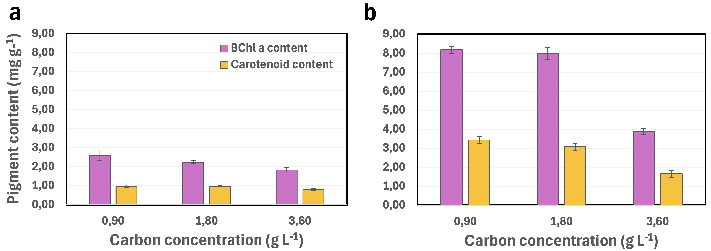
Figure 1: Effect of carbon concentration and oxygen availability on Bchl a and carotenoid final content under aerobic (1a) and anaerobic (1b) conditions
Final pigment content decreased with increasing carbon concentration under both aerobic and anaerobic conditions, and was overall 3-fold higher in anaerobiosis, in agreement with literature reporting oxygen-induced dismantling of the photosynthetic apparatus (Harwood, 2022). The decrease in pigment content with increasing carbon concentration can be explained by a metabolic shift toward chemoheterotrophic growth at higher substrate availability. As energy can be more efficiently obtained from organic carbon, the photosynthetic apparatus becomes less necessary and is consequently downregulated, leading to reduced pigment synthesis. Additionally, high carbon levels may alter the cellular redox balance and promote alternative electron sinks, further decreasing the need for light-harvesting systems.
    - Effect of oxygen availability and light intensity on biomass production and pigment content
Following the DoE assessing the combined effects of oxygen availability and light intensity on biomass and pigment productivity, the linear model was identified as the most significant (p < 0.05). Lack-of-fit values were 0.1859 and 0.0994 for biomass productivity and growth rate, respectively, and 0.2806 and 0.1275 for BChl a and carotenoid productivity, respectively. All values were nonsignificant, indicating that the models adequately captured the underlying relationship in the data. The models were based on the ANOVA analysis and are shown in Figure 2. The equations for the biomass productivity model include a logarithmic term because the Box-Cox analysis in Design-Expert indicated an improved model fit with a log transformation. These mathematical models allowed the creation of a visual representation of the results obtained with the DoE, represented by the response surface graphs, also shown in Figure 2.

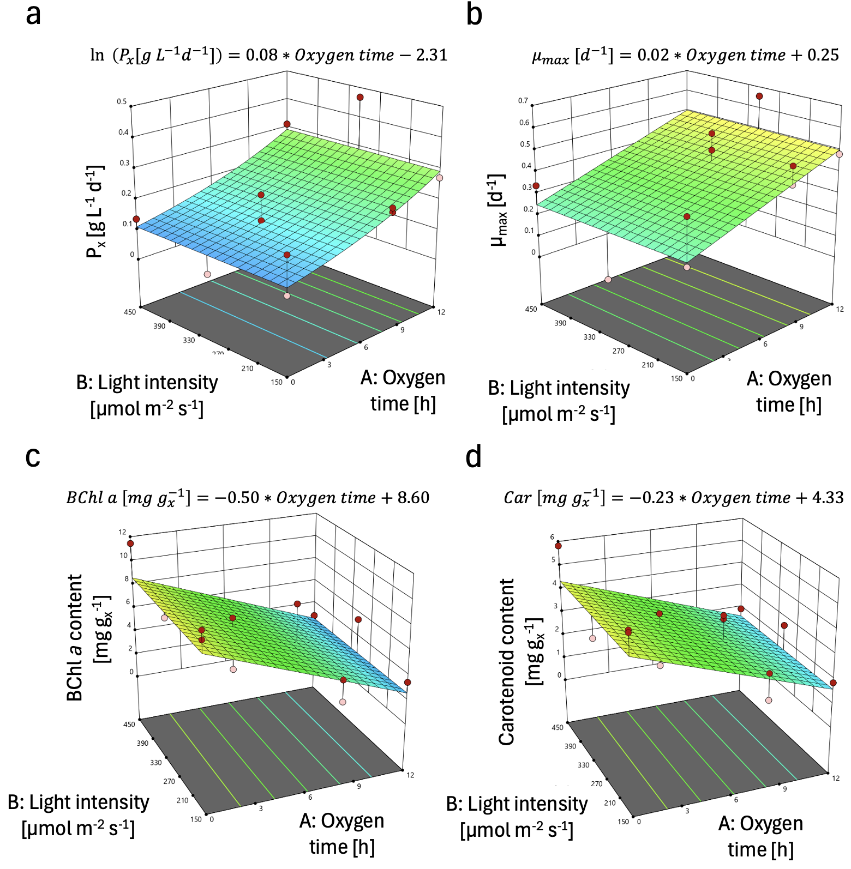
Figure 2: Surface response graphs showing the effect of oxygen availability and light intensity on growth (2a and 2b) and pigment content (2c and 2d)
The models and the surface response graphs clearly show an opposite effect of oxygen availability, which causes biomass production to rise (Figure 2a and 2b) while lowering pigment content (Figure 2c and 2d). The pigment productivity parameter enables to find the condition in which biomass productivity and pigment retention are maximized. Pigment productivity ($P_{pig}$) is the product of biomass productivity and pigment content, as shown in the equation below.
$P_{pig} \left[mg L^{-1}d^{-1}\right]=Biomass productivity*pigment content$ (3)
The optimal compromise between biomass production and pigment retention was found at 3.7 h of air bubbling time per day. In contrast, light intensity did not show any effect at the tested intensity range, probably due to a technological limit of the LED panels employed in this study. These LED panels do not emit in the NIR range, thus exciting bacteriochlorophylls suboptimally (Adessi & De Philippis, 2014). Despite these spectral limitations, LEDs' higher energy efficiency can reduce overall process costs, making them the most suitable light source. The outcome predicted by the statistical analysis of the DoE was experimentally validated in three independent biological replicates, resulting in bacteriochlorophyll a and carotenoid productivities of 0.921 ± 0,109 and 0.470 ± 0,068 mg L⁻¹ d⁻¹, respectively. These pigment productivities are consistent with the predictions of the models, which amount to 0.901 mg L⁻¹ d⁻¹ of BChl a, and 0.464 mg L⁻¹ d⁻¹ of carotenoids.
  - Conclusions
In this work, the relationship between pigment content and total gas production in Rhodopseudomonas palustris was first examined, and subsequently the influence of carbon source, carbon concentration, oxygen availability, and light intensity on biomass growth and pigment retention was systematically investigated. A relation emerged between pigment content and total gas evolution, underscoring the importance of preserving the photosynthetic apparatus, a factor often overlooked in photo-fermentative studies.
Preliminary experiments indicated that oxygen availability enhances biomass production but negatively affects pigment content, whereas variations in carbon concentration within the tested range did not significantly influence growth but affected pigmentation. Based on these observations, the lowest carbon concentration tested (0.9 g L⁻¹), supplied as glycerol, was selected for further optimization through a DoE approach. The DoE analysis confirmed that oxygen availability was the only variable significantly affecting biomass productivity and pigment levels, while light intensity showed no measurable effect within the investigated range, indicating that the lowest tested intensity can be adopted to reduce energy consumption and operational costs. Optimal conditions were identified at 3.7 hours of air bubbling per day, where pigment productivity reached its maximum, corresponding to bacteriochlorophyll a and carotenoid productivities of 0.905 and 0.468 mg L⁻¹ d⁻¹, respectively, which are consistent with the predictions of the models and were experimentally validated.
Overall, these findings demonstrate that efficient biomass and pigment production can be achieved using lower substrate concentrations, minimal oxygen supply, and low-intensity LED illumination, providing a foundation for further process optimization aimed at reducing the levelized cost of hydrogen.

References
Adessi, A., & De Philippis, R. (2014). Photosynthesis and Hydrogen Production in Purple Non Sulfur Bacteria: Fundamental and Applied Aspects (pp. 269–290). https://doi.org/10.1007/978-94-017-8554-9_12
Bosman, C. E., McClelland Pott, R. W., & Bradshaw, S. M. (2022). A Thermosiphon Photobioreactor for Photofermentative Hydrogen Production by Rhodopseudomonas palustris. Bioengineering, 9(8), 344. https://doi.org/10.3390/bioengineering9080344
Dogan-Guner, E. M., & Koku, H. (2022). Analysis of the carbon metabolism of Rhodopseudomonas palustris for biohydrogen production. Biotech Studies, 31(1), 1–9. https://doi.org/10.38042/biotechstudies.1062792
Harwood, C. S. (2022). Rhodopseudomonas palustris. Trends in Microbiology, 30(3), 307–308. https://doi.org/10.1016/J.TIM.2021.12.001
Hay, J. X. W., Wu, T. Y., Juan, J. C., & Md. Jahim, J. (2013). Biohydrogen production through photo fermentation or dark fermentation using waste as a substrate: Overview, economics, and future prospects of hydrogen usage. Biofuels, Bioproducts and Biorefining, 7(3), 334–352. https://doi.org/10.1002/bbb.1403
Hermesmann, M., & Müller, T. E. (2022). Green, Turquoise, Blue, or Grey? Environmentally friendly Hydrogen Production in Transforming Energy Systems. In Progress in Energy and Combustion Science (Vol. 90). Elsevier Ltd. https://doi.org/10.1016/j.pecs.2022.100996
Hitam, C. N. C., & Jalil, A. A. (2020). A review on biohydrogen production through photo-fermentation of lignocellulosic biomass. https://doi.org/10.1007/s13399-020-01140-y/Published
Kovač, A., Paranos, M., & Marciuš, D. (2021). Hydrogen in energy transition: A review. International Journal of Hydrogen Energy, 46(16), 10016–10035. https://doi.org/10.1016/j.ijhydene.2020.11.256
Morrison, H. M., & Bose, A. (2025). Purple non-sulfur bacteria for biotechnological applications. In Journal of Industrial Microbiology and Biotechnology (Vol. 52). Oxford University Press. https://doi.org/10.1093/jimb/kuae052
Rai, P. K., & Singh, S. P. (2016). Integrated dark- and photo-fermentation: Recent advances and provisions for improvement. International Journal of Hydrogen Energy, 41(44), 19957–19971. https://doi.org/10.1016/J.IJHYDENE.2016.08.084
Schwerzmann, R. U. (1989). Carotenoid Profiles in Pigment-Protein Complexes of Rhodospirillum rubrum. Plant and Cell Physiology.
Sharma, S., Basu, S., Shetti, N. P., & Aminabhavi, T. M. (2020). Waste-to-energy nexus for circular economy and environmental protection: Recent trends in hydrogen energy. Science of The Total Environment, 713, 136633. https://doi.org/10.1016/J.SCITOTENV.2020.136633
Singh, D., Basu, C., Meinhardt-Wollweber, M., & Roth, B. (2015). LEDs for energy efficient greenhouse lighting. Renewable and Sustainable Energy Reviews, 49, 139–147. https://doi.org/10.1016/J.RSER.2015.04.117
Spanoghe, J. (2022). Purple bacteria cultivation on light, carbon dioxide and hydrogen gas: Exploring and tuning the potential for microbial food production.
Zhang, T., Jiang, D., Zhang, H., Jing, Y., Tahir, N., Zhang, Y., & Zhang, Q. (2020). Comparative study on bio-hydrogen production from corn stover: Photo-fermentation, dark-fermentation and dark-photo co-fermentation. International Journal of Hydrogen Energy, 45(6), 3807–3814. https://doi.org/10.1016/J.IJHYDENE.2019.04.170

