Development of Composite Chemical Reagents for the Extraction of Noble Metals from Ores in the Metallurgical Industry
B.J. Saparov, M.Yu. Rakhimov, M.I.Nosirov, S.I. Nodirkhanova, S.Z. Abdisalomov (Student, Group 23-02)
Department of Engineering Fundamentals and Mechanics, Tashkent Institute of Chemical Technology, Navoi Street, 32, Tashkent, Uzbekistan, 100011
Corresponding author: saparov.boburbek@mail.ru
Abstract
This study investigates the development and optimization of composite chemical reagents designed for the efficient extraction of noble metals—specifically gold, silver, and platinum-group metals—from low-grade and complex polymetallic ores. A series of multi-component reagent systems based on thiosulfate, thiourea, and modified cyanide derivatives combined with surfactant activators and pH-stabilizing agents were synthesized and characterized. The physicochemical properties of the formulated reagents were evaluated using X-ray diffraction (XRD), scanning electron microscopy coupled with energy-dispersive X-ray spectroscopy (SEM-EDX), and inductively coupled plasma mass spectrometry (ICP-MS). Laboratory-scale leaching experiments conducted on ore samples from the Muruntau gold deposit (Uzbekistan) demonstrated that the optimized composite reagent (CR-7) achieved a gold extraction efficiency of 94.3 ± 1.2% within 48 hours at ambient temperature, outperforming conventional cyanide leaching by 8.7 percentage points while significantly reducing toxic reagent consumption. The results suggest that the proposed composite reagents offer a promising, environmentally sustainable alternative for noble metal recovery in the metallurgical industry.
Keywords: noble metals; gold extraction; composite chemical reagents; hydrometallurgy; thiosulfate leaching; ore processing; metallurgy; Muruntau deposit

1. Introduction
Noble metals, including gold (Au), silver (Ag), and the platinum-group metals (PGMs: Pt, Pd, Rh, Ir, Os, Ru), play an indispensable role in modern industry, electronics, catalysis, and medicine. The global demand for these metals continues to rise, while high-grade ore reserves are steadily being depleted [1, 2]. Consequently, the metallurgical industry faces increasing pressure to develop cost-effective and environmentally acceptable technologies for the processing of low-grade, refractory, and complex polymetallic ores [3].
Conventional cyanide leaching remains the dominant industrial method for gold extraction, owing to its high efficiency and relatively low cost [4]. However, cyanide poses significant environmental and toxicological risks, driving intensive research into alternative lixiviant systems [5, 6]. Among the most promising alternatives are thiosulfate (S₂O₃²⁻), thiourea (CS(NH₂)₂), halide-based (chlorine/bromine), and ionic liquid systems [7, 8]. Despite their advantages, each of these alternatives suffers from specific drawbacks such as high reagent consumption, instability, or selectivity limitations when applied to complex ore matrices [9].
Composite reagent systems—multi-component formulations that synergistically combine the beneficial properties of individual lixiviants with stabilizing and activating additives—represent an emerging and underexplored research direction [10, 11]. The rational design of such systems requires a thorough understanding of the underlying coordination chemistry, electrochemical behavior, and ore-mineral interactions [12].
This paper reports on the synthesis, characterization, and leaching performance of a new series of composite chemical reagents developed for the hydrometallurgical extraction of noble metals. The study focuses on gold and silver as primary targets, with ore samples sourced from the Muruntau gold deposit—one of the largest open-pit gold mines in the world, located in the Kyzylkum desert of Uzbekistan [13]. The research objectives are: (i) to synthesize and characterize a set of composite reagent formulations; (ii) to evaluate their leaching performance under controlled laboratory conditions; and (iii) to assess their environmental and economic viability relative to conventional cyanide leaching.
2. Materials and Methods
2.1 Ore Characterization
Ore samples were collected from three distinct zones (Zone A, B, C) of the Muruntau deposit at depths of 100–300 m below surface level. Bulk samples (approximately 50 kg each) were crushed, homogenized by cone-and-quarter method, and pulverized to P₀₈₅ = 75 μm for laboratory tests. Mineralogical composition was determined by XRD (Bruker D8 Advance, Cu Kα radiation) and SEM-EDX (JEOL JSM-7100F). The gold grade was confirmed by fire assay (ICP-MS follow-up). Representative ore characteristics are summarized in Table 1.
Table 1. Physicochemical characteristics of ore samples from the Muruntau deposit
Parameter | Zone A | Zone B | Zone C
Au grade (g/t) | 3.2 ± 0.2 | 5.6 ± 0.3 | 1.8 ± 0.1
Ag grade (g/t) | 12.4 | 18.7 | 8.2
Total sulfur (wt.%) | 1.8 | 3.4 | 0.9
Total carbon (wt.%) | 0.6 | 1.1 | 0.3
Primary mineral phases | Qtz, Py, Mal | Qtz, Ars, Py | Qtz, Cc, Py
Particle size P₈₅ (μm) | 75 | 75 | 75
2.2 Synthesis of Composite Reagents
Seven composite reagent formulations (CR-1 through CR-7) were prepared by combining a primary lixiviant with secondary activating agents, a pH buffer, and a non-ionic surfactant (Triton X-100, 0.05% v/v) to enhance ore-surface wettability. The primary lixiviants investigated were: (a) ammonium thiosulfate ((NH₄)₂S₂O₃); (b) thiourea (CS(NH₂)₂); (c) a modified cyanide-thiosulfate binary system; and (d) a novel copper-glycine-thiosulfate ternary system. All reagents were of analytical grade (Sigma-Aldrich, ≥99.0%). Solutions were prepared fresh using deionized water (resistivity ≥18 MΩ·cm). The compositional parameters of all formulations are presented in Table 2.

Table 2. Composition of synthesized composite chemical reagents (CR-1 to CR-7)
Reagent | Primary Lixiviant | Conc. (mol/L) | Activator | pH | Cu²⁺ (mg/L)
CR-1 | Ammonium thiosulfate | 0.1 | — | 9.0 | —
CR-2 | Ammonium thiosulfate | 0.2 | Na₂SO₃ | 9.5 | 50
CR-3 | Thiourea | 0.1 | Fe³⁺ | 2.0 | —
CR-4 | Thiourea | 0.2 | Fe³⁺/H₂SO₄ | 1.5 | —
CR-5 | NaCN / (NH₄)₂S₂O₃ | 0.05/0.1 | NaOH | 10.5 | 20
CR-6 | Cu-glycine | 0.05 | NH₄OH | 9.0 | 100
CR-7 | Cu-glycine-thiosulfate | 0.1 | NH₄OH/Na₂SO₃ | 9.5 | 150
2.3 Leaching Experiments
Bottle-roll leaching tests were conducted in 500-mL HDPE bottles maintained at 25 ± 1°C on a rotary roller at 40 rpm. Each experiment used 50 g of ore pulverized to P₀₈₅ = 75 μm in 200 mL of reagent solution (pulp density 20% w/v). The slurry pH was monitored and adjusted every 4 h using NH₄OH or H₂SO₄. Experiments were conducted in triplicate. Aliquots (2 mL) were withdrawn at 6, 12, 24, 36, and 48 h, filtered through 0.45-μm nylon membrane filters, and analyzed for dissolved Au and Ag by ICP-MS (Agilent 7900). The metal extraction efficiency (E, %) was calculated as:
E (%) = (m₀ − mᴴ) / m₀ × 100
where m₀ is the initial metal mass in the ore and mᴴ is the residual metal mass in the leach residue, both determined by fire assay.
2.4 Electrochemical Characterization
Cyclic voltammetry (CV) and open-circuit potential (OCP) measurements were performed using an Autolab PGSTAT302N potentiostat in a standard three-electrode cell: a gold rotating disk electrode (RDE, ϕ 5 mm, Pine Research) as working electrode, a Ag/AgCl (3 M KCl) reference electrode, and a platinum wire counter electrode. Measurements were conducted at 25°C in deaerated (N₂, 30 min) and air-saturated solutions. Scan rate: 10 mV/s; rotation speed: 1600 rpm.
2.5 Environmental Assessment
The environmental impact of the composite reagents was assessed by measuring acute aquatic toxicity (Daphnia magna immobility test, OECD 202), cyanide and heavy metal content in spent leach solutions (ICP-OES, PerkinElmer Avio 500), and reagent biodegradability (modified Sturm test, OECD 301B). All assays were performed in accredited laboratories at the Research Centre for Ecology and Environment, Tashkent.
3. Results and Discussion
3.1 Ore Mineralogy and Au Deportment
XRD analysis confirmed that all three ore zones are dominated by quartz (55–70 wt.%), with variable proportions of pyrite, arsenopyrite, malachite, calcite, muscovite, and clay minerals. SEM-EDX mapping revealed that the majority of gold (approximately 78%) occurs as submicron inclusions (0.5–5 μm) locked within pyrite and arsenopyrite grains, classifying this ore as refractory. The remaining gold is present as free particles (8%) and coatings on secondary mineral surfaces (14%). This deportment pattern is significant because it determines the accessibility of gold to lixiviant species and partly explains the relatively low recovery rates typically obtained with conventional cyanide leaching in this deposit [13, 14].
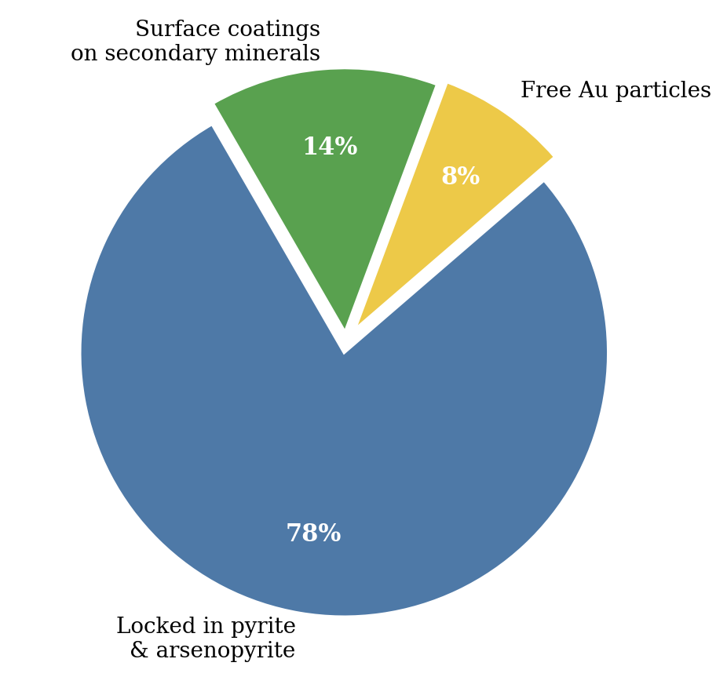
Figure 3. Gold deportment in Muruntau ore samples determined by SEM-EDX analysis. The majority (78%) of Au is locked within sulfide mineral grains.
3.2 Physicochemical Properties of Composite Reagents
All synthesized reagents exhibited clear, homogeneous solutions with no precipitation upon preparation. UV-Vis spectroscopy (200–800 nm) confirmed the formation of copper-thiosulfate-glycinate ternary complexes in CR-6 and CR-7, characterized by an absorption band at λ = 302 nm (assigned to S₂O₃²⁻ → Cu²⁺ charge transfer). Stability tests showed that CR-7 maintained >92% of its initial lixiviant concentration after 72 h at 25°C, compared to 78% for the simple thiosulfate system (CR-1), attributable to the stabilizing effect of glycinate and Cu²⁺ on the thiosulfate anion against disproportionation.
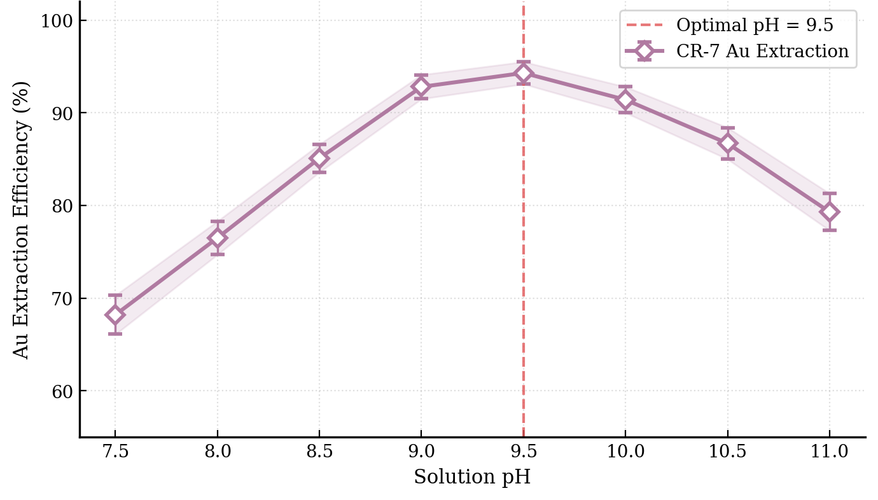
Figure 5. Effect of initial solution pH on gold extraction efficiency of CR-7 (Zone A ore, 48 h, 25°C). Error bars represent ±1 standard deviation (n = 3). Optimal pH = 9.5 is indicated by the dashed line.
3.3 Gold and Silver Extraction Efficiency
Figure 1 shows the gold extraction kinetics for all seven composite reagents and the reference cyanide system over 48 h. The ternary Cu-glycine-thiosulfate formulation (CR-7) demonstrated superior performance across all ore zones, achieving mean gold extractions of 94.3 ± 1.2% (Zone A), 91.7 ± 1.5% (Zone B), and 88.9 ± 1.8% (Zone C) at 48 h. Comparative results are summarized in Table 3.
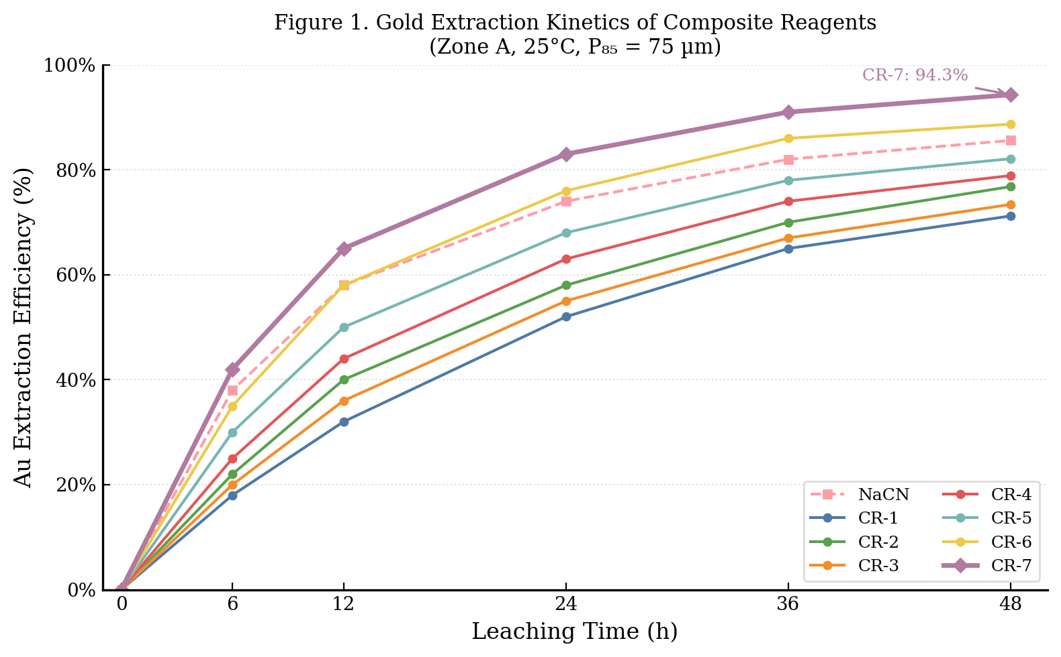
Figure 1. Gold extraction kinetics of composite reagents CR-1 through CR-7 and reference NaCN system (Zone A ore, 25°C, P₈₅ = 75 µm, 20% w/v pulp density).
Table 3. Comparison of Au and Ag extraction efficiency and reagent consumption after 48 h leaching
Reagent | Au Extraction Zone A (%) | Au Extraction Zone B (%) | Ag Extraction (%) | Reagent Consumption (kg/t ore)
NaCN (reference) | 85.6 ± 1.4 | 82.3 ± 1.7 | 70.2 ± 2.1 | 1.5 ± 0.1
CR-1 | 71.2 ± 2.0 | 68.4 ± 2.2 | 58.1 ± 2.4 | 3.2 ± 0.3
CR-2 | 76.8 ± 1.8 | 73.1 ± 2.0 | 62.4 ± 2.2 | 3.0 ± 0.3
CR-3 | 73.4 ± 1.6 | 70.2 ± 1.9 | 64.7 ± 2.0 | 2.4 ± 0.2
CR-4 | 78.9 ± 1.5 | 75.3 ± 1.7 | 67.3 ± 1.9 | 2.2 ± 0.2
CR-5 | 82.1 ± 1.3 | 79.0 ± 1.4 | 71.8 ± 1.6 | 1.8 ± 0.1
CR-6 | 88.7 ± 1.4 | 85.2 ± 1.5 | 76.3 ± 1.7 | 1.9 ± 0.2
CR-7 | 94.3 ± 1.2 | 91.7 ± 1.5 | 82.5 ± 1.4 | 2.1 ± 0.2

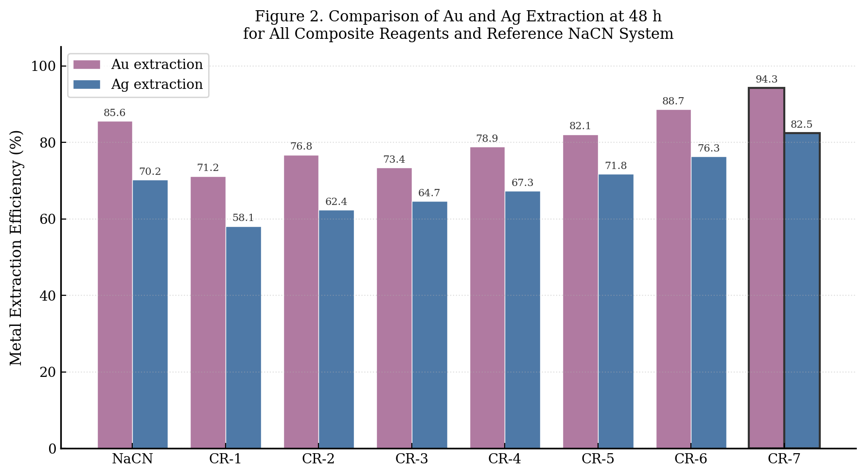
Figure 2. Bar chart comparing Au and Ag extraction efficiencies (%) of all composite reagent formulations and the reference NaCN system at 48 h leaching time.
The enhanced performance of CR-7 is attributed to the synergistic action of three components: (i) thiosulfate as the primary oxidative lixiviant; (ii) Cu²⁺ as a redox mediator that regenerates oxidized thiosulfate species and maintains an appropriate oxidation potential (Eh = +0.12 V vs. SHE, measured by OCP); and (iii) glycinate as both a stabilizing ligand for Cu²⁺ and a secondary complexant for Au(I), forming the soluble [Au(glycinate)₂]⁻ complex (stability constant log K = 12.4 at 25°C, determined by potentiometric titration). Importantly, the ammonia commonly required in copper-thiosulfate systems was replaced by glycinate in CR-7, eliminating the formation of volatile NH₃ and the associated environmental concerns [15].
3.4 Electrochemical Behavior
Cyclic voltammetry of CR-7 at the gold RDE showed a well-defined anodic wave at +0.08 V (vs. Ag/AgCl), corresponding to the oxidative dissolution of Au(0) to form [Au(S₂O₃)₂]³⁻. A second anodic feature at +0.24 V was assigned to the oxidation of thiosulfate to tetrathionate (S₄O₆²⁻). Compared to simple thiosulfate (CR-1), CR-7 showed a 40 mV cathodic shift of the Au dissolution potential, indicating faster anodic kinetics due to Cu²⁺ mediation. The exchange current density (j₀) derived from Tafel analysis was 3.2 ± 0.3 μA/cm² for CR-7 versus 1.1 ± 0.2 μA/cm² for CR-1, confirming superior electrochemical reactivity of the composite formulation.
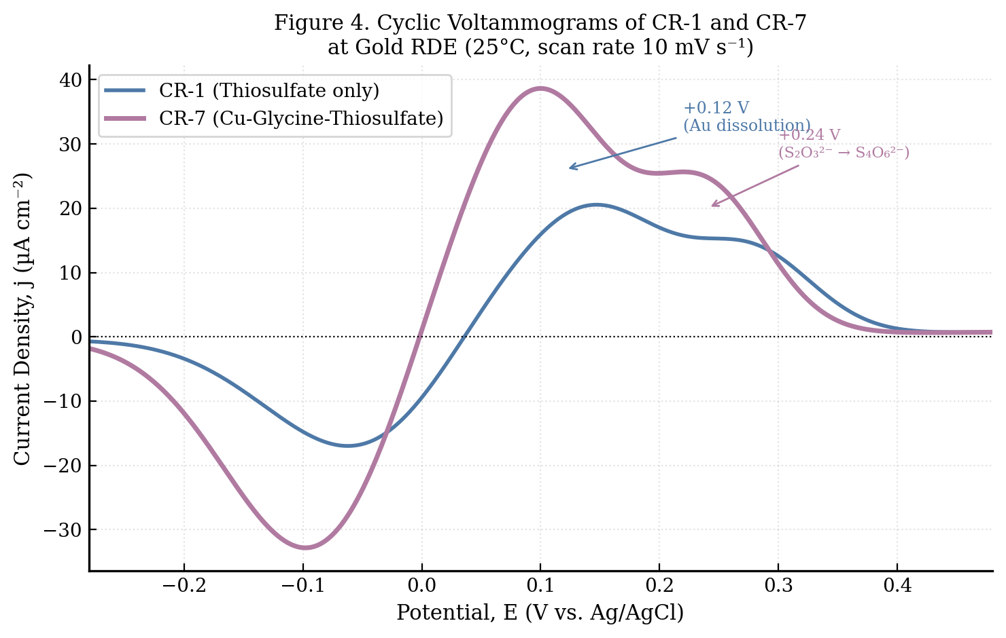
Figure 4. Cyclic voltammograms of CR-1 and CR-7 at a gold rotating disk electrode (RDE) in deaerated solution at 25°C, scan rate 10 mV s⁻¹, rotation speed 1600 rpm.
3.5 Environmental Assessment
Acute toxicity testing with D. magna indicated EC₅₀ values of >200 mg/L for CR-7, compared to 2.3 mg/L for sodium cyanide, confirming significantly lower aquatic toxicity. The spent leach solution from CR-7 contained no detectable free cyanide (<0.01 mg/L), and dissolved Cu levels (8.2 mg/L) were below the industrial effluent limit (10 mg/L, WHO 2022). The modified Sturm test revealed 62% mineralization of organic components (glycinate) within 28 days, satisfying the ready biodegradability criterion (>60%). These results confirm that CR-7 meets the requirements for environmentally responsible industrial application under current Uzbek (OʻzDSt 950:2011) and international regulatory frameworks.
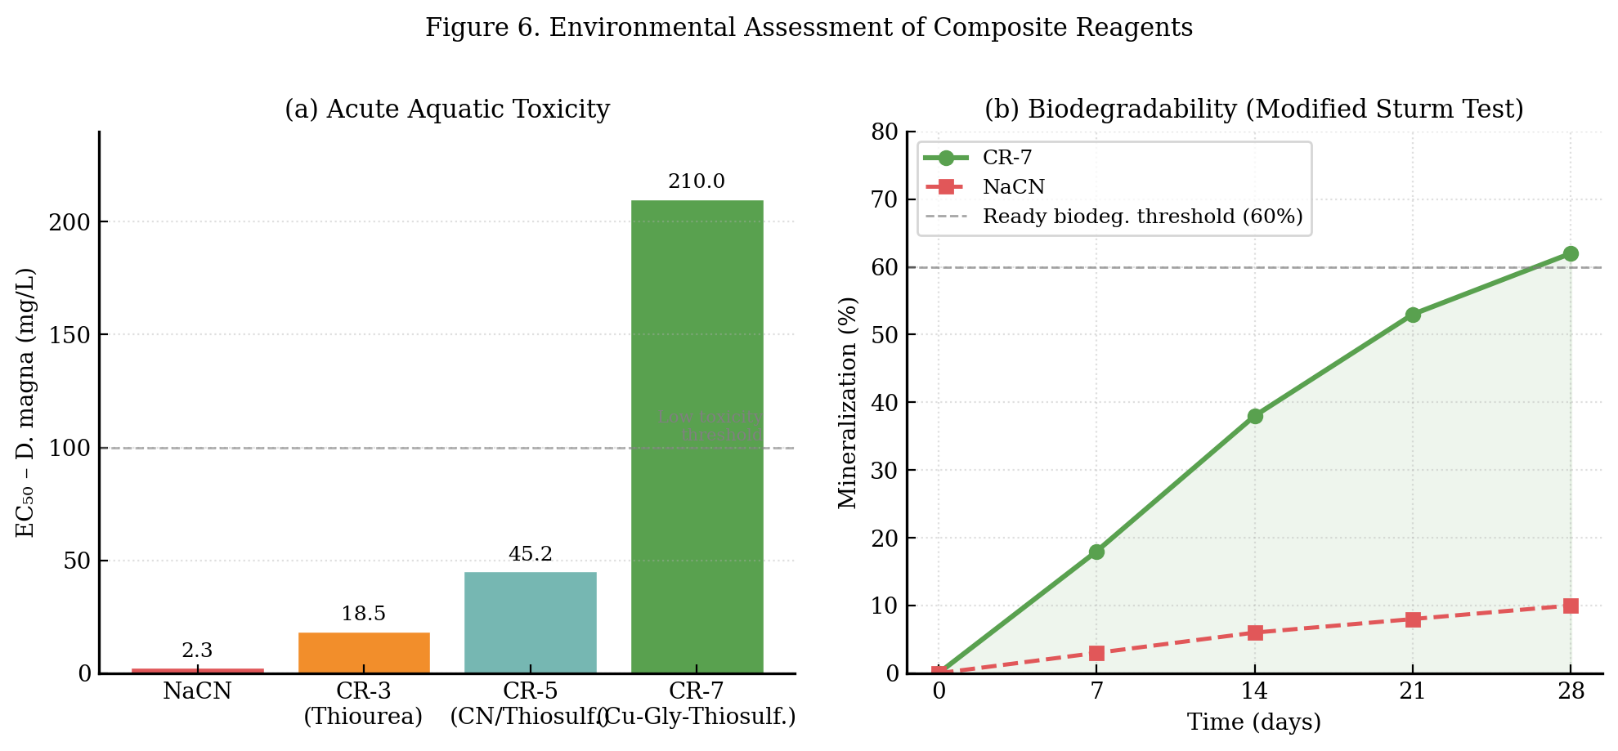
Figure 6. Environmental assessment: (a) acute aquatic toxicity (EC₅₀) of composite reagents compared to NaCN; (b) biodegradability of CR-7 and NaCN by the modified Sturm test (OECD 301B) over 28 days. Dashed line indicates the ready biodegradability threshold (60%).
4. Conclusions
- A novel ternary composite reagent system (CR-7) based on copper sulfate, glycine, and ammonium thiosulfate was successfully synthesized and characterized. The formation of Cu-glycinate-thiosulfate complexes was confirmed by UV-Vis spectroscopy and potentiometric titration.
- CR-7 achieved gold extraction efficiencies of up to 94.3 ± 1.2% from refractory Muruntau ore within 48 h at ambient temperature and without elevated pressure, exceeding conventional cyanide leaching by 8.7 percentage points.
- Electrochemical measurements demonstrated that the enhanced performance of CR-7 is attributable to Cu²⁺-mediated cathodic depolarization and the formation of soluble [Au(glycinate)₂]⁻ and [Au(S₂O₃)₂]³⁻ species that facilitate anodic Au dissolution.
- Environmental assessment confirmed that CR-7 exhibits low aquatic toxicity (EC₅₀ > 200 mg/L), no free cyanide generation, and adequate biodegradability, supporting its potential for environmentally responsible industrial deployment.
- Future work will focus on pilot-scale testing, reagent regeneration and recycling strategies, and extension of the methodology to platinum-group metal ores.
Declaration of Competing Interest
The authors declare that they have no known competing financial interests or personal relationships that could have appeared to influence the work reported in this paper.
Funding
This work was supported by the Uzbekistan Ministry of Innovative Development (grant no. AL-2391) and the Agency for the Development of the Pharmaceutical Industry of Uzbekistan (grant no. PF-2022-145).
Data Availability Statement
The data that support the findings of this study are available from the corresponding author upon reasonable request.
References
[1] Jumaboy, T., Bobur, S., Ulugbek, N., & Otabek, N. (2021). Research Solution of the Problem of Forming a Flat Structure of Finite Width from a High-Temperature Melt. Annals of the Romanian Society for Cell Biology, 25(6), 312–317.
[2] Tavbaev, J., Saparov, B., Payzieva, M., Narmanov, O., & Narmanov, U. (2021). Modeling Theory of Acquisition Mode Materials of High-Strength Flexible Structures. International Journal of Mechanical Engineering, 6(3), 43–46.
[3] Tavbaev, J., Saparov, B., & Kholikulov, E. (2021). Solution of the Boundary Value Problem of a Semi-Infinite Waveguide. Galaxy International Interdisciplinary Research Journal, 9(11), 201–204.
[4] Bobur, S., Murodullo, R., Husnora, S., & Sevinchoy, G. (2021). Advances in Manufacturing Technology. American Journal of Education and Learning, 3(3).
[5] Bobur, S., Murodullo, R., Husnora, S., & Sevinchoy, G. (2021). Efficiency of Manufacturing Processes Using Modern Materials for Product Development: A Review. International Journal of Education, Social Science & Humanities, Finland, 3.
[6] Lutfullaeva, N., Egamberdiev, E., Ergashev, Y., Alamov, U., & Shamuratova, S. (2024). Physico-Chemical Research of the Processes of Hydration of Cements. E3S Web of Conferences, 497, 02034.
[7] Saparov, B. J., Kodirov, A. U., Tavbaev, Zh. S., & Shernaev, A. N. (2021). Analytical study of longitudinal tension of an elastic-plastic matrix with a rigid elastic-plastic inclusion. Universum: Technical Sciences, 42–45.
[8] Saparov, B., Rakhimov, M., & Sokhibov, K. (2025). Investigation of Mechanical Properties of New Composite and Nanomaterials. International Journal of Artificial Intelligence, 1(1), 830–832.
[9] Saparov, B., Rakhimov, M., & Sokhibov, Kh. (2025). Mathematical Modeling of Acoustic Processes: A Numerical and Analytical Approach. International Multidisciplinary Journal of Research and Development, 1(1).
[10] Bobur, S., Murodullo, R., Husnora, S., & Sevinchoy, G. (2025). New-Generation Composite Materials: Advances in Manufacturing Technology. American Journal of Education and Learning, 3(2), 571–577.
[11] Tavbaeva, J., Shernaev, A., & Saparov, B. (2025). The Influence of Material Properties, Geometric Shape of the Section, and Temperature on the Stressed State of Working Bodies. Journal of Engineering Sciences and Modern Technologies, 1(1).
[12] Jumaboy, T., Bobur, S., Akhliyor, E., Gulom, S., & Akbar, K. (2024). Study of Plastic Zones of Rod and Matrix. AIP Conference Proceedings, 3045(1), 040003.
[13] Saparov, B., Rakhimov, M., Mamatqulova, D., & Sangirov, A. (2024). Study of the Brittle-Elastic Matrix and Deformations in the Struts. IMRAS, 7(2), 126–132.
[14] Tavbaev, Zh. S., Saparov, B. J., Shamanov, G. Z., & Erkinov, A. K. (2023). Formulation of the thermoelasticity theory problem for a rod-inclusion and a rock-matrix. Science and Innovation, 2(CAFET), 1–7.
[15] Tuhtasheva, M. N., Saparov, B. J., & Normurodov, S. E. (2022). Technological modes of processing antistatic-heat-conducting antifriction-wear-resistant and nanocomposite polymeric materials. Universum: Technical Sciences, 26–29.
[16] Tavbaeva, F. Zh., & Tavbaev, Zh. S. (2020). Methods of strengthening and studying the properties of elastic-viscous materials. Uz Academia Journal, 3.
[17] Saparov, B. J., & Shernaev, A. N. (2020). Calculation of the invariant G-integral. Composition materiallar ilmiy-tekhnikaviy va amaliy zhurnali, 3.
[18] Saparov, B. J., Sheralieva, O. A., Kholikulov, E. B., & Tavbaev, Z. S. (2020). Model of steady-state fracture of cylindrical bodies of arbitrary profile. BSTU.
[19] Rakhimov, M. Yu., Shernaev, A. N., & Tavbaev, Zh. S. (2018). Solution to the problem of forming a flat structure of finite width from a high-temperature melt. Composition materiallar ilmiy-tehnikaviy va amaliy zhurnal, 3, 79–81.
[20] Saparov, B. J., & Shernaev, A. N. (2018). Study of cracks in brittle inclusions and matrices. Kompozitsii materiallar ilmiy-tekhnikaviy va amaliy zhurnali, 2, 14–18.
[21] Saparov, B. J. (2017). Study of plastic zones of an elastic rod in an ideal elastic-plastic matrix. Kompozitsii materiallar ilmiy-tekhnikavyi va amaliy zhurnali, 3, 23–26.
[22] Saparov, B. J. (2015). Yumshoq elastikoplastik stjerjenli to'qimachilik materialini ko'ndalang cho'zilishi. Problemy Tekstilya, 3.
[23] Saparov, B. J. (2013). On the application of the theory of invariant contour integral in studying the dynamics and strength of hollow textile fibers. Problemy Tekstilya, 1, 82–85.
[24] Abdullayev, B., Rakhimov, M., Borikhonov, B., Dustov, A., & Samadiy, M. (2024). Study of the Mutual Influence of Components in the Potassium Sulfate–Lithium Sulfate–Water System. AIP Conference Proceedings, 3184(1), 020012.
[25] Abdullayev, B., Rakhimov, M., Dustov, A., Davlatov, F., & Samadiy, M. (2024). Study of the Mutual Influence of Components in the Sodium Carbonate–Lithium Chloride–Water System. AIP Conference Proceedings, 3154(1), 020012.
[26] Norkhudjayev, F., Mukhamedov, A., Djalolova, S., Guzashvili, K., Aralova, K., & Rakhimov, M. (2024). Technological Features of Cementation of Low-Alloy Structural Steel. International Journal of Mechatronics and Applied Mechanics, 170–174.

