 CHEMICAL ENGINEERING TRANSACTIONS  VOL. xxx, 2026 | A publication of  
The Italian Association
of Chemical Engineering
Online at www.cetjournal.it

Guest Editors: Flavio Manenti, Botir Usmonov, Alessandro Di Pretoro
Copyright © 2026, AIDIC Servizi S.r.l.
ISBN 979-12-81206-xx-x; ISSN 2283-9216

A Precision Method for Remote Sensing of Terrestrial Vegetation Conditions
Abdushukur Mukhamedov^{a∗}, Shamsiddin Ernazarovª, Fazliddin Isaevª, Farid Umarov^{b}
ªDepartment of Physics and Energy, Tashkent Institute of Chemical Technology, 100011, Tashkent, Uzbekistan.
^{b}Kazakhstan-British Technical University, Tole Bi 59, Almaty, Republic of Kazakhstan.
mabdushukur@mail.ru
To ensure optimal agrochemical treatment of local crop areas characterized by a deficiency of certain types of mineral fertilizers, it is necessary to employ modern tools for the rapid monitoring of the physiological state of plants. As such a tool, a method for the remote measurement of the laser-induced fluorescence (LIF) spectrum of plant leaves is proposed; this method enables the acquisition of the most reliable data on the physiological condition of crops. In laboratory studies conducted on experimental plant samples, a correlation was established between the fluorescent response, the physiological state, and the dry weight of plants — both under conditions of normal mineral nutrition and under induced mineral stress. The methodological basis of the approach consists in comparing the array of remotely obtained data (including the vertical profile and the spectral shape of the fluorescent response) with reference data generated on the basis of training samples. The practical implementation of this method ensures reliable identification of the physiological state of vegetation and allows for the quantitative assessment of biomass, which facilitates the creation of maps of problematic areas in agricultural crops that require chemical treatment. The effectiveness of the proposed method was verified during field tests: a high degree of convergence was observed between the results of remote measurements and ground-based observation data. The obtained results provide scientific and practical grounds for optimizing the application rates of mineral fertilizers within the framework of precision farming technologies.
  - Introduction
The intensification of agricultural production relies significantly on the use of chemical fertilizers. The integration of advances from the chemical industry into agriculture involves the application of mineral fertilizers (such as potassium, phosphorus, magnesium, and others), as well as chemical agents for the protection of cultivated crops against pests and diseases (Nanda, S.P.et.all.,2020; Mohammad Sarvestani, 2024). Adherence to agrochemical application norms contributes to increased crop yields. Conversely, non-compliance with these norms poses a serious threat to agroecosystems. Insufficient application of chemical fertilizers leads to a reduction in biomass and yield, whereas excessive application results in soil compaction and contamination of air and water resources.
Furthermore, the proper implementation of agrochemical measures enables substantial savings of chemical inputs within the closed cycle of agricultural production (Joni S. Adiansyaha et.all., 2021).
1.1 Existing Techniques
A key factor in optimizing agrochemical treatment is the targeted application of chemical agents, which relies on precise local data on the condition of plants across the entire area of agricultural land. In this context, plants serve as reliable indicators of the environment in which they develop. Consequently, the most effective monitoring tool remains optical surveillance using sensors mounted on board aerial vehicles — aircraft, helicopters, or unmanned aerial vehicles (UAVs).
Parameters such as biomass and overall appearance enable inferences regarding soil condition, including its chemical composition and moisture level. The spectral characteristics of plants, along with their geometric parameters (e.g., height and density), provide valuable information on plant status. Particularly informative is the fluorescent response of leaves, which is closely linked to the condition of the plants’ photosynthetic apparatus.
This factor has accounted for the widespread adoption of vegetation fluorescence response in remote sensing studies (Hoge F. E. et al., 1983; Chappelle E. W. et al., 1984). The principal advantage of this method is the capacity to discriminate signals attributable exclusively to vegetation within the upwelling radiance flux. These signals originate from chlorophyll molecules present in the leaves, which function as a unique indicator providing data on the physiological status of plants (Hazem M. Kalaji, Anjana Jajoo at.all.,2016).
The level of the fluorescence signal is generally determined by the quantity of fluorescent chlorophyll molecules present in plant organs. To avoid dependence on instrument parameters and the influence of atmospheric interference, the ratio of fluorescence intensity in two characteristic spectral regions is typically recorded, such as F690/F735 or F690/F740. This selection is justified by the fact that the chlorophyll fluorescence spectrum in the green leaf of higher plants exhibits a rather narrow short-wavelength band with a maximum in the red region around 685–690 nm, and a broad long-wavelength band with a maximum in the far-red region around 730–740 nm.
Thus, it can be stated that the ratio of chlorophyll fluorescence in the red and far-red ranges is considered a convenient tool for detecting differences in chlorophyll content in leaves, as well as for monitoring changes in the plant photosynthetic apparatus (PSA) induced by alterations in environmental conditions (Buschmann, 2007).
1.2 Factors Affecting the Fluorescence Spectrum
The functioning of the photosynthetic apparatus (PSA) is affected by a number of adverse factors, such as a deficiency of certain nutrients (N, P, K, Ca, Mg, S, or Fe) or insufficient water supply (Agati G., Cerovic Z. G. et al., 2000). These factors also exert a significant influence on the fluorescence yield. Chappelle E. W. et al. (1984) noted that nitrogen and phosphorus deficiencies reduce the fluorescence intensity at 690 and 740 nm by a factor of two to three. Analysis of the laser-induced fluorescence (LIF) spectral curves of plant leaves revealed that cotton grown under conditions without the addition of key mineral nutrients (nitrogen, phosphorus, and potassium) to the substrate exhibits a lower fluorescence yield compared to the control samples. This can be attributed solely to the reduction in chlorophyll content in the leaves under nutrient deficiency, i.e., a decrease in the number of fluorescent molecules.
However, the divergent nature of the fluorescence response to external conditions complicates the unambiguous interpretation of remote sensing data, not only based on measurements of the total fluorescence yield but also on the F680/F740 ratio. Therefore, the most appropriate approach appears to be the use of the fluorescence spectral structure across a broad wavelength range—rather than in just two spectral regions—as an indicator of plant status.
  - Methodology
2.1 Experimental Methodology
The study focused on cultivated cotton varieties C-4727 and Tashkent-4. The plants were grown in Wagner pots with a capacity of 28–30 kg at the vegetation site of the Institute of Genetics and Experimental Biology of Plants (INEBP), Academy of Sciences of the Republic of Uzbekistan. The pots were filled with a sand–soil mixture in a 1:3 ratio. The substrate moisture content was maintained at 65–70 % of the total water-holding capacity throughout the cotton development period.
The experiment on mineral nutrition of cotton was arranged according to the following scheme: five pots with cotton plants were cultivated with the application of an optimal dose of nitrogen, phosphorus, and potassium; the next five pots with cotton plants were cultivated without the addition of these elements.
Phosphorus and potassium fertilizers, at rates of 4 g and 3 g, respectively, were applied when filling the pots. Nitrogen fertilizer, at a rate of 2 g in dissolved form, was applied prior to sowing, and the remaining portion (1 g each) was administered in three top-dressing applications: during the 2–3 true-leaf stage, at budding, and at the onset of flowering. The first signs of mineral stress were detected as early as the
2–3 true-leaf stage.
Laboratory measurements of the laser-induced fluorescence (LIF) spectra of leaves from reference plants were carried out using a spectral computing device equipped with a helium–neon laser and a nitrogen laser, generating radiation in the blue and green regions of the visible spectrum at wavelengths of 514.5 nm, 488.0 nm, and 476.5 nm, with a power of approximately 1 W across all lines. Remote experiments were conducted using a spectrometric complex mounted on board an aircraft.

2.2 Algorithm for Recognizing and Calculating Plant Biomass
For mathematical processing of the results and construction of a classifier based on spectral data, an image recognition method based on the calculation of discriminant functions was used (Yu H., J. Yang, 2001).
A comparison of the statistical series curve obtained from a series of spectra (whose mathematical expectation and variance were calculated from tabulated data on cotton fluorescence spectra) with the normal distribution curve showed that the distribution of the probability density of luminescence intensity in each spectral channel obeys the normal law. At the same time, the spectral responses measured in two characteristic spectral channels were found to be dependent. These signal properties provided the basis for selecting a discriminant function in the form of a normal distribution. The discriminant function g_{i}(x) of different classes i was estimated according to the maximum likelihood rule
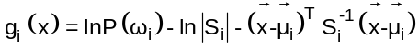, | (1)
where P(ω_{i}) is the prior probability of class i, i.e., the probability of observing an image from class i, independent of any other information.
Biomass was calculated numerically according to the following algorithm (Mukhamedov A.A. et al. 2025)
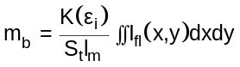, | (2)
where S_{t} is the total length of the sounding route, l_{m} is the maximum height of plants along the route, K(ε_{i}) is a correction factor that establishes the correspondence between biomass and fluorescence level for each plant class.
  - Result and Discussion
3.1. Laboratory Experiments
Analysis of the obtained laser-induced fluorescence (LIF) spectral curves of plant leaves (Figure 1a) reveals that cotton grown under conditions without the addition of key mineral nutrients (nitrogen, phosphorus, and potassium) to the substrate exhibits a lower fluorescence yield compared to the control samples. In the normalized spectra, this difference manifests as a slight increase in the relative height of the long-wavelength maximum (Figure 1b).
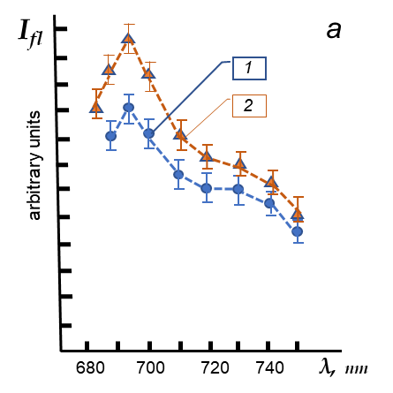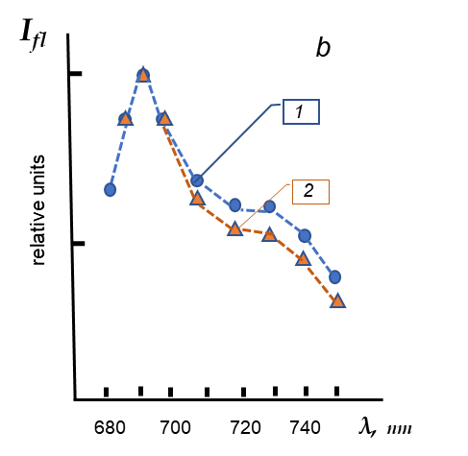
Figure 1: Laser-induced fluorescence spectrum. 1 — control plants; 2 — mineral stress. (Confidence interval at a confidence level of 0.95)
It was also established that each plant genotype exhibits an individual spectral structure in the red region of the spectrum. However, measurements conducted on a large sample of experimental plants revealed a considerable variability in the spectral profile of fluorescence emission, even within the same class (Figure 2). Naturally, this circumstance may lead to ambiguous interpretations of remote sensing data.
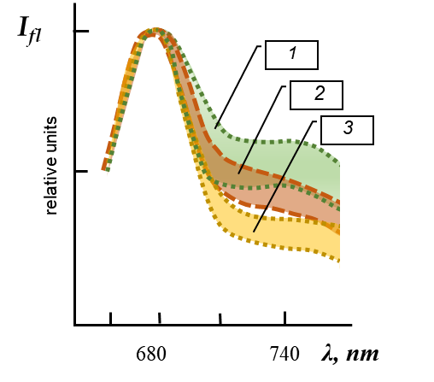
Figure 2: Statistical dispersion of spectral curves normalized to I_{fl} (680 nm) for different plant species: 1 - cotton, 2 - corn, 3 - wheat (confidence interval at a confidence level of 0.95)
Nevertheless, an in-depth statistical analysis of the data cloud, based on machine learning, enabled the identification of sufficiently stable spectral features for the accurate classification of plant species and their physiological states. This result suggests that, despite the universality of photochemical processes occurring in the photosynthetic apparatus (PSA) of higher plants, there are state-specific characteristics in the reaction dynamics that manifest in the fluorescence signature. Consequently, to address this problem effectively, it is necessary to have a set of classifiers built on a large sample of training datasets.
The spectral data consisted of digitized values normalized to the intensity of the main fluorescence maximum (approximately λ = 680 nm), along with fluorescence intensity values measured in the 670–750 nm range at 10 nm intervals. The array of digital data obtained during laboratory measurements served as training samples for the subsequent development of the classifier.
Statistical analysis of the digital values of the fluorescence spectral curves revealed a notable difference between the averaged values (mean and variance) across different plant classes (Table 1).
Table 1: Mathematical expectation and variance for healthy (class 1) and water-stressed (class 2), nitrogen-stressed (class 3), and water-nitrogen-stressed (class 4) cotton plants. Indices (1) and (2) correspond to spectral channel numbers 680 and 730 nm. (Spectral data in arbitrary units)
Classes | μ₁ | μ₂ | σ²₁₁ | σ²₂₂ | σ²₁₂
1 | 7.71 Е-01 | 7.46 Е-03 | 3.31 Е-03 | 3.59 Е-03 | 2.59 Е-03
2 | 7.30 Е-01 | 6.48 Е-01 | 3.40 Е-02 | 1.48 Е-02 | 5.48 Е-03
3 | 7.54 Е-01 | 6.97 Е-01 | 3.86 Е-03 | 4.56 Е-03 | 3.79 Е-03
4 | 8.03 Е-01 | 8.18 Е-01 | 7.02 Е-03 | 2.24 Е-03 | 2.70 Е-03

These data indicate a marked difference in the averaged values for individually selected spectral channels. Based on this, the corresponding discriminant functions for each class were constructed using multichannel spectral data.
The analysis showed that the greater the number of channels, the greater the recognition accuracy (in the case of n = 8–12, the identification accuracy is 85–95%).
3.2. Remote Experiments
The biomass estimate based on remote measurements obtained during field flight experiments using a laser-optical complex over cotton crops showed a fairly good correlation with the results of ground estimates using traditional methods, especially in the early stages of plant development. Plant biomass throughout the entire growing season (from seedling emergence to maturity), which lasted 90 days, tended to increase monotonically. However, as the leaf index increased, remote assessments became less accurate (Figure 3).
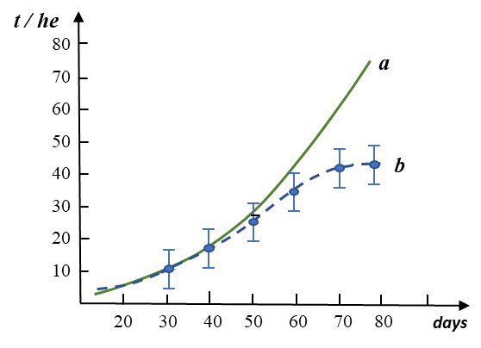
Figure 3: Seasonal changes in cotton biomass: a – ground-based data, b – remote estimates (confidence interval at a confidence level of 0.95).
This discrepancy was due to a decrease in the penetration of the probing laser beam into the depth of the crop. Obviously, in such cases, this method must be used in combination with other remote sensing tools, such as radar sounding, etc.
CONCLUSION
The study demonstrated that the state and biomass of vegetation can be assessed with sufficient accuracy based on the remote detection of the fluorescence response. To ensure accuracy, it is essential to simultaneously measure the intensity of the fluorescence signal both along the flight path of the onboard detector and with respect to plant height. A spatial representation of the distribution of fluorescent organic matter is achieved through the use of pulsed lasers in combination with a high-speed recording system.
A second critical condition for ensuring the accuracy of the calculations is the simultaneous registration of the spectral shape of the fluorescence response, which allows for accounting of the physiological state of the plants. The estimation accuracy, in this case, depends on the number of spectral channels used for signal registration.
Field flight tests showed that the rapid diagnostics of croplands covering an area of 100 ha, including the concurrent processing of digital data, requires no more than 2–3 hours of flight time. Consequently, decision-making based on remote sensing data takes no more than 3–4 hours, whereas ground-based services would require at least 5–7 working days — which significantly compromises the timeliness of implementing agrotechnical measures.
Analysis of the data from field flight tests conducted over cotton fields during different vegetation periods revealed that, during the spring maturation period — when the leaf area index enables registration throughout the entire depth of the plant canopy — the results of remote biomass estimation show good agreement with ground-based measurement data. Therefore, the application of the described method can serve as an effective tool for the rapid mapping of the condition of local crop areas, which is important for targeted agrochemical treatment of agricultural lands.
References
Agati G., Cerovic Z.G., Moya I., 2000. The Effect of Decreasing Temperature up to Chilling Values
on the in vivo F685/F735 Chlorophyll Fluorescence Ratio in Phaseolus vulgaris and
Pisumsativum: The Role of the Photosystem I Contribution to the 735 nm Fluorescence
Band // Photochemistry and Photobiology. Vol. 72. 75–84.
Claus Buschmann, 2007. Variability and application of the chlorofill fluorescence emission ratio
red/far-red of leaves. Research Article Published: 25 may Volume 92, 261-271.
https://link.springer.com/article/10.1007/s11120-007-9187-8
Chappelle E.W., De Murtrey J.E., Wood F.M., Newcomp W.W., 1984. Laser-induced Fluorescence
of green plants.1: A technique for the remote detection of plant stress and species
differentiation // Appl.Opt., V.23, № 1, 134-138.
https://doi.org/10.1364/AO.24.000074

Hazem M. Kalaji, Anjana Jajoo at.all.,2016. Chlorophyll a fluorescence as a tool to monitor
physiological status of plants under abiotic stress conditions. Acta Physiological
Plantarum.Volume 38, article number 102
https://link.springer.com/article/10.1007/s11738-016-2113-y
Hoge F.E., Swift R.N. and Jungel J.K., 1983. Feasibility of airborne detection of laser-indused
fluorescence emission from green terrestrial plants // Appl.Opt., V.22, № 19, 2981-3001.
Joni S. Adiansyaha, Hadiyanto Hadiyantoc, Naliawati Ningrumb, 2021. Application of Life Cycle Assessment for Improving the Energy and Waste Management Strategy: A Case Study of Fertilizer Plant in Indonesia .CHEMICAL ENGINEERING TRANSACTIONS VOL. 89,
ISBN 978-88-95608-87-7; ISSN 2283-9216
DOI: 10.3303/CET2189025
Mohammad Sarvestani, 2024. Plant Protection and Fertilizer Production. Journal of Chemical Sciences
ISSN: 2150-3494 Short Communication, Volume 15, Issue 5 Industrial Chemistry in Agriculture
Mukhamedov A., Ernazarov N., Khujamshukurov N., Isaev F., 2025. Estimation of Vegetation Cover Biomass by Remote Sensing. International journal of engineering research & technology (IJERT.ORG). Volume 13, Issue 06. DOI: 10.17577/IJERTCONV13IS06004
https://www.ijert.org/estimation-of-vegetation-cover-biomass-by- remote-sensing.
Nanda, S.P., Borkataki, S., Taye, R.R., & Reddy, M.D., 2020. Chemistry in Agriculture – A Review,
Ind. J. Pure App. Biosci. 8(3), 241-247. doi: http://dx.doi.org/10.18782/2582-2845.8129
Yu H., J.Yang, 2001. A direct LDA algorithm for high-dimensional data — with application to face recognition. Pattern Recognition.. -Т.34, iss. 10. DOI: 10.1016/s0031-3203(00)00162-x.

