 CHEMICAL ENGINEERING TRANSACTIONS  VOL. xxx, 2026 | A publication of  
The Italian Association
of Chemical Engineering
Online at www.cetjournal.it

Guest Editors: Flavio Manenti, Botir Usmonov, Alessandro Di Pretoro
Copyright © 2026, AIDIC Servizi S.r.l.
ISBN 979-12-81206-xx-x; ISSN 2283-9216

Chemically Synthesized h-BN Nanoparticles as Potential Fillers for Thermally Conductive and Electrically Insulating Polymer Composites
Sherzod Abdurakhmonova,*, Mastura Aripovaa, Odiljon Abdurakhmonova, Djanon Alimdjanovaa
ªTashkent Institute of Chemical Technology, 32 A. Navoi St., Tashkent, 100011, Uzbekistan
sherzod028@gmail.com
Ultrafine hexagonal boron nitride (h-BN) nanoparticles were prepared from boric acid and urea by a solution-derived precursor route followed by thermal treatment at 600 and 1000 °C. The synthesis conditions, morphology, crystal structure, and electrical response of h-BN/poly(vinyl alcohol) (PVA) films were evaluated. TEM showed primary particles mainly 4–7 nm in size, with an average of 5–6 nm. HRTEM gave d₀₀₂ = 0.332 ± 0.004 nm, while XRD identified nanocrystalline h-BN and no detectable crystalline secondary phases after washing. Incorporation of 0.99–4.76 wt.% h-BN changed the film resistivity only from 1.008 × 10⁸ to 1.042 × 10⁸ Ω·cm, indicating preservation, rather than substantial improvement, of electrical insulation. The work links a documented laboratory synthesis route with quantitative structural characterization and low-loading electrical screening. Thermal conductivity was not measured; consequently, thermal-management use is presented as a potential application requiring direct verification.
  - Introduction
The increasing power density and miniaturization of electronic devices require polymeric packaging, encapsulation, and interface materials that can dissipate heat while retaining electrical insulation. Conventional polymers generally have low thermal conductivity, and the development of thermally conductive yet electrically insulating composites therefore remains an important materials-engineering objective (An et al., 2023; Chen et al., 2024; Li et al., 2022).
Hexagonal boron nitride (h-BN) is attractive for this purpose because it combines high intrinsic thermal conductivity, electrical insulation, chemical stability, and a layered crystal structure. However, the effective thermal response of an h-BN/polymer composite depends not only on the intrinsic properties of the filler, but also on particle size, orientation, aggregation, filler–filler contacts, and interfacial thermal resistance (Ali and Abdala, 2022; Fang et al., 2016; Gonzalez-Ortiz et al., 2020; Guerra et al., 2019; Mazumder et al., 2022).
PVA is a useful water-processable matrix for preliminary composite-film studies. Previous work has shown that h-BN microplatelets or exfoliated nanosheets can improve heat transport in polymer systems when appropriate loading, orientation, and dispersion are achieved (Donnay et al., 2015; Lin et al., 2014; Xie et al., 2013). The electrical response must nevertheless be checked because filler loading and interfacial conditions can alter dielectric behavior in inorganic-filled insulating polymers (Bachtrong et al., 2017).
Boric-acid/urea precursor routes for BN are already established, and their phase evolution is known to depend strongly on precursor composition and thermal decomposition conditions (Besisa et al., 2016; Gross and Höppe, 2019; Jähnichen et al., 2022; Lian et al., 2010; Yang et al., 2024). The present study therefore does not claim the first use of H₃BO₃–urea chemistry. Earlier work by the authors established a two-stage 600/1000 °C route and showed that washing removes detectable crystalline boron-oxide by-products while retaining nanocrystalline h-BN (Abdurakhmonov et al., 2025a; Abdurakhmonov et al., 2025b).
The specific contribution of this paper is the integration of a selected H₃BO₃:(NH₂)₂CO = 1:2 precursor with a fully stated two-stage laboratory treatment, quantitative TEM/HRTEM/XRD assessment of the resulting nanoparticles, and electrical-resistivity screening of PVA films containing 0.99–4.76 wt.% h-BN. This combination clarifies what is experimentally demonstrated by the present composite study and what remains prospective.
Accordingly, the objective was to determine whether the synthesized nanocrystalline h-BN could be incorporated at low loadings without compromising the electrically insulating character of PVA. No thermal conductivity or thermal diffusivity measurement was performed; hence, conclusions concerning thermal transport are deliberately limited to the potential indicated by the structure and established literature on h-BN fillers.
  - Experimental
    - Synthesis of h-BN nanoparticles
One synthesis batch contained 0.618 g (0.010 mol) H₃BO₃ and 1.201 g (0.020 mol) (NH₂)₂CO, corresponding to a 1:2 molar ratio and 1.819 g of total starting solids. The reagents were dissolved in 100 mL of deionized water and stirred at 600 rpm and 80 °C for 2 h. The homogeneous solution was dried at 120 °C for 12 h, and the resulting solid precursor was ground to a fine powder.
The precursor was spread as a thin layer in a quartz boat placed in the quartz reaction tube of a laboratory tubular furnace. The heating rate was 5 °C·min⁻¹. In the first stage, the sample was heated to 600 °C under N₂ supplied at 5 psi according to the regulator indication and held for 2 h. It was cooled under N₂ to approximately 200 °C and then allowed to cool naturally before regrinding. In the second stage, the powder was heated at 5 °C·min⁻¹ to 1000 °C and held for 1 h under simultaneous N₂ and H₂ supply. N₂ was supplied at 5 psi, while H₂ was supplied from a JM-300 generator. Both gases were maintained during cooling to approximately 200 °C, followed by natural cooling.
No vacuum treatment was used during synthesis. Calibrated volumetric flow rates and the exact N₂:H₂ ratio were not independently recorded because mass-flow controllers were not installed; the actual gas conditions are therefore reported as the regulator and generator settings used in the experiment. The heat-treated powder was washed in 50 mL of deionized water at 80 °C and 600 rpm for 1 h, centrifuged at 5000 rpm for 30 min, and dried at 120 °C for 12 h.
    - Preparation of composite films
PVA (1.00 g) was dissolved in 20 mL of distilled water at 90 °C under stirring until a homogeneous solution was obtained. Separately, h-BN nanoparticles were dispersed in water by ultrasonication. The aqueous h-BN dispersion was then added to the PVA solution.
The h-BN additions were 10, 15, 20, 25, and 50 mg per 1.00 g of PVA, corresponding to 0.99, 1.48, 1.96, 2.44, and 4.76 wt.% h-BN, respectively, calculated from the total dry solids [m(h-BN)/(m(PVA)+m(h-BN))]. Each mixture was stirred at 70 °C, ultrasonicated again, cast onto a glass substrate, and dried at 50 °C for 12 h. The films were removed from the substrates and stored for characterization.
    - Characterization methods
Particle morphology and size distribution were examined by TEM, and local lattice ordering was evaluated by HRTEM. XRD patterns were indexed against the h-BN reference pattern JCPDS 96-201-6171; full-profile refinement was used to obtain lattice parameters, and coherent-scattering domain size was estimated from diffraction-peak broadening. The electrical resistivity of the composite films was measured with a Keithley 6517B electrometer. These data were used as comparative electrical screening within the investigated series. Thermal conductivity and thermal diffusivity were not measured.
  - Results and discussion
    - Morphology and structure of h-BN nanoparticles
The morphology and primary-particle size distribution of the synthesized h-BN powder were examined by TEM (Figure 1a,b).
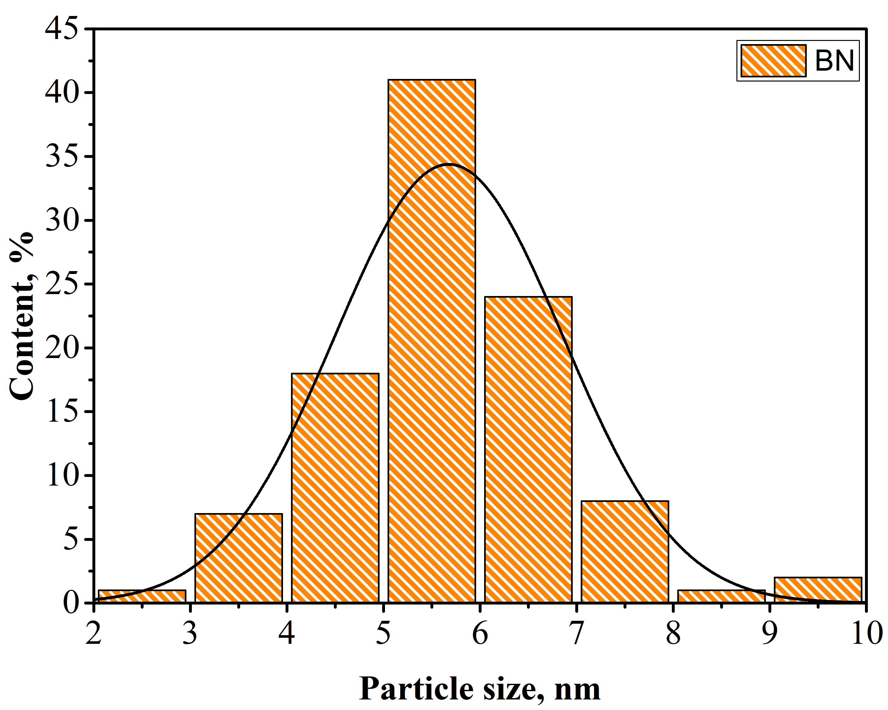
b
a
Figure 1. Morphological characterization of the synthesized h-BN nanoparticles: (a) TEM image and (b) primary-particle size distribution.
The powder consists of nanosized particles assembled into small aggregates. Individual particle boundaries remain visible, allowing size estimation. Most primary particles fall in the 4–7 nm range, with an average size of approximately 5–6 nm. Aggregation is consistent with the high surface energy of ultrafine particles after thermal treatment, washing, and drying. Importantly, this TEM observation describes the isolated powder and does not, by itself, establish uniform dispersion inside the PVA films.
HRTEM was used to examine local crystallinity and the interplanar distance of the synthesized particles (Figure 2a–d).
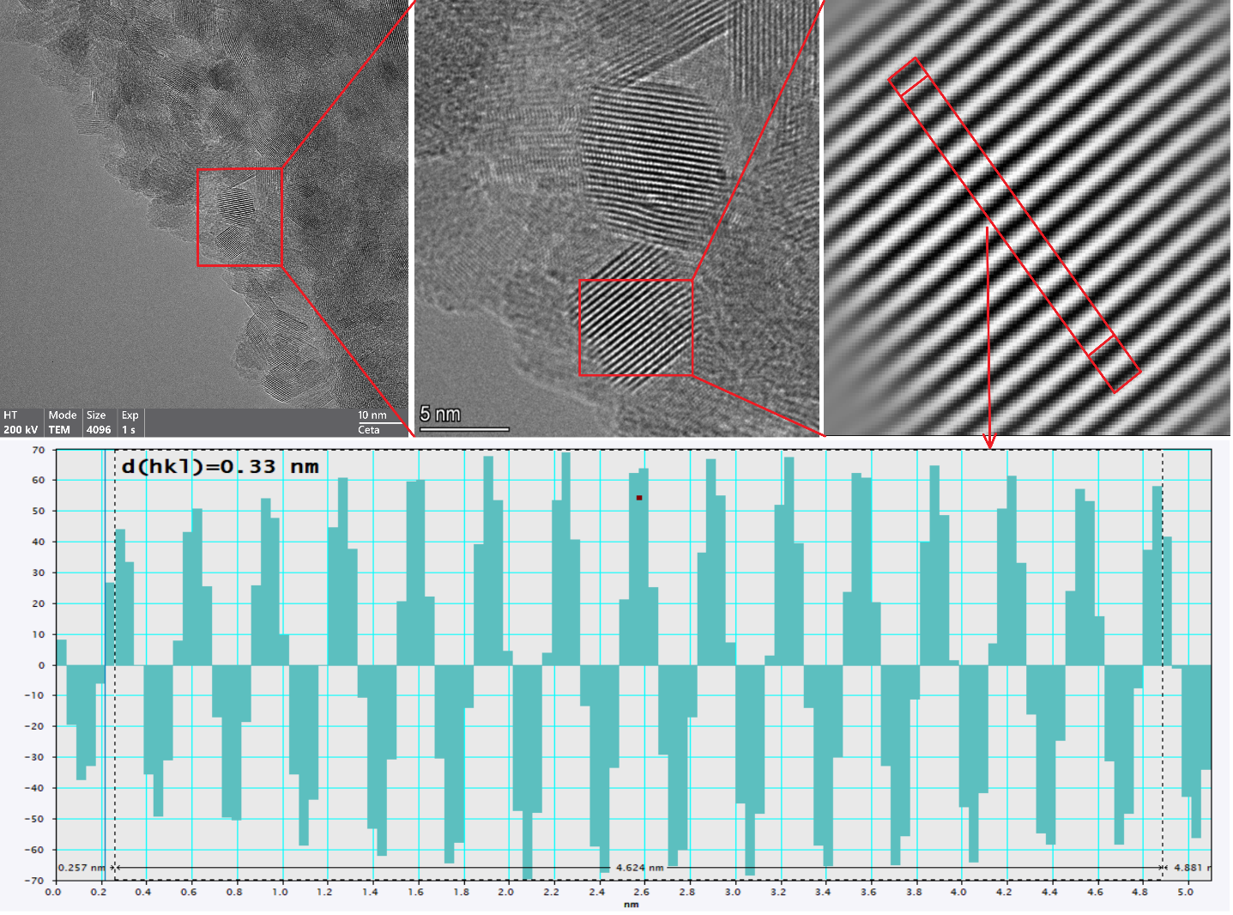
d
a
c
b
Figure 2. HRTEM analysis of the synthesized h-BN nanoparticles: (a) low-magnification TEM image, (b) lattice-resolved image, (c) magnified lattice region, and (d) line profile indicating d₀₀₂ ≈ 0.33 nm.
Aggregated nanosized particles are again visible in Figure 2a, whereas Figures 2b and 2c reveal well-defined lattice fringes within individual nanocrystalline domains. The line profile in Figure 2d gives d₀₀₂ = 0.332 ± 0.004 nm. This value agrees with the expected spacing of the (002) basal planes of hexagonal boron nitride and confirms local ordering of the layered h-BN structure.
The phase composition and average crystal structure of the washed powder were examined by XRD (Figure 3).
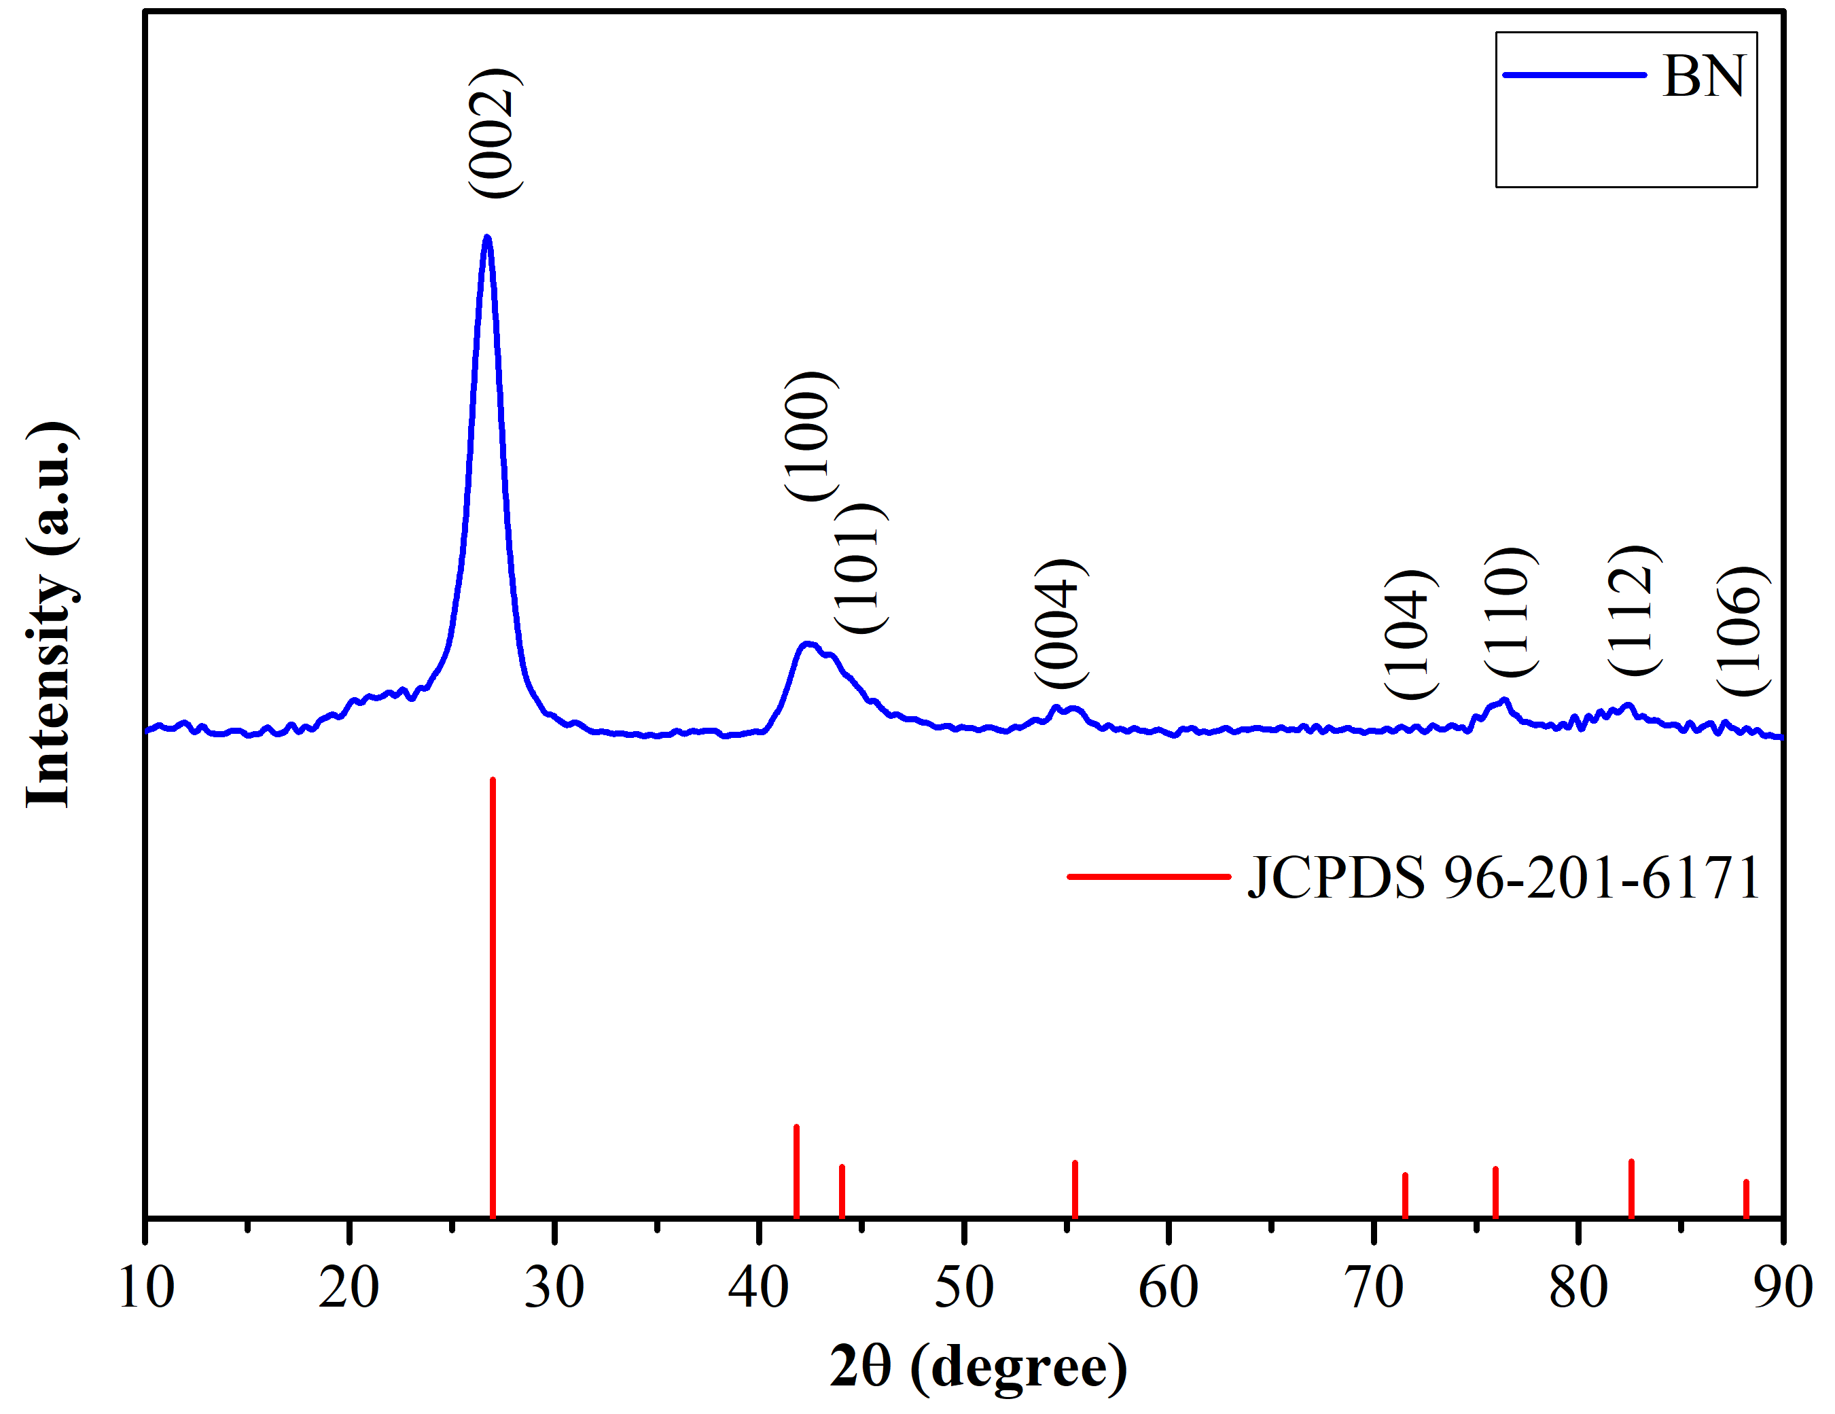
Figure 3. XRD pattern of the synthesized h-BN nanoparticles compared with the reference data for hexagonal boron nitride (JCPDS 96-201-6171).
The strongest reflection occurs at 2θ ≈ 26.7° and is assigned to (002). Weaker reflections at approximately 41.7°, 43.9°, 55.1°, 71.8°, 76.1°, 82.7°, and 88.2° are indexed as (100), (101), (004), (104), (110), (112), and (006), respectively. The indexed pattern is consistent with the P6₃/mmc structure. Full-profile analysis gave a = b = 2.504 ± 0.003 Å and c = 6.661 ± 0.008 Å; the resulting c/2 spacing of 0.333 nm agrees with the HRTEM value. The coherent-scattering domain size was 6–8 nm, which is of the same order as the TEM particle size.
After washing, no additional crystalline reflections attributable to B₂O₃ or other secondary phases were detected within the sensitivity of the XRD measurement. This supports h-BN as the dominant crystalline phase, but it should not be interpreted as proof of absolute chemical purity or complete absence of amorphous or trace species. The breadth of the reflections is consistent with the nanoscale coherent-domain size.
TEM, HRTEM, and XRD therefore provide mutually consistent evidence for nanocrystalline h-BN: the primary-particle and coherent-domain dimensions are comparable, and the measured basal-plane spacing matches the refined lattice parameter. At the same time, the powder aggregates seen by TEM mean that uniform dispersion in the polymer cannot be assumed without direct composite microscopy.
These structural characteristics are relevant to thermal-management applications, but they are not a substitute for a thermal-transport measurement. Literature shows that composite heat conduction depends strongly on filler orientation, network formation, dispersion, and interfacial resistance (An et al., 2023; Guerra et al., 2019; Mazumder et al., 2022). Accordingly, the present XRD/TEM results establish the structural basis for further testing, whereas direct thermal conductivity or thermal diffusivity must be measured before thermal performance is claimed.
    - Electrical properties of h-BN/PVA composite films
The electrical resistivity of the h-BN/PVA films was evaluated as a function of filler content (Figure 4).
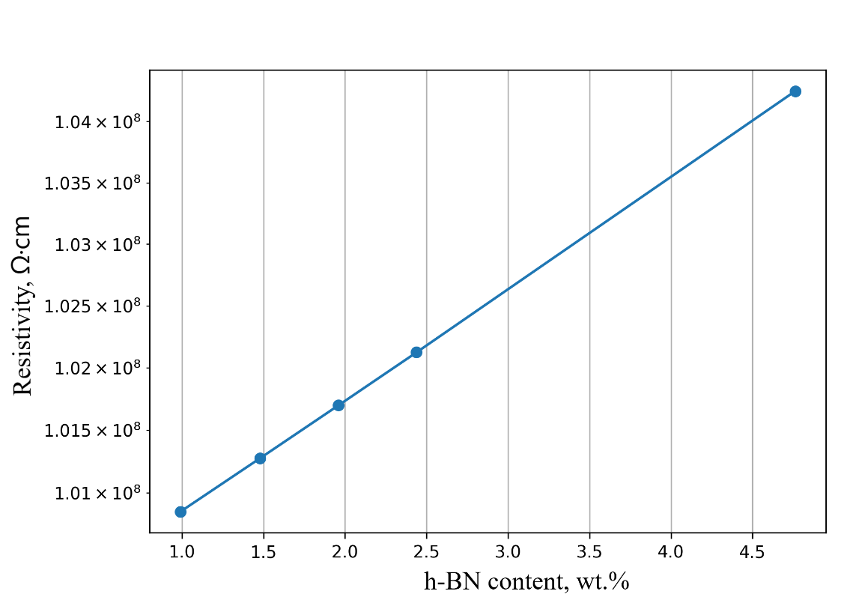
Figure 4. Electrical resistivity of h-BN/PVA composite films as a function of h-BN loading.
Across the investigated range of 0.99–4.76 wt.% h-BN, resistivity increased from 1.008 × 10⁸ to 1.042 × 10⁸ Ω·cm. The total change is approximately 3.4%, which is small compared with the magnitude of the resistivity itself.
The result should therefore not be described as a substantial enhancement of electrical resistivity. The more defensible interpretation is that adding h-BN at these low concentrations did not cause a sharp resistivity decrease and thus did not compromise the electrically insulating character of the PVA films.
This behavior is consistent with the electrically insulating nature of h-BN and with the absence of electrically conductive filler pathways. More generally, electrical behavior in filled polymers is affected by filler content, surface state, and interfaces (Bachtrong et al., 2017; Chen et al., 2024; Li et al., 2022). Because the present study did not include microscopy of the composite cross-sections, the data cannot be used to claim uniform nanoparticle dispersion. They are best regarded as preliminary evidence that electrical insulation is retained over the tested loading range.
  - Conclusions
Ultrafine h-BN nanoparticles were obtained from a H₃BO₃:(NH₂)₂CO = 1:2 precursor using two-stage heat treatment at 600 °C in N₂ and 1000 °C under simultaneous N₂/H₂ supply, followed by controlled water washing. The revised procedure reports the starting charge, heating rate, hold times, gas settings, cooling sequence, washing, centrifugation, and drying conditions.
TEM showed primary particles mainly 4–7 nm in size with an average of approximately 5–6 nm. HRTEM gave d₀₀₂ = 0.332 ± 0.004 nm, while XRD indexed the P6₃/mmc h-BN structure, gave a = b = 2.504 ± 0.003 Å and c = 6.661 ± 0.008 Å, and indicated coherent domains of 6–8 nm. No crystalline secondary phase was detected after washing within the sensitivity of XRD.
For PVA films containing 0.99–4.76 wt.% h-BN, resistivity changed only from 1.008 × 10⁸ to 1.042 × 10⁸ Ω·cm. This approximately 3.4% variation should be interpreted as preservation of electrical insulation rather than a substantial resistivity enhancement.
The nanoscale dimensions and crystalline h-BN structure make the powder a potential candidate for thermally conductive and electrically insulating polymer composites. However, thermal conductivity was not measured in this study, and the thermal-management claim remains prospective until direct thermal-transport testing and composite-dispersion characterization are completed.
References
Abdurakhmonov O., Aripova M., Abdurakhmonov S., Ruzibaev B., Ruzmatov E.I., Kurbanov M.K., Saidov D.S., Juraev T.I., Sharopov U.B., Komolov A.S., Pronin I.A., 2025a, A New Approach to Synthesis of Ultrathin Hexagonal Boron Nitride Nanoparticles by Two-Stage Thermal Treatment, Crystallography Reports, 70, 799-804, DOI: 10.1134/S106377452560111X.
Abdurakhmonov O., Aripova M., Erkinov F., Abdurakhmonov S., Sharopov U., Karimov M., Kurbanov M., Saidov D., Pędzich Z., Kozień D., Kurniawan T.A., Bondar E., 2025b, Green synthesis of high-purity hexagonal boron nitride nanoparticles, Vacuum, 239, 114386, DOI: 10.1016/j.vacuum.2025.114386.
Ali M., Abdala A., 2022, Large scale synthesis of hexagonal boron nitride nanosheets and their use in thermally conductive polyethylene nanocomposites, International Journal of Energy Research, 46, 10143-10156, DOI: 10.1002/er.7149.
An L., Yu Y., Cai Q., Mateti S., Li L.H., Chen Y.I., 2023, Hexagonal boron nitride nanosheets: Preparation, heat transport property and application as thermally conductive fillers, Progress in Materials Science, 138, 101154, DOI: 10.1016/j.pmatsci.2023.101154.
Bachtrong P., Nguyenthanh L., Phamthi H., 2017, Effect of Fly Ash from Thermal Power Plant on the Dielectric Properties of Polymer Composites Materials based on Matrix Epoxy DER 331, Chemical Engineering Transactions, 56, 1207-1212, DOI: 10.3303/CET1756202.
Besisa D.H.A., Hagras M.A.A., Ewais E.M.M., Ahmed Y.M.Z., Zaki Z.I., Ahmed A., 2016, Low Temperature Synthesis of Nano-crystalline h-Boron Nitride from Boric Acid/Urea Precursors, Journal of Ceramic Processing Research, 17, 1219-1225, DOI: 10.36410/jcpr.2016.17.12.1219.
Chen Q., Yang K., Feng Y., Liang L., Chi M., Zhang Z., Chen X., 2024, Recent advances in thermal-conductive insulating polymer composites with various fillers, Composites Part A: Applied Science and Manufacturing, 178, 107998, DOI: 10.1016/j.compositesa.2023.107998.
Donnay M., Tzavalas S., Logakis E., 2015, Boron Nitride Filled Epoxy with Improved Thermal Conductivity and Dielectric Breakdown Strength, Composites Science and Technology, 110, 152-158, DOI: 10.1016/j.compscitech.2015.02.006.
Fang H., Bai S.L., Wong C.P., 2016, “White graphene” - hexagonal boron nitride based polymeric composites and their application in thermal management, Composites Communications, 2, 19-24, DOI: 10.1016/j.coco.2016.10.002.
Gonzalez-Ortiz D., Salameh C., Bechelany M., Miele P., 2020, Nanostructured boron nitride-based materials: synthesis and applications, Materials Today Advances, 8, 100107, DOI: 10.1016/j.mtadv.2020.100107.
Gross P., Höppe H.A., 2019, Unravelling the Urea-Route to Boron Nitride: Synthesis and Characterization of the Crucial Reaction Intermediate Ammonium Bis(biureto)borate, Chemistry of Materials, 31, 8052-8061, DOI: 10.1021/acs.chemmater.9b02515.
Guerra V., Wan C., McNally T., 2019, Thermal conductivity of 2D nano-structured boron nitride (BN) and its composites with polymers, Progress in Materials Science, 100, 170-186, DOI: 10.1016/j.pmatsci.2018.10.002.
Jähnichen T., Hojak J., Bläker C., Pasel C., Mauer V., Zittel V., Denecke R., Bathen D., Enke D., 2022, Synthesis of Turbostratic Boron Nitride: Effect of Urea Decomposition, ACS Omega, 7, 33375-33384, DOI: 10.1021/acsomega.2c04003.
Li R., Yang X., Li J., Shen Y., Zhang L., Lu R., Wang C., Zheng X., Chen H., Zhang T., 2022, Review on polymer composites with high thermal conductivity and low dielectric properties for electronic packaging, Materials Today Physics, 22, 100594, DOI: 10.1016/j.mtphys.2021.100594.
Lian G., Zhang X., Zhu L., Tan M., Cui D., Wang Q., 2010, A Facile Solid State Reaction Route towards Nearly Monodisperse Hexagonal Boron Nitride Nanoparticles, Journal of Materials Chemistry, 20, 3736-3742, DOI: 10.1039/B920881J.
Lin Z., McNamara A.J., Liu Y., Moon K.-S., Wong C.-P., 2014, Exfoliated hexagonal boron nitride-based polymer nanocomposite with enhanced thermal conductivity for electronic encapsulation, Composites Science and Technology, 90, 123-128, DOI: 10.1016/j.compscitech.2013.10.018.
Mazumder M.R.H., Mathews L.D., Mateti S., Salim N.V., Parameswaranpillai J., Govindaraj P., Hameed N., 2022, Boron nitride based polymer nanocomposites for heat dissipation and thermal management applications, Applied Materials Today, 29, 101672, DOI: 10.1016/j.apmt.2022.101672.
Xie B.H., Huang X., Zhang G.J., 2013, High thermal conductive polyvinyl alcohol composites with hexagonal boron nitride microplatelets as fillers, Composites Science and Technology, 85, 98-103, DOI: 10.1016/j.compscitech.2013.06.010.
Yang D., Dai P., Jiang X., Alshehri S.M., Ahamad T., Bando Y., Wang X., 2024, Methods for Preparation of Hexagonal Boron Nitride Nanomaterials, Chemistry of Materials, 36, 10008-10053, DOI: 10.1021/acs.chemmater.4c00582.

