Development of a Processing Technology for Low-Grade Sylvinite Ores
Jasurbek Safarbaev*, Muhiddin Mavlyanov, Mohira Adilova, Aktam Erkaev
Tashkent Institute of Chemical Technology, Tashkent, Uzbekistan
Tashkent Institute of Chemical Technology, Yangiyer branch, Uzbekistan
safarboyejasurbek026@gmail.com
Low-grade sylvinite ores from the Tyubegatan deposit were investigated to establish relationships among potassium chloride (KCl) content, particle-size distribution, mechanical strength, mineralogical composition and beneficiation behaviour. Five samples containing 9.2–31.1 % KCl were separated into six size fractions from −10+7 to −0.5+0 mm. Fraction yield and mechanical strength were determined, while elemental and mineralogical compositions of selected fractions and water-insoluble residues (WIR) were examined by SEM-EDX and XRD. Mechanical strength generally increased with particle size and decreased with increasing KCl content; the maximum value was 4.30 MPa for the 9.2 % KCl sample in the −10+7 mm fraction. Halite and sylvite were the dominant phases, while silicates, carbonates and other insoluble minerals were enriched in low-KCl material. The reported desliming response differed strongly between coarse and fine fractions: coarse fractions showed a −7.2 to −18.4 % variation in desliming degree, whereas fractions below 1 mm showed +15.86 to +39.6 %. Based on KCl content, WIR and particle size, combined gravity, flotation, halurgical processing and desliming routes were proposed. The results provide a basis for selecting beneficiation routes for heterogeneous low-grade potash ores.
Keywords: low-grade sylvinite; potassium chloride; particle-size distribution; desliming; beneficiation; water-insoluble residue
  - Introduction
Sylvinite is a major raw material for potassium chloride production, but low-grade ores are difficult to process because KCl occurs together with halite and variable amounts of insoluble minerals. The mineralogical and technological properties of Tyubegatan sylvinite are affected by the distribution of KCl, halite and insoluble residues (Warren, 2016). Previous studies of Tyubegatan ores reported substantial variations in chemical and mineralogical composition and in the strength of ore fractions (Mavlyanov et al., 2023).
To determine the relationship between the chemical composition of potassium ores from the Tyubegatan deposit and the variation in their mechanical strength depending on the particle-size distribution, potassium raw material samples with different average potassium chloride (KCl) contents were investigated. The studied samples included: sylvinite-1 containing 9.2% KCl, sylvinite-2 containing 13.2% KCl, sylvinite-3 containing 19.0% KCl, sylvinite-4 containing 24.0% KCl, and sylvinite-5 containing 31.1% KCl.
The selection of an appropriate processing route requires simultaneous consideration of particle size, KCl concentration and impurity content. Size classification can expose differences between coarse and fine fractions, while desliming and flotation can be selected according to the distribution of KCl and insoluble material. Halurgical processing is relevant when selective dissolution and crystallisation can exploit differences in solubility. KCl-production studies also demonstrate the importance of impurity control in crystallisation (Ling et al., 2011; Vaccari et al., 2023). Flotation intensification and halurgical KCl-recovery studies at the Tyubegatan deposit further support the use of composition-dependent process selection (Adilova et al., 2019; Mavlyanov et al., 2022).
Flotation reagent selection is closely related to the mineralogical properties of potash ores (Aleksandrovich, 1993).
The technological literature also emphasises liberation and process conditions in flotation beneficiation of potash ores (Teterina, 2001).
Filtration behaviour of KCl concentrates and halite tailings has been investigated for Tyubegatan sylvinite processing (Mirzakulov et al., 2019).
The objective of this study was to determine the relationship between KCl content, particle-size distribution, mechanical strength and mineralogical composition of low-grade Tyubegatan sylvinite and to use these relationships to formulate practical beneficiation routes.
  - Materials and methods
Five potassium-ore samples containing 9.2, 13.2, 19.0, 24.0 and 31.1 % KCl were investigated. The samples were crushed and classified using sieves with openings of 0.5, 1, 3, 5, 7 and 10 mm. Six fractions were obtained: −10+7, −7+5, −5+3, −3+1, −1+0.5 and −0.5+0 mm. Fraction yield and mechanical strength were determined.
Elemental composition was examined by energy-dispersive X-ray spectroscopy (EDS), including analysis of WIR obtained from selected fractions. Scanning electron microscopy (SEM) was used to characterise particle morphology, and X-ray diffraction (XRD) was applied to identify the principal mineral phases. These data were used to compare gravity separation, flotation, halurgical processing and desliming routes.
  - Results and discussion
    - Particle-size distribution and mechanical strength
Sample 1, containing 9.2 % KCl, had the largest coarse fractions: −10+7 and −7+5 mm represented 23.80 and 31.35 % of the sample, respectively. In samples 2–5, the −3+1 and −1+0.5 mm fractions became more prominent, reaching 26.40 % in the −3+1 mm fraction of sample 5.
Mechanical strength generally increased with particle size and decreased as KCl concentration increased. The maximum measured strength was 4.30 MPa for sample 1 in the −10+7 mm fraction. For sample 5, containing 31.1 % KCl, strength decreased from 2.62 MPa in the −10+7 mm fraction to 2.08 MPa in the −3+1 mm fraction, followed by 2.25 and 2.40 MPa in the two finest fractions. This non-monotonic behaviour indicates that mineralogical composition and insoluble material also influence strength.
Table 1: Selected particle-size and strength characteristics
Sample | KCl, % | Fraction | Yield, % | Strength, MPa
1 | 9.2 | −10+7 | 23.80 | 4.30
2 | 13.2 | −10+7 | 15.10 | 3.90
3 | 19.0 | −10+7 | 11.30 | 3.22
4 | 24.0 | −10+7 | 12.26 | 2.89
5 | 31.1 | −10+7 | 10.40 | 2.62
    - Elemental and mineralogical composition
Average sodium contents for samples 1–5 were 21.8, 24.0, 27.1, 26.2 and 25.9 %, while the corresponding potassium contents were 4.87, 7.06, 9.65, 13.8 and 16.2 %. Average Mg, Al, Si, S and Ca contents did not exceed 3.85, 5.58, 5.45, 1.74 and 1.68 %, respectively. The WIR fractions were dominated by O, Mg, Si, Al, Ca, C and Fe.
XRD identified halite and sylvite as the principal phases. Halite represented 52.2–70.5 %, whereas sylvite represented 7.2–32.9 %. Minor phases included calcium sulfate, magnesium and calcium carbonates, magnesium chloride and Al- and Ca-bearing silicates. The higher proportion of calcium sulfate, silica and aluminosilicates in sample 1 is consistent with its higher WIR content and mechanical strength.
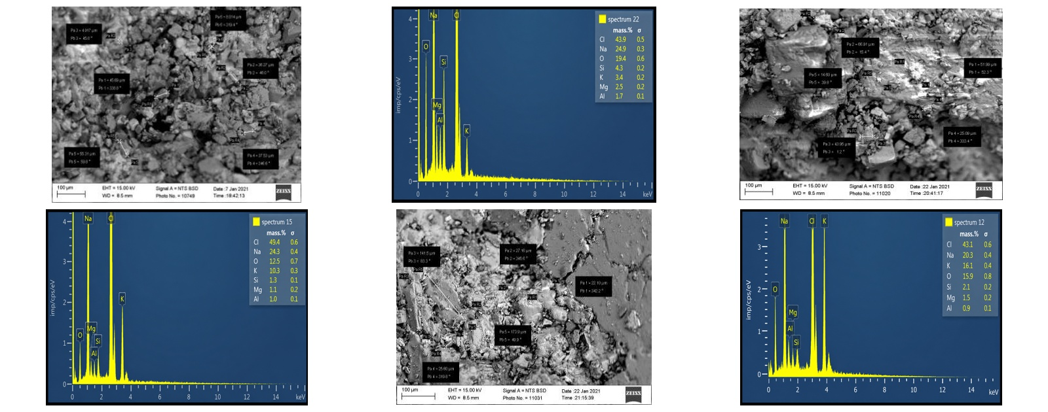
Figure 1: Representative SEM images and EDX spectra of samples 1, 3 and 5 (−3+1 mm fraction).
    - Mineralogical interpretation and impurity ratios
The decrease in KCl content was accompanied by an increase in the relative contribution of insoluble components. For sample 1, the silicate-to-KCl ratio increased from 1.95 to 3.12 as the fraction became finer. The same tendency was observed in samples 2–5. The water-insoluble-residue-to-KCl ratio reached a maximum reported value of 9.15, whereas its minimum was 0.139. Similar changes were observed for the silicate, carbonate and NaCl-to-KCl ratios.
These relationships are important for beneficiation because high insoluble content can increase ore strength and the risk of transferring gangue minerals into a concentrate. Coarser low-KCl material with high insoluble content is therefore more resistant to comminution, whereas higher-KCl material is more suitable for comminution and subsequent beneficiation.
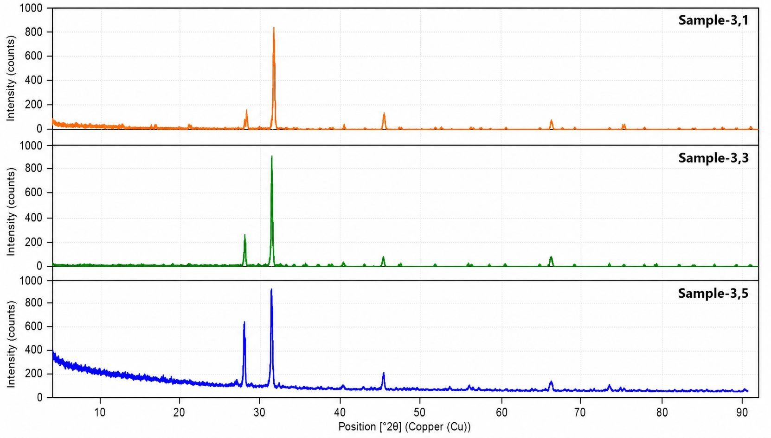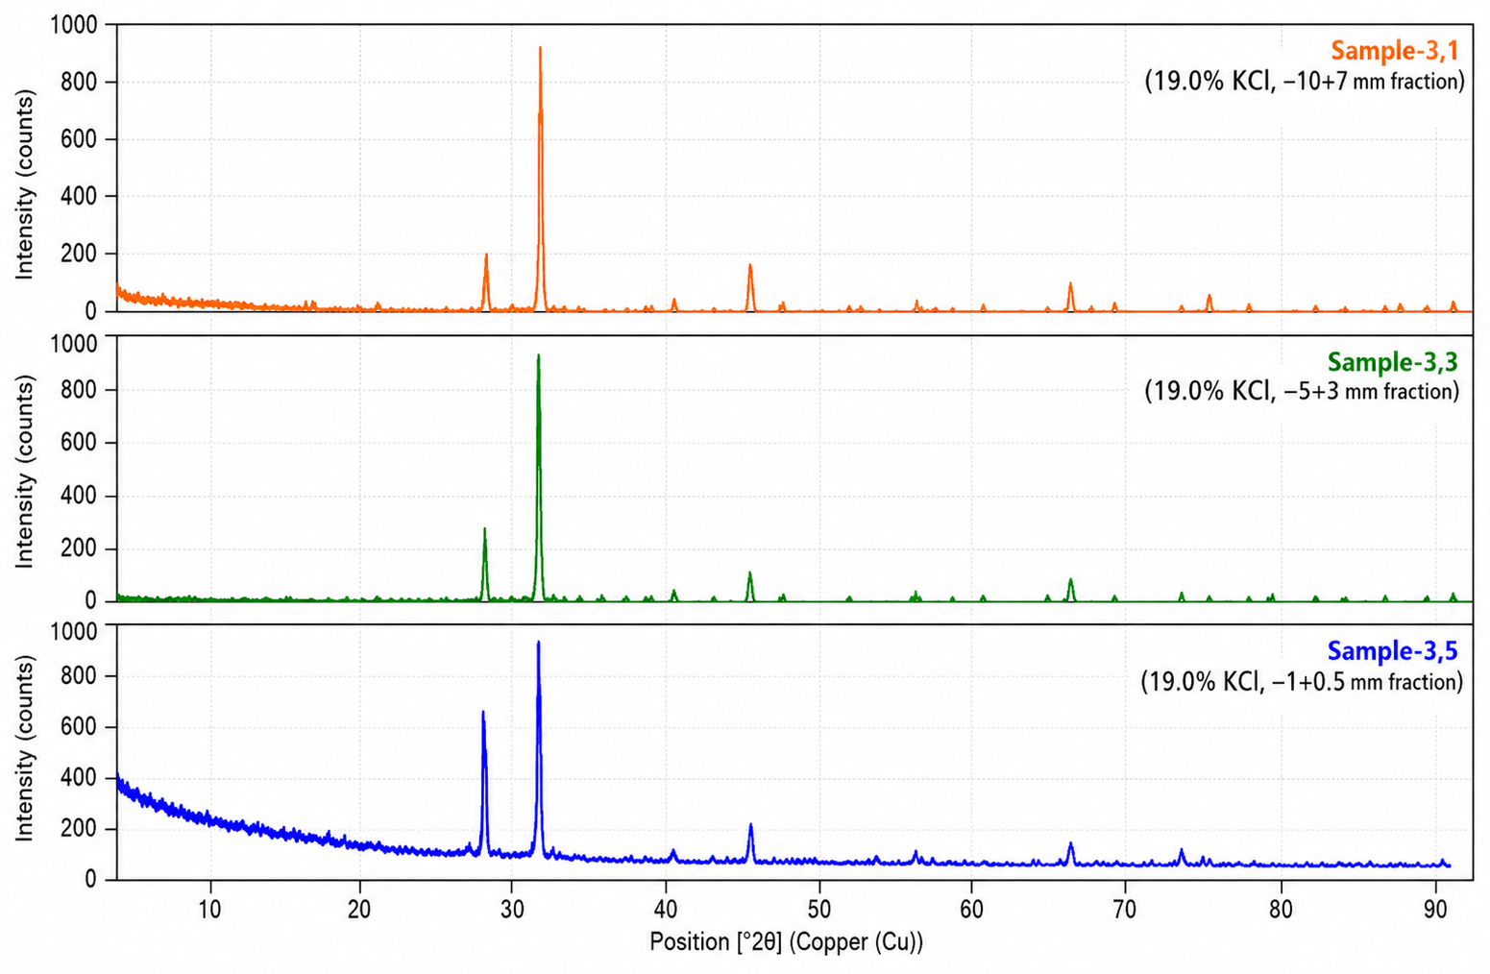
Figure 2: XRD patterns of selected sylvinite fractions and their water-insoluble residues.
    - Desliming and KCl enrichment
For fractions above 1 mm, the reported variation in desliming degree ranged from −7.2 to −18.4 %, while the corresponding reported KCl-content variation reached +12.6 to +34.75 %. For fractions below 1 mm, the reported desliming-degree variation ranged from +15.86 to +39.6 %, while the reported KCl-content variation was −14.2 to −35.25 %. The opposite signs indicate that fine fractions behave differently from coarse fractions and should be treated separately.
Table 2: Representative composition and reported desliming/KCl variations
Sample | KCl, % | NaCl, % | WIR + others, % | Coarse desliming, % | Coarse KCl, % | Fine KCl, %
1 | 9.2 | 57.1 | 33.7 | −7.2 | +12.6 | −14.2
2 | 13.2 | 63.0 | 23.8 | −8.97 | +31.45 | −32.4
3 | 19.0 | 69.7 | 11.1 | −12.9 | +33.33 | −33.82
4 | 24.0 | 69.8 | 6.1 | −18.4 | +34.75 | −35.25
5 | 31.1 | 66.2 | 3.2 | −13.33 | +33.9 | −33.6
The fine-fraction desliming-degree variations corresponding to samples 1–5 were +15.86, +16.8, +26.95, +39.6 and +38.33 %, respectively. These values reinforce the need to distinguish the fine-fraction response from the coarse-fraction response.
3.5 NaCl behaviour and selection of beneficiation routes
NaCl is the principal accompanying salt in the investigated material. The highest reported NaCl content was 70.5 % for the 19.0 % KCl sample in the −10+7 mm fraction. Because NaCl and KCl can be co-recovered during beneficiation, the NaCl trend must be considered when selecting a route and evaluating concentrate quality.
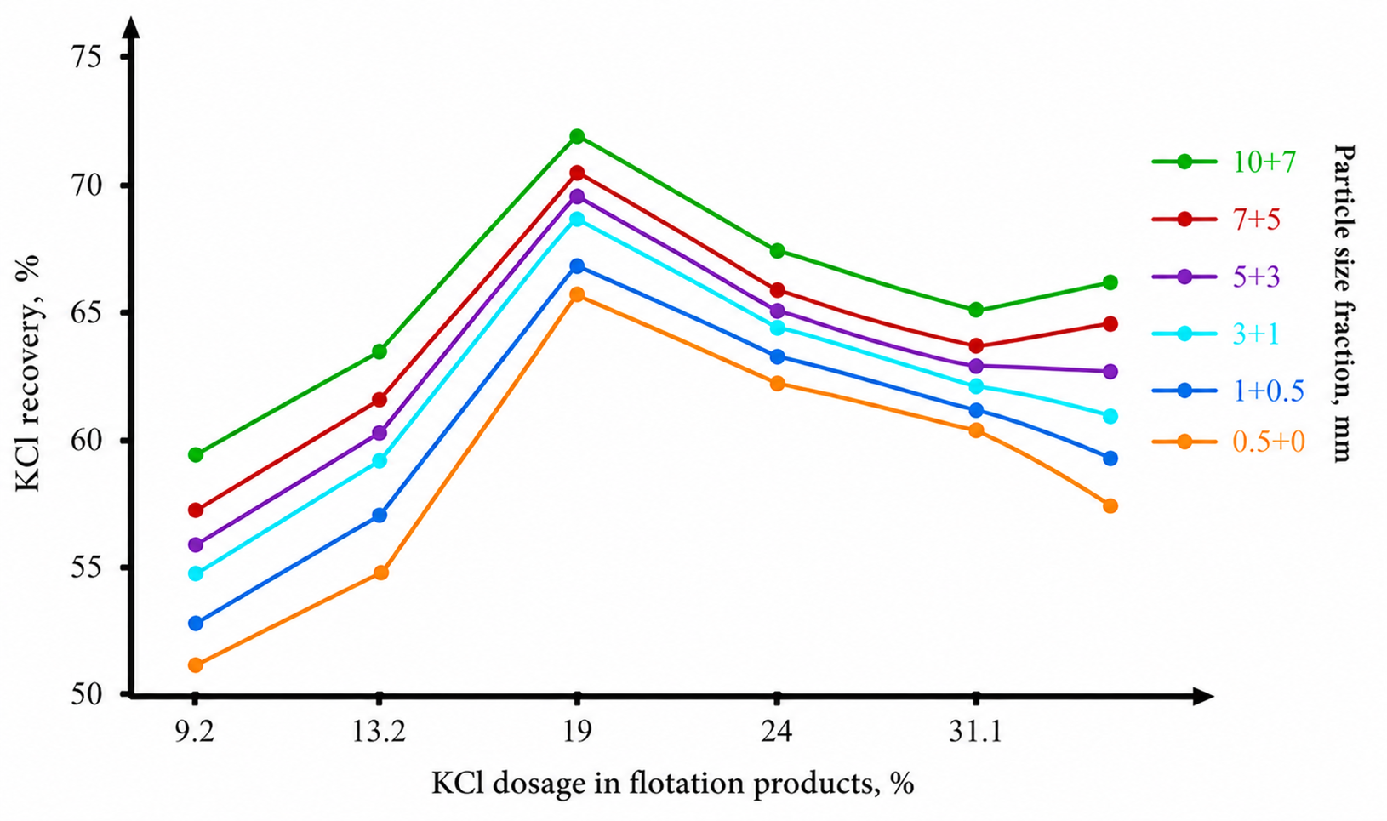
Figure 3: Variation of NaCl content in sylvinite samples as a function of particle size and KCl content in the feed material.
For ores containing less than 19.0 % KCl, direct halurgical processing can be considered for material below 5 mm; alternatively, gravity concentration can precede halurgical treatment of the fraction below 1 mm, while the coarser fraction can be subjected to desliming and flotation. For ores containing 19.0–24.0 % KCl, direct halurgical treatment remains a candidate route, while gravity concentration followed by selective treatment of fine and coarse fractions provides an alternative. For ores above 24.0 % KCl, direct flotation or halurgical processing can be considered.
These routes are selection schemes derived from the investigated composition–size relationships, not universal process guarantees. Final selection should be confirmed using recovery, concentrate grade, impurity rejection, reagent consumption, energy demand and economic assessment.
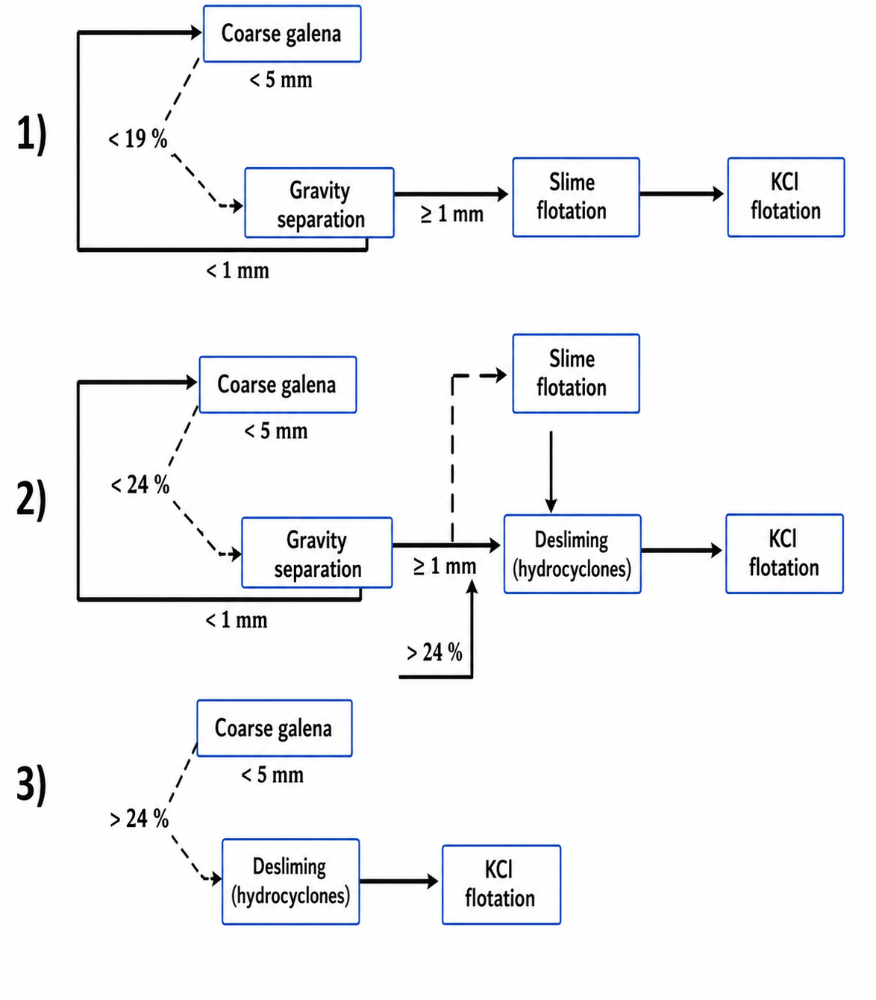
Figure 4: Proposed beneficiation routes based on KCl content, particle size and the reported desliming response.
The scheme links the measured KCl ranges and particle-size response to a practical sequence of gravity separation, desliming, flotation and halurgical treatment; it is intended as a basis for further verification rather than a universal operating rule.
  - Conclusions
The study established a relationship between KCl concentration, particle-size distribution, mechanical strength and mineralogical composition in low-grade Tyubegatan sylvinite. The 9.2 % KCl sample showed the highest measured strength, 4.30 MPa, in the −10+7 mm fraction, whereas the 31.1 % KCl sample showed 2.62 MPa in the same fraction.
Halite and sylvite were the dominant mineral phases, with reported ranges of 52.2–70.5 % and 7.2–32.9 %, respectively. The water-insoluble-residue-to-KCl ratio varied from 0.139 to 9.15. The reported desliming-degree variation was −7.2 to −18.4 % for fractions above 1 mm and +15.86 to +39.6 % for fractions below 1 mm, while KCl-content variations reached +34.75 % and −35.25 %, respectively.
Three combined beneficiation schemes involving gravity separation, flotation, halurgical processing and desliming were formulated for different KCl ranges. Halurgical processing is a promising option for selected low-grade feeds, but the present data do not justify the universal statement that all ores can be directly processed by this route. Confirmation requires recovery, product quality, impurity rejection and economic data for each feed type.
  - References
Adilova M.Sh., Bayrayeva D.A., Erkayev A.Yu., Bukhorov Sh.B., Mavlyanov M.B., 2019, Intensification of Flotation Concentration Technology of Sylvinites of the Tyubegatan Deposit (in Russian), Universum: Technical Sciences, 10, 30–34.
Aleksandrovich K.M., 1993, Basics of Reagent Application in Flotation of Potash Ores (in Russian), Science and Technology, Minsk, Belarus.
Erkaev A.U., Adilova M.Sh., Mavlyanov M.B., 2021, Study of the Low-Grade Sylvinite Enrichment Process at the Tubegatan Deposit, International Journal of Advanced Research in Science, Engineering and Technology, 8(9), 18237–18241.
Isaeva G.A., 2017, Mineralogical-Technological Properties of Sylvinites of the Tyubegatan Deposit (in Russian), Vestnik Permskogo universiteta. Geologiya, 16(3), 264–274, DOI: 10.17072/psu.geol.16.3.264.
Isaeva G.A., Moloshtanova N.E., 2014, Mineral Composition of the Insoluble Residue of Sylvinites from the Tyubegatan Deposit, Problems of Mineralogy, Petrography and Metallogeny, Scientific Readings in Memory of P.N. Chirvinsky, 17, 55–59.
Ling Z., Sha Z., Na T., 2011, Crystallization Process Investigation of Potassium Chloride from Carnallite Decomposition, Chemical Engineering Transactions, 24, 697–702, DOI: 10.3303/CET1124117.
Mavlyanov M.B., Adilova M.Sh., Erkaev A.U., 2022, Study of the Process of Obtaining Potassium Chloride by the Halurgical Method from Sylvinite of the Tyubegatan Deposit (in Russian), Universum: Technical Sciences, 11(104), 30–38.
Mavlyanov M.B., Bekchanov B.B., Adilova M.Sh., Erkaev A.U., 2023, Study of the Chemical and Mineralogical Composition of Potassium Ores of Tubegatan Mine, Science and Innovation, 2(10), 81–87, DOI: 10.5281/zenodo.10041222.
Mirzakulov Kh.Ch., Mamajonova L.A., Isakov A.F., Kalanov G.U., 2019, Intensification of Filtration Processes for Potassium Chloride Concentrate and Halite Tailings of Tyubegatan Sylvinite (in Russian), Universum: Technical Sciences, 7, 30–34.
Moloshtanova N.E., Isaeva G.A., 2013, Characteristics of Potash Ore from the Tyubegatan Deposit, Geology and Mineral Resources of the Western Urals, 13, 38–40.
Teterina N.N. (Ed.), 2001, Technology of Flotation Beneficiation of Potash Ores (in Russian), Solikamsk Printing House, Perm, Russia.
Vaccari M., Papa G., Brunazzi E., 2023, Rigorous Simulation Model of a KCl Food Production Plant to Address Impurity Precipitation, Chemical Engineering Transactions, 99, 565–570, DOI: 10.3303/CET2399095.
Warren J.K., 2016, Evaporites: A Geological Compendium, 2nd ed., Springer, Cham, Switzerland.

