|  |  |
| --- | --- |
| cetlogo ***CHEMICAL ENGINEERING TRANSACTIONS***  ***VOL. xxx, 2025*** | A publication of  aidiclogo_grande |
| The Italian Association  of Chemical Engineering  Online at www.cetjournal.it |
| Guest Editors: Bruno Fabiano, Valerio Cozzani  Copyright © 2025, AIDIC Servizi S.r.l. **ISBN** 979-12-81206-xx-y; **ISSN** 2283-9216 | |

Exploring Wearable Devices for Enhanced Ergonomic Solutions: A Pharmaceutical Case Study

Carlos Albarrán Morilloa,\*, Micaela Demichelaa, John F. Suárez-Pérezb, Nasli Yuceti Miranda Arandiac, Mónica Andrea Camargo Salinasc

aApplied Science and Technology Department, Politecnico di Torino, Turin, Italy

b Tecnologico de Monterrey, Escuela de Ingenieria y Ciencias, Ave. General Ramon Corona 2514, Zapopan, Jalisco, 45138, Mexico

cFundación Universidad de América, Bogotá, Colombia

carlos.albarran@polito.it

The new paradigm descending from Industry 4.0, known as Industry 5.0, emphasizes the significance of human-centric factors and ergonomics in industrial processes. Creating an ergonomic workplace involves considering not only physical aspects but also cognitive, environmental and organizational factors. This holistic approach is vital for enhancing human productivity, satisfaction, and safety. In the Industry 4.0 landscape, the integration of ergonomics with advanced technologies provides comprehensive data for accurately assessing occupational hazards. This paper proposes an ergonomic assessment method employing a set of non-invasive wearable devices to monitor workers' activities and physiological metrics, complemented by subjective self-assessment questionnaires, during their shifts. This approach is implemented in a real-world setting within the pharmaceutical sector, where manual work involves repetitive motion tasks, making workers susceptible to musculoskeletal disorders and high stress levels. The findings demonstrate that implementing ergonomic evaluations can help the organization identify risks, ultimately enhancing operator well-being, safety, and productivity.

* 1. Introduction

The well-being of workers is a fundamental pillar of Industry 5.0, which prioritizes human-centric, resilient, and sustainable industrial processes (Khamaisi et al., 2022). Ergonomics, as a multidisciplinary science, is critical in optimizing the interactions between human operators, machinery, and the environment (Scafà et al., 2019). The primary domains of ergonomics include physical, cognitive, environmental, and organizational aspects, each playing a significant role in promoting worker health, safety, and productivity (Scafà et al., 2019). Physical ergonomics focuses on the mechanical and physical interactions between workers and their work environment. It covers topics such as working postures, materials handling, repetitive movements, work-related musculoskeletal disorders (WMSDs), workplace layout, and occupational safety (Scafà et al., 2019). Conventional risk assessment tools like Rapid Upper Limb Assessment (RULA), Occupational Repetitive Actions (OCRA), and the Revised NIOSH Lifting Equation have been employed for evaluating these risks; however, they often rely on manual observation, which is time-consuming and prone to observer bias. Cognitive ergonomics examines cognitive processes to improve workers' interactions with systems, considering their skills and limitations. Key topics include attention, perception errors, mental workload, stress, information visualization, decision support, human-machine interaction (HMI), situational awareness, and training (Scafà et al., 2019). The increasing complexity of information systems has led to higher cognitive demands on operators, making cognitive ergonomics a critical area of focus. Current studies often use self-assessment tools like NASA-TLX, which are primarily utilized in specific fields, such as aerospace and healthcare. Environmental ergonomics addresses the physical factors that shape the workplace microclimate, including temperature, relative humidity, radiant temperature, airspeed, noise, lighting, and air quality. Regulatory standards have driven much of the research in this field, emphasizing compliance rather than directly enhancing worker comfort and well-being. Nonetheless, optimizing these factors is crucial for fostering a supportive and healthy work environment (Scafà et al., 2019). Organizational ergonomics aims to optimize socio-technical systems by improving organizational structures, policies, and processes. Topics such as resource management, work planning, and scheduling are essential for boosting operational efficiency and worker satisfaction (Scafà et al., 2019). With Industry 5.0, the concept of Operator 4.0 has emerged, emphasizing the human operator's role in smart, human-centric factories (Sun et al., 2020). Addressing ergonomic challenges now involves IoT, wearable sensors, AI, and digital twins, which provide automated, data-driven assessments, reducing the time, costs, and errors of manual evaluations.

In this study, we propose an ergonomic assessment method utilizing Industry 5.0 non-invasive wearable devices complemented by questionnaires to analyse different ergonomic aspects in a pharmaceutical industry setting, where manual work involving repetitive tasks predisposes workers to WMSDs and elevated stress levels. WMSDs are among the most prevalent occupational health issues across all sectors, affecting the back, neck, shoulder, and wrist (Punnett and Wegman, 2004) Key risk factors include poor workstation design, awkward postures, and job hazards such as vibrations and machine-paced work. These conditions not only affect worker health and lead to absenteeism but also impose significant socio-economic costs. Moreover, chronic work-related stress can result in both mental and physical health issues, including anxiety, depression, cardiovascular problems, and gastrointestinal disorders (Kivimäki and Kawachi, 2015). These consequences adversely affect worker productivity, job satisfaction, and overall well-being, underscoring the importance of thorough ergonomic assessments to identify and mitigate these risks.

The following sections outline the methodology employed in this research, including the experimental design and the setup used to assess ergonomic factors related to stress and WMSD risks. The results section will cover the identification of critical scenarios, followed by a discussion of the conclusions derived from this innovative ergonomic assessment.

* 1. Methodology
     1. Experimental setup

The research was conducted in the pharmaceutical sector, specifically within the packing and inspection areas of vials and drugs. The work environment involved handling boxes of varying sizes, including units of 1, 10, 100, and large trays across four distinct production lines. The repetitive and monotonous nature of these tasks exposed workers to significant biomechanical risks and high levels of stress.

To comprehensively analyze the ergonomic aspects, various devices and questionnaires were employed:

* Questionnaires: Self-assessment questionnaires were utilized to capture subjective perceptions of workload, stress, and discomfort. Tools like the NASA-TLX were employed to gauge cognitive workload, while standardized stress questionnaires evaluated the psychological impact of the work environment. Additionally, postural discomfort questionnaires allowed participants to rate discomfort in different body parts on a scale from 1 to 5, contributing to assessing the physical and cognitive ergonomics.
* Wearable devices: Non-invasive wearable devices, such as smartwatches, were used to collect real-time physiological data, including heart rate, skin temperature, and electrodermal activity. These devices provided objective metrics for assessing both physical exertion and stress levels, aiding in the evaluation of physical and cognitive ergonomics.
* Motion capture systems: Motion capture technology was employed to monitor operators' postures and movements during their tasks. This approach helped identify awkward postures and repetitive movements contributing to biomechanical risks.
* Environmental sensors: Environmental conditions, including temperature, humidity, noise, and lighting, were monitored with dedicated sensors to assess the workplace microclimate and its influence on worker comfort and performance, addressing environmental ergonomic aspects.

Additional wearable devices and questionnaires were also included in the setup to identify risks, such as visual and physical fatigue. However, the preliminary results presented in this article primarily focus on stress and biomechanical risks, which were identified as the highest priority for mitigation in this company.

* + 1. Subjects

A total of 43 full-time operators participated in the data collection, comprising 42 females and 1 male, as this activity is predominantly performed by women in this factory. The participants had an average age of 32.27 years (SD = 7.46), with company experience ranging from 2 months to 23 years. Individuals with current or past injuries, pain, discomfort, medical disorders, or those using medication were excluded during the initial screening process. Additionally, participants with specific vision impairments, such as wearing glasses with more than one power, undergoing eye surgeries (e.g., LASIK, RK, cataract, intraocular implants), or experiencing eye conditions like amblyopia (lazy eye), strabismus, or nystagmus, were also excluded. Participation was voluntary, with participants recruited directly from the production line without any financial compensation for their involvement. All data collected were pseudonymized to ensure that individual participants could not be identified. Prior to data collection, each participant received an informed consent form. Participants were given ample time to review and understand this information before deciding whether to participate, and they were allowed to withdraw from the study at any point without any repercussions. The research protocol adhered to the principles outlined in the Declaration of Helsinki and received approval from the Ethics Committee at Fundación Universidad de América (protocol number: 002-2024).

* + 1. Procedure

The research procedure is illustrated in the flowchart provided (Figure 1). After confirming inclusion criteria for participant eligibility, informed consent was obtained, and the setup of wearable sensors and Microsoft Kinect cameras for continuous monitoring was completed. Baseline surveys were conducted to collect subjective information on stress, workload, and well-being. Participants were then fitted with smartwatches (Albarrán Morillo and Demichela, 2023) to gather physiological data, including heart rate, electrodermal activity, and skin temperature, while environmental parameters such as humidity, temperature, illuminance, and noise were recorded at the start of each trial. Baseline measurements were collected over a two-minute period to establish reference values for subsequent activities. Participants then performed inspection and packing routine tasks for 20 minutes while monitored by the Kinect system to capture workers' movements and postures for semi-automated biomechanical risk assessment using the OCRA Checklist and wearing a smartwatch. This setup aimed to accurately capture both ergonomic and physiological data, identifying stress and biomechanical risks. The session concluded with the cessation of data recording, and the protocol was repeated at the start and end of each 8-hour work shift.

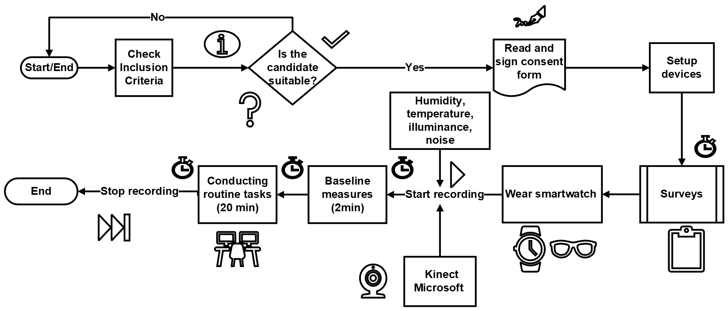

*Figure 1: Data collection procedure*

* 1. Results and discussion

In this section, we present the most significant findings, structured into two key areas: the identification of the highest biomechanical risks through a comprehensive physical ergonomic assessment and the detection of elevated stress levels via cognitive ergonomic analysis.

* + 1. Physical ergonomic assessment

The physical ergonomic assessment focused on the mechanical and physical interactions between workers and their work environment, particularly in relation to WMSDs stemming from the natural characteristics of the tasks performed in the factory. Conventional risk assessment tools, such as OCRA checklist, were employed alongside postural discomfort questionnaires. These questionnaires allowed participants to rate discomfort in different body parts on a scale from 1 to 5. The OCRA checklist method is a comprehensive biomechanical assessment tool used to evaluate worker exposure to repetitive strain, with a particular emphasis on upper limb movements (Colombini and Occhipinti, 2016). It assesses various critical factors, such as the duration, frequency, and intensity of repetitive actions, as well as postures, to determine the ergonomic risk associated with specific tasks. By combining data from checklists that evaluate postures of body parts like shoulders, elbows, wrists, and hands, as well as factors such as grip intensity, force applied, and frequency, the OCRA checklist method calculates a risk score for both the right and left sides of the body separately. This risk score helps determine whether the task falls within acceptable levels or poses a significant biomechanical risk to workers, thus guiding risk prevention strategies.

Table 1: OCRA: Risk assessment scale

|  |  |  |  |  |
| --- | --- | --- | --- | --- |
| **Score** | **Colour** | **Risk level** |  |  |
| ≤7.5 | Green | Acceptable |  |  |
| 7.6-11 | Yellow | Very light or uncertain |  |  |
| 11.1-14 | Light Red | Unacceptable. Low-level risk |  |  |
| 14.1-22.5 | Dark Red | Unacceptable. Medium-level risk |  |  |
| ≥22.5 | Purple | Unacceptable. High-level risk |  |  |

In our study, the use of Microsoft Kinect sensor jointly with computer vision (CV) algorithms (a branch of AI that enables machines to interpret and understand visual data) enabled real-time monitoring of workers' postures and movements (Camargo Salinas et al., 2024). The Kinect sensor captures precise video data that, when analyzed with CV, identifies repetitive actions, facilitating a semi-automated process and the evaluation of biomechanical risk assessments using the OCRA checklist method. By applying this technology, risk scores were obtained for different body parts, allowing for the assessment of overall exposure to strain. Based on these scores, the results revealed varying levels of risk, ranging from acceptable (green) to unacceptable levels (red and purple), as indicated by the risk scale provided in Table 1.

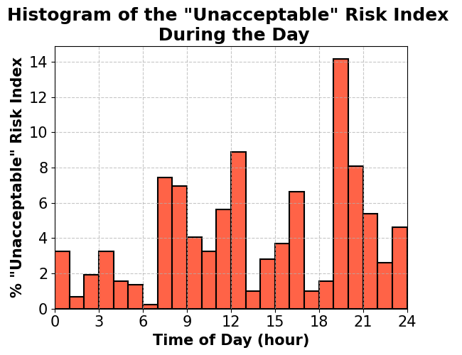  
*Figure 2: Distribution of the "Unacceptable" Risk Index during the day.*

Results show that the risk index distribution for the left side presents a mix of high-level risk (36.2%), medium-level risk (58.3%), and low-level risk (0.5%), with a small proportion being very light or uncertain (4.9%). The right side predominantly displays medium-level risks (90.8%), with a notable presence of high-level risk (9.2%).

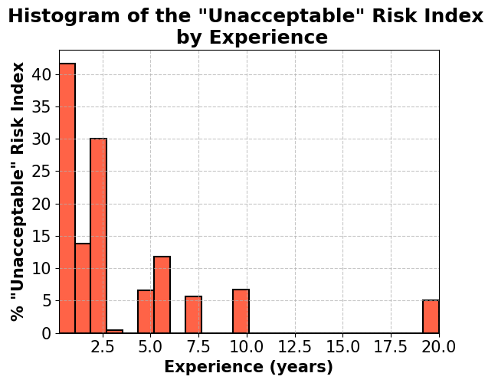  
*Figure 3: Distribution of the "Unacceptable" Risk Index by experience*

The main findings from the OCRA checklist risk assessment are represented in Figures 2 and 3. The "unacceptable" risk index for both right and left sides shows that the most significant biomechanical risks are prevalent near the end of Shifts 1 and 2, specifically between 12-1 PM and 7-8 PM, respectively. Workers with less than 2.5 years of experience showed higher levels of biomechanical risk, suggesting that these groups need immediate corrective interventions.

Furthermore, results from the discomfort questionnaires (Table 2) reveal that discomfort perceived in the upper limbs, mid-back, and lower back is prevalent among participants. The reported upper limb discomfort aligns with the findings from the OCRA checklist methodology discussed earlier. These insights highlight the need for targeted ergonomic interventions to alleviate physical strain and reduce risks, particularly for less experienced workers and during critical periods by the end of shifts 1 and 2.

Table 2: Discomfort levels across body parts rated from 1 to 5

|  |  |  |  |  |  |  |  |  |  |
| --- | --- | --- | --- | --- | --- | --- | --- | --- | --- |
|  | **Head and neck** | **Mid-back** | **Shoulders** | **Lower-back** | **Arms** | **Gluteus** | **Thigh** | **Knee** | **Feet** |
| **Mean** | 2.24 | 2.18 | 2.16 | 2.07 | 2.04 | 1.87 | 1.82 | 1.74 | 1.70 |
| **Std** | 1.10 | 1.09 | 1.02 | 1.12 | 1.04 | 1.09 | 1.06 | 0.98 | 0.95 |

* + 1. Cognitive ergonomic assessment

In this case, our primary focus was on analysing stress, identified as a significant risk within the company. Among the findings, we highlight electrodermal activity (EDA) as a key indicator of stress, as elevated EDA levels correspond to increased stress (Posada-Quintero and Chon, 2020). Figure 4 illustrates the trend of EDA across different experience levels, where Exp Level 1 (less than 8 months of experience), Exp Level 2 (8 months to 2 years of experience), Exp Level 3 (2 to 6 years of experience), and Exp Level 4 (more than 6 years of experience), demonstrating how experience influences stress responses. The data reveal that EDA decreases as experience increases, indicating reduced stress levels among more experienced workers. This suggests that experienced workers are more comfortable with their tasks and environment, which helps them manage stress effectively. In contrast, higher EDA levels in less experienced operators point to a greater risk of high stress. Therefore, targeted interventions, such as additional training and support, are recommended for less experienced workers to reduce stress and improve their familiarity with their roles.

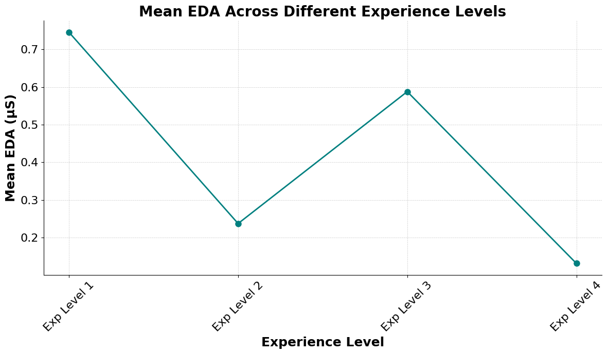  
*Figure 4: Variation in EDA mean across different experience levels*

* 1. Conclusions

The preliminary findings reveal the potential of a more comprehensive ergonomic evaluation by incorporating cognitive factors, alongside wearable technologies and AI techniques. These technologies facilitate real-time data collection and objective assessments, minimizing the biases and inaccuracies that can occur with subjective questionnaires or manual observations. These assessments accurately identify risks and highlight critical scenarios, including those associated with work shifts or differences in experience levels. Notably, workers with less experience were identified as a particularly vulnerable group due to their elevated biomechanical risks and higher stress levels.

Additionally, this project assessed environmental, organizational, and ergonomic factors, identifying risks like elevated visual and physical fatigue, as well as suboptimal lighting conditions. These findings represent a major advancement in the fields of ergonomics and process safety.

Acknowledgments

This work is funded by CISC project, which is part of the grant H2020-MSCA-ITN-2020 grant agreement no.955901.

References

Albarrán Morillo, C., Demichela, M., 2023, Exploring the Impact of Repetitive Exercise on Physical Fatigue: A Study of Industrial Task Simulation in a Controlled Fitness Setting, Chemical Engineering Transactions, 99, 163-168.

Camargo Salinas, M. A., Miranda Arandia, N. Y., Suárez Pérez, J. F., 2024, State of the Art in Evaluation of Automated Risk Detection Methods in Industrial Work Environments, Occupational Safety and Health Management, 6(2), 25-37.

Colombini, D., Occhipinti, E., 2016, Risk Analysis and Management of Repetitive Actions: A Guide for Applying the OCRA System (Occupational Repetitive Actions) (3rd ed.), CRC Press.

Khamaisi, R. K., Brunzini, A., Grandi, F., Peruzzini, M., Pellicciari, M., 2022, UX Assessment Strategy to Identify Potential Stressful Conditions for Workers, Robotics and Computer-Integrated Manufacturing, 78, 102403.

Kivimäki, M., Kawachi, I., 2015, Work Stress as a Risk Factor for Cardiovascular Disease, Current Cardiology Reports, 17(9), 630.

Posada-Quintero, H. F., Chon, K. H., 2020, Innovations in Electrodermal Activity Data Collection and Signal Processing: A Systematic Review, Sensors, 20(2), 479.

Punnett, L., Wegman, D. H., 2004, Work-Related Musculoskeletal Disorders: The Epidemiologic Evidence and the Debate, Journal of Electromyography and Kinesiology, 14(1), 13-23.

Scafà, M., Papetti, A., Brunzini, A., Germani, M., 2019, How to Improve Worker’s Well-Being and Company Performance: A Method to Identify Effective Corrective Actions, Procedia CIRP, 81, 162-167.

Sun, S., Zheng, X., Gong, B., García Paredes, J., Ordieres-Meré, J., 2020, Healthy Operator 4.0: A Human Cyber–Physical System Architecture for Smart Workplaces, Sensors, 20(7), 2011.