|  |  |
| --- | --- |
| cetlogo ***CHEMICAL ENGINEERING TRANSACTIONS***  ***VOL. xxx, 2025*** | A publication of  aidiclogo_grande |
| The Italian Association  of Chemical Engineering  Online at www.cetjournal.it |
| Guest Editors: Bruno Fabiano, Valerio Cozzani  Copyright © 2025, AIDIC Servizi S.r.l. **ISBN** 979-12-81206-xx-y; **ISSN** 2283-9216 | |

Safety Studies for Approval of Green Ammonia Bunkering Terminals – How Best to Apply CFD Modelling

Olav R. Hansena\*, Eirik S. Hansena and Steinar Kostølb

aHYEX Safety AS, Grindhaugvegen 57, 5259 Hjellestad, Norway

bAzane Fuel Solutions AS, Storgata 27, 3210 Sandefjord, Norway

olav@hyexsafe.com

Green ammonia (NH3) produced by hydrogen from water electrolysis using renewable electricity is considered to have an important role in the ambitions to decarbonize the maritime sector. With a boiling point of -33.4 °C, much closer to ambient temperatures than LH2, NH3 is less complicated to handle and to store. While the low flammability of NH3 represents a challenge as a fuel, this is an advantage regarding handling, and the volumetric energy density of NH3 is almost 50% higher than for LH2. A disadvantage with NH3 is its toxicity and odour, already at 5-50 ppm most people will recognize its characteristic odour, and at concentrations of 1% in air NH3 may be fatal within minutes. For a successful introduction of NH3 as a maritime fuel, safe handling is critical. To shorten the construction time and increase flexibility related to scale-up to meet possible future increasing demands, AZANE Fuel Solutions has developed a bunkering concept with NH3 stored in floating barges permanently moored at the bunkering site. With partial support from the Research Council of Norway the bunkering concept has been further developed, one of the key tasks was to ensure a best possible safety level of the terminal. To achieve this the NH3 is stored refrigerated near its boiling point with all penetrations on top and redundant cooling systems. The tank is further well protected against impact with B/5 separation from the hull of the barge. For the siting studies the NH3 toxicity is the primary concern, and as the terminal will store more NH3 than 200 tonnes, the Seveso-III upper tier major accident legislation applies. To develop required risk contours for the approval, all possible loss of containment scenarios must be evaluated considering expected leak rates and durations from statistical rupture and hole size frequency distributions. These scenarios must be evaluated considering the actual geometry and terrain and actual distribution of wind speed and direction. The toxic dose fatality probability contribution must then be assessed using probit functions considering exposure concentration and duration for each leak scenario, wind direction, wind speed and distance. In addition to defining risk contours temporary safety zones during bunkering must be established using a consequence-based approach estimating the maximum distance to 1% fatality risk in case of hose rupture with expected safety systems working as intended. The leak and dispersion dynamics of liquid NH3 strongly depend on storage temperature and pressure. For storage near the boiling point there is no overpressure to push liquid NH3 out of the tank through top penetrations, while with increasing temperature and saturation pressure a larger fraction of the tank content can be pushed out as liquid NH3 in the tank will boil when the pressure reduces. Leaks of refrigerated and semi-refrigerated NH3 (< 0 °C) will generally form buoyant plumes. Evaporation rates will be limited by heat transfer and cooling of substrate. When spilled onto water a major fraction of liquid NH3 will dissolve in water, while the spill dynamics will decide whether the evaporation of the remaining 30% or more is immediate or spread over minutes. For releases of warm liquid NH3 (> 10 °C) most NH3 is expected to flash-boil and form denser than air plumes with extensive hazard distances. The complexity of the NH3 siting studies is high. Even with leaks grouped into 15 scenarios of primary concern, the wind conditions simplified to 16 wind directions and 4 wind speed categories, consequences from 1000 scenarios would need to be assessed, considering transient concentration predictions at 100 different distances from leaks with duration of seconds, minutes or hours. Only a limited number of scenarios is feasible to model in detail using computational fluid dynamics (CFD). If simpler plume models are used for dispersion, important geometry details near the site and terrain will generally be ignored. The article will describe the assessment and illustrate how a limited use of CFD modelling can help improve the precision of the study.

* 1. Introduction

NH3 is being introduced as a zero-carbon fuel for ships. At IMO CCC10 meetings in September 2024 Interim guidelines for ships using NH3 as fuel were agreed, which is assumed to accelerate the construction of ships using NH3 as fuel. To prevent a “chicken-and-egg” situation in this situation partners with the Ammonia Fuel Bunkering Network (AFBN) have worked actively on many fronts since 2020. Early 2024 Azane, together with Yara Clean Ammonia supported by AFBN partners received a permit to build an NH3 bunkering terminal at Fjord Base in Florø, Norway. June 2024 Yara started operation at their 24 MW (10 tpd) green hydrogen production by PEM-electrolysis (55 tpd NH3) in Porsgrunn, Norway. In March 2022 Amon Maritime received the first approval in principle from class (DNV) and a preliminary design approval from the Norwegian Maritime Authorities (NMA) for their prototype platform supply vessel (PSV), the first preliminary flag approval for an ammonia powered ship in the world. In 2023 Viridis Bulk Carriers received approval in principle for an ammonia-fuelled bulk carrier from Bureau Veritas. HYEX Safety has supported the AFBN and members with safety studies for concept development and permitting processes.

* + 1. NH3 releases – gas and cold liquid form buoyant plumes and warm liquid denser than air plumes

Toxicity to people with exposure is the primary safety concern with NH3. While the smell from ammonia is reported at concentrations as low as 5 ppm, occupational safety thresholds (TWA – 8 h average) are typically in the range 15-25 ppm, while short term limits (STEL – 15 min average) are somewhat higher, in Norway 50 ppm. The IDLH-limit is at 300 ppm, derived based on expectation of no irreversible injuries for exposure less than 30 minutes. The fatality probability is a function of dose (exposure concentration and time), for fatality risk within minutes concentrations above 10,000 ppm (1%) is generally required. The lower flammability limit is around 150,000 ppm (15%). The reactivity is very low with downwards flame propagation not predicted possible at room temperature, see illustration from (Coward & Jones, 1952) in Figure 1a. Explosion risk is primarily a concern for large, indoor releases. With a few exceptions of limited practical importance, gas phase releases and evaporation of spills of refrigerated NH3 at ambient pressure form plumes which are buoyant in air. Unless trapped near ground (and diluted) by wind, the bulk of such releases will become buoyant and lift off the ground. For releases from semi-refrigerated NH3, plumes formed from evaporation of liquid spills are generally buoyant with low aerosol formation. The flash-boiling of superheated ambient temperature NH3 becomes more aggressive with increasing pressure exploding the liquid spray into aerosols. At storage temperatures of 10 ºC and higher, the majority of NH3 may form a fine fog, cool towards -70 ºC during evaporation, and remain airborne as a dense plume, see estimates using the Flash utility program of FLACS CFD tool in Figure 1b.

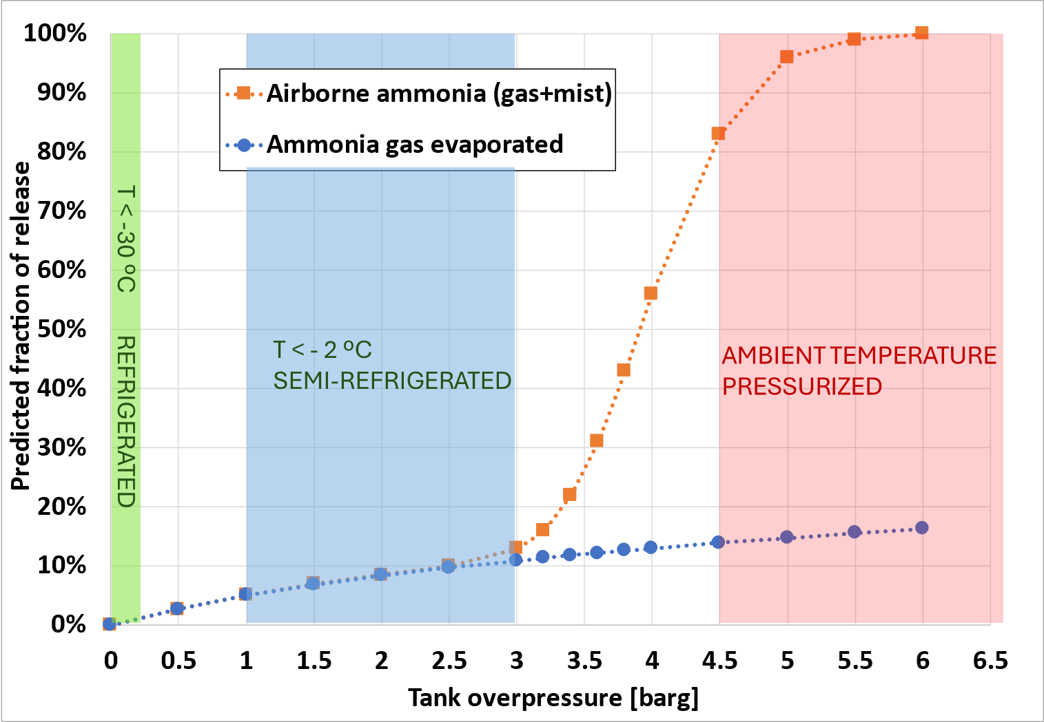

*Figure 1: Concentration/temperature limits (left) for upward, horizontal and downward flames (Coward & Jones, 1952). Estimated fraction of evaporation (blue dots) and airborne gas+aerosols (orange squares) for leaks from refrigerated (T < -33 ºC green), semi-refrigerated (T < -2 ºC blue) and pressurized (ambient T – red) storage.*

For spills falling into water the majority of NH3 is normally resolved in water while a fraction of the order 35% or higher may immediately evaporate as highly buoyant gas during a spill. Figure 2a shows a photo of the buoyant plume during an 8 kg/s spill into water from the Red Squirrel experiments (Dharmavaram et al., 2023). For a pressurized ambient temperature release the plume stays on the ground for a long time with less dilution, representing a much more severe hazard to people, see 0.1 kg/s flashing release from same tests in Figure 2b. With increasing tank temperature, the release rates increase, and scenario severity increases. While a rupture of a liquid tank connection for refrigerated storage may give literally no NH3 release at all, only some vapour diffusion, the leak rates for semi-refrigerated tanks are much higher but boil-off and evaporation limited (except into water), and for storage at ambient temperature the leak rate is higher, with the entire release rate potentially forming a hazardous NH3 cloud along the ground, see in Table 1.

*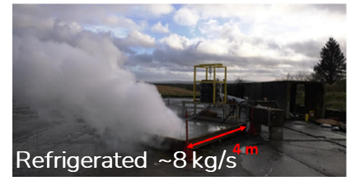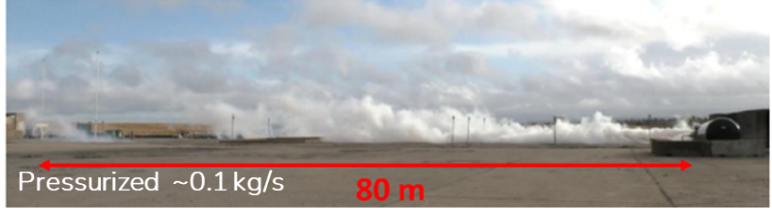*

*Figure 2: Release of cold NH3 into water (left) and warm pressurized NH3 (right) (Dharmavaram et al., 2023)*

Table 1: Comparison releases from 50 mm ammonia liquid tank connection ruptures (3 m tank level)

|  |  |  |  |  |  |
| --- | --- | --- | --- | --- | --- |
| Tank condition | Leak rate | Boil-off | Airborne | Spill (concrete / water) | Plume |
| 0.0 barg (-33 ºC) – top | 0.0 kg/s | 0.0 kg/s | 0.0 kg/s | Pool (~0.03 kg/m2s / ~35%) | Buoyant |
| 0.0 barg (-33 ºC) – bottom | 6.4 kg/s | 0.0 kg/s | 0.0 kg/s | Pool (~0.03 kg/m2s / ~35%) | Buoyant |
| 3.0 barg (-2 ºC) | 24 kg/s | 2.7 kg/s | 3.2 kg/s | Pool (~0.03 kg/m2s / ~35%) | Buoyant |
| 6.3 barg (15 ºC) | 34 kg/s | 5.8 kg/s | 34 kg/s | Cold fog (down to -70 ºC) | Denser than air |

* + 1. Azane NH3 bunkering barge – safety concepts

The Azane NH3 bunkering barge will be installed at various locations. Some of these can be expected to have workplaces or traffic close in immediate vicinity of the bunkering operation and residential areas a few hundred meters away. To ease the permitting process, a safe design is important, utilizing the best available technology (BAT) where feasible. In Figure 3a the CAD model of the Fjord Base bunkering barge and an NH3 fueled vessel concept from Viridis Bulk Carrier and an NH3 truck are shown.

*Figure 3: Illustration of Azane NH3 bunkering barge (left) and HYEX Safety CFD model (right) at Fjord Base terminal, with a Viridis cargo vessel ready to bunker. The truck represents a back-up solution for filling the barge.*

The following safety features can be mentioned:

* Up to 650 tonnes of NH3 is stored refrigerated at atmospheric pressure with all tank penetrations on top
* There are ESD valves where all liquid lines leave the tank, and a bund around
* Redundant refrigeration loops with emergency generator ensure continuous cooling
* The robust storage tank is place well inside the hull of the barge (B/5 from side shell)
* The barge is permanently moored to land
* Operators use full-body PPE for handling hoses and have dedicated control room during transfer operations
* Two PSVs release NH3 to mast if pressure build-up beyond design, with ARMS installed to clean releases
* Emergency release system (ERS) is initiated by a vessel separation distance (VSD) wire
* If VSD fails a breaking pin will initiate dry break-away from the vessel if hose is strained
* Filling warm NH3 from truck is not intended during normal operation but is a back-up solution for delivery
* Manual and automatic alarm/ESD is initiated at leak detection by operators or gas alarms, 10 s and 20 s ESD-times at automatic detection for bunkering and filling operations, 35 s and 45 s with manual detection
  1. Risk Assessment Approach

For a Norwegian major accident facility, risk-based consideration zones must be established around the site and operations, more specifically an inner, middle, and outer consideration zone with location specific individual fatality risk (LSIR) above 1E-5/year, 1E-6/year, and 1E-7/year, respectively. As a main rule, the inner zone should remain within the facility, the middle zone could include workplaces and transport corridors in which people are temporarily present, the outer zone allows for residences, while particularly vulnerable objects like schools, hospitals, kindergartens, hotels, malls and arenas should be outside the outer zone. In addition, according to requirements from Norwegian regulator DSB, bunkering safety zones, and monitoring and security areas must be enforced during bunkering of flammable gases in a similar way as described for LNG in the ISO 20519 standard. The maximum hazard distances from a full-bore hose rupture scenario corresponding to 1% toxic fatality probability, define the bunkering safety zone, while a security area outside must be monitored to prevent unauthorized approach into the safety zone. For flammable gases the safety zone is defined at the LFL dispersion distance. A depowering of possible electric ignition sources is expected during bunkering.

* + 1. Challenges establishing risk consideration zones

The toxic fatality risk from ammonia exposure depends on a toxic dose and for each combination of exposure concentration and exposure time a fatality probability is estimated using probit relations from RIVM (Ruiten, 2017), see example curves in Figure 4a. Based on failure frequencies from HSE (HSE, 2017) loss of containment scenarios from small to catastrophic leaks, from both liquid and gas phase, were assessed for various hole sizes for inactive mode with atmospheric tank pressure below 0.1 barg, and for different transfer operations with increased tank pressure as refrigeration loop is running. An overview of the 49 loss of containment scenarios assessed is given in Table 2, these were combined into a total of 20 scenarios for which the consequences were assessed. All leak scenarios except for leaks from the tank, can be stopped by ESD, whether manual (35-45 s) or automatic (10-20 s). The exposure probability at any location around the facility from each scenario beyond the immediate near field will depend on wind direction and strength, as well as local topology/geometry. Hourly wind statistics were available from Florø Airport (see Figure 4b) and Florø Port in 12 and 16 directions and 5 strengths, and these were combined to 16 directions and 4 wind speeds used for the assessment. To summarize, a total of 49 scenarios with spill/leak rate and duration, with wind from 16 directions and 5 wind speeds (~4000 scenarios) each with a frequency, are assessed, to estimate the toxic dose from probit functions at any distance downwind to establish risk contours around the facility. To resolve the contours 200 different distances were considered, requiring 800,000 estimates of fatality probability, or 1250 scenarios and 250,000 fatality estimates with the simplification to group into 20 scenarios and 4 wind speeds. Performing the entire assessment using CFD modelling would require several CPU-years and a challenging postprocessing as results will be transient in time and space and is not an option.

*Figure 4: Fatality probabilities as function of exposure concentration and time using RIVM probit function (Ruiten, 2017) shown left, and one of two nearby wind statistics near the site in Florø used for the study.*

Table 2: NH3 loss of containment scenarios assessment (ship loading/bunkering scenarios combined)

|  |  |  |  |  |  |
| --- | --- | --- | --- | --- | --- |
| Leak category | Scenarios | Modelled | Spill/leak | LoC scenario | Primary concern |
| Tank leaks | 17 | 5 | 0.7 - 433 kg/s | Gas & pool (no ESD) | Pool at sea (buoyant) |
| Process/piping leaks | 16 | 5 | 3.5 - 270 kg/s | Gas & pool (ESD) | Pool in bund (buoyant) |
| NH3 truck loading | 6 | 5 | 0.2 - 15 kg/s | Gas & flashing (ESD) | Flashing liquid (dense) |
| NH3 carrier loading | 3 |  |  |  |  |
| NH3 ship bunkering | 7 | 5 | 1.7 - 77 kg/s | Gas & pool (ESD) | Pool at sea (buoyant) |

* + 1. Use of basic dispersion models to develop risk contours

To be able to directly calculate probability of fatality at any distance from a dispersion model, the model formulation must be simple. Basic dispersion models were developed and calibrated based on various dispersion experiments for gas phase release, pool evaporation and flashing liquid releases of the form:

with C0 = 0.1 (100,000 ppm) and Vref = 3 m/s (1)

Reference distance Dref is defined as function of release type and spill/leak rate, for flashing releases it is $20\sqrt{m_{rate}} (m)$ with leak rate (mrate) in kg/s. The diffusion exponent E1 is 1.67 for gas release, 1.5 for pool evaporation and 1.33 for flashing releases showing dense gas behaviour. The simple HYEX dispersion models were compared to selected FLACS CFD simulations and EPA ALOHA model runs (Jones et al., 2013). The FLACS CFD model has been extensively validated against experiments with LNG (Hansen et al., 2010) and other gases (Hanna et al., 2004). Estimates were generally found to be reasonable for flashing releases and pool dispersion, while uncertainties were larger for gas releases as dispersion distances depend more on leak source direction. Pool spill estimates were concluded conservative in the near-field due to point-source representation, and hazard distances were overestimated for gas and pool scenarios in low wind, as the buoyancy effects with plume lift-off are not considered. The basic models were also conservative in the near field as geometry and terrain were ignored. In Figure 5a a comparison between the basic HYEX flashing liquid dispersion predictions and Desert Tortoise large scale experiments (Goldwire et al., 1985) is shown. In Figure 5b the resulting risk contours from the assessment are shown. Outside the transfer operations the risk from the refrigerated NH3 tank at the barge is concluded very low, with the primary contribution from the unlikely catastrophic rupture scenario of the barge and the tank contributing to the outer consideration zone (1E-7/year) risk contour up to 740 m along the prevailing wind direction. The inner and middle consideration zones, primarily defined by transfer operation leaks, are well within the facility with maximum distances 133 m and 40 m along the prevailing wind direction.

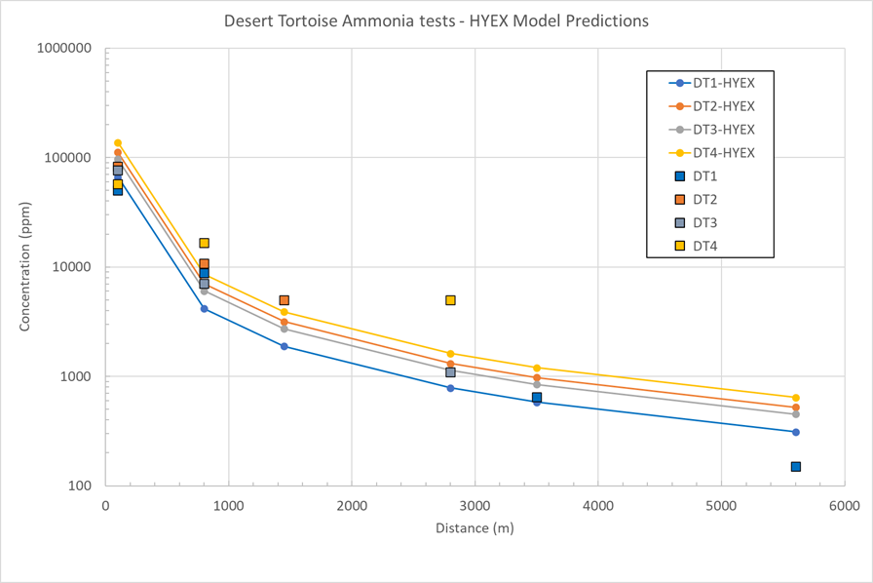

*Figure 5: HYEX dispersion models compared to Desert Tortoise NH3 flashing release tests (left). Proposed inner (1E-5/y), middle (1E-6/y) and outer (1E-7/y) consideration zones used as basis for the building permit (right).*

* + 1. Using CFD modelling for the scenarios of primary concern

While the development of risk contours is efficient using basic dispersion models, accuracy in the consequence modelling is sacrificed when not modelling the near field with 3D CFD. For a hose rupture scenario releasing the full bunkering rate of 47 kg/s NH3 into water until ESD (16 kg/s assumed vaporized) the basic dispersion model assuming a flat terrain predicts 1% probability for fatality at a distance of 45 m from the spill, which would be basis for the bunkering safety zone in Norway. As the spill from the hose between the bunkering barge and the ship falls into the sea between the two vessels, the highly buoyant concentrated NH3 plume would have to climb above the barge to a height of 8 m before blowing with the wind towards shore. When simulating this scenario with CFD the maximum 1% fatality distance is reduced to 35 m at an elevation 20 m above the quay, and the maximum distance to 1% fatality probability into the quay for any wind speed is only 13 m from the barge. In Figure 6 predicted plume development for a hose rupture bunkering scenario in 5 m/s wind towards shore is shown illustrating how the plume is lifted. CFD predictions can investigate how the local environment with barge, vessel, shoreline and terrain may influence the wind fields and contribute to vertical mixing or lifting of a toxic plume to the surroundings, and the main scenarios contributing to risk contours can be simulated with wind in different directions. The output from CFD models is more extensive and transient than for a basic dispersion model. To develop more accurate consideration zones the CFD results are imported from tables with maximum concentrations at various distances, replacing the predictions of the basic dispersion model.

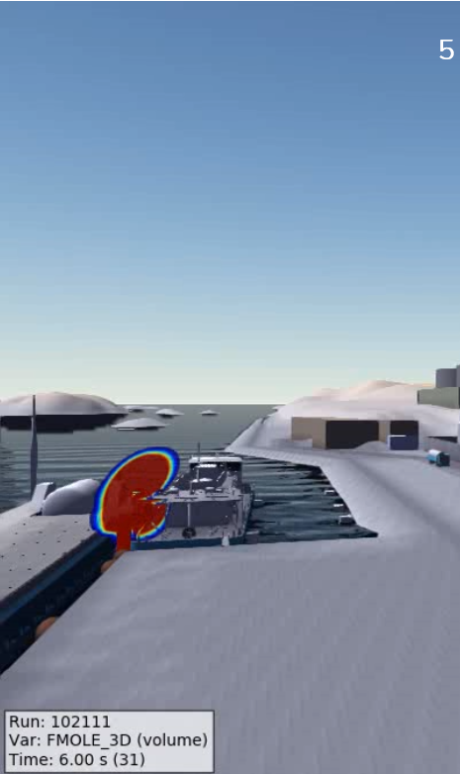 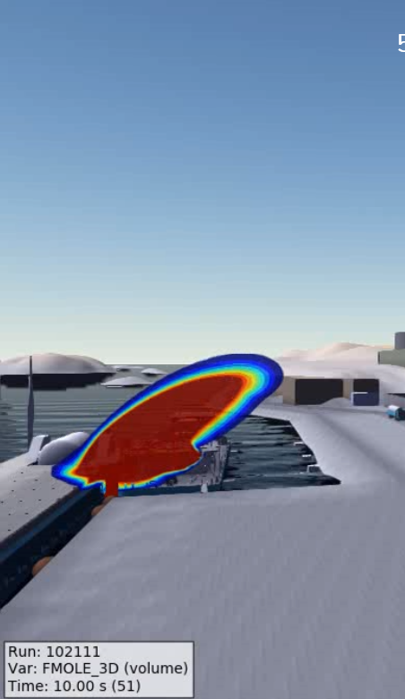 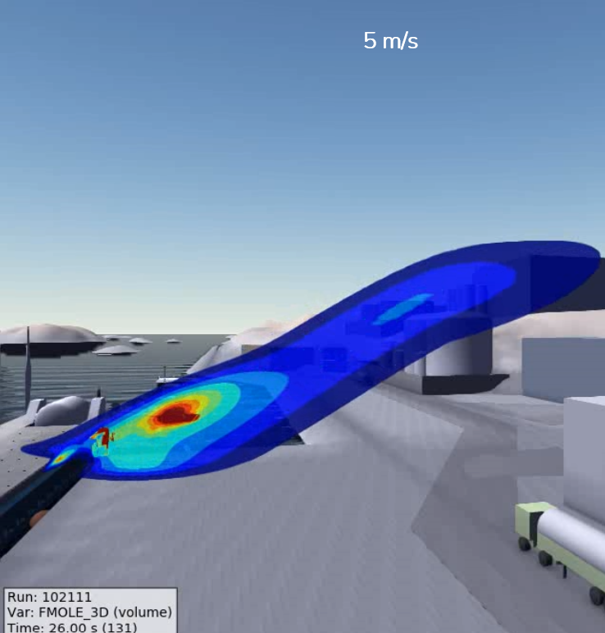

*Figure 6: For spill scenarios CFD simulations including ship/barge geometry and local wind fields may improve precision when predicting hazard distances.* Plume lifting for *hose rupture into the sea in 5 m/s wind shown.*

* 1. Conclusions

Ammonia is being introduced as a zero-carbon fuel for ships. One part of the effort for this to succeed is the development of bunkering infrastructure for ships. This article has described the risk assessment for an NH3 bunkering terminal for with a safety design had a high focus. There are several challenges related to performing probabilistic risk assessments for a site handling NH3, both related to understanding and modelling the gas dispersion and fatality risk. Numerous scenarios and wind conditions must be assessed to estimate risk contours, with fatality risk depending on exposure time and concentration, which must be estimated for any distance and direction. For the risk assessment for the first terminal, this was handled by using basic dispersion models supported by comparisons with more accurate dispersion models and experiments. A refined approach using 3D CFD modelling to increase precision of the consequence modelling for the scenarios of primary concern was also illustrated. Distance tables for concentration based on CFD simulations is used when developing the risk contours. A low risk was documented and the first permit to build was obtained early 2024.

Acknowledgments

The authors would like to thank the other partners of the Ammonia Fuel Bunkering Network (AFBN) and its support from the Norwegian Research Council (project number 328723), including partners and associated companies Yara Clean Ammonia, Fjord Base, Ocean Hyway Cluster, GOT, Amon Maritime, Econnect Energy, Viridis Bulk Carriers and SINTEF.

References

Coward, H. F., & Jones, G. W. (1952). Limits of flammability of gases and vapors. US Bureau of Mines. Washington, DC, USA: US Government Printing Office.

Dharmavaram, S., Carroll, M. J., Lutostansky, E. M., McCormack, D., Chester, A., & Allason, D. (2023). Red Squirrel Tests: Air Products' ammonia field experiments. Process Safety Progress, 2023, Vol. 42, 481-498.

Goldwire, H. C., McRae, T. G., Johnson, G. W., Hipple, D. L., Koopman, R. P., McClure, J. W., Morris, L. K. Cederwall, R. T. (1985). *Desert Tortoise series data report: 1983 pressurized ammonia spills.* Livermore, CA, USA: Lawrence Livermore National Laboratories.

Hanna, S. R., Hansen, O. R., & Dharmavaram, S. (2004). FLACS CFD air quality model performance evaluation with Kit Fox, MUST, Prairie Grass, and EMU observations. *Atm. Env., Vol. 38*, pp. 4675-4687.

Hansen, O. R., Gavelli, F., Ichard, M., & Davis, S. G. (2010). Validation of FLACS against experimental data sets from the model evaluation database for LNG vapor dispersion. Journal of Loss Prevention in the Process Industries, Vol. 23, No. 6, pp. 857-877.

HSE. (2017). *Failure Rate and Event Data for use within Risk Assessments (06/11/17), PCAG chp\_6K Version 14.* Health and Safety Executive. Bootle, EN, UK: HMSO.

Jones, R., Lehr, W., Simecek-Beatty, D., & Reynolds, R. M. (2013). *ALOHA (Areal Locations of Hazardous Atmospheres) 5.4.4 Technical Documentation.* U.S. Department of Commerce. Seattle, WA, USA: National Oceanic and Atmospheric Administration.

Ruijten, I. M. (2017). Probit function technical support document. Netherlands’ National Institute of Public Health and the Environment (RIVM). Bilthoven, Netherlands: RIVM.