|  |  |
| --- | --- |
| cetlogo ***CHEMICAL ENGINEERING TRANSACTIONS***  ***VOL. xxx, 2025*** | A publication of  aidiclogo_grande |
| The Italian Association  of Chemical Engineering  Online at www.cetjournal.it |
| Guest Editors: Bruno Fabiano, Valerio Cozzani  Copyright © 2025, AIDIC Servizi S.r.l. **ISBN** 979-12-81206-xx-y; **ISSN** 2283-9216 | |

Evaluating Ammonia's Flammability and Explosion Hazards in Air and Oxygen at Elevated Conditions: Data Generation and Review According to the New European Standard

Benoit Tribouilloya\*, Esteban Paillerya, Roberto Palominob, Alexis Vignesa

aIneris, Institut national de l'environnement industriel et des risques, Parc Technologique ALATA BP 2 60550 Verneuil-en-Halatte, France

bATLAS AGRO Company, Oberallmendstrasse 18, 6300 Zug, Switzerland.

[benoit.tribouilloy@ineris.fr](mailto:benoit.tribouilloy@ineris.fr)

**Abstract**

Many industrial processes operate under non-atmospheric conditions, involving high pressure and temperature in a variety of oxidising media. It is therefore essential to assess the potential for explosive atmospheres of (vapour)/oxidising gases under these conditions. Explosive limits depend on pressure, temperature and the oxidising environment, and are determined using a variety of methods. To standardise these practices, the European standardisation committee CEN TC 305 has introduced a new method in 2022. The candidate for this study was ammonia, a promising carbon-free energy carrier (green ammonia) with a low environmental impact but which also presents challenges related to its manufacture and use. However, data on the flammability and explosibility of ammonia is limited, particularly under non-atmospheric conditions. A review of these data is presented in this document. The experimental part of this work aims to produce new data on the explosive limits of ammonia and the explosion severity according to this new standard in oxygen at an initial pressure of 0.5 MPa and at 200 °C. The main conclusions are as follows (1) the lower explosive limit remains around 10%vol, as proposed by Doring (1931), (2) the upper explosive limit reaches 93%vol under the conditions tested, (3) the maximum explosion pressure measured is 42 MPa (explosion ratio of 8.3), and (4) the maximum rate of pressure rise is 920 MPa.s-1. The application of the EN 17624 standardised method makes it possible to generate new, up-to-date data to improve our understanding of the safety limits of ammonia.

* 1. Introduction

The current standardised methods (EN 1839, 2017) for determining explosion limits are designed for atmospheric pressures (and temperatures ranging from ambient up to 200 °C). European Directives 1999/92/EC (on health and safety at work) and Directive 2014/34/EU (on equipment and protective systems intended for use in potentially explosive atmospheres) refer only to atmospheric conditions and do not address the full range of ATEX challenges encountered in industry. This is why the CEN TC 305/WG1 working group (Test methods for determining the flammability characteristics of substances) of the European Committee for Standardisation released a new standard (EN 17624, 2022) as the result of collaboration between five European laboratories, for determining the explosive limits of gases and vapours under non atmospheric conditions. The aim of this work is to introduce the operating conditions related to this standard and by applying them to ammonia, whose flammability data are poor compared with hydrogen or methane, for example. Ammonia, a non-carbon molecule and a nitrogen derivative of hydrogen, is one of the most promising energy carriers. Like hydrogen, its use as a fuel does not emit carbon dioxide, carbon monoxide or soot particles, but has the advantage of being easier and more economical to produce and handle. This makes it an attractive candidate for solving storage, transport and distribution problems, from sustainable energy recovery to mobile and stationary energy use on a wide range of scales: from micro-propulsion to maritime transport, from refrigeration systems to power generation systems, not forgetting agriculture, where it is now widely used. The Haber-Bosch process is the traditional way of producing ammonia from nitrogen and hydrogen. However, this synthesis represents a major environmental and energy challenge, since it contributes to 1.3% of the world's carbon dioxide emissions and consumes 1% of the planet's energy. The alternatives to the energy-intensive process of producing ammonia at 20 MPa and 600 °C are to convert hydrogen into green ammonia in small, flexible, decentralised units that can cope with the intermittent nature of renewable energies. These units will be economically viable provided that the synthesis can be carried out under much more moderate temperature and pressure conditions (300 °C to 350 °C and 1 MPa to 5 MPa).

* 1. Review of flammability and explosibility data for ammonia in air and oxygen

Before reviewing the flammability and explosibility characteristics of ammonia, it is interesting, from a historical perspective, to note that the first studies on this subject date back to the early 19th century. The first flammability limits for an ammonia-oxygen mixture were published in 1809 (Henry, 1809). Despite these particularly early results the flammable and explosive nature of ammonia was long ignored. For example, it is reported that German experts at the beginning of the 20th century attributed explosions in refrigeration plants to the decomposition of ammonia (Buckley and Husa, 1962). The various parameters given in the literature which characterize the flammability or explosibility of an ammonia-air or ammonia-oxygen mixture, i.e. the explosive limits and the violence of explosion, are listed below. An early review of the data on the flammability of ammonia in air, oxygen and other oxidizing atmospheres was carried out by Coward and Jones (1952). Harris and MacDermott (1977) have determined the explosive limits of ammonia in oxygen-nitrogen mixtures as well as in air. Also, several data were generated during the SAFEKINEX project (SAFe and Efficient hydrocarbon oxidation processes by KINetics and Explosion eXpertise) that aimed to fundamentally improve the understanding, risk assessment, efficiency and safety of hydrocarbon oxidation processes, particularly under elevated conditions (high temperature and/or pressure). Table 1 and Table 2 shows these parameters determined in air for four temperatures and two initial pressures in a 6 dm3 cylinder at with a height to diameter ratio of 1,01 (Holtappels, 2006).

Table 1: Explosion limits and explosion severity of ammonia in air at Pi of 0,1 MPa and four temperatures

|  |  |  |  |  |
| --- | --- | --- | --- | --- |
| Temperature (°C) | 20 | 100 | 200 | 250 |
| LEL (%vol.) | 13,4 | 12,4 | 10,4 | 10,4 |
| UEL (%vol.) | 42,5 | 44,6 | 48,0 | 49,0 |
| (pex/pi)max | 5,9 | 5,4 | 4,8 | 4,2 |
| for %vol NH3 in air | 25 | 23 / 25 | 23 / 25 | 23 |
| (dp/dt)max (MPa.s-1) | 3,1 | 4,3 | 7,2 | 5,0 |
| for %vol NH3 in air | 25 | 23 | 25 | 23 |

Table 2: Explosion limits and explosion severity of ammonia in air at 0,5 MPa and four temperatures

|  |  |  |  |  |
| --- | --- | --- | --- | --- |
| Temperature (°C) | 20 | 100 | 200 | 250 |
| LEL (%vol.) | 15,0 | 14,0 | 12,4 | 12,4 |
| UEL (%vol.) | 36,0 | 37,6 | 39,6 | 39,6 |
| (pex/pi)max | 7,3 | 6,2 | 4,9 | 4,7 |
| for %mol NH3 in air | 23 | 23 | 23 | 23 |
| (dp/dt)max (MPa.s-1) | 20,1 | 28,5 | 23,1 | 32,1 |
| for %vol NH3 in air | 23 | 23 | 23 | 25 |

More recently, Fu et al. (2024) determined the explosive limits of ammonia in air in a 20-liter sphere for temperatures ranging from 25 °C to 150 °C for initial pressures ranging from 0,05 MPa and 0,5 MPa based on ASTM E918 (2019) and EN 1839 (2017). Table 3 shows the values measured at 25°C, 100°C and 150°C for initial pressure equal to 0,1 MPa and 0,5 MPa.

*Table 3: Explosion limits and explosion severity of ammonia in air at 0,1 MPa and 0,5 MPa at three temperatures*

|  |  |  |  |
| --- | --- | --- | --- |
| Temperature (°C) | 25 | 100 | 150 |
| LEL (%vol.) /1 bara | 16,3 | 15,1 | 14,1 |
| UEL (%vol.) / 1 bara | 30,2 | 31,3 | 33,6 |
| LEL (%vol.) / 5 bara | 15,5 | 14,7 | 14,0 |
| UEL (%vol.) / 5 bara | 30,8 | 32,9 | 34,9 |

There are also a few data on the flammability of ammonia in oxygen than in air. In 1931, Doring proposed lower explosive limits for ammonia in oxygen of 14%vol, 12.0%vol and 10%vol for initial pressures of 0,1 MPa, 0,5 MPa and 2 MPa respectively. Coward and Jones (1952) propose a flammability range of ammonia between 15%vol. and 79%vol. in ambient conditions. Recently, Cheng and Zhang (2023) analyzed the explosion characteristics of ammonia-oxygen mixtures by determining the maximum explosion pressure (pmax) and the rate of rise in maximum explosion pressure ((dp/dt)max) up to an initial pressure of 0.16 MPa and at ambient temperature. He was able to measure a pmax equal to 2 MPa and a (dp/dt)max equal to 150 MPa.s-1 at the stoichiometric concentration.

* 1. Experimental method
     1. Genesis

The development of this standard is based on the work carried out as part of the SAFEKINEX project, which began in the early 2000s and aimed to fundamentally improve the safety of hydrocarbon oxidation processes, particularly under severe conditions (high temperature and/or pressure). More than ten years later, research into the determination of flammability parameters under non-atmospheric conditions, i.e. initial pressures (pi) and temperatures higher than atmospheric conditions and oxidants other than air, was published (Meye et al., 2012, Tschirschwitz et al., 2015, Zakel et al., 2019). Among other things, they defined the ignition criteria, the volumes and shape of the test containers and the nature and position of the ignition source in them. Building on this research, an inter-laboratory test campaign involving five laboratories (three in Germany, one in the Czech Republic and Ineris) began in 2018, making it possible to calibrate the test protocol for determining explosive limits under atmospheric conditions, in preparation for the standard set to come into effect in 2022.

* + 1. Test set up

In accordance with standard EN 17624, which entered into force since 2022, the tests to determine the explosion limits and explosion severity were carried out in a stainless-steel cylinder with a capacity of 6 liters and a diameter/height ratio of 1. Its maximum operating pressure is 135 bar at 300°C (Figure 1). This equipment, which was used in the interlaboratory tests to develop the EN 17624 standard. (see Figure 1) was used to test ammonia in oxygen. The ammonia and oxygen used have a purity of over 99.99%. The cylinder (1) is placed in an oven (2) and fitted with a heating collar (3) to bring it up to test temperature more quickly.

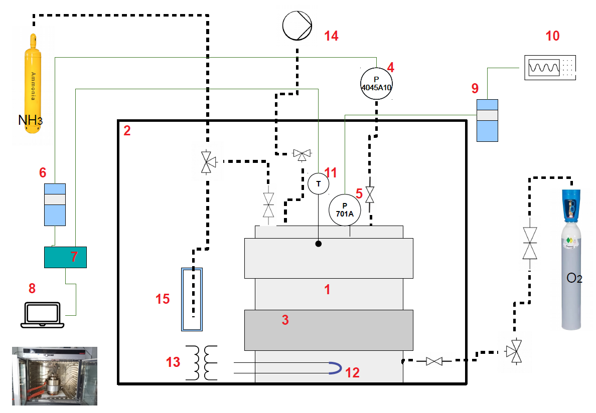

*Figure 1: Schematic diagram of the test set-up*

* + 1. Measuring Instruments

The cylinder is equipped with two pressure sensors: a KISTLER type 4045A10 piezoresistive sensor (4) for preparing the mixtures to be tested and a KISTLER type 701A piezoelectric sensor (5) for measuring the explosion overpressure. The signal from the first is collected by a piezoresistive amplifier (6) connected to a data acquisition unit (HBM, MX440B) (7) connected to a computer (8) equipped with software for monitoring absolute pressure over time. The signal from the second is recovered by a charge amplifier (9) and displayed on an oscilloscope (TEKTRONIX, DPO 4054) (10). A temperature sensor (11) of the K thermocouple type with a diameter of 1 mm is also connected to the data acquisition unit to monitor changes in temperature in the cylinder.

* + 1. Ignition System

The ignition source used in the tests was an exploding wire igniter as described in EN 1839 (2017) and EN 15967 (2022). The ignition source used is the fuse wire (12) method shown in Figure 2. The electrical energy needed to melt the wire and generate the arc is supplied by an isolation transformer (13). This consists of generating an electric arc by causing a metal wire to break by melting a metal wire caused by the passage of an electric current. The arc is formed between the two ends of the wire when it breaks. This wire is made of a Nickel-Chromel alloy, and its dimensions are 5 millimeters long and 0.15 millimeters in diameter. The energy supplied during the tests is estimated at 10 joules.

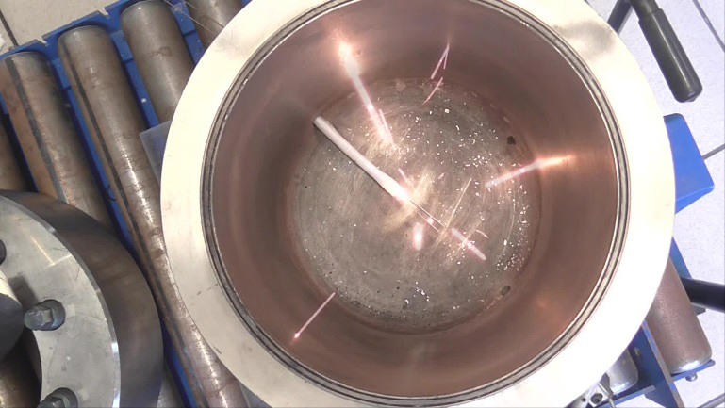

*Figure 2: The fuse wire at the bottom of the cylinder bursts*

* + 1. Test procedure

The test gas mixture was prepared directly in the test autoclave according to the partial pressure method, i.e. each component of the gas mixture was filled according to its partial pressure. After heating the cylinder to around 200 °C, an initial vacuum (14) is created. Oxygen is then introduced into the cylinder up to approximately 0,1 MPa. A second vacuum is then performed. This stage considerably reduces the amount of air, and therefore nitrogen, initially present in the cylinder. The quantity of ammonia required to reach the target level is then introduced. Oxygen is then introduced up to 0,5 MPa. After allowing the gas mixture to rest, the ignition source is activated. The explosion overpressure is then measured. The cylinder is depressurised towards a trap (15) to capture the ammonia. the passage of electrodes to which the filament is attached is then removed for replacement. The vacuum pump is switched on to purge air from the cylinder.

* + 1. Test Results

As a reminder, standard EN 17624 is used to determine the explosive limits of gases and vapours in atmospheric conditions. We nevertheless used the same device to determine the explosion severity of ammonia in oxygen. According to this standard, a test gas mixture is defined as explosive if the overpressure measured during an ignition test is equal to or greater than 2% of the initial pressure. Under these conditions, the lower explosive limit is estimated at 9 %vol (ignition at 10 %vol) and the upper explosive limit at 93 %vol (ignition at 92 %vol).The ratio of explosion pressure to initial pressure (pex/pi) and the rate of explosion pressure rise (dp/dt)ex were determined, five times, for ammonia concentrations in oxygen of between 10 %vol. and 90 %vol. All the results obtained are presented in Table 5 and Table 6 respectively.

*Table 5: Explosion pressure ratios of ammonia/oxygen mixtures at 200 °C and initial pressure pi of 0,5 MPa*

|  |  |  |  |  |  |  |  |  |  |
| --- | --- | --- | --- | --- | --- | --- | --- | --- | --- |
| Content of NH3 in O2 (%vol.) | 10 | 20 | 30 | 40 | 50 | 60 | 70 | 80 | 90 |
| pex/pi | 2,4 | 4,1 | 6,1 | 7,6 | 8,3 | 7,7 | 5,9 | 4,0 | 2,2 |
| 2,3 | 4,1 | 5,8 | 7,1 | 8,3 | 6,4 | 6,1 | 3,9 | 2,3 |
| 2,4 | 3,7 | 5,9 | 7,1 | 8,0 | 6,3 | 5,6 | 4,1 | 2,3 |
| 2,3 | 4,6 | 5,2 | 6,9 | 6,7 | 6,2 | 6,1 | 4,1 | 1,0 |
| 2,5 | 4,5 | 5,4 | 7,3 | 7,6 | 6,4 | 5,6 | 4,3 | 1,0 |
| Average | 2,4 | 4,2 | 5,7 | 7,2 | 7,8 | 6,6 | 5,9 | 4,1 | 1,8 |
| Standard deviation | 0,1 | 0,3 | 0,3 | 0,2 | 0,5 | 0,4 | 0,2 | 0,1 | 0,6 |
| Maximal value | 2,5 | 4,6 | 6,1 | 7,6 | 8,3 | 7,7 | 6,1 | 4,3 | 2,3 |

*Table 6: Rate of pressure rise of ammonia/oxygen mixtures at 200 °C and initial pressure pi of 0,5 MPa*

|  |  |  |  |  |  |  |  |  |  |
| --- | --- | --- | --- | --- | --- | --- | --- | --- | --- |
| Content of NH3 in O2 (%vol.) | 10 | 20 | 30 | 40 | 50 | 60 | 70 | 80 | 90 |
| (dp/dt)ex (MPa.s-1) | 10,0 | 45 | 220 | 740 | 920 | 760 | 540 | 220 | 8 |
| 12,0 | 36 | 320 | 680 | 780 | 480 | 540 | 240 | 11 |
| 12,0 | 46 | 240 | 740 | 880 | 480 | 500 | 270 | 6 |
| 8,0 | 34 | 360 | 680 | 440 | 520 | 440 | 222 | 0 |
| 11,0 | 32 | 320 | 580 | 560 | 480 | 560 | 270 | 0 |
| Average | 11 | 39 | 292 | 684 | 716 | 544 | 516 | 244 | 5 |
| Standard deviation | 1 | 5 | 50 | 45 | 173 | 86 | 37 | 20 | 4 |
| Maximal value | 12 | 46 | 360 | 740 | 920 | 760 | 560 | 270 | 11 |

All these data are shown graphically in Figure 3.

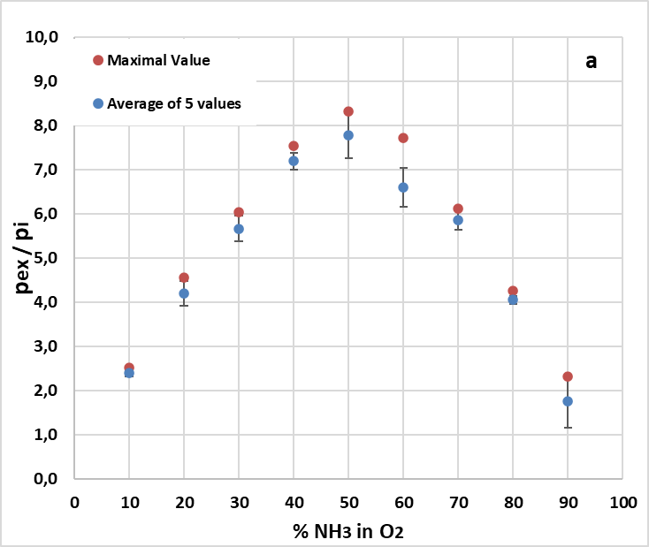 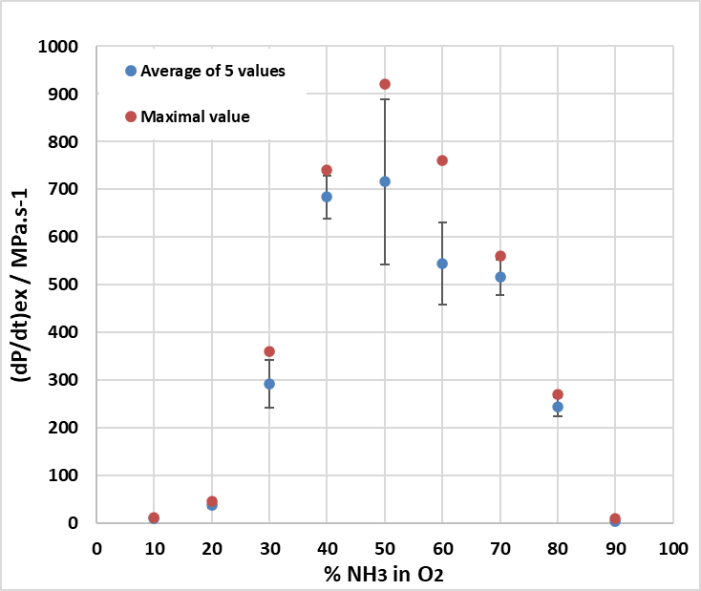

**b**

*Figure 3: Average and maximum explosion ratio measured a), rate of rise in explosion pressure b) as a function of ammonia content in oxygen at 200°C and 0.5 MPa*

As these are safety parameters, the maximum values should be used. Table 7 shows the data measured using the test method described in standard EN 17624.

*Table 7: Safety parameters measured by application of EN 17624 standard*

|  |  |  |
| --- | --- | --- |
| Parameters | Value | Estimated uncertainty of measured parameters |
| LEL (%vol.) | Between 9 and 10 | ± 0,5 % absolute |
| UEL (%vol.) | Between 92 and 93 | ± 0,5 % absolute |
| (pex/pi)max | 8,3 | Standard deviation: 0,5 |
| for %vol NH3 in air | 50 | ± 0,5 % absolute |
| (dp/dt)max (MPa.s-1) | 920 | Standard deviation: 173 |
| for %vol NH3 in air | 50 | 0,5 % absolute |

* 1. Conclusions

Like hydrogen, ammonia is of interest as an energy carrier with a low environmental impact. However, unlike hydrogen, data on its flammability and explosibility remain limited, especially under non-atmospheric conditions. The application of the standardized EN 17624 method will facilitate the generation of new data and provide a harmonized update to existing information. The lower explosive limit of ammonia in oxygen determined in this work remains the same as that proposed originally by Doring (1931), i.e. around 10%vol for an initial pressure of 0.5 MPa. The upper limit reaches 93%vol. at 200 °C and 0.5 MPa. The maximum explosion pressure measured is 42 MPa (explosion ratio equal to 8.3) and a maximum pressure rise rate of 920 MPa.s-1.

* 1. Acknowledgement

This work was supported by Atlas Agro Company and the French Ministry of Higher Education and Research.

* 1. References

ASTM E918, 2019, Standard Practice for Determining Limits of Flammability of Chemicals at Elevated Temperature and Pressure

Buckley W. L., Husa H. W., 1962, Combustion properties of ammonia. Chemical Engineering, Progress 58, 2, 81–84

Cheng J., Zhang B., 2023, Analysis of explosion and laminar combustion characteristics of premixed ammonia-air/oxygen mixtures, Fuel 351 (2023) 128860, https://doi.org/10.1016/j.fuel.2023.128860

Coward H.F., Jones G. W., 1952, Limits of Flammability of Gases and Vapors (Bulletin 503, Bureau of Mines)

EN 1839, 2017, Determination of the explosion limits and the limiting oxygen concentration (LOC) for flammable gases and vapours

EN 15967,2022, Determination of maximum explosion pressure and the maximum rate of pressure rise of gases and vapours

EN 17624, 2022, Determination of explosion limits of gases and vapours at elevated pressures, elevated temperatures or with oxidizers other than air

Franck H. H. , Döring G., 1931, Investigation of the explosion limits of ammonia-air and ammonia-oxygen mixtures at higher initial pressures, Angewandte Chemie , Volume 44 (15)

Fu W., Zhou Y., Wu J., Zhang K., Meng X., 2024, Flammability Limits of Ammonia in Air from 298 to 423 K at Elevated Pressures, Energy & Fuels 2024 38 (11), 10168-10182, DOI: 10.1021/acs.energyfuels.4c01111

Harris G.F.P., MacDermott P.E., 1977, Flammability and explosibility of ammonia, ICHEME. SYMPOSIUM SERIES No. 49

Henry W., 1809, Experiments on Ammonia, and an Account of a New Method of Analysing it, by Combustion with Oxygen and Other Gases,

Holtappels K., 2006, SAFEKINEX project (contractual deliverable n°8), Report on the experimentally determined explosion limits, explosion pressures and rates of explosion pressure rise - Part 1: methane, hydrogen and propylene, https://www.morechemistry.com/SAFEKINEX/deliverables/44.Del.%20No.%208.pdf

Holtappels K, 2006, SAFEKINEX project (contractual deliverable n°9), Report on the experimentally determined explosion limits, explosion pressures and rates of explosion pressure rise - Part 2: Ethane, n-butane, ethylene, ammonia and carbon monoxide, contractual livrable n°9, https://www.morechemistry.com/SAFEKINEX/deliverables/46.Del.%20No.%209.pdf

Meye T., Brandes E., Höding M., Busse S., Safety characteristics at non-atmospheric conditions. - oxidizers other than air, Oral presentation by Th. Meye at IXth ISPHMIE, Cracow, 2012, https://www.ptb.de/cms/fileadmin/internet/fachabteilungen/abteilung\_3/3.7\_grundlagen\_des\_explosionsschutzes/3.71/Bericht\_oxidizers.pdf

SAKEKINEX Project (2003 – 2006), https://www.morechemistry.com/SAFEKINEX/index.html

Tschirschwitz R., Schröder V., Brandes E., Krause U., Determination of explosion limits - Criterion for ignition under non atmospheric conditions, Journal of Loss Prevention in the Process Industries 36 (2015) 562-568, https://doi.org/10.1016/j.jlp.2015.01.012

Zakel S., Brandes E., Schröder V., Reliable safety characteristics of flammable gases and liquids – The database CHEMSAFE, Journal of Loss Prevention in the Process Industries 62 (2019) 103914, https://doi.org/10.1016/j.jlp.2019.07.002