|  |  |
| --- | --- |
| cetlogo ***CHEMICAL ENGINEERING TRANSACTIONS***  ***VOL. xxx, 2025*** | A publication of  aidiclogo_grande |
| The Italian Association  of Chemical Engineering  Online at www.cetjournal.it |
| Guest Editors: Bruno Fabiano, Valerio Cozzani  Copyright © 2025, AIDIC Servizi S.r.l. **ISBN** 979-12-81206-xx-y; **ISSN** 2283-9216 | |

Focus on the environmental impact of Lithium-Ion batteries

Benjamin Truchota,\*, Caroline Gayaa, Arnaud Bordesa, Loraine Torres-Castrob, Joshua Lambb

a Ineris, Parc ALATA 60550 Verneuil en Halatte, France

b Sandia National Laboratories …

benjamin.truchot@ineris.fr

The use of lithium-ion batteries (LIBs) is rapidly increasing as part of the energy transition aimed at limiting human influence on global warming. This technology can replace numerous carbon-based systems to limit carbon dioxide production. However, these batteries are subject to the intrinsic risk of thermal runaway, which can lead to fires. The specificities of those fires are mainly due to, the materials used in the batteries, the specific propagation mode of thermal runaway and the extinguishing difficulties. In light of public concerns regarding the environmental impact of fires, estimating the potential consequences of these incidents and considering both short-term toxicity and long-term effects has become a significant issue. To address this objective, this paper proposes a review of existing data on lithium-ion battery fire emissions. This review shows that, while some data are available regarding acute toxicity through emitted gases, very few exist on other gases or particles that could lead to long-term consequences. Furthermore, the different types of emissions, water pollution, or direct impacts on the ground are rarely studied, even though they could be the primary sources of pollution from large lithium-ion battery fires.

* 1. Introduction

LIBs have become a leading energy storage solution that is now prevalent in many applications, from small devices to massive energy storage systems and electric vehicles. Given recent large fires involving LIBs and the potential environmental impact of such incidents, it is essential to define the emissions from LIB fires to unlock future development of these technologies.

Although LIB can appear as a generic term, it encompasses several technologies corresponding to different chemistries, generally named based on their cathode composition. The most common chemistries currently in use are Lithium Iron Phosphate (LFP), Nickel Manganese Cobalt (NMC), and Nickel Cobalt Aluminum (NCA). Aside from the differences in cathodes, the global compositions of these batteries are similar, comprising four main components: a graphite-based anode, the aforementioned cathode, an electrolyte (organic carbonate-based solvents with a lithium salt), and a separator (usually made of polypropylene/polyethylene). These components, detailed by Accardo et al. (2021), are of primary importance while dealing with emissions, as the fuel composition directly governs the substances found in smoke. Since carbon-based solvents are used, carbon-based pollutants are expected and likely encountered in smoke in the event of a thermal runaway (including carbon oxides but also more complex molecules). Another essential component is lithium salt, which might contain fluorine and phosphorus (commonly LiPF6), leading to smoke toxicity hazards. Other battery technologies exist, such as Lithium Metal batteries, but because they differ from LIBs and there is a significant lack of data on them, they are not considered in the present study.

Several recent incidents have illustrated the potential hazard for LIB systems, but little data has been collected on how they impacted the environment. A more exhaustive list is available online at <https://storagewiki.epri.com/index.php/BESS_Failure_Event_Database>, but some recent significant events highlight the wide variety of potential fires that could affect large industrial facilities and domestic applications, including electric vehicles (EV) and battery energy storage systems (BESS). The first two incidents occurred in 2024 and impacted large battery facilities, including a dramatic fire in South Korea on June 24th, 2024, which resulted in more than 20 fatalities and produced an impressive smoke cloud. Later, a major fire in a recycling plant in southeast Missouri on October 30th, 2024, resulting in another remarkable smoke cloud that propagated to the neighborhood. Pictures from these two large fires are reproduced in Figure 1.

|  |  |
| --- | --- |
|  |  |
| South Korea, 06/24/2024 | Southeast Missouri, 10/30/2024 |

*Figure 1: Picture from two major fires involving lithium-ion batteries in 2024.*

Two fires, among others, illustrate typical accidents that concern domestic LIB use. A fatal fire occurred in Nice on September 1st, 2024 when an electric scooter battery caught fire while charging. In the Madrid subway on October 19th, 2023, another electric scooter battery went into thermal runaway, apparently without injuries, but the consequences were significant. Due to the widespread use of LIBs, such events will likely be more frequent in the near future. Therefore, the consequences of LIB fires should be addressed, including immediate consequences like thermal effects, toxicity, and, in some situations, overpressure, as well as the environmental impact of fire, the main topic of this paper.

* 1. Environmental impact of fire

Defining the environmental impact of LIB thermal runaway implies evaluating the environmental impact of fire. Following ISO 26367-1 (2019), the environmental impact of fire should include potential contamination of the atmosphere, the ground, different waters, and the sewage system while considering all potential contamination modes, as described in Figure 2.

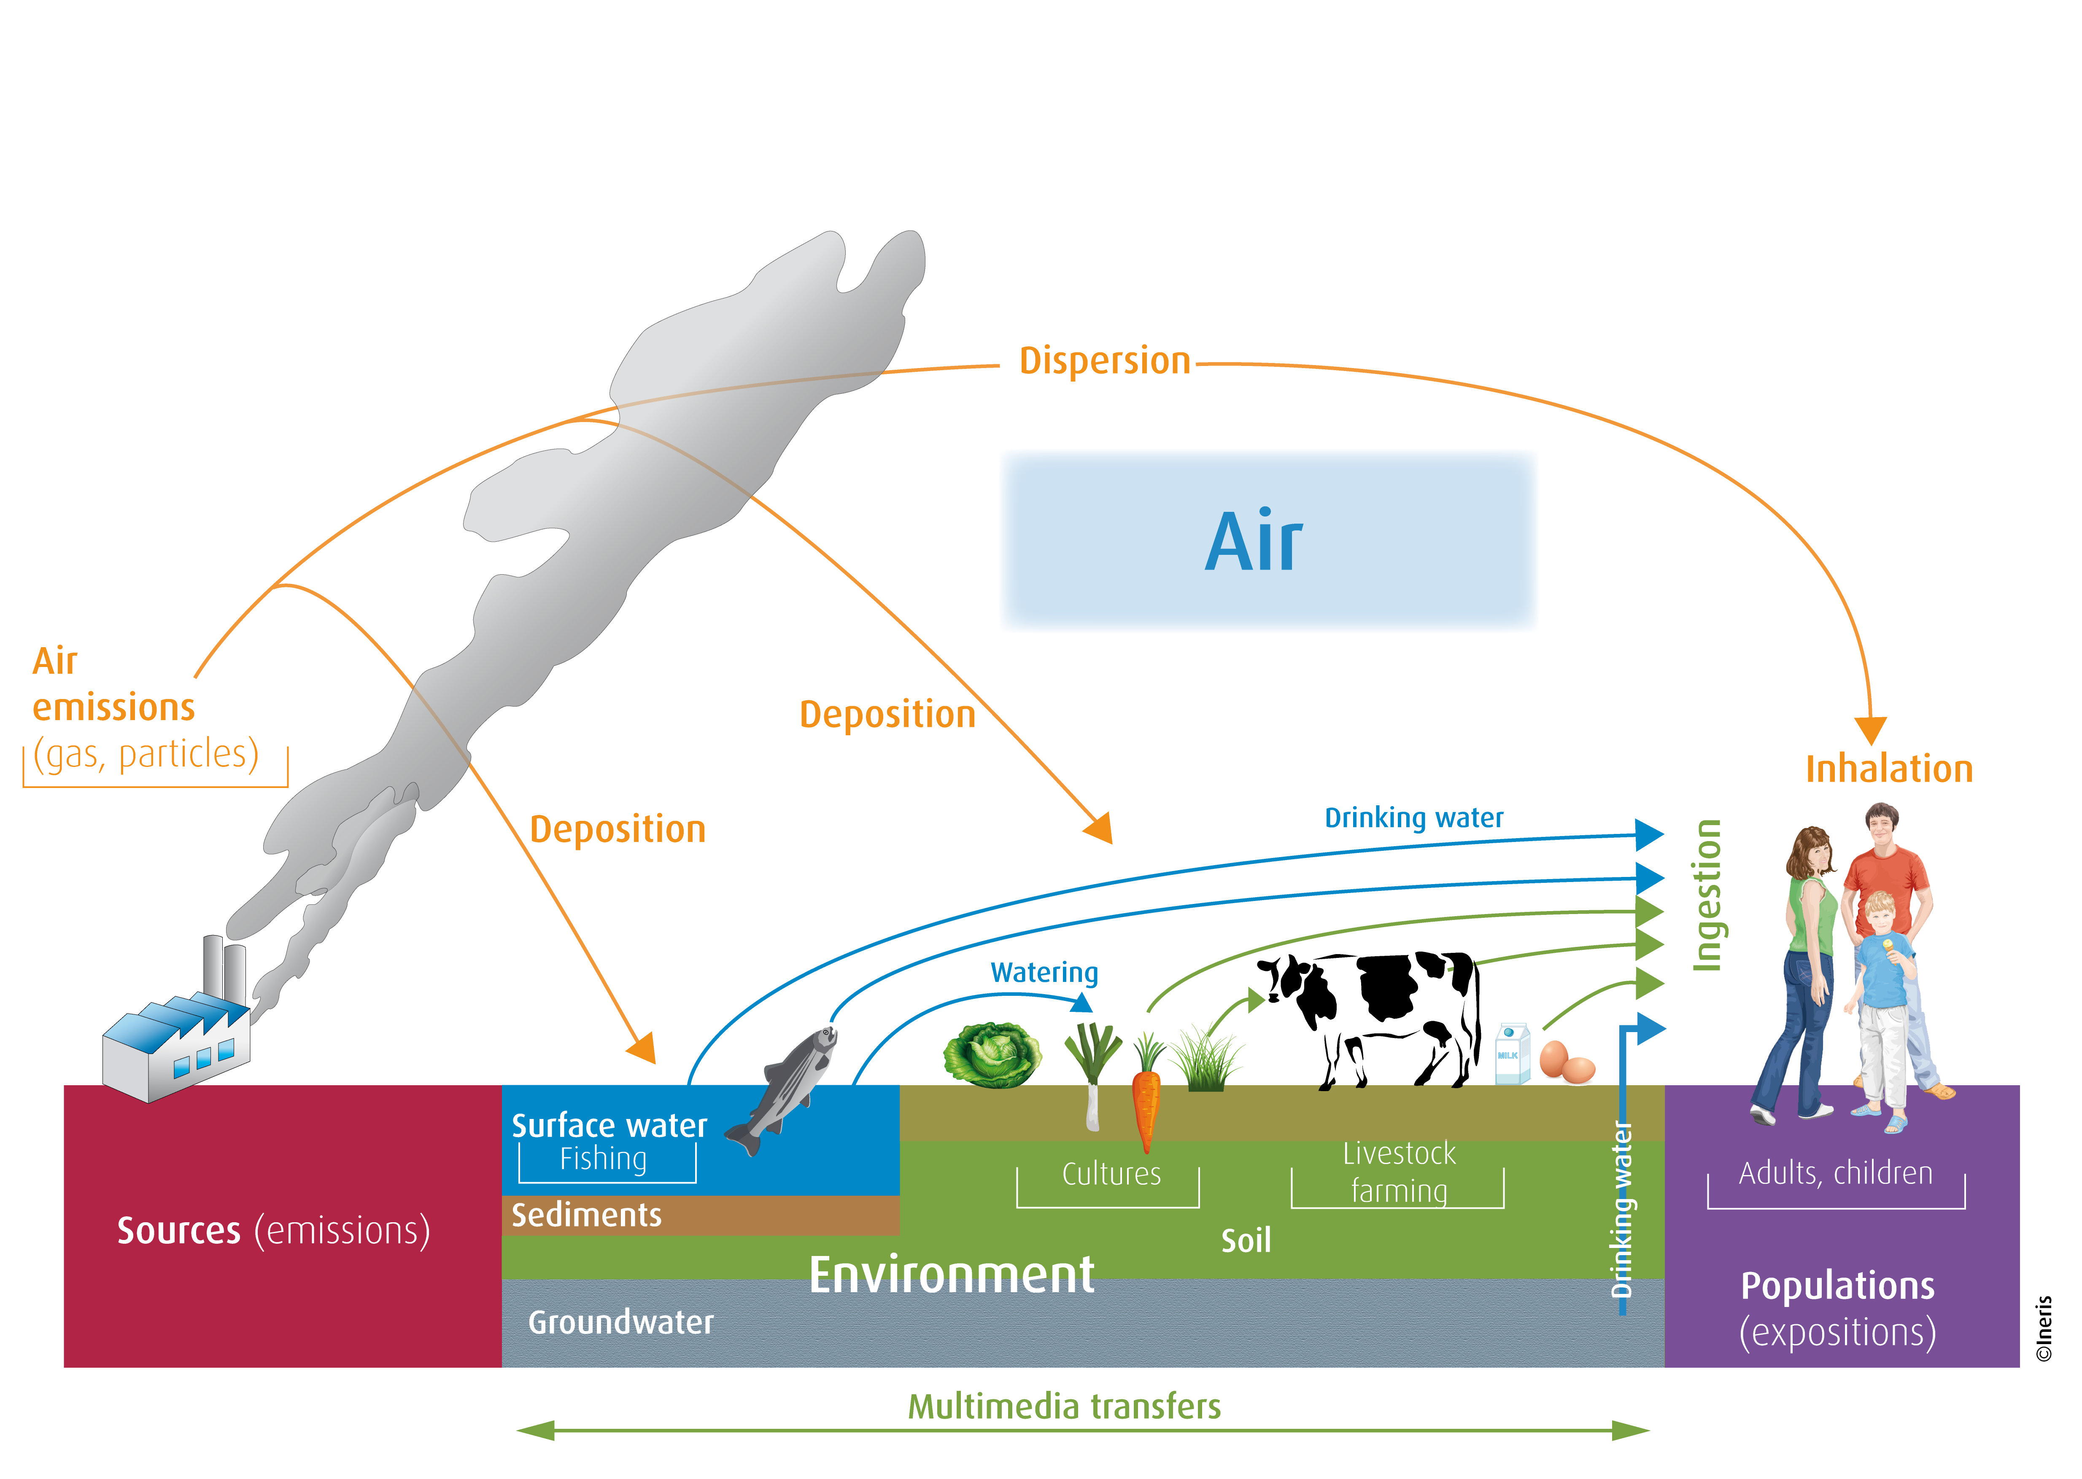

Figure 2: Emission pathways from fires.

This definition requires knowledge about the LIB fire emissions to enable any evaluation of potential contaminations. To meet this objective, it is essential to characterize the different fire emissions and their effects on the atmosphere, water, and soil. These emissions should also consider the different pollutants identified in ISO 26367-3 (2019). The contaminants this specific standard considers include halogenated acids, metals, volatile organic compounds (VOC), polyaromatic hydrocarbons (PAH), polychlorinated dibenzodioxins (PCDD), and perfluorinated compounds, including PFAS, that are particularly scrutinized.

* 1. Towards emission factors for lithium-ion battery fires

This section proposes a review of the available data in the literature about LIB emissions. This analysis is split into the three main types of emissions:

* Gaseous emissions,
* Aerosol emissions, including particles ranging from µm to nm scale, combined with liquid droplets,
* Solid particle releases with sizes from mm to above.

As this will be detailed later, most of the published data were obtained in lab-scale tests, and extrapolation to large fires is not so obvious; therefore, this data should be used with caution. Transposition to real scale situation remains a challenge.

* + 1. Gaseous emissions

Gaseous emissions are most extensively studied emissions from LIBs, with numerous papers in the literature considering the different effects of LIB chemistry and shape. The main objective of this section is to highlight the influencing factors and the current knowledge about emissions based on the state-of-the-art.

A first relevant element to consider is the different thermal runaway mechanisms that can be encountered, with, on the one hand, a gas release without combustion and, on the other hand, a gas release with combustion. Obviously, the presence or lack of combustion thereof strongly changes the characteristics of gaseous emissions, as shown by Bordes et al. (2022). It should also be noted that the emission characteristics will depend on the phenomena that trigger the thermal runaway, as demonstrated by Larsson et al. (2014). This, however, does not strongly modify the list of emitted gases. Considering, for instance, the publication from Nedjalkov et al. (2013), which involved several tests using nail penetration of NMC pouch cells, they identified the main components of the emissions as carbonates typical in LIB electrolytes, including ethyl methyl carbonate (EMC), ethylene carbonate (EC) and dimethyl carbonate (DMC), as well as carbon monoxide (CO) and carbon dioxide (CO2). A large variety of other gases were also identified, including acrolein, toluene, styrene, biphenyl, and hydrogen fluoride (HF). This extensive list, without considering the emission factor at this stage, was confirmed by several publications with multiple chemistries, including publications from Golubkov et al. (2015) and Larsson et al. (2017). In some situations, as illustrated by Maloney (2016), a significant amount of hydrogen (H2) can be identified in the emissions.

Concerning the governing parameters when dealing with thermal runaway, the state-of-charge (SOC) appears as a critical parameter, as shown by Golubkov et al. (2015) and Willstrand et al. (2023). The battery chemistry and shape also strongly influence the emissions, specifically influencing the proportions between species rather than the overall list of species. This was detailed in the Rappsilber et al. paper (2023), with the corresponding results presented hereafter in Figure 3. This figure illustrates the impact of these parameters on CO generation during battery failure. Considering a single chemistry and shape, one can see that the total amount of carbon monoxide increases by a factor of about 5 between 25% SOC and 100% SOC. Focusing on a given SOC and shape, for instance, a fully charged pouch cell, a factor of 2.5 is observed. Last but not least, the influence of the cell shape could lead to a factor of 4.

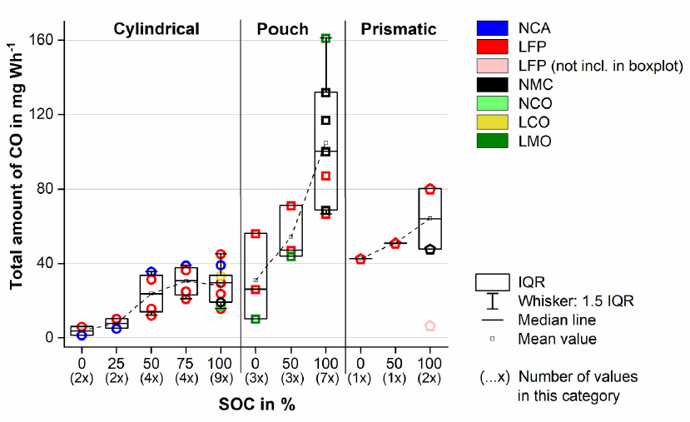

Figure 3 : CO emission for different type of LIBs, shape and chemistry, and different SOC, reproduced from Rappsilber et al’s paper (2023).

A key issue regarding these emission measurements is the focus on specific products, such as carbon oxides, hydrogen fluoride, carbonates, or hydrogen for some tests. Considering the target of the environmental impact assessment, key products, such as volatile organic compounds (VOC) or polyaromatic hydrocarbons (PAH), should be considered but may not be specifically tested or detected in lab tests. Furthermore, it should be noted that real-world situations can differ significantly. Consequently, emissions during a fire can vary from those measured at the lab scale due to factors such as upscaling impact, the presence of additional materials at the system level, and other variables.

* + 1. Aerosols and solid particle emissions

While gas emissions were extensively studied in the literature, few studies have been published regarding aerosol and solid particle emissions, which are critical for environmental impact assessment. When dealing with particle or aerosol emissions, not only should the total emission amount and corresponding emission factor be considered, but also the chemical composition and the diameter distribution. The first, chemical composition, is directly connected to the potential impact; the second, diameter distribution, governs the particle dispersion after atmospheric release.

Barone *et al*. (2021) published an aerosol comparison for different LIB chemistries, showing an important difference between NMC and LFP in terms of both sizes and composition. Larger particles were found after LFP cell abuse testing (micro-scale) compared to NMC, which starts at nanoscale (up to microscale). Also, while NMC particle emissions were composed mostly of cathode components (nickel, aluminum, cobalt), mostly carbonaceous particle linked to organic component decomposition were encountered for LFP (with some fluoride and silicon content). Buston et al. (2023) encountered cathode metal species in all the particles emitted by lithium cobalt oxide (LCO), NMC and NCA abused cells. It is worth pointing out that the particle composition ratio evolves with respect to the particle size considered, as noted by Wang et al. (2021). In the breathable range of particle size and with respect to their composition, LIB particle emissions represent a hazard for the environment that needs to be addressed by a deeper analysis of their characteristics during large fire incidents.

* + 1. Focus on water contamination

Considering LIB thermal runaway, a major challenge in terms of firefighting is the large amount of water required, along with very long firefighting sequences. It is therefore essential to characterize water contamination in such situations. While few data is available for large scale fires, some tests performed at module scale by Bordes et al (2024) have already pointed out the presence of metallic compounds (Ni, Mn, Co, Li, Al) and some undecomposed solvents used in battery electrolytes in wastewater. Their extrapolation from module to large fire underscores the potential detrimental effect on the water ecosystem (PNEC values above acceptable levels).

The LCCP study (2012), in partnership with major EV manufacturer, also highlighted exceeding concentrations of several components (such as fluoride, nickel, manganese, and copper) compared to those allowed for wastewater (decree of February 2, 1998), as well as some other significant concentrations for chlorides, barium, methanol, ethanol, cobalt and lithium. The study also pointed out the presence of pollutants attributed solely to the full system, such as calcium and zinc ions, as well as the increased water contamination in scenarios where the fire induced large battery damage. To highlight water contamination by smoke emission only, smoke abatement by water spray was analyzed in the EMPA study (2020) on a 4 kWh NMC module. In this case, no direct contact between the system and water took place, leading to moderate contamination when considering PAHs, chlorides, sulfates, nitrate and phosphate, and fluoride ions, along with notable contamination due to cathode metal content (which was well above the authorized concentration for industrial effluent).

* 1. Emission comparison

While emission factors could provide an indication of the potential environmental contamination, when dealing with fire, it remains important to consider not only the absolute values but also to compare with those of other fuels. Based on a specific series of tests conducted under identical conditions, emission factors from different fuels have been compared, as shown in Figure 4. This reveals comparable emission factors for CO and CO2 for LIBs compared to other fuels, along with increased nitrogen oxide emissions and larger emission factor for HF. Soot production also appears to be smaller for LIBs; however, the soot composition gap is not considered here (likely differing between carbon-based fuels and LIBs, mainly due to the presence of metals in the soot from LIBs). The emission factors for VOCs and PAHs are of the same order of magnitude as those observed for other fuels.



Figure 4: Emission factors from different fuels.

* 1. Conclusions

Determining the emission factor of numerous species is crucial for considering the environmental impact of LIB fires. This paper highlights the current substantial limitation in meeting this objective, as most publications that consider gas emissions focus on acute toxicity, such as hydrogen fluoride emissions, and rarely consider other products that induce environmental impact. Furthermore, since water contamination from run-off water contributes to environmental impact, specific tests and analyses addressing this issue should be implemented.

Estimating the emission factors and environmental impact of LIB fires using available data is a challenging task. This highlights the need for future test series focused on this objective. Despite a significant level of uncertainty in evaluating these emission factors, their general magnitude can be inferred from various scientific publications and targeted fire tests. It should be noted that most of the data come from small scale test and transposition to real situation is a challenge.

By considering these magnitudes rather than exact values, emission factors of LIB fires can be compared to those of other fuels involved in significant fire incidents. The findings suggest the following:

* Carbon monoxide emissions from LIB fires are comparable to those from traditional fires.
* Hydrogen fluoride serves as a clear indicator of emissions from LIB fires.
* The total soot emissions from LIB fires are lower than those from fires that produce significant smoke, such as hydrocarbon fires; however, the chemical structure of the particles differs, containing a considerable amount of metals.
* Volatile organic compound (VOC) emissions from LIBs are similar to those from conventional fuels.
* Polycyclic aromatic hydrocarbon (PAH) emissions from LIB fires appear to be lower than those observed for other fuel types.

Acknowledgments

The authors strongly acknowledge the NFPA research foundation for funding this research.

Sandia National Laboratories is a multimission laboratory managed and operated by National Technology & Engineering Solutions of Sandia, LLC, a wholly owned subsidiary of Honeywell International Inc., for the U.S. Department of Energy’s National Nuclear Security Administration under contract DE-NA0003525. This paper describes objective technical results and analysis. Any subjective views or opinions that might be expressed in the paper do not necessarily represent the views of the U.S. Department of Energy or the United States Government.

References

Accardo A, Dotelli G, Musa ML, Spessa E., 2021, Life Cycle Assessment of an NMC Battery for Application to Electric Light-Duty Commercial Vehicles and Comparison with a Sodium-Nickel-Chloride Battery. Applied Sciences; Vol 11(3):1160

Barone TL, Dubaniewicz TH, Friend SA, Zlochower IA, Bugarski AD, Rayyan NS, 2021, Lithium-ion battery explosion aerosols: Morphology and elemental composition. Aerosol Sci Technol. Vol 55(10):1183-201.

Bordes A, Marlair G, Zantman A, Herreyre S, Papin A, Desprez P, et al., 2022, New insight on the risk profile pertaining to lithium-ion batteries under thermal runaway as affected by system modularity and subsequent oxidation regime. Journal of Energy Storage. 52:104790

Bordes A, Papin A, Marlair G, Claude T, El-Masri A, Durussel T, et al., 2024, Assessment of Run-Off Waters Resulting from Lithium-Ion Battery Fire-Fighting Operations. Batteries. 10(4):118.

Buston JEH, Gill J, Lisseman R, Morton J, Musgrove D, Williams RCE., 2023, Experimental determination of metals generated during the thermal failure of lithium ion batteries. Energy Advances. 2(1):170-9.

EMPA.,2020, Minimisation des risques d'incendie de véhicules électriques dans les infrastructures de circulation souterraine.

Golubkov AW, Scheikl S, Planteu R, Voitic G, Wiltsche H, Stangl C., 2015, Thermal runaway of commercial 18650 Li-ion batteries with LFP and NCA cathodes – impact of state of charge and overcharge. RSC Advances. Vol 5(70):57171-86

Golubkov AW, Scheikl S, Planteu R, Voitic G, Wiltsche H, Stangl C, et al., 2015, Thermal runaway of commercial 18650 Li-ion batteries with LFP and NCA cathodes – impact of state of charge and overcharge. RSC Advances. 5(70):57171-86.

Larsson F., Mellander B-E., 2014, Abuse by External Heating, Overcharge and Short Circuiting of Commercial Lithium-Ion Battery Cells. Journal of The Electrochemical Society. 161(10):A1611-A7

LCPP., 2012, Étude de l'impact de feux de véhicules électriques (RENAULT) sur les intervenants des services de secours.

ISO 26367-1, 2019: Guidelines for assessing the adverse environmental impact of fire effluents. Part I: General.

ISO 26367-3, 2019: Guidelines for assessing the adverse environmental impact of fire effluents – Part 3: Sampling and analysis.

Larsson F, Andersson P, Blomqvist P, Mellander BE, 2017, Toxic fluoride gas emissions from lithium-ion battery fires. Sci Rep. Vol 7(1):10018

Maloney, 2016, Lithium Battery Thermal Runaway Vent Gas Analysis. DOT/FAA/TC-15/59.

Nedjalkov A, Meyer J, Köhring M, Doering A, Angelmahr M, Dahle S, et al, 2013, Toxic Gas Emissions from Damaged Lithium Ion Batteries—Analysis and Safety Enhancement Solution. Batteries. Vol 2(1):5.

Wang Y, Wang H, Zhang Y, Cheng L, Wu Y, Feng X, et al., 2021, Thermal oxidation characteristics for smoke particles from an abused prismatic Li(Ni0.6Co0.2Mn0.2)O2 battery. Journal of Energy Storage. 39:102639.

Willstrand O, Pushp M, Andersson P, Brandell D., 2023, Impact of different Li-ion cell test conditions on thermal runaway characteristics and gas release measurements. Journal of Energy Storage. Vol 68:107785