|  |  |
| --- | --- |
| cetlogo ***CHEMICAL ENGINEERING TRANSACTIONS***  ***VOL. xxx, 2025*** | A publication of  aidiclogo_grande |
| The Italian Association  of Chemical Engineering  Online at www.cetjournal.it |
| Guest Editors: Bruno Fabiano, Valerio Cozzani  Copyright © 2025, AIDIC Servizi S.r.l. **ISBN** 979-12-81206-xx-y; **ISSN** 2283-9216 | |

Hydrogen Safety in Solid Oxide Fuel Cells: An LSTM-Based Model for Predicting Temperature Anomalies and Change Points

Tomaso Vairo\*, Davide Clematis, Maria Paola Carpanese, Bruno Fabiano

DICCA – Civil, Chemical and Environmental Engineering Department, Polytechnic School – Genova University, Via Opera Pia, 15 – 16145 Genova, Italy

\*tomaso.vairo@edu.unige.it

Temperature anomalies in solid oxide fuel cells (SOFC) can significantly affect performance, induce thermal stress and evolve towards accident scenario. Accurately predicting these anomalies is critical for maintaining system integrity and safety, possibly providing weak early signals before an incident occurs. This paper presents the development of a predictive model utilizing Long Short-Term Memory (LSTM) networks to forecast temperature anomalies and detect change points between normal and abnormal states in SOFCs. The LSTM model is trained on extensive historical temperature data, capturing temporal dependencies and patterns indicative of potential anomalies. Change point detection mechanisms are integrated to identify transitions between normal and abnormal operating states, enabling timely interventions. The model efficacy in predicting temperature-related issues and detecting change points with high accuracy is verified by extensive runs in a laboratory scale plant. The results indicate that the LSTM-based model significantly outperforms traditional methods in both prediction accuracy and early anomaly detection. The research findings underscore the potential of advanced neural network architectures in predictive maintenance applications, providing a robust tool for managing performances and ensuring operational safety, in hydrogen fuel cell-power generation.

* 1. Introduction

Hydrogen fuel cells are considered since a long time one of the cleanest and most efficient system to convert the chemical energy stored in hydrogen into electricity, owing to their high conversion efficiency, environmental compatibility with water as the only by-product (Perego et al., 1988). As outlined in the work by Tronstad et al. (2017), the two most promising technologies for fuel cell applications aiming at power generation are the Polymer Electrolyte Fuel Cells (PEMFCs) and the solid oxide fuel cells (SOFCs). Among these, PEMFCs are the most widely used, due to the attained higher maturity level. Nevertheless, as a main drawback, PEMFC electrodes are based on platinum and then are highly sensitive to contaminations thus requiring a high purity hydrogen. SOFCs are less sensitive to pollutant traces, operate at high temperatures (between 500 and 1000 °C) and typically feature a thin, dense layer of ceramic ionic conductors like Yttrium Stabilized Zirconia (YSZ) and Gadolinium Doped Ceria (GDC) as the electrolyte. The anode usually consists of a porous Ni-YSZ composite, while the porous cathode is made of Mixed Ionic Electronic Conductors (MIEC) such as Lanthanum Strontium Manganite (LSM) (1st SOFC generation) or Lanthanum Strontium Cobalt Ferrite (LSCF), which represent the current state-of-the-art for commercial application. These materials exhibit good catalytic activity towards the Oxygen Reduction Reaction (ORR) and are compatible with conventional electrolytes. SOFCs are used in large-scale power production, with capacities up to 10 MW, and are flexible in their fuel usage, capable of operating on direct methane (Chen et al., 2014), methanol (Liu et al., 2008), hydrogen, ethanol (Laosiripojana et al, 2007) and LNG (Yang et al., 2020). Recently, ammonia (NH3) has garnered attention due to its high hydrogen content and ease of liquefaction under mild conditions. Ammonia boasts one of the highest gravimetric hydrogen densities (17.8% w/w) and the highest volumetric hydrogen densities (0.107 kg-H2/l) (Valera-Medina et al., 2018). New technologies for hydrogen production from ammonia, such as complete cracking, are currently under investigation. Using ammonia for clean energy involves producing hydrogen for fuel cells by cracking ammonia at the anode within the cell, eliminating the need for a fore-line ammonia reformer (Lan et al., 2020). This method of generating clean electricity has gained significant interest over the past decade, particularly for developing new automotive units, as ammonia can be directly fed to the SOFC fuel electrode (Wan et al., 2021). Even though ammonia likewise methanol can be produced sustainably, attention must be given to the hazardous nature of these substances not only related to fire hazard (Palazzi et el., 2022) and influential studies and research need to be performed before possible implementation and commercial deployment of ammonia at a larger scale (Pasman et. 2023). Dealing with SOFCs a physics-informed gradient-boosted tree model was recently proposed to predict the behaviour focusing on weak signals suitable to anticipate internal hydrogen leakage conditions enhancing resilience (Vairo et al., 2023a). Additionally, maintaining the operational integrity of fuel cells is crucial for their efficiency and longevity (Liu et al., 2024) and one significant challenge for early warning is represented by thermal stress, which can cause structural damage and degrade the performance. Machine Learning tools to enhance system resilience are receiving an increased impetus driven by energy transition but critical challenges on system requirement definition and reliability of learning processes need to be addressed (Vairo et al., 2023b). Mounira et al., (2014), explored the degradation arising from the temperature elevation and studied the thermal expansion mismatch between the cell components. The temperature profiles generated by a thermo-electrochemical model were applied to calculate the thermal stress distributions in a multiple-cell module. Maintaining temperature profile in a solid oxide fuel cell (SOFC) is one of the essential issues that need to be addressed during the load tracking. In the paper by Chen et al., (2022), a control scheme with three-loop structure is developed to mitigate SOFC temperature profile variation. Chen et al. (2021) compared three SOFC temperature control strategies, including only anode-side control, only cathode-side control, and two-side control. The comparison results indicate that the cathode-side temperature control strategy can effectively maintain the system efficiency. In the work by Nakajo et al., (2006), a Weibull analysis was used to calculate the global probability of survival for the assessment of the thermal risks related to both operating points and load changes. Chiang L. et al. (2008), evaluate, by the means of CFD modelling, the fuel/oxidant gas distributions as well as thermal stresses of an anode-supported solid oxide fuel cell (SOFC) test cell under different operating conditions. Cai et al., (2024) developed a three-dimensional numerical model to analyse the local thermodynamic state of a SOFC. The attention to thermal anomalies evident in the outlined state-of-the-art analysis shows how the early detection of abnormal temperature conditions represents a crucial focus not only for stable and optimal performance ensuring, but above all for safety. Such a process control is essential to prevent these issues. This study proposes a Long Short-Term Memory (LSTM) network to monitor temperature data and detect anomalies indicative of thermal stress, for identifying the precursors of those unwanted, and dangerous, situations. The LSTM predictions are then analysed with a Real-Time Change Point Detection system, a Bayesian algorithm for detecting the time steps when some statistical property of the time series changes (Killick et al., 2016).

* 1. Materials and methods

Temperature data and cell voltage from a pilot, ad-hoc designed SOFC, under normal and abnormal operating conditions, were collected. The investigation was performed on a complete LSCF//YSZ//Ni-YSD cell with an active geometric area around 1 cm2. To identify the conditions that can lead to thermal stress in the fuel cells, a situation that can lead to an abrupt decrease in cell performance, as well as a rupture of the sealant, with consequent loss of hydrogen containment and eventually explosion, several experimental runs were conducted on the cell just described above. The variables measured and recorded are:

1.Cell voltage [V]

2. Temperature [°C] of the system acquired by means of a K-type thermocouple positioned near the cathode.

3.Cell voltage normalised to reference conditions.

4.Temperature normalised to reference conditions.

The normalisation of potential (voltage) and temperature is performed with respect to the reference conditions, i.e. the initial voltage and temperature values. The tests were conducted with intact and damaged sealant, a condition which obviously produces a change in the system. The flow rate values taken as reference are:

Anode: 50 ml/min H2 and Cathode: 11.2 ml/min air.

Data acquisition was conducted continuously over time by using an Autolab PGSTAT302N (Metrohm, Origgio-VA, Italy) for cell potential (voltage) and a Keithley 2700 multimeter (Oakley, Bedfordshire, UK), with a sampling time of 1 second for temperature acquisition. Figure 1 provides an example of the potential (voltage) and temperature trends over time, in the presence of damage sealant occurrence, including relevant operative conditions. The datasets were pre-processed (centered and normalized) to ensure consistency. The data were subsequently validated and properly structured for LSTM input, by creating sequences of temperature readings and corresponding cell voltage.

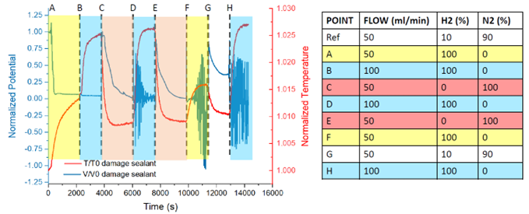

*Figure 1: Potential (Voltage) and temperature trends with corresponding flow rate and composition of the anodic flux change in the presence of a damaged sealant.*

* 1. Theoretical

As widely known, LSTM networks are a type of recurrent neural network (RNN) designed to recognize patterns in sequences of data, such as time series, speech, and text. Unlike traditional RNNs, LSTMs are capable of learning long-term dependencies, allowing data to flow both forwards and backwards within the network making them well-suited for tasks where context is important over longer periods. The key components of the LSTM networks are depicted in Figure 2 and summarized as follows.

1. Memory Cell: The core of an LSTM is the memory cell, which maintains information over long periods. The cell state allows information to be carried across many time steps.

2. Gates: LSTMs use gates to control the flow of information into and out of the cell state, according to three main gates:

a. Forget Gate: It is decided what portion of the previous cell state should be forgotten. It takes the previous hidden state and the current input and outputs a number between 0 and 1 for each number in the cell state.

b. Input Gate: It is determined what new information should be added to the cell state. Furthermore, the gate considers the previous hidden state and the current input to decide which values are to be updated.

c. Output Gate: It is controlled what part of the cell state should be provided as an output. It determines which part of the cell state should be passed to the next hidden state and contribute to the final output.

3. Cell State Update: The cell state is updated by combining the old cell state (after applying the forget gate) with the new candidate values (after applying the input gate).

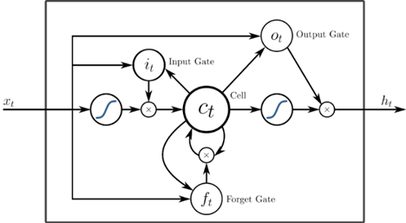

Figure 2: Schematic layout of the conceived LSTM network.

The working mechanism of the LSTM network was conceived according to the following sequential steps:

1. Initialization: at the beginning, the cell state and the hidden state are initialized, usually to zero.

2. Processing Input: for each time step in the input sequence:

• The Forget Gate decides what part of the previous cell state should be discarded. This is done using a sigmoid function that outputs a value between 0 and 1 for each number in the cell state.

• The Input Gate determines which values from the current input and the previous hidden state should be used to update the cell state, using a decision sigmoid function and a tanh function to create new candidate values.

• The Cell State is updated by combining the old cell state (modulated by the forget gate) with the new candidate values (modulated by the input gate).

• The Output Gate decides what part of the current cell state should be output. This is done using a sigmoid function and then modulating the cell state with a tanh function to output the new hidden state.

3. Output: The hidden state produced at each time step is used as the output of the LSTM for that time step.

4. Training: LSTM networks are trained using backpropagation through time (BPTT), which adjusts the weights of the network to minimize the error between the predicted and actual outputs over the entire sequence.

LSTMs are considered powerful tools because they can remember important information for long periods and forget irrelevant information, thus offering noteworthy capability for tasks where context and sequence are crucial, such as time series prediction. The LSTM model presented in this paper was developed using as starting reference the Keras library (Charles, 2013). The model was trained on the normalized potential (voltage) and temperature data, with sequences of 10 timesteps used to predict the next temperature value. The head of the dataset is in the following Table 1. The model performance was validated using mean squared error (MSE) on both training and test datasets. The predicted values were then used to determine, by the means of a Bayesian change-point detection algorithm, to predict the transition from normal to abnormal conditions.

Table 1: Head of the dataset.

|  |  |  |
| --- | --- | --- |
| Time | Potential (Voltage) [V] | Temperature [T] |
| 0 | 0.79987 | 0.766939 |
| 1 | 0.79865 | 0.757326 |
| 2 | 0.79803 | 0.754587 |
| 3 | 0.79803 | 0.753773 |

* 1. Results and discussion

The LSTM model demonstrated satisfactory performance in predicting temperature values during normal operations, with low training and validation errors. However, predictions for abnormal operations showed larger deviations, effectively identifying potential thermal stress.

The loss during training and validation phases (MSE) are shown in Figure 3. The final values for the trained model are calculated equal to 0.0032 and 0.0013, respectively for the training loss and the validation loss.

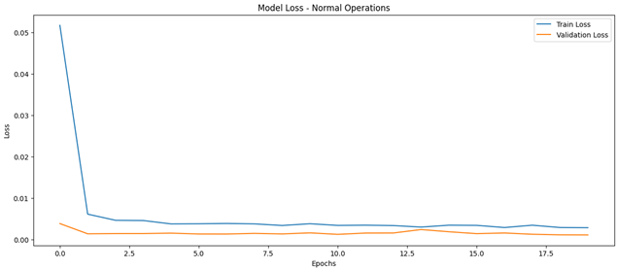

*Figure 3: Loss during training and validation.*

The predictive ability of the developed model is remarkable, as shown in diagram of immediate readability in Figures 4 and 5, respectively referred to normal and abnormal conditions temperature. The traces of recorded (blue for normal operations and red for abnormal ones) and predicted (green for normal operations and yellow for abnormal ones) temperatures, represented in the following figures, are almost superimposed.

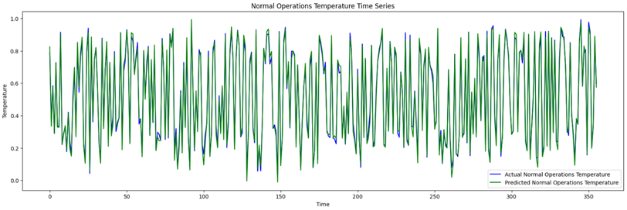

*Figure 4: Comparison of predicted vs. recorded temperatures under normal conditions.*

*Figure 5: Comparison of predicted vs. recorded temperatures under abnormal conditions.*

Subsequently, the trained LSTM model was used to monitor new temperature data in real-time.

The obtained predictions were subsequently analysed according to the Real-Time Change Point Detector methodology. The predicted time series were compared against defined thresholds, with any deviation beyond the thresholds indicating the presence of a precursor for potential thermal stress. Figure 6 provides a visual demonstration of the model capability in assessing the change point detection among the predicted temperatures, thus allowing the attainment of a dynamic early warning.

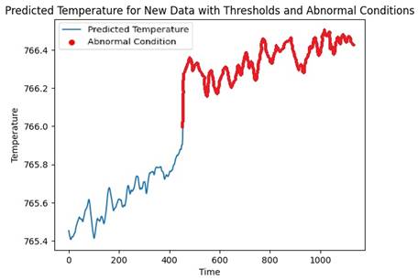

*Figure 6: Change point prediction.*

The LSTM model effectively identified thermal stress in hydrogen fuel cells by predicting temperature deviations, providing an early signal of hazardous deviations. The predictive capabilities of this model offer substantial benefits for pre-emptive maintenance strategies, enhancing overall system reliability and reducing the risk of performance degradation and accidents. In this regard, the inclusion of real-time monitoring and threshold-based anomaly detection provides a robust system for maintaining operational safety and efficiency. As an ongoing refinement, the model performance can be further enhanced by incorporating additional features such as pressure, humidity, and power output, alongside with advanced hyperparameter optimization.

* 1. Conclusions

This study presents a novel application of LSTM networks for detecting thermal stress in hydrogen fuel cells. By monitoring temperature data and identifying anomalies, the model can proactively alert operators to potential issues, thereby improving the safety and longevity of fuel cells. The application of LSTM models to fuel cell operations has proved extremely effective in enhancing the system safety; moreover, the integration of LSTM networks with the Real-Time Change-Point Detection has demonstrated significant performances in capturing long-term dependencies in time-series data identifying and predicting thermal stresses in hydrogen fuel cells. This hybrid approach leverages the predictive power of the designed networks to forecast temperature fluctuations accurately, while the Change Point detector provides a robust mechanism for detecting abrupt changes that could signal the onset of abnormal conditions. Experimental results evidence that the proposed model provides a dual-layered defence mechanism: the LSTM predicts future temperatures based on historical data, while the detector continuously monitors these predictions for any signs of sudden changes. This synergy enhances the reliability and safety of the hydrogen fuel cell systems by ensuring that both gradual trends and abrupt shifts are accurately identified and addressed, representing a powerful toolset as well for the predictive maintenance. Future research should focus on refining the model and exploring its application to other critical systems, further enhancing their robustness and applicability in various industrial contexts.

Acknowledgments

The authors gratefully acknowledge funding by INAIL within the framework of the call BRIC/2021/ID3 (Project DRIVERS Approccio combinato data-driven ed experience-driven all’analisi del rischio sistemico).

References

Cai W., Zhou R., Yuan J., Tu Y., Zhang Z., 2024, The electrochemical performance and thermal behavior analysis of SOFC containing thin gadolinium-doped ceria diffusion barrier layer, Int. Commun. Heat Mass Transf., 155, 107577,

Charles P.W.D., 2013, Project Keras, GitHub repository, https://github.com/charlespwd/project-title, accessed 18.10.2024

Chen J., Hu Z., Zhang H., 2022, A novel control scheme to mitigate temperature profile variation in a SOFC System, Energy Reports, 8, 10604-10613.

Chen J., Li Y., Zhang H., Weng S., 2021, Comparison of different fuel cell temperature control systems in an anode and cathode ejector-based SOFC-GT hybrid system, Energy Convers. Manage., 243, 114353.

Chen Y., Zhang Y., Lin Y., Yang Z., Su D., Han M., Chen, F., 2014, Direct-methane solid oxide fuel cells with hierarchically porous Ni-based anode deposited with nanocatalyst layer, Nano Energy, 10, 1-9.

Chiang L., Liu H., Shiu Y., Lee C., Lee R., 2008, Thermo-electrochemical and thermal stress analysis for an anode-supported SOFC cell, Renewable Energy, 33 (12), 2580-2588.

Killick R., Fearnhead P., and Eckley I.A., 2012, Optimal detection of changepoints with a linear computational cost. Journal of the American Statistical Association. 107. 1590-1598.

Lan R., Tao S., 2010, Direct ammonia alkaline anion-exchange membrane fuel cells. Electrochem. Solid State Lett., 13(8), B83-B86.

Laosiripojana N., Assabumrungrat S. Catalytic steam reforming of methane, methanol, and ethanol over Ni/YSZ: The possible use of these fuels in internal reforming SOFC. J. Power Sources, 163, 943-951.

Liu M., Peng R., Dong D., Gao J., Liu X., Meng G., 2008, Direct liquid methanol-fueled solid oxide fuel cell. J. Power Sources, 185, 188-192.

Liu X., Sun S., Dai,Y., Zhang H., Li C., 2024, Numerical study of temperature distribution in tubular segmented-in-series SOFC with co-flow and counter-flow arrangements, Int. Journal of Hydrogen Energy, 74, 447-458.

Mounir H., Belaiche M., El Marjani A., El Gharad A., 2014, Thermal stress and probability of survival investigation in a multi-bundle integrated-planar solid oxide fuel cells IP-SOFC, Energy, 66,378-386.

Nakajo A., Stiller C., Härkegård G., Bolland O., 2006, Modeling of thermal stresses and probability of survival of tubular SOFC, Journal of Power Sources, 158(1), 287-294.

Palazzi E., Currò F., Fabiano B., 2020, Low rate releases of hazardous light gases under semi-confined

geometry: A consequence based approach and case-study application, Journal of Loss Prevention in the

Process Industries, 63, 104038.

Pasman H., Sripaul E., Khan F., Fabiano B., 2023, Energy transition technology comes with new process safety challenges and risks, Process Safety and Environmental Protection, 177, 765-794.

Perego P., Fabiano B., Ponzano G.P., Palazzi E., 1998, Experimental study of hydrogen kinetics from agroindustrial by-product: Optimal conditions for production and fuel cell feeding. Bioprocess Engineering, 19, 205-211.

Tronstad T., Høgmoen Åstrand H., Haugom G.P., Langfeldt L., 2017, DNV-GL - EMSA Study on the use of Fuel Cells in Shipping, DNV GL – Maritime www.emsa.europa.eu/publications/item/2921-emsa-study-on-the-use-of-fuel-cells-in-shipping, accessed 15.05.2024.

Vairo T., Cademartori D., Clematis D., Carpanese M.P., Fabiano B., 2023a, Solid oxide fuel cells for shipping: A machine learning model for early detection of hazardous system deviations, Process Safety and Environmental Protection, 172, 184-194.

Vairo T., Pettinato M., Reverberi A.P., Milazzo M.F., Fabiano B., 2023b, An approach towards the implementation of a reliable resilience model based on machine learning, Process Safety and Environmental Protection 172, 632-641.

Valera-Medina A., Xiaoa H., Owen-Jones M., David P.J. Bowen W.I.F., 2018, Ammonia for power. Prog. Energy Combust. Sci., 69, 63-102.

Wan Z., Tao, Y., Shao, J., Zhang, Y., You, H., 2021, Ammonia as an effective hydrogen carrier and a clean fuel for solid oxide fuel cells. Energy Convers. Manag., 228, Article 113729.

Yang X., Zhao H., Hou Q., 2020, Proposal and thermodynamic performance study of a novel LNG-fueled SOFC-HAT-CCHP system with near-zero CO2 emissions. Int. J. Hydrog. Energy, 45, 19691-19706.