|  |  |
| --- | --- |
| cetlogo ***CHEMICAL ENGINEERING TRANSACTIONS***  ***VOL. xxx, 2025*** | A publication of  aidiclogo_grande |
| The Italian Association  of Chemical Engineering  Online at www.cetjournal.it |
| Guest Editors: Bruno Fabiano, Valerio Cozzani  Copyright © 2025, AIDIC Servizi S.r.l. **ISBN** 979-12-81206-xx-y; **ISSN** 2283-9216 | |

Considerations on safety parameters for flames of cold and cryogenic gases

Sven Eckarta,\*, Ernesto Salzanob, Loreto Pizzutic, Hartmut Krausea, Gianmaria Piob,\*

aInstitute of Thermal Engineering, TU Bergakademie Freiberg, Freiberg, Germany

bDepartment of Civil, Chemical, Environmental and Materials Engineering, University of Bologna, Italy

cFederal University of ABC, UFABC, Brazil

\* [sven.eckart@iwtt.tu-freiberg.de](mailto:sven.eckart@iwtt.tu-freiberg.de) , gianmaria.pio@unibo.it

The continuous development of alternative and optimized solutions for a convenient and sustainable utilization of cryogenic conditions has recently involved several industrial sectors, including fuel transportation. The availability of large quantities of flammable and hazardous materials stored under extremely low temperatures requires specific evaluations on the safety of these innovative solutions to guarantee a robust spread worldwide as well as to provide sufficient information for proper protocols and regulations. Evaluating the laminar burning velocity represents an essential step toward the achievement of these targets. To this scope, a comparative analysis of the existing techniques for the experimental characterization of low initial temperature reactive systems in terms of laminar burning velocity is presented in this work. Among the others, the heat flux burner was identified as a promising solution for the experimental quantification of the laminar burning velocity at low temperatures, although the current layout does not allow for the investigation of these conditions. Therefore, possible modifications were proposed to adapt a heat flux burner for these extreme conditions, ensuring precise and reliable measurements. In addition, a numerical analysis assessing the effects of the initial temperature on the flammability limits of cryogenic fluids was presented. The collected data can be also intended as indications for further refining the design of the existing burners, allowing for accurate experimental determination of laminar burning velocity at low initial temperature and, thus, validation of kinetic mechanisms and utilization of advanced models for consequence analyses.

* 1. Introduction

Cryogenic and cold conditions are utilized in various fields and applications at an industrial level also dealing with hazardous materials (Olewski et al., 2013). In the process industry, gases such as nitrogen, oxygen, argon, helium, natural gas, carbon dioxide, and hydrogen are liquefied for diverse purposes and handled as cryogenic liquids. In metallurgy and chemistry, cryogenic gases are used for heat treatment of metals and chemical processes that require extreme cold. In semiconductor manufacturing, cryogenic gases like nitrogen are used to rapidly cool semiconductor components, enhancing their performance. However, larger quantities of hydrogen, methane/biomethane, and ammonia will also be transported globally in liquid cryogenic form in the future energy section. In the presence of an ignition source, leakages of flammable substances in these conditions can lead to flame-related scenarios, such as flash fires and pool fires (Mocellin et al., 2023).

To evaluate the exothermicity and the chemistry of reactive systems concisely, the laminar burning velocity represents a key parameter to be monitored and assessed, especially once low initial temperatures are of concern (De Liso et al., 2023). Besides, it is a critical parameter in characterizing the global combustion behaviour of fuels, including cold and cryogenic gases (Eckart et al., 2023) since this parameter provides essential insights into the reactivity, diffusivity, and exothermicity of fuel-oxidizer mixtures. In addition, it helps determine the flammability limits of a gaseous mixture, which is important for the safe design and operation of combustion equipment and processes (Pio et al., 2024). Additionally, the parameter is used to calculate the deflagration index, an important parameter for assessing the explosion hazards associated with gaseous mixtures. Accurate knowledge of the laminar burning velocity is further necessary for developing and validating chemical kinetic models (Eckart et al., 2024), which are essential for simulating and optimizing industrial processes (Pio et al., 2022).

In the context of cold and cryogenic gases, the importance of the laminar burning velocity is heightened due to the unique challenges associated with their combustion and safe handling, such as low temperatures, high densities, and potential condensation effects. Accurate determination of the laminar burning velocity for these gases is crucial for designing and operating cryogenic propulsion systems and other applications involving cryogenic fuels. From these considerations, existing systems for measuring burning velocity were reviewed to assess their suitability for cold and cryogenic gases.

* 1. Outline of the existing experimental systems

To determine the characteristic size of the adiabatic laminar burning velocity, various experimental methods have been developed over time. These methods have been comprehensively analyzed, summarized, and evaluated by Egolfopoulos et al. (Egolfopoulos et al., 2014) and Konnov et al. (Konnov et al., 2018). The measurement methods can be divided into two global categories: stationary and non-stationary combustion systems, and further distinguished into vessel and burner methods. All measurement methods developed so far can be categorized into these four groups, as shown in Figure 1a. Furthermore, in Figure 1b the maximum possible temperature and pressure ranges of these methods were extracted from the literature. Some of the known methods are briefly explained below:

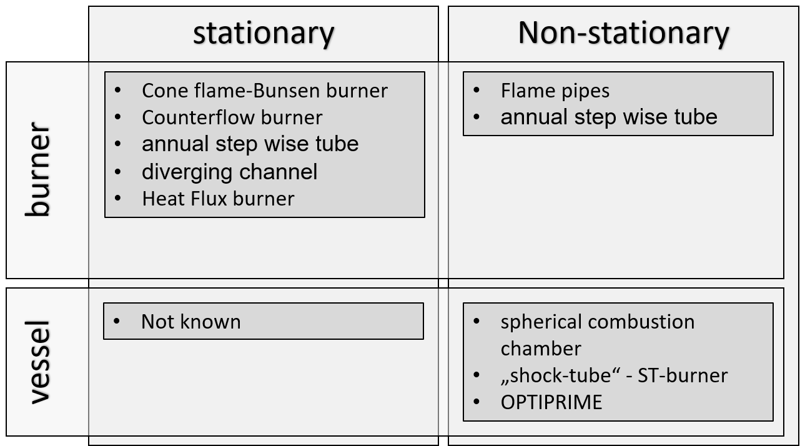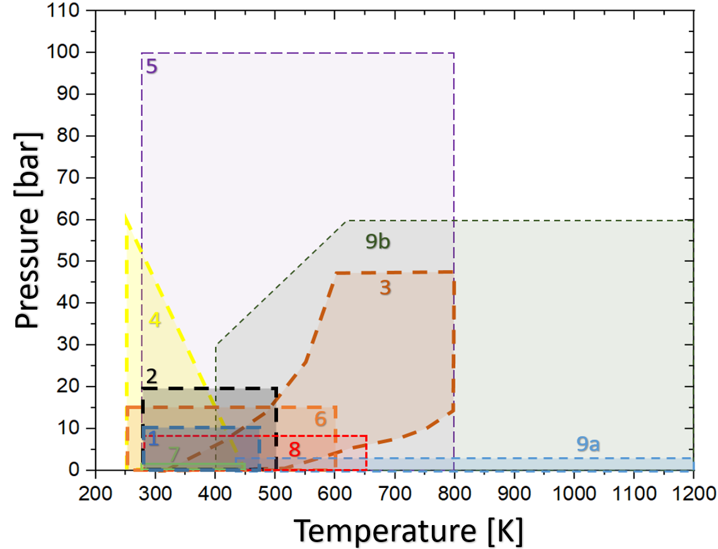

Fig 1: a) Classification of methods for determining the laminar burning rate and b) Application limits of known measuring methods for determining the laminar firing rate. Please consider the following definitions: 1 heat flux burner; 2 counterflow burner; 3 constant volume chamber; 4 constant pressure chamber; 5 OPTIPRIME; 6 conical flame/ Bunsen burner; 7 annual step wise tube; 8 diverging channel; 9a shock tube; 9b theoretical shock tube.

* + 1. Conical Flame / Bunsen Burner Method

This method, one of the oldest for studying adiabatic laminar burning velocity, was first introduced in 1867 (Bunsen, 1867). It analyzes the angle between the flame fronts formed by a premixed conical flame at the exit of a burner. The setup produces a rotationally symmetric flame, which can be visualized using schlieren photography, chemiluminescence, or laser-induced fluorescence (LIF) (Meier et al., 2000). By detecting radicals like CH or OH, the flame front position is determined. The adiabatic laminar burning velocity (SL) is calculated from the enclosed angle (α), the known flow rate, and the inflow velocity (ug). This rather simple technique has some limitations from the influence of flow near the burner mouth and flame curvature effects, which require corrections during the calculation of the LBV. Previous investigations (Scholte and Vaags, 1959) extensively used this method to analyze various fuel mixtures. Further advancements by Liu and MacFarlane (Liu and MacFarlane, 1983), Chung and Law (Chung and Law, 1988), and others improved accuracy by addressing flow and curvature effects, extending the method to turbulent flame speed measurements with different turbulence grids.

**Cooling Methodology:** In the last decades, it has been shown that this technique could be adopted to Various fuels and mixtures, and was also extended to turbulent flames. The feasibility for use in cold temperatures has been recently demonstrated by Gosh (Ghosh et al., 2022). However, controlled temperature regulation is not possible, especially for maintaining high volumetric flows over extended periods. Nonetheless, the introduction of the system into a cooled environment, such as an ultra freezer or a cryogenic cooler with liquid nitrogen, is conceivable for the gas mixing line. The curvature and elongation of the flame still cause uncertainties in the measurement methodology.

* + 1. Spherical Combustion Chamber Method

The spherical combustion chamber method involves igniting a premixed fuel-air mixture at the center of a closed chamber, allowing the flame front to propagate spherically. This process can occur under either constant pressure or constant volume conditions and is characterized by the flame's radius.

In flame propagation, the flame expands spherically within a closed chamber, and the flame front can be visualized using optical methods like schlieren photography and laser-induced fluorescence (LIF). This method has two main variants: the constant pressure method and the constant volume method. The constant pressure method analyzes combustion by maintaining a constant pressure throughout the process. Challenges in this method include accounting for ignition energy, radiation effects, and non-linear extrapolation. These factors require corrections to accurately determine the laminar burning velocity (LBV) (Clavin, 1985)(Faghih and Chen, 2016). Over the past three decades, significant improvements and corrections have been summarized by researchers such as Egolfopoulos. The constant volume method, on the other hand, is evaluated through pressure-time relationships rather than optical methods. Early approaches were inaccurate because they neglected the effects of flame stretch. Recent approaches consider these effects, making it possible to estimate the unstretched LBV once the pressure exceeds 20% of its initial value. Despite these improvements, discrepancies in LBV data across different setups persist, complicating direct comparisons (Movaghar et al., 2020). In conclusion, the spherical flame method, both in its constant pressure and constant volume variants, provides essential insights into laminar burning velocities. However, careful corrections and considerations are necessary to address various influencing factors.

**Cooling Methodology:** In this method, cooling is fundamentally conceivable if the system is designed as a double-walled structure or if the entire chamber is integrated into a refrigerator. However, each ignition leads to a significant heat input into the walls and glasses of the chamber, which results in extremely long waiting times between two measurements for cooling down. Additionally, lower temperatures reduce the burning velocities, which can lead to a noticeable slowdown of the flame. This results in slow laminar burning velocities (LBV) that are influenced by buoyancy effects, similar to those observed in ammonia flames (Kanoshima et al., 2022).

* + 1. Counterflow Burner

The stagnation or counterflow flame configuration was proposed by Simmons and Wolfhard (Simmons and Wolfhard, 1957) and is widely used to experimentally investigate the structure, stability, and extinction behavior of premixed and non-premixed flames. Law et al. developed the stagnation method to experimentally determine the extinction limits for propane-air mixtures. Wu and Law (Law et al., 1981), along with Egolfopoulos and co-workers (Egolfopoulos et al., 1991), subsequently devised a method to extract laminar burning velocities from the counterflow configuration, assuming the centre as a 1-D laminar flame. The stagnation flow field is created either by influencing two identical jet streams or by directing a generated flow onto a wall. For a premixed fuel-air mixture, two identical flames are stabilized at equal distances from the stagnation plane, which eliminates downstream heat losses due to flame symmetry, with minimal radiation losses to the surroundings. The introduction of a nonlinear stretching correction led to reduced LBV values and smaller deviations in current methane comparison measurements. In contrast to methane, higher hydrocarbons exhibit greater uncertainties due to lower diffusion rates (Konnov et al., 2018). The impact of the Lewis number (Le) on flame structure and LBV was investigated, revealing that flame behavior in hydrocarbon-rich mixtures is influenced by diffusion. The ratio of SL,ref to SL remains independent of the Lewis number, with SL,ref increasing with flame stretching for Le > 1. For Le < 1 (Han and Chen, 2015)(Salusbury and Bergthorson, 2015)v, as seen in hydrogen/air mixtures, reaction rates increase with stretching, affecting flame extinction behavior at shorter residence times. The uncertainties in the measurement method primarily arise from the control and management of flow measurement and mixture preparation.

**Cooling Methodology:** In this method, both the flushing flows (usually nitrogen) and the two jet gases must be cooled, as they spend an extended time in the burner, which also needs cooling. A chamber solution is recommended; however, since the flame hovers in open space between the two nozzles, significant heat release from the exhaust is expected, complicating uniform cooling. As this burner has a stable time-independent flame this can be very sensitive to this issue. This setup cannot be easily adapted to low temperatures unless rapid cooling is integrated into the inlet area, similar to a heating element in hot gas applications.

* + 1. Effects of Wall Interaction

In both the annual stepwise tube method and the externally heated diverging channel method, a significant wall effect is observed see the review paper of Konnov et al. (Konnov et al., 2018). This effect would be further intensified at lower temperatures due to the direct contact or very small distance between the flame and the wall. Consequently, heat losses would need to be factored into the corrections without being able to measure or determine them accurately.

**Cooling Methodology:** Thus, the utilization of these methods in a low-temperature environment does not seem to be feasible to exactly measure the LBV.

* + 1. Heat Flux Burner

The Heat Flux burner method stabilizes a quasi-adiabatic flat flame and measures its laminar burning velocity (de Goey et al., 1993). This technique involves heating an unburned gas mixture from a heated burner plate, creating a quasi-adiabatic volume between the flame front and the plate. Radial temperature measurements are taken using thermocouples embedded in a highly perforated, conductive burner plate (Konnov et al., 2018). To maintain adiabatic conditions, a heated jacket surrounds the plate, compensating for heat loss, while an additional heating circuit keeps the premixing chamber at the same temperature as the gas mixture. Extensive error analysis shows minimal variability in measurements, attributed primarily to mass flow controllers and thermocouples. The Heat Flux method produces reproducible results for both gaseous and liquid fuels and has been extended to high pressures (Goswami et al., 2016). These experimental studies have reported LBV measurements mixtures at pressures up to 10 bar, with an unburned gas mixture inflow velocity limited to ~75 cm/s. Research indicated (Wang et al., 2020) no significant interaction between the stabilized flame and the burner plate. Based on these insights, Han et al. (Han et al., 2021) developed a method to extrapolate burning velocities at specific feed gas temperatures, enabling measurements at temperatures up to 498 K, which could be also used for lower temperature in a certain range.

**Cooling Methodology:** This method is considered one of the most feasible for adaptation to cold temperatures alongside the Bunsen burner. The entire inlet area would need to be temperature-controlled, and instead of the first heating element, a cooling chamber would surround the burner to externally cool the mixing chamber. Flowing a cold medium through a heat exchanger in the mixing chamber would be beneficial, ensuring laminar flow is not affected. Subsequently, the second circuit for the burner plate could be adjusted to maintain a temperature with the same temperature differential as in conventional burners, allowing exhaust gases to escape outside the chamber. This setup could preserve the principle of a quasi-adiabatic flat flame, and it is expected that this system could achieve the highest accuracy.

* 1. Numerical investigation

The detailed kinetic mechanism KIBO (Pio and Salzano, 2018) has been employed for the evaluation of the laminar burning velocity of the ammonia, hydrogen, and methane at initial temperatures within the range 200 K – 300 K, atmospheric pressure, and in the air as a function of the equivalence ratio. A mono-dimensional, steady state, adiabatic, and premixed flame was simulated. Grid refining parameters of ratio = 3, slope = 0.06 and curve = 0.10 were used for this scope. Additional information on the employed procedure can be found elsewhere (Pio et al., 2024). The collected data were considered for the evaluation of the flammability limits, following the limiting laminar burning velocity theory first proposed by Hertzberg (Hertzberg, 2009), namely, the flammability limits were assumed once the estimated laminar burning velocity equalled a threshold value: the limiting laminar burning velocity ($S_{u,lim}$), defined in Eq(1).

|  |  |
| --- | --- |
| $$S_{u,lim}={\left(2α∙g∙\frac{ρ_{b}}{ρ_{u}}\right)}^{1/3}$$ | (1) |

where $α$ and *g* stand for effective thermal diffusivity and gravitational acceleration, respectively, whereas $ρ$ indicates the density having the burned and unburned conditions expressed by the subscripts *b* and *u*.

* 1. Results

Figure 2 reports the numerical estimations of lower flammability limits (LFL) (Fig. 2a) and upper flammability limits (UFL) (Fig. 2b) as a function of the initial temperature for the investigated fuels in air and atmospheric pressure.



Fig 2. Estimated lower flammability limits (a) and upper flammability limits (b) of ammonia, hydrogen, and methane in air at atmospheric pressure, as a function of the initial temperature.

It is worth noting that the relative decrease in UFL with respect to the value at standard conditions from 300 K to 200 K is ~ 3.4 % for all the investigated, indicating a reduced impact of the chemistry of the analysed substances at the investigated temperatures. Besides, under the investigated conditions, an almost linear trend with the initial temperature can be observed either for the LFL or UFL, suggesting that the thermal properties are reaching a determining role in the definition of flammability limits at low-temperatures, in agreement with the dedicated literature (Pio et al., 2020). Nevertheless, a larger relative variation in LFL can be observed, reaching ~ 10% for the case of hydrogen. This aspect is essential in the framework of consequence analysis, especially for the quantification of scenarios assuming a delayed ignition. Indeed, the current practice is to assume the LFL at standard conditions as a threshold value for the quantification of stand-off distances of flash fires, neglecting the effects of initial temperatures on this parameter. Although this approach represents a suitable strategy for simplified and preliminary assessment, the increased capacities for the evaluation of the temporal and spatial distribution of temperature and composition in the proximity of an accidental release promotes the use of accurate values, such as the ones reported in this work, to this aim.

* 1. Conclusions

This work presents an investigation of the flammability limits of hydrogen, ammonia, and methane at atmospheric pressure as a function of the initial temperature. Particular emphasis was given to cryogenic and low-initial temperatures in the view of possible characterization of accidental releases from cryogenically liquefied storage systems. An in-depth analysis of the current state of the art of the existing technologies for the quantification of the overall reactivity and flammability of gaseous mixtures was reported in this work. The possible applicability and limitations in the view of a possible use at low-temperature conditions were discussed. A numerical analysis was performed by means of a detailed kinetic mechanism largely validated in the current literature. The relative decrease in UFLs with temperature was found to be minimal for the analysed substances, suggesting a dominant role of thermal properties. Hydrogen exhibits a significant LFL reduction (~10%) within the investigated range of temperature, highlighting the importance of combining the initial temperature and distribution of flammable species in consequence analysis. This refinement can improve significantly the accuracy of risk assessments, particularly for flash fire scenarios of cryogenic storage systems.

References

Bunsen, R., 1867. Ueber die Temperatur der Flammen des Kohlenoxyds und Wasserstoffs. Ann. der Phys. und Chemie 6, 161–179.

Chung, S.H., Law, C.K., 1988. An integral analysis of the structure and propagation of stretched premixed flames. Combust. Flame 72, 325–336. https://doi.org/10.1016/0010-2180(88)90131-9

Clavin, P., 1985. Dynamic behavior of premixed flame fronts in laminar and turbulent flows. Prog. Energy Combust. Sci. 11, 1–59. https://doi.org/10.1016/0360-1285(85)90012-7

de Goey, L.P.H., van Maaren, A., Ouax, R.M., 1993. Stabilization of Adiabatic Premixed Laminar Flames on a Flat Flame Burner. Combust. Sci. Technol. 92, 201–207.

De Liso, B.A., Palma, V., Pio, G., Renda, S., Salzano, E., 2023. Extremely Low Temperatures for the Synthesis of Ethylene Oxide. Ind. Eng. Chem. Res. https://doi.org/10.1021/acs.iecr.3c00402

Eckart, S., Pio, G., Zirwes, T., Zhang, F., Salzano, E., Krause, H., Bockhorn, H., 2023. Impact of carbon dioxide and nitrogen addition on the global structure of hydrogen flames. Fuel 335, 126929. https://doi.org/10.1016/j.fuel.2022.126929

Eckart, S., Zsely I. G., Krause, H., Turanyi, T., 2023. Effect of the variation of oxygen concentration on the laminar burning velocities of hydrogen-enriched methane flames. International Journal of Hydrogen Energy, 49, 533-546. https://doi.org/10.1016/j.ijhydene.2023.08.217

Egolfopoulos, F.N., Hansen, N., Ju, Y., Kohse-Hoinghaus, K., Law, C.K., Qi, F., 2014. Advances and challenges in laminar flame experiments and implications for combustion chemistry. Prog. Energy Combust. Sci. 43, 36–67. https://doi.org/10.1016/j.pecs.2014.04.004

Egolfopoulos, F.N., Zhu, D.L., Law, C.K., 1991. Experimental and numerical determination of laminar flame speeds: Mixtures of C2-hydrocarbons with oxygen and nitrogen. Symp. Combust. 23, 471–478. https://doi.org/10.1016/S0082-0784(06)80293-6

Faghih, M., Chen, Z., 2016. The constant-volume propagating spherical flame method for laminar flame speed measurement. Sci. Bull. 61, 1296–1310. https://doi.org/10.1007/s11434-016-1143-6

Ghosh, A., Munoz-Munoz, N.M., Chatelain, K.P., Lacoste, D.A., 2022. Laminar burning velocity of hydrogen, methane, ethane, ethylene, and propane flames at near-cryogenic temperatures. Appl. Energy Combust. Sci. 12, 100094. https://doi.org/10.1016/j.jaecs.2022.100094

Goswami, M., Bastiaans, R.J.M., de Goey, L.P.H., Konnov, A.A., 2016. Experimental and modelling study of the effect of elevated pressure on ethane and propane flames. Fuel 166, 410–418. https://doi.org/10.1016/j.fuel.2015.11.013

Han, W., Chen, Z., 2015. Effects of Soret Diffusion on Premixed Counterflow Flames. Combust. Sci. Technol. 187, 1195–1207. https://doi.org/10.1080/00102202.2015.1019623

Han, X., Wang, Z., He, Y., Wang, S., Zhu, Y., Liu, Y., Konnov, A.A., 2021. A projection procedure to obtain adiabatic flames from non-adiabatic flames using heat flux method. Proc. Combust. Inst. 38, 2143–2151. https://doi.org/10.1016/j.proci.2020.07.027

Hertzberg, M., 2009. The Theory of Flammability Limits: Flow Gradient Effects and Flame Stretch, Volume 886. ed.

Kanoshima, R., Hayakawa, A., Kudo, Takahiro, Okafor, E.C., Colson, S., Ichikawa, A., Kudo, Taku, Kobayashi, H., 2022. Effects of initial mixture temperature and pressure on laminar burning velocity and Markstein length of ammonia/air premixed laminar flames. Fuel 310, 122149. https://doi.org/10.1016/j.fuel.2021.122149

Konnov, A.A., Mohammad, A., Kishore, V.R., Kim, N. Il, Prathap, C., Kumar, S., 2018. A comprehensive review of measurements and data analysis of laminar burning velocities for various fuel+air mixtures. Prog. Energy Combust. Sci. 68, 197–267. https://doi.org/10.1016/j.pecs.2018.05.003

Law, C.K., Ishizuka, S., Mizomoto, M., 1981. Lean-limit extinction of propane/air mixtures in the stagnation-point flow. Symp. Combust. 18, 1791–1798. https://doi.org/10.1016/S0082-0784(81)80184-1

Liu, D.D.S., MacFarlane, R., 1983. Laminar burning velocities of hydrogen-air and hydrogen-airsteam flames. Combust. Flame 49, 59–71. https://doi.org/10.1016/0010-2180(83)90151-7

Meier, W., Barlow, R.., Chen, Y.-L., Chen, J.-Y., 2000. Raman/Rayleigh/LIF measurements in a turbulent CH4/H2/N2 jet diffusion flame: experimental techniques and turbulence–chemistry interaction. Combust. Flame 123, 326–343. https://doi.org/10.1016/S0010-2180(00)00171-1

Mocellin, P., Pio, G., Carboni, M., Pilo, F., Vianello, C., Salzano, E., 2023. On the effectiveness of mitigation strategies for cryogenic applications. J. Loss Prev. Process Ind. 84, 105123. https://doi.org/10.1016/j.jlp.2023.105123

Movaghar, A., Lawson, R., Egolfopoulos, F.N., 2020. Confined spherically expanding flame method for measuring laminar flame speeds: Revisiting the assumptions and application to C1C4 hydrocarbon flames. Combust. Flame 212, 79–92. https://doi.org/10.1016/j.combustflame.2019.10.023

Olewski, T., Vechot, L., Mannan, S., 2013. Study of the vaporization rate of liquid nitrogen by smalland medium-scale experiments. Chem. Eng. Trans. 31, 133–138. https://doi.org/10.3303/CET1331023

Pio, G., Dong, X., Salzano, E., Green, W.H., 2022. Automatically generated model for light alkene combustion. Combust. Flame 241, 112080. https://doi.org/10.1016/j.combustflame.2022.112080

Pio, G., Eckart, S., Richter, A., Krause, H., Salzano, E., 2024. Detailed kinetic analysis of synthetic fuels containing ammonia. Fuel 362, 130747. https://doi.org/10.1016/j.fuel.2023.130747

Pio, G., Renda, S., Palma, V., Salzano, E., 2020. Safety parameters for oxygen-enriched flames. J. Loss Prev. Process Ind. 65, 104151. https://doi.org/10.1016/j.jlp.2020.104151

Pio, G., Salzano, E., 2018. Flammability parameters of liquified natural gas. J. Loss Prev. Process Ind. 56, 424–429. https://doi.org/10.1016/J.JLP.2018.10.002

Salusbury, S.D., Bergthorson, J.M., 2015. Maximum stretched flame speeds of laminar premixed counter-flow flames at variable Lewis number. Combust. Flame 162, 3324–3332. https://doi.org/10.1016/j.combustflame.2015.05.023

Scholte, T.G., Vaags, P.B., 1959. The influence of small quantities of hydrogen and hydrogen compounds on the burning velocity of carbon monoxide-air flames. Combust. Flame 3, 503–510. https://doi.org/10.1016/0010-2180(59)90056-2

Simmons, R.F., Wolfhard, H.G., 1957. Some limiting oxygen concentrations for diffusion flames in air diluted with nitrogen. Combust. Flame 1, 155–161. https://doi.org/10.1016/0010-2180(57)90042-1

Wang, Z., Han, X., He, Y., Wang, S., Ji, R., Zhu, Y., Cen, K., 2020. Investigation of flame and burner plate interaction during the heat flux method used for laminar burning velocity measurement. Fuel 266, 117051. https://doi.org/10.1016/j.fuel.2020.117051