|  |  |
| --- | --- |
| cetlogo ***CHEMICAL ENGINEERING TRANSACTIONS***  ***VOL. xxx , 2025*** | A publication of  aidiclogo_grande |
| The Italian Association  of Chemical Engineering  Online at www.cetjournal.it |
| Guest Editor: Bruno Fabiano, Valerio Cozzani  Copyright © 2025, AIDIC Servizi S.r.l. **ISBN** 979-12-81206-xx-y; **ISSN** 2283-9216 | |

Analysis of the Prediction when Calculating the Evaporation Rate of an Accidental Liquid Spill during Long Time

Frederic Heymesa,\*, Serge Forestierb, Clement Chanuta

a Laboratory for risk sciences (LSR), IMT mines Alès, 30319 Ales, France

b Givaudan International SA, Kemptpark 50, 8310 Kemptthal, Switzerland

Numerous scientific works aimed a predicting the evaporation rate of a spill in order to predict safety distances during atmospheric dispersion or to calculate the time necessary to evaporate the totality of the spill. Evaporation involves heat and mass balance equations and mass transfer dynamics estimates. A number of parameters have to be estimated: what is the surface of the spill? What is the wind velocity? What is the soil temperature? What is the liquid thickness? What is the initial liquid temperature?

This work aimed at estimating the key parameter which will influence the actual rate of evaporation, and to quantify the sensitivity of the existing models when doing an error on the initial parameters estimate. It is demonstrated that both experiments and models doesn’t give the same importance on the parameters. On an another point of view, a mistake on initial parameters will influence the evaporation rate calculation with a changing importance with time: for example, the initial temperature of liquid will influence strongly the evaporation rate calculation at start of evaporation, but will not influence the evaporation rate after a given time (in fact, when the steady state is reached).

* 1. Introduction

Accidental spills occur regularly in industries dealing with hazardous substances. In case of evaporating species, a cloud may be created and dispersed around the leak location. If the compound is flammable or toxic, harmful consequences can be feared such as vapour cloud explosion for example. A well-documented case was the accident of Buncefield (2005) during which a spill of gasoline resulted in a catastrophic vapor cloud explosion. The knowledge of the evaporation rate of volatile liquids in pools or bunds is therefore very important to properly estimate the dispersion of vapours in the surroundings.

The evaporation rate results from mass transfer from liquid to vapour, and from heat exchanges between the liquid and the surrounding environment (soil; air; sun). The determining equations are balance equations:

|  |  |
| --- | --- |
| $$\frac{dm}{dt}=S.F_{mass}$$ | (1) |
| $$\frac{d(m.Cp.T)}{dt}=\frac{dm}{dt}{∆H_{vap}\left(T\right)+S.F}_{heat, rad}+S.F_{heat,conv}+{S.F}_{heat,cond}$$ | (2) |

Where (m, S, T) are the (mass, surface area and temperature) of the liquid, Cp and Hvap are thermodynamic properties of the liquid and F are the mass and heat fluxes (radiative, convective and conductive). Many semi-empirical models were proposed in the literature. Some authors propose only an equation for the mass transfer; whereas others propose a full model including also heat transfer equations. The work of Mackay and Matsugu (1973) is the most cited model, but other models exist and it is difficult to choose the right model for a case study. Other models cited in this work are Hummel (1996), Braun (1989), Chaineaux (2006), Brighton (1985), Sutton (1934), Geankoplis (1993), Gilliland (1934) and McAdam (1942). Bubbico and Mazzarotta (2016) performed a literature review and discussed the accuracy of a selected set of models to compare their accuracy to represent experimental data.

These semi-empirical models are widely used because of their simplicity of use. However, a rigorous modelling of the evaporation rate of a pool of liquid requires solving hydrodynamics, mass transfer and heat transfer equations in a 3D configuration (CFD models). Such a fancy modelling is required when taking into account complex environments (obstacles, walls from containment bund; roughness for atmospheric dispersion). Galeev at al. (2015) have performed a numerical simulation of volatile liquids and demonstrated that CFD adds worth knowledge when considering low wind speed for example. However; such an accurate modelling is time consuming and is disproportionate in terms of precision when one considers the uncertainties concerning the scenario studied. Indeed; many variables are unknown when modelling the evaporation rate of volatile liquid: soil nature and temperature; air temperature and speed; solar irradiation, evaporation surface, quantity of spilled liquid. Il the spilled liquid is absorbed in the soil the overall modelling equations have to be reconsidered.

This paper aimed at investigation how input parameters will affect the prediction results. The studied parameters are liquid initial temperature, soil initial temperature, wind velocity, air temperature and liquid thickness. In a first part, it is experimentally investigated the dependence of evaporation rate to these input parameters. Then, a selection of models is tested against our results. A last part evaluates how the best model takes into account the input parameters, and underlines the difference with experimental results.

* 1. Materials and methods
     1. Experimental setup

In order to investigate how uncertainty of input parameters affects evaporation rate, a statistical investigation was performed on five parameters which were varied in a set of experiments. The experimental setup was described previously in (Heymes et al, 2013). A wind tunnel was used to evaporate a pool containing a given mass of acetone. A sketch of the setup is given in Figure 1. Mass loss, wind speed, air and soil temperature were measured. The initial mass of acetone was measured before the test.

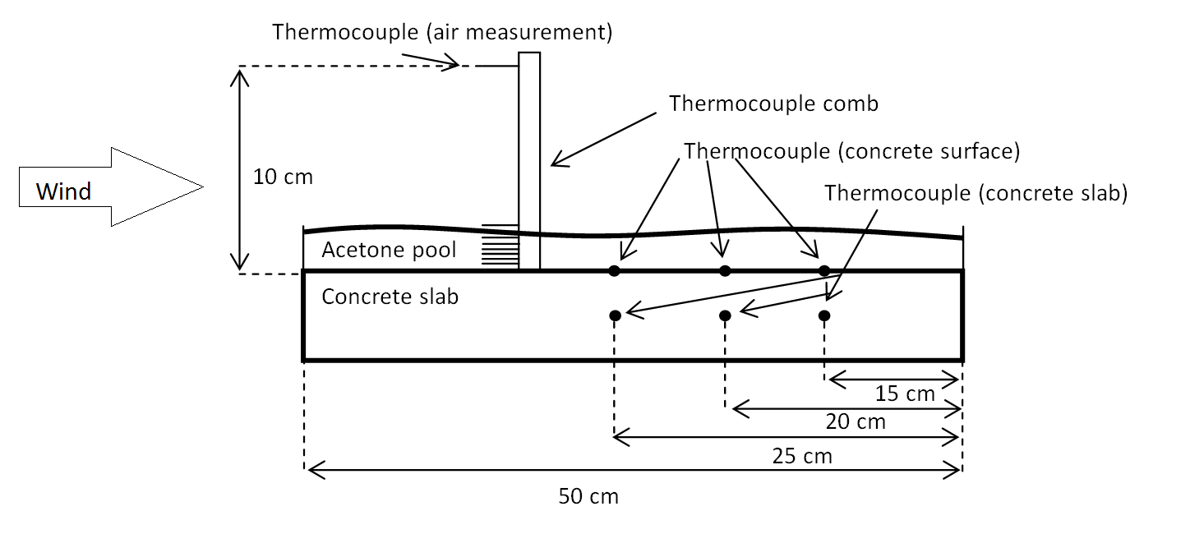

Figure 1*: Experimental setup of liquid evaporation in a wind tunnel*

The input parameters were varied in a [Low-High] level range reported in Table 1, defined according to an estimate of conditions that could happen during a liquid spill. It has to be noted that the soil temperature was heated up to 60°C before testing to represent a hot summer day. These parameters have been scaled as dimensionless numbers in the range [-1; +1] for statistical processing of data and a complete experimental table was designed and performed. The parameters were labelled x1 to x5.

Table 1: Experimental input parameters

|  |  |  |  |  |  |
| --- | --- | --- | --- | --- | --- |
| Parameter | Initial Tliq x1 | Initial Tsoil x2 | Wind velocity Uwind x3 | Air temp Tair x4 | Pool thickness Hthick x5 |
| High level (1) | 22°C | 60°C | 5 m.s-1 | 25°C | 10 cm |
| Low level (-1) | 4°C | 4°C | 2 m.s-1 | 15°C | 2 cm |

* + 1. Determination of input parameters weight on evaporation dynamics

The aim of an experimental design consists at expressing an output parameter (either initial or nearly steady liquid evaporation rates) as a linear polynomial function of the input parameters (initial liquid temperature, initial soil temperature, wind velocity, air temperature and initial liquid thickness) and their interactions. For a 5 parameters experimental design and neglecting the interactions of three parameters or more, the general equation of each output is the following:

|  |  |
| --- | --- |
| $$y=a_{0}+a_{1}x_{1}+a_{2}x_{2}+a_{3}x_{3}+a_{4}x_{4}+a_{5}x_{5}+a_{12}x_{12}+a_{13}x_{13}+a_{23}x_{23}+a_{14}x_{14}+a_{24}x_{24}+a_{34}x_{34}+a_{15}x_{15}+a_{25}x_{25}+a_{35}x_{35}+a_{45}x_{45}$$ | (3) |

This statistical analysis supposes that the output y (evaporation rate) can be calculated by a linear combination of inputs xi and interaction inputs xij. The value of each coefficient ai or aij represents the weight of the input xi or xij. The linearity of the evaporation rate in the selected range was investigated and was shown to be acceptable (linear regression coefficient between 0.88 and 0.99).

In order to check the validity of each polynomial function, a ratio between two terms (the p-value) is computed (equation 26). The first one is the sum of the squared difference between the experimental evaporation rate (yi) and the modeled one (ym) while the second is the sum of the squared difference between the mean of the evaporation rate for two experiments in the same conditions and the modeled value.

|  |  |
| --- | --- |
| $$p= \frac{\sum{{\left({\overline{y}}_{i}-y_{m}\right)}^{2}}}{\sum{{\left({\overline{y}}_{t}-y_{m}\right)}^{2}}}$$ | (4) |

If the p value is less than 5%, the hypothesis according to the polynomial determined from the measurements describes precisely the phenomena is hold. For cases that presented in this work, the p value was less than 0.5% ensuring that the initial and nearly steady evaporation rates are correctly described by the polynomial function in the experimental conditions studied. These polynomial functions are then compared to the ones obtained by modeling the phenomena under the assumption that the Mackay and Matsugu’s equation describes perfectly the phenomena. This statistical analysis was performed on experimental data but also on the Mackay and Matsugu’s model.

* 1. Results
     1. Experimental results: mass loss, evaporation rate and steady state time

An example of experimental data is given on Figure 2 (left). The black curve represents the experimental mass loss of acetone during the test. This data was derived to calculate the evaporation rate (red curve) which started at 4.5 g.s-1.m-2 and finished at 1.5 g.s-1.m-2 after 140 minutes of test. The evaporation rate was again derived to determine the steady state time. In case of Figure 2 (right), the steady state was observed at approximately 40 minutes of test. In the next parts, early evaporation was taken after 30 seconds of evaporation, and steady state evaporation was taken after steady state time.

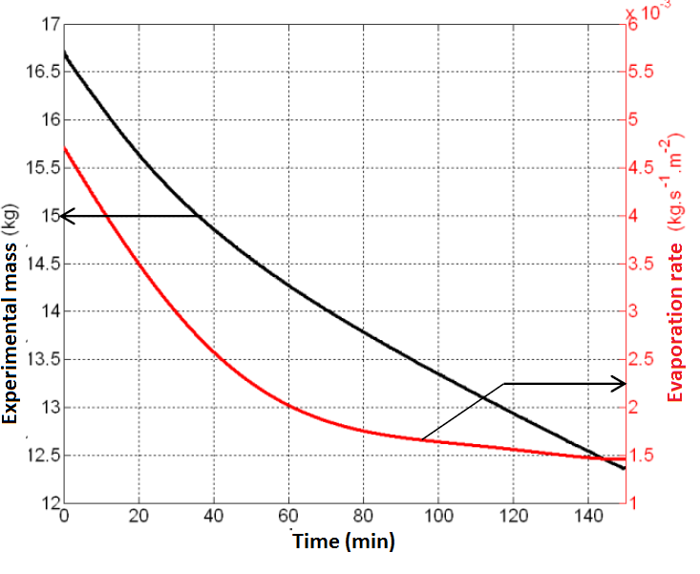 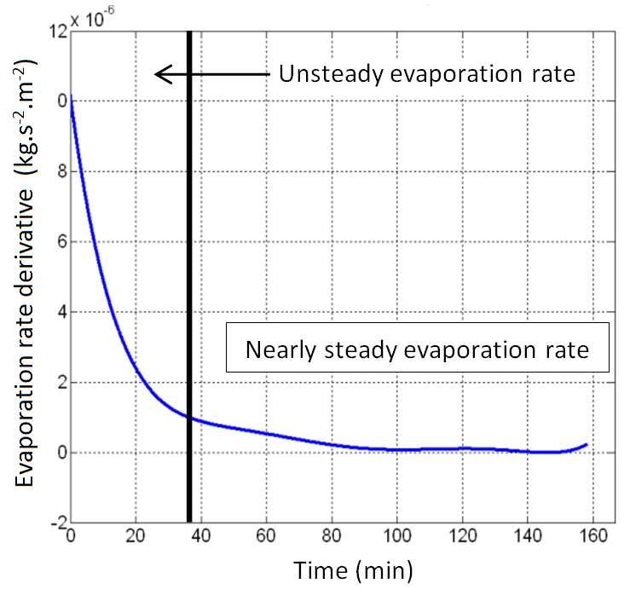

Figure 2*: Experimental data of mass loss, evaporation rate and evaporation rate derivative*

As explained in the introduction part, evaporation phenomena can be described by two balance equations. The driver equation is the mass balance equation, representing that it is wind that will promote evaporation and mass loss. The evaporation will consume phase change heat and will cool the liquid top layer, changing heat balance. Since heat transfer dynamics is quite slow compared to evaporation dynamics, the heat balance will take a long time to reach a pseudo steady state. Mass and heat transfer are of course linked and one phenomenon will influence the other one. Evaporation at initial time is much more intense that at steady state. This is because heat is abundant at initial state and reduced at steady state.

* + 1. Statistical analysis of experimental data

Figure 4 gives the coefficient values (weights) at early time (left) and at steady state (right). At initial time, the most governing parameter is wind (x=3), then soil initial temperature (x=2) and liquid initial temperature (x=1). This is consistent with the physics governing the phenomenon. Wind is the source of evaporation, and the heat required for evaporation is taken in the liquid itself or in the soil. The coefficients are positive, which confirm that a strong wind, high soil and liquid temperatures increase evaporation rate at early time. Liquid thickness and air temperature have a very low impact on the evaporation dynamics at early time.

At steady state, inputs importance change. The most important parameter is the initial liquid thickness. This could be explained by the heat capacity provided by more liquid, but it is tricky to say since at steady state the heat flux necessary to evaporate is exactly compensated by the heat fluxes and independent from the liquid heat. A better explanation requires considering the experimental procedure. For each test, the initial liquid level corresponds to the boundary edge height. When liquid evaporates, the liquid level decreases and the edge wall creates an obstacle to the air flow, like a cavity. The more the liquid level was high at initial time, the more a cavity shape appears during liquid evaporation.

Wind velocity and soil temperature are still important parameters, but their effect decreases significantly. It has to be noted that the initial liquid temperature effect is negative at steady state. This was not expected and is difficult to explain. This is probably related to the whole timeline of evaporation.

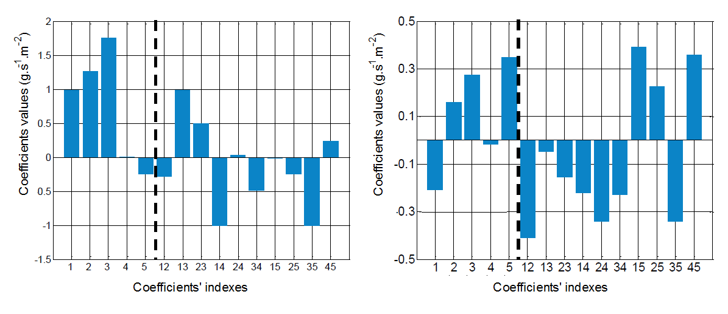

Figure 4*: Statistical analysis of experimental early evaporation (left) and steady state evaporation (right)*

* + 1. Comparison of models with experimental data

Most works aiming at studying and comparing the evaporation accuracy of models only considered the early stage of evaporation, when the liquid temperature equals initial temperature. However, as explained in the previous part, evaporation is time-dependent and the accuracy of models should be tested with time, requiring calculating also the heat transfer equations. This is very important, since an overestimating model for mass transfer will lead to a quicker temperature decrease of the liquid, and a quicker decrease of evaporation rate due to low vapor pressure. On the other side, an underestimating model with lead to a slower temperature decrease and a slower decrease of evaporation rate.

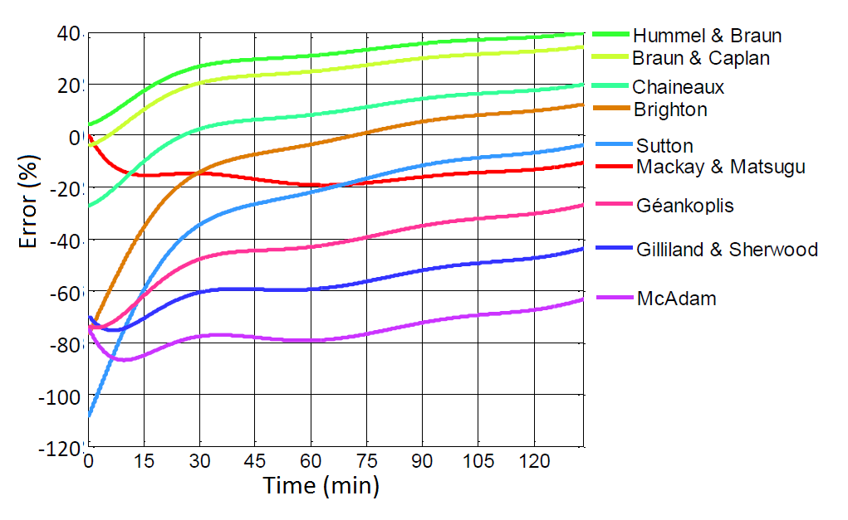

Figure 3: Prediction error of evaporation correlations

A full computation of heat and mass transfer equations with the different models was performed and is given in Figure 3. The experiment was (Tsoil = 4°C; Uwind = 2 m.s-1; Tair = 15°C; Tliq = 22°C, Hthick= 10cm). Results show that the Mackay and Matsugu, the Hummel and Braun and the Braun and Caplan models provide the best prediction for evaporation rate at early stage. The error is less than 5%. Other models underestimate strongly the evaporation rate.

The figure also shows how all models predict the evaporation rate with time. The Mackay and Matsugu model remains acceptable, a slight trend of underestimation keep an accuracy of 10% after 120 minutes. The largest error was observed after one hour, with an underestimation of 20%. The models of Hummel and Braun, and Braun and Caplan deviate with time, reaching an overestimating prediction error close to 40%. On the opposite side, models which underestimated strongly the evaporation rate tend to reduce the error with time. The Sutton model even reaches a very good accuracy after 120 minutes of test.

As a conclusion of this part, most models prediction accuracy change with time, sometimes for better or sometimes for worse accuracy. Only the model of Mackay and Matsugu remained accurate for the 120 minutes of test.

* + 1. Statistical analysis of Mackay and Matsugu evaporation equation

The statistical analysis of Mackay and Matsugu equation was performed the same way as for the experimental data. At early time, the weight of the different entries is very similar to the experimental data. Wind speed, liquid and soil temperature are determining entries of the model. The phenomenon is well understood and described by the equations.

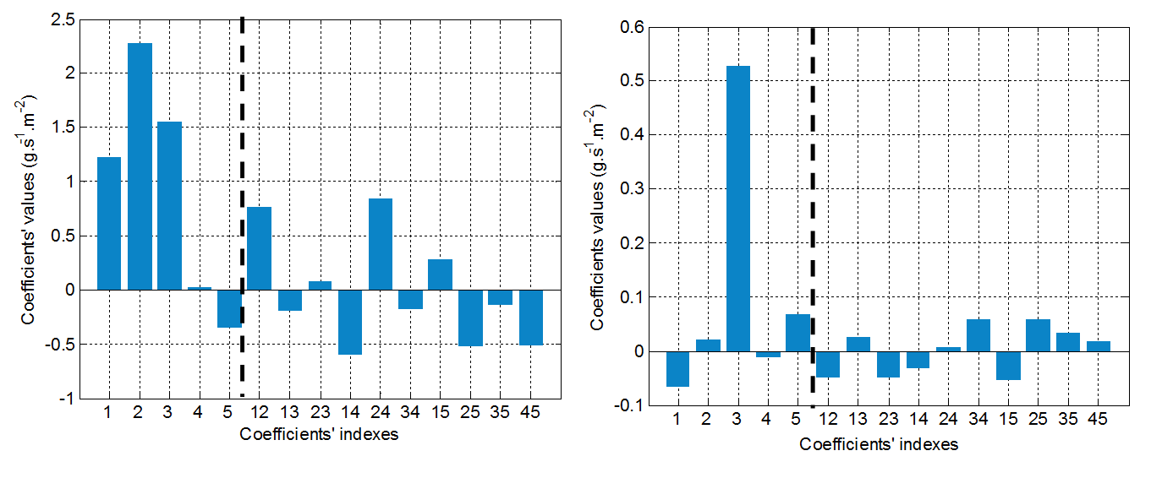

Figure 5*: Statistical analysis of theoretical early evaporation (left) and steady state evaporation (right)*

When considering the steady state, a clear difference is visible. The Mackay and Matsugu model is quite only dependent of the wind speed. Other parameters have a very small impact on the evaporation rate, meaning that the heat balance is negligible in the model. This shows that this probably not correctly described.

* 1. Conclusions

Several conclusions can be drawn from this work. First, it was shown that the Mackay and Matsugu correlation was the most suitable to represent our tests. This was also observed by Bubbico and Mazzarotta (2016). A second important conclusion concerns the evolution of predictions as a function of time. The work clearly shows that the prediction accuracy evolves strongly as a function of time, and only the Mackay and Matsugu correlation is acceptable for the whole duration of the tests. This is especially important for chemical compounds whose toxicity also depends on the duration of exposure, requiring therefore long term evaporation computation.

Finally, the statistical study showed that the best model (Mackay and Matsugu) do not correctly represent the phenomenology of evaporation over a long time. This shows that more work would be required on the thermal aspect of the evaporation phenomenon.

Acknowledgments

The authors are grateful to CEA (Commissariat à l’Energie Atomique et aux Energies Alternatives) for the financial help for this research project.

References

Braun, K., & Caplan, K., 1989. Evaporation rate of volatile liquids*.* Washington: US environemntal protection Agency.

Brighton, P. W., 1985. Evaporation from a plane liquid surface into a turbulent boundary layer. Journal of Fluids Mechanics,159, 323-345.

Bubbico, R., Mazzarotta, B., 2016, Predicting evaporation rates from pools, Chemical Engineering Transactions, 48, 49-54.

Chaineaux, J., Jamois, D., Bonnet, P., Laurent, M., Degaude, D., Menier, P., 2006, Etude du débit d'évaporation et de la concentration atmosphérique d'un composé organique volatil*.* INERIS.

Gallev, A.D., Salin, A.A., Ponikarov, S.I., 2015, Numerical simulation of evaporation of volatile liquids, Journal of Loss Prevention in the Process Industries, 38, 39-49

Geankoplis, C., 1993. Transport Properties and Unit Operations. Prentice Hall Internationnal, Inc.

Gilliland, E., & Sherwood, T., 1934. Diffusion of Vapors into Air Streams. Industrial and Enginnering Chemistry, *26*, pp. 516-523.

Heymes, F., Aprin, L., Bony, A., Forestier, S., Cirocchi, S., Dusserre, G., 2013, An experimental investigation of evaporation rates for different volatile organic compounds, Process Safety Progress, 1-6.

Hummel, A. A., Braun, K. O., & Fehrenbacher, c., 1996, Evaporation of a liquid in a flowing air stream. American Industrial Hygiene Association Journal (57).

Mackay, & Matsugu., 1973, Evaporation rate of liquid hydrocarbon spills on land and water. Canadian Journal of Chemical Engineering, 51, pp. 434-439.

McAdam, W.H., 1954, Heat transmission McGraw-Hill, New York-London, ed. 3

Sutton, O. (1934). Wind structure and evaporation in a turbulent atmosphere, Sutton, O. G. (1934). Wind structure and evaporation in a turbulent atmosphere. Proceedings of the Royal Society of London. Series A, Containing Papers of a Mathematical and Physical Character, 146(858), 701-722.