|  |  |
| --- | --- |
| cetlogo ***CHEMICAL ENGINEERING TRANSACTIONS***  ***VOL. xxx, 2025*** | A publication of  aidiclogo_grande |
| The Italian Association  of Chemical Engineering  Online at www.cetjournal.it |
| Guest Editors: Bruno Fabiano, Valerio Cozzani  Copyright © 2025, AIDIC Servizi S.r.l. **ISBN** 979-12-81206-xx-y; **ISSN** 2283-9216 | |

Interaction Between High Pressure Releases From Small Holes And The Ground Surface

Alessandro Pinciroli, Renato Rota, Valentina Busini\*

[valentina.busini@polimi.it](mailto:valentina.busini@polimi.it)

High-pressure releases are a significant concern in industrial safety, particularly when they involve flammable gases, as these can have severe consequences for both workers and the environment. Common flammable compounds include methane, propane, and hydrogen — the latter being a relatively recent energy carrier gaining traction in various applications. High-pressure releases are notable for their high momentum, which can extend the flammable cloud over considerable distances and potentially cause damage to vulnerable structures.

One well-known fluid behavior is the Coanda effect, which occurs near flat surfaces such as the ground. In the event of a high-pressure release, this effect can further expand the flammable area. Previous studies have explored the influence of the ground on the extension of high-pressure jets from large orifices. This work aims to investigate releases from small orifices to understand their behavior near the ground and determine whether they can be treated similarly to larger releases. Further investigation is also focused on determining whether the low release height allows the jet to hit the ground due to its natural opening angle and the possible incidence of this phenomenon in relation to the Coanda effect.

* 1. Introduction

Future energy systems could rely on hydrogen (H2) to achieve decarbonization and net-zero goals because one approach is to use hydrogen instead of natural gas, or in blend with it, in the gas grid to provide a source of low-carbon heat in the future. Gaseous compounds are largely used among various process industries in all sectors. The transport and storage of gases are done under high pressure conditions which span from a few times the atmospheric pressure to hundreds of bars. The main advantage is the reduced space occupied and consequently, the higher efficiency of transportation and storage. Furthermore, many processes and chemical reactions require pressurized gases to work correctly. Accidental releases of pressurized gases, in particular flammable ones, are characterized by a high momentum and can lead to catastrophic consequences due to many reasons; the possible scenarios include explosions and fires, among which are jet fires and flash fires depending on the ignition time. Furthermore, in congested areas the consequences magnitude can be even worse due to the possibilities of domino effects. High pressure unignited releases can reach significant distances from the jet source thanks to the high initial velocity, so it is common practice during the risk assessment to evaluate the jet length in terms of maximum distance reached by the lower flammable limit concentration (Woodward and Pitbaldo, 2010). Many models are available to predict the velocity and concentration decay of jets. Integral models are the most used ones since they are reliable and do not require high resources to obtain valuable data considering that they can be done by hand. The main drawback of integral models is the impossibility to consider the interaction of the jet with obstacles and surfaces which could significantly change the shape, direction and area of influence of releases, so they are only reliable in a free-jet scenario. CFD models are therefore the only way to take into account complex geometries and obstacles and the interaction of the jet with them but require high computational costs as well as a strong understanding of simulation software, which is often complex and requires specialized training. The application of CFD models is therefore limited although the last technology progresses let to have better computational resources, faster calculation times and lower overall costs.

An interaction between the jet and a flat surface is relevant to safety because a surface, such as the ground, can significantly elongate the maximum distance thanks to the Coanda effect and consequently the portion of jet between the flammable limits that could ignite. Many works studied the interaction between high pressure jet and obstacles (Colombini et al., 2020c, 2022; Colombini and Busini, 2019; Moscatello et al., 2021; Pinciroli et al., 2024;) or flat surfaces (Bénard et al., 2016; Colombini et al., 2020a, 2020b; Hourri et al., 2009). In this work, we studied the interaction between the ground and horizontal jets of methane, propane and hydrogen discharged from small orifices with a 10 mm and 5 mm diameter at various heights from the ground. Small orifices are the loss normally considered for a gas distribution line and the aim is to obtain an empirical correlation, dependent on the substance type and the release height, that can predict the maximum jet distance when an interaction between the jet released from a small orifice and a flat horizontal surface happens. In particular, the simulations are aimed at verify whether the dominant phenomenon with small orifice, which must be very close to a wall to be deflected by the Coanda effect, is the Coanda effect itself or vice versa the impingement of the jet due to the natural opening of the jet.

* 1. Materials and methods
     1. Software

The software used to perform the simulations, from the geometry definition to the solution, is part of the Ansys package. Both Ansys Design Modeler and Ansys Mesher were used for domain creation and mesh generation respectively with the parameters reported in the next sections. Finally, the numerical simulations were conducted using Ansys Fluent 21 (ANSYS Inc., 2021) with steady state conditions. The Workbench environment allowed a parametric study of all the cases described in the results section.

* + 1. Pseudo – source

A supersonic jet is characterized by complex phenomena during the expanding phase in the vicinity of the release source. This portion of the jet, generally referred to as near field zone, was modelled using the Birch pseudo source approach (Birch et al., 1984) which has been widely used in similar works (Bénard et al., 2016; Colombini et al., 2022, 2020a, 2020b; Colombini and Busini, 2019;). The aim of this method is to avoid the numerical simulation of the near field zone which would be computationally expensive, keeping the reliability of the results with an overall lower simulation time.

* + 1. Wind profile

To achieve realistic outdoor scenario conditions, this work was modelled using the 5D atmospheric stability class with the same flow direction as the jet. Even though the release is under sonic conditions, the wind presence is a valid assumption since it could elongate the maximum extent of the LFL cloud. To input the wind velocity to the domain the power law reported in eq. 1 was used and implemented in the software with a user defined function:

$$\begin{aligned}\begin{aligned}u_{y}=u_{ref}×{\left(\frac{y}{10}\right)}^{β} \#\#\#\#\#\#\#\#\#\#\end{aligned} \#\left(1\right)\end{aligned}$$

Where:

* $u_{ref}$ is the wind velocity at 10 m above ground
* y is the height above the ground
* $β=0.25$ is a factor that accounts for atmospheric stability and the type of ground surface (Crowl and Louvar, 2019).
  + 1. Computational domain

The computational domain was designed to guarantee reliable results while minimizing simulation times. Therefore, a similar approach as (Hourri et al., 2009) and (Bénard et al., 2016) was used to define the overall dimensions, following the theory discussed in (Franke and Baklanov, 2007). Hence, the domain consists of a rectangular box 20 m wide, and 100 m long as shown in . The total height is 15 m for methane and propane and 50 m for hydrogen releases due to its natural buoyancy. The pseudo source is positioned on the front face of a 7 m nozzle to ensure enough separation from the domain inlet to avoid boundary effects (i.e., convergence problems related to the high velocity gradient between the wind inlet and the jet inlet). The release height from the ground is not constant as it is defined by the case study. Domain boundaries showed in Figure 1 are defined as velocity inlets for the wind, pressure outlet on the face opposite to the jet inlet, wall for the ground and a symmetry plane which lets to halve the computational cost of the simulations.

|  |  |
| --- | --- |
|  |  |

Figure 1: computational domain and mesh

The grid consists of a tetrahedral mesh built similarly to (Colombini et al., 2022, 2020c; Colombini and Busini, 2019). On the jet axis, a series of lines, Core, Far 1, Far 2, Far 3 and Far 4, were used to define five edges local sizing so that near the orifice the mesh is finer and becomes coarser as it gets further away. A proximity sizing of 10 was adopted on the nozzle as well as other boundaries. The overall volume meshing has a size of 3 m except for the local sizing parts. In the mesh size and growth rate are reported for the bodylines and for the nozzle.

Table 1: mesh sizing parameters

|  |  |  |  |  |  |  |
| --- | --- | --- | --- | --- | --- | --- |
|  | Nozzle | Core | Far 1 | Far 2 | Far 3 | Far 4 |
| $$\frac{Cell size [m]}{line lenght [m]}$$ | - | 35 | 35 | 70 | 140 | 390 |
| $$\frac{Inlet diameter [m]}{Cell size [m]}$$ | 10 | 73 | 18 | 10 | 3 | 1 |
| Growth Rate | 1.2 | 1.075 | 1.1 | 1.15 | 1.175 | 1.2 |

For the solver setup, a coupled pseudo-transient formulation was chosen for the pressure-velocity solution method. A second-order spatial discretization scheme was employed for all variables to enhance accuracy. The convergence criteria are the ones suggested in the software manual, a ${10}^{-3}$ residual value for all the variables except the energy equation that has a smaller residual criterion of .

* 1. Results
     1. Case studies

The main aim of the work is to study the interaction between horizontal high-pressure jets released from small orifices and the ground surface. To have a comparison case, for all three substances a free jet case was simulated to obtain the overall dimension of a jet which does not interact with the ground. Then, a series of releases were simulated varying the height from the ground starting from $h=D_{eq}$ and increasing the height until the free - jet was reached. Release conditions were chosen to consent to a comparison with a previous work (Colombini et al., 2020a). Storages are kept at ambient temperature of 300 K and the internal pressure is 65 bar for Methane, 8 bar for Propane and 101 bar for Hydrogen.

* + 1. Hole with 5 mm diameter

For the smaller leak, a 5 mm hole was chosen. The main release parameters for the three substances are reported in Table 2 along with the free – jet case maximum extension (MEfj).

Table 2 Release parameters.

|  |  |  |  |
| --- | --- | --- | --- |
|  | Deq [m] | Mass flow rate [kg/s] | MEfj [m] |
| Methane | 0.0287 | 0.1773 | 3.33 |
| Propane | 0.0102 | 0.037 | 1.7 |
| Hydrogen | 0.038 | 0.1233 | 15.84 |

Release heights were taken as multiple of the equivalent diameter, starting from $\frac{h}{D_{eq}}=1$ until reaching the free – jet conditions. The primary phenomenon observed, consistent with previous studies (Bénard et al., 2016; Colombini et al., 2020a, 2020b; Hourri et al., 2009) is the Coanda effect. This effect, resulting from a pressure differential between the air above and below the jet, causes the jet to adhere to the ground, thereby extending its travel distance compared to the free-jet scenario. Additionally, due to the low release height, the jet naturally contacts the ground during the expansion phase, a phenomenon that can possibly increase the contribution of the terrain to the jet total length. In Figure 2 the results are plotted in the same space of (Colombini et al., 2020a) to visualize the correlation between the release height and the ground influence.

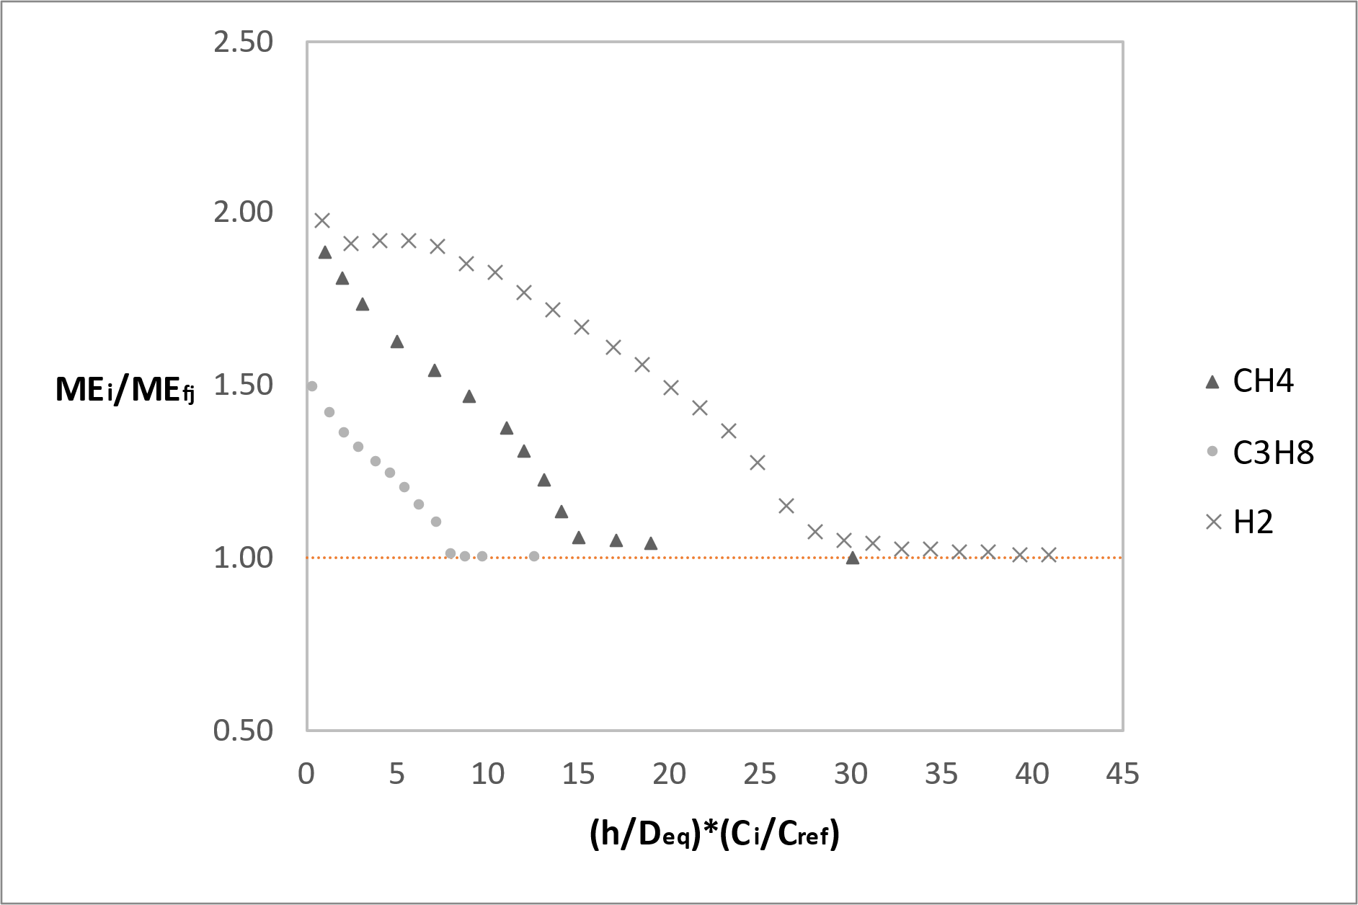

Figure 2: plot of the jet ME in relation to the scaled release height for the 5 mm release case

For every substance there is a threshold value beyond which the jet is not influenced by the terrain, and it behaves as a free – jet. Threshold values for each substance are slightly lower but remain comparable with the ones reported by (Colombini et al., 2020a) meaning that even for a smaller release diameter the Coanda effect is predominant even if its release point is near the ground and that the jet impacts the terrain due to its opening angle in a point that is beyond the point of adherence due to the Coanda effect as shown in Figure 3.

Figure 3: LFL contour showing the Coanda effect overcoming the jet opening angle

* + 1. Hole with 10 mm diameter

The same procedure as for the 5 mm diameter scenario was followed, with the main release characteristics reported in Table 3.

Table 3 Release characteristics

|  |  |  |  |
| --- | --- | --- | --- |
|  | Deq [m] | Mass flow rate [kg/s] | MEfj [m] |
| Methane | 0.0574 | 0.7639 | 6.67 |
| Propane | 0.2034 | 0.1489 | 3.5 |
| Hydrogen | 0.07624 | 0.4953 | 31.3 |

Results plotted in Figure 4 showed a comparable behavior between the two scenarios, with a threshold value of (h/Deq)(Ci/Cref) beyond which the ground does not influence anymore the jet. In this scenario, the threshold value for methane and propane is respectively 13 and 7, while for hydrogen is 25. Comparing it with the results of the 5 mm diameter release and the ones obtained in previous works with large discharging holes (Bénard et al., 2016; Colombini et al., 2020a), they are similar, confirming that also in this case the Coanda effect is still the most influencing phenomenon while the impact with the ground due to the jet expanding phase does not affect the overall behavior.

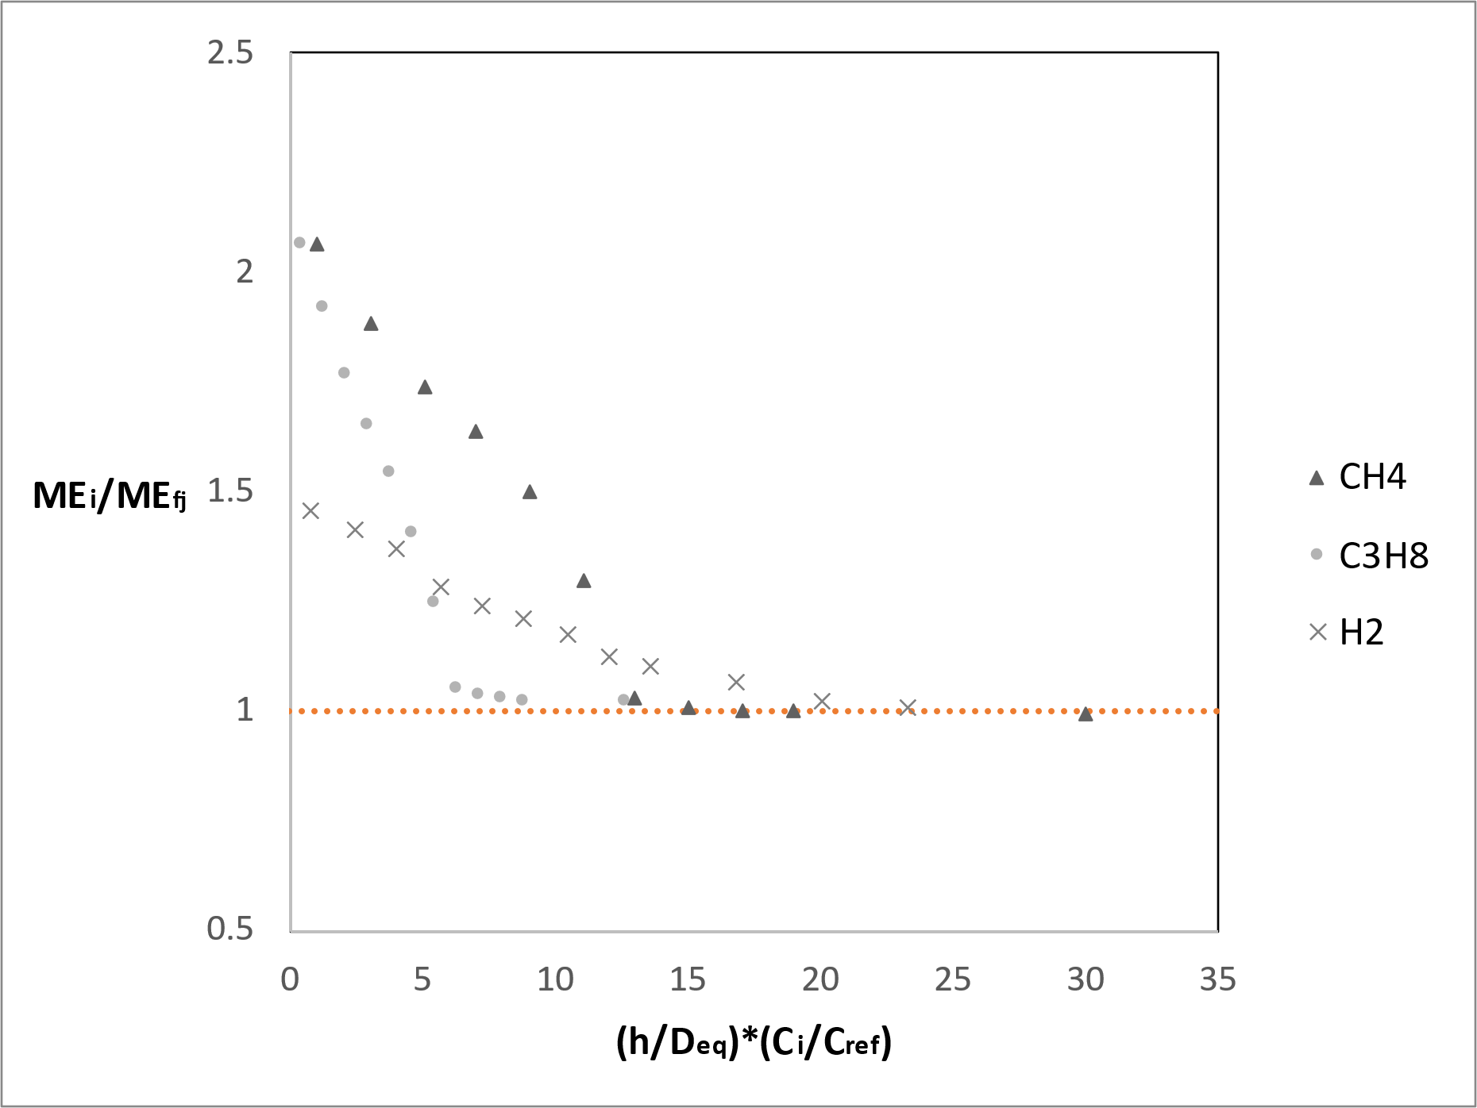

Figure 4: plot of the jet ME in relation to the scaled release height for the 10 mm release case

* 1. Conclusions

In this work, high – pressure releases of methane, propane and hydrogen through small holes were studied to investigate if the behavior of the jet impinging the ground could be affected by the discharging hole diameter or by the direct impact with the terrain due to the low release height. The source was an orifice of 5 mm in the first case and 10 mm in the second one, with a variable release height starting from h/Deq = 1 until reaching the free – jet conditions. Results are consistent with previous similar works showing that the Coanda effect is still the predominant phenomenon, although a slightly difference was noted in the value of the h/Deq threshold that separates the jet – ground interaction behavior and the free – jet behavior. Future works may take into consideration different storage conditions as well as parametric studies about the correlation between release height and mas flow rate discharged.

* 1. Nomenclature

Ci – LFL concentration of the i substance, -

Cref – LFL concentration of methane, -

Deq – equivalent source diameter, m

h – release height above ground, m

MEi – jet maximum extension of i substance, m

MEfj – free – jet maximum extension, m

y – vertical coordinate, m

uref – wind velocity at 10 m above the ground, m/s

uy – wind velocity along vertical direction, m/s

β – exponential factor, -

* 1. References

ANSYS Inc., 2021. ANSYS Fluent 21 User’s guide.

Bénard, P., Hourri, A., Angers, B., Tchouvelev, A., 2016. Adjacent surface effect on the flammable cloud of hydrogen and methane jets: Numerical investigation and engineering correlations. International Journal of Hydrogen Energy 41, 18654–18662. https://doi.org/10.1016/j.ijhydene.2016.08.173

Birch, A.D., Brown, D.R., Dodson, M.G., Swaffield, F., 1984. The Structure and Concentration Decay of High Pressure Jets of Natural Gas. Combustion Science and Technology 36, 249–261. https://doi.org/10.1080/00102208408923739

Colombini, C., Busini, V., 2019. Obstacle Influence on High-Pressure Jets based on Computational Fluid Dynamics Simulations. Chemical Engineering Transactions 77, 811–816. https://doi.org/10.3303/CET1977136

Colombini, C., Carlini, L., Rota, R., Busini, V., 2020a. Ground Interaction on High-pressure Jets: Effect on Different Substances. Chemical Engineering Transactions 82, 367–372. https://doi.org/10.3303/CET2082062

Colombini, C., Martani, A., Rota, R., Busini, V., 2020b. Ground influence on high-pressure methane jets: Practical tools for risk assessment. Journal of Loss Prevention in the Process Industries 67, 104240. https://doi.org/10.1016/j.jlp.2020.104240

Colombini, C., Maugeri, G., Zanon, G., Rota, R., Busini, V., 2020c. Unignited High-Pressure Methane Jet Impinging a Pipe Rack: Practical Tools for Risk Assessment. Journal of Loss Prevention in the Process Industries 69, 104378. https://doi.org/10.1016/j.jlp.2020.104378

Colombini, C., Iannantuoni, C., Rota, R., Busini, V., 2022. Unignited high-pressure methane jet impacting a cylindrical obstacle: An assessment tool for consequences analysis. Journal of Loss Prevention in the Process Industries 76, 104593. https://doi.org/10.1016/j.jlp.2021.104593

Franke, J., Baklanov, A., 2007. Best Practice Guideline for the CFD Simulation of Flows in the Urban Environment: COST Action 732 Quality Assurance and Improvement of Microscale Meteorological Models.

Hourri, A., Angers, B., Bénard, P., 2009. Surface effects on flammable extent of hydrogen and methane jets. International Journal of Hydrogen Energy 34, 1569–1577. https://doi.org/10.1016/j.ijhydene.2008.11.088

Moscatello, A., Uggenti, A.C., Gerboni, R., Carpignano, A., 2021. A novel approach to high-pressure gas releases simulations. Journal of Loss Prevention in the Process Industries 72, 104531. https://doi.org/10.1016/j.jlp.2021.104531

Pinciroli, A., Ferrario, F., Rubbuano, L., Rota, R., Busini, V., 2024. Cuboid obstacle influence on high-pressure jet dispersion: A CFD study. Journal of Loss Prevention in the Process Industries 91, 105416. https://doi.org/10.1016/j.jlp.2024.105416

Woodward, J.L., Pitbaldo, R.M., 2010. LNG Risk Based Safety: Modeling and Consequence Analysis. John Wiley & Sons, Ltd. https://doi.org/10.1002/9780470590232.fmatter