|  |  |
| --- | --- |
| cetlogo ***CHEMICAL ENGINEERING TRANSACTIONS***  ***VOL. xxx, 2025*** | A publication of  aidiclogo_grande |
| The Italian Association  of Chemical Engineering  Online at www.cetjournal.it |
| Guest Editors: Bruno Fabiano, Valerio Cozzani  Copyright © 2025, AIDIC Servizi S.r.l. **ISBN** 979-12-81206-xx-y; **ISSN** 2283-9216 | |

Experimental Study on Pressure Relief of Gas Explosions in Large Vessels

Simon Drost\*, Vera Hoferichter, Sebastian Benzinger, Robert Blanchard

BASF SE, 67056 Ludwigshafen, Germany

simon.drost@basf.com

The study aims to contribute insights into the design and implementation of pressure relief systems in industrial applications, presenting an experimental study of pressure relief during gas explosions within a 4.4 m³ vented vessel. The experiments focus on evaluating various combustible gases, specifically ammonia, methane, propane, ethylene, and hydrogen, five model combustibles representing different ranges of laminar burning velocity. A series of burst discs with varying diameters and static activation pressures were tested to assess their impact on the reduced explosion pressure. The experimental results were compared against two low-order models from existing literature, providing a validation framework for these theoretical approaches.

* 1. Introduction

Explosion pressure vents are essential safety devices used when explosive mixtures within a containment cannot be avoided, and the equipment cannot withstand the pressures resulting from a potential explosion. These vents open at a specific overpressure to release gas from the containment, thereby reducing the internal pressure to what is known as the reduced explosion pressure. This reduced explosion pressure is dependent on factors such as vent size, the static activation pressures/opening pressure of the venting device, and the explosion characteristics of the gas mixture. The design guidelines for pressure relief systems are established in EN 14994; however, the limitations of this standard, as highlighted by Blanchard (2013), include the potential for negative venting areas for gases with very low rate of pressure rise, as well as unrealistic predictions of venting area requirements. In response to these issues, BASF's safety engineering group has developed an improved design procedure based on the physical processes of explosion pressure venting, resulting in two low-order models: 1. Blanchard and Schildberg (2013) and 2. Hoferichter and Schildberg (2019).

This paper compares the predictions of these two models with experimental data. Experiments are conducted using various combustible gases with different laminar burning velocities and rates of pressure rise, while also varying the thickness and size of the burst discs to assess the models’ prediction accuracies depending on activation pressure and venting area.

* 1. Methodology

The experimental setup and the experimental conditions are described below, followed by a brief explanation of the simulations performed with the two low-order models. Detailed information on both models can be obtained from the cited literature.

* + 1. Experimental setup

The experiments were conducted in a large 4.4 m³ vessel as illustrated in Figure 1a and 1c. The vessel is designed as a cylinder with a diameter of 1050 mm and a length of approx. 5250 mm. Pressure relief was achieved using various burst discs with diameters of 50, 100, 200, and 310 mm. The discs were manufactured from aluminum foil with thicknesses of 0.2 and 0.3 mm, an example is shown in Figure 1b.

To detect the rupture of the discs, a wire was mounted in front of the disc. This wire is positioned such that it does not have direct contact with the burst disc, allowing for the elastic and plastic deformation of the disc before it ultimately bursts. The distance of the wire to the burst disc was determined in preliminary tests. In these tests, the vessel was slowly pressurized, and the maximum deformation just before bursting was recorded. The wire distance was then adjusted according to this deformation. For CH4 and small burst discs, the rupture was sometimes triggered by placing a nail in front of the disc. Due to the elastic deformation of the disc, the nail destroyed the disc and initiated the rupture. However, this approach was time-consuming and was therefore only applied for the CH4 experiments.

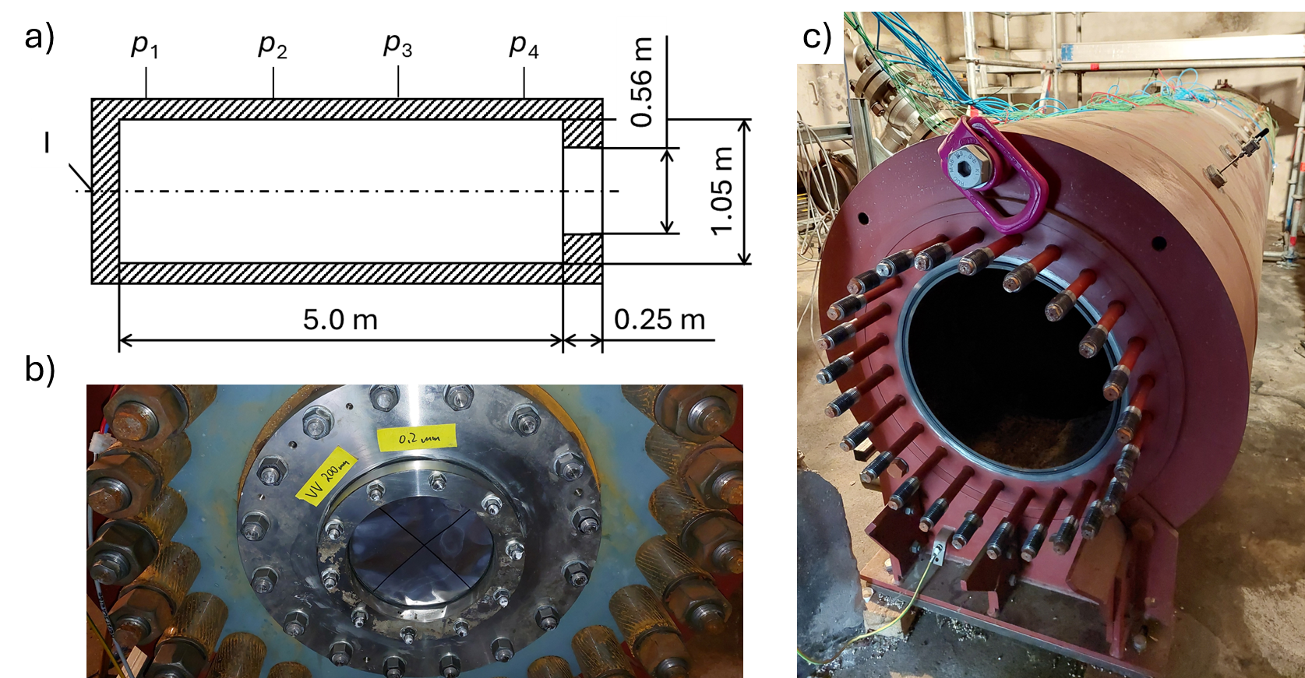

*Figure 1: Experimental setup a) sketch of the vessel with main dimensions*; b) example of an installed burst disc; c) vessel without an installed burst disc.

Pressure within the vessel was measured at four different axial positions (Figure 1a, *p*1 to *p*4) using piezo-electric pressure sensors from *PCB* with a range of 325 bar, each equipped with a *Kistler* charge amplifier. The gas mixture was ignited using a half-wave ignition device, with an ignition energy of approximately 20 J (Figure 1a, I). Prior to each experiment, the vessel was evacuated to a pressure of about 0.02 barabs. After evacuation, the combustible gas was filled into the vessel, followed by air to a total pressure of about 1.04 barabs. Stoichiometric mixtures with air were investigated for methane (CH4), propane (C3H8), ethylene (C2H4) and ammonia (NH3). Hydrogen (H2) was measured from lower explosion limit up to 21 mol-% H2. The mixture composition was investigated in preliminary tests by GC measurements at different positions and at different mixing times to ensure a homogeneous mixture.

* + 1. Experimental conditions

The investigated gas compositions along with their corresponding properties, including the heat capacity ratio *κ* (as ideal gas at standard conditions), mean molecular weight *M*W, and laminar burning velocity *s*L, explosion pressure ratio *r*Ex, and normalized rate of pressure rise / deflagration index *K*G are presented in Table 1. The explosion pressure ratio is defined as the explosion pressure *p*Ex divided by the initial pressure *p*0

|  |  |
| --- | --- |
| . | (1) |

The maximum rate of pressure rise ${dp\left(t\right)}/{dt}$ is normalized with respect to the volume of the vessel $V$

|  |  |
| --- | --- |
| $$K_{G}=\max\left({dp\left(t\right)}/{dt}\right)V^{1/3}.$$ | (2) |

All tested gas mixtures are close to stoichiometric mixtures of the combustible gas in air apart from H2. The measurements were conducted at ambient temperature, approximately 15 - 20 °C, with an initial pressure that corresponds to the atmospheric pressure, 1 barabs. Early experiments with H2 resulted in detonations, prompting the abandonment of further H2-tests due to unsuitability of explosion pressure relief as a protection concept. Burning velocity data is taken from Marinov et al. (1995), Zhang et al. (2021), Zhao et al. (2004), Drost et al. (2023). Explosion pressure ratio and rate of pressure rise data is taken from BAM and Technical University Delft (2006), Swift (1989), Technical University Delft et al. (2006).

Table 1: *Overview of the investigated gas mixtures and their properties, ordered by K*G*-values.*

|  |  |  |  |  |  |  |  |  |
| --- | --- | --- | --- | --- | --- | --- | --- | --- |
| Gas mixture / mol-% | | | | *κ* / - | *M*W / kg/mol | *s*L / m/s | *r*Ex / - | *K*G / bar m/s |
| Argon | Oxygen | Nitrogen | Combustible |  |  |  |  |  |
| 0.78 | 16.38 | 60.84 | NH3: 22.00 | 1.374 | 0.0263 | 0.063 | 5.2 | 3.2 |
| 0.90 | 18.96 | 70.43 | CH4: 9.70 | 1.388 | 0.0277 | 0.36 | 8.3 | 66.6 |
| 0.96 | 20.16 | 74.88 | C3H8: 4.00 | 1.369 | 0.0296 | 0.404 | 7.9 | 96 |
| 0.94 | 19.73 | 73.28 | C2H4: 6.05 | 1.385 | 0.0289 | 0.64 | 8.6 | 193.2 |

* + 1. Simulations

In this study, two low-order models were used to predict the reduced explosion pressure of the performed experiments:

* Model 1 (BASF Blanchard): The model incorporates several input parameters, including key characteristics of the gas such as the normalized rate of pressure rise ($K_{G}$-value), the maximum explosion pressure $p_{Ex}$ the volume of the vessel $V$, the venting area of the burst disc $A_{D}$, and the opening pressure/static activation pressure $p_{stat}$ (Blanchard and Schildberg, 2013).
* Model 2 (BASF Hoferichter): The BASF Hoferichter model extends the analysis by considering not only the volume of the vessel but also its length. This allows for predicting reduced explosion pressures as a function of the vessel geometry, reducing the degree of conservatism of the prediction especially for elongated vessels. Key input parameters of this model include the explosion pressure ratio $r_{Ex}$, the laminar burning velocity $S_{L}$, and the flame acceleration factor $C_{st}$. The latter is determined by fitting the simulated pressure-time curve to standard experiments, such as those conducted in a closed 20-liter spherical vessel (Hoferichter and Schildberg, 2019).

Both models do not include chemical kinetics and are thus dependent on a few parameters only, which can also be provided for complex gas mixtures. By comparing the predictions of both models to results from large-scale experiments, the study aims to further validate both models.

* 1. Results

First, results for explosions in a closed vessel are presented. These data can be utilized as input for a more accurate validation of the low-order models. The gases used in the experiments can be categorized based on their laminar burning velocity or rates of pressure rise. The second section summarizes the results for pressure relief using gases with medium laminar burning velocities, specifically CH4 and C3H8. In the third section, the results for gases with low (NH3) and high (C2H4 and H2) laminar burning velocities are presented.

* + 1. Closed vessel experiments

For these experiments, the vessel was sealed with a metal disc able to withstand the explosion pressure. Due to the varying positions of the pressure sensors and the elongated vessel geometry, the rate of pressure rise slightly differs across the measurements; therefore, a range is provided for each mixture. Table 2 presents the results, including the corresponding maximum explosion pressure $p_{Ex}$ observed during the experiments. Additionally, Table 2 indicates the time-duration from ignition to the attainment of maximum pressure $t_{Ex}$. These data highlight the dynamic behavior of the pressure response within the vessel and underscore the influence of sensor positioning on the measured rates of pressure rise. Data for H2 is at that point not shown, because only several lean mixtures have been investigated.

Table 2: Results for closed vessel experiments.

|  |  |  |  |  |
| --- | --- | --- | --- | --- |
| Gas | $K_{G}^{ }$/ bar m/s | ${max⁡(dp\left(t\right)}/{dt} )$/ bar/s | $p_{Ex}$/ barabs | ./ s |
| CH4 | 29.6 – 32.6 | 18.1 – 19.9 | 7.4 | 1.2 |
| C3H8 | 34.6 – 38.2 | 21.1 – 23.3 | 8.0 | 1.0 |
| C2H4 | 42.1 – 48.3 | 25.7 – 29.5 | 8.6 | 0.5 |
| NH3 | 5.0 – 5.7 | 3.1 – 3.5 | 6.1 | 4.6 |

In comparison to values from literature, e.g. BAM and Technical University Delft (2006), Swift (1989), the *K*G values for the gases CH4, C3H8, and C2H4 are relatively low. This is expected based on the tubular geometry, as studies from the literature, such as those by Phylaktou (1991), indicate. One explanation for this discrepancy is the geometry of the vessel used in the experiments.

Typically, gases are measured in spherical vessels with a surface/volume ratio of approximately 3 with a central ignition. Ignition in this experiment occurs at the end site of the vessel. In spherical experiments with central ignition, the flame front increases faster over time (spherical flame propagation), than in the tubular experiment (surface/volume ratio of about 7.6), resulting in a higher rate of pressure rise. Additionally, when ignition occurs near the wall, the flame travels through the entire volume for a longer duration compared to ignition occurring within the volume itself. This extended time also results in more heat being transferred to the vessel wall. The greater heat losses result in a lower explosion pressure.

* + 1. Vented experiments with methane and propane

Figure 2 (left) depicts a comparison of reduced explosion pressure over the static activation pressure *p*stat of the burst disc. The static activation pressure is varied by using different discs (different thicknesses and sizes). The black points indicate the measured maximum pressure near the burst disc, while the error bars represent the maximum pressures recorded across all pressure sensors within the entire system. Data from Table 1 (Section 2.2), which were typically measured in a 20-liter sphere, were used as input for the low-order models. Additionally, the static activation pressure and venting area were incorporated as input. On the one hand, the BASF Blanchard model significantly overestimates the reduced explosion pressure in the low activation pressure range by nearly 100%. As the activation pressure increases, the deviation is decreased. A high overprediction of the explosion pressure is also found for small burst disc diameters. For small burst discs, the rupture was sometimes triggered to reduce the activation pressure. The combination of low activation pressure and small burst disc diameter is overly conservative well by the BASF Blanchard model (CH4 at *p*stat = 3 and 5 barabs). The overprediction of the explosion pressure by the model is caused by the cylindrical geometry. The geometry is not considered. The experiment has a length-to-diameter ratio of approximately 5.1. Various approaches can be used to convert the *K*G value or the explosion pressure to cylindrical geometries. Here, the value from the closed volume experiment (Table 2) is used. These results are presented in Figure 2, left, as Blanchard (tube). The trend that experimental data are better predicted when the *K*G value is adjusted for the geometry is observed for all species. However, for the sake of clarity, this will not be further illustrated.

On the other hand, the BASF Hoferichter model closely aligns with the experimental data, showing an improvement, particularly at very low activation pressures and small diameters. To simulate the data for CH4, the flame acceleration factor was adjusted (*C*ST = 1.84) to match the pressure curve measured in a 20-liter sphere (*s*L = 0.36 m/s and *K*G = 66.6 bar m/s).

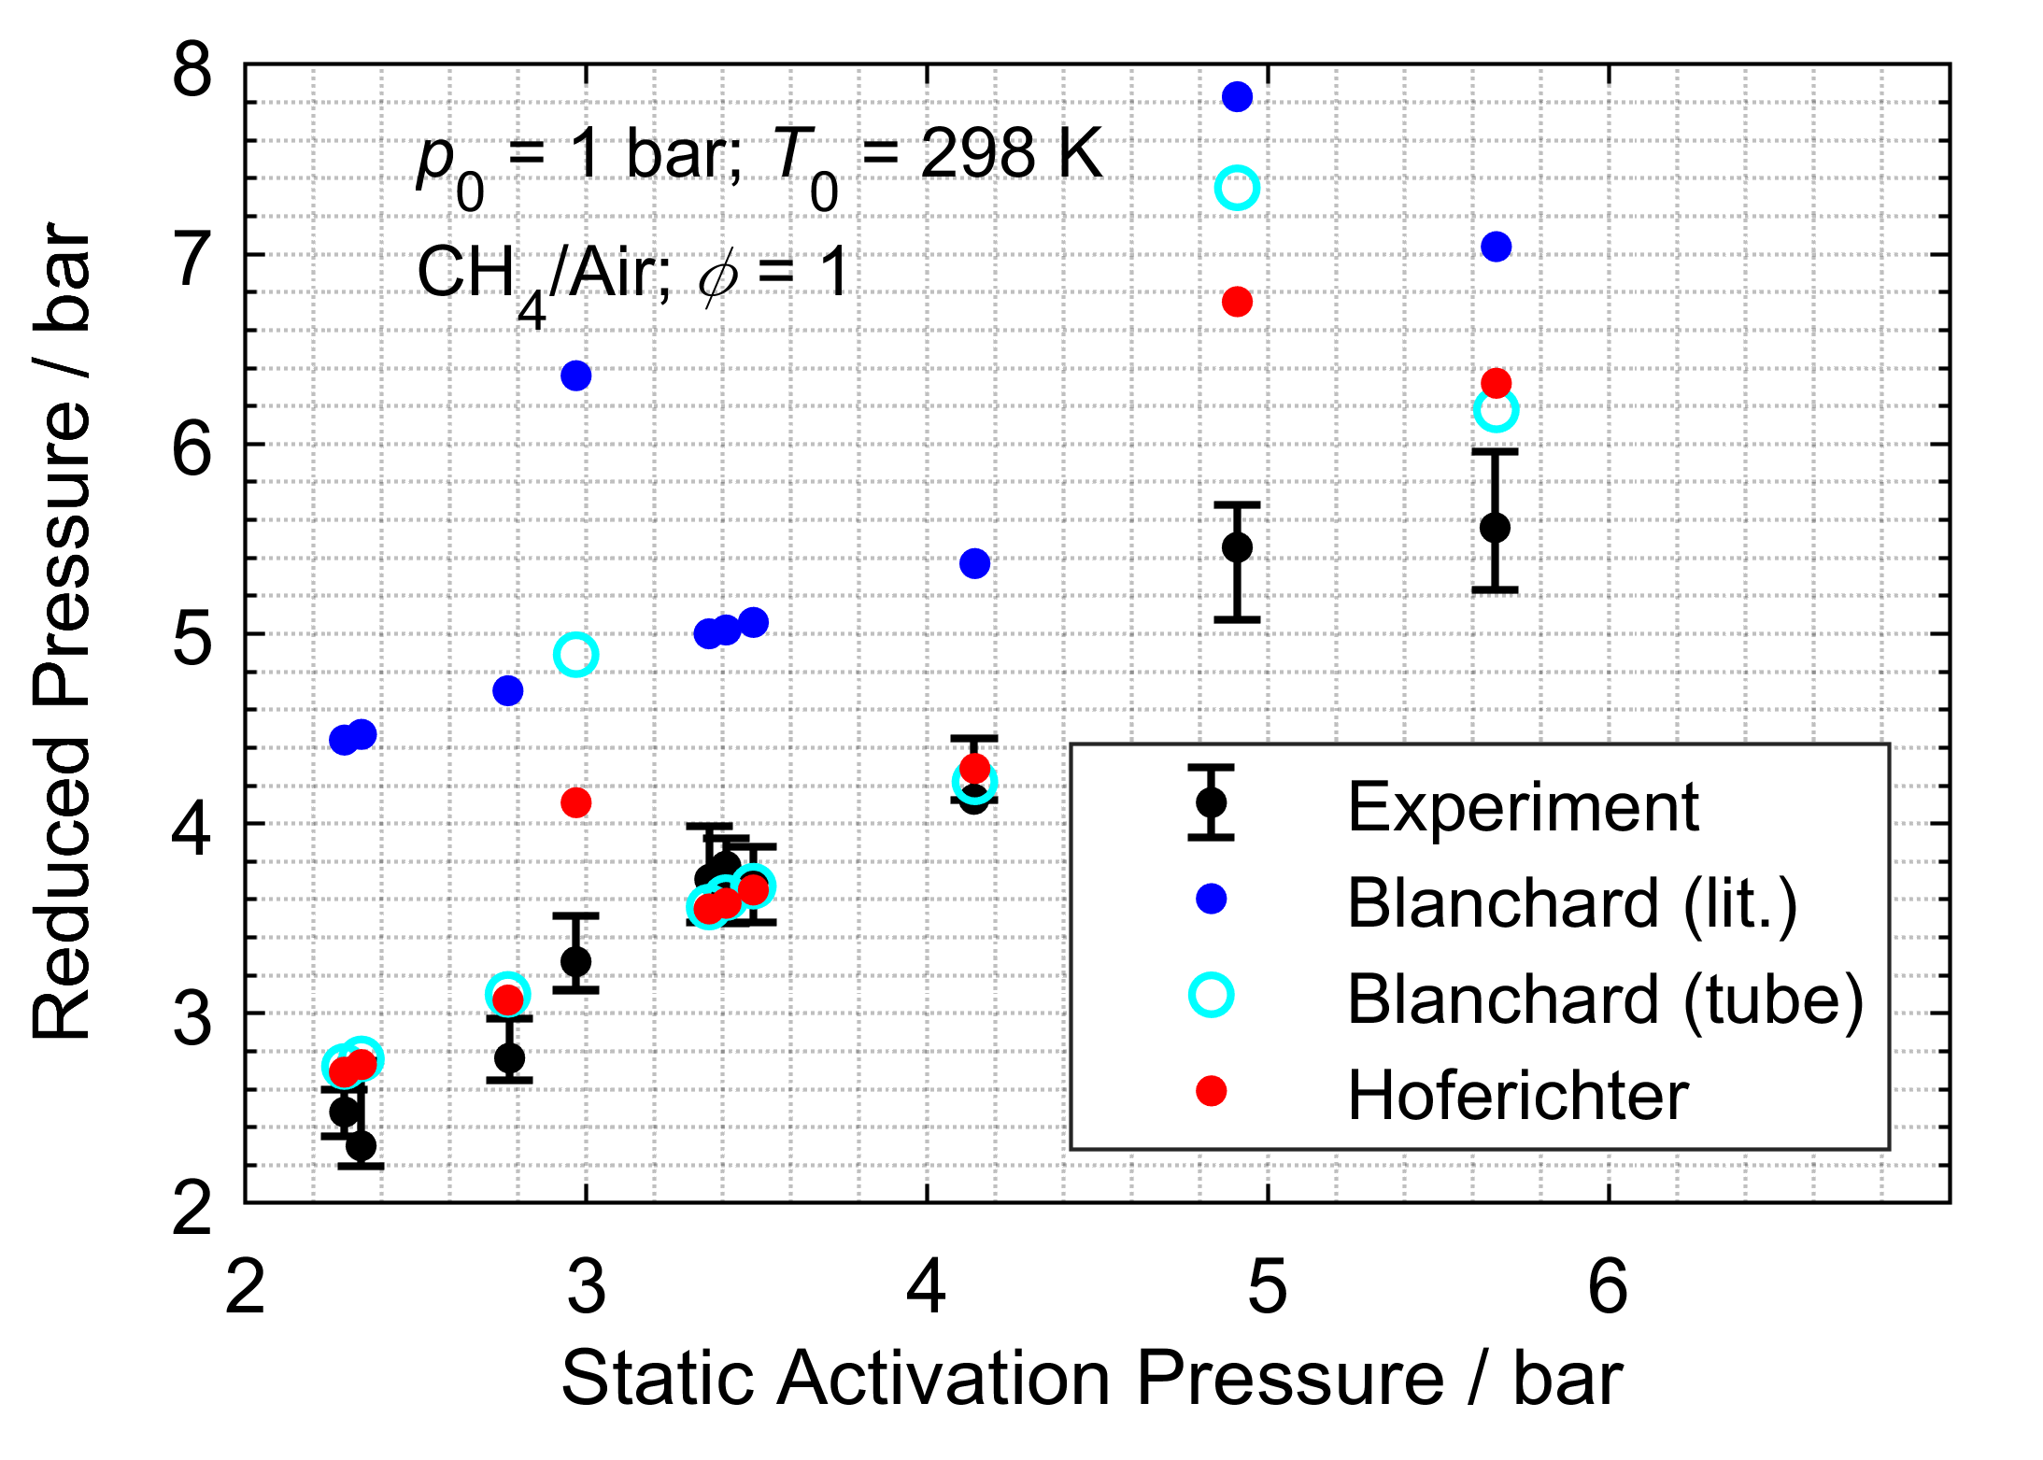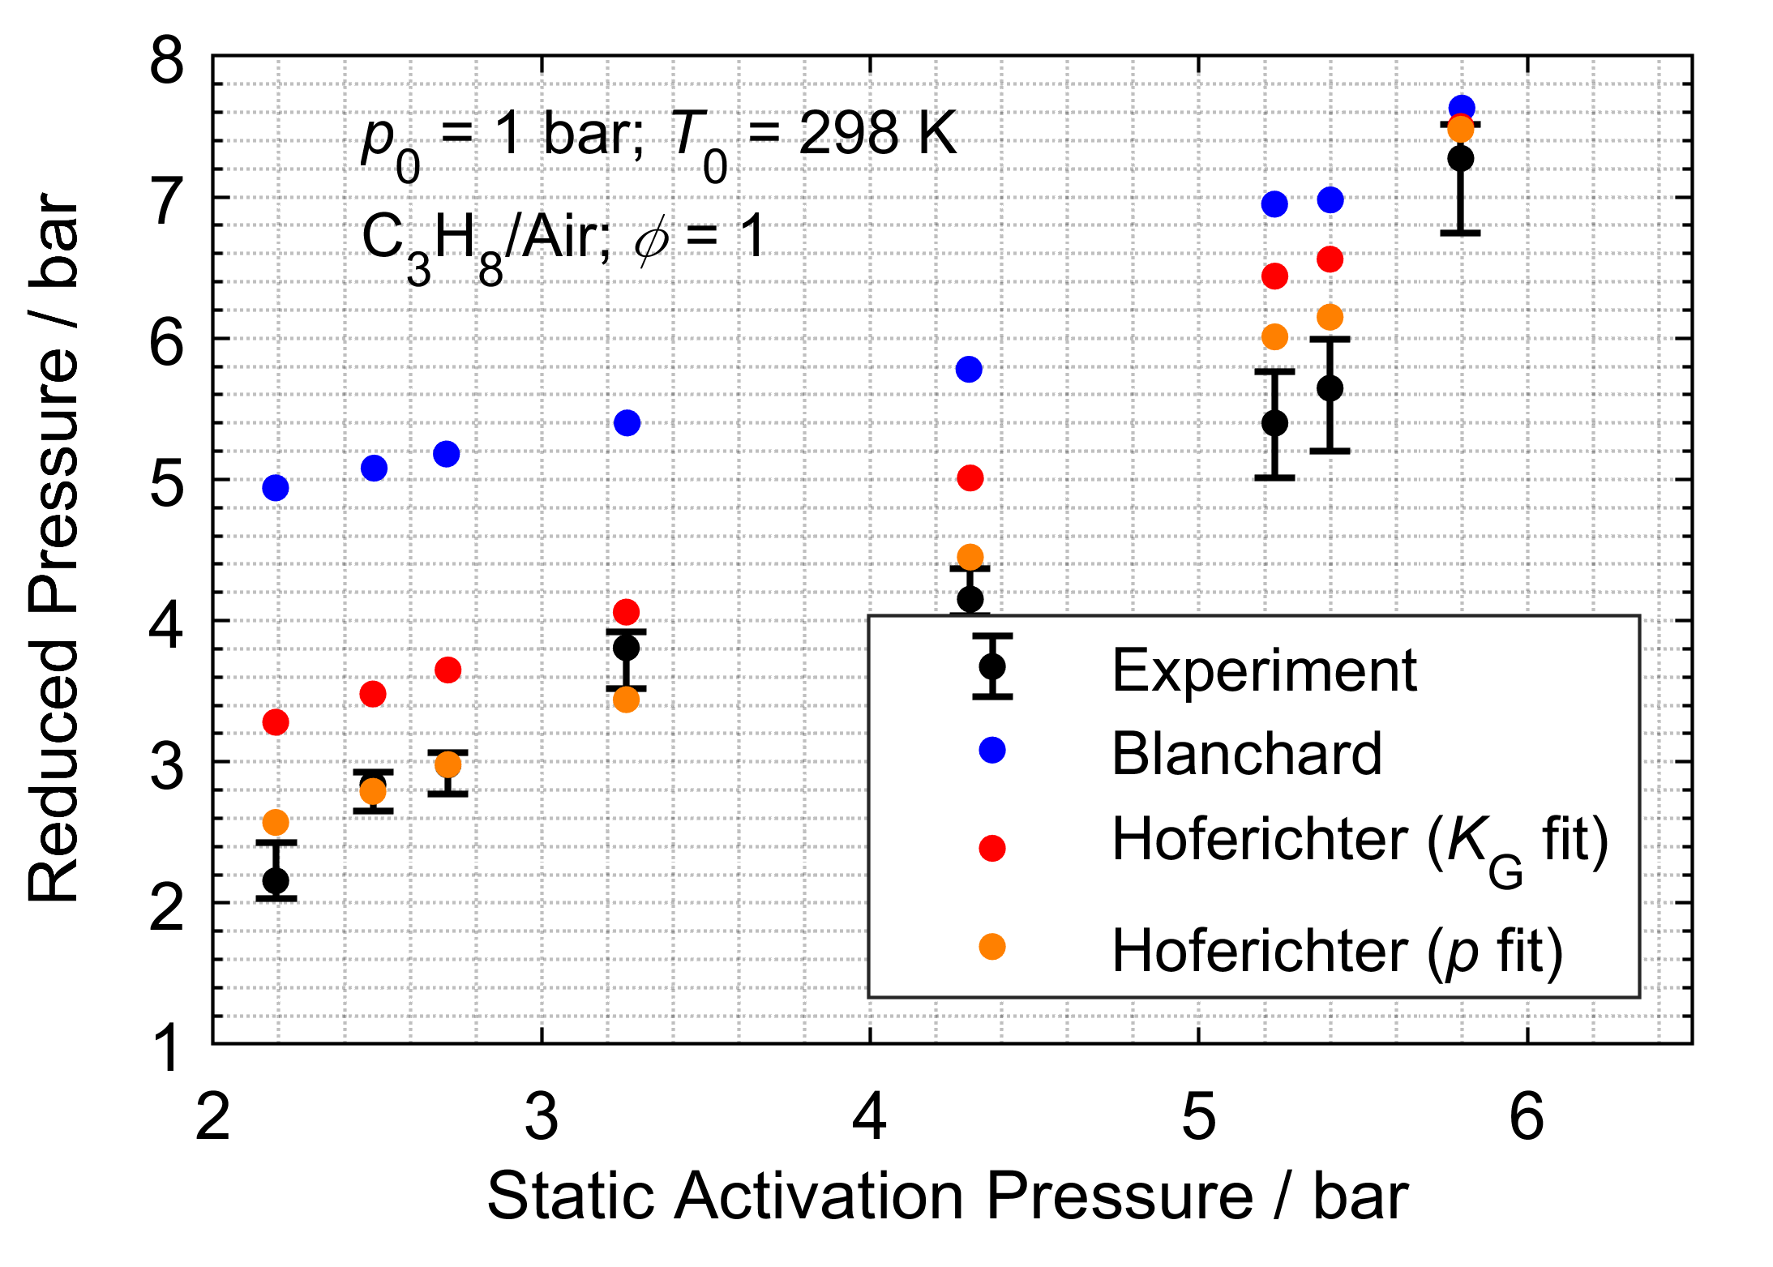

*Figure 2: Reduced explosion pressure over static activation pressure of the various burst disc configurations. Left: methane/air, right: propane/air.*

In comparison to CH4, C3H8 reacts slightly faster regarding laminar burning velocity and rate of pressure rise; however, the values are within the same order of magnitude. Figure 2 (right) illustrates the comparison of reduced explosion pressure over static activation pressure for propane. The same trend as observed in the CH4 results is noted for the BASF Blanchard model: low static activation pressure lead to an overestimation of the reduced explosion pressure. The BASF Hoferichter model performs well in representing the experimental results, although it remains conservative in its predictions. A flame acceleration factor of *C*ST = 3.34 was chosen to accurately represent the normalized rate of pressure rise for C3H8 (Figure 2, right, data *K*G fit). The result can be improved further, by adjusting the flame acceleration factor *C*ST to a pressure-time trace of a closed vessel experiment and not only to the *K*G value. This has been done here for C3H8, with a pressure curve that was measured in our laboratory (Figure 2, right, data *p*fit). The explosion pressure was slightly higher in comparison to the value from Table 1 (*p*Ex = 8.8 barabs), resulting in a flame acceleration factor of *C*St = 1.9.

* + 1. Vented experiments with ethane, ammonia and hydrogen

Figure 3 (left) presents experimental results for stoichiometric C2H4/air mixtures. This mixture reacts approximately twice as fast compared to CH4/air and C3H8/air (*t*Ex is reduced by a factor of 2, maximum rate of pressure rise is much higher due to higher laminar burning velocity). The BASF Blanchard model tends to overestimate the reduced explosion pressure; however, the dependence on static activation pressure is predicted correctly. The BASF Hoferichter model closely matches the experimental data. In this case, a flame acceleration factor *C*ST = 3.7 was chosen, by matching the *K*G value from BAM and Technical University Delft (2006). The burning velocity is taken from Marinov et al. (1995).

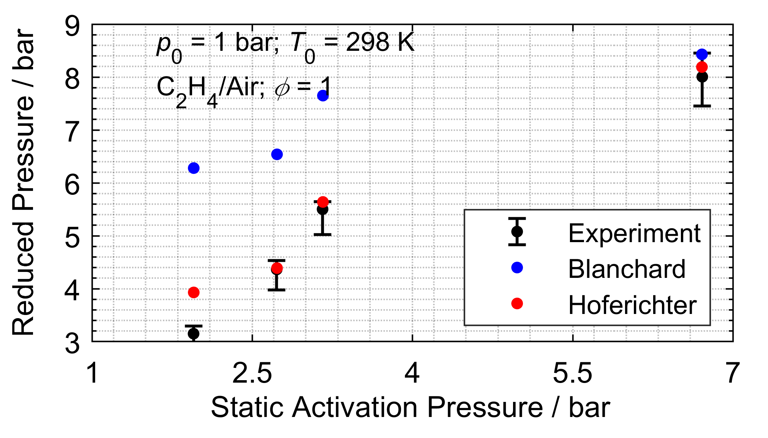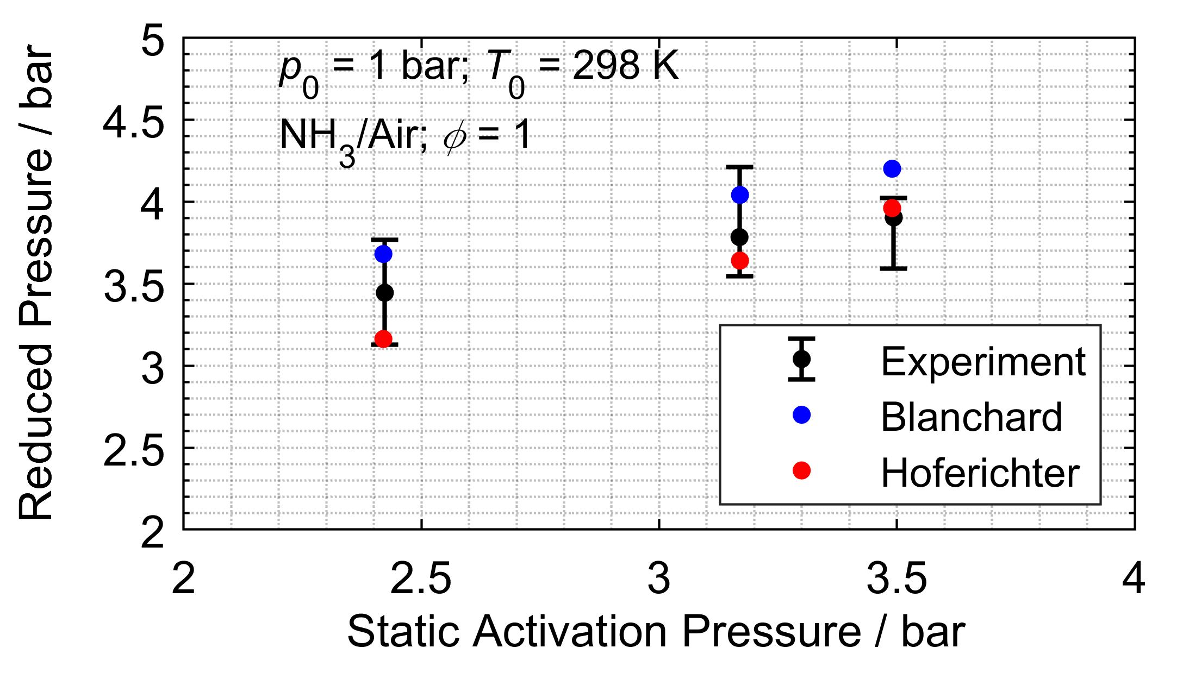

*Figure 3: Reduced explosion pressure over static activation pressure of the various burst disc configurations. Left: ethene/air, right: ammonia/air.*

Figure 3 (right) illustrates experimental results for stoichiometric NH3/air mixtures. The reaction is significantly slower than the reaction of CH4/air mixture. However, in contrast to data from literature (see Section 2.2, Table 1), the NH3 mixture appears to react noticeably faster in the large vessel: higher explosion pressures and increased *K*G values were measured in the closed vessel in comparison to literature data. With a laminar burning velocity of approximately 6 cm/s for NH3, a total combustion of the mixture in the big vessel would take about 80 s; however, the entire volume reacted in approximately 4.6 s (closed vessel experiments). At this point, it is noted that the hydrocarbons also react faster than the laminar burning velocity would suggest. For CH4, the reaction of the entire volume would take approximately 14 s according to the laminar burning velocity, but in the experiment, it takes only about 1.2 s. The ratio of actual burning velocity to laminar burning velocity is of the same order of magnitude for all experiments. Therefore, it is assumed that the turbulence in all experiments is approximately the same. However, this may indicate that the literature data for NH3 are not conservative when measured in a volume of several Liters. In our laboratory we measured CH4 and NH3 in a 20 l sphere. NH3 reacts over approx. 0.7 s in comparison to CH4 with a reaction time of approx. 0.1 s. After additionally 1 s, the pressure decreased by 50 % for NH3 and about 60 % for CH4. The pressure decrease is caused by heat losses after exothermal reaction. For NH3 the pressure increase caused by the reaction is in the same order of magnitude as the pressure decrease caused by heat losses. Thus, heat losses in combination with a slow reaction can be one explanation for why the normalized rate of pressure rise *K*G and explosion pressure ratio *r*Ex for NH3 from literature are so low compared to the measured data from the 4.4 m³ vessel. In slow exothermal reactions, heat losses increase disproportionately compared to fast exothermal reactions. Furthermore, the data from literature was measured in a volume of only 6 l.

The literature data for NH3 does not seem to be conservative, as the normalized rate of pressure rise *K*G and the explosion pressure ratio *r*Ex observed in the experiment are greater than those reported in the literature. This trend contrasts with the behaviour of other substances. For this reason, the normalized rate of pressure rise *K*G and explosion pressure ratio *r*Ex from the closed vessel experiments were utilized for simulation (Section 3.1, Table 2). In the BASF Hoferichter model, the literature value for laminar burning velocity was applied, and the *C*ST factor was adjusted until the *K*G value from the closed vessel experiment was achieved (*C*ST = 13). The adjusted flame acceleration factor is very high, indicating that the effect of turbulence on the burning velocity is also high. In experiments with a burst disc, the rate of pressure rise significantly increased further after the disc had ruptured. For this reason, the turbulence factor in the BASF Blanchard model was adjusted in the same way. Both models, BASF Blanchard and BASF Hoferichter, accurately predicted the experimental results.

For the hydrogen experiments, lean mixtures were analysed to prevent detonation. Starting with 12 mol-% H2 in the gas mixture, the H2 content was increased until the explosion pressure was sufficiently high to activate the burst disc. At 21 mol-% H2 (*ϕ* = 0.63), the burst disc activated, but the explosion transitioned to a detonation. Pressure relief was hence not possible.

* 1. Conclusions

This study presented experimental data on vented gas explosions, comparing the obtained reduced explosion pressures with predictions from two low-order models: The BASF Blanchard and the BASF Hoferichter model. The BASF Blanchard model is conservative and well-suited for the investigated gases. In contrast, the improved BASF Hoferichter model offers a more realistic prediction of the experimental results, although its predictions remain conservative. This model is applicable for gases with low to very high laminar burning velocities and rates of pressure rise represented by the chosen model combustibles ammonia (NH3) and ethene (C2H4).

Nomenclature

*C*st – flame acceleration factor, -

d*p*(*t*)/d*t* – rate of pressure rise, bar/s

*K*G – normalized rate of pressure rise / deflagration index, bar m/s

*M*W – mean molecular weight, kg/mol

*p*0 – initial pressure, bar

*p*Ex – explosion pressure, barabs

*p*Red – reduced explosion pressure, barabs

*p*stat – static activation pressure, barabs

*r*Ex – explosion pressure ratio, -

*s*L – laminar burning velocity, m/s

*T* – temperature, K

*t*Ex – time until (reduced) explosion pressure is reached, s

*V* – volume, m³

*κ* – heat capacity ratio, -

Acknowledgments

The authors thank René Hain (BASF SE) and Eric Vincent (BASF SE) for their technical and organizational support.

References

Alnajideen M., Shi H., Northrop W., Emberson D., Kane S., Czyzewski P., Alnaeli M., Mashruk S., Rouwenhorst K., Yu C., Eckart S., Valera-Medina A., 2024, Ammonia combustion and emissions in practical applications: a review, 3 (1), art. no. 13.

BAM and Technical University Delft, 2006, Report on the experimentally determined explosion limits, explosion pressures and rates of explosion pressure rise - Part 2: Ethane, n-butane, ethylene, ammonia and carbon monoxide, EC-Project SAFEKINEX Report No. 9.

Blanchard R.J. Schildberg H.-P., 2013, Sizing of Explosion Pressure Relief for Gases with Low KG

Values using the Efflux Function, Chemical Engineering Transactions, 31, 667–672.

Drost S., Eckart S., Yu C., Schießl R., Krause H., Maas U., 2023, Numerical and Experimental Investigations of CH4/H2 Mixtures: Ignition Delay Times, Laminar Burning Velocity and Extinction Limits, Energies, 16:6, art. no. 2621.

Hoferichter V., Schildberg H.-P., 2019, Prediction of the Reduced Explosion Pressure During Vented Gas Explosions Using a One-Dimensional Combustion Model in Combination with the Efflux Function, Chemical Engineering Transactions, 77, 145-150.

Marinov N.M., Pitz W.J., Westbrook C.K., 1995, Numerical study of ethylene and acetylene laminar flame speeds, UCRL-JC-120449; CONF-9504161-3; ON: DE95014203, Lawrence Livermore National Lab. (LLNL), Livermore, CA, United States.

Phylaktou H., Andrews G.E., 1991, Gas Explosions in Long Closed Vessels, Comhust. Sci. and Tech.,. 77, 27-39.

Swift I., 1989, NFPA 68 guide for venting of deflagrations: what's new and how it affects you, Journal of Loss Prevention in the Process Industries, 2, 1, p 5-15.

Technical University Delft, BAM, BASF, INERIS, Warsaw University of Technology, 2006, Report on the experimentally determined explosion limits, explosion pressures and rates of explosion pressure rise - Part 1: methane, hydrogen and propylene, EC-Project SAFEKINEX Report No. 8.

Zhao Z., Kazakov A., Li J., Dryer F.L., 2004, The initial temperature and N2 dilution effect on the laminar flame speed of propane/air, Combust. Sci. andTech.,176: 1-19.

Zhang X., Wang J., Chen Y., Li C., 2021, Effect of CH4, Pressure, and Initial Temperature on the Laminar Flame Speed of an NH3–Air Mixture, ACS Omega, 6 (18), 11857-11868.