Apparatus effects on calorimetric safety parameters and their impact on operation limits
Adrian Zentel^{a)}, Dominik Ohlig, Jana Sartorius, Johannes Schröder^{a)}, Marc-André Serrer*^{a)}, Markus Gödde^{b)}, Robert John Blanchardª
ª Safety Assessment & Testing (BASF SE, Carl-Bosch-Straße 38, 67056 Ludwigshafen, Germany)
^{b} Process Safety (BASF SE, Carl-Bosch-Straße 38, 67056 Ludwigshafen, Germany)
*Corresponding author E-Mail: marc-andre.serrer@basf.com
1. Introduction
In the chemical process industry, it is essential to minimize accident risks to protect human life, the environment, and assets. Process safety experts advocate for a balanced approach between economic efficiency and necessary risk reduction measures. Conservative safety characteristics can negatively impact overall process economics, as they are closely linked to data quality and the sensitivity of the chosen characterization methods. A comprehensive understanding of these methods, including their sensitivities and uncertainties, is essential for reducing potentially overly conservative safety margins, thereby allowing for increased process temperatures and enhanced production capabilities. For instance, even a small rise in the maximum allowable process temperature can yield significant benefits for a production plant.
One of the key safety characteristics is the TMR₂₄, the temperature at which the time to the maximum decomposition rate is 24 hours under adiabatic conditions. The TMR₂₄ can be derived from differential scanning calorimetry (DSC) by distance rules or kinetic evaluation or directly measured by adiabatic calorimetry. The maximum allowable process temperature T_{exo} correlates directly with the TMR₂₄ by T_{exo} = TMR₂₄ - 10 K.^{[1]} The correlation between TMR₂₄ and the onset temperature (T_{Onset}) for non-autocatalytic thermal decomposition reactions is defined as TMR₂₄ = T_{Onset, DSC} - 100 K for DSC or TMR₂₄ = T_{0,1W/kg} - 10 K. Therefore, both characteristics are influenced by the uncertainties of the respective calorimetric method. To determine the TMR₂₄ by kinetic evaluation of dynamic DSC scans especially the tau lag and the time constants of the DSC device are the critical apparatus effects which must be considered. Tau lag comprises the heating rate dependent temperature offset between the oven temperature and the respective temperature inside the reference cell. The time constants describe the thermal relaxation of the crucible and sensor as well as the sample and crucible. If the TMR₂₄ is directly measured by adiabatic calorimetry the critical apparatus effects are the phi-factor and the detection limit of the measuring system.
To explore and mitigate these uncertainties, a detailed study on apparatus effects impacting TMR₂₄ determination was conducted using a known model system of 40 wt.% dicumyl peroxide (DCP) in ethylbenzene.^{[2]}

2. Methods
To assess the apparatus effects of differential scanning calorimetry (DSC) and adiabatic calorimetry impacting the determination of TMR₂₄, a comprehensive study was conducted based on the thermal behaviour of 40 wt.% dicumyl peroxide (DCP) in ethylbenzene (EB).
DSC measurements were performed on Mettler Toledo DSC-1 and DSC-3 instruments. To determine the tau lag and time constants melting peaks of indium and zinc were measured in V4A, V2A, HC, gold, and glass crucibles (in-house). The heating rate dependent shift of the melting point was used to calibrate for tau lag. The time constants were derived from the relaxation curve of the heat signal after melting was completed. Measurements of DCP/EB in V4A and Glass crucibles were conducted with devices calibrated for the respective crucible types and compared to those calibrated solely with V4A crucibles. Subsequently, a formal kinetic model was developed utilizing the software "Thermal Safety Series-Advanced Reaction Kinetics Simulation (TSS-ARKS)" from Cheminform St. Petersburg Ltd. The DSC data of runs conducted at 1-5 K/min underwent several corrections, including adjustments for thermal resistance of the measurement cell, normalization, smoothing, background subtraction, and data thinning. The heat capacity was conservatively estimated at 2.00 J g⁻¹ K⁻¹. The optimal model was derived from a reaction of n-th order (A → B), characterized by the equation r_{i} = k₀e^{-E/RT} (1-α)^{n}. An example of the kinetics derived from the corrected measurements will be presented in the following. However, all conducted measurements were evaluated analogously to determine the overall influence of the mentioned parameters.
Table 1: Formal Kinetics derived from DSC measurements of the 40 wt.% dicumyl peroxide (DCP) in ethylbenzene.
ln(k₀)  [ln(s⁻¹)] | E_{a}  [kJ mol⁻¹] | n  [-] | Q  [kJ kg⁻¹]
36.7 | 153.30 | 1.03 | 356.60

The determined parameters are presented in Table 1, with a comparison between model predictions and experimental results illustrated in Figure 1.
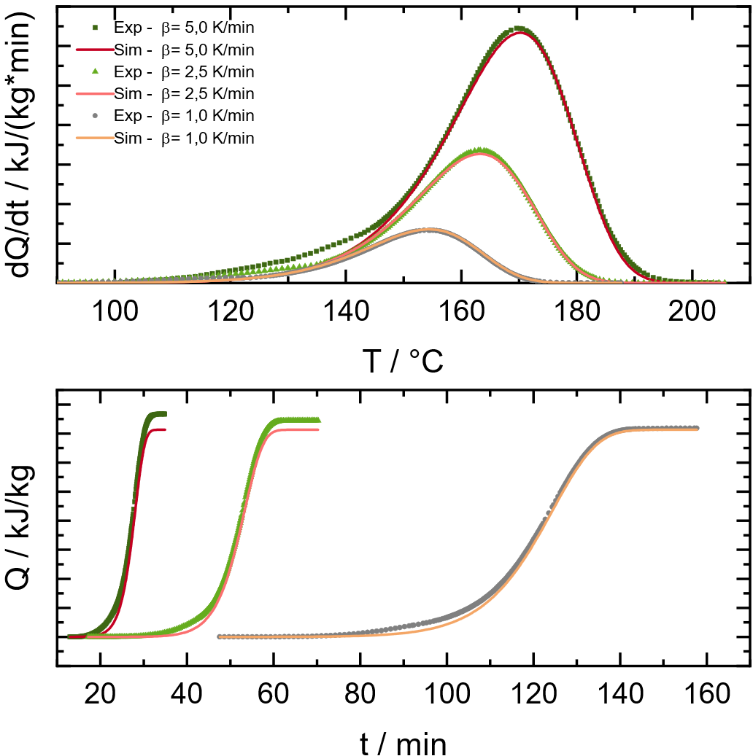
Figure 1: Comparison of experimental DSC data (points) of the 40 wt.% dicumyl peroxide (DCP) in ethylbenzene with the fit of the formal kinetic model (line).
The comparison depicted in Figure 1 reveals a satisfactory alignment between the experimental DSC data (points) and the model (line), indicating the model's applicability for calculating temperature-dependent heat flows and TMR.

  - Heat accumulation pressure vessel test
The apparatus employed for these investigations was developed in-house by BASF. The temperature-dependent detection limit of the apparatus was determined as follows: An inert heating oil with a known heat capacity was utilized, and a defined power input was applied to the system through electrical impulses. This established a measurement curve, as illustrated in Figure 2.
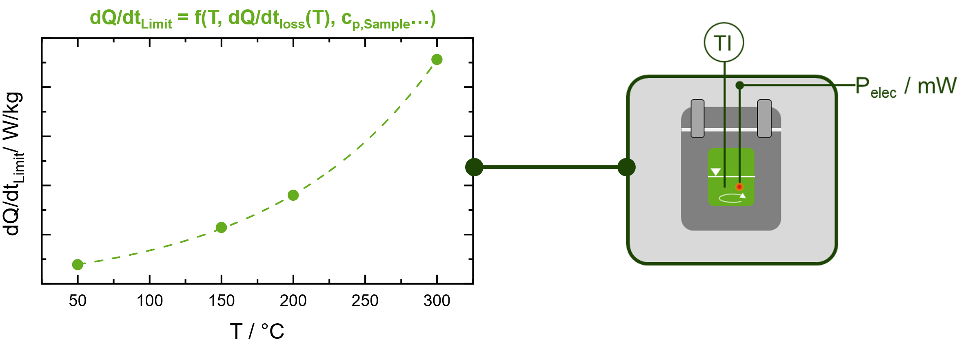
Figure 2: Temperature dependent detection limit of the in-house heat accumulation pressure vessel test.
Based on the determined detection limit, two measurements were conducted using the model system: The first measurement was performed at 75 °C for three days, remaining below the detection limit, followed by a temperature increase to 87 °C, just above the detection limit. The second measurement commenced directly at 90 °C, above the detection limit. Subsequently, the TMR₂₄ for the conducted experiments was calculated using the aforementioned methodology and the software code from Cheminform St. Petersburg.

3. Results and discussion
First, the impact of the crucible material on the tau lag of the DSC device was investigated.

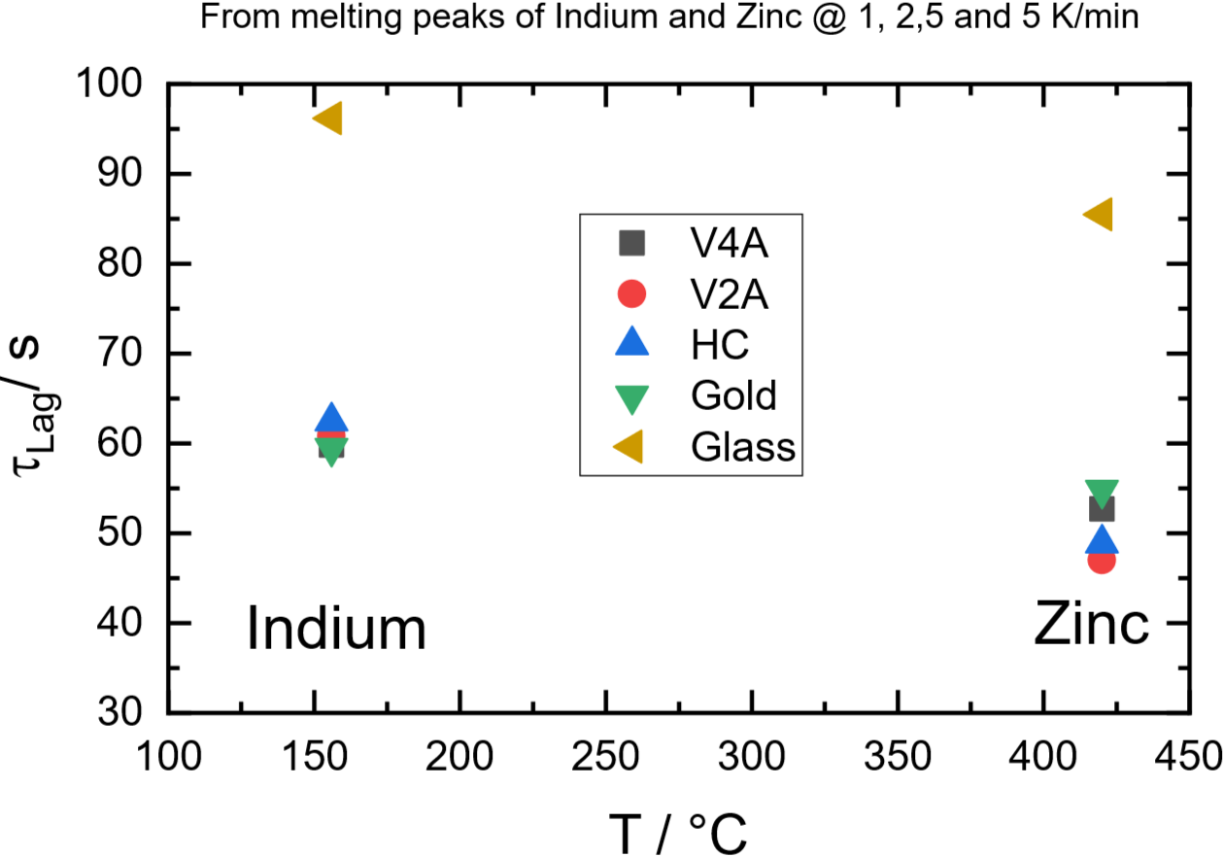
Figure 3: Impact of different crucible materials (V4A, V2A, HC, Gold and Glass) on the tau lag.
The results in Figure 3 show for both reference materials, i.e. indium and zinc, that the metal crucibles resulted in similar tau lag values while for the glass crucibles a tau lag of approximately 30 seconds higher was obtained. Using a DSC device calibrated with a tau lag of a metal crucible with a glass crucible led to an onset temperature shift of up to 5 K (at a heating rate of 10 K/min) as well as a loss of about 9% in the detected enthalpy due to wrong enthalpy calibration. Hence, it can be concluded that when applying new measurement crucibles, the tau lag needs to be determined to check whether the use of the same tau lag for all crucibles is sufficient, or a separate tau lag calibration must be applied.
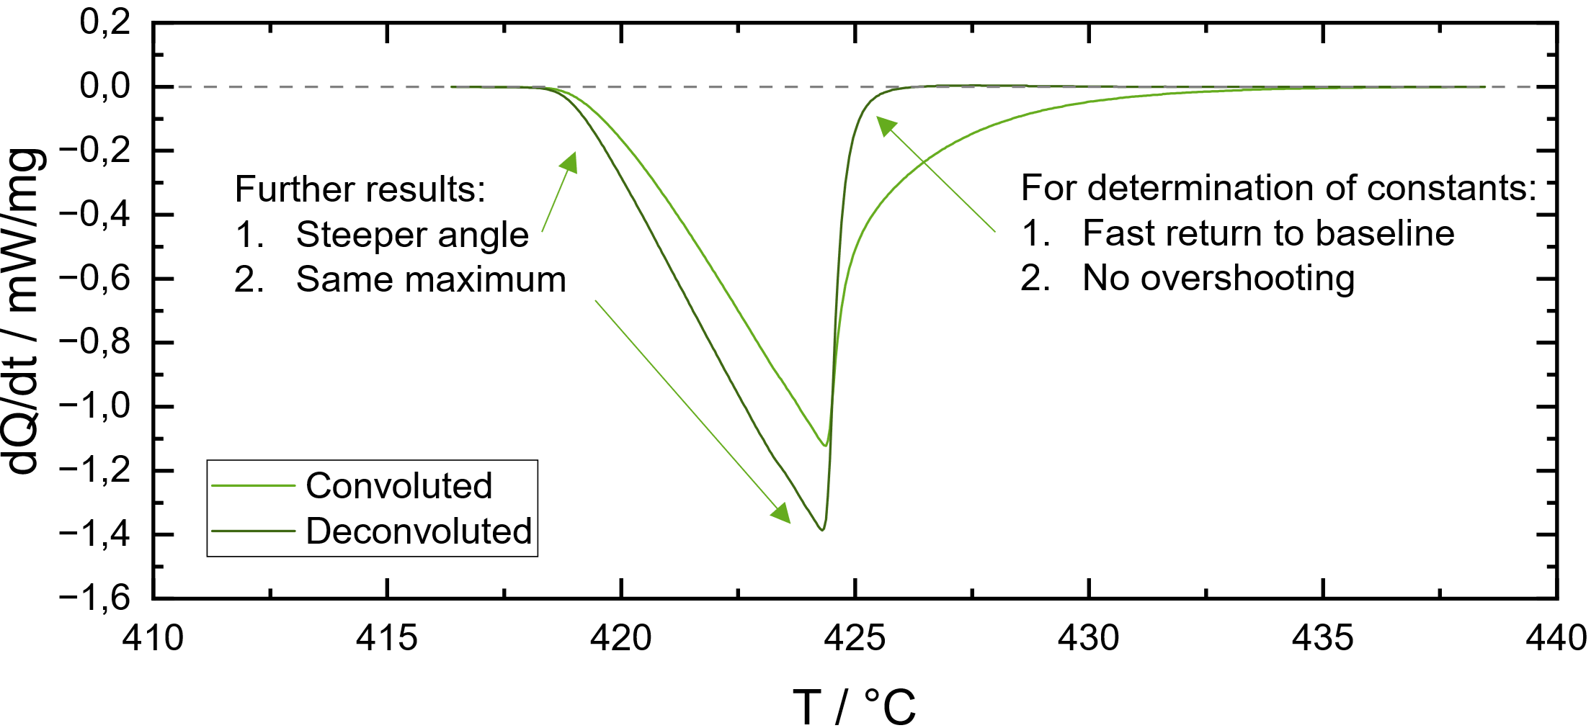
Figure 4: Effect of deconvolution on a DSC Peak.
Other parameters that impact the TMR are time constants. To investigate their impact on the activation energy (that significantly impacts the determination of the TMR), the data was deconvoluted, i.e. corrected by these time constants. The impact of the deconvolution is shown in Figure 4: The slope of the peak is corrected. As the activation energy of the thermal decomposition is derived from the slope of the peak, the deconvolution has a direct impact thereon.
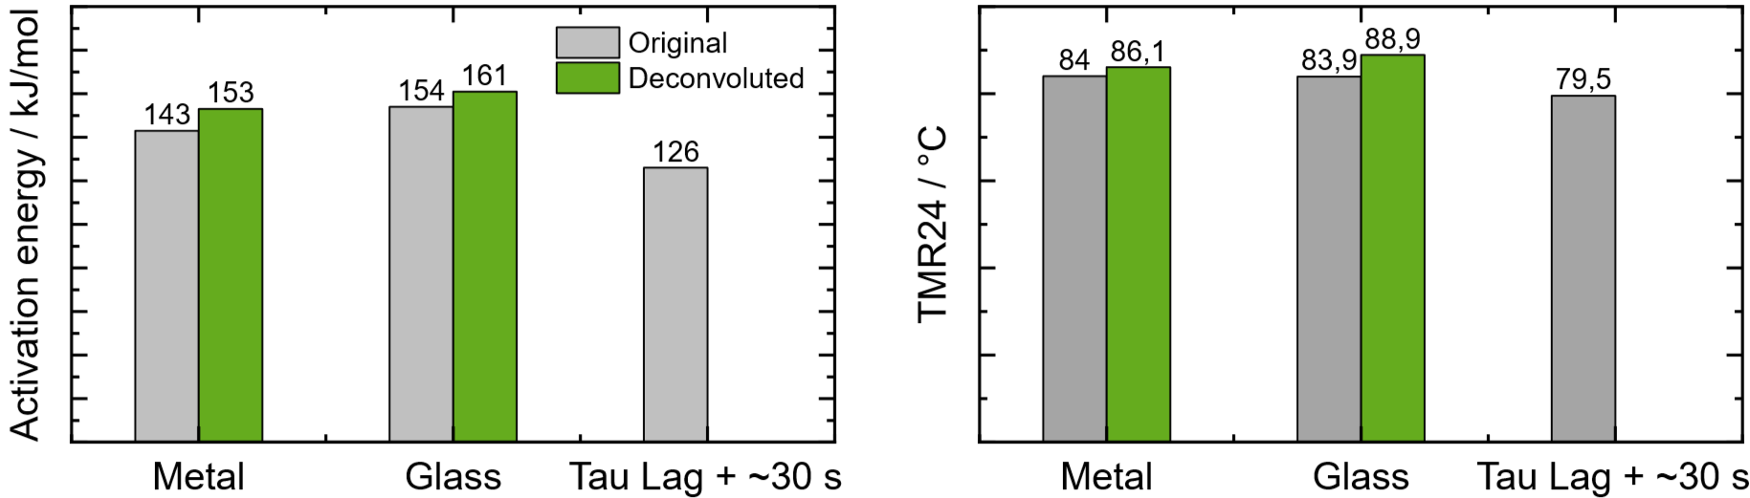
Figure 5: Influence of the deconvolution of DSC data on the activation energy (left) and the TMR₂₄ (right) for metal and glass crucibles. The original data is depicted in grey, the corresponding deconvoluted data in green. Tau lag + ~30 s depicts a glass vial on a DSC device calibrated with a metal vessel and without deconvolution.
According to the results shown in Figure , the deconvolution resulted in an increase in activation energy by approximately 10 kJ/mol, which corresponds to an increase in TMR₂₄ of 2 to 5 K. Conversely, uncorrected DSC data from inadequately calibrated instruments (e.g. glass crucibles measured on a device calibrated for metal crucibles) significantly underestimated the TMR₂₄, compromising economic potential (cf. Figure , Tau Lag + ~30 s).
Hence, the tau lag as well as the time constants tau for the relaxation of crucible/sensor relaxation and sample/crucible, have a significant influence on the measurement results and the uncertainties in the thereof derived TMR₂₄.
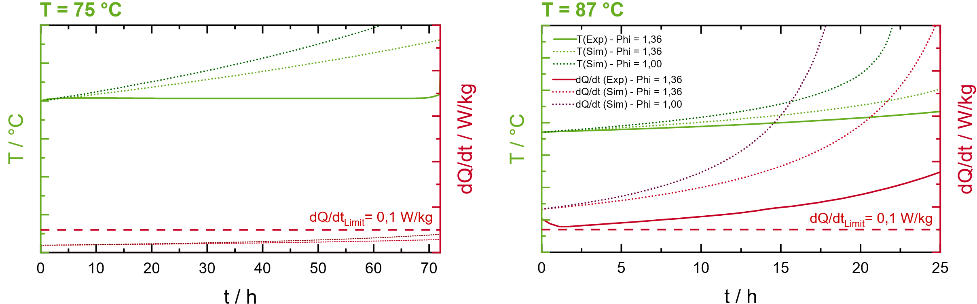
Figure 6: Comparison of a non-optimized experimental run (left) started at 75 °C with a model-based optimized experimental design (right) started at 87 °C of an adiabatic measurement of 40 wt.% dicumyl peroxide (DCP) in ethylbenzene.
Adiabatic calorimetry is a technique employed to directly measure TMR₂₄. This requires a precise sensitivity calibration, which can be achieved using an external heat source and/or known reference materials, as elaborated in section 2.2. To analyse the effects of detection limits and experimental design on results, a kinetic model derived from differential scanning calorimetry (DSC) was utilized to simulate the adiabatic behaviour of a 40 wt.% DCP in an ethylbenzene solution across various initial temperatures. This simulation aimed to identify the temperature at which the heat release during the onset of thermal decomposition reaches the sensitivity threshold of the adiabatic calorimeter.
Adiabatic experiments were subsequently performed at temperatures both below and above this detection limit. At 75 °C, which is beneath the detection threshold of 0.1 W/kg (cf. Figure , left), the simulated initial heat generation rate was lower than this limit, suggesting that heat loss surpassed the heat generated by thermal decomposition (dQ/dt). Consequently, no measurable temperature increase was observed, indicating a no exothermic reaction. The dotted curves in the results illustrate the temperature profiles that would have been observed if the calorimetric setup had a detection limit of 0 W/kg (pale green dotted curve) and if the phi-factor were 1 (dark green dotted curve), implying no heat loss to the reactor walls. These findings demonstrate that measuring a sample with unknown thermal kinetics may lead to an underestimation of its energetic potential, particularly critical when used for scale-up where low surface-to-volume ratios of reactors approach almost adiabatic conditions.
In the next phase, the aged sample was heated to 87 °C, a temperature predicted by the simulation to yield heat generation exceeding the detection limit (cf. Figure , right). Hence, the measurement program follows the widely known heat-wait-search method. It is essential to note that the simulation did not comprise the thermal history of the sample, thus neglecting the energy losses due to previous storage at 75 °C during heat-wait-search. This results in artificially elevated temperature and energy generation curves in the simulated data. This demonstrates that the implications of thermal aging on samples, particularly regarding heat generation below detection limits, necessitates further investigation concerning their impact on the final TMR₂₄. To achieve this, the phi-corrected TMR₂₄ was calculated using three methodologies.
Table 2: Formal Kinetics derived from DSC measurements of the 40 wt.% dicumyl peroxide (DCP) in ethylbenzene.
Kinetic | DSC | Adiabatic Calorimetry | Method | TMR₂₄
Kinetic 1 | X |  | Dynamic | 86,1 °C
Kinetic 2 | X | X | One Step | 86,3 °C
Kinetic 3 | X | X | HWS | 88,6 °C

Kinetic 1 is derived from data generated on a well calibrated DSC device including all aforementioned corrections (cf. Figure 1). Kinetic 2 is based on the DSC data from Kinetic 1 and further supplemented by an adiabatic experiment that was directly started with a fresh sample above the detection limit of the setup (not shown). Kinetic 3 is based on the DSC data from Kinetic 1 and further supplemented with the adiabatic experiment from the heat-wait search experiment shown in Figure . The results are summarized in Table 2. It is shown that using the data from an adiabatic calorimetry with thermal history below the detection limit of the setup, e.g. due to heat-wait search method or due to long heat up phases, might result in a TMR₂₄ that is not conservative.

4. Conclusions
In conclusion, precise characterization of calorimetric measurement devices is essential for accurately determining safety-relevant characteristics in thermal process safety. The study underscores that uncorrected data from poorly calibrated instruments (DSC) or prolonged measuring times close to the detection limit (adiabatic calorimetry) can lead to significant variation in TMR₂₄, resulting in overly conservative and uneconomic or even underestimated safety margins. Integrating kinetic modelling supports accurate and cost-efficient experimental planning while simultaneously reducing experimental uncertainties. This study demonstrates that a careful attention to apparatus effects and data processing might significantly influence the quality of derived safety characteristics. Furthermore, an optimization and minimization of such uncertainties facilitates the reduction of conservative safety margins and provides economic benefits in the operation of exothermic chemical processes while ensuring consistent safety levels.

References
- Bundesministerium für Umwelt, Naturschutz und Reaktorsicherheit, 2021. Technische Regel für Anlagensicherheit (TRAS) 410, Kommission für Anlagensicherheit, Bundesanzeiger.
- Duerrstein S. H., Kappler C., Neuhaus I., Malow M., Michael-Schulz H., Goedde M., 2016. Model-Based Prediction of the Adiabatic Induction Period and SADT of Dicumyl Peroxide Solution and Comparison to Large-Scale Experiments Performed Using 216.5-Liter Steel Drums in the UN-Test H.1, Chemical Engineering Transactions, 48, 475-480. DOI:10.3303/CET1648080.

