 CHEMICAL ENGINEERING TRANSACTIONS  VOL. xxx, 2025 | A publication of  
The Italian Association
of Chemical Engineering
Online at www.cetjournal.it
Guest Editors: Bruno Fabiano, Valerio Cozzani
Copyright © 2025, AIDIC Servizi S.r.l.
ISBN 979-12-81206-xx-y; ISSN 2283-9216

Hydrogen-air combustion limits
at low and cryogenic temperatures
Igor A. Kirillov *, Vadim Yu. Plaksin
KinTech Lab Ltd, 121087 Moscow, Russia
kirillov@kintechlabs.com
The effective advancement and societal acceptance of new LH₂ systems and technologies depend on a comprehensive understanding of their safety levels. Beyond the general safety principles associated with LH2 solutions, it is essential to have detailed knowledge of their safety attributes, including concentration, pressure, and temperature limits. While well-established data exists for hydrogen-air combustion concentration limits at standard and elevated temperatures, there is a notable lack of information regarding these limits at low and cryogenic temperatures. This report aims to provide an exhaustive review of two categories of hydrogen-air combustion limits: concentration and temperature. It first highlights the existing gaps and deficiencies in the available empirical concentration limits for temperatures ranging from 90 K to 850 K. Following this, it introduces fundamental limits for detonation flames, deflagration flames, and flame balls, which are consistent regardless of the testing facility, methodology, or measurement standards. These fundamental limits help clarify some previously recorded experimental findings and shed light on the relationship between empirical and theoretical concentration limits. Additionally, the report makes a qualitative prediction of a newly identified combustion phenomenon referred to by the authors as the "cryogenic temperature limit for hydrogen combustion." Lastly, it offers practical suggestions for conservatively estimating the concentration limits of flames that could trigger fast turbulent or detonating flames at low and cryogenic temperatures, presented through an analytical correlation.
  - Introduction
Understanding and precise quantification of the concentration limits for hydrogen-air combustion is crucial for the design of hydrogen systems, as it helps to establish adequate requirements for alarms, explosion protection measures, and mitigation systems. It also contributes to the effective standardization and regulatory support of hydrogen systems and sites. Starting with Coward's pioneering article in 1914, the concentration limits for numerous types of flames capable of traveling indefinitely through combustible mixtures have been explored, primarily through experimental research. For slow flames (those with speeds lower than the sound speed $c_{s}$ in the reaction products), studies have focused on the concentration limits of flammability as well as the thresholds for both ascending and descending flames. In the case of fast flames, researchers have investigated the concentration limits associated with choked turbulent flames and detonation waves. Most prior studies have largely concentrated on the concentration limits at normal and elevated temperatures, reaching up to 650 K.
This study has the following objectives: 1. to pinpoint deficiencies in current knowledge and incomplete data related to empirical concentration limits of combustion at low and cryogenic temperatures; 2. to show that theoretical estimates of the fundamental concentration limits for plane deflagration and detonation waves have predictive value and can serve as a conservative estimate for hydrogen-air explosions; 3. to examine and offer a qualitative explanation for a novel combustion limit, referred to by the authors as the “cryogenic temperature limit for hydrogen combustion” that has yet to be explored experimentally.
  - Gaps and limitations of empirical concentration limits
To offer informed recommendations to engineers, safety experts, and regulatory agencies concerning the concentration limits for both slow and fast flames, a systematic analysis of the published data is essential. This analysis must prioritize the evaluation of the data's completeness, accuracy, and consistency. The development of recommendations is complicated because the experimental results on concentration limits depend significantly on the type, scale, volume, and material of the experimental setup, as well as the measurement procedure and criteria used.
Figure 1 displays the primary sets of experimental data alongside semi-empirical correlations concerning concentration limits, represented by symbols and lines, respectively. Datasets were compiled from published papers on slow (White, 1925; Coward and Jones 1952; Karim et al., 1984; Hustad, 1988; Wierzba, et al., 1992; Wierzba&Ale, 1998; Terpsta&Wang, 2004; Wierzba&Wang, 2006; Kuznetsov et al., 2013; Liaw, 2016; Pio and Salzano, 2019; Proust and Jamois, 2021) and fast (Cicarelli et al., 1994; Cicarelli et al., 1996; Dorefeev et al., 199; Cicarelli et al. 2019; Kuznetsov et al., 2022) flames.
Figure 1: The temperature dependences of the empirical concentration limits for slow and fast flames at 1 atm (Plaksin and Kirillov 2025)
Analysis of the published empirical and phenomenology-based data results in the following findings.
    - Incompleteness of datasets for rich limits of the fast flames
Currently, there is no reliable experimental data available on the rich concentration limits for effective flame acceleration, choked flame, DDT, and detonation waves.
    - Contradictions in temperature dependence behavior
The temperature dependences of the experimental datasets for the choked flame limit (Ciccarelli et al., 1996), the DDT (Ciccarelli et al., 1996), the fast flame limit (Ciccarelli et al., 2019), and the flame acceleration limits (Kuznetsov, et al. 2022) show different behavior compared to the temperature dependence of the detonability limit (Ciccarelli, 1994). The causes of these temperature-dependent patterns would be investigated.
  - Fundamental concentration limits
The conservativeness and consistency of empirical estimates cannot be evaluated using only the empirical approach (without additional observations and interpretations from theoretical side).
To enhance our understanding of flammability and explosive limits across varying temperatures and environmental conditions, a unified theoretical framework for assessing fundamental concentration limits for different flame types (deflagration, detonation, flame balls) has been introduced (Plaksin and Kirillov, 2023). This non-empirical framework builds on Belles' concept (Belles, 1958) of the kinetic nature of concentration limits related to combustion.
The term "fundamental" (Law and Egolfopoulos, 1990) here refers to the intrinsic physico-chemical characteristics of gas mixtures that do not depend on the testing facility, procedures, or measurement criteria. Usefulness and validity of the non-empirical estimates of the concentration limits are given below for two cases – 1) analysis of the structure of the ternary diagram for the hydrogen-air-water steam mixtures at 1 atm and 373K, 2) “blind” predictions (without any relying on experimental measurements) of temperature dependencies of the fundamental concentration limits for the basic combustion modes – a) 1-dim detonation flame (Belles, 1958), b) plane deflagration flames (Kirillov, 2017), c) adiabatic spherical flame balls (Plaksin and Kirillov, 2023)
    - Fundamental concentration limits as a conservative estimate of empirical limits for slow flames
In Figure 2, the fundamental concentration limits, determined using a proposed non-empirical framework, are compared with the empirical data from Cheikhravat et al. (2015) and Kumar (1985).
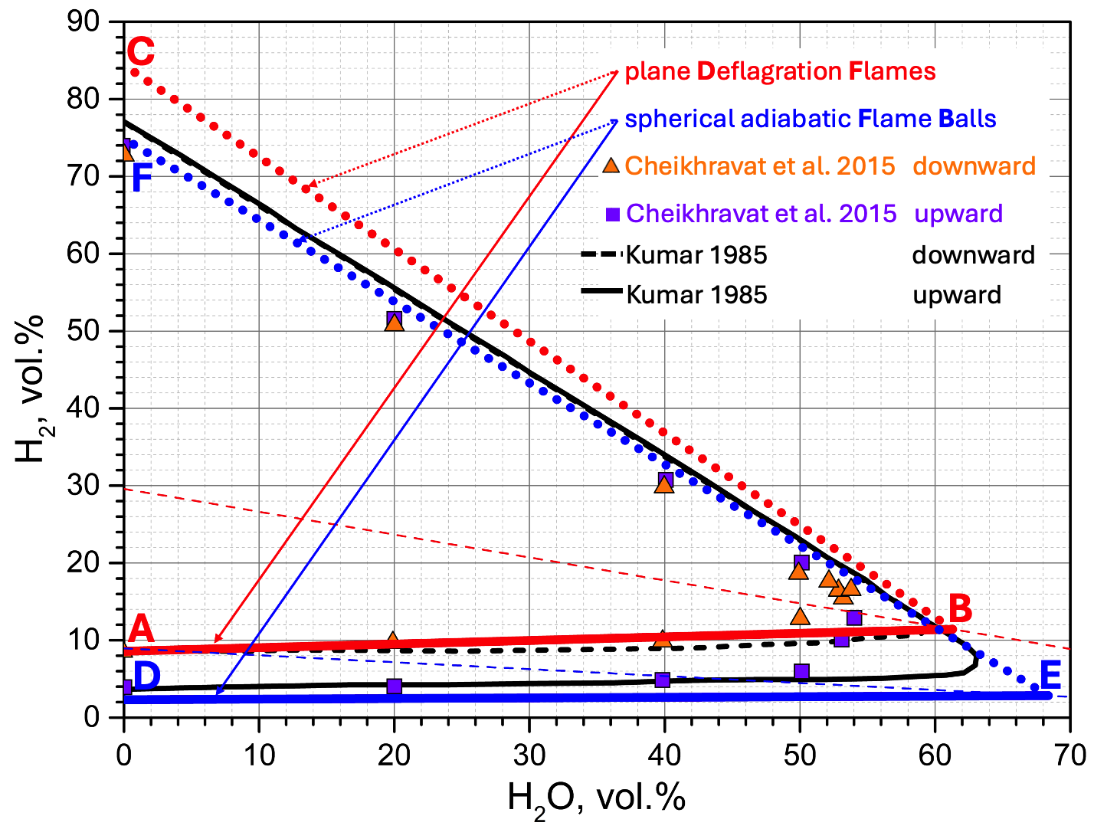
Figure 2: Ternary diagram for flammability of the hydrogen-air-steam mixtures at 1 atm and 373K: non-empiric models (Plaksin & Kirillov 2025) - for plane deflagrations (red) and adiabatic spherical flame balls (blue); experiments - Cheikhravat et al., (2015) (squares and triangles), Kumar (1985) (black continuous and dashed lines)
In Figure 2, all the experimental points for lean upward propagating flames are located above the lean fundamental limit for flame balls (blue line DE), and all the experimental data for rich downward and upward propagating flames is located below the rich fundamental limit for plane deflagration flames (red dotted line BC). These two facts can be interpreted from two perspectives. From a geometrical perspective, lines, representing fundamental limits, act as an "envelope" or "ultimate or absolute boundary" for empirical points. From a safety standpoint, the fundamental concentration limits offer a more cautious estimate than empirical values. So, rich fundamental concentration limits for deflagration flames can be considered as a “conservative” estimate and geometrical “envelope” (or “absolute limit”) for both rich empirical limits of the upward and downward propagating flames. Lean fundamental concentration limits for stationary flame balls can also be regarded as “conservative” and geometrical “envelope” for the lean empirical limits of upward propagating flames.
    - Fundamental concentration limits as a conservative estimate of empirical limits for fast flames
Figure 3 depicts how temperature influences the fundamental concentration limits for two basic flame families: 1) slow flames (such as plane deflagration flames and spherical flame balls) and 2) fast flames (detonation waves) in dry hydrogen-air mixtures at normal pressure, across a broad range of initial temperatures (90 – 850 K).
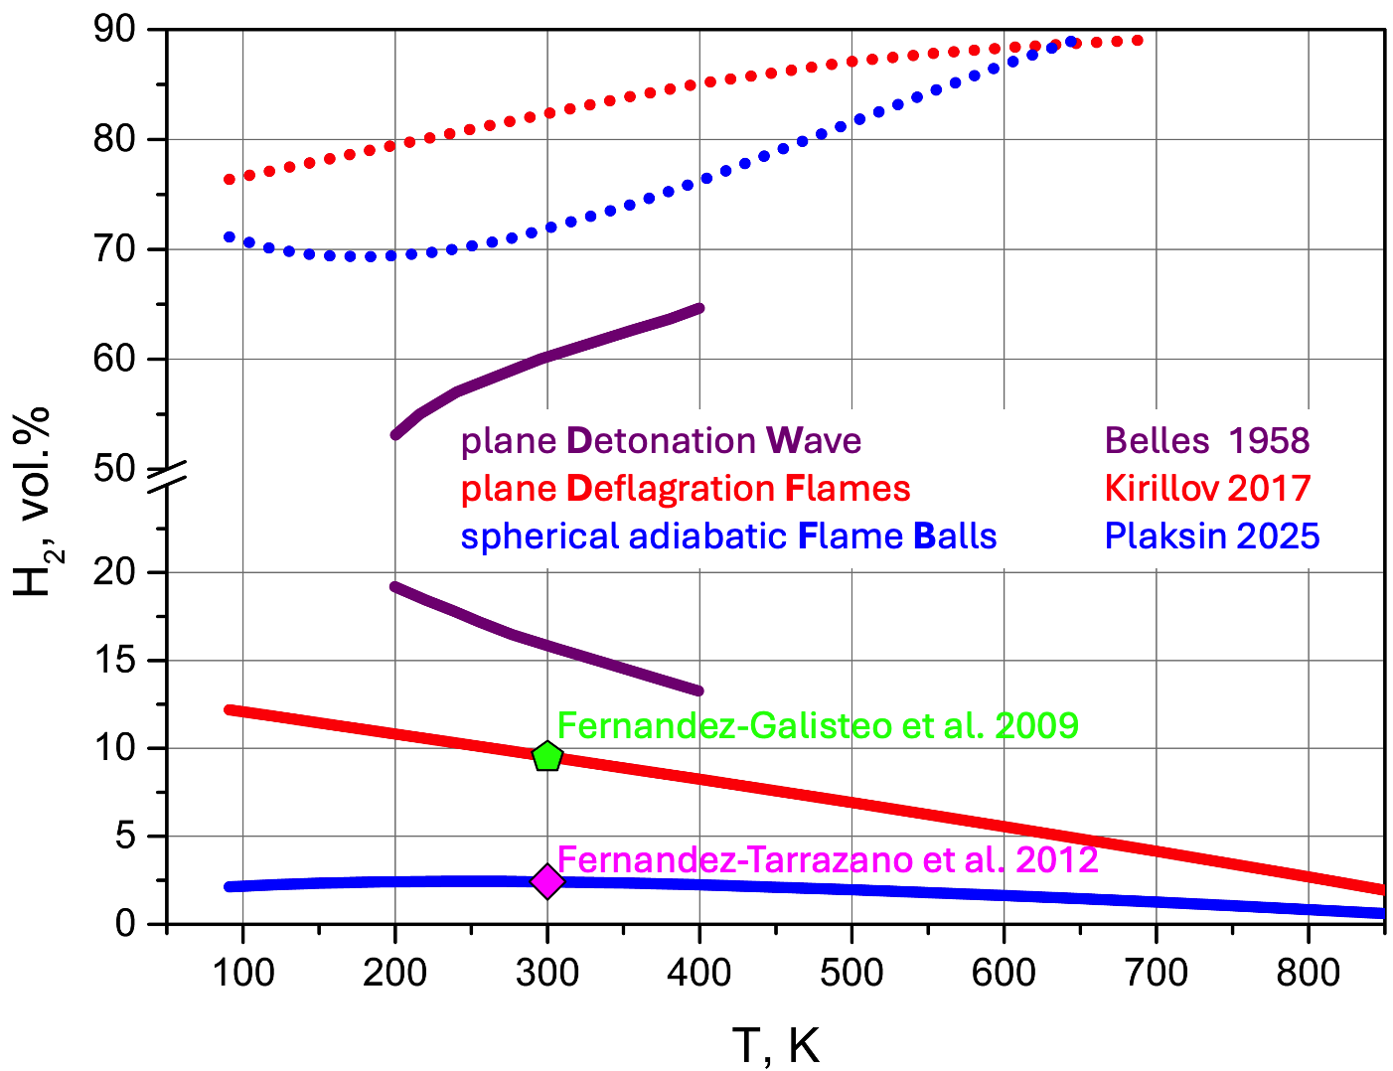
Figure 3: Temperature dependenсes of the fundamental concentration limits in dry hydrogen-air mixtures at normal pressure: purple – 1dim detonation (Belles, 1959), red - plane deflagration (Kirillov, 2017), blue lines - adiabatic spherical flame balls (Plaksin and Kirillov, 2025).
Figure 4 illustrates a comparison of how temperature affects the empirical and fundamental concentration limits in hydrogen-air mixtures at normal pressure, with temperatures varying from 90K to 850K.
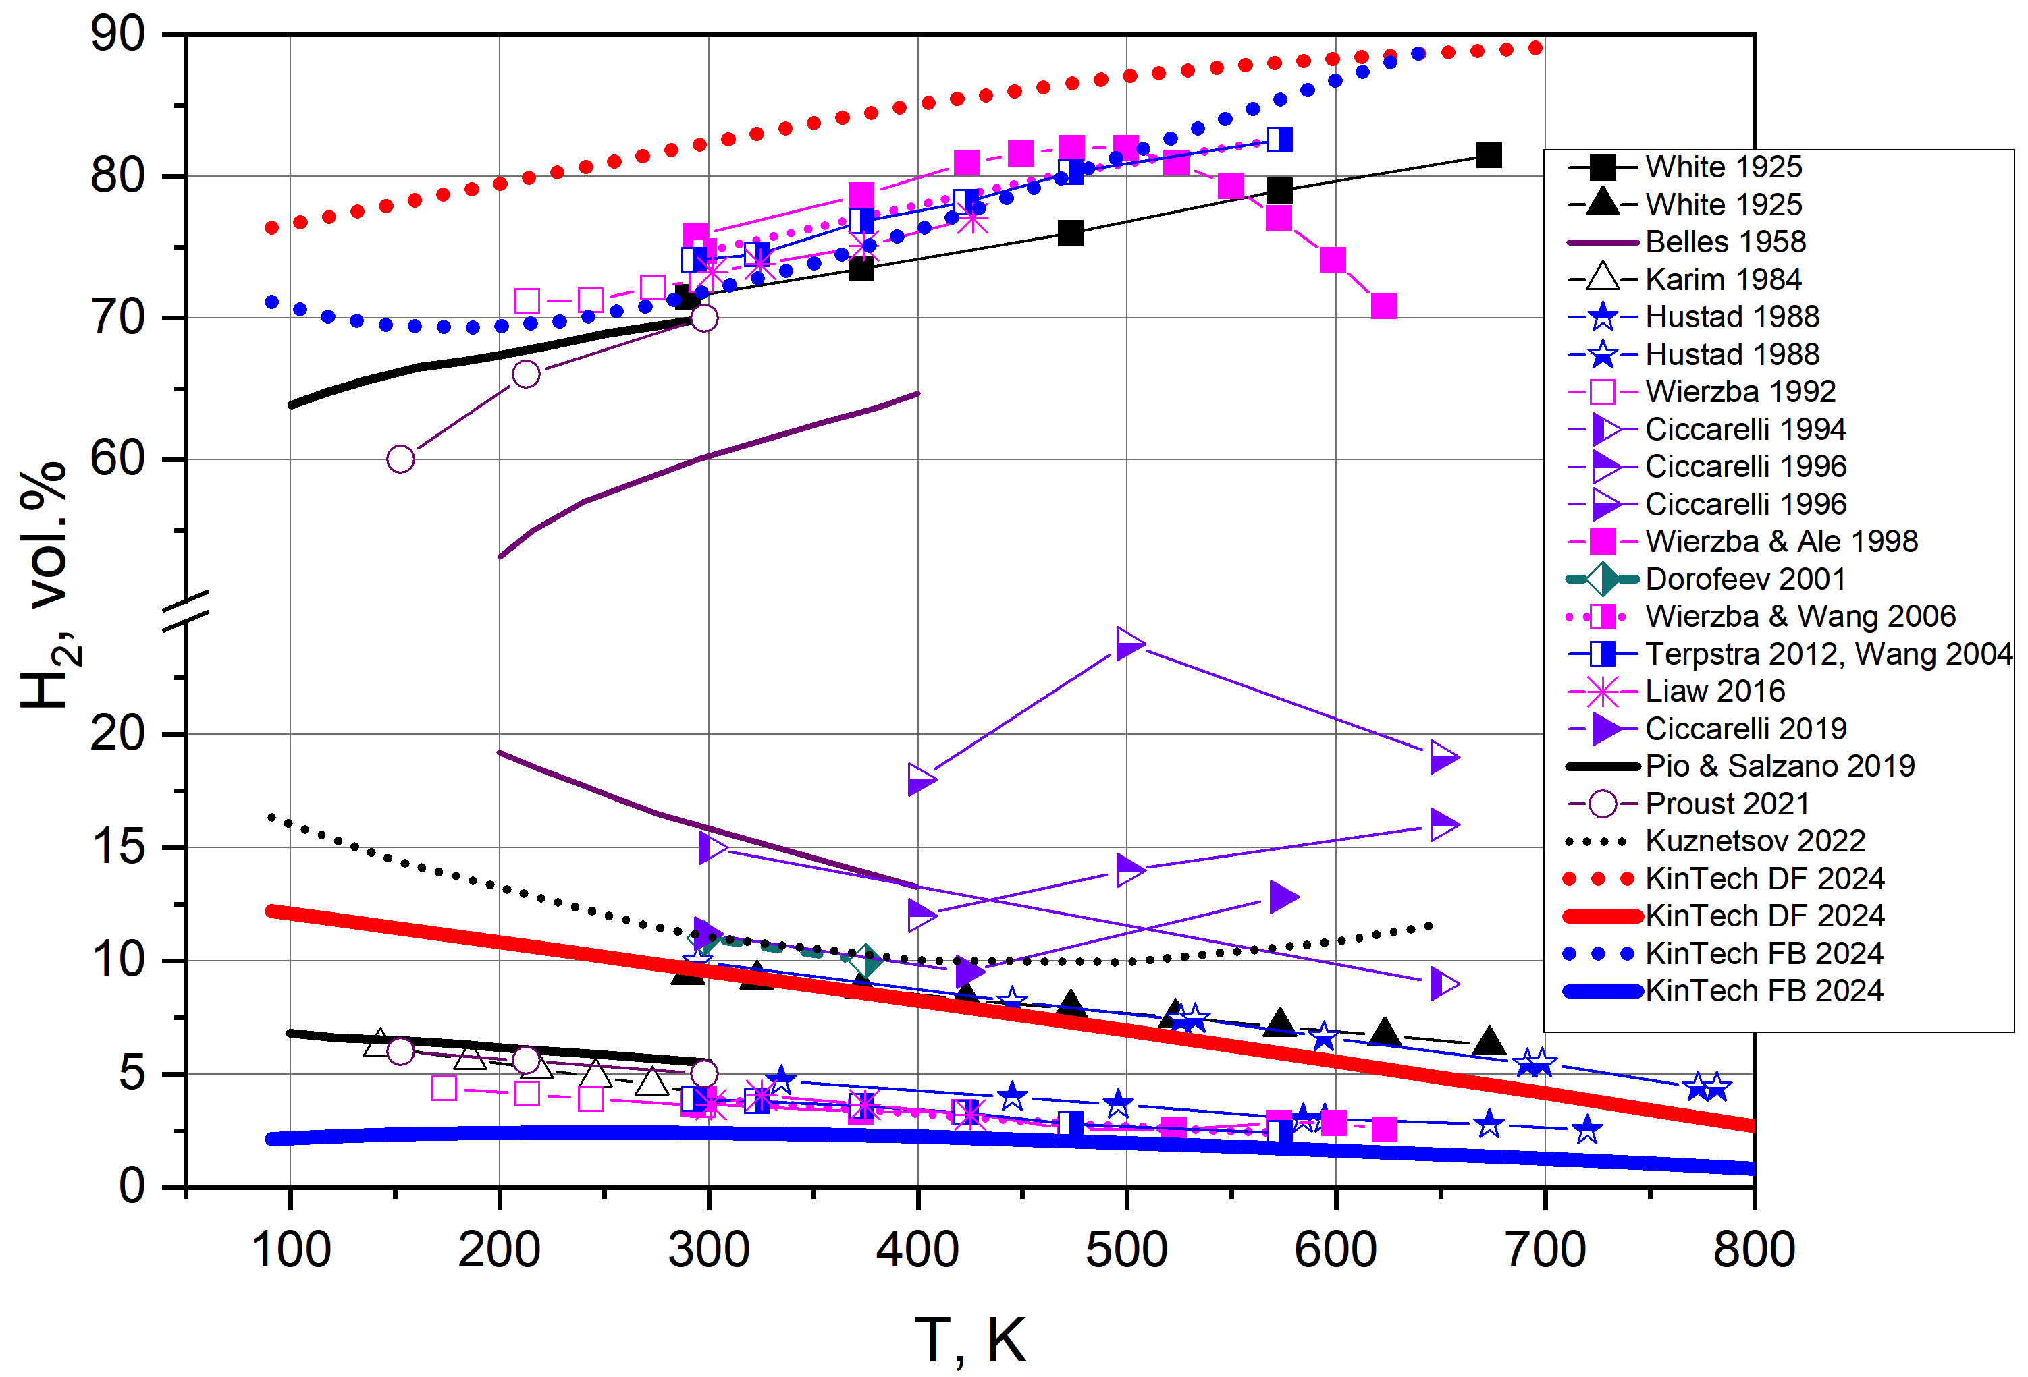
Figure 4: Comparison of the temperature dependencies for the empirical and fundamental concentration limits in hydrogen-air mixtures at normal pressure and temperatures from 90 to 850K
The analysis of Figure 4 leads to the following conclusion. The temperature dependence of the fundamental concentration limits for all primary types of flames (flame balls, deflagration, and detonation) can be effectively represented by linear relationships within the temperature range of 300 to 400 K. These fundamental limits can be viewed as conservative safety boundaries for both slow and fast flame empirical datasets across the entire temperature range of 90 to 850 K.
  - Cryo-temperature limit phenomenon
All proposed linear correlations regarding the temperature dependence of empirical (Zabetakis, 1967; Eichert and Fischer, 1999; Schroeder and Holtappel, 2005; Kuznetsov et al., 2013; Kuznetsov et al., 2022) and fundamental (Belles, 1958; Kirillov, 2017; Plaksin and Kirillov, 2023) concentration limits exhibit a similar trend in the cryogenic temperature range: as the temperature of the mixture decreases, the concentration limits become narrower.
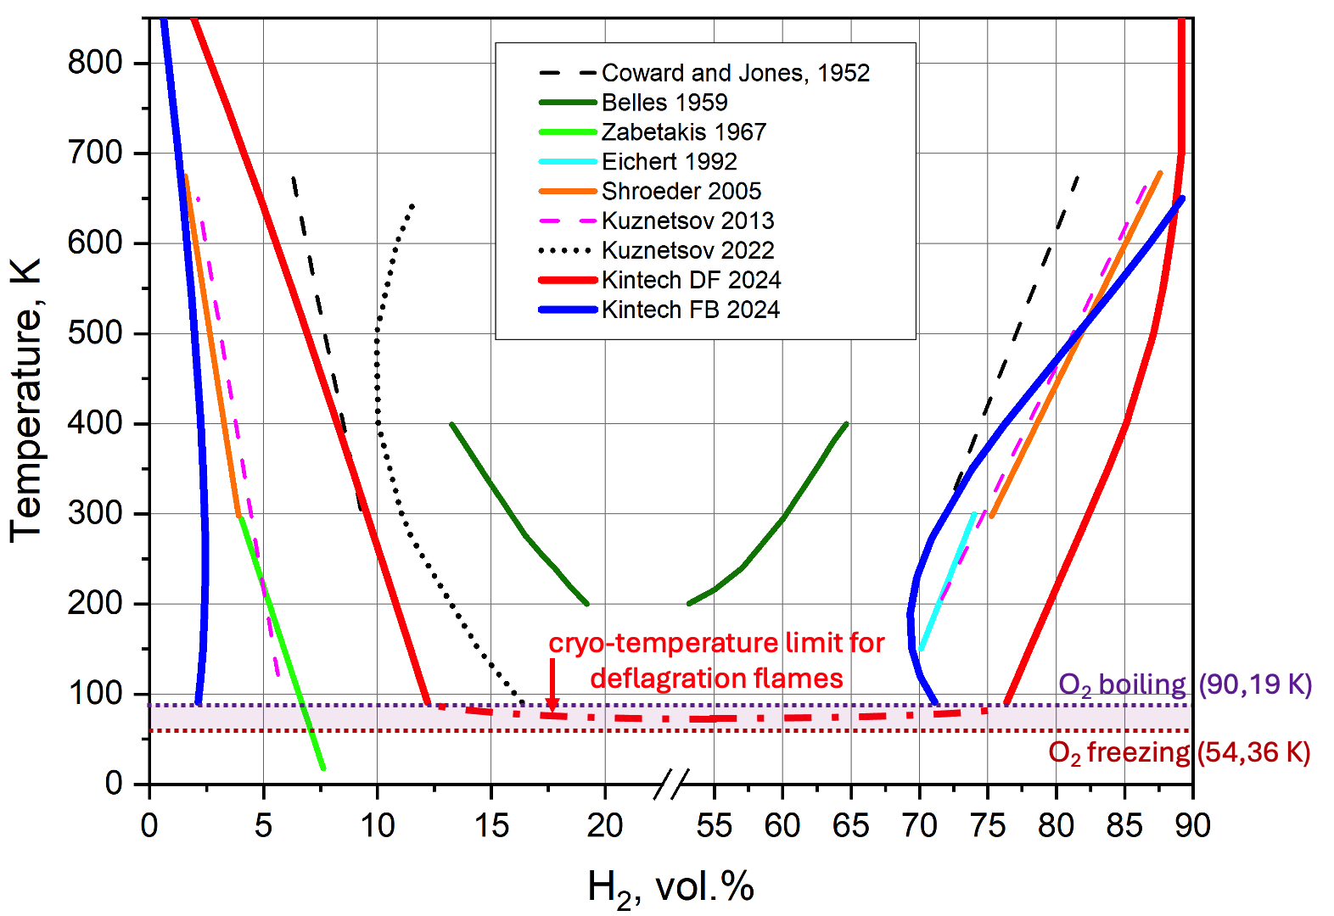
Figure 5: A comparison of empirical correlations with non-empirical ones from KinTech Lab for the temperature dependences of the flammability and explosion limits concentration in low- and cryo-temperature ranges
Kinetch Lab's non-empirical linear correlations for the lower and upper concentration limits of plane deflagration flames (DF) (shown at Figure 5 by thick red lines) within 90,19 K – 400 K temperature range can be written as:

$\begin{matrix}c_{lower}^{DF}\left(T\right)=13,38-0,01288∙T \\ c_{upper}^{DF}\left(T\right)=73,79+0,02843∙T\end{matrix}$
where $c_{lower}^{DF}\left(T\right)$ – concentration limits in lean dry hydrogen-air mixtures, $c_{upper}^{DF}\left(T\right)$ – concentration limits in rich dry hydrogen-air mixtures, T – initial temperature of mixture in Kelvins.
For hydrogen-air mixtures, term “cryogenic temperature” means temperature lower then 90.19 K (boiling point of oxygen). When extrapolated to cryogenic temperatures, all the abovementioned correlations result in a non-zero range of limiting concentrations (see Figure 5).
Certainly, that these extrapolations are not valid due to following reason. As the temperature of hydrogen-oxygen mixtures gradually drops from 90.19 K, oxygen starts to "freeze," leading to a decrease in its molar fraction within the remaining gas phase. At a specific temperature, which we have called the "cryo-temperature limit," the concentration of oxygen will drop below the Limiting Oxygen Concentration (LOC) for the corresponding mixture stoichiometry and temperature. The core of this phenomenon refers to the lowest initial temperature at which combustion waves can travel through a hydrogen and air mixture.
On the temperature scale, the phenomenon of “cryo-temperature limit” is the opposite of the well-known “thermal (or spontaneous) autoignition” phenomenon. It should be stressed, that each of the basic combustion mode – flame balls, deflagrations and detonations – can be characterized by different numerical values for the respective cryo-temperature limits.
As for the deflagration flame specifically, at a qualitative level, its concentration limits near the cryo-temperature limit can be graphically represented in Figure 5 by dash-dotted red line. To the best of the authors knowledge, this work is the first to propose the hypothesis regarding the "cryo-temperature limit". Details regarding the specific characteristics for visually observing this phenomenon, which could aid in experimental planning, and quantitative estimations will be addressed in another paper.
  - Conclusions
The concentration limits for hydrogen-air combustion, encompassing both slow and fast flames at low temperatures (from 300 K to 90 K) and cryogenic temperatures (below 90 K), remain significantly under-explored. Current empirical correlations and theoretical estimates require improvements in completeness, precision, and consistency. Review of relevant studies indicates that the experimental data on how temperature impacts concentration limits for specific fast flame scenarios—such as choked flame limits, deflagration-to-detonation transition (DDT), fast flame limits, and flame acceleration limits—exhibit unexpected trends when compared to the temperature dependence of detonability limits. This inconsistency highlights a significant gap in understanding, pointing to the necessity for further theoretical and experimental research.
To enhance the predictive capabilities of computational models used in safety assessments and to provide more accurate and reliable technical and regulatory guidance on hydrogen safety—especially at cryogenic temperatures—it's crucial to validate the precision of existing non-empirical models that estimate combustion concentration limits across a wide temperature range. This task requires a detailed examination of at least three specific cases. The first case involves examining the temperature dependence of detonation limits and choked flame concentration limits in both dry and wet rich and near-stoichiometric hydrogen-air mixtures. The second case seeks to explore how temperature influences the critical concentrations of water vapor, which can entirely prevent flame acceleration, choked flame formation, and detonation propagation. Lastly, the third case will compare the concentration limits for flame acceleration in standard horizontal tubes against those in vertical tubes, evaluating both upward and downward flame acceleration in relation to gravity.
A review of existing literature indicates that the current empirical and theoretical correlations regarding the combustion concentration limits of hydrogen predominantly focus on temperatures ranging from 300 K to 90 K. This report demonstrates that theoretical calculations of fundamental concentration limits for planar deflagration flames yield more conservative estimates than the empirical limits associated with flame acceleration. As a result, it is recommended to use this theoretical correlation for planar deflagration limits in safety applications within the temperature range of 90 K to 400 K.
Additionally, this article introduces a new concept termed the "cryogenic flame propagation limit." To the authors' knowledge, this concept has not been previously defined or discussed. This phenomenon expands upon existing combustion concepts related to "concentration limits" for both slow and fast flames, and qualitative reasoning supporting this hypothesis is presented, warranting experimental validation.
References
Belles F.E., 1958, Detonability and Chemical Kinetics: Prediction of Limits of Detonability of Hydrogen. 7th Symp. Int. on Combustion, 745-751.
Cheikhravat H., Gaulier J., Bentaib A., Meynet N., Chaumex, N., Paillard, C.E., 2015, Effects of water sprays on flame propagation in hydrogen/air/steam mixtures. Proc. Comb. Institute 35, 2715-2722.
Ciccarelli G., Ginsburg T., Boccio J., Finfrock C., Gerlach L., Sato K., Kinoshita M., 1994, High-Temperature Hydrogen-Air-Steam Detonation Experiments in the BNL Small-Scale Development Apparatus, NUREG/CR-6213, BNL-NUREG -52414.
Ciccarelli G., Ginsburg T. , Boccio J., Finfrock C., Gerlach L., Sato K., Kinoshita M., 1996, The Influence of Initial Temperature on Flame Acceleration and Deflagration-to-Detonation-Transition, 26th Symp. Int. on Combustion, 2973-2979.
Ciccarelli G., Chaumeix N., Mendiburu A.Z., N’Guessan K., 2019, Fast-flame limit for hydrogen/methane-air mixtures, Proc. Combustion Institute. 37(3), 3661-3668.
Coward H. F., and Brinsley F., 1914, Dilution limits of inflammability of gaseous mixtures. I. Determination of dilution limits. II. Lower limits for hydrogen, methane, and carbon monoxide in air, J. Chem. Soc. 105, 1859-1885.
Coward H.F. and Jones, G.W., 1952, Limits of flammability of gases and vapors. Bureau of Mines, US government printing office, Washington.
Dorofeev. S.V., et. al, 1999, Effect of Scale and Mixture Properties on Behaviour of Turbulent Flames in Obstructed Areas, IAE-6137/3 or FZKA-6268.
Eichert H., Fischer M., 1992, Gefährdungspotential bei einem verstärkten Wasserstoffeinsatz, Deutsches Zentrum für Luft- und Raumfahrt (DLR), Stuttgart.
Gasse A., 1992, Experimentelle Bestimmung and Simulation von Explosionsgrenzen, untersuch an wasserstoff Brenngasgemishen, Dissertation, Uni-GH Paderborn, Germany.
Hustad J.E. and Sonju O., 1988, Experimental Studies of Lower Flammability Limits of Gases and Mixtures of Gases at Elevated Temperatures, Combustion and Flame, 71: 283-294.
Kirillov I.A., 2017. Non-empirical method for quantitative estimation of the concentration limits for deflagration flame propagation in hydrogen-air gaseous mixtures. Proc. XXIX Int. Scientific and practical conference dedicated to the 80th anniversary of VNIIPO, Russian Ministry of Emergency, part 2, 5-8 (in Russian).
Kumar R., 1985, Flammability limits of hydrogen-oxygen-diluent mixtures, J. Fire Sci. 3, 245-262.
Kuznetsov M., Czerniak M., Grune J., Jordan T., 2013, Effect of temperature on laminar flame velocity for hydrogen-air mixtures at reduced pressures. Proc. 5th Int Conf Hydrogen Safety, Brussels, paper 231.
Kuznetsov M., Denkevitz A., Veser A., Friedrich A., 2022, Flame propagation regimes and critical conditions for flame acceleration and detonation transition for hydrogen-air mixtures at cryogenic temperatures, J. Hydrogen Energy. 47(71), 30743-30756.
Law C.K. and Egolfopoulos F.N., 1990. A kinetic criterion of flammability limits: the C-H-O-inert system. 23rd Symp. Int. Comb. 413-421.
Pio G., Salzano E., 2019, Flammability Limits of Methane (LNG) and Hydrogen (LH2) at Extreme Conditions. Chem. Eng. Trans. 77, 601-606.
Plaksin V.Yu. and Kirillov, I.A., 2023, “Lean” Unified Non-Empiric Model for Fundamental Concentration Limits of Spherical Flame Balls and Plane Deflagration Flames in the Hydrogen-Containing Mixtures, 29th ICDERS, July 23-28, 2023, paper 225.
Plaksin V.Yu. and Kirillov I.A., 2025, Hydrogen flammability and explosion concentration limits for a wide temperature range, J. Loss Prevention in the Process Industries, 94, 105554.
Schroeder V., Holtappel K., 2005, Explosion Characteristics of Hydrogen-Air and Hydrogen-Oxygen Mixtures at elevated Pressures, Proc. 1st Int. Conf. Hydrogen Safety (ICHS), Pisa, September 8-10, paper 120001.
Terpsta M., 2012, Flammability limits of hydrogen-diluted mixtures in air, MSc thesis, Uni. Calgary.
White A.G., 1925, Limits for the propagation of flame in inflammable gas-air mixtures. III. The effects of temperature on the limits, J. Chem. Soc. 127, 672-684
Wierzba I., et al., 1992, Effect of low temperature on the rich flammability limits in air of hydrogen and some fuel mixtures containing hydrogen, Int. J. Hydrogen Energy, 17(2), 149-152.
Wierzba I., Shrestha S. B., Karim G. A., 1994, A Thermodynamic Analysis of the Lean Flammability Limits of Fuel-Diluent Mixtures in Air, ASME J. Energy Resources Technology, 116, 181-185.
Wirzba I. and Ale B. B., 1998, Effects of temperature and time of exposure on the flammability limits of hydrogen-air mixtures, Int. J. Hydrogen Energy. 23(1), 1197-1998.
Wierzba I. and Wang, Q., 2006, The flammability limits of H2-CO-CH4 mixtures in air at elevated temperatures. Int. J. Hydrogen Energy, 31, 485-489.
Zabetakis M.G., 1967, Safety with cryogenic fluids, Plenum Press, New York.

