 CHEMICAL ENGINEERING TRANSACTIONS  VOL. xxx, 2025 | A publication of  
The Italian Association
of Chemical Engineering
Online at www.cetjournal.it

Guest Editors: Bruno Fabiano, Valerio Cozzani
Copyright © 2025, AIDIC Servizi S.r.l.
ISBN 979-12-81206-xx-y; ISSN 2283-9216

Influence of cathode composition on air-cooling efficiency of Lithium-ion cells
Carla Menaleª, Roberto Bubbico^{b}*
ªLaboratory for Development of Chemical and Thermal Fluid Dynamics Processes for Energy, ENEA,Via Anguillarese 301, 00123, Rome, Italy
^{b}Department of Chemical Material and Environmental Engineering, “Sapienza” Rome University, Via Eudossiana 18, 00184, Rome, Italy
roberto.bubbico@uniroma1.it
Lithium-Ion batteries, so far represent the technology that best fits the needs of electric mobility, due to a number of advantages with respect to other alternative solutions, such as higher energy and power densities and longer cycle life. However, there are safety concerns that still hinder their adoption in a wider range of applications: in the absence of efficient temperature control, at high operating temperatures a thermal runaway can occur, with possible destruction of the cell itself and the generation of other dangerous phenomena (fires and explosions). This problem is particularly important when a large number of cells are connected together in a whole pack, where the failure of a single cell can impact additional cells in its proximity with the possible generation of even more catastrophic consequences.
In the present study, 3D simulations have been carried out to assess the cooling efficiency of an air flow, under various operating conditions, on several cylindrical Li-ion cells, characterized by different cathode compositions. Under the investigated configurations, it was found that, beyond a minimum value of the passing air velocity, it is possible to prevent a generalized thermal runaway keeping the cells within safe temperature conditions; however, the cathode material also plays a significant role, with some configurations showing a safer behaviour with respect to others, characterized by a more pronounced susceptibility to thermal instability.
  - Introduction
Li-ion batteries are presently adopted in a wide range of applications, from portable devices (cell phones, laptops, etc.) to electric and hybrid electric vehicles (Berckmans et al., 2017; Feng et al., 2018). However, despite their widespread availability, they are still affected by a number of problems, mainly associated with their thermal instability. In fact, under particular operating conditions, and especially under so-called “abuse conditions” (overcharge/overdischarge, thermal or mechanical abuse, etc.) they can incur fast exothermic reactions (“thermal runaway”) (Sabbah et al., 2008; Guo et al., 2013; Hendricks et al., 2015; Wang et al., 2012) which can finally generate serious accidents with catastrophic consequences, such as fires and explosions (Maleki et al., 1999; Chen and Evans, 1996; Kim et al., 2007). This issue becomes more and more important when considering the continuously increasing energy densities required by many applications to these energy storage systems.
Basically, the occurrence of a thermal runaway is associated with an internally produced heat larger than that dissipated towards the exterior of the cell, and this phenomenon becomes even more critical when multiple cells are present in a pack or module, as it is usually the case, with increased likelihood of accidents of high-impact consequences due to the possibility of domino effects.
Due to the importance of this topic, several papers have been published in the literature about the causes and modalities of failure of Li-ion cells (Hendricks et al., 2015; Bubbico et al., 2018; Zhang et al., 2020, Menale et al., 2022; Lopez et al., 2015; Waag et al., 2013, Abada et al., 2016; Melcher et al., 2016, to name a few).
Despite the large number of publications available, because of the many parameters involved, either connected with the cell structure (geometry, electrodes composition, solvent and separator, and so on) or with the operating conditions, a clear understanding of the influence of those parameters on the thermal behaviour of the cell is not yet available.
In a previous analysis (Menale and Bubbico, 2023) a theoretical model has been developed to assess the influence of an air-cooling system on the thermal behaviour of a LCO cell. In the present paper, the model has been extended to compare the influence of the cell composition on the temperature increase under high-current operating conditions. In particular, the influence of the cathode materials on the cooling efficiency of the air flow has also been investigated, adopting four different cathodes.
  - Methodology
In the present study, cylindrical 18650 cells (main dimensions are reported in Table 1) in a battery pack with cooling air flowing through the cell arrows, have been modelled in COMSOL Multiphysics, where both the electro-chemical and the thermal processes have been simultaneously represented making use of the Battery and Fuel Cell module, adopting a multi-scale approach (Forgez et al, 2010). The anode and the electrolyte were graphite and LiPF₆ lithium salt in 1:1 EC:EMC solvent, respectively, and the cells were assumed to be subjected to continuous cycles of charge/discharge phases at 80 A/m².
The influence of the cathode composition on the cooling efficiency of an external air flow has been investigated, adopting four different cathodes, namely:
- LiCoO₂ (LCO),
- LiMn₂O₄ (LMO),
- LiNi_{0.4}Co_{0.2}Mn_{0.4}O₂ (NMC),
- LiFePO₄, (LFP).

The capability of an air flow to prevent a thermal runaway has been checked by conducting several simulations under various operating conditions: an inlet air temperature of 283.15, 293.15 and 313.15 K, and an inlet velocity of 0.1, 1 e 1.42 m/s, have been adopted. All the adopted air velocities corresponded to a laminar flow condition.
Table 1 Cell dimensions
r_{cell} [m] | h_{cell} [m] | h_{connector} [m]
9·10⁻³ | 6.5·10⁻² | 3·10⁻³
Radius of the cell | Height of the cell | Height of the connector

In order to optimize the calculation burden, three different geometries were setup and connected to each other to exchange the required information (Spotnitz and Franklin, 2003; Lee et al., 2013). The one- and two-dimensional geometries have been used to manage all physical properties of the cell’s materials and the basic chemical reactions of the specific type of cell, and to simulate the heat generation within the cell, respectively. The 3-D simulations have been carried out to simulate and accurately calculate the thermal behaviour of both the cells and the cooling air flowing around them. In this case, the geometrical configuration consisted of four domains corresponding to the active material, the mandrel, the cylindrical connector on top of the cell and the air volume (Figure 1). The dimensions of the air channel are reported in Table 2.
The electrochemical model is based on the theory of the porous electrode, and the equations required to describe the system have already been presented (Cianciullo et al., 2022).
Table 2 Air channel dimensions
l_{inlet} [m] | h_{inlet} [m] | s_{inlet} [m]
0.045 | 0.068 | 0.0135
Width | Height | Length
= 2·r_cell + 3·r_cell | = h_cell + h_connector | = 3*r_cell/2

The physical properties of the materials involved have been considered as a function of the changing temperature over time but have been considered constant in space. The thermal conductivity has been assumed anisotropic, while the specific heat and density are calculated according to previous literature (Lopez et al., 2015; Melcher et al., 2016).

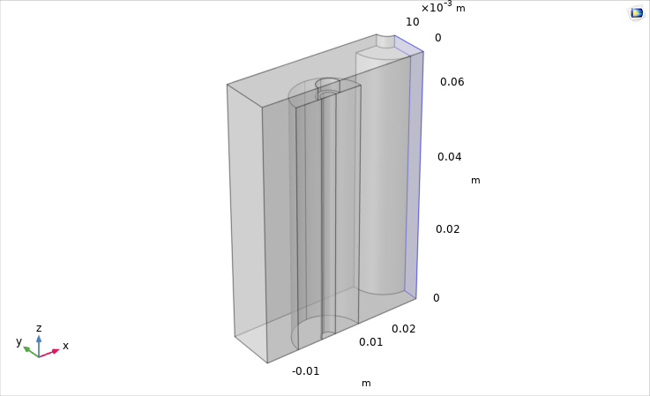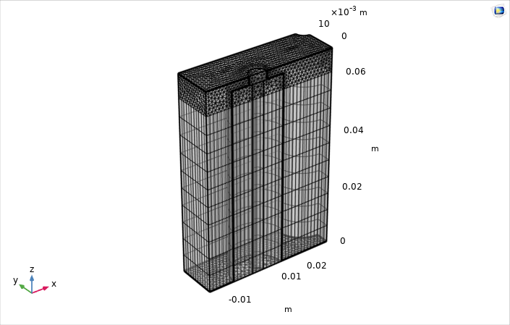
Figure 1 Geometry for the 3-D thermal model and the set-up mesh.

  - Results and discussions
In Figures 2-4, the temperature profile as a function of time is reported for the four cathode configurations.
It can be seen that increasing the air velocity provides a significant improvement in terms of cooling efficiency: at the lower air velocity, the cell temperature increases with the number of cycles, but by far more slowly than in the absence of cooling, as reported elsewhere (Cianciullo et al., 2022). At higher velocities, the cell temperature always remains well within the safe operating range, thus preventing the occurrence of conditions where a thermal runaway might develop. In particular, by increasing the air velocity from 0.1 to 1 m/s, the final temperature of the cells decreases by 10-20 degrees, depending on the cathode material.
Similarly, a reduction in the inlet air temperature will cause a decrease in the final cell temperature of the cell: roughly speaking, a reduction of 30 degrees in the air temperature will determine an equivalent reduction in the cell temperature, the higher variation being associated with the LCO cathode.
As far as the cathode material is concerned, it is found that the LCO cell is characterized by the worst thermal behaviour, similar to that of the LMO cell, with the largest temperature increase, while the MNC and, above all, the LFP cells show the best performance in terms of temperature increase. This finding is in agreement with previous results obtained under different operating conditions (Cianciullo et al., 2022). At the same time, the temperature reduction obtained with the adoption of the refrigeration system is larger for the LCO and LMO cells, thus suggesting that for the more critical storage apparatuses the use of a temperature control system is particularly important.
In Table 3 the final temperatures obtained for the different cells under all the investigated conditions are summarized for direct comparison.

Figure 2. Cell temperature profile at different air velocities: a) LCO, b) LMO, c) NMC, d) LFP; T=283 K.

Figure 3. Cell temperature profile at different air velocities: a) LCO, b) LMO, c) NMC, d) LFP; T=293 K.

Figure 4. Cell temperature profile at different air velocities: a) LCO, b) LMO, c) NMC, d) LFP; T=313 K.
Table 3. Temperature values for different cathode materials at different air velocities and temperatures.
Material | Initial air temperature (K) | Final cell temperature (K)
 |  | V_{in}=0.1 m/s | V_{in}=1 m/s | V_{in}=1.42 m/s
 | 283.15 | 315.4 | 293.93 | 292.37
LCO | 293.15 | 324.9 | 303.64 | 302.13
 | 313.15 | 345.71 | 323.4 | 321.9
 | 283.15 | 308.11 | 293.59 | 292.05
LMO | 293.15 | 315.22 | 302.07 | 300.69
 | 313.15 | 334.63 | 320.05 | 318.79
 | 283.15 | 305.63 | 288.91 | 287.98
NMC | 293.15 | 312.99 | 298.5 | 297.6
 | 313.15 | 332.84 | 318.06 | 317.23
 | 283.15 | 299.28 | 289.19 | 288.11
LFP | 293.15 | 308.04 | 298.31 | 297.51
 | 313.15 | 328.12 | 317.74 | 317.1
  - Conclusions
A comprehensive electrochemical and thermal model of Li-ion cells has been applied to investigate the capability of a conventional air-cooling system to prevent overheating of a cell contained in a battery module under high-current abuse conditions. The influence of the cathode material has also been assessed.
It has been found that, under the investigated conditions, a thermal runaway of the cells can be actually prevented, especially, as might be expected, at low initial temperature and at higher flow rates of the inlet air flow. As already found in previous analyses, LFP- and NMC-cathode cells are less prone to thermal instabilities, while LCO and LMO represent a more critical condition, which, however, can more efficiently benefit from an adequate cooling system. These results are of particular interest for cell modules or packs, where the failure of a single cell can easily impact adjacent cells with the possible generation of high consequence outcomes.
Acknowledgments
The results of this work have been obtained with the financial support of the National Recovery and Resilience Plan (PNRR), Mission 4 Component 2 Investment 1.3, funded by the European Union - NextGenerationEU, within the Spoke 6 "Energy Storage" of the Extended Partnership (PE2) NEST - Network 4 Energy Sustainable Transition.
References
Abada S., Marlair G., Lecocq A., Petit M., Sauvant-Moynot V., Huet F., 2016, Safety focused modeling of lithium-ion batteries: A review, Journal of Power Sources, 306, 178-192.
Berckmans, G., Messagie, M., Smekens, J., Omar, N., Vanhaverbeke, L., Van Mierlo, J., 2017, Cost Projection of State of the Art Lithium-Ion Batteries for Electric Vehicles Up to 2030, Energies 10, 1314.
Bubbico, R.; Greco, V.; Menale, C, 2018, Hazardous scenarios identification for Li-ion secondary batteries, Saf. Sci., 108, 72–88.
Chen, Y., Evans, J.W., 1996, Thermal analysis of lithium-ion batteries, J. Electrochem. Soc. 143 (9) 2708–2712.
Cianciullo M., Vilardi G., Mazzarotta B., Bubbico R., 2022, Simulation of the Thermal Runaway Onset in Li-Ion Cells—Influence of Cathode Materials and Operating Conditions, Energies, 15, 4169.
Feng X., Ouyang M., Liu X., Lu L., Xia Y., Hea X., 2018, Thermal runaway mechanism of lithium ion battery for electric vehicles: A review, Energy Storage Materials, 10, 246–267.
Forgez C., Do D.V., Friedrich G., Morcrette M., Delacourt C., 2010, Thermal modeling of a cylindrical LiFePO4/graphite lithium-ion battery, J. Power Sources, 195, 2961–2968.
Guo, M., White, R.E., 2013, A distributed thermal model for a Li-ion electrode plate pair, J. Power Sources 221, 334-344.
Hendricks, C., Williard, N., Mathew, S., Pecht, M., 2015. A failure modes, mechanisms, and effects analysis (FMMEA) of lithium-ion batteries. J. Power Sources 297,113–120.
Kim G.H., Pesaran A., Spotnitz R., 2007, A three-dimensional thermal abuse model for lithium-ion cells, Journal of Power Sources, 170, 476–489.
Lee, K.-J., Smith, K., Pesaran, A., Kim, G.-H., 2013, Three dimensional thermal-, electrical-, and electrochemical-coupled model for cylindrical wound large format lithium-ion batteries, J. Power Sources 241 20-32.
Lopez C.F., Jeevarajan J. A., and Mukherjee P. P., 2015, Characterization of Lithium-Ion Battery Thermal Abuse Behavior Using Experimental and Computational Analysis, Journal of The Electrochemical Society, 162 (10), A2163-A2173.
Maleki, H., Deng, G., Anani, A., Howard, J., 1999, Thermal Stability Studies of Li‐Ion Cells and Components, J. Electrochem. Soc. 146, 3224-3229
Melcher, A., Ziebert, C., Rohde, M., Seifert, H.J., 2016, Modeling and Simulation of the Thermal Runaway Behavior Li-Ion Cells- Computing of Critical Parameters, Energies, 9, 292.
Menale C., Constà S., Sglavo V., Della Seta L., Bubbico R., 2022, Experimental Investigation of Overdischarge Effects on Commercial Li-Ion Cells, Energies, 15, 8440, https://doi.org/10.3390/en15228440.
Menale C., Bubbico R., 2023, Temperature Control of Lithium-ion Battery Packs under High-Current Abuse Conditions, Chemical Engineering Transactions, 99, 175-180 DOI:10.3303/CET2399030
Sabbah, R., Kizilel, R., Selman, J.R., Al-Hallaj, S., 2008, Active (air-cooled) vs. passive (phase change material) thermal management of high power lithium-ion packs: Limitation of temperature rise and uniformity of temperature distribution, J. Power Sources 182, 630–638
Spotnitz R., Franklin J., 2003, Abuse behavior of high-power lithium-ion cells, Journal of Power Sources, 113, 81–100.
Waag, W., Käbitz, S., Sauer, D. U., 2013, Experimental investigation of the lithium-ion battery impedance characteristic at various conditions and aging states and its influence on the application, Applied Energy, 102, 885–897.
Wang Q., Ping P., Zhao X., Chub G., Sun J., Chen C., 2012, Thermal runaway caused fire and explosion of lithium ion battery, Journal of Power Sources, 208, 210–224.
Zhang, L., Zhao, P., Xu, M., Wang, X., 2020, Computational identification of the safety regime of Li-ion battery thermal runaway, Applied Energy 261, 114440.

