|  |  |
| --- | --- |
| cetlogo ***CHEMICAL ENGINEERING TRANSACTIONS***  ***VOL. xxx, 2025*** | A publication of  aidiclogo_grande |
| The Italian Association  of Chemical Engineering  Online at www.cetjournal.it |
| Guest Editors: Bruno Fabiano, Valerio Cozzani  Copyright © 2025, AIDIC Servizi S.r.l. **ISBN** 979-12-81206-xx-y; **ISSN** 2283-9216 | |

Deflagration Pressure Prediction using the NFPA 68 Engineering Model: Sensitivity of Fuel-Air Gas Properties

Stefan Krafta,\*, Marius Blochingb, Lorenz R. Boeckc

aJensen Hughes, 2020 Kraft Dr, Blacksburg, Virginia, USA

bREMBE® GmbH Safety + Control, Zur Heide 35, Brilon, Germany

cREMBE® Inc, 9567 Yarborough Rd, Fort Mill, South Carolina, USA

skraft@jensenhughes.com

To calculate pressures resulting from gaseous deflagrations, the NFPA 68 (2023) engineering model requires various fuel-air mixture properties as input. Key properties include the fundamental burning velocity and maximum explosion pressure, for which NFPA 68 provides worst-case values for common industrial gases. Default values are provided for other properties, but their use is restricted to flammable gases with stoichiometric fuel concentrations of 5% or less. Many gases exceed this threshold (e.g., hydrogen at 29.5%), and obtaining specific mixture properties often requires specialized chemical databases or modeling tools.

This work explores three aspects of this problem: summarizing resources and methods for obtaining gas properties; performing a sensitivity study for a 20-ft ISO container geometry to determine parameter impacts; and comparing NFPA 68 pressure predictions against large-scale experimental results using both default and calculated mixture-specific properties.

The results demonstrate that using appropriate fuel-air mixture properties can significantly improve prediction accuracy. For the experimental cases investigated in this study, using calculated mixture-specific properties instead of default values reduced predicted deflagration pressures by 15% on average while maintaining conservative predictions in most scenarios. The improvements were most pronounced for hydrogen applications, with pressure reductions up to 65%, reflecting the significant impact of hydrogen's distinct gas properties. These findings suggest that while default properties can serve for preliminary design assessments, calculated mixture-specific properties should be used for final designs to ensure both standard compliance and optimal vent sizing, particularly for applications involving hydrogen.

* 1. Introduction

The accurate prediction of deflagration pressures is crucial for industrial safety design, particularly in the context of explosion venting systems governed by NFPA 68 (2023.) This standard provides an engineering model that requires various fuel-air mixture properties as input parameters. While the model is widely used in industry, challenges can arise in obtaining accurate input parameters. The standard provides worst-case values for fundamental burning velocity (Su) and maximum explosion pressure (Pmax) for common industrial gases, along with default values for other parameters. However, the applicability of these default values is limited to flammable gases with stoichiometric fuel concentrations of 5% or less, which excludes gases like hydrogen where the stoichiometric concentration (29.5%) far exceeds the 5% threshold.

This study addresses three aspects of NFPA 68 (2023) vent sizing applications. First, available resources and tools for obtaining gas properties are briefly discussed, including both open-access and commercial databases and tools. Second, a systematic sensitivity study is performed for a representative 20-ft ISO container geometry to identify the relative influence of mixture properties. Third, comparisons are made between vented deflagration pressure predictions using default properties versus calculated mixture-specific properties, including validation against large-scale experimental results.

* 1. Background
     1. NFPA 68 (2023) Vented Gas Deflagration Model

The NFPA 68 (2023) vented gas deflagration model provides a comprehensive framework for calculating required vent areas in explosion protection systems. The model, detailed in Chapter 7 of the standard, distinguishes between two types of protected enclosures based on their structural strength: weak enclosures (Pred ≤ 0.5 bar-g, Sec. 7.2.1) and strong enclosures (Pred > 0.5 bar-g, Sec. 7.2.2). For weak enclosures, the model primarily employs equations Eq(1) and Eq(2) to determine the required vent area Av,0, before taking into account potential partial-volume deflagration effects (not considered in this work):

|  |  |
| --- | --- |
| $$A_{v,0}=\frac{A_{S}C}{\sqrt{P_{red}}} ,$$ | (1) |
| $$C=\frac{S_{u}ρ_{u}λ}{2G_{u}C_{d}}\left[{\left(\frac{P_{max}+1}{P_{0}+1}\right)}^{1/γ_{b}}-1\right]{\left(P_{0}+1\right)}^{1/2} .$$ | (2) |

For strong enclosures, the following equations, Eq(3) and Eq(4) are solved:

|  |  |
| --- | --- |
| $$A_{v,0}=A_{S}\frac{\left[1-{\left(\frac{P_{red}+1}{P_{max}+1}\right)}^{{1/γ}_{b}}\right]}{\left[{\left(\frac{P_{red}+1}{P_{max}+1}\right)}^{{1/γ}_{b}}-δ\right]} \frac{S_{u}ρ_{u}}{G_{u}}\frac{λ}{C_{d}},$$ | (3) |
| $$δ=\frac{{\left(\frac{P_{stat}+1}{P_{0}+1}\right)}^{1/γ_{b}}-1}{{\left(\frac{P_{max}+1}{P_{0}+1}\right)}^{1/γ_{b}}-1}.$$ | (4) |

Both models incorporate several key mixture properties that influence the required vent area. Primary properties include the fundamental burning velocity (Su), maximum explosion pressure (Pmax), and geometric characteristics. Secondary parameters encompass the unburned mixture density (ρu), sonic flow mass flux (Gu), and ratio of specific heats of the burned mixture (γb). Turbulence effects are accounted for through the turbulent burning velocity correction parameter $λ$, which is a function of geometric parameters and, particularly relevant in this study, mixture properties including the unburned mixture dynamic viscosity (μu), speed of sound (au), ρu, and Su. Further details of the complete calculation method are given in the standard.

* + 1. Mixture Parameter Data Sources

Available sources for fuel-air mixture property data can be categorized into three groups: codes & standards [e.g., NFPA 68 (2023) default values], commercial chemical property databases and tools (e.g., DIPPR, Chemkin-Pro), and open-access tools (e.g., Cantera, Gaseq, NASA CEA). Each source presents different advantages and limitations in terms of accessibility, comprehensiveness, and validation level. While codes & standards offer standardized values intended for conservative design, they often lack specific data for non-standard conditions or specific industrial gases. Commercial databases provide more comprehensive coverage but require investment, while open-access resources may require additional validation.

The default parameter values provided in NFPA 68 (2023) are given in Table 1. The use of default values is limited to mixtures with stoichiometric concentrations of XSt < 5% (except Gu) and ambient initial temperature.

Table 1: Default fuel-air mixture parameters according to NFPA 68 (2023), Sec. 7.2.3.

|  |  |  |  |  |  |
| --- | --- | --- | --- | --- | --- |
| Parameters | ρu | Gu | γb | μu | au |
| Units | kg/m3 | kg/m2-s | - | kg/m-s | m/s |
| Default values | 1.2 | 230.1 | 1.15 | 1.8e-5 | 343 |
| Limits of applicability | | | | | |
| XSt | < 5% | N/A | < 5% | < 5% | < 5% |
| T0 | ambient | ambient | ambient | ambient | ambient |

* 1. Model Implementation and Methodology for Determining Mixture Parameters

Within this work, Cantera (Goodwin et al., 2023) was used uniformly to determine mixture properties, incorporating thermochemical data as described in (Blanquart et al., 2009) and references therein. Unburned mixtures were defined according to their specific molar gas compositions, unburned mixture properties (ρu, Gu, μu, au) were computed, followed by calculations of burned mixture property γb using the results of an adiabatic chemical equilibrium calculation at constant pressure, approximating most common vented deflagration pressures. The sonic flow mass flux Gu was determined using Eq(5) for ideal compressible gas at unity Mach number,

|  |  |
| --- | --- |
| $$G_{u}=\frac{P_{t}}{\sqrt{T_{t}}}\sqrt{\frac{γ_{u}M_{u}}{R}}{\left(\frac{γ_{u}+1}{2}\right)}^{-\frac{γ_{u}+1}{2(γ_{u}-1)}} .$$ | (5) |

For the unburned mixture viscosity, the equation of Herning and Zipperer was used (Davidson, 1993), and individual gas component viscosities and their temperature dependencies were calculated from Sutherland’s law (Sutherland, 1893). Maximum constant-volume explosion pressures, Pmax, were taken from the solutions of Cantera constant-volume adiabatic equilibrium calculations. Finally, fundamental burning velocities Su were computed using Cantera’s freely propagating 1-D laminar flame model and the detailed chemical kinetic model of Blanquart et al. (2009).

* 1. Experimental Data

In this work, two sets of data were used as reference to evaluate the relative accuracy of the default and calculated mixture-specific properties on NFPA 68 (2023) predictions.

* + 1. Gas Deflagration Venting Literature

Table 2 summarizes the literature data included in the following comparison analysis. The data were chosen for their relative importance to current green energy research and to provide a wide range of scenarios.

Table 2: Experimental literature studies used for the evaluation of mixture property effects.

|  |  |  |
| --- | --- | --- |
| Reference | Gas | Configuration |
| Skjold et al. (2019) | Hydrogen | 20-ft ISO |
| Lecocq et al. (2024) | Hydrogen | 20-ft ISO |
| Li et al. (2017) | Methane | LNG Storage Tank |
| Yoon et al. (2024) | Hydrogen | Cuboid structure 20.33 m3 |

* + 1. REMBE® Data

Additional previously unpublished data were incorporated from experiments conducted at the REMBE® Research + Technology Center in Brilon, Germany. These experiments were performed in cylindrical vented vessels with volumes ranging from 2.7 m3 to 13.5 m3 with aluminum foil as a vent cover and center ignition, under initially quiescent conditions. Table 3 summarizes all tests included in this additional dataset.

Table 3: Additional data from REMBE® facilities used for the evaluation of mixture property effects.

|  |  |  |  |  |
| --- | --- | --- | --- | --- |
| V (m3) | Gas mixture | Av (m2) | Pstat (bar-g) | Pred (bar-g) |
| 2.7 | 35 % hydrogen in air | 0.28 | 0.5 | 3.52; 3.31 |
| 2.7 | 9.5% methane in air | 0.19 | 0.04 | 0.06 |
| 2.7 | 16.6% fuel in air; fuel 37% hydrogen and 63% methane | 0.19 | 0.04 | 0.51 |
| 2.86 | 35 % hydrogen in air | 0.54 | 0.2 | 1.45; 1.2 |
| 13.49 | 35 % hydrogen in air | 1.04 | 0.2 | 4.19; 4.40; 4.43 |

* 1. Results and Discussion
     1. Basic Sensitivity Analysis of Mixture Properties using 20-ft ISO Container Geometry

To evaluate sensitivity, a systematic study was conducted using a standardized 20-ft ISO container geometry, a common test configuration and one relevant to various industrial applications. This theoretical study examined the impact of varying each mixture property independently while holding others constant at their default values. The NFPA 68 (2023) model for low-strength enclosures (Pred £ 0.5 bar-g, Sec. 7.2.1) was first solved, both forward (to determine Av for a given Pred) and backward (to determine Pred for a given Av). Second, the model for high-strength enclosures (Pred > 0.5 bar-g, Sec. 7.2.2) was also solved for Av and Pred. Sensitivity was expressed for each mixture property in terms of normalized sensitivity coefficients per Eq(6),

|  |  |
| --- | --- |
| $$β_{i}=\frac{∂y/y}{∂x_{i}/x_{i}} ,$$ | (6) |

where x and y represent the investigated input (i.e. mixture properties) and output (i.e., Av or Pred), respectively. Each input was varied by ±1% of the base value given in Table 4. For parameters ρu, Gu, γb, μu, and au, the base values given in Table 1 correspond to the default values provided in NFPA 68 (2023.) The calculations assumed stoichiometric fuel concentrations above 10% (XSt > 10%), precluding the simplified calculation of vent sizing parameter C that NFPA 68 (2023) permits for lower concentrations.

Table 4: Parameters used in the basic sensitivity analysis.

|  |  |  |  |  |  |
| --- | --- | --- | --- | --- | --- |
| Mixture parameters | Base values | Geometric parameters |  | Vent parameters |  |
| Su | 0.4 m/s | V | 33 m3 | Pstat | 0.1 bar-g |
| Pmax | 8 bar-g | AS | 67 m2 | Cd | 0.7 |
| ρu | 1.2 kg/m3 | L/D | 2.5 |  |  |
| Gu | 230.1 kg/m2-s | Dhe | 2.4 m |  |  |
| γb | 1.15 |  |  |  |  |
| µu | 1.8e-5 kg/m-s |  |  |  |  |
| au | 343 m/s |  |  |  |  |

Figure 1a shows the results for low-strength enclosures, where Pred was prescribed at 0.2 bar-g for the base case. Each property is sorted on the abscissa according to its relative normalized sensitivity. Properties that exhibit positive sensitivity result in an increase in the output (Av or Pred) when increased, whereas negative sensitivities indicate the opposite influence. Overall, sensitivities related to Av and Pred show the same relative trends across input properties, as expected based on the model equations. Quantitatively, Su and Pmax had an impact at least 1:1 positive correlation as expected. Interestingly, γb and ρu show higher sensitivities and therefore also have the potential to significantly influence the calculation results. The properties Gu and μu exhibit a lesser effect. Note that au shows a sensitivity of zero since the vented flow velocity does not reach sonic conditions at low Pred and the value of au therefore does not affect the calculation. Figure 1b shows the results of an equivalent analysis for high-strength enclosures. Overall, these results are nearly equivalent to the results for low-strength enclosures, as expected based on the mathematical formulations of each model. Since Pred was prescribed at 1 bar-g for this base case, au now exhibits a non-zero sensitivity.

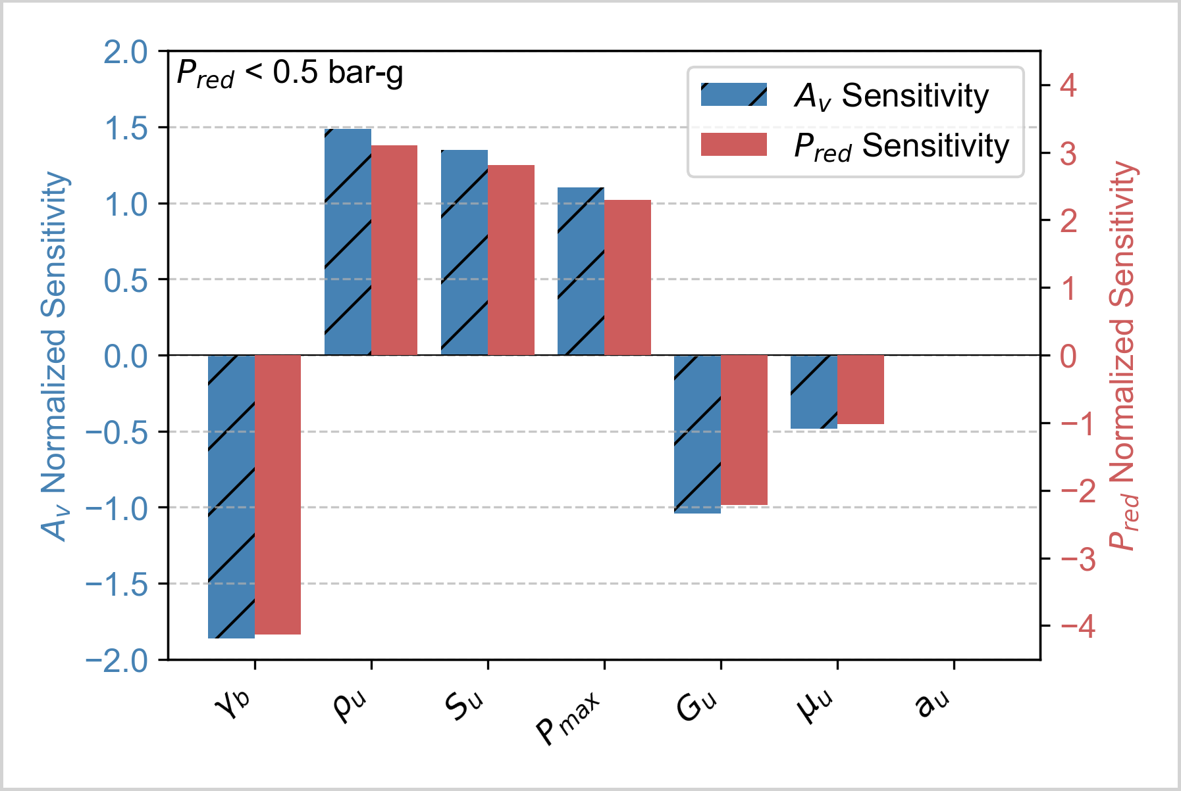 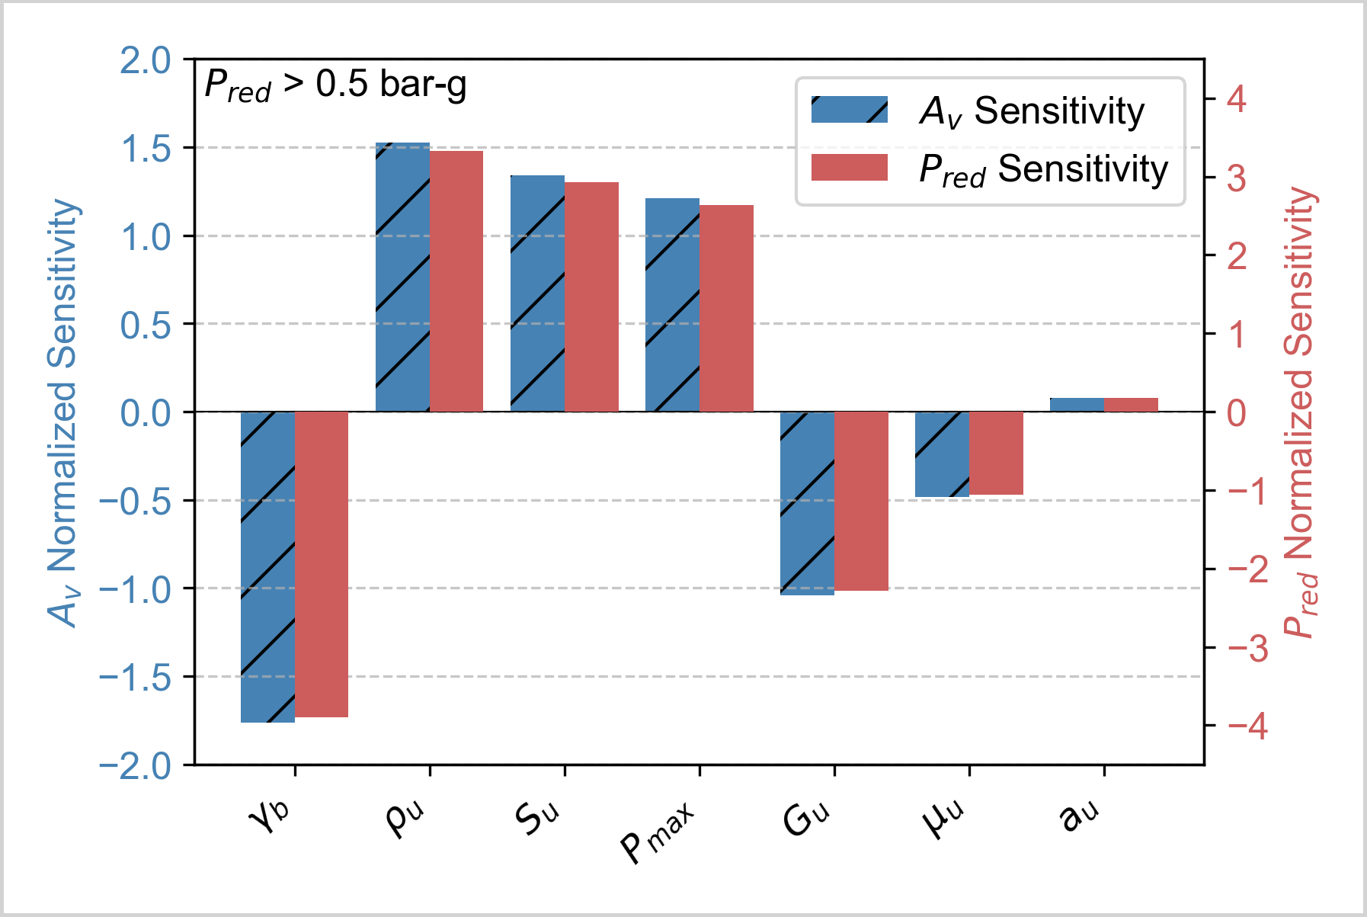

(a) (b)

Figure 1: Relative parameter sensitivities sorted from high to low, for low-strength enclosures [(a) Pred £ 0.5 bar-g] and high-strength enclosures [(b) Pred > 0.5 bar-g].

* + 1. Comparisons of Default Properties and Calculated Mixture-specific Properties

To evaluate the impact of using default properties versus calculated mixture-specific properties, a systematic comparison was performed across all experimental cases indicated in Sec. 4. The analysis revealed that NFPA 68 (2023) calculated overpressures were consistently greater when using the default properties compared to calculated mixture-specific properties. As shown in Figure 2(a), the use of calculated properties led to an average reduction in predicted Pred by 15%, with certain cases, particularly HYSEA and INERIS 20-ft ISO cases containing hydrogen, showing reductions of up to 65%. These differences align with the sensitivity study results, with the lower unburned mixture density and the higher ratio of specific heats for the burned gas leading to lower predicted Pred for the calculated mixture-specific properties. The density effect is particularly pronounced in hydrogen scenarios.

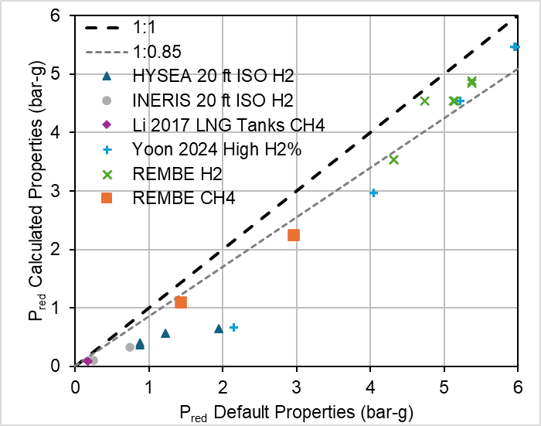 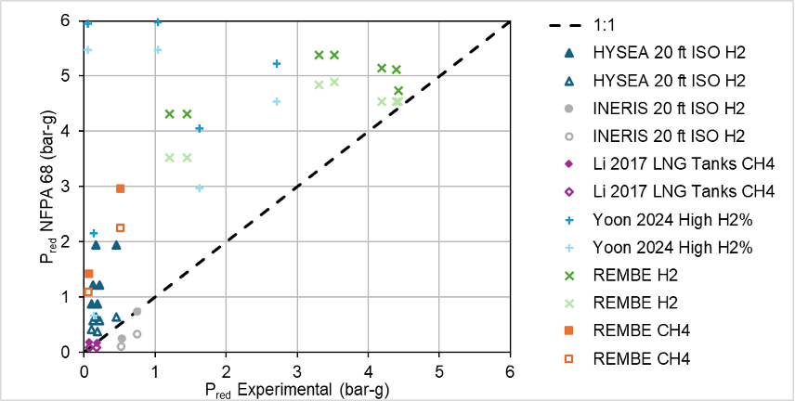

(a) (b)

Figure 2: Comparison of NFPA 68 (2023) predictions for Pred using default and calculated properties (a); comparison of Pred predictions with experimental results (b).

A comparison between predicted and experimental Pred values is presented in Figure 2(b), where predictions using default properties are shown as filled symbols or darker colors, while predictions using calculated mixture-specific properties are shown as empty symbols or lighter colors of the same shape. Both approaches demonstrate predominantly conservative behavior across the dataset, with default properties yielding a larger safety margin and calculated properties providing improved accuracy.

Two sets of cases deviated from the generally conservative predictions. The first involved the INERIS 20-ft ISO container experiments, where unexpected structural responses occurred during testing. While the designated deflagration vent functioned as designed, the container doors unlatched and opened during the deflagration. Although the door areas were included in calculations as low-inertia vents, this simplification likely underestimated the actual door inertia, contributing to underpredicted Pred values. Furthermore, the structural container failure observed in both tests represents a complex phenomenon not accounted for in the model calculations. The second case involved the LNG tank experiments by Li et al. (2017), which exhibited relatively low experimental pressures (Pred = 0.07 bar-g and 0.15 bar-g). In these tests, the higher-pressure case (0.15 bar-g) was not predicted conservatively when using calculated properties, suggesting potential limitations of the model for low-pressure scenarios or effects of experimental variability.

The analysis demonstrates that calculated mixture-specific properties yield more accurate predictions of deflagration pressures and required vent areas while maintaining conservative predictions for the majority of investigated scenarios. These findings have direct practical implications: while NFPA 68 (2023) default values provide a conservative basis suitable for preliminary design assessments, the use of calculated mixture-specific properties offers more refined predictions appropriate for detailed engineering design, particularly for applications involving hydrogen, and is required to fully comply with the standard for fuels with stoichiometric concentrations exceeding 5%.

* 1. Conclusion

This work evaluated the influence of mixture properties on deflagration pressure predictions and required vent areas using the NFPA 68 (2023) gaseous deflagration venting model. A systematic sensitivity analysis revealed that certain properties, particularly the unburned gas density and burned ratio of specific heats, have greater impact on calculation results than commonly emphasized in practice. Through analysis of experimental data relevant to green energy applications, the study demonstrated that using calculated mixture-specific properties instead of default values yields more accurate predictions while generally maintaining conservative results. Quantitatively, pressure predictions were reduced by 15% on average when using calculated properties, with hydrogen applications showing the most significant reductions of up to 65% due to their distinct mixture properties.

The findings have direct implications for industrial practice. While NFPA 68 (2023) default values provide a conservative basis suitable for preliminary design assessments, they are limited to fuels with stoichiometric concentrations below 5%. For final designs, particularly those involving hydrogen or other fuels exceeding this threshold, calculated mixture-specific properties should be used to ensure compliance with the standard and achieve more realistic yet safe vent area specifications.

Nomenclature

AS – Total surface area of vessel (m²)

Av – Required vent area (m²)

au – Speed of sound in unburned mixture (m/s)

βi – Normalized sensitivity coefficient (-)

C – Vent sizing parameter (-)

Cd – Discharge coefficient (-)

Dhe – Hydraulic equivalent diameter (m)

δ – Normalized static activation pressure (-)

Gu – Sonic flow mass flux (kg/m²-s)

γb – Ratio of specific heats of burned mixture (-)

γu – Ratio of specific heats of unburned mixture (-)

L/D – Enclosure length-to-diameter ratio (-)

λ – Turbulence factor (-)

Mu – Molecular weight of unb. mixture (kg/kmol)

μu – Dynamic viscosity of unb. mixture (kg/m-s)

P0 – Initial pressure (bar-g)

Pmax – Maximum explosion pressure (bar-g)

Pred – Reduced explosion pressure (bar-g)

Pstat – Static activation pressure (bar-g)

Pt – Total pressure (Pa)

ρu – Density of unburned mixture (kg/m³)

R – Universal gas constant (J/kmol-K)

Su – Fundamental burning velocity (m/s)

T0 – Initial temperature (K)

Tt – Total temperature (K)

Tu – Temperature of unburned mixture (K)

V – Enclosure/vessel volume (m³)

XSt – Stoichiometric fuel concentration (vol%)

References

Blanquart G., Pepiot-Desjardins P., Pitsch H., 2009, Chemical mechanism for high temperature combustion of engine relevant fuels with emphasis on soot precursors, Combustion and Flame, 156, 588-607.

Davidson, T.A., 1993. A Simple and Accurate Method for Calculating Viscosity of Gaseous Mixtures (No. RI 9456). United States Department of the Interior.

Goodwin D.G., Moffat H.K., Schoegl I., Speth R.L., Weber B.W., 2023, Cantera: An object-oriented software toolkit for chemical kinetics, thermodynamics, and transport processes. <https://www.cantera.org>. Version 3.0.0. doi:10.5281/zenodo.8137090.

Lecocq G., Amouzou S., Leprette E., Le-Roux B., Charrondière S., Mathieu L., 2024, Study of the behaviour of walls and doors of 20 ft ISO containers through real-scale explosion tests. In 15th International Symposium on Hazards, Prevention and Mitigation of Industrial Explosions (ISHPMIE 2024).

Li J., Hernandez F., Hao H., Fang Q., Xiang H., Li Z., et al., 2017, Vented methane-air explosion overpressure calculation—a simplified approach based on CFD. Process safety and environmental protection, 109, 489-508.

NFPA 68, 2023, Standard on explosion protection by deflagration venting. Retrieved from https://link.nfpa.org.

Skjold T., Hisken H., Bernard L., Mauri L., Atanga G., Lakshmipathy S., et al., 2019, Blind-prediction: estimating the consequences of vented hydrogen deflagrations for inhomogeneous mixtures in 20-foot ISO containers. Journal of Loss Prevention in the Process Industries, 61, 220-236.

Sutherland W.,1893, The viscosity of gases and molecular force, Philosophical Magazine, 5-36, 507-531.

Yoon U. G., Park B., Kim W., Kim Y., 2024, Large scale experiment of a roof vented deflagration of high-concentration hydrogen-air mixtures. Process Safety and Environmental Protection, 184, 1411-1423.