|  |  |
| --- | --- |
| cetlogo ***CHEMICAL ENGINEERING TRANSACTIONS***  ***VOL. xxx, 2025*** | A publication of  aidiclogo_grande |
| The Italian Association  of Chemical Engineering  Online at www.cetjournal.it |
| Guest Editors: Bruno Fabiano, Valerio Cozzani  Copyright © 2025, AIDIC Servizi S.r.l. **ISBN** 979-12-81206-xx-y; **ISSN** 2283-9216 | |

Interpreting Pseudo-Adiabatic Data: An Excel-Based Approach to Kinetic Modeling for Thermal Hazard Evaluation

Kevin Antien\*, Gérard Vilain

TÜV SÜD Schweiz AG, Mattenstrasse 22, 4058 Basel, Switzerland.

kevin.antien@tuvsud.com

This paper presents an innovative Excel-based tool designed for kinetic modeling and simulation of adiabatic runaway scenarios, utilizing data derived from Accelerating Rate Calorimeter (ARC) measurements. By harnessing the capabilities of Excel's Solver and VBA macros, empowers users to exert direct control over the modeling process, promoting both precision and transparency. Comprehensive validation against both simulated and real-life data underscores its accuracy and adaptability in managing complex exothermic systems. With the integration of φ-factor corrections, this approach offers an accessible yet robust methodology for predicting critical safety parameters, such as the Time to Maximum Rate (${tmr}_{ad}$), thereby enhancing safety assessments in chemical processes.

* 1. Introduction

Pseudo-adiabatic calorimetry was developed for thermal hazard evaluation, providing essential time, temperature, and pressure data for chemical reactions under near-adiabatic conditions. This data is key to predicting runaway behavior. Accurate estimation of the Time to Maximum Rate (${tmr}_{ad}$) and self-heating rate (SHR) is crucial for thorough thermal hazard assessment and vent sizing. To reflect true adiabatic conditions as seen on an industrial scale, correcting the measured data for thermal inertia is essential. While simple zero-order extrapolations can sometimes be sufficient, using more precise kinetic models often yields better results.

The primary objective of this paper is to present an Excel-based approach for kinetic modeling, φ-factor correction, and the simulation of adiabatic runaway curves using data from Accelerating Rate Calorimeter (ARC) measurements (which are typically associated with high thermal inertia) (Towsend, 1980). This method puts the kinetic modeling and data-fitting directly in the hands of the user, allowing for precise adjustments and ensuring full transparency. It removes the reliance on opaque automated tools, giving the analyst full oversight and control over the process. As recently pointed out by Kossoy *et al.* (2020), it is important to recognize that *pseudo*-adiabatic measurements are not without their limitations, including potential non-uniformity, non-equilibrium conditions, and variability in the φ-factor, which can all affect data accuracy and interpretation. As such, the early stages of the SHR curve are considered the most reliable for extrapolating true adiabatic conditions, and efforts should be made to model these stages rather than the high-temperature regions.

* 1. Approach and validation

This section details the Excel-based tool developed for kinetic modeling, φ-factor correction, and simulation of adiabatic runaway curves. The primary objective of this tool is to enable user-driven data fitting and simulation, using experimental data obtained from ARC measurements. By describing its inner workings, we aim to ensure transparency and facilitate its application in thermal hazard assessments.

* + 1. Data extraction

The first step in the process involves extracting the key experimental variables: time, temperature, and SHR. While pressure and pressure rise rate data are also available, they fall outside the scope of this work and will not be discussed herein. These data points need to be imported into a dedicated section within the Excel template. Following this, the user manually selects the specific range of data to be modeled. The labelled datapoints are then extracted using an INDEX/MATCH spill formula, allowing direct point-by-point comparison between the experimental data and the model output. VBA macros are employed in the background to spill the modeled data over the defined range, ensuring that each experimental data point has a corresponding model counterpart. Importantly, these macros are always triggered manually by the user, thus avoiding unnecessary strain on computational resources.

* + 1. Kinetic Model

For data fitting, a kinetic model is selected that balances simplicity with robustness, minimizing the number of parameters to streamline the computational process. The fitting process relies on Excel's Solver tool, employing the Evolutionary algorithm. This method iteratively optimizes model parameters within user-defined boundaries by generating a population of solutions that evolve through processes akin to natural selection, refining the model to best fit the experimental data. To minimize computational complexity, a single-stage reaction model incorporating self-accelerating kinetics is used. While more complex kinetics could be modeled or approximated, as noted previously, the focus should remain on the low-temperature region of the exothermic event observed in ARC measurements, where true adiabatic conditions are most likely to prevail. It is assumed that the kinetics of the initial reaction stage largely determine the subsequent runaway behavior. The adopted kinetic model is shown in Equation (1) and follows the so-called Berlin model (Hugo *et al*. 1993; Grewer, 1994; Steinbach, 1999), with *P* as the self-accelerating factor, *m* representing the autocatalytic reaction order, $E_{a}$ the activation energy, R the ideal gas constant, $k_{0}$ the Arrhenius pre-exponential factor, and α the chemical conversion.

|  |  |
| --- | --- |
|  | (1) |
| $$α= \frac{T-T_{onset}}{{δT}_{max}-T_{onset}}=\frac{T-T_{onset}}{{∆T}_{δ,meas.}}$$ | (2) |

To enhance computational efficiency within Excel, the model utilizes temperature as a proxy for conversion, assuming a direct proportionality for single-stage reactions under *pseudo*-adiabatic conditions, as shown in Equations (1) and (2). Provided sample uniformity and constant thermal inertia are maintained, the experimental temperature data can safely be used to develop the model. In cases where multiple exothermic events overlap and the event of interest cannot be modeled over its entire range, a conversion scale factor 𝛿 is introduced in Equation (2). This adjustment implicitly informs the model that the exothermic event extends beyond the specified $T_{max}$. The SHR may then be expressed again as shown in Equation (3), where $k_{0}$ is expressed as a function of the onset parameters (Equation (4)).

|  |  |
| --- | --- |
|  | (3) |
|  | (4) |

The corresponding time scale may then be recalculated from the SHR according to Equation (5) (Kossoy *et al*. 2015). In this Excel implementation, the rectangle method for numerical integration is preferred, providing results comparable to more advanced integration techniques such as those available in Python libraries.

|  |  |
| --- | --- |
|  | (5) |

* + 1. Optimization process

The data fitting and modeling rely on iterative, non-linear optimization techniques. The user selects which parameters will be optimized, including the conversion scale factor 𝛿, the activation energy $E_{a}$, the reaction order

𝑛, the self-accelerating factor 𝑃, the order of the autocatalytic reaction 𝑚, the conversion scale factor 𝛿 and the SHR at the measured onset ${\left.{dT}/{dt}\right|}_{T_{onset}}$ Optimizing this last parameter is crucial for enhancing the convergence of the kinetic model, as it actively compensates for the high noise present at the onset of the thermal event. Additionally, raw data is preferred over pre-filtered data, such as that obtained from the ARC’s ".exo" file, which often underwent excessive smoothing through simple averaging, hence severely limiting flexibility in model development while also drastically culling the number of available datapoints.

A built-in macro controls Excel’s Solver, which optimizes the model within user-defined boundaries until a minimum deviation between the model and experimental data is achieved. The user can select multiple optimization targets – such as minimizing the maximum, median, and average deviations or the root mean square error – between model predictions and experimental data, for both the $f\left(1/T\right)={dT}/{dt}$ and $f\left(t\right)=T$ curves. Each target is then assigned a weight, and the Solver minimizes the weighted sum of these targets. This approach enables simultaneous optimization of various model aspects, providing users with flexibility in refining the model. Ultimately, users maintain full control over the optimization process, allowing adjustments to boundaries, parameters, and weights as needed to achieve a chemically meaningful and accurate model.

* + 1. Validation

To validate the quality of data fitting achieved through this approach, simulated SHR data was generated using Python with known kinetic parameters. Under real-life conditions, significant noise is expected in the SHR signal at the beginning of any thermal event. Additionally, chemical reactions are seldom observed in their entirety due to initial conversion occurring below the detection limit of the ARC. Standard practice dictates that the ARC switches from heat-wait-search mode to adiabatic tracking mode upon detecting an SHR of 0.02 K/min. As a consequence, and to accurately reflect real-life experimental conditions, Gaussian noise (0.01 K/min) was added to the simulated signal, while the first approximately *ca* 5°C were removed from the dataset, resulting in a starting point of 45.2°C and an initial expected SHR of 0.01838 K/min. Furthermore, recognizing that exothermic signals frequently overlap with other events, the last 10°C of the dataset were also excluded before subjecting the data to modeling. The results of the modeling process are displayed in Table 1 and Figure 1.

Table 1: Fitting quality validation

|  |  |  |  |  |  |  |  |
| --- | --- | --- | --- | --- | --- | --- | --- |
|  | **Temp. range** | $${{dT}/{dt}}_{45.2°C}$$ | $$E_{a}$$ | **𝑛** | **𝑃** | **𝑚** | **𝛿** |
| **Python simulation** | 40–140°C | 0.01838 K/min | 117.50 kJ/mol | 1.000 | 5.000 | 2.000 | / |
| **Modeled kinetics** | 45.2–125.4°C | 0.01832 K/min | 119.47 kJ/mol | 1.007 | 3.987 | 1.836 | 1.117[a] |
| [a] Corresponds to 84.53% of full signal. Expected based on dataset: 84.60% | | | | | | | |

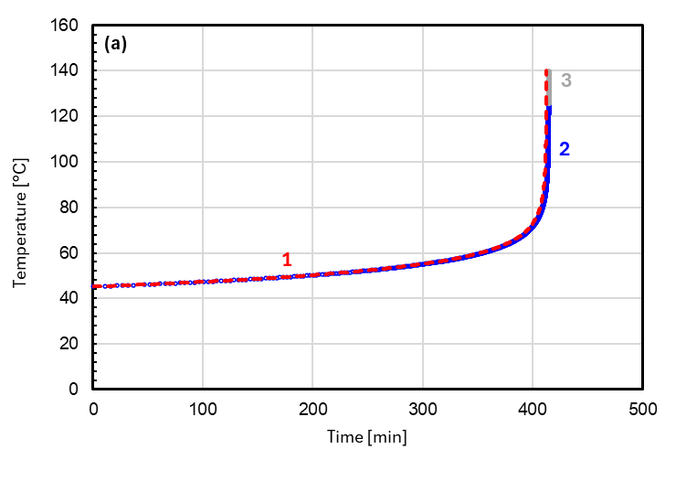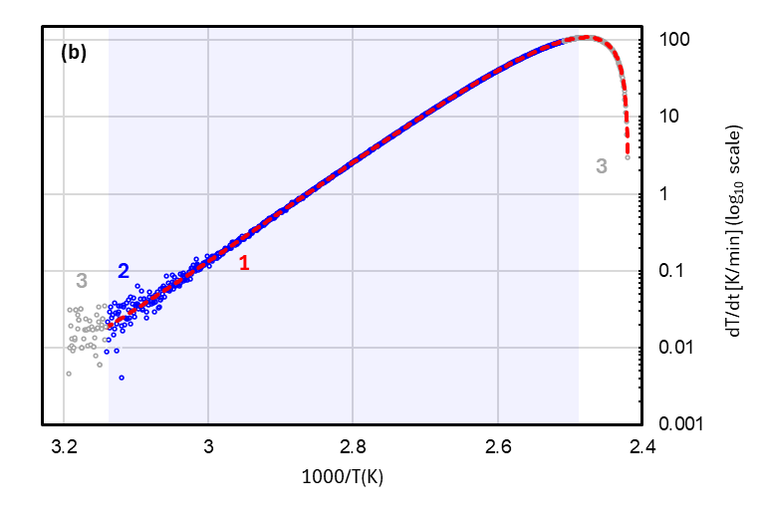  
Figure 1: Fitting quality validation. (a) Temperature vs time curve. (b) SHR vs 1/T curve. (1) Kinetic model. (2) Modeled data range. (3) Culled section of the dataset prior to modeling.

The overlap of the modeled SHR and time data with the simulated ARC data is excellent, as depicted in Figure 1. The mathematical correlation between the developed model and the input data is nearly flawless, with an *R2* value exceeding 0.9999, as is the correlation with the initial simulated data (without gaussian noise). An identically high correlation is observed with the original simulated data (prior to the addition of Gaussian noise). This computational validation experiment demonstrates the mathematical robustness of an Excel-Solver-based data fitting approach.

* + 1. Simulation of adiabatic scenarios

Once the kinetic model is established, the user can proceed to simulate adiabatic conditions for the system. The first step is to recalculate the adiabatic onset temperature, which corresponds to the temperature at which the same initial SHR observed during the ARC experiment would occur under adiabatic conditions. This is done using the method recommended by Fisher *et al.* (1992), applying Equation (6). The previously determined activation energy is here required. Since the conversion at the onset is minimal, zero-order kinetics are assumed to extrapolate the initial SHR at different temperatures, as per Equation (7). The expected adiabatic temperature rise is also calculated using Equation (8), providing the relevant temperature range for the simulation. Based on these equations, the user can alternatively simulate scenarios under real industrial conditions by adjusting the thermal inertia accordingly. This is done by dividing the φ-factor from the ARC measurement by the φ-factor of the industrial vessel, resulting in a new thermal inertia parameter. This φ’-factor can then be applied in equations (6) and (8), allowing the model to accurately reflect the behavior of the system in an industrial context.

|  |  |
| --- | --- |
| $$\frac{1}{T_{onset,ad}}=\frac{1}{T_{onset}}+\frac{R}{E}lnφ$$ | (6) |
|  | (7) |
| $${∆T}_{ad}={φ∆T}_{δ,meas.}$$ | (8) |

For each temperature in this range, spaced in 0.1°C intervals, the adiabatic SHR is calculated using the kinetic model from equation (4). The corresponding time scale of the adiabatic scenario is then recalculated as described in Section 2.2. This temperature interval was determined through trial and error and represents an optimal balance between computational efficiency and accuracy of integration when using the rectangle method.

Finally, for any given starting temperature, the ${tmr}_{ad}$ is determined by reading the time required to reach the point of maximum SHR in the simulated scenario. This metric is essential for evaluating the thermal safety of the system and can be regarded as the culmination of the tool presented herein.

* + 1. Practical considerations

To optimize the performance of the tool, the model fitting process is segregated from other functions of the Excel file, thereby minimizing computational load and enhancing overall efficiency. Extensive use of VBA macros enables swift adjustments of formulas, allowing the tool to adapt to varying situations without requiring all calculations to run simultaneously when they are unnecessary. This approach further reduces superfluous computations. For advanced users, the tool may be supplemented with Python optimization techniques, providing additional flexibility and increased computation speed for more complex analyses and scenarios.

* 1. Application of the method to real-life examples

This section illustrates the application of the tool to real-life chemical systems. By utilizing experimental data from ARC measurements, a kinetic model is developed to predict system behavior under adiabatic conditions, culminating on the estimation of the .

* + 1. Formaldehyde 37%w/w and Phenol (1:1)

A system consisting of formaldehyde (37% in water) mixed with an equimolar amount of phenol was analyzed (φ = 1.93, assuming a heat capacity of 2.0 kJ/(kg K)). The SHR for this system, when plotted as the logarithm of SHR against inverse temperature, reveals a distinct convex shape – indicative of self-accelerating kinetics (Figure 2b). To accurately capture this behavior, the kinetic model was designed to allow flexibility in exploring parameters 𝑃 and 𝑚. During the analysis, it was observed that the experimental SHR data became unreliable above 165°C, likely due to the limitations of the measurement apparatus. As a result, the initial attempt to model the system involved fitting the temperature curve independently from the SHR curve. This approach produced an excellent fit for the temperature data alone, but proved insufficiently conservative when compared to a dynamic DSC measurement of the material (gold-plated crucible, 4 K/min heating rate, argon atmosphere), where the model predicted a delayed onset. Upon further refinement, the best fit was obtained by focusing the model on approximately 70.8% of the exothermic signal—up to the point where the SHR data began to exhibit erratic fluctuations. This partial signal fitting proved to be a more reliable representation of the system's behavior. With this adjustment, the model produced excellent alignment for both the SHR and temperature curves, accurately capturing the system's kinetics (R2(SHR)=0.9985 and R2(time)>0.9999 across 802 datapoints;see Table 2 and Figure 2). Pleasingly, the kinetic model also demonstrated excellent predictive capability when validated against the dynamic DSC measurement. This validation allowed for confident extrapolation of the ${tmr}_{ad}$ at lower temperatures, as shown in Figure 2d. As such, the temperature at which this time is 24 hours (TD24) is determined to be 84°C based on the established kinetic model.

Table 2: Formaldehyde 37% / Phenol 1:1 mixture. Best fit parameters.

|  |  |  |  |  |  |  |  |
| --- | --- | --- | --- | --- | --- | --- | --- |
|  | **Temp. range** | $${{dT}/{dt}}_{110.5°C}$$ | $$E_{a}$$ | **𝑛** | **𝑃** | **𝑚** | **𝛿** |
| **ARC event** | 110.5–204.5°C |  |  |  |  |  |  |
| **Modeled kinetics** | 110.5–125.4°C | 0.02203 K/min | 83.90 kJ/mol | 1.0888 | 10.8058 | 1.0000 | 1.1548 |

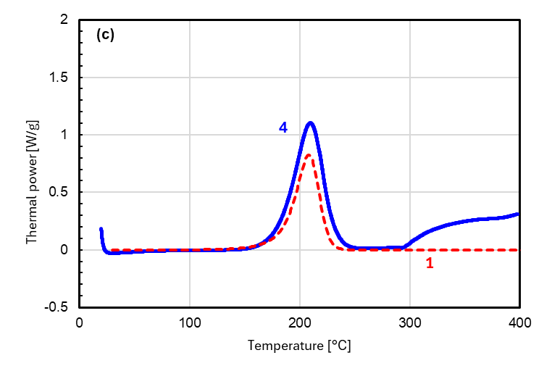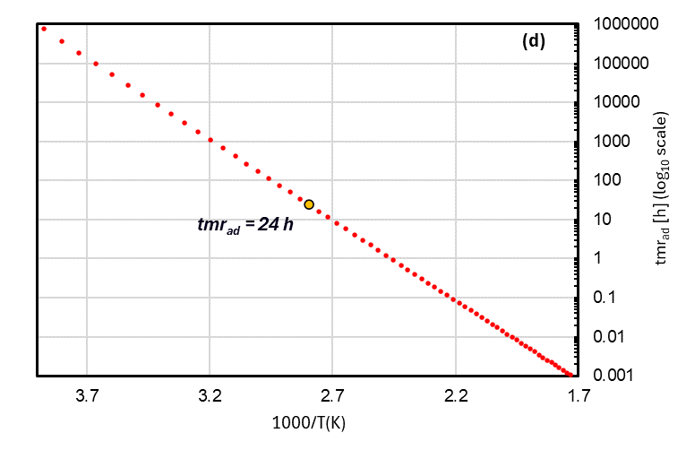

Figure 2: Formaldehyde 37% / Phenol 1:1 mixture. (a)Temperature vs time curve (ARC). (b) SHR vs 1/T curve (ARC). (c) Model validation with DSC (dynamic, 4 K/min). (d) tmradprediction based on kinetic model. (1) Kinetic model. (2) Modeled data range. (3) Culled section of the dataset prior to modeling. (4) Dynamic measurement.

* + 1. Urea in Nitric acid 67%w/w (1:11)

A nitration mixture composed of urea and concentrated nitric acid (67% w/w) in a 1:11 weight ratio was then investigated (φ = 2.38, based on a measured heat capacity of 2.6 kJ/(kg K)). The exothermic behavior of this system was found to be complex, with the overall reaction subdivided into three distinct exotherms (see Figure 3b). Given the assumption that the first of these exothermic events would predominantly dictate the overall runaway kinetics on industrial scale, modeling efforts were focused on this initial stage.

At first glance, the system did not appear to exhibit a self-accelerating behavior. However, a closer examination of the data revealed a subtle, slightly convex curvature at the beginning of the first exothermic event – suggesting the presence of a self-accelerated subevent. Further ARC measurements at lower fill levels (higher φ) confirmed this observation, revealing a small exothermic event that occurs immediately prior to the first major decomposition. Under conditions closer to adiabaticity, this small exotherm merges with the primary decomposition event, simplifying the overall interpretation. Interestingly, this pre-event was also detected in dynamic DSC measurements, manifesting as a shoulder on the low-temperature side of the first major exothermic peak (Figure 3c). To facilitate modeling, inconsistent data points at the signal’s onset (1.1 K range) were removed. The system was modeled up to the onset of the second exothermic event measured at *ca* 144°C. The kinetic model yielded an excellent fit, accurately representing both the SHR and temperature profiles (R2(SHR)>0.9985; R2(time)>0.9999 across 198 data points; see Table 3 and Figure 3). Validation against dynamic DSC measurements yielded a conservative estimate, which appeared slightly shifted toward lower temperatures. The discrepancy in peak heights is attributed to a 19% higher energy being measured in the DSC experiment. Given the model’s conservative nature, it was deemed valid for the prediction of the ${tmr}_{ad}$ at lower temperatures as depicted in Figure 3d. TD24 is here determined to be 35°C. This example highlights the tool's ability to manage complex exothermic systems and accurately predict thermal behavior.

Table 3: Urea / Nitric acid 1:11 mixture. Best fit parameters.

|  |  |  |  |  |  |  |  |
| --- | --- | --- | --- | --- | --- | --- | --- |
|  | **Temp. range** | $${{dT}/{dt}}_{76.6°C}$$ | $$E_{a}$$ | **𝑛** | **𝑃** | **𝑚** | **𝛿** |
| **ARC event** | 75.5–257.5°C |  |  |  |  |  |  |
| **Modeled kinetics** | 76.6–143.9°C | 0.12407 K/min | 82.84 kJ/mol | 1.2491 | 3.8067 | 1.0000 | 1.0084 |

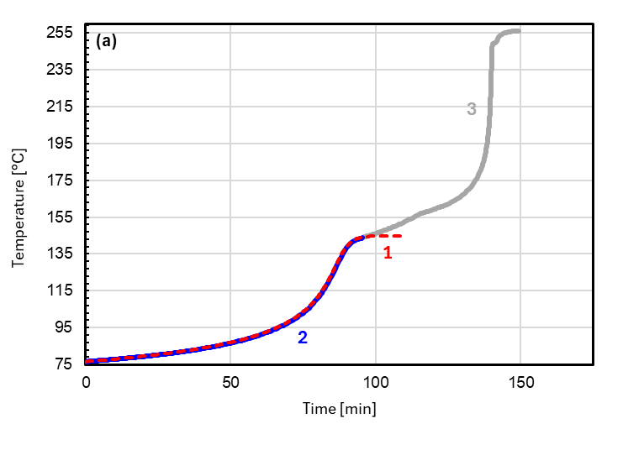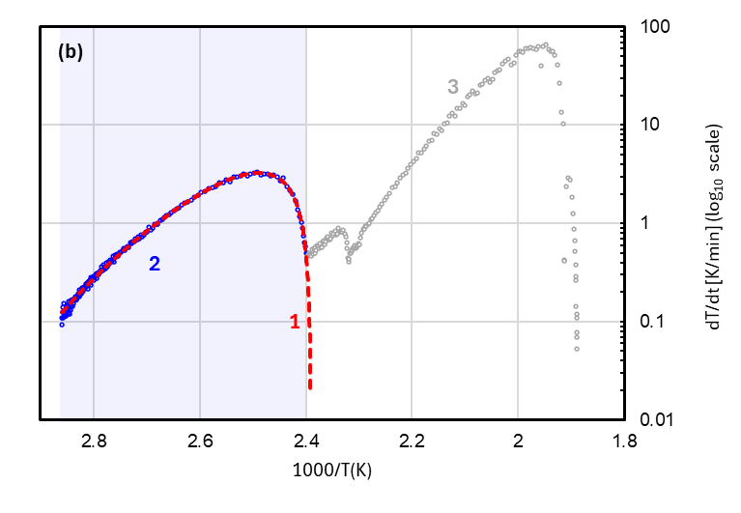

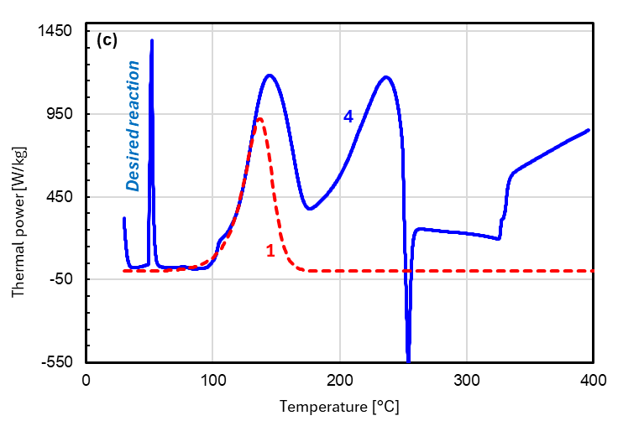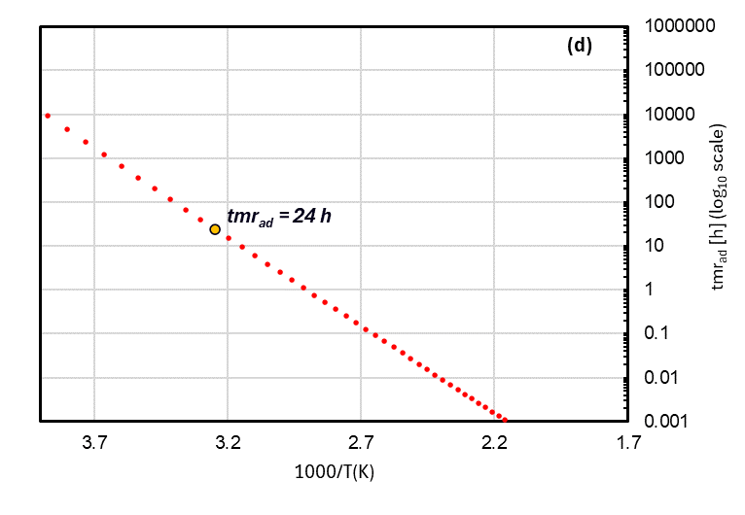

Figure 3: Urea / Nitric acid 1:11 mixture. (a)Temperature vs time curve (ARC). (b) SHR vs 1/T curve (ARC). (c) Model validation with DSC (dynamic, 4 K/min). (d) tmradprediction based on kinetic model. (1) Kinetic model. (2) Modeled data range. (3) Culled section of the dataset prior to modeling. (4) Dynamic measurement.

* 1. Conclusions

This paper presents an Excel-based tool for kinetic modeling and simulation of adiabatic runaway scenarios integrating φ-factor correction, designed in the context of thermal hazard assessments using data from ARC measurements. The tool relies on user-driven optimization. This approach offers transparency and flexibility, enabling users to refine thermokinetic models for systems of varying complexity. The validation of the method against simulated and real-world experimental data, including examples like formaldehyde-phenol and urea-nitric acid mixtures, demonstrates the tool’s effectiveness in predicting key safety metrics such as the ${tmr}_{ad}$. Among the examples examined, the TD24 was determined to be 84°C for the formaldehyde-phenol system, while the urea-nitric acid mixture displayed a TD24 of 35°C. The developed approach provides a reliable, user-friendly solution for evaluating the thermal risks of chemical processes based on a single *pseudo*-adiabatic measurement.

References

Fisher, H.; Forrest, H.; Grossel, S.; Huff, J.; Muller, A.; Noronha, J.; Shaw, D.; Tilley, B., 1992, Emergency Relief System Design Using DIERS Technology: The Design Institute for Emergency Relief Systems (DIERS) Project Manual, John Wiley & Sons.

Grewer, T., 1994, Thermal Hazards of Chemical Reactions, Industrial Safety Series, Vol. 4, Elsevier, Amsterdam.

Hugo, P.; Wagner, S.; Gnewikow, T., 1993, Determination of Chemical Kinetics by DSC Measurements: Part 1, Theoretical Foundations, Thermochim. Acta, 225 (2), 143–152.

Kossoy, A. A.; Singh, J.; Koludarova, E. Y., 2015, Mathematical Methods for Application of Experimental Adiabatic Data – An Update and Extension, J. Loss Prev. Process Ind., 33, 88–100.

Kossoy, A., 2020, An In-Depth Analysis of Some Methodical Aspects of Applying Pseudo-Adiabatic Calorimetry, Thermochim. Acta, 683, 178466.

Steinbach, J., 1999, Safety Assessment for Chemical Processes, VCH, Weinheim.

Townsend, D. I.; Tou, J. C., 1980, Thermal Hazard Evaluation by an ARC, Thermochim. Acta, 37, 1–30.