|  |  |
| --- | --- |
| cetlogo ***CHEMICAL ENGINEERING TRANSACTIONS***  ***VOL. xxx, 2025*** | A publication of  aidiclogo_grande |
| The Italian Association  of Chemical Engineering  Online at www.cetjournal.it |
| Guest Editors: Bruno Fabiano, Valerio Cozzani  Crown Copyright © 2025 **ISBN** 979-12-81206-xx-y; **ISSN** 2283-9216 | |

Evaluation of the performance capability using drones for remote visual inspection of high hazard plant and assets

Adam C. Bannister, George T. Alliott\*, Michael Stewart

Health and Safety Executive, Morland Way, Harpur Hill, Buxton, Derbyshire, United Kingdom, SK17 9JN

George.Alliott@hse.gov.uk

Close visual inspection (CVI) forms a cornerstone of integrity assurance for surface flaws and corrosion damage in assets such as offshore structures, vessels, and tanks. Recent advances in access technologies, such as drones, have led to their increased use for remote visual inspection (RVI) as partial, or complete, replacement of CVI. However, comparative studies of capabilities and limitations of RVI in terms of reliable detection of different types of defects are currently limited.

In collaboration with a group of industrial partners, a series of trials to evaluate the capabilities of drone inspections has been completed. The aim of the trials was to develop the evidence base for the types and sizes of defects and degradation that can be reliably found using currently available drone and camera technology. The results were analysed in terms of ability of participating organisations to find, identify and size features present in a range of materials. Features included welding defects, impact damage, coating damage, and linear defects. Feature resolution capability was assessed through the use of Image Quality Indicator samples.

The results were evaluated in respect of the overall capability of RVI in comparison with CVI. Results showed that in respect to finding defects, the best participant score could be comparable to CVI, however, there were exceptions, and no participant was consistently the best. In respect to identifying defects, RVI scored consistently lower than CVI. In respect to sizing defects, RVI accuracy was very variable, with some features significantly undersized. An assessment of RVI’s sensitivity to different variables is also presented in this paper.

* 1. Introduction

Close visual inspection (CVI) forms a cornerstone of integrity assurance and is often the primary means of detecting and sizing surface defects. Recent advances in technologies such as unmanned aerial vehicles (UAVs), or drones, have led to their increased use. Remote visual inspection (RVI), using these technologies can present benefits, such as minimising potentially hazardous CVI activities. However, studies exploring the capabilities and limitations of RVI to inspect a variety of materials for defects of different types and sizes are currently limited in both number and scope.

In collaboration with a group of industrial partners, a series of trials have been completed with the aim of evaluating the inspection capabilities of drones relative to CVI. In particular, to develop the evidence base for the types and sizes of defects and degradation that can be reliably inspected with current drone and camera technology. Further aims of the trials, in the context of high hazard plant, were to:

* Define the limitations of RVI techniques for performing inspections
* Establish the effect of variables, e.g., weather, depth of field and camera type
* Establish requirements for technique validation and capability of pilot/inspector
* Establish how human factors can impact RVI results
* Compare probability of detection (POD) rating of CVI and RVI

CVI provides the reference point for comparison with RVI. The requirements for CVI are covered in a range of standards that include product-specific inspection (e.g. fusion welds), requirements for personnel and demonstration of visual capability. Standards such as BS EN 13018:2016 (*Non-destructive testing – Visual testing – General principles*) set CVI requirements for parameters such as viewing distance (≤600 mm), viewing angle (≥30 degrees from the surface), lighting level (≥500 lux). Visual acuity requirements are given in BS EN ISO 9712:2022 (*Non-destructive testing – Qualification and certification of NDT personnel*) as a resolution of Times New Roman text of 4.5 point, at not less than 30 cm. Specific standards also exist for the visual inspection of fusion welded joints in both thermoplastic and metallic materials. Specific British Standards for RVI do not currently exist, although guidance documents have been produced by e.g. HOIS (Burch 2018), American Bureau of Shipping (2019), and Construction Industry Research and Information Association (CIRIA) (2019). These tend to focus on the steps required for a successful RVI process, rather than a validation of its inherent capability as compared to CVI.

* 1. Outline of inspection trials and assessment method

Five organisations participated in the trials, comprising a series of bespoke samples located on three structures: a 5 m high indoor steel tower (Figure 1a); a 25 m high outdoor steel tower (Figure 1b); and two faces of a concrete block wall. Participant C generated two sample sets using different drones, therefore, a total of six inspections were carried out as part of the trials. The samples included a range of materials (carbon steel, stainless steel, welded joints, coated steel, brass, composites, and concrete) of varying surface finish. Based on a survey of the sponsors, a range of the most concerning, frequent, and difficult to inspect features, defects, and damage were created in the samples. These included welding defects, fatigue cracks, impact damage, pitting corrosion, heat damage, and artificial notches. In total six different sample materials, eleven different types of features and defects, and eight different surface conditions were used in a variety of combinations across 45 samples, on the indoor and outdoor towers. Samples were fixed to the towers in different orientations so that they would have to be inspected above, below, and in front of, the drones.

|  |  |
| --- | --- |
| a | b |

Figure 1: Samples on the (a) 5 m indoor and (b)25 m outdoor tower, at HSE Buxton

Each participant was sent a trial briefing document beforehand, and a briefing was held on the day(s) of each visit. The trials briefing document included information on the aims, sample numbering system, the material from which the samples were manufactured and the locations of the samples on the tower. Specific information from each participant was also noted, such as qualifications of personnel, Civil Aviation Authority (CAA) drone pilot licenses, documentation and flying permissions, roles of personnel, equipment used, and method statements. An overview of the participants, their hardware and team composition is given in Table 1.

Results for both CVI and RVI were assessed, according to specific scoring criteria, as outlined in Table 2, to enable comparisons between the two techniques on the same samples in the same locations on the towers. Participant results were combined and anonymised. Problems encountered during the trials, observations of human factors issues, and examples of good practice in reporting were also evaluated.

Table 1: Overview of participants, hardware, and team composition

|  |  |  |  |  |  |
| --- | --- | --- | --- | --- | --- |
|  | Participant A | Participant B | Participant C1 | Participant D | Participant E |
| Nature of business | Inspection company | Facilities operator | Facilities operator | Facilities operator | Inspection company |
| Month of Inspection | June | June | September | August | December |
| Drone(s) used | DJI Mavic 3 | DJI Mavic 2 Enterprise Advanced | C1: Flyability Elios 2  C2: Intel Falcon 8+ | DJI Mavic M300 with RTK2 system | DJI Mavic M300 |
| Camera | As-sold (not interchangeable) | As-sold (not interchangeable) | C1: As-sold (not interchangeable)  C2: Sony A7r with fixed 35 mm and 50 mm prime lenses | Zenmuse H20T (used for video)  Phase One P3 (for stills) | Zenmuse H20T |
| RVI team composition3 | 2 People  (1p; 1i) | 1 Person  (p and i) | 3 People  (1p; 1i: 1c) | 2 People  (1p; 1i) | 2 People  (1p; 1i) |
| Data analysis and reporting | By same team | By same person and review by a second inspector | By different person and review by a second inspector | By same team | By different person and review by a second inspector |

Notes: (1) Participant used two different drone/camera combinations: designated in the results as C1= Elios 2; C2= Intel Falcon 8+; (2) Real Time Kinematic; (3) The commonest team composition was one pilot (p) and one inspector (i) operating together, only one team also had a coordinator (c)

Table 2: Scoring criteria for trial samples

|  |  |
| --- | --- |
| Rating Criteria | Example of Applicability |
| Features found Yes/No? | Pitting in stainless steel; impact damage in GFRP1 pipe; fatigue crack in C-steel2; missing weld bead; spalling in concrete |
| Features correctly identified? | Pitting in stainless steel; named weld defects; EDM3 notches in C-steel2 |
| All regions of damage found? | Heat damage on coated steel; punch and score damage in coated steel |
| Dimensions given? | EDM4 notches in C-steel2; fatigue crack length; length of missing weld; width and length of GFRP1 impact damage; |
| Features incorrectly identified? | Cracks vs weld shadow; scratches vs cracks |
| Extraneous features identified? | Corrosion and percentage coverage; scratches; weld spatter; other unintended blemishes |
| Total number of features found vs actual number | EDM3 notches in C-steel2 plates; heat damage spots in coated steel |
| Minimum size of feature found | Drilled holes in stainless steel plate; holes and notches in brass tube |

Notes: (1) Glass-fibre reinforced plastic; (2) Carbon steel; (3) Electrical discharge machining

The overall capability of RVI was determined against a three-tier assessment based on the ability of participants to find features and defects (is there anything there?), identify them (what is the feature?), and size them (what are their dimensions?) in each sample. In addition, Image Quality Indicators (IQI) were used to determine feature resolution, and artificial notches used to assess POD.

* 1. Example sample sets

The survey amongst the industrial sponsor group highlighted that reflectivity of surfaces under inspection and surface preparation/finish featured among the top challenges of RVI. Examples of reflective sample materials described in this paper include welded stainless steel, powder coated steel, and GFRP.

Due to its ability to resist aggressive chemicals and corrosive liquids, stainless steel is often used in the chemical processing and oil and gas industries in applications such as pipework and tanks, where welding is a frequently used joining technique. Butt-welded, stainless-steel plates, each fabricated with specific features (e.g. multiple passes, missing weld bead, and excessive spatter), formed this part of the trials.

Coatings perform crucial corrosion protection function in the case of carbon steels used in a variety of environments such as offshore, chemical processing, shipping, bridges, and buildings. In the current work, carbon steel plates with a white powder-coated surface were used. These were subject to scoring/hatching and punch damage of the coating, followed by accelerated weathering to induce local corrosion of the substrate, where the coating was damaged. Two regions of cross-hatched scoring damage and six regions of punch damage, ranging from one to ten points, were made on the sample.

GFRP is used for storage tanks, pipework, and composite wrap repairs. Due to the layered structure of the material, it can be difficult to identify certain types of defects, including ones that are safety critical. Impact damage, e.g. caused by dropped objects, can cause structural damage to the material, which can take the form of delamination between the layers. However, little evidence of deformation is visible on the surface. The reflectively of the material, and its curvature in some applications, add to the complexity of visual inspection. Three GFRP pipes, of diameter 250 mm and length 1 m, were included in the trials in two orientations. Impact damage of varying severity was present on all three pipes, and on the outdoor tower had also been subject to weathering and water ingress.

In addition to high reflectivity samples, carbon steel samples containing notches of varying dimensions are also discussed. Artificial notches are used to represent linear defects, such as cracks, which can be safety critical and difficult to find and identify. Notched steel samples with four different surface conditions were inspected to assess the impact this has on POD. The surface conditions were, as-rolled, weathered, heavily weathered, and weathered then wire brushed.

* 1. Example assessments of selected samples
     1. Stainless steel welded plates

The stainless steel butt weld in both orientations and locations (indoors and outdoors) scored high in inspections by all participants, other than for the indoor sample in data set C1, which was carried out using an Elios 2. Particularly high-quality images and assessments were provided by Participant D, the approach being to provide a high resolution (100 MP), low magnification image of the sample on the tower and to then provide detailed images from the same photograph of each location, an example of which is shown in Figure 2.

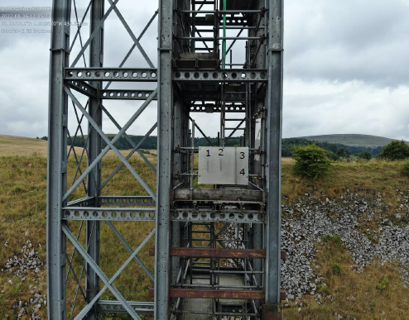 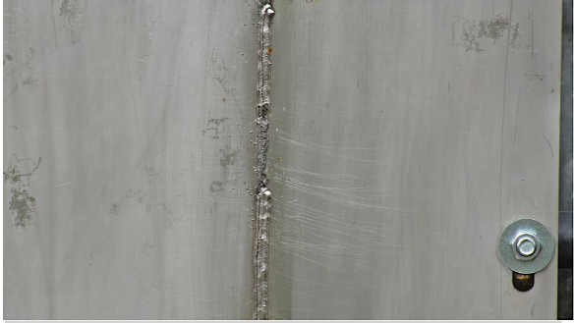

3

Figure 2: Images from Participant D's report showing approach to imaging welded stainless steel sample

CVI of the welds showed that all principal features could be located and correctly identified. No features were incorrectly identified in any of the welds. Overall, the incorrect observations were either not significant or were conservative (identifying the weld edge as a potential crack, rather than a shadow). The contrast between the welded regions and the parent plate appears to be beneficial in terms of identifying the pertinent features.

* + 1. Powder coated steel plates

CVI of this sample showed a high success rate in detecting all regions of damage to the coating, including the single point defect. Five out of six RVI inspections found all features, while one found only the areas of cross-hatch damage. The latter participant reported issues with low light levels at the time of their inspection and the necessary high ISO camera settings. This participant seemed to be an outlier in the data set. Example images from Participant E’s report identifying all areas of damage, including a close-up of an area of punch defects, are shown in Figure 3.

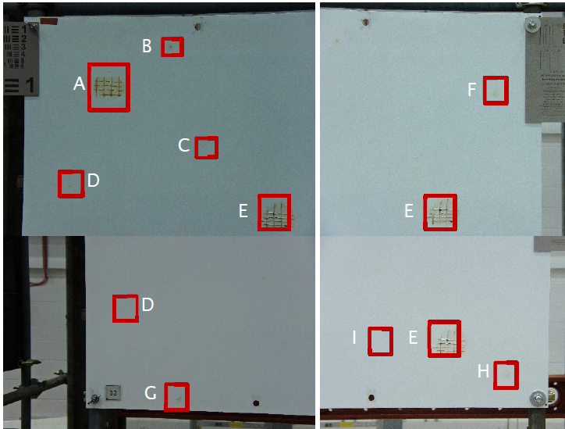 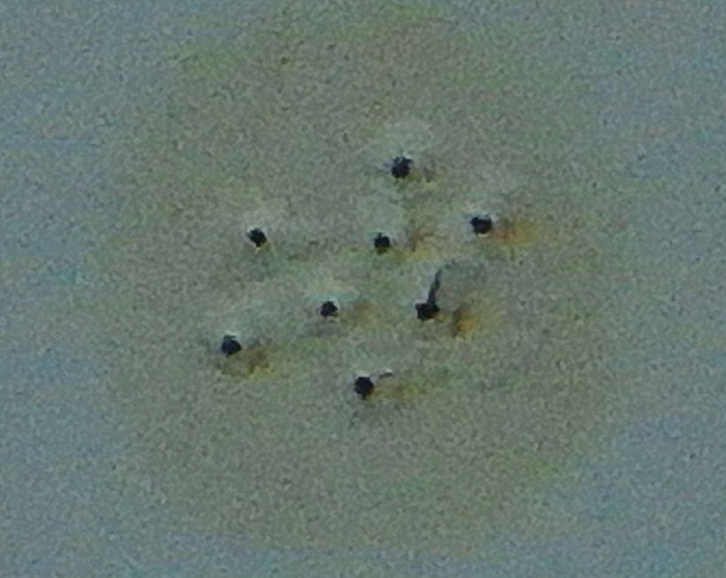

Figure 3: Images from Participant E showing reporting of defects and substrate corrosion on coated steel plate

The CVI inspection identified the nature of the coating breakdown and holes in the coating, while the RVI reports were less specific on the nature of the point defects. The contrast between the white polymer coating and the dark features of the corroded substrate likely contributed to the high success rate of RVI. Overall, the RVI inspection proved equally as capable as the CVI for detecting the range of damage in the coated samples.

* + 1. Glass-fibre reinforced plastic (GFRP) pipes

CVI was only carried out on the outdoor sample, and this correctly identified the impact damage with cracking and water ingress, as well as providing the correct size for the affected area. In the case of the vertical pipe sample indoors, two of five participants found the area of damage, although there was a lack of consistency in the description of the damage, while three reported that no features were present. The images provided from RVI inspections A to E are shown in Figure 4, along with the regions of anomalies identified by Participants A and E.

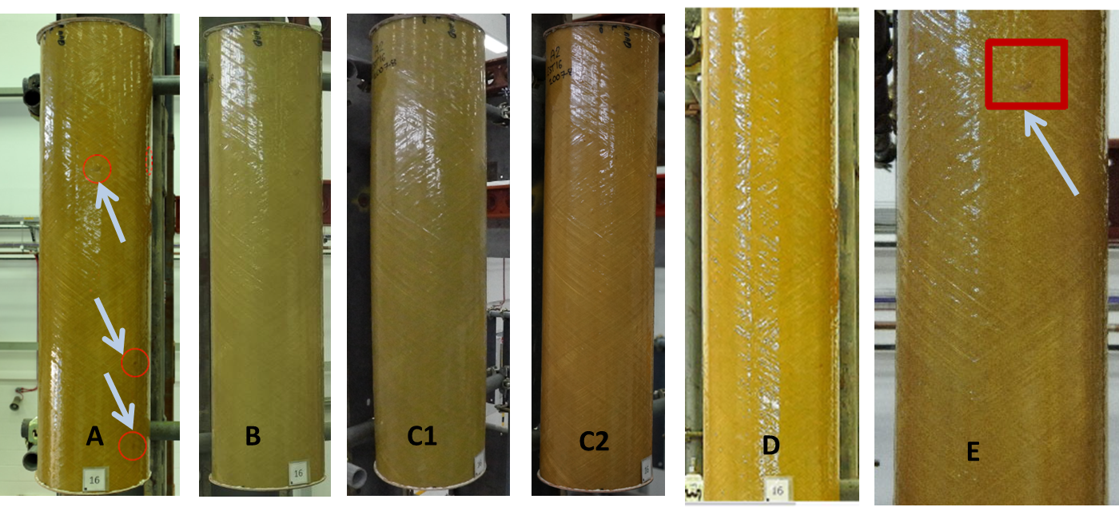

Figure 4: Images of indoor, vertical, GFRP sample from six RVI inspections

Participants noted difficulties in assessing this sample due to its highly reflective and curved nature. All five participants identified the presence of the defect in the outdoor GFRP pipe, reporting it in a consistent manner.

Overall, the results for the three GFRP pipe samples were highly variable and more descriptive than for other samples. Only the more gross type of damage, coupled with subsequent weathering which led to a change of colour, was reliably detected.

* + 1. Notched carbon steel plates

Artificial notches were created in carbon steel plates using Electro Discharge Machining (EDM) with notch widths of 0.3, 0.5, and 1.0 mm and notch lengths 10, 25, 50, and 100 mm. Each plate included both horizontal and vertical notches, with twelve notches in total. All plates were inspected in the face-on orientation.

POD curves for RVI were determined for each surface condition. The number of participants finding a particular notch expressed as a percentage of the total number of participants inspecting the plate, gives the POD. Not every notch width was present in every notch length; hence, only trends could be established, and the total number of RVI inspections was limited to six. In general, the POD was highest for the as-rolled condition, potentially due to contrast between the notch and the plate surface, and the lowest for the heavily weathered surface. Weathering without subsequent brushing reduced the POD for a given notch, as compared with the original as-rolled surface and the weathered and brushed condition. As an example, these trends can be seen in the PODs for the 0.5 mm wide x 50 mm long notches, which were 67% for as-rolled, 50% for weathered, 20% for heavily weathered, rising to 75% for weathered and brushed. This demonstrates the importance of surface condition and preparation when visually inspecting. Figure 5a shows Participant E’s inspection of the as-rolled condition (10 out of 12 notches found) and Figure 5b shows Participant a's inspection of the weathered condition (6 out of 12 notches found).

b

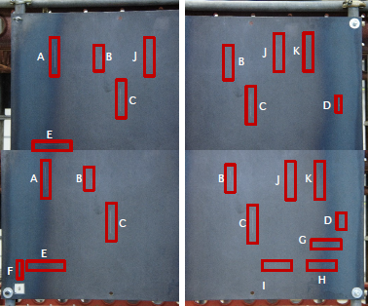 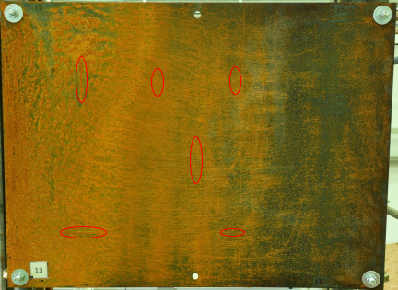

a

Figure 5: Example outputs from inspection reports showing (a) Participants E's inspection of the as-rolled, notched sample, and (b) Participant A's inspection of the weathered, notched sample

CVI was limited to one inspection set so POD cannot be determined. However, the single CVI of each sample resulted in all notches being found in the as-rolled and wire brushed conditions, while in the weathered and heavily weathered conditions all except the smallest notch (0.3 mm x 10 mm) were found.

* 1. Issues observed in the trials and RVI sensitivity to variables

Common issues related to the technology and equipment included poor image resolution and image contrast, an inability to accurately size defects, an absence of depth profile, and spatial restrictions for indoor drone flying. The limited battery life of drones also appeared to be a frequent distraction (range anxiety).

Environment issues also featured highly, particularly related to lighting conditions, both indoors and outdoors, and the reflectivity of some sample types. Poor lighting sometimes resulted in the need for sub-optimal camera settings, and post processing. Drone sensitivity to wind, resulting in curtailment of an inspection or increase in stand-off distance is both a weather and technology related issue.

The sensitivity of the RVI results to the many variables has been ranked in terms of whether they had a low, medium, or high effect on results. An overview is summarised in Table 3

Table 3: Summary of RVI results sensitivity to variables present in the trials

|  |  |  |  |  |
| --- | --- | --- | --- | --- |
| Category | Variables | Sensitivity | | |
| Low | Medium | High |
| Hardware and file storage | Drone |  |  |  |
| Camera |  |  |  |
| Image format/file compression |  |  |  |
| Personnel | Inspector experience with material/feature set |  |  |  |
| Inspection team composition (pilot, pilot + inspector, etc.) |  |  |  |
| Person inspecting images present at inspection |  |  |  |
| Extrinsic environment | Weather |  |  |  |
| Lighting |  |  |  |
| Indoor/outdoor |  |  |  |
| Aspect (north, east, south, west) |  |  |  |
| Intrinsic environment (Sample features) | Sample orientation |  |  |  |
| Surface reflectivity |  |  |  |
| Feature depth |  |  |  |
| Surface corrosion |  |  |  |
| Notch/crack length |  |  |  |
| Notch/crack width |  |  |  |
| Notch/ crack orientation |  |  |  |

* 1. Conclusions

The results were analysed in terms of the combined ability of the participants to find, identify and size the features and defects. The capabilities of RVI relative to CVI, for these three criteria, are summarised as follows.

Find: RVI was successful in finding features/defects and the best participant in each sample set was comparable to the performance of CVI in this respect. Exceptions were primarily the smallest/narrowest defects. The mean of all the RVI inspections was, however, usually poorer than CVI, and the lowest performing often significantly.

Identify: RVI was not as successful in identifying the nature of features as CVI. RVI has inherent limitations such as, poorer depth of field, and the inability to touch surfaces. Nevertheless, a large number of features were correctly identified, especially where the material type was familiar to the inspector. Most incorrect calls by RVI were safe-sided; however, several were not and would have led to non-conservative conclusions on integrity.

Size: Sizing was based on calibration from the known size of the datum marker or sample dimensions. Only two participants provided sizing for features, and only larger features were sized. Accuracy was variable, with some significantly undersized (i.e., non-conservative) and wide ranges given for others. The ability for UAVs to provide adequate sizing data for features seems limited at present and would benefit from further development.

Although these trials were carried out using drones, there are observations and findings that can be applied to remote visual technology in general, regardless of platform. For example, borescopes will still face challenges with reflectivity of bright metals, and variability may still exist in how colour is captured by different borescopes.

References

American Bureau of Shipping, 2019, ABS guidance notes on the use of remote inspection technologies

Construction Industry Research and Information Association (CIRIA), 2019, Unmanned aerial vehicles for managing assets C783

S. Burch, 2018, HOIS guidance on image quality for UAV/UAS based external remote visual inspection in the oil and gas industry – HOIS G005, HOIS

Acknowledgements and disclaimer: The work described in this paper was funded by the shared research project industrial sponsor group and the HSE. Its contents, including any opinions and/or conclusions expressed, are those of the authors alone and do not necessarily reflect HSE policy.