|  |  |
| --- | --- |
| cetlogo ***CHEMICAL ENGINEERING TRANSACTIONS***  ***VOL. xxx, 2025*** | A publication of  aidiclogo_grande |
| The Italian Association  of Chemical Engineering  Online at www.cetjournal.it |
| Guest Editors: Bruno Fabiano, Valerio Cozzani  Copyright © 2025, AIDIC Servizi S.r.l. **ISBN** 979-12-81206-xx-y; **ISSN** 2283-9216 | |

Enhanced Monte Carlo-Assisted Safety Monitoring in Process Industries: A Tank System Case Study

Huxiao Shi\*, David Javier Castro Rodriguez, Morena Vitale, Gabriele Baldissone, Micaela Demichela

Applied Science and Technology Department, Politecnico di Torino, Turin, Italy

huxiao.shi@polito.it

Safety is a critical concept in process industries. However, the complexity as the characteristic of process industries brings different challenges when conducting industrial monitoring for the sake of system safety, which is summarized as lacking a holistic view of target systems. In this study, multiple failure modes are considered in the case of a methanol storage tank by applying Hazard and Operability Analysis (HAZOP), with the identified deviations, causes, and consequences. Furthermore, the effects of some failure modes are quantified through the application of Monte Carlo (MC) simulations. Firstly, a model of the methanol storage tank is established through Phenomenology analysis. By sampling different types of failure data, simulation results can reflect system behavior responding to different failure scenarios. As for the safety evaluation of the target system, since flammability is one of the critical hazardous characteristics of the methanol, the flammability diagram is applied to indicate if the system is in a flammable condition during the simulations. Hence, effects from multiple failure modes towards the system flammability are reflected on the flammability diagram, which is allowed to be compared and analyzed in different ways. The results of this study contribute to targeting key variables that are sensible towards multiple failure modes in the tank system. This study is meaningful to practical monitoring activities. A more appropriate monitoring strategy is feasible by focusing on critical variables and critical failure modes. With the capability of simulating the system behavior, it is possible to conduct predictive maintenance strategies and improve current failure prevention measures like intelligent warning systems.

**Keywords:** safety monitoring, storage tank, flammability, Monte Carlo simulation.

* 1. Introduction

In industrial activities, monitoring is conducted not only to minimize the downtime of the process but also to ensure the safe operation of people and assets. This is highly stressed by scholars and practitioners in process industries, where safety is considered a critical concept. As Pasman et al. (2013) pointed out, accidents in the process industry still occur though process safety knowledge has been accumulated, and analysis tools and safety management systems have been introduced currently. To guarantee seamless production activities, process industries are expected to conduct dynamic monitoring activities with consideration for personal and process safety. As a broad industrial domain, process industries are widely considered to have the characteristic of complexity, which is reflected by the variety of specialized equipment, diverse processes, and non-standard labour activities (Shi and Demichela, 2024). These mentioned characteristics increase the difficulty of conducting effective monitoring. For this challenge, the development of industry 4.0 techniques like the Internet of Things (IoT) supports monitoring operation-related parameters by deploying multiple sensors and establishing the behavior model through Artificial intelligence (AI)-assisted analysis tools. One of the other challenges is to embed safety concerns in process monitoring and decision-making phases. As discussed by Vitale et al. (2024), traditional management systems might be insufficient for monitoring critical safety issues. This is reflected by the fact of the misalignment between identified scenarios and actual accidents (Hansler et al., 2022). One of the potential reasons might be the interactions between components of complex systems and even with environmental conditions, the perspective from one or few components limits to development of a holistic view of target systems (Johnson, 2006). According to Reis and Gins (2017), one variable could affect the contributions given for all the variables that are connected with it, decreasing the effectiveness of diagnosis. In terms of system reliability in process industries, focusing on the system’s behavior under the single failure modes might ignore the interaction among different failure modes, and limit the prediction functions from monitoring activities. It is meaningful to study the system behavior from an integral and practical perspective.

For this purpose, an enhanced Monte Carlo-assisted safety monitoring is conducted on a case of the methanol storage tank in process industries, whose flammability is evaluated under multiple failure modes. The results contribute to building a comprehensive pattern of the target system and figuring out key variables that are sensible toward system safety under multiple failure modes. Moreover, the results from the simulations and evaluations are expected to support the development of safety monitoring and predictive maintenance strategies, and the improvement of current failure prevention measures like intelligent warning systems.

* 1. Methodology

In this section, the established tank model, research framework, and applied methods are introduced.

* + 1. The establishment of the tank model

The case study focuses on the storage tank system of methanol. The establishment of the system model follows the previous work of Baldissone et al. (2022), where a simplified model of built to specify the safe operating envelope under nonstandard conditions. In his work, a soft sensor was defined to monitor with continuity the state of the tank vapor space. In this research, the flammability hazard is expected to be evaluated, which might support safety monitoring.

A vertical storage tank with a fixed roof is targeted, which is designed to store the methanol required for a process. Nitrogen is fed into the system as the blanketing gas. The availability of the reagent is expected to be always guaranteed with an ideally constant flow. Figure 1 shows the schematic diagram of the methanol storage tank. The storage tank is considered to work in such assumptions:

1. Isothermal behavior, no impacts caused by temperature exchange in/outside of the tank.
2. Liquid is incompressible and does not react with the gas phase.
3. The gas phase obeys the ideal gas law and the transfer of material takes place only from the liquid phase to the gas phase, e.g., no dissolution of oxygen and nitrogen in the liquid and no condensation of methanol.
4. The vapor phase and liquid phase at the starting condition are in equilibrium.

To establish the mathematical model, the liquid phase and gas phase are divided as two subsystems of the tank, which could be modeled based on the define of five streams: methanol inlet stream (F1), methanol outlet stream (F2), nitrogen inlet stream (F3), vent inlet stream (F4), and vent outlet stream (F5). Specifically, separate streams from the vent are respectively calculated in vacuum pressure and overpressure condition of the system. The adopted equations and parameters in the modelling are detailly discussed by Baldissone et al. (2022), through considering the mass balance, mass transfer, and equilibrium conditions in/between the gas/liquid phase.

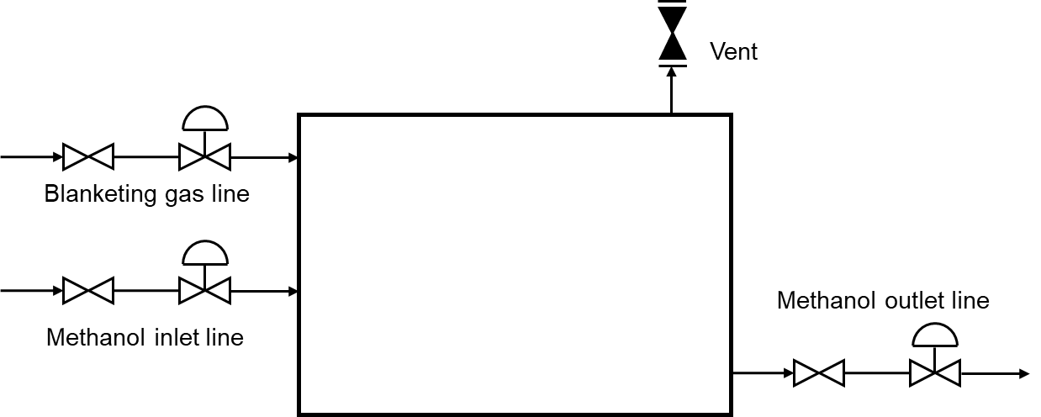

Figure 1. Schematic diagram of the tank model.

* + 1. Research framework

The research framework of this study is shown in Figure 2. Firstly, the behavior model of the system without involving any failures was established as a benchmark based on the analysis from phenomenology. Then, multiple failure modes of the system were identified through the Hazard and Operability Analysis (HAZOP), and corresponding system performances were simulated with the application of the Monte Carlo (MC) technique, which was regarded as altered behavior. The flammability diagram was adopted in the safety evaluation module. The flammability limits of the system’s gas phase were estimated in a binary perspective (heating and quenching), where the variation of each species was added into the estimation scheme, facilitating managing the contribution of fuel/oxygen/diluents under the same systematic framework (Ma, 2011). By comparing the benchmark and altered behavior, the effects from multiple failure modes were evaluated considering the flammability of the gas phase in the methanol storage tank.

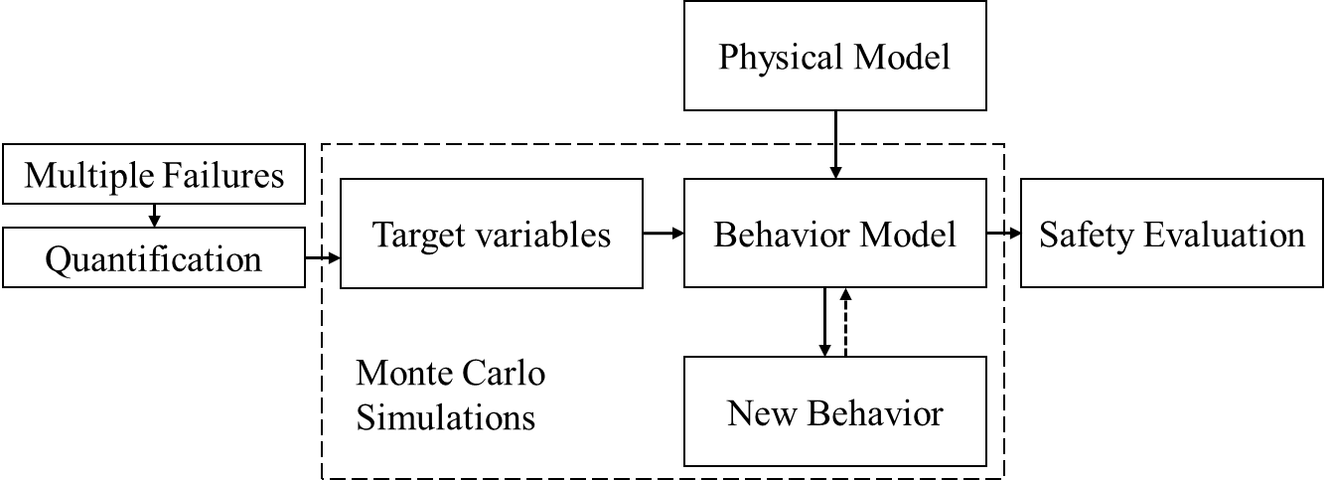

Figure 2. Research framework.

* 1. Results

In this section, the identified failure modes, the simulation results of system operating behavior, and the flammability evaluation under multiple failure modes.

* + 1. Identified failure modes

It was possible to identify not only traditional safety risks but also issues related to the operability of the processes. The application of HAZOP in this study starts from defining the parameters of the system, such as flow rates, pressures, liquid levels, and even concentrations of the species to identify the deviation between them with the ideal conditions. Table 1 shows an example of a HAZOP worksheet considering the system pressure as a critical parameter. The deviation considers both high and low pressures and potential causes could be related to human errors and valve broken. The involved valves are the pressure safety valve (PSV), the control valve in the blanketing gas line (BCV), and the manual valve in the blanketing gas line (BMV). Notably, this study discusses valves in a general way without considering their specific types. A more detailed analysis will be available if the valve type has been specified in practical scenarios.

Table 1: A section of a HAZOP worksheet considering pressure deviations.

|  |  |  |  |
| --- | --- | --- | --- |
| Deviation | Cause | Consequences | Top Event |
| High pressure | PSV malfunction (e.g., blockage) | Rupture of the tank | TE1 |
| Failure of BCV (e.g., unresponsive to control signal) |
| BMV malfunction (e.g., stuck open) |
| Human Error (e.g., imprecise operation) |
| Valve malfunction (high) | Aging | High pressure |  |
| Material degradation |
| No/insufficient Maintenance |
| Low pressure | BCV malfunction (e.g., stuck, incorrect positioning) | Collapse of the tank | TE2 |
| PSV malfunction (e.g., blockage) |
| Human Error (e.g., set higher supply speed) |
| Valve malfunction (low) | Aging | Low pressure |  |
| Material degradation |
| No/insufficient Maintenance |

Based on the established mathematic model, the defined five variables related to streams might be influenced by failure modes. Various failure modes can affect the performance of the target system by impacting the inflow rate of liquid methanol during the feeding period (F1), the outflow rate of liquid methanol during the supply period (F2), the inflow rate of nitrogen gas in the blanketing gas line (F3), the flow rate of the gas in the vent at conditions of low pressure and overpressure (inflow rate of the air: F4, outflow rate of the gas: F5). Quantifying the effects on these five variables from identified failure modes provide a potential way to evaluate their impacts from a systematic point of view. For example, a PSV malfunction with the blockage is defined as a range from 0 (full blockage) to 20% of the default F5 value (partial blockage), which supports the application of sampling techniques in the later step. Table 2 provides an example of the designed sampling range of each variable based on HAZOP analysis results, the range is designed as a proportion to the default value. The sampling technique is applied to sample the value of each variable according to potential failure modes, each sampling provides a variable set, which is the input of the numeric model as the target methanol storage tank system. System performances under multiple failure modes can be simulated through MC simulations by increasing sampling times.

Table 2: Designed sampling range of each variable.

|  |  |  |
| --- | --- | --- |
| Failure | Variable | Range (Proportion to default value) |
| PSV: blockage | F5 | 0 to 10% |
| F4 | 0 to 10% |
| BCV: unresponsive to the control signal | F3 | 100% |
| BCV/BMV: stuck open | F3 | 100% to +20% |
| BCV/BMV: stuck closed | F3 | 0 |
| BCV/BMV: incorrect positioning | F3 | -5% to +5% |
| Human Error: imprecise operation | F1 | - 5% to +5% |
| F2 | - 5% to +5% |
| Human Error: set higher supply speed | F2 | 100% to +30% |

* + 1. Simulation results of system operating behavior

This part shows the simulation results by comparing the performance of the benchmark model with one exemplified by multiple failure scenarios. Specifically, the established benchmark model represents the ideal working condition of the methanol storage tank system by taking all variables as default values. The benchmark model is designed to have three main phases:

* The supply process of the methanol.
* PSV opening and pressure balancing.
* External methanol supplement.

For a better comparison of the performance difference between the benchmark model and its altered behavior in each phase, the performance of the benchmark model is simulated as shown in Figure 3 (blue line).

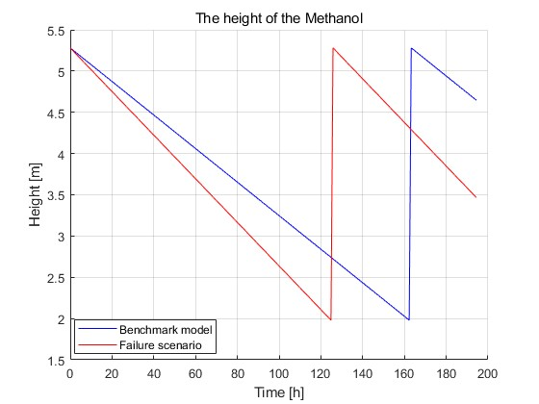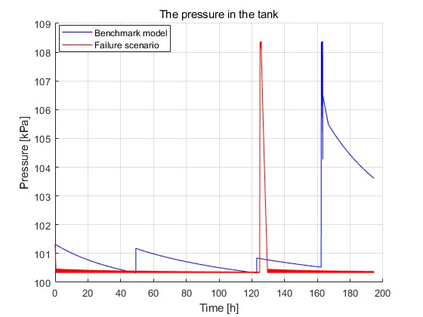 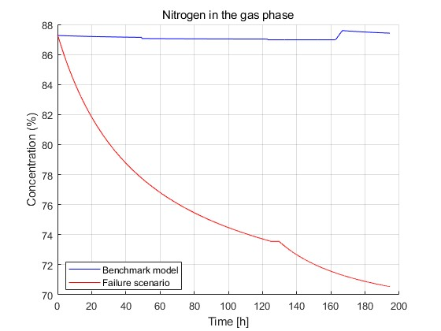

(a). Height of liquid methanol

(b). The pressure in the tank

(c). Concentration of Nitrogen

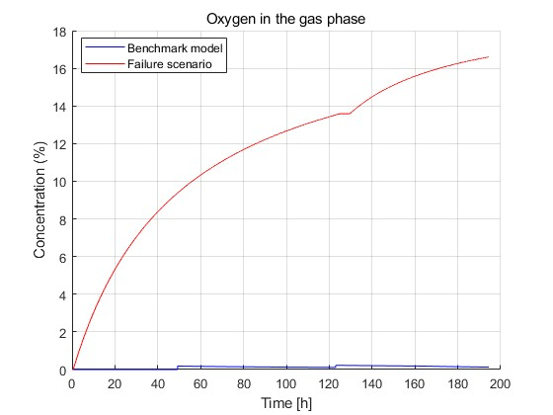 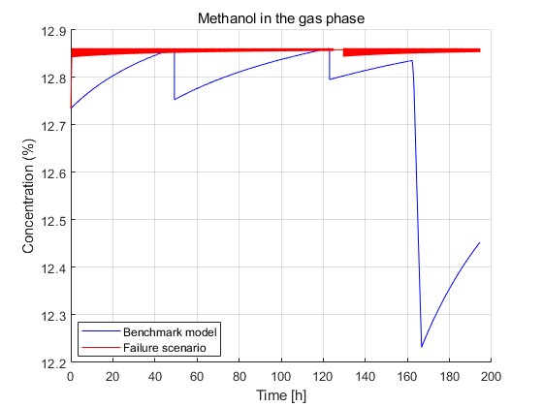

(d). Concentration of Oxygen

(e). Concentration of Methanol

Figure 3. Performance comparisons between the benchmark and its altered behavior.

Specifically, the storage tank is planned to work for 194 hours (around 8 days), constantly providing the reagent to later processes. The methanol is reloaded from external resources after working 162.28 hours. To balance the pressure during the process, the vent has been opened twice for inletting the air due to the low pressure after working 49.26 hours and 122.98 hours, and releasing the gas to the environment when there is overpressure because of the loading (after working 162.36 hours). To simulate the altered behavior of the target system, an exemplified failure scenario has been selected involving the following failures:

* BCV malfunction: stuck closed (with F3 value as 0)
* PSV malfunction: blockage (with F4, F5 as 10% of their default values)
* Human Error: set higher supply speed (with F2 as 30% more of its default value)

The red line in Figure 3 shows the altered behavior during the operation processes. Figure 3a shows the comparison towards the liquid level in the tank. With the embedded failures, the methanol supplement from external resources happens 37.45 hours before the benchmark. The comparison of pressure is shown in the figure 3b. In order to balance the low-pressure situation, the system has to frequently open the vent for inletting the air, which brings more oxygen into the system (Figure 3d). Thus, the concentration of each gas species in the system is affected by failures with the maximum change of 16.88% (Nitrogen), 16.47% (Oxygen), and 0.63% (Methanol gas). More Oxygen gas in the system increases the risk of system flammability, which will be further evaluated in section 3.3.

* + 1. Flammability evaluation under multiple failure modes

During the reagent supply process, the reduction of methanol volume in the tank results in a decrease in internal pressure, which may lead to the opening of the vent to maintain pressure equilibrium, potentially allowing ambient air to enter the tank and increasing the risk of combustion. Thus, the evaluation module is designed in this section to evaluate the flammability of the target system under multiple failure modes. A binary system constructed by Ma (2011) is applied to determine the flammability limits of the storage tank system. Specifically, in the gas phase with the fuel, oxidizer, and diluent (methanol, air, and nitrogen in the case), each species’ heating (releasing energy) and quenching (absorbing energy) capability are considered, and flammability limits are contributed by the balance and competition between them provided by Eq(1) and Eq(2). According to equations, $x_{L,m}$ and $x_{U,m}$ are lower/upper flammability limit of the mixture, $H_{F,m}$, $Q_{F,m}$ , and $H_{O,m}$ are corresponding energy potentials of fuel and oxygen in the mixture based on air.

|  |  |
| --- | --- |
| $$x_{L,m}=\frac{1}{1+H_{F,m}-Q_{F,m}}$$ | (1) |
| $$x_{U,m}=\frac{H_{O,m}/4.773-1}{H_{O,m}/4.773-1+Q_{F,m}}$$ | (2) |

Figure 4 shows the evaluation results of the benchmark model and its altered behavior through the application of the flammability diagram for methanol by calculating its lower flammability limit (LFL) and upper flammability limit (UFL) in the tertiary (fuel/oxidizer/diluent) system.

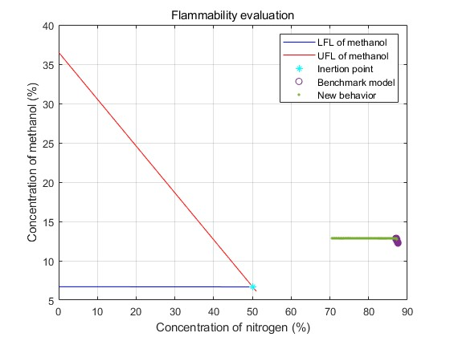

Figure 4. Flammability diagram for methanol.

According to the figure, the concentration of nitrogen (diluent) in the tertiary system influences the LFL and UFL of the methanol (fuel), which dynamically influences the safety condition of the storage tank in the case study. The Inertion Point (the intersection of LFL and UFL) is shown as the blue dot in the figure, which is calculated as 50.07% corresponding to the nitrogen concentration. The area inside the LFL and UFL intersection is considered the flammable region, where there is a risk of combustion or explosion when encountering an ignition source. Thus, the established flammability diagram supports the safety evaluation in the case study.

According to the evaluation results shown in Figure 4, there are higher levels of flammable risks faced by the target system within the designed failure scenario, which is reflected by the system concentration getting closer to the flammable region. Even though the system is still considered as being non-flammable in this case, its condition and performance have greatly changed compared with the benchmark model. It is reasonable to deduce that the vulnerability of the system to flammability has been increased. Specifically, if considering the vulnerability of system flammability as the smallest difference between values of the inertion point (IP) and the nitrogen concentration (NC) in the system’s gas phase, the variance of system vulnerability (VV) within the designed failure scenario is calculated as 44.54%, followed by the Eq(3). The subscripts $b$ and $f$ denote the behavior of the benchmark model and it within failure scenarios.

|  |  |
| --- | --- |
| $${VV}_{Flammability}=\frac{{NC}_{b,min}-{NC}_{f,min}}{{NC}_{b, min}-{NC}_{IP}}$$ | (3) |

In summary, using the embedded evaluation module allows us to measure the effect of multiple failure modes on flammability hazards proactively through real-time monitoring. At the same time, by understanding the system's altered behavior during the operating period, it may be possible to inform the decision-making process by taking into account more suitable operating/maintenance measures and the optimal moment to intervene with a higher confidence level.

* 1. Conclusion

In this study, safety monitoring in the case of a methanol storage tank in process industries is conducted through enhanced Monte Carlo simulations. The analysis results are meaningful in two ways. Firstly, the simulation of the system's altered behavior facilitates comprehending the system's real-time performance under multiple failure modes, which supports establishing a behavior predictor based on actual monitoring activities. Moreover, by combining the evaluation results on flammability hazards, it is possible to foresee systems' safety conditions and develop intelligent warning systems based on the availability of industrial resources in practical scenarios. In the future, it is expected to involve more hazardous concerns in safety evaluations, like toxicity, and other hazards on health or environment.

Acknowledgments

This research is supported by the program of the China Scholarship Council (No. CSC202207930021).

References

Baldissone, G., Camuncoli, G., Demichela, M., 2022, Simplified Model of the Internal Atmosphere of Flammable Liquid Tanks in Case of Air Inlet from a Pressure Safety Valve, ACS Omega 7, 28198–28205. <10.1021/acsomega.2c02312>

Hansler, R.J., Bellamy, L.J., Akkermans, H.A., 2022, Ageing assets at major hazard chemical sites – The Dutch experience, Safety Science 153, 105788.

Johnson, C.W., 2006, What are emergent properties and how do they affect the engineering of complex systems? Reliability Engineering & System Safety, Complexity in Design and Engineering 91, 1475–1481.

Ma, T., 2011, A thermal theory for estimating the flammability limits of a mixture, Fire Safety Journal 46, 558–567.

Pasman, H.J., Knegtering, B., Rogers, W.J., 2013, A holistic approach to control process safety risks: Possible ways forward, Reliability Engineering & System Safety 117, 21–29.

Reis, M.S., Gins, G., 2017, Industrial Process Monitoring in the Big Data/Industry 4.0 Era: from Detection, to Diagnosis, to Prognosis, Processes 5, 35.

Shi, H., Demichela, M., 2024, Stochastic Degradation Modelling Based Monitoring And Predictive Maintenance Framework In Process Industries, Advances in Reliability, Safety and Security: ESREL 2024 Collection of Extended Abstracts, Vol. 1. Polish Safety and Reliability Association, 2024, 181-182.

Vitale, M., Shi, H., Castro Rodriguez, D.J., Barresi, A., Demichela, M., 2024, Ageing in Process Industry: Identification of Material Degradation from Past Accidents Analysis, IFAC-PapersOnLine, 12th IFAC Symposium on Fault Detection, Supervision and Safety for Technical Processes SAFEPROCESS 2024 58, 568–573.