Surrogates for Health Aware Control Cost-to-Go
Eden Ngowi^{1*}, Rafael de Olivera¹, Johannes Jäschke¹
¹ Department of Chemical Engineering, Norwegian University of Science and Technology, Sem Sælandsvei 4, Trondheim, 7491, Norway
*Corresponding Author E-Mail: eden.ngowi@ntnu.no
1. Introduction
Maintenance strategies have been evolving over the years from reactive (fix upon break-down) towards a predictive maintenance paradigm where one anticipates the degradation and plans operations accordingly [1].
In the recent years, prognostics and health monitoring techniques have been integrated with advanced control methods for creating automatic control systems which can be used to realize optimally the balance between maximizing instantaneous profit and prolonging the equipment’s remaining useful life (RUL) [1]. Model Predictive Controllers (MPCs) have been shown to be a promising framework for achieving this trade-off. This has also been referred to as Health-Aware Control (HAC) [2].
HACs usually require an accurate degradation model to predict the system’s health evolution. Moreover, the time scale difference between degradation and control dynamics is very large: the former and latter differing in orders of magnitude of weeks and minutes respectively [2]. Naively including the very long degradation time-scale of weeks and months into the model predictive controller results in optimization problems that are too large to be solved on the fast time-scale required for control [3]. Therefore, the idea of this contribution is to create a simple surrogate model that takes the long-term effects into account, and to add it as the “cost-to-go” in the short-term MPC control problem [4]. The surrogate will approximate the long-term effects of the short-term control actions and allow to solve the short-term MPC problem sufficiently fast.
A case study of a gas-lifted oil well network is used to evaluate this strategy as seen in Figure 1. Here, the optimal operation of the gas-lift choke valves is being sought to maximize profit and extend the RUL of oil production chokes undergoing sand erosion, which is typical in brown fields [5].
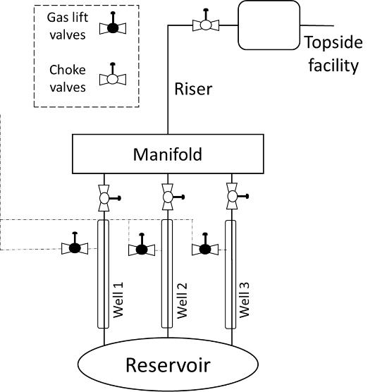
Figure 1: A Schematic Diagram of Gas-lifted Well Network [5]
This is important as most of these subsea facilities are difficult to access and require costly maintenance intervention to restore the plant back to operation after breakdown [5]. Thus, our learning-assisted MPC uses the surrogate to take into consideration the long-term degradation effects, while not substantially increasing the computational cost of solving the short-time MPC problem.
2. Methods
All simulations are done using MATLAB with CasADi add-on which contains algorithms for solving non-linear programming (NLP) problems. A surrogate model is trained to approximate the long-term effects related to degradation. This model is included as arrival cost in the short-term model predictive control problem. As such, the MPC problem remains small and easy to solve, while still taking the long-term degradation into account.
3. Results and Discussion
An online open-loop simulation by [5] can be seen in Figure 2. Each well has different sand rates with Well 1 and Well 3 having the highest and lowest sand rates respectively. The HAC adjusts accordingly the gas-lift rate to avoid reaching the maximum erosion limit before the next planned maintenance while simultaneously achieving the maximum possible oil production rate. However, these simulations are computationally expensive, bearing in mind the long prediction horizon of degradation processes. Surrogate models are used for speeding up the computations.
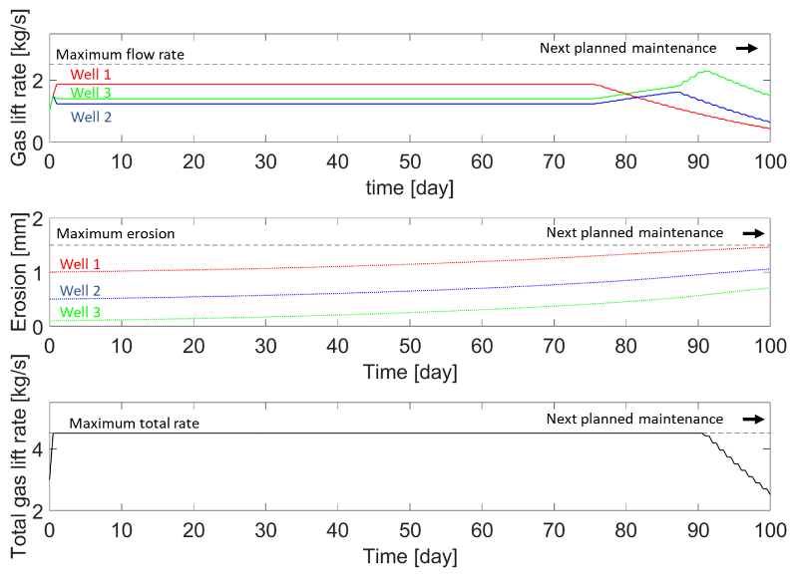
Figure 2: Online Open-loop Simulations for the Whole Gas-lift Oil Network [5].
4. Conclusions
Quicker HAC actions are being envisioned for varying prediction horizons using an offline surrogate model.
This work addresses the challenges that arise in Health-Aware Control, where the control action happens on a fast time scale, while the degradation phenomena occur on a much slower time scale.
References
- Escobet, T., Puig, V., & Nejjari, F. (2012). Health aware control and model-based prognosis. In 2012 20th Mediterranean Conference on Control & Automation (MED) (pp. 691-696). IEEE.
- De Oliveira, R. D.& Jäschke, J. (2024). Integration of Time Scales in Health-Aware Control. IFAC-PapersOnLine, 58(14): p. 227-227, 2024. ISSN 2405-8963. https://doi.org/10.1016/j.ifacol.2024.08.340
- Abdufattokhov, S., Zanon, M., & Bemporad, A. (2021). Learning convex terminal costs for complexity reduction in MPC. In 2021 60th IEEE Conference on Decision and Control (CDC) (pp. 2163-2168). IEEE.
- Turan, E. M., Mdoe, Z., & Jäschke, J. (2023). Learning a convex cost-to-go for single step model predictive control. arXiv preprint arXiv:2312.02650.
- José Matias, Joachim Ågotnes, and Johannes Jäschke (2020). Health-Aware Advanced Control Applied to a Gas-Lifted Oil Well Network, IFAC-PapersOnLine, 53(3): p. 301-306. ISSN 2405-8963. https://doi.org/10.1016/j.ifacol.2020.11.048

