Early Integration of Safety in Process Design:   
an Index-based approach for streams

Silvia Pelucchi1,\*, Filippo Carretta1, Federico Galli2, Paolo Mocellin1,3

1 Università degli Studi di Padova, Dipartimento di Ingegneria Industriale, Via Marzolo 9, 35131 Padova, Italia.

2 Département de Génie Chimique et de Génie Biotechnologique, Université de Sherbrooke, 2500, boul. de l’Université,

Sherbrooke, Québec, J1K 2R1, Canada.

3 Università degli Studi di Padova, Dipartimento di Ingegneria Civile Edile e Ambientale, Via Marzolo 9, 35131 Padova, Italia.

\*Corresponding author E-Mail: [silvia.pelucchi.1@phd.unipd.it](mailto:silvia.pelucchi.1@phd.unipd.it)

1. Introduction

The traditional and most applied way to design a process considers the fulfilment of technical and economic targets as the main objectives, while environmental and safety matters are often addressed after the main process design is concluded, leaving limited room for improvement. This traditional process design protocol can lead to further economic investments to adjust part of the project to meet safety or environmental requirements if deficiencies are identified.

In this context, a research need emerges: including safety considerations during the conceptualisation of a process, when the level of detail available is limited.

The maximization of safety and minimization of environmental burdens must be integral objectives of process design rather than constraints, on par with technical decisions and economics. Safety, in particular, must always take precedence among design objectives. An unsafe plant is not only inherently hazardous but also detrimental to profitability due to the massive potential production and capital losses resulting from accidents. For these reasons, safety considerations should shape design decisions from the initial stages of a project (Heikkilä, 1999; Rahman et al., 2005). An alternative and beneficial approach is to integrate inherent safety principles during the chemical process design stage. An inherently safer design avoids hazards rather than controlling them, particularly by reducing the amount of hazardous material and the number of hazardous operations in the plant. When safety is inherent, it is built into the process or product rather than added on later.

In this framework, implementing inherent safety principles is most effective during the early stages of design when adjustments can be readily made to incorporate safer features. Applying these strategies after the design is finalized necessitates additional investment compared to modifications made during the preliminary design phase.

The objective is to introduce some metrics or indexes that provide immediate feedback on the safety performance of a process flowsheet under development, in the same way that ROI, IRR, and productivity do for economic and technical aspects.

Over the past few decades, the use of inherent safety metrics for measuring, ranking, and selecting inherently safer process alternatives has increased. These metrics have been gaining popularity because they are fast, easy to implement and require limited information, making them appropriate for the conceptual stage of design. These metrics can be classified into four categories: consequence-based metrics, graphical assessments, risk-based metrics, and index-based metrics. This work focuses on index-based metrics, which are the most targeted because they consist of mathematical models that output a numerical value, usually ranging over a scale (Park et al., 2020). Although an assessment conducted by a team of experts can never be fully replaced by an automated method, linking the safety assessment to process simulation simplifies, systematizes, and speeds up the design process (Mohammadi et al., 2023).

Despite significant advancements in developing safety indexes and considerable efforts in the field, no unified metric exists for assessing inherent safety (Gao et al., 2021; Qian et al., 2024; Zhu et al., 2022). Therefore, there remains a demand for new, simple indices to evaluate different process alternatives during the conceptual design phase, whether for new or retrofitting processes (Ordouei et al., 2016).

A key challenge highlighted in the literature is that many indexes lack a standardized scale (e.g., from 0 to 10), making it difficult to interpret the index without direct comparison with alternatives, and they often use step functions. Another prominent issue is subjectivity and the absence of automatization, which makes the calculation of such indexes slow and tedious.

In this work, we develop and implement an index capable of evaluating the safety of a generic process stream, incorporating all the possible information available at the conceptual stage. The index ranges over a simple scale (from 0 to 10) and uses continuous functions rather than steps.

The proposed code is fully automated in MATLAB, as it receives all the required information from the simulator or a built-in database and immediately computes the index for each stream. The index provides immediate feedback about the safety of the stream. When process conditions change, the index is recalculated, allowing users to quickly understand how different choices impact the overall safety of the process. This study introduces a new pattern, starting from the analysis of process streams rather than units. Process simulators, like Aspen Plus, provide the user with extensive information about streams rather than units, and once the indexes for the streams are available, they can be combined to calculate the indexes for the units.

2. Methods

The index was developed as a MATLAB code coupled with Aspen Plus, which calculates mass and energy balances. The database was constructed using a Python code capable of retrieving all relevant chemical properties from the CAMEO Chemicals database. The Phyton code extracts the properties of interest and exports the, into an Excel sheet.

The algorithm evaluates the safety performance of a stream, whether it carries a liquid, a gas, or a liquid-gas mixture. We introduced a standardized, easy-to-understand scale from 0 to 10: the higher the index, the better the safety performance. Our objective is to develop an index that is both comprehensive and user-friendly.

The Stream Safety Index (SSI) is the result of the combination of seven different sub-indexes, each covering key properties areas available at conceptual design stage: IP (pressure index), IEN (temperature and internal energy index), IAT (autoignition temperature index), IFL (flammability limits index), IFP (flash point index), ITOX (toxicity index), IFL,cloud (index for the flammability limits of the cloud).

For clarity, the algorithm is divided into two sections (Figure 1). In the first section, the indexes are calculated using the properties as computed and provided by Aspen Plus, and so we analyze aspects such as operative temperature, pressure and flammability. In the second section, we consider the possibility of experiencing a loss of containment. In this situation, the pressure decreases and part of the liquid (if present) vaporizes. A code based on thermodynamic formulas computes the new composition of both the cloud released in air and the liquid puddle. Here we analyze two more relevant aspects such as toxicity of the cloud and its flammability. The indexes are computed considering the newly computed composition.

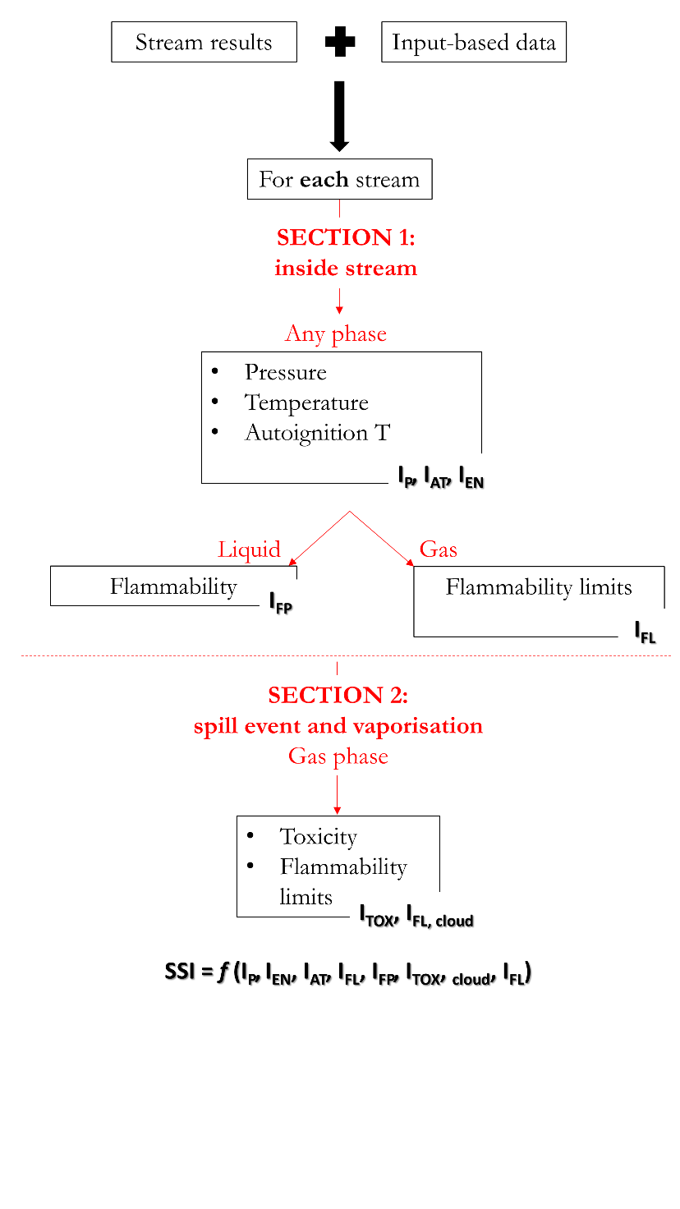

*Figure 1. Structure of the algorithm that computes the Stream Safety Index (SSI).*

This work proposes an alternative to traditional approaches presented in the literature, where safety indexes are built based on penalties assigned using step functions (Athar et al., 2022; Gangadharan et al., 2013; Heikkilä, 1999). The main limitation of the step-function approach is that it assigns the same penalty value across a wide range of values. For instance, a vessel operated at 0.5 bar and one operated at 5 bar may receive the same hazard rating, despite the significant difference in operating conditions.

To address this limitation, continuous mathematical functions were developed to represent trends based on key reference points. These functions have a fixed y-axis ranging from 0 to 10 (corresponding to the index value), while the x-axis represents the property under study.

The reference points were selected based on literature sources (Gangadharan et al., 2013; Heikkilä, 1999; Park et al., 2020; Qian et al., 2024), expert opinions, or a combination of both.

The functions used include logistic, logarithmic, and power functions, and were intentionally designed to be parametric. For each function, an optimization algorithm was implemented in MATLAB to determine the optimal parameters that best fit the desired curve.

This methodology eliminates the need for step functions and predefined ranges, resulting in a cleaner and more efficient computation of the safety index.

We applied our index to a case study of the partial oxidation (POX) process (Figure 2), which converts shale gas into methanol. This process is comprehensively descrived in the work by Julian-Duran et al. (Julián-Durán et al., 2014). Aspen Plus was used to solve mass and energy balances, and stream summary results served as input for the safety index calculation. In the POX process, oxygen is supplied by an air separation unit and mixed with the shale gas feed. The feed is preheated to 300 °C. Partial oxidation occurs at 1350 °C and 30 bar in a reactor modelled using an RGibbs reactor in Aspen Plus. Subsequently, a water gas shift reactor, modelled as an RStoic reactor, is employed to increase the H2/CO ratio from 1.8 to 2. The product stream is then cooled and passed through a flash drum to remove water. Afterward, tea separator removes 99.8% of CO2. Finally, the syngas is compressed to 83 bar before entering the methanol reactor, which operates at 260 °C.

Figure 2. Simplified process flow diagram of the partial oxidation process used as a case study.

3. Results and discussion

When the code is run, it produces first the results for each stream. The code is then iterated for the number of streams in the flowsheet to produce at the end an overall Stream Safety Matrix for the process (Figure 3).

Figure 3. Stream Safety Matrix of the POX process here used as a case study.

According to the matrix, S-5 has the lowest safety performance overall (Stream Safety Index = 1.63) (Figure 3, 4). S-5 exits the partial oxidation reactor, which operates at 1350 °C and 30 bar. The sub-indexes IEN, IFL and IFL,cloud are very low (< 1) due to the extremely high operating temperature (1350 °C), and the presence of H2 in the stream, which is characterized by a wide flammability range. Additionally, most of the components have autoignition temperatures lower than the operating temperature of the stream.

Figure 4. PFD of the partial oxidation process with SSI labels for each stream.

The safest part of the flowsheet under study is the cluster comprising the H2O and CO2 separators.

On the other hand, the cluster consisting of COMP-1, HX-4, METREAC and COOL-3 requires attention due to the low index values of the streams involved. Although the evaluation of individual units has not yet been considered, the stream index alone already highlights the most sensitive parts in the flowsheet.

Only 3 streams out of 28 fall within the green zone, and one of these, S-16, is a placeholder used for calculation purposes. Most of the streams have an overall index below 6.8, reflecting the fact that the process operates at high pressures (> 30 bar) and handles flammable components such as CH4, C2H6, C3H8 and H2.

The automation offered by the SSI distinguishes it from other proposed indexes. Although automation may not be a primary concern during the conceptual design stage, we believe it enhances the usability and dissemination of such tools. The POX process analyzed here consists 28 streams, making manual computation of an index feasible but time-consuming. In larger flowsheets (e.g., 40 + streams), manual calculation becomes impractical due to the required time and cost. Additionally, any minor adjustment in the process simulator necessitates recalculating the safety index. Without automation, this involves re-copying simulation results into the Excel file, further prolonging the process.

The proposed code addresses this issue by linking the database, the MATLAB script, and the simulator properties, allowing the computation to be accomplished in seconds. For the current 28-streams flowsheet, the matrix is generated in around 20 seconds (with the time depending on the computer’s RAM). This speed enables users to quickly recalculate the index after making process modifications. Furthermore, the SSI gives a comprehensive overview of the most property areas available at conceptual stage, unlike other indexes that focus solely on flammability or explosiveness. The SSI also returns information on flammability and toxicity conditions in the event a loss of containment occurs and the stream gets in contact with air.

4. Conclusions

The traditional approach to process design prioritizes technical and economic targets, often addressing safety considerations later in the process. This can undermine the overall performance of the technology and lead to additional investments to address safety gaps. Safety should be a primary consideration from the early stages of process design, despite the limited information available during the conceptual phase. Safety indexes provide a quick, generally easy-to-implement tool that offers immediate feedback on the safety performance of the process. Significant advancements have been made in this field, with numerous indexes developed in the recent years. However, there remains room for improvement in aspects such as reducing subjectivity, using continuous rather than stepwise functions, automating calculations, and establishing a standardized scale.

In this work we presented the new Stream Safety Index (SSI), designed to assess the safety performance of a generic individual process stream of a flowsheet under development. The SSI uses data from process simulators and retrieves missing properties from a database built using Python and CAMEO Chemicals. The SSI evaluates the safety performance of liquid, gas or liquid-gas streams and, ranging from 0 to 10 on a standardized scale. The SSI comprises seven sub-indexes that cover different property areas, such as pressure, enthalpy, autoignition temperature, flash point, flammability limits, and toxicity. Continuous functions interpolated over a specific combination of data are used to build each sub-index, eliminating the need for stepwise penalty. The index was tested on a case study involving the partial oxidation process for methanol production, demonstrating its practicality and advantages. A key benefit of the SSI is its automation, which significantly reduces computation time compared to manual methods. While this advantage may seem less critical in small flowsheets, it becomes essential for larger ones. For the 28-streams case study, the index matrix was computer in just 20 seconds. Automation also allows for rapid recalculation following changes in the process simulator.

Although the SSI improves safety assessment in many ways, some level of subjectivity remains. However, the code’s parametric structure allows users to customize data inputs to optimize parameters based on their specific needs.

Future work includes the development of unit-level safety indexes derived from stream-level indexes, which can be aggregated to assess the overall safety performance of a flowsheet. Additionally, a key objective is to develop an environmental safety index, as current approaches primarily focus on personnel safety.

References

Athar, M., Shariff, A. M., Buang, A., Umer, A., & Zaini, D. (2022). Inherently safer process route ranking index (ISPRRI) for sustainable process design. Journal of Loss Prevention in the Process Industries, 104909. https://doi.org/10.1016/j.jlp.2022.104909

Gangadharan, P., Singh, R., Cheng, F., & Lou, H. H. (2013). Novel methodology for inherent safety assessment in the process design stage. Industrial and Engineering Chemistry Research, 52(17), 5921–5933. https://doi.org/10.1021/ie303163y

Gao, X., Abdul Raman, A. A., Hizaddin, H. F., Bello, M. M., & Buthiyappan, A. (2021). Review on the Inherently Safer Design for chemical processes: Past, present and future. Journal of Cleaner Production, 305, 127154. https://doi.org/10.1016/j.jclepro.2021.127154

Heikkilä, A. (1999). Inherent safety in process plant design, Technical research center of Finland. 1–132.

Julián-Durán, L. M., Ortiz-Espinoza, A. P., El-Halwagi, M. M., & Jiménez-Gutiérrez, A. (2014). Techno-economic assessment and environmental impact of shale gas alternatives to methanol. ACS Sustainable Chemistry and Engineering, 2(10), 2338–2344. https://doi.org/10.1021/sc500330g

Mohammadi, H., Jafari, M. J., Pouyakian, M., Keighobadi, E., & Moradi Hanifi, S. (2023). Development of a new index for assessing the inherent safety level of chemical processes using a multi-criteria fuzzy decision-making approach. Journal of Loss Prevention in the Process Industries, 105238. https://doi.org/10.1016/j.jlp.2023.105238

Ordouei, M. H., Elsholkami, M., Elkamel, A., & Croiset, E. (2016). New composite sustainability indices for the assessment of a chemical process in the conceptual design stage: Case study on hydrogenation plant. Journal of Cleaner Production, 124, 132–141. https://doi.org/10.1016/j.jclepro.2016.02.107

Park, S., Xu, S., Rogers, W., Pasman, H., & El-Halwagi, M. M. (2020). Incorporating inherent safety during the conceptual process design stage: A literature review. In Journal of Loss Prevention in the Process Industries (Vol. 63). Elsevier Ltd. https://doi.org/10.1016/j.jlp.2019.104040

Qian, Y., Vaddiraju, S., & Khan, F. (2024). Inherent Process Risk Index (IPRI) – A tool for analyzing Inherently Safer Design using Aspen Plus simulation. Process Safety and Environmental Protection. https://doi.org/10.1016/j.psep.2023.12.070

Rahman, M., Heikkilä, A. M., & Hurme, M. (2005). Comparison of inherent safety indices in process concept evaluation. Journal of Loss Prevention in the Process Industries, 18(4–6), 327–334. https://doi.org/10.1016/j.jlp.2005.06.015

Zhu, J., Liu, Z., Cao, Z., Han, X., Hao, L., & Wei, H. (2022). Development of a general inherent safety assessment tool at early design stage of chemical process. Process Safety and Environmental Protection, 167, 356–367. https://doi.org/10.1016/j.psep.2022.09.004