 CHEMICAL ENGINEERING TRANSACTIONS  VOL. xxx, 2025 | A publication of  
The Italian Association
of Chemical Engineering
Online at www.cetjournal.it
Guest Editors: Bruno Fabiano, Valerio Cozzani
Copyright © 2025, AIDIC Servizi S.r.l.
ISBN 979-12-81206-xx-y; ISSN 2283-9216

Self-heating Risks associated with Agromining Processes
Agnès Janès^{a,b}, Rémi Demolª, Baptiste Laubieª, Marie-Odile Simonnotª, Olivier Dufaud ^{a,*}
ªUniversité de Lorraine, CNRS, LRGP, F-54000 Nancy, France
^{b}Carsat Hauts-de-France, 59650 Villeneuve-d’Ascq, France
olivier.dufaud@univ-lorraine.fr
The thermal stability of powders and pellets from agromining and miscanthus was assessed using basket tests and thermogravimetric analyses. Isothermal basket tests were carried out according to ISO/TS 20049-2 standard. In addition to the thermal stability of the biomass piles, the combustion gases were analysed by micro-gas chromatography. The influences of storage temperature, dimension and pellet/powder size were studied. The significant effect of oxygen accessibility and bed permeability was highlighted. Although pellets produced from agromining appear to be slightly more sensitive to self-ignition than miscanthus, the deviation is not significant enough to require the implementation of specific, additional preventive measures. The presence of nickel, due to agromining process, does not appear to be the cause of this sensitivity.
  - Introduction
In a world where primary resources are dwindling and environmental damage is multiplying, agromining is a process that is all the more interesting as it combines critical metals extraction with soil decontamination. Indeed, agromining is a set of processes that involves using hyperaccumulator plants to extract metals from the soil. The plants are collected, crushed and pelletized, then burned to recover heat and concentrate the metallic compounds by eliminating the organic matter. Although other processes are developed, acid leaching of ash is mainly applied to obtain metal salts, which can be introduced as battery components or for colouring glasses or ceramics.
While at first sight, this process seems to have a number of advantages, both ecological and economic, the question of process safety associated with these new approaches should also be addressed. In particular, when focusing on the storage stage prior combustion, the risk of self-heating of these organic compounds containing metallic elements must be assessed. More generally, during various stages of the process, powders, pellets or ash are stored in large quantities, which can present risks of self-heating. Although these accidental phenomena are well-known, specific studies of these storage facilities are still necessary because of the presence of metal in varying concentrations in the biomass and post-treatment residues. Agromining process has mainly been developed to recover nickel, which is particularly well known for its catalytic properties. Therefore, can the presence of nickel modify the reactivity of the powders, ashes and pellets handled? If so, from which concentration and in what form? Indeed, after acid bleaching, nickel is recovered as a double salt ANSH (Ammonium Nickel Sulphate Hexahydrate) and not directly as native metal.
To limit the risks associated with the storage of such products and propose concrete measures ensuring the safety of agromining processes, this study focused on the determination of safe storage conditions of powders and pellets containing nickel and on the comparison between their reactivity and those of biomass products containing no metals.
  - Materials and methods
Two kinds of materials were used: miscanthus and agromining pellets of 10 to 30 mm length and 6 mm diameter. Their moisture content was close to 8 wt% and the nickel content in the pellets from agromining reached 1 wt%.
    - Samples preparation
To highlight the influence of fuel density and porosity on self-heating, tests were performed both on raw pellets and on ground and sieved samples. Depending on the nature of the powders, different sieves were used to collect fractions below 4, 1.19, 1 and 0.5 mm. To cover all the parameter levels of the designs of experiments, powders and pellets were mixed using a 3D shaker mixer (Turbula). A few rare tests have also been carried out in sorting manually the longest pellets of the samples.
    - Thermogravimetric analyses
Thermogravimetric analyses (TGA - STARe System from Mettler Toledo) were carried out under air on 15 mg samples of biomass powders. Samples were heated under constant temperature ramps (β) of 5, 10, 15 and 20 °C.min⁻¹ up to 800 °C. Differential methods such as Friedman and Kissinger’s were applied to determine the activation energy E_{a} of the combustion kinetics, assuming an Arrhenius law. In Kissinger method, the peak temperature T_{p} was first obtained by considering the derivative of the conversion (𝛼) as a function of time. Then, $ln⁡(\frac{β}{T_{p}^{2}} )$ was plotted against 1/T_{p} in order to determine E_{a}. In Friedman method, the representation of $ln⁡(β.\frac{dα}{dt} )$ as a function of 1/T directly led to the determination of the slope E_{a}/R.
    - Thermal stability
The thermal stability of both miscanthus and agromining powders/pellets samples was studied through basket-tests as defined by ISO/TS 20049-2 (2020) standard. Two methods were applied for the determination of the kinetic parameters: the crossing-point method and isoperibolic tests.
The ignition criteria defined by EN 15188 (ECS, 2020) were chosen to validate the self-ignition phenomenon. Knowing the critical temperature T_{a} of various basket sizes (half-edge of the cube r), Frank-Kamenetskii theory (Bowes, 1984; Janès et al., 2019) can be applied to assess the activation energy using the following equation:
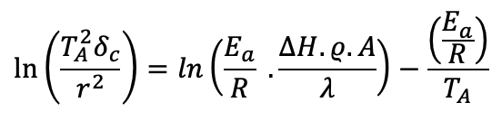 | (1)
where ρ is the density, $∆H$, the specific enthalpy, A, the pre-exponential factor and $λ$, the thermal conductivity. δ_{c} is the critical value of Frank-Kamenetskii parameter, set at 2.569 for a cubic geometry.
The crossing point time t_{cp} is reached when the temperature at the center of the basket exceeds the other temperatures measured between the center and the basket walls. The placement and number of thermocouples used depends on the size of the basket. The influences of the particle size distribution, the basket dimension and of temperature were examined. A Doehlert experimental design was used to distribute the test uniformly of the control volume.
Flue gases were collected using a stainless-steel tube placed in the oven above the basket. Permanent gases were analysed by micro-gas chromatography (SRA 3000, equipped with a TCD detector, 3 ways).
  - Results and discussion
    - Critical conditions for thermal explosion
The first tests were performed on the raw pellets to determine the critical conditions of storage. At first, it should be highlighted that the pellets underwent significant structural changes during their self-heating (Figure 1): after drying, their size decreased, then a few cracks appeared at the same time as torrefaction occurred; finally, combustion spread throughout the pellet, generating ashes with a residual carbon content that varied according to oxygen accessibility in the porous medium.
Figure 1: Evolution of pellets from agromining in a small basket at a) 20 °C, b) 160 °C, c) 200 °C and d) 220 °C.
Tests were carried out on both miscanthus and agromining pellets in baskets ranging from 8 cm³ to 2744 cm³, until there was a maximum difference of 10 °C between ignition and non-ignition conditions. Repeatability was assessed by reproducing the same experiment three times in the case of the maximum temperature leading to a non-ignition. Figure 2 shows both the critical conditions obtained for miscanthus and agromining products, and the extrapolation of the results using Frank-Kamenetskii theory.
Figure 2: Self-heating behaviour of raw agromining pellets and miscanthus pellets
Although the critical self-heating conditions obtained for agromining pellets were systematically lower than those obtained for miscanthus, suggesting less stability, the difference was not significant enough to conclude that the presence of nickel promoted self-heating. Furthermore, the application of Frank-Kamenetskii model led to similar critical conditions for both products for larger storage volumes and lower temperatures, e.g. approximately 10 m of critical dimension at 70 °C.
Using equation 1, activation energies were determined and compared to their values obtained by applying Kissinger and Friedman methods to TGA results (Table 1). As potential changes in reactions were observed as a function of temperature and two distinct reaction phases could be identified in TGA, ranges of activation energies combining these two stages have been defined in Table 1 for Friedman method. Results obtained by TGA were very similar and showed no significant difference between miscanthus and agromining pellets. These findings are consistent with those of Guo et al. (2014) and Gupta et al. (2021) obtained for wood pellets and pine woods, respectively. It should be noted that Blomqvist and Van Hees (2006) have found larger activation energies ranging from 59 to 84 kJ.mol⁻¹ for wood pellets using the crossing point method for baskets tests. Indeed, the activation energies obtained through basket tests are much greater (Table 1), which is probably due to the differences between the volumes tested (a few mL for TGA) and the influence of oxygen accessibility for large baskets.
Table 1: Determination of the activation energy of pellets self-heating
Activation  Energy (kJ.mol⁻¹) | TGA analyses |  | Basket test
 | Kissinger | Friedman |  | Frank-Kam.
Miscanthus | 47 | 25-49 |  | 136
Agromining | 43 | 23-41 |  | 148

The size of the storage also affects the location of the hot spot during self-heating. Figure 3 shows an instance of test performed on pellets from agromining stored at 220 °C for which the influence of oxygen accessibility and internal heat propagation is clearly visible. Indeed, the self-heating phenomenon was initially perceptible close to the walls of the basket (V3, V4) and not at its centre. The thermal wave then propagated to the centre of the storage (V5) and finally reached the bottom of the basket (V6, V7), with the height of the fuel gradually decreasing as combustion proceeds. This behaviour demonstrated the effect of the pile porosity: self-heating therefore depends on the balance between fuel density and oxygen availability (Schmidt et al., 2003).
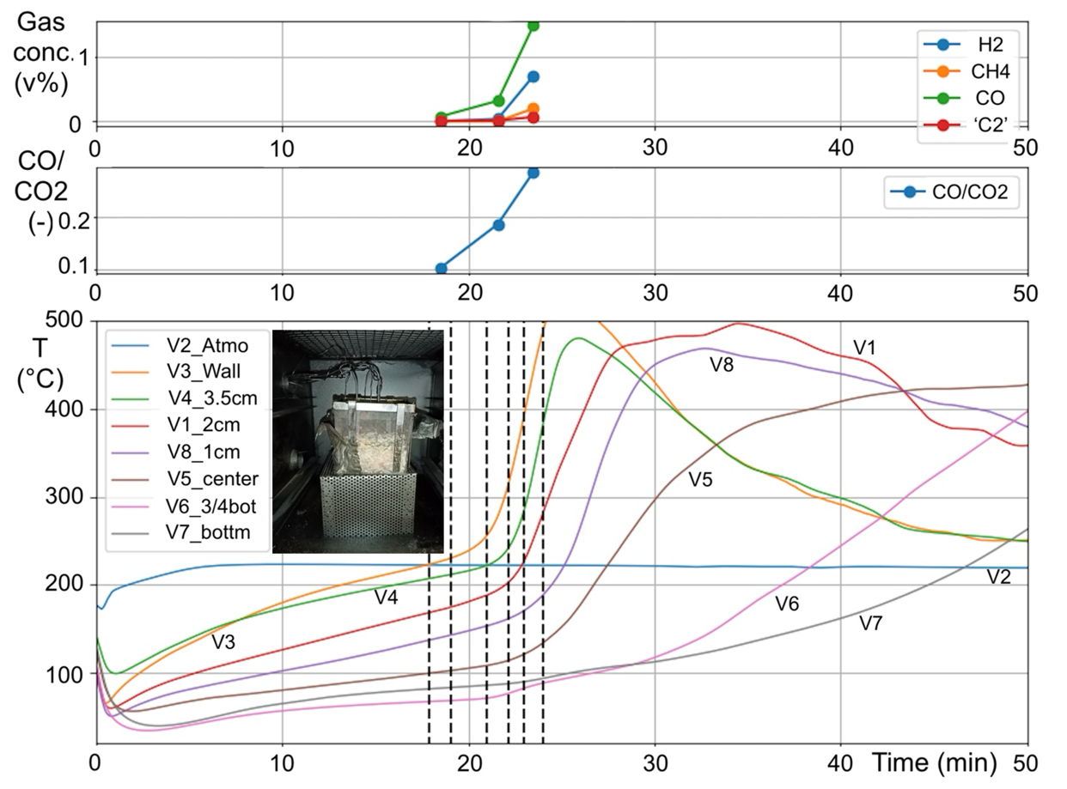
Figure 3: Self-heating of pellets from agromining at 220 °C in a 1000 cm³ basket: gas and temperature evolution
During multiple tests performed on miscanthus and pellets from agromining, combustion gases were collected and analyzed. CO/CO₂ ratio remained below 0.1 before reaching the point at which the first thermocouple measured a temperature higher than that of the oven. This ratio raised from 0.1 to 0.3 well before the crossover point was reached. Therefore, this parameter can be a good indicator of the evolution of self-heating, at least in the early stages. The presence of other gases, such as methane or hydrogen, should also be highlighted.
Figure 4: Cross-influences of the temperature, basket size and agromining products size on their thermal stability
    - Sensitivity analysis: effects of temperature, biomass particle size and basket dimensions
Influences of particle/pellet size, basket dimensions and temperature on the thermal stability have been highlighted using the crossing point method. Results are shown in Table 2 both for miscanthus and agromining products. Real variables A_{i} can be converted into coded variables x_{i} using the following ratio: $\frac{A_{i}-\overline{A}}{A_{max}-A_{min}}$.
Table 2: Results of thermal stability tests; coded variables
Product | Test | Coded variables |  |  | Real variables |  |  | Results
 | Number | x₁ | x₂ | x₃ | Fuel size (mm) | T(°C) | Bask. size(cm) | Ignit. / t_{cp} (min)
Miscanthus | 1 | 0 | 0 | 0 | Medium (5) | 300 | 10 | 68.7
 | 2 | 0 | 0 | 0 | Medium (5) | 300 | 10 | 62.5
 | 3 | 0 | 0 | 0 | Medium (5) | 300 | 10 | 70.4
 | 4 | 0.5 | 0.866 | 0 | Raw (7) | 400 | 10 | 93.2
 | 5 | 1 | 0 | 0 | Large (9) | 300 | 10 | 10.8
 | 6 | -1 | 0 | 0 | Fine (1) | 300 | 10 | 14.3
 | 7 | -0.5 | -0.866 | 0 | 1.19-4 (3) | 200 | 10 | 108.3
 | 8 | 0.5 | 0.289 | 0.816 | Raw (7) | 333 | 15 | 48.0
 | 9 | -0.5 | -0.289 | -0.816 | 1.19-4 (3) | 266 | 5 | 10.7
 | 10 | 0.5 | -0.866 | 0 | Raw (7) | 200 | 10 | 103.8
 | 11 | 0.5 | -0.289 | -0.816 | Raw (7) | 266 | 5 | 14.3
 | 12 | 0 | 0.577 | -0.816 | Medium (5) | 366 | 5 | 5.6
 | 13 | -0.5 | 0.866 | 0 | 1.19-4 (3) | 400 | 10 | 9.6
 | 14 | -0.5 | 0.289 | 0.816 | 1.19-4 (3) | 333 | 15 | 54.8
 | 15 | 0 | -0.577 | 0.816 | Medium (5) | 233 | 15 | 60.5
Agromining | 1 | 0 | 0 | 0 | Medium (3.8) | 295 | 6 | 11.7
 | 2 | 0 | 0 | 0 | Medium (3.8) | 295 | 6 | 10.7
 | 3 | 0 | 0 | 0 | Medium (3.8) | 295 | 6 | 12.1
 | 4 | 0.5 | 0.866 | 0 | Raw (6.6) | 400 | 6 | 8.1
 | 5 | 1 | 0 | 0 | Large (13.2) | 295 | 6 | 9.0
 | 6 | -1 | 0 | 0 | Dust (0.5) | 295 | 6 | 12.4
 | 7 | -0.5 | -0.866 | 0 | Fine (1) | 190 | 6 | 76.5
 | 8 | 0.5 | 0.289 | 0.816 | Raw (6.6) | 330 | 10 | 18.3
 | 9 | -0.5 | -0.289 | -0.816 | Fine (1) | 260 | 2 | 11.5
 | 10 | 0.5 | -0.866 | 0 | Raw (6.6) | 190 | 6 | 56.7
 | 11 | 0.5 | -0.289 | -0.816 | Raw (6.6) | 260 | 2 | 9.8
 | 12 | 0 | 0.577 | -0.816 | Medium (3.8) | 365 | 2 | 3.8
 | 13 | -0.5 | 0.866 | 0 | Fine (1) | 400 | 6 | 10.6
 | 14 | -0.5 | 0.289 | 0.816 | Fine (1) | 330 | 10 | 37.7
 | 15 | 0 | -0.577 | 0.816 | Medium (3.8) | 225 | 10 | 37.8

Using Doehlert's design, a mathematical model relating the three coded variables can be proposed for agromining products (t_{cp} in min):
(2)
The same approach was presented by Demol et al. (2023) for miscanthus. While playing a role in the self-heating of such powders, the particle size distribution seems to have less influence than the basket dimensions or the temperature. Figure 4 shows that the crossing point time increases when the pellets are finely ground, meaning that a reduced porosity tends to stabilize such biomass storage by decreasing the airflow rate (Yazdanpanah et al., 2010). No clear optimum was obtained, contrary to the behavior observed with miscanthus (Demol et al., 2023). The greatest coefficient, i.e. effect, is related to the temperature. It confirms that, once the stability conditions exceeded, an increase in temperature significantly reduces the delay at which the thermal explosion will occur.
    - Influence of nickel content and nature
Table 2 and Figure 5 show that, under comparable storage conditions, the time at which the crossing point is reached is significantly lower for products from agromining than for miscanthus, especially at high temperature and volume. Additional tests were performed at 190 °C with baskets of 6 cm size by mixing miscanthus (90 wt%) and ashes (nickel-rich residues) from agromining pellets, collected after self-ignition. No significant modification was observed. Similar tests were carried out with pellets and powders issued from agromining, mixed with 10 wt% ashes: once again, no increase in thermal instability was noted. Finally, ANSH (Ammonium Nickel Sulphate Hexahydrate) was mixed with fine (1 mm) miscanthus powder (6 cm basket, 220 °C), without any notable modification. These results show that the slight increase in sensitivity to self-ignition may not be directly due to the presence of such compounds (minerals or nickel salts).

Figure 5: Comparison of crossing points determined for miscanthus and agromining products
  - Conclusions
Pellets and powders generated by the agromining process are slightly more sensitive to self-ignition than other biomass, especially at high temperatures. However, such evolution, not necessarily linked to the presence of metal salts, does not lead to any significant changes in the preventive measures to be implemented.
References
Blomqvist P., Van Hees P., 2006, Spontaneous ignition of biofuels - an experimental investigation through small and large-scale tests, Swedish national testing and research institute (SP), Report 2006:41 Fire Technology.
Bowes P., 1984, Self-heating: evaluating and controlling the hazards, Elsevier Science Publishers, Leeds, UK.
Demol R., Janès A., Lacourt A., Dufour A., Dufaud O., 2023, ‘Self-heating is in the air’: the role of oxygen diffusion on the thermal stability of biomass piles, Chem. Eng. Trans., 104, 19-24.
European Committee for Standardization (ECS), 2020. EN 15188:2020, Determination of the spontaneous ignition behaviour of dust accumulations, ECS, Brussels, Belgium.
Gupta A., Siddiqui H., Rathi S., Mahajani S., 2021, Intra-pellet transport limitations in the pyrolysis of raintree leaves litter, Energy, 216, 119267.
Guo W., Trischuk K., Bi X., Lim C.J., Sokhansanj S., 2014, Measurements of wood pellets self-heating kinetic parameters using isothermal calorimetry, Biomass and Bioenergy, 63, 1-9.
ISO/TS 20049-2, 2020, Solid biofuels - Determination of self-heating of pelletized biofuels - Part 2: Basket heating tests, International Organization for Standardization.
Janès, A., Vignes, A., Dufaud, O., 2019, Ignition temperatures of dust layers and bulk storages in hot environments, Journal of Loss Prevention in the Process Industries, 59, 106-117.
Restuccia F., Fernandez-Anez N., Rein G., 2019, Experimental measurement of particle size effects on the self-heating ignition of biomass piles: Homogeneous samples of dust and pellets, Fuel, 256, 115838.
Schmidt M., Lohrer C., Krause U., 2003, Self-ignition of dust at reduced volume fractions of ambient oxygen Journal of Loss Prevention in the Process Industries, 16 (2), 141-147.
Schwarzer L., Jensen P.A., Wedel S., Glarborg P., Karlström O., Holm J.K., Dam-Johansen, K., 2021, Self-heating and thermal runaway of biomass – Lab-scale experiments and modeling for conditions resembling power plant mills, Fuel, 294, 120281.
Yazdanpanah, F., Sokhansanj, S., Lau, A.K., Lim, C.J., Bi, X., Melin, S., Afzal, M., 2010, Permeability of wood pellets in the presence of fines, Bioresource Technology, 101 (14), 5565-5570.

