|  |  |
| --- | --- |
| cetlogo ***CHEMICAL ENGINEERING TRANSACTIONS***  ***VOL. xxx, 2025*** | A publication of  aidiclogo_grande |
| The Italian Association  of Chemical Engineering  Online at www.cetjournal.it |
| Guest Editors: Bruno Fabiano, Valerio Cozzani  Copyright © 2025, AIDIC Servizi S.r.l. **ISBN** 979-12-81206-xx-y; **ISSN** 2283-9216 | |

Effect of Atmosphere on Thermal Decomposition of Sodium percarbonate

YosukeNishiwaki

National Institute of Occupational Safety and Health, Japan

nishiwaki@s.jniosh.johas.go.jp

**Abstract**

Sodium carbonate-hydrogen peroxide (SPC, sodium percarbonate) is an oxidizing agent used for bleaching and cleaning. The decomposition of SPC produces water, oxygen and heat. The heat generated by SPC can cause fire accidents. Previous studies reported the effect of water vapor on the decomposition of SPC, but the particular details of the effect have not been revealed. In this study, the effect of the atmospheric conditions (airflow rate and humidity) on the thermal decomposition of SPC is elucidated.

The thermal behaviour was evaluated by placing SPC on a wire basket in an isothermal oven, and a Grewer oven was used to control the temperature of the system. Self-heating of SPC was observed at temperatures above130 °C. Isothermal analysis in the Grewer oven under various atmospheric conditions revealed that a higher airflow rate resulted in a larger temperature rise, and lower humidity resulted in a larger temperature increase at 25% RH. These findings indicate that water vapuor from the surrounding atmosphere and the decomposition product of SPC decreased the rate of thermal decomposition. On the other hand, an additional peak corresponding to the exothermic decomposition of SPC was observed at nearly-saturated humidity at elevated temperature. The experimental results indicate that water vapor enhanced the thermal decomposition because of the deliquescence of SPC under high humidity. These results contribute to the safety management of SPC during storage and manufacture.

* 1. Introduction

Sodium carbonate-hydrogen peroxide, also termed sodium percarbonate (SPC), is a well-known perhydrate. SPC is used for bleaching (Toninelli, 1978) and synthesis (Mekillop and Sanderson, 1995). The ideal formula of SPC is Na2CO3·1.5H2O2, where the H2O2 molecules are bound to the CO32- ions via hydrogen bonds (Adams and Pritchard, 1977). Decomposition of SPC generates heat and oxygen, which present a fire hazard. Thus, studying the self-heating mechanism of SPC is important for analysing the thermal hazard during bleaching and in the chemical industry.

A simple equation for SPC decomposition was proposed (Nakano, et al., 2015) as follows:

|  |  |
| --- | --- |
| ${Na}_{2}{CO}_{3}·1.5H_{2}O_{2}\left(s\right)→{Na}_{2}{CO}_{3}\left(s\right)+1.5H_{2}O_{2}\left(g\right)$ | (1) |
| $H_{2}O_{2}\left(g\right)→H_{2}O\left(g\right)+0.5O_{2}\left(g\right)$ | (2) |

The mechanism of SPC decomposition is complex. Galwey et al. (1979) reported that the decomposition of solid SPC is an autocatalytic process. Wada et al. (2015) reported that the decomposition involves a multi-step reaction that is separated by the outer surface layer of SPC. The outer surface layers of SPC hinder the diffusional removal of product gases generated by the decomposition of internal SPC. The reaction rate of SPC decreases because of an increase of the internal pressure due to generated gas as the reaction advances. However, the decomposition rate accelerates once cracks are formed in the outer surface layer at the midpoint of the reaction. The exothermic decomposition of SPC increases the temperature of the material and the rate of thermal decomposition as a runaway reaction. Carson et al. (2006) reported that the exothermic decomposition of SPC occurs at 63.9 °C, based on adiabatic rate calorimetry (ARC), and the self-accelerating decomposition temperature is 56 °C. Using the wire-basket test under isothermal conditions, Morrison et al. (2008) reported self-heating of SPC in a 50 mm cube basket above 100 °C.

Water is one of the chemical materials that affect the decomposition of SPC. Galwey and Hood (1979) reported that liquid water accelerates the decomposition of SPC. Johansson et al. (2007) observed that water vapour accelerates the decomposition of SPC at 30 °C and 70% RH. However, Galwey and Hood (1979) reported that the rate of SPC decomposition decreases upon contact with water vapour at 4% RH. Wada et al. (2015) mentioned that water vapour at 6% RH hinders the diffusional removal of the gaseous products generated by the thermal decomposition of internal SPC. These previous studies indicate that water vapor in the atmosphere of SPC exerts complex effects on the thermal hazard of SPC. The airflow rate is thought to be important in the decomposition process because water is a decomposition product of SPC (Eq(2)) and the airflow rate influences accumulation of the gas product. In this study, the effect of the atmospheric conditions (airflow rate and humidity) on the thermal decomposition is elucidated for ensuring the safety of SPC.

* 1. Experimental section
     1. Sample preparation

SPC (Thermo Scientific) was used as received without further purification. The purity of SPC was determined by titration with potassium permanganate before the experiments; the amount of H2O2 in SPC is ca. 8.66±0.09 mmol/g (Na2CO3·1.3H2O2).

* + 1. Isothermal test in Grewer oven

To observe the effect of the atmosphere during self-heating of SPC, a Grewer oven was chosen for the self-heating analysis. The Grewer oven enables measurement of the autoignition temperature under an air stream (as VDI2263 Part l); the test material was placed into a stainless steel wire basket (approximately 8 mL) with a thermocouple and placed in the oven at a controlled temperature (Jaeger and Siwek, 1999)). The oven was heated by a heater and metal heating blocks. The metal heating blocks also heated the air stream before contact with the samples. The oven has six pits for the wire basket, and one basket is used as a reference. The reference basket contains graphite. The temperature curve of graphite indicates the oven temperature without the effect of self-heating of the sample material. A schematic and photograph of the Grewer oven are presented in Figure 1. In this study, the Grewer oven was used under isothermal conditions.

Figure 1 Schematic and photograph of Grewer oven.

A Me-40DP-H90 humidity controller (Micro Equipment inc.) was used to control the humidity of the flowing air. The airflow rate was controlled by two mass flow controllers, as shown in Figure 2.

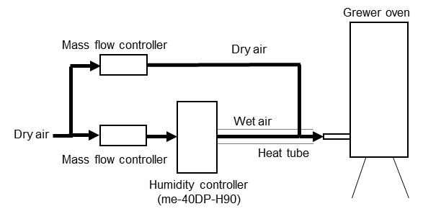

Figure 2 Schematic of system for controlling flow rate and humidity.

* 1. Results and discussion
     1. Effect of airflow rate on self-heating of SPC

The temperature variations of SPC in the Grewer oven are shown in Figures 3 and 4. The effect of the airflow rate (0, 0.5, 2, and 3 L/min) on the maximum temperature increase of SPC is summarised in Table 1 and Figure 5. Figure 3 shows the self-heating under various airflow conditions and Figure 4 shows the self-heating under natural convection. Based on the comparison between the two conditions, it is deduced that the exothermic decomposition of SPC is accelerated by air supply, although air is not required for the exothermic reaction, as shown in Eq(1) and (2). As shown in Table 1 and Figure 5, the maximum temperature increase became more pronounced as the oven temperature increased. These results indicate that the airflow influences the removal of product gases such as water (which inhibits the reactions in Eq(1) and (2) according to chemical equilibrium). Thus, the effects of water vapor were measured using the humidity-control system, as shown in Figure 2.

Figure 3 Temperature variation during self-heating of SPC at airflow rate of 2 L/min.

Figure 4 Temperature variation during self-heating of SPC at airflow rate of 0 L/min.

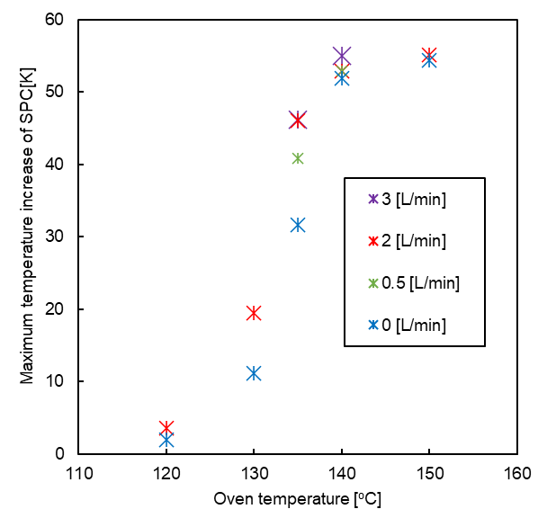

Figure 5 Maximum temperature increase of SPC at various airflow rates

Table 1 Maximum temperature increase [k] of self-heating of SPC at various airflow rate.

|  |  |  |  |  |  |
| --- | --- | --- | --- | --- | --- |
| Airflow condition | Temperature [oC] | | | | |
| 120 | 130 | 135 | 140 | 150 |
| 3 [L/min] Dry air | - | 23.3 | 46.2 | 55.0 | - |
| 2 [L/min] Dry air | 3.6 | 19.5 | 46.0 | 52.9 | 55.1 |
| 0.5 [L/min] Dry air | - | 11.2 | 40.8 | 52.9 | - |
| 0 [L/min] Dry air  (Natural convection) | 2.0 | 11.1 | 31.6 | 51.9 | 54.4 |

* + 1. Effect of humidity on self-heating of SPC

The temperature variation of SPC in the Grewer oven under wet air flowing at a rate of 0.5 L/min at 135°C is shown in Figure 6. Figure 6 shows that increasing the humidity around SPC reduced the maximum temperature rise and time from the maximum self-heating (induction period). At a humidity of 421 g/m3, which is the absolute humidity, the relative humidity of the atmosphere was 25% at 135 °C. In the same way, 51 g/m3 is converted to 3% RH. The effect of humidity on the maximum temperature rise and induction period are summarized in Table 2. These results indicate that water vapor inhibits the self-heating of SPC within the RH range of 3‒25%. The accumulated water vapor generated from the product gas of SPC decomposition increased the humidity surrounding SPC in the case of natural convection and decreased the rate of self-heating of SPC. On the other hand, an additional peak corresponding to the exothermic decomposition of SPC was observed at nearly-saturated humidity during the elevated-temperature process. The experimental results indicate that water vapor at nearly-saturated humidity enhanced the thermal decomposition because of the deliquescence of SPC at high humidity.

Figure 6 Temperature change during self-heating of SPC at airflow rate of 0.5 L/min at 135 °C

Table 2 Maximum temperature increase during self-heating of SPC at various humidities

|  |  |  |
| --- | --- | --- |
| Humidity at 135oC %RH | Maximum temperature increase [K] | Induction period [min] |
| 0 | 40.8 | 10.9 |
| 3 | 33.1 | 13.5 |
| 25 | 23.0 | 22.1 |

* 1. Conclusion

The thermal behaviour was measured by placing SPC on a wire basket in an isothermal oven, where a Grewer oven was used to control the temperature of the system. A system for manipulating the humidity and flow rate was manufactured for controlling the atmosphere of SPC in the Grewer oven. Self-heating of SPC was observed above 130 °C. The isothermal test in the Grewer oven under various atmospheric conditions revealed that a higher airflow rate resulted in a larger temperature rise, and lower humidity resulted in a larger temperature rise at 25% RH. These findings indicate that water vapor generated from the surrounding atmosphere and the decomposition of SPC decreased the rate of thermal decomposition. On the other hand, an additional peak corresponding to the exothermic decomposition of the SPC was observed at nearly-saturated humidity during the elevated-temperature process. The experimental results indicate that water vapor at nearly-saturated humidity enhanced the thermal decomposition because of the deliquescence of SPC at high humidity. These results are expected to contribute to the safety management of SPC under various atmospheres during storage. The isothermal test in the Grewer oven indicates that storage under natural convection or wet airflow at 25% RH decreases the thermal hazard of SPC.

Acknowledgments

The author would like to thank Editage (www.editage.com) for English language editing by native English speakers.

References

Adams, J.R., Merz, A.R., 1929. Hygroscopicity of Fertilizer Materials and Mixtures. Ind. Eng. Chem. 21, 305–307.

Carson, P.A., Fairclough, C.S., Mauduit, C., Colsell, M., 2006. Peroxy bleaches Part 2. Determination of the thermodynamic and kinetic chemistry of some peroxy compounds. J. Hazard. Mater. A136, 446–454.

Galwey, A.K., Hood, W.J., 1979. Thermal Decomposition of Sodium Carbonate Perhydrate in the Solid State. J. Phys. Chem. 83, 1810–1815.

Jaeger, N., Siwek, R., 1999, Prevent explosions of combustible dusts, Chemical Engineering Progress, 95, 25–37.

Johansson, C., Pekonen, P., Forsström, D.S., 2007. The Long-term Stability of Sodium Percarbonate in Presence of Zeolite as Measured by Heat Flow Calorimetry. Tenside Surf. Det. 44, 214–217.

Mckillop, A., Sanderson, W.R., 1995, Sodium Perborate and Sodium Percarbonate: Cheap, Safe and Versatile Oxidising Agents for Organic Synthesis, Tetrahedron, 51, 6145–6166.

Morrison D.R., Ogle, R.A., 2008. Evaluating Kinetic Parameters for Solid Substances Exhibiting Complex Self-Heating Behavior. The proceedings of American Institute of Chemical Engineers 2008 Spring National Meeting 42nd Annual Loss Prevention Symposium, New Orleans, LA, 55–89.

Nakano, M., Wada, T., Koga, N., 2015, Exothermic Behavior of Thermal Decomposition of Sodium Percarbonate: Kinetic Deconvolution of Successive Endothermic and Exothermic Processes, et al., The Journal of Physical Chemistry A, 119, 9761–9769.

Toninelli, G., 1978, Sodium percarbonate as bleaching agent in detergent powders, Tenside Detergents, 15, 252–258.

VDI 2263 Part 1, Test Methods for the Determination of the Safety Characteristic of Dusts, 1990.

Wada, T., Nakano, M., Koga, N., 2015. Multistep Kinetic Behavior of the Thermal Decomposition of Granular Sodium Percarbonate: Hindrance Effect of the Outer Surface Layer. J. Phys. Chem. A119, 9749–9760.