 CHEMICAL ENGINEERING TRANSACTIONS  VOL. xxx, 2025 | A publication of  
The Italian Association
of Chemical Engineering
Online at www.cetjournal.it
Guest Editors: Bruno Fabiano, Valerio Cozzani
Copyright © 2025, AIDIC Servizi S.r.l.
ISBN 979-12-81206-xx-y; ISSN 2283-9216

Relationship between heat dose and the onset of secondary fires
Elin Bloem*, Paul A.M. Uijt de Haag
RIVM, A. van Leeuwenhoeklaan 9, 3721 MA Bilthoven, the Netherlands
elin.bloem@rivm.nl
In the Netherlands, focus areas have been introduced around activities involving large amounts of hazardous substances. A focus area is defined as the effect zone where an incident can have life-threatening consequences for people inside buildings that are situated outside the plant boundary (“external safety”). There are three different focus areas, for toxic clouds, explosions (overpressure) and fire (heat radiation). Focus areas help policymakers to decide whether additional protective measures are needed.
This paper investigates whether a dose relationship can be used to determine the fire focus area. In a dose relationship, both the heat flux and the duration of exposure are taken into account. First, the criterion for life-threatening consequences was established to be the onset of secondary fires. Next, a literature search was done to evaluate experimental data on the ignition of materials used in and around buildings. Based on these experimental data, a relationship between the heat radiation dose and the ignition of materials was determined. Finally, four accidents of high-pressure natural gas pipelines were used to calibrate the dose relationship. Based on this study, it is proposed to use the dose relationship ∫ (R(t) - C)^{B} dt = A for the onset of secondary fires, where R is the heat flux in kW/m², C = 5 kW/m² is the critical heat flux, B = 2, t is the time in s, and A = 28150 s⋅(kW/m²)² is the reference dose.
  - Introduction
In the Netherlands, Quantitative Risk Assessments (QRA) are used for decisions on land use planning around sites with dangerous substances. Two measures are used, Individual Risk (IR) and, until 2024, Societal Risk (SR). From 2024 onwards the calculation of Societal Risk has been replaced with the concept of focus areas (IPLO, 2024). A focus area is defined as the effect zone where an incident can have life-threatening consequences for people inside buildings. There are three different focus areas, for toxic clouds, explosions (overpressure) and fire (heat radiation). In focus areas policymakers have to decide whether additional protective measures are needed.

The effect of heat radiation is determined by (at least) two parameters: the heat flux and the duration. The fire focus area would therefore best be described with a heat dose relationship. The following steps are done to develop a dose relationship for the calculation of the fire focus area:
1. Different mechanisms in which a heat flux may endanger people inside buildings were reviewed. The results are described in Section 2.
2. As secondary fires were considered to be the primary danger to people inside buildings, a literature search was done to the effect of external heat radiation on materials found in and near buildings and the initiation of secondary fires. The results of the literature study are described in Section 3.
3. Based on the literature search, a dose relationship for the initiation of secondary fires was developed. The dose relationship was calibrated with four incidents of high pressure natural gas pipelines (Sections 4 and 5).

  - Danger to people inside buildings
An incident with flammable substances results, after ignition, in a fire, such as a flash fire, pool fire, jet fire or fireball. The resulting heat radiation may endanger people. Direct exposure of people to high levels of heat radiation may result in second- or third-degree burns which may lead to death. Although windows do not block heat radiation entirely, people inside a building can find protection against direct exposure. Even if direct exposure to heat radiation is avoided, heat radiation may still have life-threatening consequences for people in buildings through the following phenomena: the collapse of the building, too high temperature in the building and secondary fires in the building.
    - Collapse of the building
Intense heat radiation weakens steel constructions and may result in the collapse of buildings. However, this phenomena requires high levels of heat radiation, in the order of 100 kW/m² or more for at least half an hour (VROM, 2003). As shown in Section 3, the threshold for the initiation of secondary fires is lower. Hence, the collapse of buildings is not used as criterion for the boundary of the fire focus area.
    - Too high temperature in building
Intense heat radiation will increase the temperature in a building. If the temperature becomes too high, people can die due to heat stroke, skin burns or respiratory tract burns. It is assumed that during the type of incidents for which the focus areas are intended fatalities will not occur below 60 ˚C and may occur above this threshold (Hazebroek et al, 2015).
The heat radiation increases the air temperature inside the building indirectly. The building absorbs the heat radiation and warms up. This in turn increases the air temperature inside the building. A simple calculation shows that a heat flux of 10 kW/m² on a brick wall with heat capacity 1500 kJ/m³.K and a thickness of 0.2 m leads to a 30˚C temperature rise of the wall after 900 s. This is a very conservative approach by assuming that all radiation is absorbed and all heat loss terms due to conduction and convection are ignored. Furthermore, the temperature rise inside the building is reduced by unexposed walls. A heat flux of 10 kW/m² during 900 s is comparable to the threshold for the initiation of secondary fires (see Section 3). Given the very conservative approach, it is concluded that secondary fires initiate before indoor temperature rises to dangerous levels. Therefore the temperature inside buildings is not used as criterion for the boundary of the fire focus area.
    - Initiation of secondary fires
If a combustible material is exposed to heat radiation, it may catch fire if the combination of duration and intensity of the radiation is large enough. If materials near or in buildings catch fire, people in buildings may suffer life-threatening consequences. The radiation dose required for secondary fires is lower than the dose required for lethal temperatures in the building or required for the collapse of the building. Therefore, the initiation of secondary fires is used as boundary of the fire focus area (Boxman et al, 2022).
  - Literature study on ignition data
A literature study was done to find the relation between heat radiation and time to ignition for materials found in and near buildings. To derive the dose relationship for the onset of secondary fires, data from piloted ignition experiments is used. This is a more conservative approach as it takes the presence of an ignition source into account. For example dry leaves on a window sill can ignite much faster than the window sill itself, thereby becoming an ignition source for the window sill. Also glowing or burning material spread from the fire may become an ignition source. DNV (DNV GL, 2018), Bilo and Kinsman (1997) and HSE (Burrell and Hare, 2006) also use piloted ignition for their dose relationship, for the same reasons.
    - Data on piloted ignition
The time to ignition for piloted ignition experiments with constant heat flux from 25 different papers were collected, giving over 600 datapoints. The data is plotted in Figure 1.

Two things are noticeable. First is the very limited amount of data available below 10 kW/m². There may be various reasons for this. One reason may be that it was considered as not interesting to study because of the long time to ignition. Another reason may be limitations of the experimental setup. Second is that there appears to be a difference between wood and plastic. It seems that below 20 kW/m² the first materials to ignite are plastics, while above 20 kW/m² this is wood.

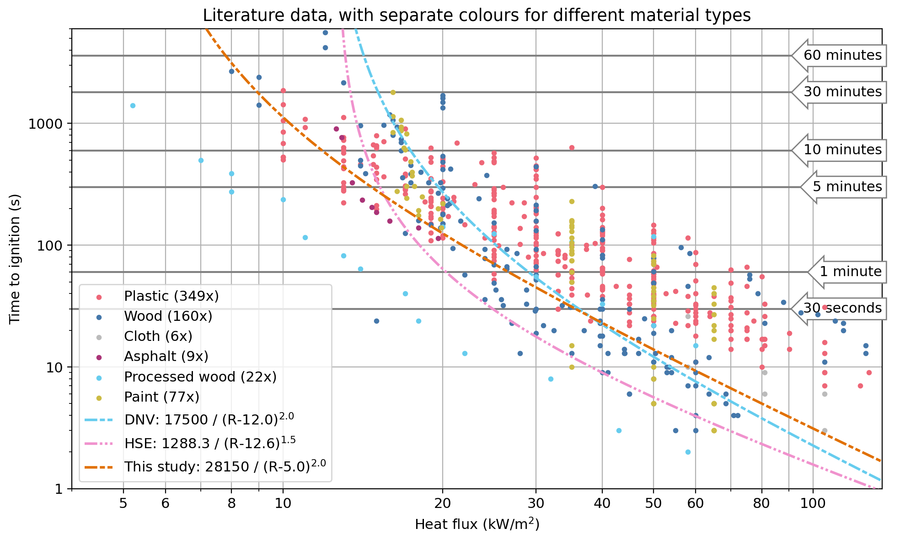
Figure 1: Log-log plot of the time to ignition for different materials and the dose relationships according to DNV (DNV GL, 2018),HSE (Burrell and Hare, 2006), and the one found in this study.
Also shown in Figure 1 are the dose relationships derived by DNV (DNV GL, 2018),HSE (Burrell and Hare, 2006), and the one found in this study. The dose relationships for the piloted ignition of materials are given by Eq (1).

$∫{(R(t)-C)}^{B} dt=A$ (1)

With R heat flux in kW/m², C the critical heat flux in kW/m², B a constant and A the reference dose leading to ignition in s.(kW/m²)^{B}. The values used by DNV and HSE are respectively C = 12.0 kW/m², B = 2, A = 17500 s.(kW/m²)² and C = 12.6 kW/m², B = 1.5, A = 1288 s.(kW/m²)^{1.5}. In general, the DNV dose relationship predicts longer time to ignition than the HSE relationship. In addition, 39% of the datapoints in the graph are below the curve of DNV, i.e. the materials will ignite faster than predicted by the dose relationship. In both relationships the critical heat flux seems too high as materials can ignite well below the critical heat flux of 12.6 kW/m². An explanation for this can be that the dose relationships of both DNV and HSE have been (partially) based on experimental data on the time to ignition for wood (Bilo and Kinsman, 1997), while plastics may ignite at lower heat fluxes.
    - Dose relationship
Based on the time to ignition for all materials as shown in Figure 1, a dose relationship is derived using Eq (1). First, the constant B was derived by fitting all datapoints to Eq (2).
$t_{ign} =\frac{A}{R^{B}}$ (2)
With t_{ign} the time to ignition in s, B a constant and A the reference dose leading to ignition in s.(kW/m²)^{B}. This corresponds to Eq(1) with C = 0 kW/m². The fit results in B = 2.0.

Next, a range of values for the critical heat flux, C, was determined. In countries near the equator the heat radiation from the sun can reach 1 kW/m² and materials don’t ignite there, even after long exposure to the sun. The critical heat flux should therefore be above 1 kW/m². From the literature study it emerged that even though there is very little data below 10 kW/m², the critical heat flux should be below that. This is lower than the values used by DNV (DNV GL, 2018) , HSE (Burrell and Hare, 2006), and Bilo and Kinsman (Bilo and Kinsman, 1997). In all these cases the critical heat flux was based on the ignition of wood. In our literature study it emerged that plastics have a much lower critical heat flux. It was decided that the critical heat flux is between 1 kW/m² and 10 kW/m². For this study C = 3, 5, and 8 kW/m² was used.

Finally, a range of values for the reference dose leading to ignition, A, was determined. Because the value of A differs significantly on the values of B and C, the value of A was determined using a percentile value, i.e. the percentage of points in Figure 1 below the curve. When a data point is below the curve it means the time to ignition is shorter than the dose relationship predicts. A lower percentile value will result in a lower reference dose and a more conservative approach. For this study percentile values 10%, 20%, 30%, 40% and 50% were used.
  - Calibrating the dose relationship with accident data
Using literature data on piloted ignition, the values of A were determined for the different values of C and percentile values by calibrating the dose relationship using real-world accidents with damage due to heat radiation.
    - Selection of accidents
Accidents were selected based on three criteria:
- There has to be enough data to model the fire with reasonable accuracy, such as source terms and weather conditions.
- There has to be enough information to estimate the area where secondary fires occurred, i.e. the damage area.
- There should be a relationship between the fire (heat radiation) and the damage; this excludes for example accidents with flash fires and explosions and accidents where fire brigades intervene to limit the damage by e.g. cooling buildings.

In practice, this limited the search to pipeline fires. The databases from the NTSB (US) and TSB (Canada) were searched for accident reports. Both databases contain in-depth reports with extensive factual information about the conditions at the time of the rupture. The description of the damage is not as extensive, especially when the incident occurred in remote areas. Three incidents in the US occurred in built-up areas and the damage was described. In Canada most incidents occurred in remote areas. In addition, for the pipeline accident in Ludwigshafen (Germany) data were also available. In total, four accidents with high pressure natural gas pipelines were available for calibrating the dose relationship:
- September 9th, 2010: San Bruno, California, US (NTSB, 2011)
- December 11th, 2012: Sissonville West Virginia, US (NTSB, 2014)
- October 13th, 2014: Ludwigshafen, Germany (Gasunie, 2024)
- August 1st, 2019: Danville, Kentucky, US (NTSB, 2022)

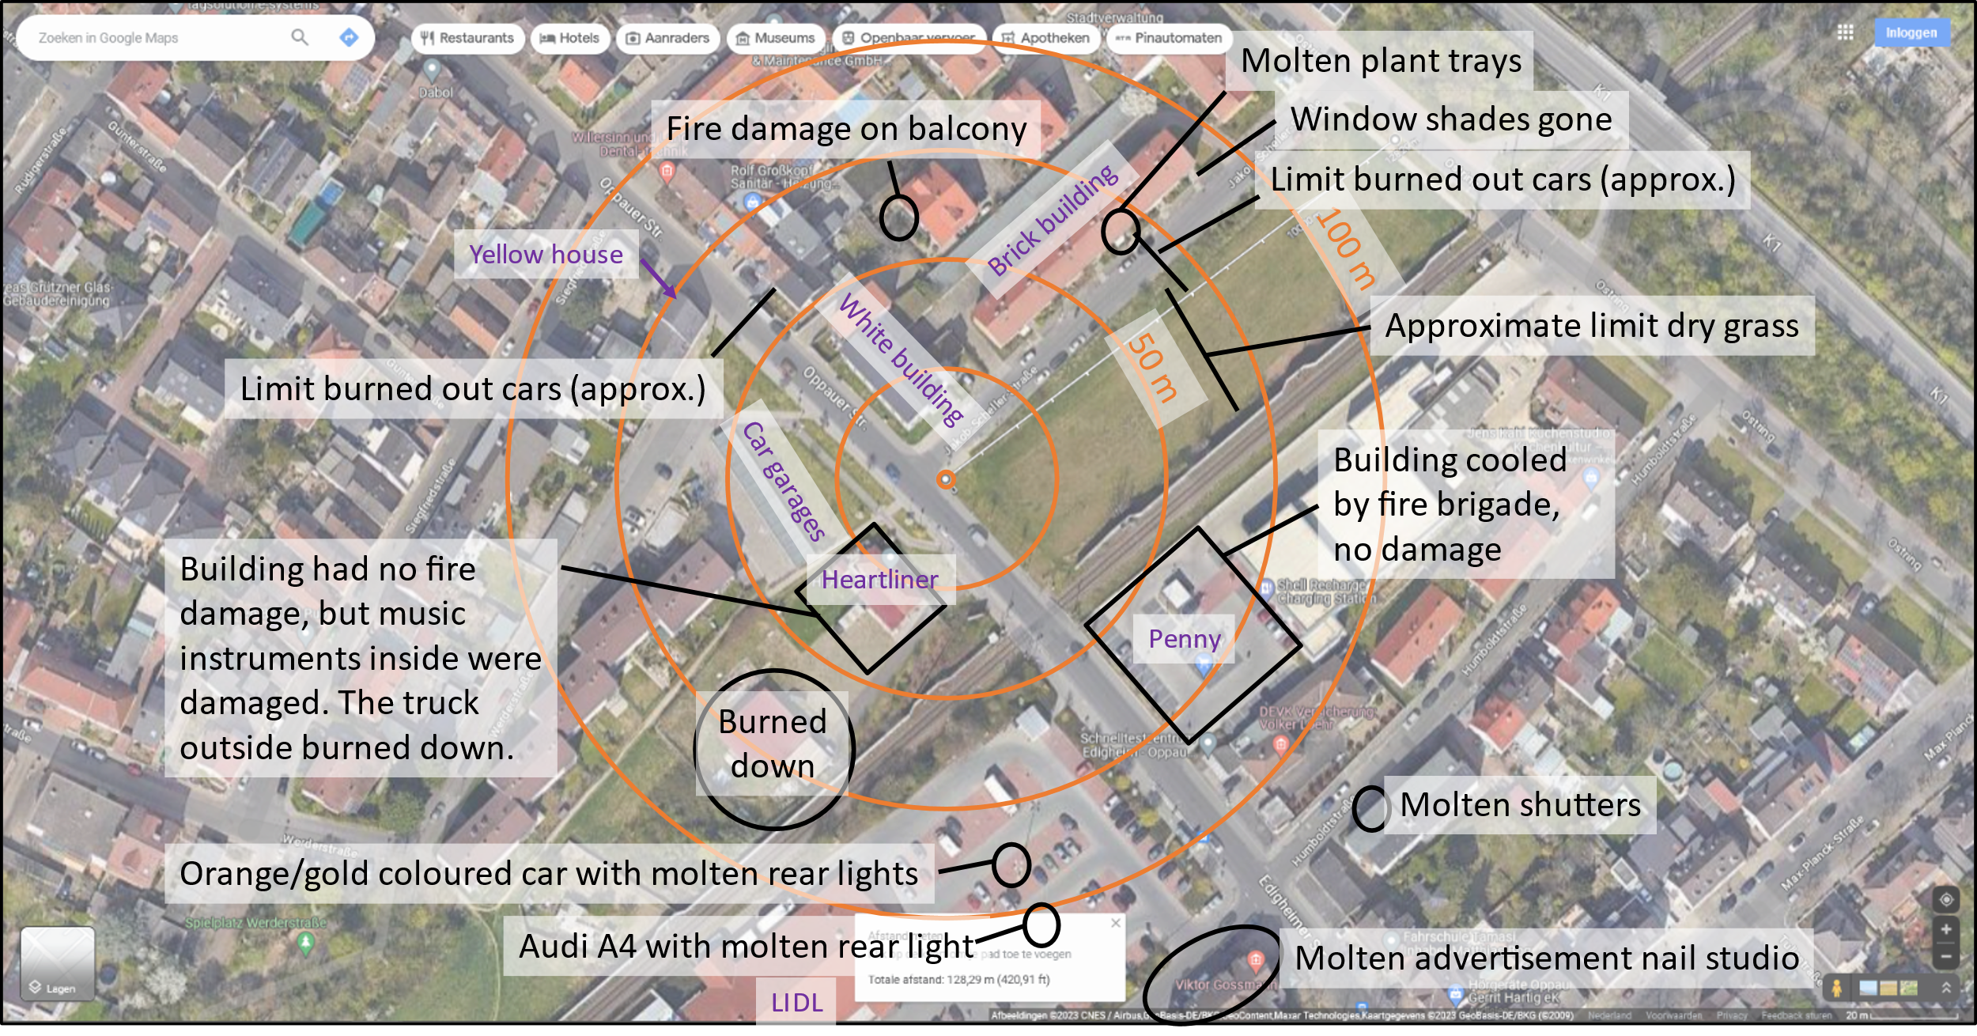
Figure 2: Damage due to the fire in Ludwigshafen. Source: Google Maps, with annotations by the authors.

For each accident, an estimation was made of the damage area where secondary fires may have occurred based on photographs and descriptions as illustrated in Figure 2, and from NTSB reports. From this, a minimum and maximum damage distance was derived.

    - Calculation of damage area
The heat radiation dose was calculated for each accident as function of distance, The calculations were done in Safeti-NL 8.8 (DNV, 2024) using the long pipeline model with methane and the pipeline characteristics and meteorological conditions. In all accidents, a vertical jet fire was assumed. As Safeti-NL 8.8 does not give the proposed heat radiation dose as output directly, the release was divided in nine time steps and the dose was calculated by adding up the contributions of each time step.

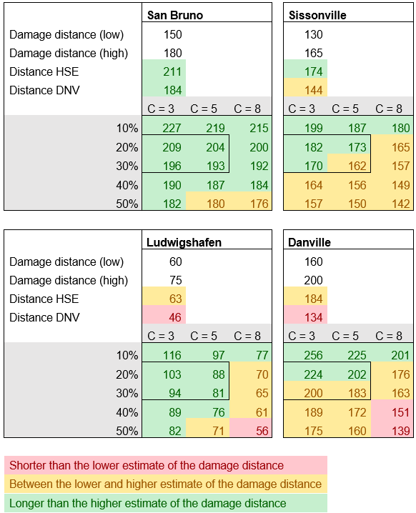
Figure 3: Infographic with the estimated damage distances, and the distances calculated with the dose relationship, using the equations by HSE and DNV, and using the range of parameters discussed in Section 3. The colors show how the distance compares to the estimated damage distances.

    - Calibrating the heat dose relationship
Using the heat flux calculated by Safeti-NL, the heat radiation dose was calculated for the selected values of the critical heat flux C. The distance to the reference dose A was then calculated for the selected percentile values and compared with the minimum and maximum damage distance observed. The results are shown in Figure 3.

The colors in Figure 3 help make clear whether the dose relationship over- or underestimates the damage distance. The dose relationships of DNV and HSE both underestimate the distances for Ludwigshafen and Danville. For our parameters, the results show that a 10% percentile value always overestimates the damage distance. Percentile values of 40 and 50% regularly underestimate the damage distance. The best correspondence between the calculated distance and the observed distance is obtained for C = 3 or 5 kW/m² and percentile values 20 or 30%. Based on these results, a choice was made for percentile value 20%, corresponding with A = 28150 s⋅(kW/m²)², B = 2 and C = 5 kW/m². This choice is slightly conservative.
  - Conclusions
In the Netherlands, a focus area is defined as the effect zone where an incident can have life-threatening consequences for people inside buildings that are situated outside the plant boundary (“external safety”). The goal of this study was to develop a method to calculate the fire focus area. After studying various threats of fire, the initiation of secondary fires due to radiation was considered to be the most relevant.

A dose relationship was derived based on literature data and calibrated using four pipeline accidents. Based on this study, it is proposed to use the dose relationship ∫ (R(t) - C)^{B} dt = A for the onset of secondary fires, where R is the heat flux in kW/m², C = 5 kW/m² is the critical heat flux, B = 2, t is the time in s, and A = 28150 s⋅(kW/m²)² is the reference dose for piloted ignition. Compared to dose relationships used by HSE and DNV the dose relationship proposed results in damage distances that are larger, but match the damage seen in pipeline accidents better. A major difference is a much lower critical heat flux, C = 5 kW/m² instead of 12.6 kW/m² and 12.0 kW/m², for HSE and DNV respectively. Both HSE and DNV based their critical heat flux (mostly) on wood, while this report also considers plastics and other materials.
References
Bilo, M., Kinsman, P.R., 1997, Thermal radiation criteria used in pipeline risk assessment, Pipes and Pipelines International (November-December)
Boxman A.M.C, Stam, G., Uijt de Haag, P.A.M., van Vliet, A.A.C, 2022. Advice on focus areas: considering a proposal for an alternative method of calculating focus areas , RIVM (in Dutch)
Burrell, G. and Hare, J., 2006, Review of HSE Building Ignition Criteria, HSE.
DNV, 2018, PIPESAFE collaboration Definition of house burning distance for public domain document, DNV GL
DNV, 2024, Safeti. www.dnv.com/software/services/plant/quantitative-risk-analysis-safeti/
Gasunie, 2024, personal communication.
Hazebroek, J.C., Greven, F.E., Morssche, K. G.-T., Dikkenberg, R. v. d., 2015, ‘Things can change’, a study of fire development and survivability, Instituut Fysieke Veiligheid (in Dutch)
IPLO, 2024, Environment and Planning Act in the Netherlands. iplo.nl/regelgeving/omgevingswet/english-environment-and-planning-act/
NTSB, 2011, Pacific Gas and Electric Company Natural Gas Transmission Pipeline Rupture and Fire, San Bruno, California, September 9, 2010, DC, National Transportation Safety Board
NTSB, 2014, Columbia Gas Transmission Corporation Pipeline Rupture, Sissonville, West Virginia, December 11, 2012, DC, National Transportation Safety Board
NTSB, 2022, Enbridge Inc. Natural Gas Transmission Pipeline Rupture and Fire, Danville, Kentucky, August 1, 2019, DC, National Transportation Safety Board
VROM, 2003, PGS 1B: Effects of fire on constructions (in Dutch)

