|  |  |
| --- | --- |
| cetlogo ***CHEMICAL ENGINEERING TRANSACTIONS***  ***VOL. xxx, 2025*** | A publication of  aidiclogo_grande |
| The Italian Association  of Chemical Engineering  Online at www.cetjournal.it |
| Guest Editors: Bruno Fabiano, Valerio Cozzani  Copyright © 2025, AIDIC Servizi S.r.l. **ISBN** 979-12-81206-xx-y; **ISSN** 2283-9216 | |

Learning from past accidents, is it possible?

Elisa Zondaa, Marco Barozzib,\*, Aurora Lafioscac, Sabrina Copellib, Sara Perellic

aDepartment of Theoretical and Applied Science, University of Insubria, Via Valleggio 9, 22070, Como (CO), Italy

bDepartment of Science and High Technology, University of Insubria, Via Jean Henry Dunant 3, 22100, Varese (VA), Italy

cDEKRA Italia s.r.l., Process Safety Business Unit, Via Fratelli Gracchi 27, 20122 Cinisello Balsamo (MI), Italy

marco.barozzi@uninsubria.it

Industrial accidents, though unwanted and often catastrophic, serve as valuable sources of information for identifying deficiencies in the process safety management of chemical plants. Severe accidents have usually been an occasion to revise standards and recommendations for process safety. Many national and international organizations (such as the European Commission, the Institution of Chemical Engineers, or the Chemical Safety Board) constantly produce reports and accident reconstructions, providing invaluable data to improve the level of process safety. The scope of this paper is to highlight deficiencies in the reporting system, which often leads to confusion in the use of information about industrial accidents. The paper analyses a set of 19 worldwide chemical accident reports from different sources, involving acrylic substances and ethylene oxide. A Root Cause Analysis is applied to those accidents, based on identifying the failures of the Process Safety Management. The failure of elements is based on a merged system proposed by the authors on the guidelines proposed by the Center for Chemical Process Safety (CCPS) and the Occupational Safety and Health Administration (OSHA). It is shown that, according to the information provided, only in the 37% of observed cases a Root Cause could be identified. It would be of great help in identifying a more standardized and global approach to reporting industrial accidents, with the scope of providing valuable information to improve process safety worldwide.

* 1. Introduction

Industrial safety is a dynamic field that requires continuous updates to adapt to new technologies, substances, and production methods (Abedsoltan et al., 2024; Chiang, 2024; Kletz, 1996). Studying past events helps in identifying the Root Cause of accidents (Barozzi et al., 2020). Moreover, past accidents provide valuable learning and improvement opportunities by analysing the causes and circumstances or consequences that led to such events. The infamous accident of 1976 in the city of Seveso (Italy) set the base to the develop the namesake European Directive. The explosion of Kunshan (China) in 2014 led to a study by Li et al. (Li et al., 2016) that discovered of an exothermic reaction between aluminium dust deposits and water that was never observed before. The Institution of Chemical Engineers (IChemE) constantly works to improve the process safety culture with seminars, documents, and reports. Combustible dust accidents in the US analysed by the Chemical Safety Board helped in the definition of novel recommendations for safe combustible material handling and storage. However, despite the efforts and work done, industrial accidents are still today a major issue (Casson Moreno et al., 2019).

According to the eMars database, the European Database for Major Accidents, in companies under the Seveso Directive (as shown in Fig. 1), the total number of accidents (by summing up near misses, major accidents and other events), shows a relatively steady trend in the latter 10 years (2013-2023), with the total number of yearly accidents in Seveso companies (independently from the tier), between 30 and 52. Data are updated on 5/12/2023, so the minimum value for 2023 could be not yet definitive. The eMars database was established in accordance with the requirements of the Seveso III Directive (Directive 2012/18/EU), which mandates systematic and publicly available reporting of industrial accidents and near misses.

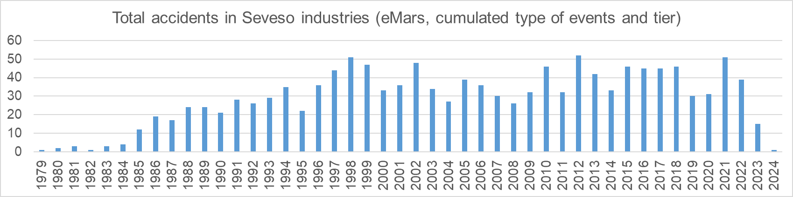

Figure 1: Total accidents in Seveso industries in Europe, type of accidents and Seveso tier are cumulated (elaborated from eMars database).

The Seveso III Directive indicates information that should be provided within the report for the Commission. The respective part of the standard is here quoted: “the Member State, the name and address of the authority responsible for the report; the date, time and place of the accident, including the full name of the operator and the address of the establishment involved; a brief description of the circumstances of the accident, including the dangerous substances involved, and the immediate effects on human health and the environment; a brief description of the emergency measures taken and of the immediate precautions necessary to prevent recurrence; the results of their analysis and recommendations.” As it is easy to understand, the requirements are not complete for a detailed reconstruction: a reference to the Root Cause is missing. The Root Cause Analysis (RCA) (Mbogu and Nicholson, 2024) is a well-known tool, based on structured investigations that are used to identify underlying causes of an accident (within this framework). RCA is a powerful tool for process safety, but it requires proper data.

The scope of this paper consists of highlighting the necessity of a more standardized and organized procedure in reporting and reviewing industrial accidents, and investigates the two following questions: how do we organize the information from an accident report? What can we do with such data? The study analyses 19 industrial accidents, involving hazardous substances such as Ethylene Oxide (EO) and acrylates, chosen randomly from available literature and database. For the first question, the authors propose to carry out a Root Cause analysis coupled with the identification of the failure of Process Safety Management (PSM), according to the guidelines about the constitutive elements defined by the CCPS (Centre for Chemical Process Safety) and from the OSHA (Occupational Safety and Health Administration), using a 20 elements model. For the second question, each accident was studied, and both PSM elements that failed or were functional were evaluated and joined together for a simple statistical analysis. Emphasis was placed on the presence or not of a Root Cause, on the availability of elements that worked, and on missing information.

* 1. Materials and methods

In order to propose a single method to establish the safety elements failed, both OSHA and CCPS distinct process safety guidelines have been compared and integrated in order to make the study of process safety as comprehensive as possible.

* + 1. OSHA and CCPS guidelines

There are two main guidelines referred to when implementing a Process Safety Management system: the OSHA guideline and the CCPS guideline. Both are based on key principles that include various elements with the aim of ensuring careful monitoring of process safety. Both identify four main areas:

* Commitment to process safety;
* Understanding hazards and risks;
* Risk management;
* Learning from experience.

The two distinct process safety guidelines have been compared and integrated to ensure a comprehensive approach to the study of process safety.

Although the CCPS includes 20 elements and OSHA 14, it was considered appropriate to harmonize the research between these elements in order to emphasize the phases of a risk-based approach to PSM.

Table 1 highlights a comparison that underscores the CCPS approach, which is structured into 21 elements, including six additional ones compared to the OSHA approach. The OSHA approach defines six elements that do not find a straight correlation. On the contrary, the OSHA approach includes an element that is not present in the CCPS approach: trade secrets. To facilitate the analysis of the various incidents, a comparison between the two models has been proposed, based on the structure outlined in Table 1. In the current study, the first 20 elements have been considered, providing a detailed set of conditions.

Table 1: Overview of the OSHA and CCPS Approaches

|  |  |  |  |  |  |
| --- | --- | --- | --- | --- | --- |
| # | CCPS | OSHA | # | CCPS | OSHA |
| 1 | Process Safety Culture | Cannot be applied | 11 | Contractor Management | Contractors |
| 2 | Compliance with Standards | Process Safety Information | 12 | Training and Performance Assurance | Training |
| 3 | Process Safety Competency | Cannot be applied | 13 | Management of Change | Management of Change (MOC) |
| 4 | Workforce Involvement | Employee participation | 14 | Operational Readiness | Pre-Startup Safety Preview |
| 5 | Stakeholder Outreach | Cannot be applied | 15 | Conduct of Operations | Cannot be applied |
| 6 | Process Knowledge Management | Process Safety Information | 16 | Emergency Management | Emergency Planning and Response |
| 7 | Hazard Identification & Risk Anaysis | Process hazard analysis | 17 | Incident Investigation | Incident Investigation |
| 8 | Operating Procedures | Operating procedures | 18 | Measurement and Metrics | Cannot be applied |
| 9 | Safe Work Practices | Operating procedures Hot work permit | 19 | Auditing | Compliance Audits |
| 10 | Asset Integrity and Reliability | Mechanical Integrity | 20 | Management Review and Continuous Improvement | Cannot be applied |
|  |  |  | 21 | Cannot be applied | Trade secrets |

* + 1. Accidents database

1. Table 2 provides a short summary of the 19 accidents studied.

Table 2: Summary of analysed accidents

|  |  |  |  |  |  |  |  |
| --- | --- | --- | --- | --- | --- | --- | --- |
| # | Main chemical | Location-type of accident | Year | # | Main chemical | Location-type of accident | Year |
| 1 | Buthyl acrylate | Synthron, LLC, Morganton (North Carolina, US) | 2007 | 11 | EO | Distillation unit explosion (EU) | 1989 |
| 2 | Acrylic acid | Himeji, Nippon Shokubai (JPN) | 2012 | 12 | EO | Purification unit explosion (EU) | 1987 |
| 3 | Acrylic acid | Wacker-Chemie (DE) | 1994 | 13 | EO | Decomposition in blocked pump (US) | 1962-2007 |
| 4 | Acrylic acid | Kakogawa, Hyogo (JPN) | 1998 | 14 | EO | Decomposition in blocked pump (US) | 1962-2007 |
| 5 | EO, ammonia | EO production and  derivatives plant | 1962 | 15 | EO | Decomposition in reflux pump (EU) | 1962-2007 |
| 6 | EO, water | Railcar explosion | 1962-2007 | 16 | EO | Flange leak (EU) | 1962-2007 |
| 7 | EO, clay | Railcar contamination and explosion (EU) | 1962-2007 | 17 | EO | Sterigenics, Ontario (US) | 2004 |
| 8 | EO, water | Railcar contamination and explosion (US) | 1973 | 18 | EO | IQOXE Plant, Tarragona (ES) | 2020 |
| 9 | EO | Contamination (EU) | 1962-2007 | 19 | Methyl acrylate | Fu-Kao Chemical Plant | 2001 |
| 10 | EO | Ethoxylation plant explosion | 1962-2007 |  |  |  |  |

19 accidents involving Ethylene Oxide and acrylates have been randomly chosen from available databases, with 5 accidents involving acrylates, and 14 accidents involving ethylene oxide.

* Ethyleneoxide - third edition (2007) (American Chemistry Council, 2007)
* Chemical Safety Board (CSB, 2007, 2004)
* Icheme publications (Tzou et al., 2003)
* Investigation reports (DNV GL, 2020; Failure Knowledge Database, 1998; IchemE, 2020; Nippon Shokubai Co., 2013)

Accidents studied occurred in Europe (Germany, Spain), Asia (Japan, Taiwan), and America (US), covering a wide region, covering a period between 1962 and 2020.

For what concerns the accidents that occurred, storage, transportation, distillation, pumping, and chemical synthesis are involved, resulting in fires, dispersions, explosions and domino effects.

* + 1. Database generation

A table was generated, associating to each of the 20 PSM elements a score: 0,1 or N/A. 0 stands for total or partial failure of an element,1 indicates that the element worked, and N/A indicates that no sufficient information was available inside the report to deduct a precise answer. The presence of a Root Cause was considered positive if, with the information provided in the report, a clear cause-consequence relationship could be identified between the underlying events and the resulting accident. Results have been generated from those data.

* 1. Results and discussion

In the following, overall and specific considerations for the accidents studied are reported. For what concerns Ethylene Oxides accidents, most of them are associated with chemical production, purification, and storages. In storage, often issues of contamination are involved, like using water or ammonia to wash. In chemical production and purification, often Ethylene Oxide leakages lead to explosion and decomposition reactions. For what concerns acrylates accidents, storage of acrylic acid, and chemical production of polymers based on acrylates are involved. In this case, improper storage policies and uncontrolled recipe changes are involved, leading to fires and explosions.

* + 1. Overall considerations

Out of the 19 accidents analyzed, only 37% (7 accidents) could be fully analyzed, resulting in the identification of the Root Cause. Those events are the accidents #1,2,3,4,14,15,16. For event #1, the Root Cause was a modification of an industrial recipe with a batch size increase without specific studies. For Event #2, the Root Cause is a combination of inadequate management of tank modification and lack of process safety information. For Event #3, the accident was caused by the inadequate knowledge of the chemistry/thermodynamics of the reaction and inability to maintain effective and continuous management of the system temperature, particularly in emergency situations such as power failure. When a Root Cause cannot be identified, the analysis usually results in a list of non-conformities or inadequate safety protection or process safety cultures, without the identification of a specific event that led to the disaster. As an example, even for the well-known Seveso (1976) and Bhopal (1984) accidents, there is not yet consensus on the effective cause that led to such accidents. Additionally, for 52.3% of accidents analysed (10 in total), it was possible to deduct most of the failures of the PSM, highlighting the process safety criticalities. Those accidents have been further analysed, providing in the following a detailed analysis of the failed elements.

* + 1. Elements failed

For the 10 accidents analysed in detail, a distribution of failed elements was reported in Figure 2. According to the data, process safety culture, process knowledge management, hazard identification and risk analysis are the most crucial elements, showing to fail in 9.1% of the total failures, with a total of 27.3%. Process safety competency and incident investigation follow, with 8.9% each. The 3rd most significant causes are Compliance with Standards and Asset Integrity and Reliability, with 6.7% each. Those elements cover 58.5% of the sample. Emergency management contributes to only 4.4% of total failures, this can be associated with a good overall knowledge of the hazard represented by toxic substances such as Ethylene Oxide and acrylates.

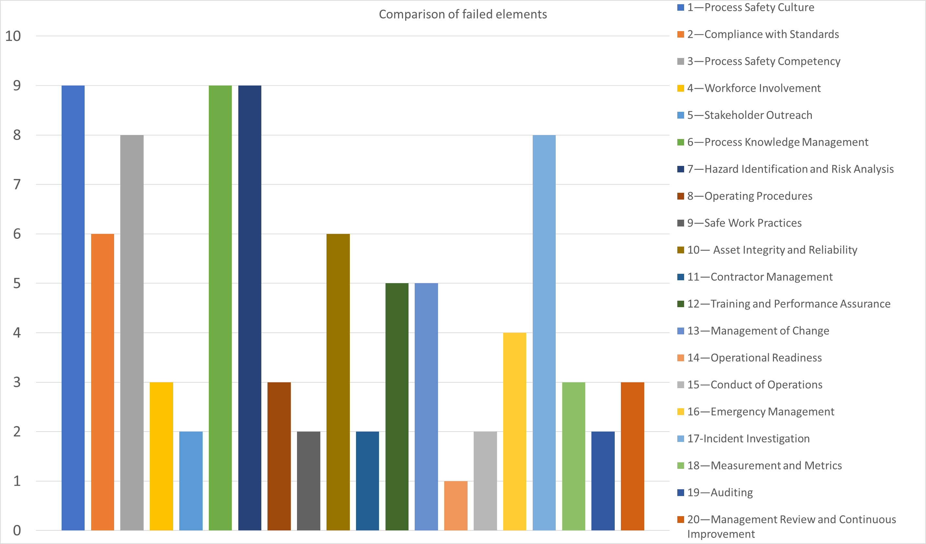

Figure 2: PSM failed elements in accidents where the information was available or deductible

It is possible to compare this result with the historical work of Barton and Nolan (Barton and Nolan, 1987), where 189 accidents involving runaway reactions have been analysed. According to this pioneer work, the main flaws emerging from the data at the time were the following: lack of understanding of process chemistry and thermochemistry, inadequate design for heat transfer; inadequate control systems and safety backup systems, and inadequate operational procedures, including training. Comparing such old data with this novel set, Process Safety Culture, Emergency Management and Operating procedures are still today among the most crucial aspects of process safety.

* + 1. Functional elements

Fig. 3 reports instead the list of elements that resulted as functional at the time of the accident.

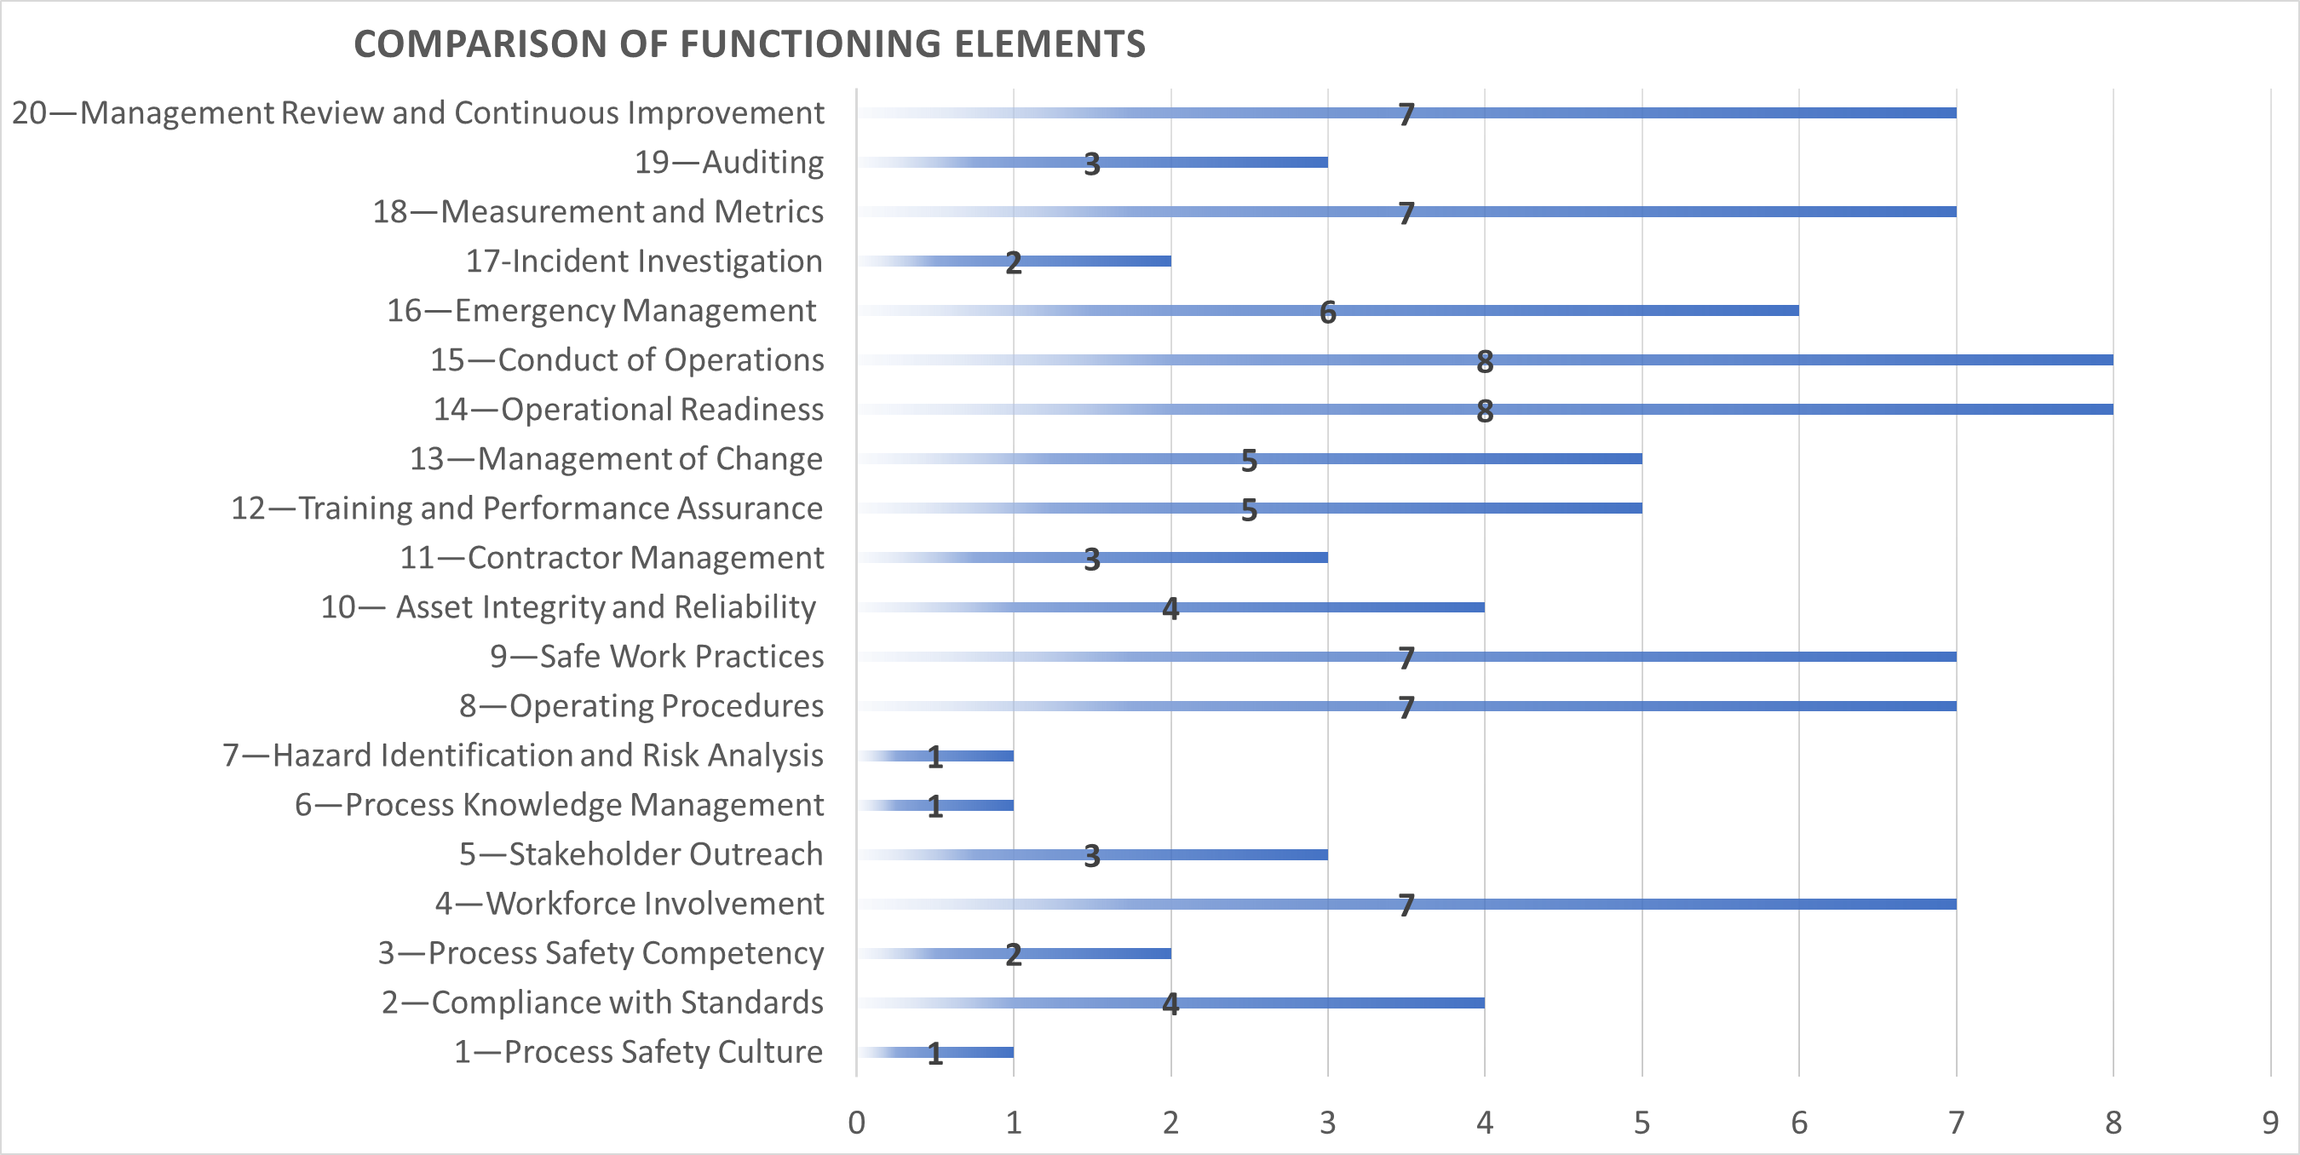

Figure 3: PSM functioning elements in accidents where the information was available or deductible

In this case, operational readiness and conduct of operations are the best-performing indicators, covering 7.8% of each of the positively working elements. After that, management review and continuous improvement, safe work practices, measurement and metrics, and workforce involvement are the second-best indicators, with 9% each, covering a total of 56% of functional elements. For some specific elements, namely Auditing, Contractor Management, Stakeholder Reach, the relevance is low because these elements are rarely discussed in detail, and they have been classified as N/A in most of the accidents analyzed.

* 1. Conclusions

The analysis revealed that the information on chemical accidents available in the various datasets is incomplete, hindering a comprehensive assessment of the failure of PSM elements. A Root Cause is rarely identified, and it is not generally clearly stated straight as such, it is necessary to thoroughly check the report. Also, references to PSM elements that work are rarely highlighted. This aspect should be more emphasized in accident reporting: when an element is not investigated, even if marginal compared to the extent of the accident, it does not necessarily mean that it worked effectively.

Despite the limitations of requiring a fully detailed PSM assessment for industrial accidents (such as the secrecy of industrial processes and worker privacy) it is crucial to develop a strategy for providing meaningful information to commissions and organizations responsible for database development. This strategy should aim to standardize reporting procedures and provide useful data for improving process safety.

References

Abedsoltan, H., Abedsoltan, A., Zoghi, Z., 2024. Future of process safety: Insights, approaches, and potential developments. Process Safety and Environmental Protection 185, 684–707. https://doi.org/10.1016/j.psep.2024.03.034

American Chemistry Council, 2007. Ethyleneoxide, Third Edition.

Barozzi, M., Copelli, S., Scotton, M.S., Torretta, V., 2020. Application of an Enhanced Version of Recursive Operability Analysis for Combustible Dusts Risk Assessment. International Journal of Environmental Research and Public Health 17. https://doi.org/10.3390/ijerph17093078

Barton, J.A., Nolan, F., 1987. Incidents in the chemical industry due to thermal-runaway chemical reactions. IChemE SYMPOSIUM SERIES 115.

Casson Moreno, V., Danzi, E., Marmo, L., Salzano, E., Cozzani, V., 2019. Major accident hazard in biodiesel production processes. Safety Science 113, 490–503. https://doi.org/10.1016/j.ssci.2018.12.014

CCPS | Center for Chemical Process Safety [WWW Document], 2012. URL https://www.aiche.org/ccps (accessed 11.19.24).

Chiang, Y.W., 2024. Process intensification technologies to enhance agricultural sustainability and safety. Chemical Engineering and Processing - Process Intensification 205, 110029. https://doi.org/10.1016/j.cep.2024.110029

CSB, 2007. Runaway Chemical Reaction and Vapor Cloud Explosion [WWW Document]. URL https://www.csb.gov/synthron-chemical-explosion/

CSB, 2004. Sterigenics - Investigation Report [WWW Document]. URL https://www.csb.gov/sterigenics-ethylene-oxide-explosion/

DNV GL, 2020. CHEMICAL EXPLOSION AT IQOXE IN TARRAGONA Incident Investigation Report, Rep. 2020-9184, Rev. 1.

Failure Knowledge Database, 1998. Explosion of acrylic acid in the drum can in the heating cabinet for dissolution [WWW Document]. URL https://www.shippai.org/fkd/en/sfen/SC1200102.html (accessed 1.29.25).

Home | Occupational Safety and Health Administration [WWW Document], n.d. URL https://www.osha.gov/ (accessed 11.19.24).

IchemE, 2020. Loss Prevention Bullettin, Issue 272.

Kletz, T.A., 1996. Inherently safer design: The growth of an idea. Process Safety Progress 15, 5–8. https://doi.org/10.1002/prs.680150105

Li, G., Yang, H.-X., Yuan, C.-M., Eckhoff, R.K., 2016. A catastrophic aluminium-alloy dust explosion in China. Journal of Loss Prevention in the Process Industries 39, 121–130. https://doi.org/10.1016/j.jlp.2015.11.013

Mbogu, H.M., Nicholson, C.D., 2024. Data-driven root cause analysis via causal discovery using time-to-event data. Computers & Industrial Engineering 190, 109974. https://doi.org/10.1016/j.cie.2024.109974

Nippon Shokubai Co., 2013. Explosion and Fire at Acrylic Acid Production Facility - Investigation report.

Tzou, T.-L., Edwards, D.W., Chung, P.W.H., 2003. An Explosion Accident - Causes and Safey Information Management Lessons to be Learned. IChemE SYMPOSIUM SERIES 149, 591–604.