CHEMICAL ENGINEERING TRANSACTIONS  VOL. 73, 2019 | A publication of
The Italian Association
of Chemical Engineering
Online at www.aidic.it/cet
Guest Editors: Andrea D’Anna, Paolo Ciambelli, Carmelo Sunseri
Copyright © 2019, AIDIC Servizi S.r.l.
ISBN 978-88-95608-70-9; ISSN 2283-9216

A pH Study for the Degradation of Acetaminophen with Iron Oxide Nanostructures
Bianca Lucas-Granados, Rita Sánchez-Tovar, Ramón M. Fernández-Domene, José García-Antón*
Ingeniería Electroquímica y Corrosión (IEC). Instituto Universitario de Seguridad Industrial, Radiofísica y Medioambiental (ISIRYM). Universitat Politècnica de València. Valencia. Spain.
jgarciaa@iqn.upv.es
Nowadays, there is an increasing interest in the degradation of organic compounds in wastewater, since they are detrimental for the water quality. Different metal oxides have been studied as photocatalysts in the photoelectrocatalytic degradation of pharmaceutical products using UV light. Iron oxide nanostructures are a promising option in this field since their band gap (~ 2.1 eV, corresponding to ~590 nm) can absorb visible light, which in turn allows the degradation by using sunlight.
Iron oxide nanostructures are known to be stable in alkaline solutions, but some organic compounds can vary their structure with pH. Then, a pH study is needed in order to stablish the optimum value to guarantee both the nanostructures and the organic molecule stability. In this work, acetaminophen (more known as paracetamol) is studied in different pH media (from pH 9 to pH 13) in order to evaluate the viability of iron oxide nanostructures as photocatalysts in the acetaminophen degradation process.
Results showed that pH is a determinant parameter in the degradation process since the paracetamol UV-Vis spectrum varied with it. However, a pH compromise value is stablished in order to ensure the viability of the usage of iron oxide nanostructures in the acetaminophen degradation process.
  - Introduction
Acetaminophen (N-(4-hydroxy-phenyl)ethanamide) is an analgesic-antipyretic drug commonly known as paracetamol (see the molecule in Figure 1). This drug is one of the most globally used, so paracetamol is discharged into the water bodies arriving to the groundwater, drinking water and surface water, and then its degradation is required (Bianchi et al., 2018; Ferreira et al., 2015). Photocatalysis is one of the technologies used for the degradation of different organic compounds such as dyes (Mais et al., 2017), herbicides (Nascimento da Silva et al., 2017) or drugs (Lei et al., 2016).

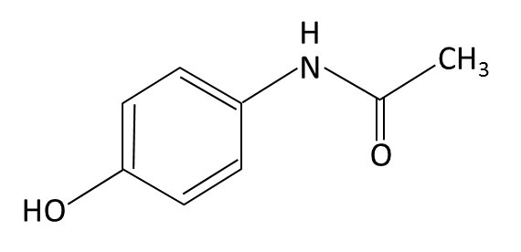
Figure 1: Paracetamol (Acetaminophen) molecule.
Among the different photocatalysts, iron oxide, in particular hematite (α-Fe₂O₃), is an attractive material because of its band gap (2.1 eV) that can absorb in the visible region, abundance and low cost. Using nanotubular iron oxide nanostructures for photodegradation of organic pollutants is a good option since the nanotubular morphology can guide the carriers to the metallic substrate overcoming its poor mobility, and the thin walls of the nanotubes can overcome the short holes diffusion lengths (Lee et al., 2014). Then, the photogenerated holes can reach the electrode/electrolyte surface and oxidize the organic compounds. Therefore, photodegradation of paracetamol by using iron oxide nanostructures and visible light (420 nm) is a promising option.
In this way, iron oxide nanostructures are commonly used in alkaline solutions for photoelectrochemical applications. In particular, for water splitting experiments they are used in a solution of KOH or NaOH with pH 14 since their chemical stability is ensured (Rangaraju et al., 2009; Mushove et al., 2015). However, acetaminophen is an organic compound that changes its UV-Vis spectrum in alkaline media. According to this, the purpose of this work is to evaluate the possibility of using iron oxide nanostructures for degradation of organic compounds such as paracetamol. There is no so much work in this field with iron oxide nanostructures and acetaminophen, so the relevance of this paper is to stablish the conditions in order to carry out this investigation and achieve good results in the degradation process in the future. Then, a pH study is needed to stablish a compromise value to ensure the stability of both paracetamol and nanostructure during the photoelectrodegradation tests.
  - Experimental procedure
    - Synthesis of iron oxide nanostructures
Iron oxide nanostructures were synthesized by electrochemical anodization of iron (99.9 % purity) at 50 V for 10 minutes in an ethylene glycol based solution containing 0.1 M NH₄F and 3 %vol. H₂O. Anodization was performed under hydrodynamic conditions by rotating the electrode at 1000 rpm during the process (Lucas-Granados et al., 2017). Once anodized, samples were annealed in a tubular furnace at a heating rate of
15 ⁰C · min⁻¹ with argon atmosphere for 1 hour at 500 ⁰C. Samples were cooled within the furnace by natural convection.
The morphology of the nanostructures was examined by means of Field Emission Scanning Electron Microscopy (FE-SEM) at an Extra High Tension (EHT) of 3 kV. Furthermore, the crystalline structure of the samples was measured with Raman Laser Confocal Spectroscopy, with a 632 nm neon laser with ~750 µW.
    - Preparation of paracetamol solutions
Different paracetamol solutions were prepared at different pH values, i.e. 9, 10, 11, 12 and 13, in order to study the influence of the pH on the stability of paracetamol and nanostructures. The pH was modified by adding different amounts of NaOH 0.01/0.1 M. Also, a paracetamol solution in 1 M NaOH was prepared to study the stability of paracetamol at this condition.
    - Measurements of absorbance
In order to measure the absorbance of each solution, 4 mL of liquid were transfer to a quartz cuvette. Measurements of absorbance of the different solutions were carried out in a UV-Vis Spectrometer in the range from 190 to 500 nm. Solutions at the same pH but water based (i.e. without paracetamol) were used as a blank in each measurement.
    - Degradation tests
Degradation of the paracetamol with the nanostructure was performed in a quartz glass reactor with a configuration of three electrodes being the iron oxide nanostructure the working electrode, a platinum tip the counter electrode and a Ag/AgCl (3 M KCl) electrode the reference. Prior to the degradation experiments, samples were immersed in the solution under stirring with a magnet-stirrer for 30 minutes to reach an equilibrium. Degradation tests were performed in a 40 ppm paracetamol solution at pH 11 and 12, at 0.5 V (vs. Ag/AgCl) under 420 nm light by using a 1000 W Xe light lamp (100 mW · cm⁻²). During the degradation tests, 4 mL of solution were taken every 30 minutes and measured with the UV-Vis spectrophotometer. Then, the liquid was returned to the reactor in order to continue the process with the same volume conditions.
  - Results and discussion
Figure 2 a) shows the register of the current density versus time during the synthesis of the nanostructures. On the one hand, the curve shows the shape of a nanotubular formation (Jubb et al., 2010; de Faria et al., 2007). On the other hand, Figure 2 b) and c) indicate that, actually, the morphology of the samples was nanotubular with a homogeneous surface, which enhances the charge separation processes. Then, the photogenerated holes that are strong oxidizing agents can oxidize the organic compounds in the solution and/or react with the water to form hydroxyl radicals that also can oxidize the organic compounds (Müller & Schmuki, 2014).

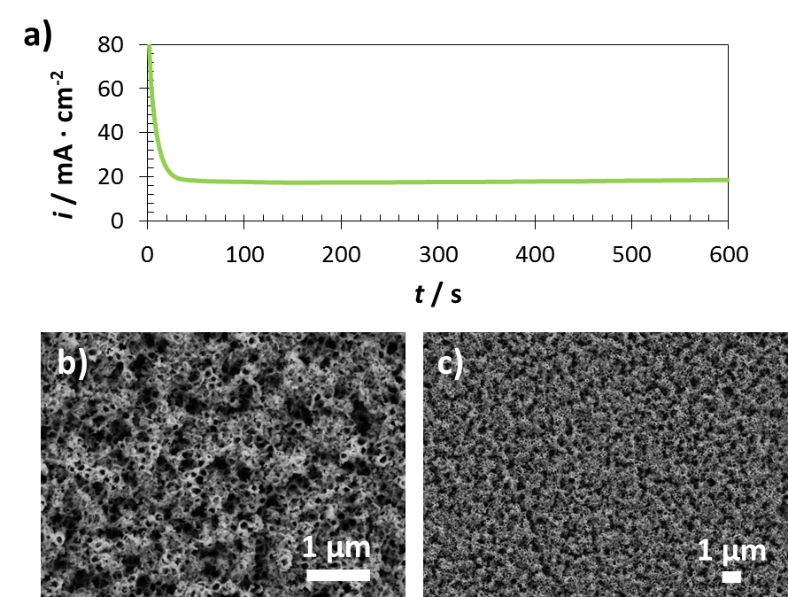

Figure 2: Register of current density versus time during anodization of iron (a), and FE-SEM images at 5,000X (a) and 15,000X(b) magnifications of the iron oxide nanostructures used for the degradation of paracetamol.
In order to determine the crystalline structure of the obtained samples, Figure 3 shows the Raman spectrum of the nanostructures. It is clearly seen that most of the peaks correspond to the hematite, but some peaks associated to the magnetite also appeared (Xie et al., 2014; Mohapatra et al., 2009).

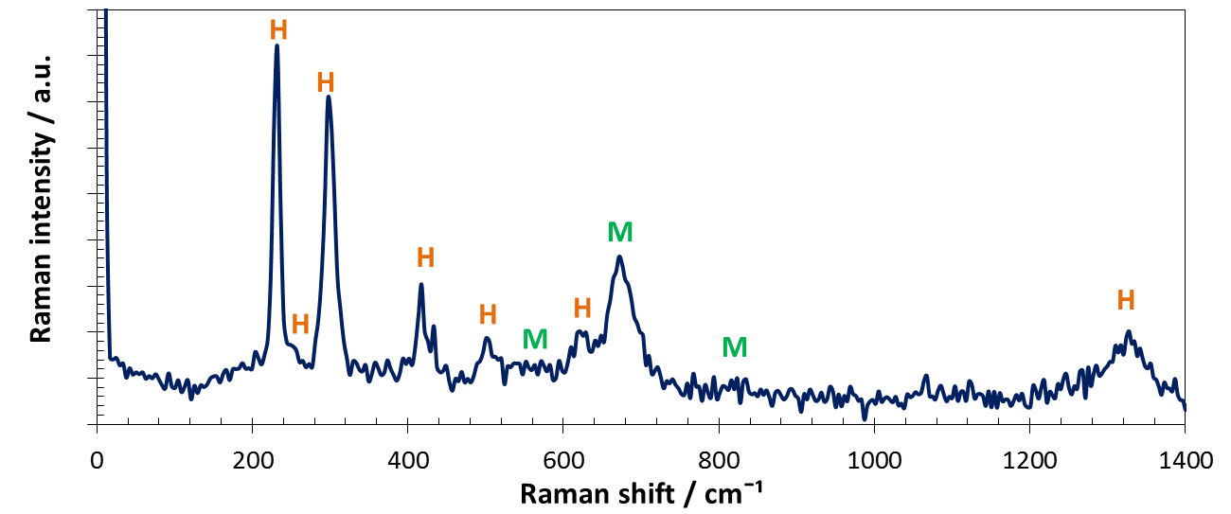
Figure 3: Raman spectra of the iron oxide nanostructures used for the degradation of paracetamol.
Then, the nanostructures were composed by mainly hematite, but some amount of magnetite appeared also in its structure. This presence of magnetite enhances the conductivity of the sample, so it is beneficial for the photodegradation process.
Iron oxide nanostructures are stable in alkaline solutions. Because of that, a 1 M NaOH solution of paracetamol was prepared in order to test its stability in this media by measuring its UV-Vis spectrum at different times from preparation. Figure 4 shows that the UV-Vis spectrum completely changed after 1 week, and continued changing after two months. So paracetamol is not stable in 1 M NaOH with pH 14.

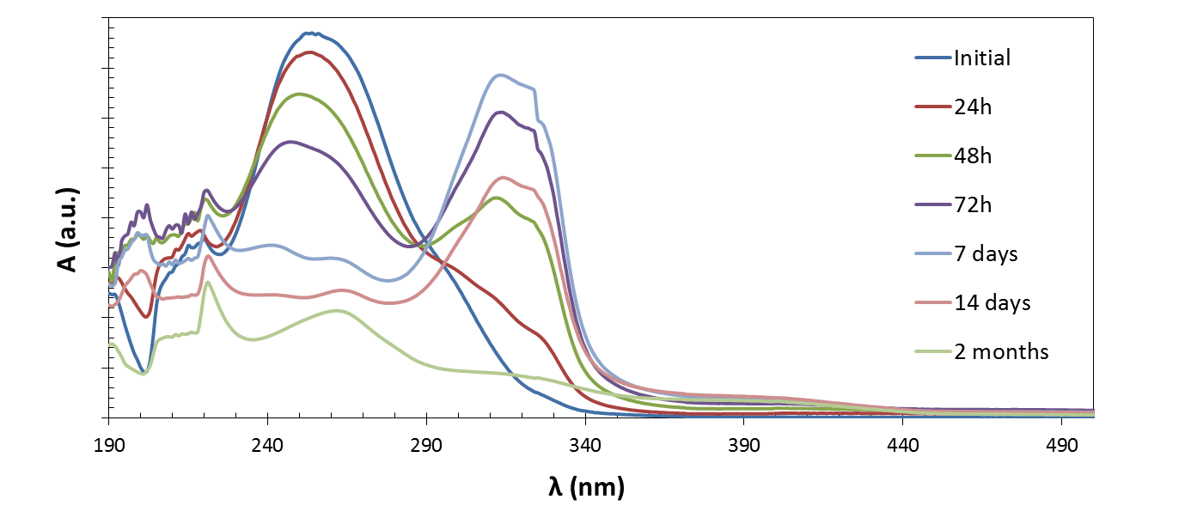
Figure 4: Evolution of UV-Vis spectra of 1 M NaOH solution with paracetamol with time.
According to the pKa of paracetamol (9.7), the maximum pH at which paracetamol is not ionized is around this value. Then, a compromise between stability of paracetamol and iron oxide nanostructures in terms of pH is needed. In this way, a study of the stability of paracetamol at different pH was performed. Figure 5 shows the spectrum of different paracetamol solutions with pH values from 9 to 13. As Figure 5 shows, the solutions with pH 9 and 10 did not change its characteristic peak (λ = 243 nm). However, a pH value of 11 started to change its characteristic peak until 252, and higher pH values (i.e. 12 and 13) changed the peak until 256.
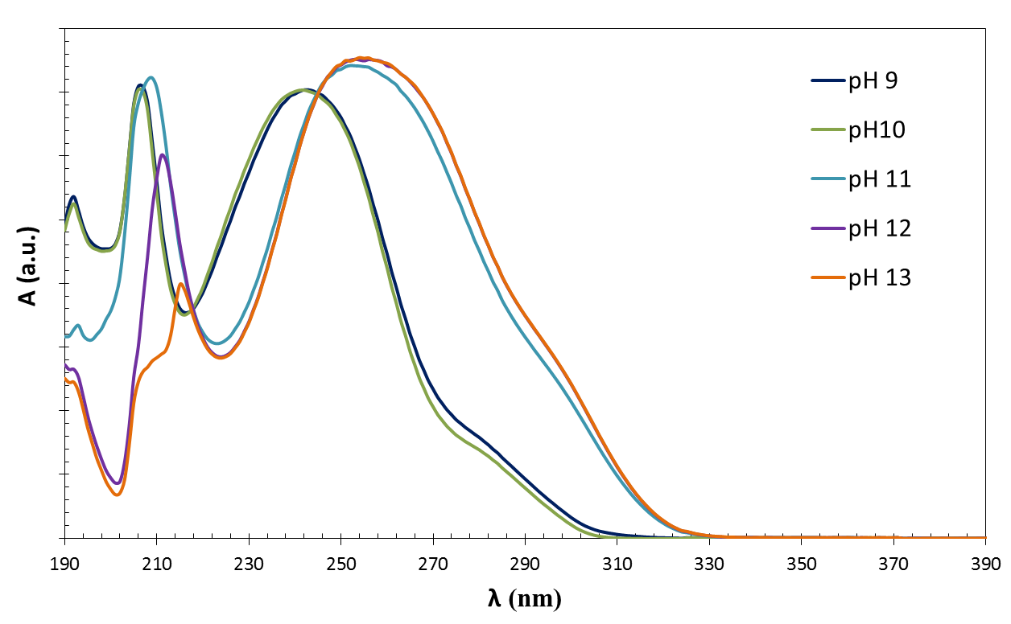
Figure 5: Evolution of UV-Vis spectra of paracetamol solution at different pH.
Once the main peak of the spectrum was stablished at the different pH values, it was possible to carry out a degradation test by monitoring the UV-Vis spectrum in a paracetamol solution. Since the iron oxide nanostructure was stable at alkaline solutions, the first degradation test was performed in a solution of paracetamol with pH 11. The UV-Vis spectrum was measured each 30 minutes. Nevertheless, as Figure 6 indicates, after 2 hours of experiment, the main peak of the spectrum started to increase and move to lower wavelengths, and the solution was also starting to get yellowish. This was because the nanostructure started to dissolve in the solution due to the pH value.
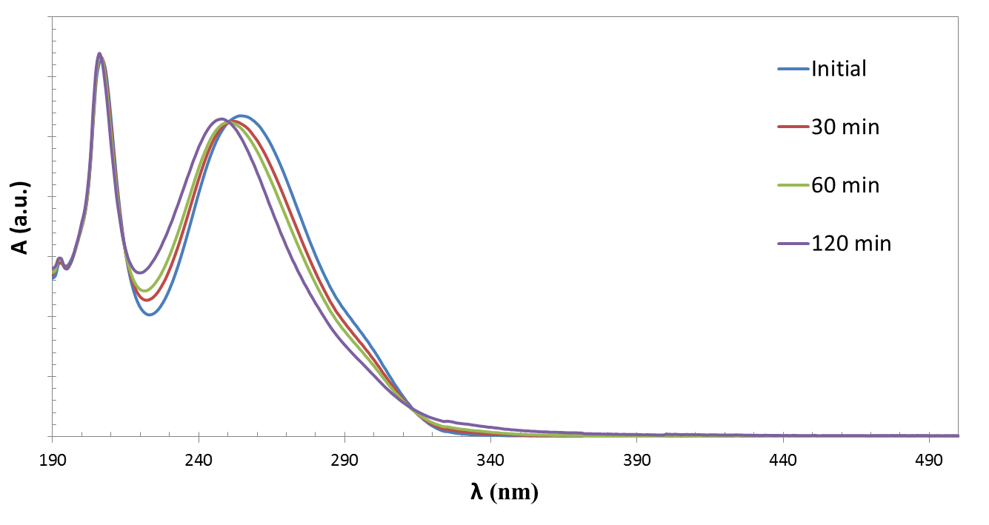
Figure 6: Evolution of UV-Vis spectra of paracetamol solution with time while degradation with iron oxide nanostructure at pH 11.
Therefore, a new degradation test at pH 12 was performed, and Figure 7 shows the evolution of the UV-Vis spectrum of paracetamol. It is clear that at this pH value the spectrum did not change its λ during the degradation test, which indicated that the iron oxide nanostructure was stable at this pH. However, the characteristic peak at 256 nm decreased with time, which indicated that degradation of paracetamol was taken place.
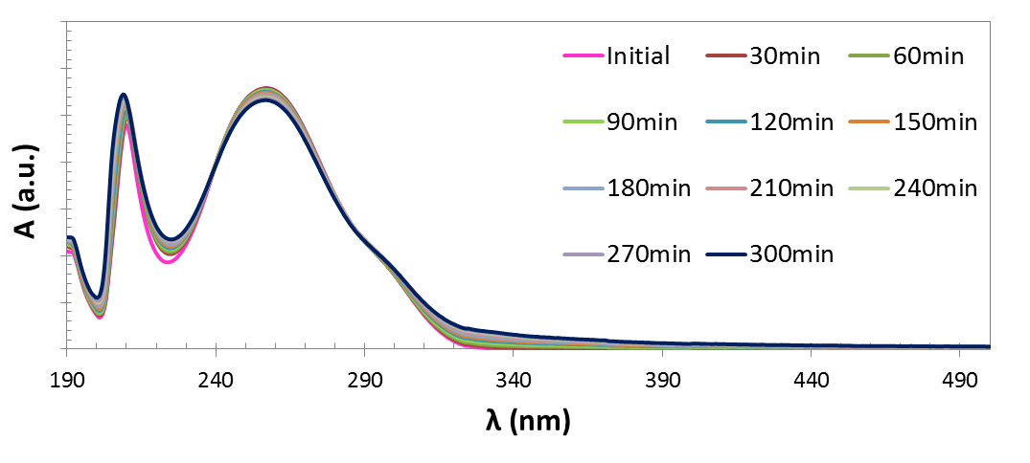
Figure 7: Evolution of UV-Vis spectra of paracetamol solution with time while degradation with iron oxide nanostructure at pH 12.
Nevertheless, the degradation rate was very low, achieving only 4.65 % degradation of paracetamol after 5 hours. In this way, once stablished the pH value at which both paracetamol and iron oxide nanostructure are stable, future work will be focused on adjusting different parameters of the process in order to achieve higher efficiencies.
  - Conclusions
This work studied the influence of the pH value in the degradation of paracetamol using iron oxide nanostructures. Results indicated that a compromise pH of 12 maintain the stability of both paracetamol molecule and iron oxide nanostructure. In this way, degradation experiments achieved 4.65 % of efficiency, so future work is focused on adjusting the process parameters in order to obtain higher efficiencies.
Acknowledgments
The authors would like to express their gratitude for the financial support granted to Bianca Lucas Granados by the Ministerio de Economía y Competitividad (Reference: BES-2014-068713 and Project CTQ2016-79203-R), for its help in the Laser Raman Microscope acquisition (UPOV08-3E-012) and for the co-finance by the European Social Fund, and to the UPV for the concession of a post-doctoral grant (PAID-10-17) to Ramón M. Fernández Domene.
References
Bianchi C.L., Sacchi B., Capelli S., Pirola C., Cerrato G., Morandi S., Capucci V., 2018, Micro-sized TiO₂ as photoactive catalyst coated on industrial porcelain grès tiles to photodegrade drugs in water, Environmetal Science and Pollution Research, 25, 20348–20353.
De Faria D., Lopes F., 2007, Heated goethite and natural hematite: Can Raman spectroscopy be used to differentiate them?, Vibrational Spectroscopy, 45, 117-121.
Ferreira R.C., Couto Junior O.M., Carvalho K.Q., Arroyo P.A., Barros M.A.S.D., 2015, Effect of Solution pH on the Removal of Paracetamol by Activated Carbon of Dende Coconut Mesocarp, Chemical and Biochemical Engineering Quarterly, 29, 47–53.
Jubb A.M., Allen H.C., 2010, Vibrational spectroscopic characterization of hematite, maghemite, and magnetite thin films produced by vapor deposition, ACS Applied Materials and Interfaces, 2, 2804-2812.
Lee C-Y., Wang L., Kado Y., Killian M.S., Schmuki P., 2014, Anodic nanotubular/porous hematite photoanode for solar water splitting: substantial effect of iron substrate purity, ChemSusChem, 7, 934-940.
Lei Z., Wang J., Wang L., Yang X., Xu G., Tang L., 2016, Efficient photocatalytic degradation of ibuprofen in aqueous solution using novel visible-light responsive graphene quantum dot/AgVO₃ nanoribbons, Journal of Hazardous Materials, 312, 298-306.
Lucas-Granados B., Sánchez-Tovar R., Fernández-Domene R.M., García-Antón J., 2017, Controlled hydrodynamic conditions on the formation of iron oxide nanostructures synthesized by electrochemical anodization: Effect of the electrode rotation speed, Applied Surface Science, 392, 503–513.
Mais L., Vacca A., Mascia M., Corgiolu S., Palmas S., 2017, Highly Ordered TiO₂ -WO₃ Modified Nanotubes Array for Photoelectrocatalytic Oxidation of Methyl Orange, Chemical Engineering Transactions, 60, 217–222.
Mohapatra S.K., John S.E., Banerjee S., Misra M., 2009 Water Photooxidation by Smooth and Ultrathin α-Fe₂O₃ Nanotube Arrays, Chemistry of Materials, 21, 3048-3055.
Müller V., Schmuki P., 2014, Efficient photocatalysis on hierarchically structured TiO₂ nanotubes with mesoporous TiO₂ filling, Electrochemistry communications, 42, 21–25.
Mushove T., Breault T.M., Thompson L.T., 2015, Synthesis and characterization of hematite nanotube arrays for photocatalysis, Industrial and Engineering Chemistry Research, 54, 4285–4292.
Nascimento da Silva G., Maschio Souza G., de Almedia Neto A.F., de Matos Jorge L.M., Andreo dos Santos O.A., 2017, Influence of ZnO Content in Mixed Oxides Catalysts Applied in the Photocatalytic Degradation of Atrazine, Chemical Engineering Transactions, 57, 637–642.
Rangaraju R.R., Panday A., Raja K.S., Misra M., 2009, Nanostructured anodic iron oxide film as photoanode for water oxidation, Journal of Physics D: Applied Physics, 42, 135303–135312.
Xie K., Guo M., Huang H., Liu Y., 2014, Fabrication of iron oxide nanotube arrays by electrochemical anodization, Corrosion Science, 88, 66-75.

