|  |  |
| --- | --- |
| cetlogo ***CHEMICAL ENGINEERING TRANSACTIONS***  ***VOL. 73, 2019*** | A publication of  aidiclogo_grande |
| The Italian Association  of Chemical Engineering  Online at www.aidic.it/cet |
| Guest Editors: Andrea D’Anna, Paolo Ciambelli, Carmelo Sunseri  Copyright © 2019, AIDIC Servizi S.r.l. **ISBN** 978-88-95608-70-9; **ISSN** 2283-9216 | |

Sorptive Deformation of Porous Sorbents

Andrei V. Tvardovskiy a,\*, Anatolii A. Fomkinb

aTver State Technical University,22 Af. Nikitin Embankment, City of Tver 170026 Russia

bRussian Academy of Sciences A.N. Frumkin Institute of Physical Сhemistry and Electrochemistry RAS,31 Leninsky Prospect, Moscow 119991 Russia

tvardovskiy@tstu.tver.ru

Deformations of granulated recuperative activated carbon AR-V (produced in granulated form from coal dust (coals mixture) and adhesion agents by steam treatment at the temperature of 1100 — 1200K) upon carbon tetrachloride adsorption has been studied. To solve this problem a dilatometer was used. Its main part was a line differential transformer, the core of which was connected to the adsorbent by means of a rod. Any changes in the adsorbent height caused a change in the core position in the transformer, which influenced the signal recorded from its secondary winding. These results were compared with the adsorption isotherms.

Alsodeformations of cation – substituted vermiculite (*Na* form) upon water vapor sorption have been studied. The sorbent used was plate – formed, anisotropic, and swelled only in the direction perpendicular to the plane of the plates. The results obtained were compared with the sorption, calorimetry (a Calvet – type microcalorimeter with a microbalance attachment was used) and X-ray data. High sensitivity of the dilatometric method to the structural changes of the laminated silicates whose cell structures expand upon hydration has been shown. The dilatometer used allowed the measurement of absolute deformations in the range 1⋅10-7 to 3⋅10-3 m.

* 1. Introduction

As early as (Meehan 1927),it was established that solid bod­ies change their size when adsorbing gases or vapors. Even now, however, it has not yet been generally accepted that the adsorbent is being deformed, i.e., is not inert, in the process of adsorption. Nevertheless from a physical view­point it can be stated that there can be no inert adsorbents at all. In fact, if we consider the simplest adsorption on the flat uniform surface of an adsorbent, even here the surface tension of the adsorbent declines when adsorbate molecules interact with the surface atoms. Thus, the uncompensated force affecting the surface atoms of the adsorbent decreases and this causes deformation of the adsorbent. It is clear that the deformation degree will be different in different cases: it depends on the properties of particular adsorptive systems. Nevertheless, even minor deformations of the ad­sorbents contribute considerably to the total thermodynamic characteristics determined from adsorption and calorimetry experiments (Tvardovskiy 2006). Despite this, direct measurements of adsorptive deformation essentially are not conducted nowadays.

Only measurements of structural characteristics of clay minerals (Tvardovskiy et al. 1997; Tvardovskiy et al. 1999; de la Calle et al. 1988), polymeric materials (Keller et al. 1999; Zhang et al. 1997) carbons (Bangham et al. 1937; Haines et al. 1947; Wiig et al. 1949; Yakovlev et al. 2003; Yakovlev et al. 2004; Fomkin 2005; Zaytsev et al. 2017) and zeolites (Krasilnikova et al. 1988) and some theoretical works (Coudert et al. 2016; Balzer et al. 2015) are performed.

For a long time the progress of research in this direction was hampered by the lack of theoretical concepts and by considerable experimental and methodical difficulties. How­ever, studying the deformation of solids in the process of adsorption and absorption is of great importance, as mentioned, for both the progress of thermodynamics and practi­cal applications.

This work presents the dilatometric investigations of the sorptive deformation of adsorbents. To solve this problem, an inductive-type dilatometer was used.

* 1. Materials and methods

Deformation of the AR-V microporous carbon adsorbent during adsorption of *CCl4* in the temperature interval from 255.5 to 353 К and at pressures of 1-14⋅103 Pa was studied.

The structure-energy characteristics of AR-V adsorbent were determined based on the adsorption isotherm of the standard benzene vapor at 293 K using the computational apparatus of Dubinin’s theory (Dubinin et al.1947) of the volumetric filling of micropores (TVFM) The following characteristics of the adsorbent sample were obtained: micropore volume Wo = 0.26 cm3/g, characteris­tic energy of adsorption E0=15.8 kJ/mol, and characteristic micropore half-width x0 = 0.76 nm.

An inductive-type dilatometer designed for measuring small deformations of solids during adsorption in pressure and temperature ranges of 1-2 ∙ 107 Pa and 77-570 K, re­spectively, was used. The scheme of the dilatometer is shown in Figure 1: the core (7) of the induction converter (8) of linear displacements is connected with the rod (5) supported on the quartz plate (2), which is placed on the sample (3). The latter is placed inside the ampoule (4) between the quartz disks (2). The ampoule is connected to the dilatometer body through the screw (6). A change in the sample length results in the dis­placement of the core, which is detected by a digital voltmeter using a transformer. The dilatometer is connected to adsorption installation through a vacuum valve.

During experiments, the temperature in the dilatometer section containing the sample was held constant with an er­ror of ± 0.2 K. The rest volume of the dilatometer, along with the induction converter and the adsorption installa­tion, was thermostatted in an air thermostat at 303 K.

The induction converter of displacements of the dilatome­ter was calibrated at 303 К using a set of standard plates with thicknesses of 0.01-1.00 mm. The dilatometer was adjusted to changes in temperature and gas pressure on a "model" of fused quartz analogous to the adsorbent sample in shape and sizes. The dilatometer used allowed measurement of absolute deformations in the range from 1⋅10-7 to 3⋅10-3 m. Absolute er­rors of relative linear adsorbent deformation, Δl/l, if plot­ted, did not exceed the linear size of the experimental points presented in Figure 3. Adsorption of *CCl4* was studied using a gravimetric vacuum adsorption installation with the electronic compensation of the weight change in three intervals with limits of 1, 10, and 100 mg. The error of measurement did not exceed 1 %. The gas pressure was determined by M 10 and M l000 pressure bellows gauges with measurement intervals of 1-1 ⋅ 103 and 10-1.5 ⋅ 105 Pa and errors of ± 0.1 and ±1.0 Pa, re­spectively.



Figure 1: Dilatometric part of the unit: 1 - thermostat; 2 – quartz polished disks; 3 – adsorbent; 4 –ampoule with the adsorbent; 5 - rod; 6 - nut; 7 - core; 8 - transformer.

Prior to the measurements, adsorbent AR-V were degassed by heating at corresponding temperatures in vacuum down to a residual pressure of 1,33⋅10-3 Pa in the system. Carbon tetrachloride was thoroughly purified and dried, after *CCl4* was degasses in vacuum, its vapor pressure corresponded to the tabular value.

Also In the present work dilatometric measurements of a sorbent-relative linear deformation () in water vapor at different (vapor relative pressure) have been carried out, using  specimen of Kovdor vermiculite having an exchange capacity of 1.35 mg-eq/g. Basic physicochemical characteristics of the Kovdor vermiculite are heat of wetting, 46.3 cal/g; and specific surface with respect to nitrogen, hexane, and water is 12, 14, and 471 m2/g, respectively. Its crystallochemical formula is



The results obtained are discussed jointly with sorption, calorimetry, and - ray data. Differential heats and isotherms of sorption were obtained using a microcalorimeter of Calvet-type with a microbalance (MacBen – Bacre) attachment. The heat, , and sorption,  values were determined within an error of 2 % or less. As was noted above, the dilatometer used allowed the measurement of absolute deformations () in the range 110 to 3 mm. Thus, absolute errors of , , and  measurements, if plotted, did not exceed the linear size of the experimental points presented in Figure 4.

The calibrated dilatometer was placed in a liquid thermostat at the test temperature (K). The equilibrium pressures were measured by means of M 10 and M 1000 bellows gauges.

As sorbent we used plate-shaped specimen of the cation – substituted form () of vermiculite with a height  from 0.08 to 0.235 mm and area  from 27.50 to 51.48 mm2. These sorbent was anisotropic, and it swelled only in the direction perpendicular to the plane of the plate. The conditions of sorbent preparation for the experiment were analogous to those used in (Polyakov et al. 1982). Before use in the measurements, the sorbent was dehydrated for 8 h at 423 K under a residual pressure of approximately 10-2 Pa. The initial state was an equilibrium, and it was suggested that the relative vapor pressure value,  corresponds to this state.

* 1. Results and discussion

The isotherms of carbon tetrachloride vapor adsorption on dehydrated AR-V samples (Figure 2) are S-shaped and characterized by narrow hysteresis loops in the relative pressure range P/Ps = 0.2–0.3. Initial parts of the isotherms are reversible.

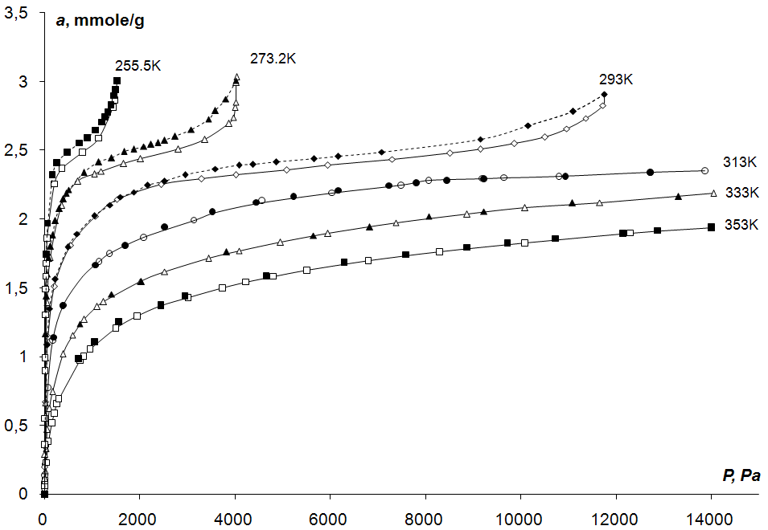

*Figure 2: Isotherms of carbon tetrachloride vapor adsorption on microporous carbon adsorbent AR-V at different temperatures.*

The plots of the relative linear deformation of the AR-V carbon adsorbent as function of vapor pressure CCl4 at temperatures from 255.5 to 353 К are presented in Figure 3. As follows from the data in Figure 3, the contraction of the sample achieves a value of 0.68 % at 353 K. At higher value of adsorption, the contraction is replaced by expansion. With the temperature decrease the effect of relative expansion increases from 0.17 % at 313 К to 0.78 % at 255.5 K.

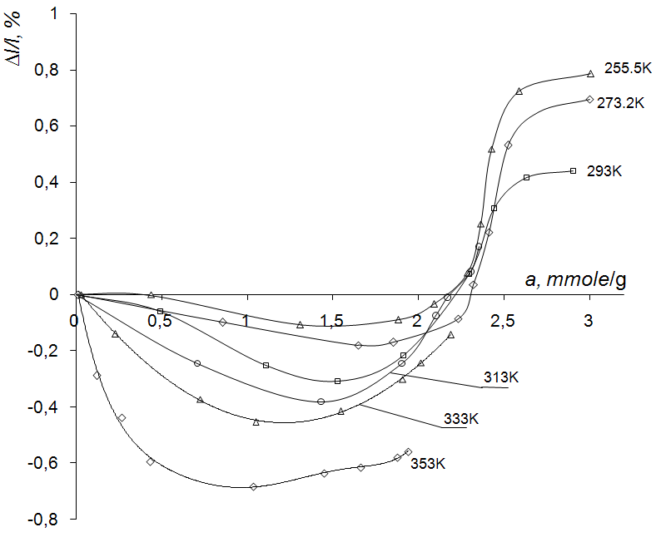

Figure 3: Relative linear deformation of the microporous carbon adsorbent AR-V (∆l/l) vs. CCl4 amount adsorbed at different temperatures.

The data obtained in the dilatometric, sorption, and calorimetric studies of the  vermiculite are presented in Figure 4. The figures show that the correlation of  and  dependencies is quite evident. It can also be noted that two-step curves, , are in good agreement with the idea of formation of two-layer hydrates in the vermiculite types under investigation. The latter follows, for example, from - ray data obtained in [11]: the interlayer space values, , for  vermiculite saturated with water were 5.6 Å.

The initial positive deformation and the subsequent transition to contraction (compression) indicate that adsorption at low  (< 0.05) takes place on the external surface of the sorbent. This lowers the surface

tension of the sorbent, and positive deformation is observed. In this stage, it should be noted that there is an increase of the differential heat of adsorption, suggesting uniformity of the external surface of the sorbent which is an analog of surfaces bounded by interlayer spaces. The molecules are adsorbed in such a manner that the landing areas of the surface (active centers) prove to be energetically equivalent.

With positive deformation, there is a slight increase in the width of the interlayer spaces, or, more precisely, of their peripheral regions, where the platelets of the mineral do not completely touch upon dehydration. To these regions, at  a large quantity of water molecules is directed. In this connection, we cannot ignore the presence of the secondary pore structure of the vermiculite. Here we observe a sharp decrease of the heat of sorption, in that the water molecules are randomly distributed on the structure, and their intermolecular bonds are not fully realized in comparison with adsorption on the external surface. In this situation, a change in the actual field of the sorbent is also possible.

Next, with increasing sorption, we observe a different phenomenon – contraction. The water molecules evidently have an ordering effect on the secondary pore structure of the vermiculite, playing the role of typical bridges. In the interval  there are peaks on the plots of  and  as functions of .

In the next stage of sorption we see a sharp increase in the deformation of the sorbent, related to a very pronounced opening of the interlayer spaces. Here there is a sharp drop of , caused solely by the decrease in strength of the field (opening of interlayer spaces) into which the sorbate molecules are entering. The sorbent deformation curve passes out onto a step with  at = 0.26.



а/ mmol/g

p/ps

Qa/ kJ/mol

η/ %

qL

≈

≈

≈

340

380

*Figure 4: - vermiculite/water vapour system: isotherm(□); differential calorimetric heat Q*a *as a function of p/p*s  *value (○); dilatometric curve (×). Temperature of experiment was 299.4 K.*

Judging from the increase of the parameter “” of the - vermiculite upon formation of a single-layer hydrate (for the dehydrated specimen  nm, for the single – layer hydrate  nm;  nm), we can estimate the magnitude of anisotropic positive deformation of the test specimen from the  - ray data:  The calculated value coincides exactly with the dilatometric data.

From the deformation curves we can conclude that complete formation of monolayers in the interlayer spaces of - vermiculite takes place at  which corresponds to the isotherm. The next stage is the formation of a second layer in the interlayer spaces. We observe a sharp rise of the deformation curve, the isotherm, and the plot of  as a function of  Thus, the increase of deformation corresponds to an increase of . This is not at all remarkable, since with increasing amounts of sorption two factors are competing in the energy aspect: a decrease in the strength of the field in which the sorbate molecule is located, in connection with deformation of the sorbent, and an increase in the strength of the field upon interaction of water molecules with exchange cations, surface layers, and other sorbed molecules. In this specific case, the second factor predominates over the first.

An analysis of the dilatometric curves reveals a new structural aspect of the intracrystalline swelling of laminar silicates with expanded structural cells: the formation of a new hydrate fraction is always preceded by a certain compression of the previous fraction. On the dilatometric curve, after the start of the step with  % there is a small minimum and then a sharp increase of the deformation, related to the transition from a single-layer to a two-layer hydrate.

Contraction of the system with increasing sorption can be explained only on the basis of filling of all structural sites in the interlayer spaces by water molecules and by the formation of the maximum number of bonds that is possible for the particular level of hydration, these bonds including water-cation, water – surface oxygen atoms, and water – water. Here the water molecules play the role of typical bridges that draw together the elementary silicate layers.

It is interesting that the step and the minimum on the dilatometric curve also correspond to an intermediate minimum (kJ/mol) on the plot of  this minimum being explained by filling all possible positions in the single-layer hydrate by water molecules (Polyakov et al. 1982).

* 1. Conclusions

Deformations of activated carbon adsorbent AR-V upon *CCl4* adsorption and deformations of cation – substituted vermiculite (*Na* form) upon water vapor sorption have been studied. To solve this problem, a dilatometer was used. Its main part was a line differential transformer, the core of which was connected to the adsorbent by means of a rod. Any changes in the adsorbent height caused a change in the core position in the transformer, which influenced the signal recorded from its secondary winding. These results were compared with the adsorption isotherms, calorimetry (a Calvet – type microcalorimeter with a microbalance attachment was used) and X-ray data. High sensitivity of the dilatometric method has been shown. The dilatometer used allowed the measurement of absolute deformations in the range 1⋅10-7 to 3⋅10-3 m.

Nomenclature

 - specific volume of the micropores; - characteristic micropore half – width; - characteristic energy of benzene adsorption; =  - relative linear deformation of the solid body; - height of the sorbent; - absolute deformations; - base area of the sorbent; - interlayer space values; - first basal reflection;

 - vapor relative pressure; - differential calorimetric heat; - sorption;

Reference

Balzer C., Braxmeie S., Neimark A.V., Reichenauer G., 2015, [Deformation of microporous carbon during adsorption of nitrogen, argon, carbon dioxide and water studied by in-situ dilatometry](http://sol.rutgers.edu/~aneimark/PDFs/CarbonDeformation_Langmuir_2015.pdf), Langmuir. 31, 12512-12519.

Bangham D.H., Razouk R.J.,1937, The wetting of charcoal and the nature of the adsorbed phase formed from saturated vapors, Transactions of the Faraday Society. 33, 1463-1472.

De la Calle C., Suquet H., 1988, Vermiculites, Rev. Mineralogy. 19, 455-496.

Coudert F.-X.,Fuchs A. H.,Neimark A.V., 2016, [Adsorption deformation of microporous composites](http://sol.rutgers.edu/~aneimark/PDFs/CompositeDeformation_DaltonTrans_2015.pdf), Dalton Transactions. 45, 4136-4140.

Dubinin М.М., Zaverina E.D., Radushkevich L.V., 1947, Structural types of the activated carbons, Journal of Physical Chemistry. 21, 1351-1390 (in Russian).

Fomkin A.A.,2005, Adsorption of gases, vapors and liquids by microporous adsorbents, Adsorption. 11, 425-436.

Haines R.S., Mclntoch R., 1947, Length changes of activated carbon rods by adsorption of vapors, Journal of Chemical Physics. 15, 28 – 32.

Keller J.U., Rave H., Staudt R.,1999, Measurement of gas absorption in a swelling polymeric material by a combined gravimetric-dynamic method, Macromolecular Chemistry and Physics. 200, 2269-2275.

Krasilnikova O.K., Kochirzhik M., 1988, Study of intracrystalline diffusion by the adsorptive deformation． Bull. Acad. Sci. USSR. Div. Chem. Sci. 4, 735-740 (in Russian).

Meehan F.T., 1927, The expansion of charcoal on sorption of carbon dioxide, Proc. R. Soc. London. A 115, 199-207.

Polyakov V.E., Polyakova I.G., Tarasevich Y.I., 1982, Micro-calorimetric study of the adsorption of water on the cation-substituted vermiculite, Colloid Journal. 44, 795-798 (in Russian).

Tvardovskiy A.V.,2006, Sorbent Deformation. Elsevier, Amsterdam, the Netherlands.

Tvardovskiy A.V., Fomkin A.A., Tarasevich Yu.I., Zhukova A.I.,1997, Hysteresis phenomena in the study of sorptive deformation of sorbents, J. Colloid Interface Sci. 191, 117-119.

Tvardovskiy A.V., Fomkin A.A., Tarasevich Yu.I., Zhukova A.L., 1999, Adsorptive deformation of organosubstituted laminar silicates, J. Colloid Interface Sci. 212, 426-430.

Wiig O.K., Juhola A.J., 1949, The adsorption of water vapor on activated charcoal, Journal of the American Chemical Society. 74, 561-567.

Yakovlev V.Yu., Fomkin A.A., Tvardovski A.V., 2003, Adsorption and deformation phenomena at the interaction of CO2 and a microporous carbon adsorbent, J. Colloid Interface Sci. 268, 33-36.

Yakovlev V.Yu., Fomkin A.A., Tvardovski A.V., 2004, Adsorption and deformation phenomena at interaction of N2 and microporous carbon adsorbent, J. Colloid Interface Sci. 280, 305-308.

Zaytsev D.S., Tvardovskiy A.V., Shkolin A.V., Guryanov V.V., Nabiulin V.V., Fomkin A.A.,2017, Adsorption of microporous carbon adsorbent FAS-3 at vapor adsorption from the nitrogen carrier gas, Colloid Journal. 79, 740-746.

Zhang Y., Gangwani K.K., Lemert R.M., 1997, Sorption and swelling of block copolymers in the presence of supercritical fluid carbon dioxide, The Journal of Supercritical fluids. 11, 115-134.