CHEMICAL ENGINEERING TRANSACTIONS  VOL. 73, 2019 | A publication of
The Italian Association
of Chemical Engineering
Online at www.aidic.it/cet
Guest Editors: Andrea D’Anna, Paolo Ciambelli, Carmelo Sunseri
Copyright © 2019, AIDIC Servizi S.r.l.
ISBN 978-88-95608-70-9; ISSN 2283-9216

Amelioration of Shear-Induced Migration of Sub-Micron Particles using Thermal Pulse-Induced Brownian Motion: Improving Conductivity in Nano-Conduit Flows
Ugur Tuzun
Churchill College, University of Cambridge, United Kingdom
prof.ugur.tuzun@cantab.net
Nanoparticle suspensions are used in a variety of applications involving the transport of reagents and products to and from structured material surfaces. The more efficient alignment of particle layers adjacent to and in contact with a reactive surface such as found in fuel cell, bio-medical and electrochemical device applications is often reliant upon the effective control of the dynamics of particle assembly motion within narrow conduits. One such control is through the use of thermal pulsing to generate controlled Brownian motion of particles; demonstrated by numerical simulation here to be highly effective when sub-micron size particles are conveyed in viscous fluids close to neutrally buoyant condition. Inter-particle and particle-wall connectivity in suspension flow has profound effect on thermal and electrical conductivity.
1. Introduction
The shallow flows of nano-particles in planar conduits is a common feature of many industrial device applications as well as being one of the primary generic routes used for transporting reagents and products to and from structured material surfaces as part of selective heterogeneous surface interactions ranging from adsorptive separations to reaction catalysis; see for example (Pawar and Lee, 2015), (Merino-Garcia et al., 2018). The more efficient alignment of particle layers adjacent and in contact with a reactive surface such as found in fuel cell, bio-catalysis and electrochemical surface coating applications is profoundly important to the efficiency of the processes required to generate, store and release renewable energy as well as providing uniform surface scaffolds for varied environmental emission detection and separation devices. Previous work using pore-scale CFD simulations (see for example Crevacore et al., 2017) has investigated the effects of varying the direction of the gravity force on colloidal suspensions from orthogonal to parallel to the fluid flow direction and the resulting impact on Brownian motion and particle settling.
Einstein (1956) formulated the mathematical framework for the kinetics of Brownian motion of particles in suspension by considering the auto-correlation of fluctuating velocities and the spectral density of the intensity of fluctuations. It is possible to augment the physics of pressure-driven dense assembly flows of near-neutrally buoyant particles by combining the effects of i) the lubrication forces due to the conveying fluid-immersed particle interactions and ii) the drag forces due to fluid viscosity with those due to iii) the thermal pulse-induced Brownian motion of particles.
In a series of DEM simulations of sub-micron Poiseuille flow in a narrow planar channel, the amelioration effect of the quadratic pulse intensity is demonstrated for different combinations of pulse intensity, relaxation time and time-step of simulations as a function of solid fraction of the suspensions. Most significantly, it is possible to re-direct the clustering of particles in better alignment with the conduit wall surface when thermal pulses are applied. In the absence of pulses, the pressure-driven flows tend to favour shear-induced migration of particles towards the centre of the conduit where the bulk shear gradient is reduced to zero due to symmetry; see (Koenders et al., 2008).

2. Modeling of Lubrication and Viscous Drag Forces
With dense particle suspensions, the forces between particle pairs are dominated by the lubrication limit, which holds when the gap width between particles, h, is much smaller than their mean diameter. The interaction needs to be modified to take account of the roughness of the particle surfaces (no matter how small this may be) to avoid a singularity at h = 0. The interaction needs further augmentation to indicate what happens at h = 0 and for this eventuality a simple collision rheology is introduced as follows.
When two perfectly smooth particles in a fluid in slow flow come close together the fluid mechanics may be approximated by the lubrication limit. In this limit, the interactive force for approach or departure normal to the smooth surfaces at surface-to-surface distance h is proportional to $\dot{h}/$h. It is therefore never possible for perfectly smooth particles to have a solid contact (h = 0) at finite velocity. In nature, physical surfaces are never perfectly smooth and the interaction deviates from the ideal. A roughness dimension has to be introduced. In a paper by Jenkins and Koenders (2005) it is argued that the rough surface effectively behaves as a permeable medium, so that the fluid in squeeze flow can escape by flowing parallel to the surface through the asperities on the surface. In this case a finite relative velocity is possible and the interactive force behaves more like $\dot{h}$/ (h + h₀), where h₀ is a measure of the surface asperity size. Now it is possible to reach h = 0; the particles can touch.
For the purposes of the investigation, suspension flow is here approximated by the motion of an aggregate of neutrally buoyant particles of more or less equal diameter. Then the lubrication force F₁₂ is calculated by using the following equation;-

F₁₂ = - 3$πηD^{2}/$8 (h + h₀)$.($ (v₁- v₂). ${\hat{n}}_{12} ) {\hat{n}}_{12}$ (1)

Where $η$ is the viscosity, ${\hat{n}}_{12}$is the unit normal vector pointing from the surface of particle 1 to the surface of particle 2, D is the diameter of the particles, v₁ and v₂ are the velocities of particles 1 and 2. The force mediated by the fluid in this way works purely normal to the surfaces and a detailed discussion and derivation is in Vahid (2008). The tangential interaction is of an order less than the leading term in Eq(1) behaving as
$\dot{h}$ln (h/D), see Jeffrey and Onishi (1984).
When particles touch at a finite velocity a collision mechanism is invoked. The normal velocity is updated using the coefficient of restitution, e using the unit normal vector

(v₂ - v₁)/. ${\hat{n}}_{12}$= -(1-e) (v₂ - v₁). ${\hat{n}}_{12}$ (2)

${\overline{n}}_{12}$is introduced as the tangential vector such that $\overline{n}$.$\overline{n}$ = 0. The tangential velocity is unaffected by the collision, so

(v₂ - v₁)/.${\overline{n}}_{12}$ = (v₂ - v₁). ${\overline{n}}_{12}$ (3)

and momentum is conserved,

(m₁v₁+ m₂v₂ ) = m₁v₂+ m₂v₂ (4)

These equations have been solved (with a symbolic manipulation program) for v₁/ and v₂/ and then implemented in the computer program.
In order to characterise the viscous drag forces in a particle suspension flow, two alternative approaches may be introduced. The “ensemble-averaged” option based on a continuum consideration of the interstitial fluid is to choose the width of the channel and the “suspension viscosity” that is the viscosity of the particle-fluid mixture. In general, the mixture viscosity is a solid fraction dependent factor greater than that of the interstitial fluid, see for example Thomas (1965)). The second option is to choose the particle diameter and the viscosity of the interstitial fluid thus then allows the calculation of a fluid-drag coefficient as a function of particle size and sphericity; see for example Seville et al., (1997).
For suspension Reynolds numbers close to Re=1 (i.e. Stokes dynamics) of the suspension comprising near-neutrally buoyant particles, the effect of the fluid viscosity on the collisional dynamics of the particles can be estimated with the “ensemble-averaged” approach. One such estimate is provided by Koenders et al.,(2008), where the following formula is derived for the shear viscosity of an isotropic medium;-

$\overline{η}$ = [3$ηϕN_{C}$ / 40] . (D/$\overline{h}$) (5)

Here, $\overline{η}$ is the suspension viscosity, N_{c} is the average number of nearby neighbours (N_{c} = 6 is a good average for a dense suspension) and D/$\overline{h}$ is the ratio of particle diameter to mean surface-to-surface distance is a solid fraction dependent quantity that was estimated by Torquato et al., (1990);-

$\overline{h}$/D = $\left(1-ϕ\right)$³ / 12 $ϕ$ $\left(2-ϕ\right)$ (6)

where the value of the solid fraction, $ϕ$ typically ranges from 0.1 to about 0.5 through aggregation of dilute to dense suspensions; see for example Clayton et al., (2012).
3. Implimentation of Brownian Motion by Thermal Pulses
For small particles in the sub-micron range, Brownian agitation introduces extra fluctuations, but this motion is thermally induced. While shear-induced fluctuations are position-dependent in flow in a conduit, the thermal fluctuations are position-independent (assuming an isothermal set-up) and therefore, when thermal fluctuations are greater or of the same order as the shear-induced ones the migration pattern previously observed with shear-induced particle motion is diminished by this effect.
Brownian motion is implemented through a time-dependent, fluctuating force on the particles. Starting from dilute aggregates, a fluctuating force spectrum is derived, which embodies the properties of the fluid and the momentum transfer from the fluid which can be carried over to the dense suspension case; see Ibrahim (2012) for details. By adding fluctuations, the aggregate increases its energy, which has to be conducted away through the walls of the flow channel. Thermal conduction process is initiated by giving the walls a fixed temperature.
The recent work by Ishizuka et al., (2016) has demonstrated the use of pulsed gas flow in controlling the solids mass flow rate in the riser and downer sections of a triple-bed circulating fluidised reactor. The modulations of pulse width and pulse density (frequency) are used to optimise solids circulation rates by a combination of a low-pass filter and the electrical pulse voltage facilitated by a switching power supply.
In order to introduce thermal fluctuation to the suspension flow simulation, a spectral intensity approach of impulse distribution has been used on particles for a given fluid viscosity and temperature. The mean quadratic pulse intensity is dependent on the pulse duration and relaxation time, which is calculated by an auto correlation function whilst assuming that the pulse duration, $λ$ is much smaller than the relaxation time,

The mean quadratic impulse value is given by;-

< $Ι$²> = $\int{Ι^{2}p\left(Ι\right)d^{2}Ι}$ = - $\frac{β}{π}$ $\frac{∂}{∂β}$ $\int{e^{βI^{2 }}d^{2}Ι}$= 1/$β$  (7)

The value of $β$is proportional to the mean kinetic energy imparted where $β=m/\left(2b^{2 }k_{B }T\right)$identified in two-dimensions for small values of the pulse duration, $λ$by replacing the mean kinetic energy by k_{B}T, instead of ½ k_{B}T (which is the one-dimensional value). It also follows that b = 2$\sqrt{2m\overline{\frac{γ}{λ}}}$ where $m/\overline{γ}$ is the mean relaxation time. Here, the pulse duration, $λ$ << $m/\overline{γ}$.

To generate the impulse distribution, the angle is chosen to be entirely random. So, if the probability to encounter a value of I with components between I₁ and I₁ + dI₁ and I₂ and I₂ + dI₂ is

p($Ι$₁,$Ι$₂) = $\frac{β}{π } e^{-βI^{2}}dΙ$₁$dΙ$₂, (8a)
then
p($Ι$,$θ$) =$\frac{β}{π } e^{-βI^{2} }Ι dΙ_{1}dθ$ (8b)
Integrating over the angle then gives the distribution of the magnitude of the impulses

p($Ι$) = 2 $\frac{β}{π } e^{-βI^{2}}$ $Ι$d$Ι$ (9)
In practice, the impulses at very high values of I cannot be attained. In order to control this limitation consider the values generated up to a maximum I_{max}. Integrating the frequency distribution in the interval 0 < I < I_{max} results in

$\int_{0}^{u}{P\left(Ι\right) }$=$\int_{0}^{u}{2βΙe^{-βI^{2}}}$= 1-$e^{bI_{max}^{2}}$ (10)

The value of $Ι$_{max} is chosen such that 99% of all values are covered. In practice values are stored in an array, according to frequencies that correspond to Eq(9)), up to the value of $Ι$_{max}, which occurs only once. The angle is chosen at random between 0 and 2$π$. The simulation results can then be analysed in terms of three key parameters; pulse duration, relaxation time and simulation time step for particle motion.
4. Dem Simulation Results
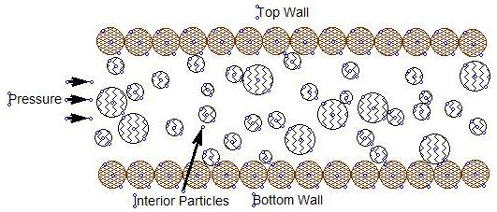

Figure 1: Simulation Channel for Particle-Fluid Suspension
The simulation runs for external pressure-driven particulate suspension flow case are most easily characterised by means of the Péclet number (see also Morris and Boulay (1999) and Frank, et al., (2003) which is defined as

$P_{e}$=$\frac{ 6πη\dot{γ}}{k_{B}T} {\overline{r}}^{3}$ (11)

where $η$ is the fluid viscosity, $\dot{γ}$ is the shear rate, $\overline{r }$is the mean radius of the particles, k_{B} is the Boltzmann constant and T is the thermodynamic temperature.

In order to determine these parameters, the graphs of the profiles generated by the simulations are used. For $\dot{γ}$ ̇, the velocity profile is employed and an average is calculated from the maximum and minimum velocities and the width of the channel Hp ;-

$\dot{γ}$ $≅$ 2 (v_{max} - v_{min}) / H_{p} (12)

k_{B}T is estimated from the equi-partition assumption and is found from the value of the kinetic energy profile at the centre of the channel.
The Péclet number is evaluated for the external pressure driven flow and it is observed that, as for low Péclet number (e.g. P_{e} =3), the solid fraction profile is flatter and the migration effect disappears; see Figure 2(a).
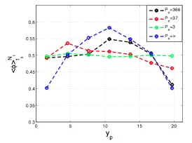
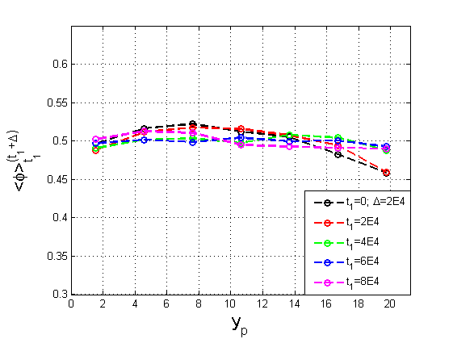

Figure2(a) Solid FractionProfileswith Péclet No=3 Figure2(b) Solid Fraction Profiles with Different
at different simulation time steps Péclet numbers
A number of DEM simulation runs are presented, both with and without Brownian motion. It is shown that the simulation captures the migration effect very well and shows that when the Brownian forces are increased (i.e. reduction of the Péclet number) the migration effect fades. In Figure 2(b), when the Brownian motion is switched off; i.e. Péclet number equals infinity, the case of near parabolic solid fraction profile is recovered as evidence of high degree of migration towards the centre of the planar channel in Poiseuille flow. These results agree well with the near parabolic solid fraction and particle assembly velocity profiles reported earlier by Morris and Boulay (1999) and Frank et al., (2003). Statistics of microscopic data, such as the particulate fluctuation energy can also be presented from DEM simulation results; see Ibrahim (2012).
Figures (3) and (4) below compare the thermally pulsed assembly with that of externally pressurised flow after steady-state is achieved within the flow channel in 60k simulation time steps. The simulations were run for 120k time steps to achieve accurate and reproducible results. This duration of flow simulation on average pumps the whole aggregate through the channel about 40 times, which corresponds to 12 seconds real-time.
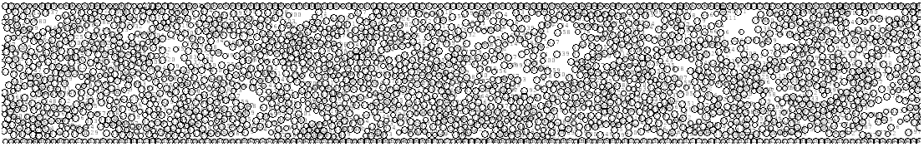

FIG.3(a) Thermally-pulsed particulate assembly flow snapshot at time step = 80k
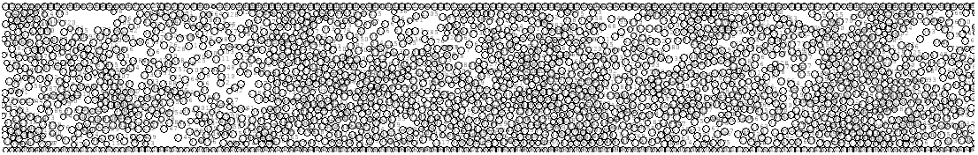
FIG.3(b) Thermally-pulsed assembly flow snapshot at time step = 100k

In thermally-pulsed flow, the particles tend to cluster together, creating holes periodically in the spatial distribution, which never totally disappears. A typical dimension of the holes and clusters is some several particle diameters.
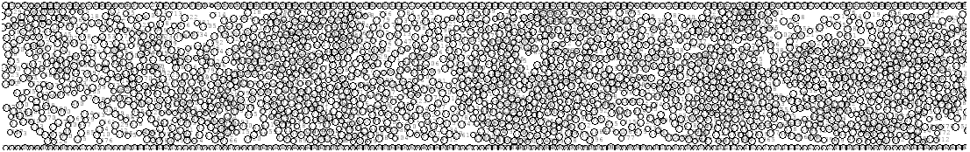
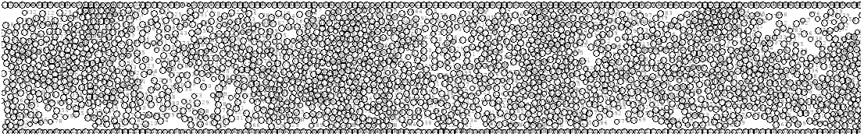
FIG.4(a) External Pressure driven flow of particulate assembly snapshot at time step = 80k
FIG.4(b) External Pressure driven flow of particulate assembly snapshot at time step = 100k

In external pressure driven flow, the suspension is advanced by the creation of periodic cavities adjacent to the planar channel walls coupled with the migration of particles towards the channel centre. There is the significance of the choice of the value of the coefficient of restitution, e = 0.2 (e.g. pharmaceutical compacts; see for example (Bharadwaj et al., 2010) and the fluid viscosity of $η$ = 0.985 Pa-s (e.g. castor oil) with density similar to that of water in the simulation results presented here to highlight the interactions between highly inelastic “soft” collisions in the presence of moderately high fluid viscosity. These choices were made to allow the assembly simulations to reach “steady-state” within a reasonable computational time frame whilst the effects of the variation of particle coefficient of restitution and fluid viscosity on the “connectivity” of particle flows in planar channels remain to be further fully investigated.
5. Conclusions
The results presented of DEM simulations of neutrally-buoyant sub-micron particles in flow regime where Re$≅$0.8 (i.e. Stokes flow) concur well with the earlier observations made of channel flow experiments of suspension flows whilst highlighting the effects of the controlled Brownian motion of particles via thermal pulsing. The amelioration of the shear-induced migration of particles in planar channel flows is demonstrated by the use of a DEM simulation framework that uses particle collisional dynamics in the presence of the fluid lubrication and viscous drag forces which also allows for the implicit consideration of the surface roughness of particles through D/(h+h₀) ratio. The simulation results presented in Figs. 2-4 demonstrate convincingly that the particle-particle and particle-wall thermal and electrical conduction processes are controlled effectively and could be enhanced to suit practical purpose such as in electrode charging in fuel cells (Canizares et al., 2007), photovoltaic cells for solar energy storage (Mellor et al., 2016) by manipulating the Brownian motion of the sub-micron particles. Conversely, the Brownian motion could be arrested to a measure to reduce the particle/wall friction experienced in micro-fluidic flows such as in the targeted introduction of bio-pharmaceuticals in the bloodstream, see Pele et al., (2015).
The analytical framework of calculations presented here is capable of incorporation of short-range inter-particle attractive forces and gravitational acceleration to account for particle settling effects and could be extended to flows in 3-D cylindrical tube configuration; see for example Crevacore et al., 2017). However, near-planar channel flows (2D) are also of significance in many microfluidic device applications. Most microfluidic devices rely on the operation of a peristaltic pump equivalent and the thermal pulsing analysis presented here could be adapted to model the effects of pulse width and frequency modulation on collective particle motion in both surface (2D) and tubular (3D) flows; see Ishizuka et al., (2016) for the latter.
References
Bharadwaj, R., Smith, C., Hancock, B.C., 2010, The Coefficient of Restitution of Some Pharmaceutical Tablets /Compacts, Int. J. Pharmaceutics, 402(1-2), 50-56.
Canizares, P., Jim$\acute{e}$nez, C., Martinez, F., S$\acute{a}$ez, C., Rodrigo, M.A., 2007, Study of the Electrocoagulation Process using Aluminium and Iron Electrodes, Industrial and Engineering Chemistry Research, 46(19), 6189-6195.
Clayton, T.C., Schwarzkopf, J.D., Sommerfeld, M., Tsuji, Y., 2012, Multiphase Flows with Drops and Particles, CRC Press, Taylor& Francis Group, LLC, Boca Raton, FL, USA, ISBN: 978-1-4398-4050-4.
Crevacore, E., Boccardo,, G., Grillo, A., Marchisio, D.L., Sethi, R., 2017, Pore-Scale Simulations of Particle Transport for Groundwater Remediation: The effect of Gravitational Settling, Chemical Engineering Transactions, 60, 193-198.
Einstein, A., 1956, Investigations on the Theory of the Brownian Movement, NewYork–Dover. ISBN: 0-486-60304-0.
Frank, M., Anderson, D., Weeks, E.R., Morris, J.F., 2003, Particle Migration in Pressure-Driven Flow of Brownian Suspension, J. Fluid Mechanics, 493, 363-378.
Ibrahim, M., 2012, Migration in Slow Slurry Flow including the Effect due to Brownian Motion, Ph.D. Thesis, University of Surrey.
Ishizuka, M., Mizuno, H., Kansha, Y., Tsutsumi, A., 2016, Control of Solid Mass Flow Rate in Circulating Fluidised Bed by Pulse Gas Flow, Chemical Engineering Transactions, 52, 127-132.
Jeffrey, D.J., Onishi, Y., 1984, Calculation of the Resistance and Mobility Functions for Two Unequal Rigid Spheres in Low Reynolds Number Flow, J. Fluid Mechanics, 139, 261-290.
Jenkins, J.T., Koenders, M.A., 2005, Hydrodynamics Interaction of Rough Spheres, Granular Matter, 7, 13-18.
Koenders, M.K., Davis, M., Vahid, S., 2008, The Granular Temperature Model for Oscillated Slurries: A Cell Model, J. Proc. IMechE, Part C: Mechanical Engineering Science, 22(C10), 2864-2871.
Mellor, A., Hylton, N.P., Hauser, H., Thomas, T., Lee, K.H., Al-Saleh, Y., Giannini, V., Braun, A., Loo, J., Vercurysse, D., Dorpe, P.V.,Bl$\ddot{a}$si, B., Maier, S., Ekins-Daukes,, N.J., 2016 , Nanoparticle Scattering for Multijunction Solar Cells: The Tradeoff between Absorption Enhancement and Transmission Loss, IEEE J. Photovoltaics, 6, 1678-1687.
Merino-Garcia, I., Albo, J., Kryzwda, P., Guido, M., Irabien, A., 2018, Bi-Metallic Cu-Based Hollow Fibre Electrodes for CO2 Reduction, Proceedings of 6th Int. Conf. on Green Process Engineering, 3-6 June, Toulouse, France.
Morris, J.F., Boulay, F. (1999) Curvilinear Flows of Non-Colloidal Suspensions: The Role of Normal Stresses”, J. Rheology, 43(5), 1213-1237.
Pawar, R.C., Lee, C.S., 2015, Heterogeneous Nano-Composite Photocatalysis for Water Purification, Micro & Nano Tech. Series, Elsevier Publ., ISBN: 978-0-323-39310-2.
Pele, L.C., Thoree, V., Bruggraber, S.F.A, Koller, D., Thompson, R.P.H., Lomer, M.C. Powell, J.C., 2015, Pharmaceutical/food grade TiO2 particles are absorbed into the Bloodstream of Human Volunteers, Particle and Fibre Toxicology, BIOMed Central, Springer Nature, DOI: 10.1186/s12989-015-0101-9.
Seville, J.P.K., Tuzun, U., Clift R.,1997 Processing of Particulate Solids, Blackie Academic & Professional-Powder Technology Series, Chapman & Hall, London, Kluwer Publ., Amsterdam, ISBN:978-0-7514-0376-8.
Torquato, S., Lu, B., Rubenstein, K., 1990, Nearest Neighbour Distribution Functions in Many-Body System, Physical Review A, 41(4), 2059-2071.
Vahid, S., 2008, Migration and Structure Formation in Sheared Slurries, PhD. Thesis, University of Kingston.

