CHEMICAL ENGINEERING TRANSACTIONS  VOL. 73, 2019 | A publication of
The Italian Association
of Chemical Engineering
Online at www.aidic.it/cet
Guest Editors: Andrea D’Anna, Paolo Ciambelli, Carmelo Sunseri
Copyright © 2019, AIDIC Servizi S.r.l.
ISBN 978-88-95608-70-9; ISSN 2283-9216

Cr(VI) Removal by Chitosan-Magnetite Nano-Composite in Aqueous Solution
Irene Bavasso*ª, Srikanth Vuppala^{b}, Claudio Cianfrini^{b}
The production of functionalized nano-composites represents an important research activity in the environmental remediation field. The use of iron-based nano-particles (IBNs) supported on bio-polymer matrix might lead to the development of active nano-materials characterized by a notable eco-compatibility. Chitosan is a biodegradable biopolymer that can be effectively used to produce active nano-composites with IBNs. In this study, a chitosan-magnetite nano-composite was produced in the laboratory and used in batch experimental tests for the removal of Hexavalent Chromium, Cr(VI), in aqueous solutions. Cr(VI) is considered one of the most toxic compounds present in the Mediterranean Area due to its carcinogenic and mutagenic characteristics, besides its notable solubility and mobility in the environment. The most effective way for the remediation of Cr(VI)-polluted groundwater is represented by the combination of chemical reduction and co-precipitation processes, generating Cr(III) species, characterized by very low toxicity and solubility in comparison to Cr(VI) ones. The synthesized nano-composite was used in batch lab-scale reactors and the kinetics of the process was studied varying the initial nano-composite concentration (0.25, 0.5, 0.75, 1 g/L) at fixed Cr(VI) initial concentration (20 mg/L). In addition, the initial pH influence on the Cr(VI) removal efficiency was analyzed in the range 3-7.
  - Introduction
Remarkable efforts have been done by various researchers as regards the use of nanoparticles in different sectors (Bavasso et al., 2016), in particular the use of iron-based nanoparticles in industrial (De Falco et al., 2017), in civil (Di Palma et al., 2015) and in the environmental one (Vilardi et al., 2017a) has been extensively studied (Vilardi et al., 2019a). The presence of heavy metals in both soils (Di Palma et al., 2007) and aquatic environmental media still represents an issue of great concern (Gueye et al., 2016), in particular for the Developing Countries. Hexavalent Chromium, Cr(VI), is a carcinogenic compound, characterized by a high solubility and mobility in the environment (Vilardi et al., 2018a) in comparison with its trivalent form, Cr(III), that is characterized by a very low solubility in neutral-alkaline environment and that tends to rapidly precipitate with other metals, such as iron (Bavasso et al., 2018). Various processes based on nano-catalyst and nanoparticles technologies have been proposed and applied for the treatment of polluted wastewaters and groundwater (Sarno et al., 2017a) from both inorganic (Stoller et al., 2017) and organic materials (Vilardi et al., 2018b), but towards heavy metals the use of biological processes (Di Palma and Verdone, 2009) and of biological adsorbent materials, such as spent coffee grounds or fruit peels (Vilardi et al., 2018c) has been proved to be the more suitable way to remove and recover the heavy metals in aqueous solutions.
Considering the necessity to develop environmentally friendly technologies for a sustainable remediation procedure of polluted environments (Stoller et al., 2016), the production of organic-inorganic nanocomposites may play an important role (Sarno et al., 2017b) since can lead to remarkable improvements and production cost reduction. In particular, different nanocomposite has already been used towards heavy metals removal in an aqueous environment (Vilardi et al., 2018d). For instance, the U retention capacity of a polymer-nano silica composite prepared by Milja et al. (2011) reached 8.93 mg/g at an initial U concentration of 10 mg/L, that is a notable removal efficiency value if compared with those obtained through classical biological methods (Marsili et al., 2005) or by means of combined biological-geochemical methods (Marsili et al., 2007).
Therefore, the aim of this work was to investigate on the removal efficiency of a hazardous heavy metal, Cr(VI), using a bio-nanocomposite material, produced using chitosan as bio-polymer and nanomagnetite as iron-based nanoparticles. Kinetic experiments were conducted at different temperature and pH, once the optimal nanocomposite amount has been found. The kinetic data were fitted to a suitable mathematical model, as well as the kinetic constant/temperature data were fitted to a classical Arrhenius model.
  - Materials and Methods
    - Materials
All the reagents were purchased at analytical grade from Sigma Aldrich (Milan). The solutions were prepared in deionized water. The following reagents were used in the experiments: NaOH, NaCl, Chitosan, K₂Cr₂O₇, FeCl₃·6H₂O, FeSO₄·7H₂O, NH₄OH (33% v/v) Diphenyl carbazide, and H₂SO₄. The chromium salt was dissolved in deionized water to prepare a solution with an initial Cr(VI) concentration equal to 20 mg/L, whereas the basic and acid solutions were diluted up to 0.1 M and subsequently used to modify the initial Cr(VI) solution pH, measured by a Crison pH-meter.
    - Bio-Nanocomposite Synthesis
The followed procedure is a modification of a previous synthesis reported elsewhere (Tran et al., 2010). In brief, the iron precursors were dissolved in the aqueous chitosan solution (prepared dissolving 1 g of chitosan in 90 mL of deionized water and 10 mL of H₂SO₄ 0.1 M) using a molar ratio of 2:1 among Fe(III) and Fe(II) species (0.1 M of FeSO₄·7H₂O and 0.2 M of FeCl₃·6H₂O). The solution was stirred at 300 rpm for 30 min and subsequently, the Bio-nanocomposite (BNC) was synthesized adding NH₄OH solution dropwise until reaching the required amount according to the theoretical stoichiometric molar ratio of (8:1 with respect to initial Fe(II)). The solution was kept in stirring for 1 h and then the BNC particles were magnetically separated, recovered and washed with pure ethanol. The BNC particles were then characterized by Dynamic Light Scattering (Brookhaven), showing a mean dimension of 38 ± 4.4 nm. Point of Zero Charge (PZC), was determined by suspending different material amounts (0.01, 0.1, 1, 5, 10, 20 % wt) in 0.1 M NaCl solution and measuring the solution pH after 24 h of contact time, according to (Chung et al., 2012). A pH of zero charge equal to 4.5 was determined, similar to the value obtained for the modified nano-magnetite, 4.8, reported by Chung et al. (2012).
    - Experiments
Four different BNC concentration (0.25, 0.5, 0.75, 1 g/L) were tested at 24 h in synthetic Cr(VI) solution (Cr(VI)₀=20 mg/L, initial pH=4.6) to find the optimal amount according to the obtained higher sorption capacity, q (mg/g), defined by the following equation (Vilardi et al., 2017c) (1):
$$q= \frac{V_{L}}{m_{BNC}} \left[{Cr\left(VI\right)}_{0}- {Cr\left(VI\right)}_{t}\right] (1)$$

where V_{L} (L) is the reaction volume and m_{BNC} is the loaded BNC mass (g). Subsequently, according to the optimal BNC concentration, the initial pH of Cr(VI) solution was varied to investigate on the pH effect on the Cr(VI) removal efficiency at 24 h, fixing the initial pH at 3, 5 and 7. Once the optimal pH was found, kinetic tests were performed at 25, 35 and 45 °C, fixing the temperature by a water bath, the stirring rate at 300 rpm and sampling a liquid volume of 2 mL according to the following time schedule: 10, 20, 30, 45, 60, 90 and 120 min. The BNC particles were separated through a magnet and after filtration, at 220 nm filter paper the liquid phase was withdrawn to proceed with the Cr(VI) measure through diphenyl-carbazide method (Vilardi et al., 2017b).
    - Mathematical modelling
The kinetic data were fitted to a classical pseudo-n-th order kinetic model (Vilardi, 2019), expressed by the following equation:
$${{Cr(VI)}_{t}}^{n-1}=\frac{{Cr(VI)}_{0}^{n-1}}{1+\left(n-1\right){Cr(VI)}_{0}^{n-1}kt} (2)$$

where n is the reaction order and k (M^{1-n}/s) is the kinetic constant. The non-linear regression of experimental data was accomplished in Excel environment, using the non-linear solver of Excel (Microsoft). The regressed kinetic constant values obtained at different initial temperature were fitted to the Arrhenius model, expressed by the following equation:

$k=k_{0}\exp\left(-\frac{E}{RT}\right) (3)$

where R (8.31 J/K mol) is the gas constant, E (J/mol) is the activation energy, k₀ (M^{1-n}/s) is the pre-exponential constant and T (K) is the reaction volume temperature.
  - Results and Discussion
    - Optimal Bio-Nanocomposite concentration and pH values determination
Figure 1 displays the obtained q values at different initial BNC concentration.

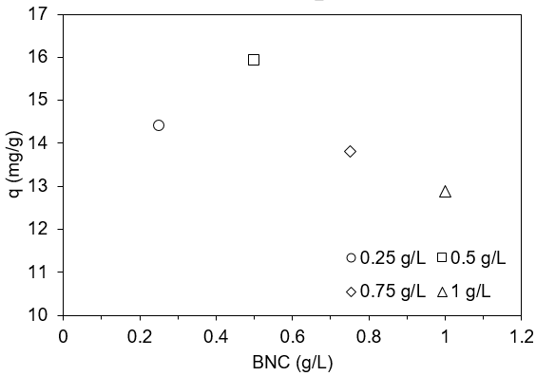
Figure 1: q values obtained at different initial BNC concentration (stirring rate 300 rpm, temperature=25°C, Cr(VI)₀=20 mg/L, contact time=24 h).

The maximum q value (15.92 mg/g) was obtained for a BNC initial concentration of 0.5 g/L. This implies that the best mass ratio between pollutant and adsorbent was 0.04 that is analogous to the best ratio obtained in a previous study using solely nanomagnetite particles (Bavasso et al., 2018). Therefore, for subsequent experiments, the BNC concentration was fixed equal to 0.5 g/L.
Figure 2 displays the obtained q values at three different pH values.

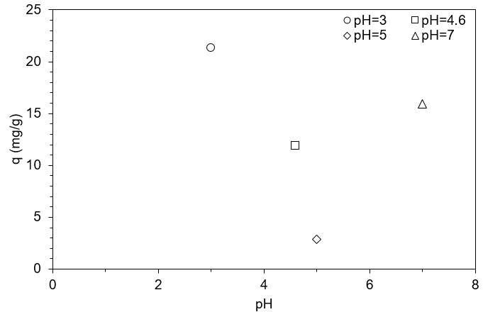
Figure 2: q values obtained at different initial pH (stirring rate 300 rpm, BNC concentration= 0.5 g/L, temperature=25°C, Cr(VI)₀=20 mg/L, contact time=24 h).

As expected the acid pH favors the Cr(VI) removal (Vilardi et al., 2017b), since the hexavalent chromium species in an aqueous medium are present as oxyanions and their removal is foster in presence of adsorbent materials characterized by a positively charged surface. Considering that the pH of zero-charge of the prepared BNC particles was equal to 4.5, for pH lower than 4.5 it's surface results positively charged, improving the sorption of anions in the liquid bulk.
In subsequent kinetic experiments, the optimal pH equal to 3 was adopted.
    - Kinetic tests at a different initial temperature
Figure 3 shows the kinetic experimental data at a different initial temperature, with the fitted pseudo-nth order kinetic model.

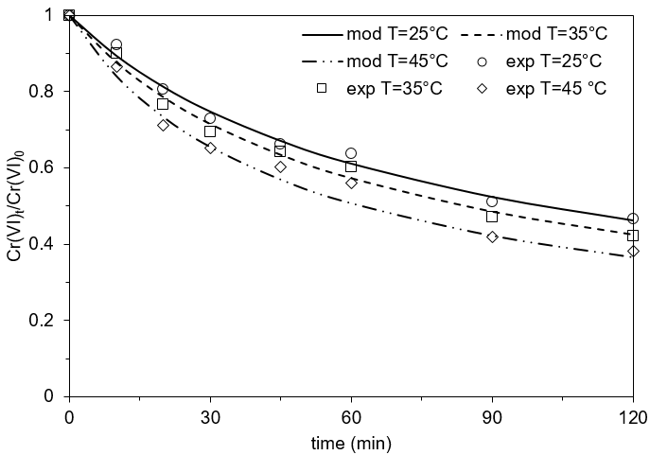
Figure 3: kinetic data obtained at different initial temperature (points) and pseudo-nth order kinetic model (lines) (stirring rate 300 rpm, BNC concentration= 0.5 g/L, Cr(VI)₀=20 mg/L, pH=3).

The Cr(VI) removal efficiency at 120 min was 53.4, 58 and 62% for temperature equal to 25, 35 and 45°C, respectively. According to the experimental evidence (regressed k values are reported in Table 1), the Cr(VI) removal process was characterized by faster kinetics at higher temperature values.

Table 1: regressed k and n values.
T (°C) | k (M^{1-n}/s) | n | R²
25 | 4.91x10⁻³ | 2.51 | 0.993
35 | 5.98x10⁻³ | 2.51 | 0.991
45 | 7.97x10⁻³ | 2.51 | 0.984

The increase of k value with temperature increase was expected, according to the Arrhenius model. The regressed kinetic constant values were 4.91, 5.98 and 7.97x10⁻³ M^{-1.51}/s, for temperature fixed at 25, 35 and 45°C, respectively; whereas the regressed n order value was 2.51.
The kinetic constant values at different temperature values were reported in figure 4 and fitted to the Arrhenius model in its non-linear form.
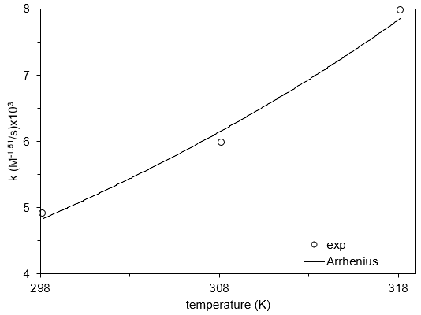
Figure 4: kinetic constant values at different temperature values (point) and fitted the Arrhenius model (line).
From the non-linear regression of experimental data the following parameters values were obtained: k₀= 0.0035 and E= 4.78 J/mol. The estimated activation energy value was of the same order of magnitude of those reported by other authors for other nanomaterials, such as Mn₃O₄ (60.7 J/mol) (Cantu et al., 2014).
  - Conclusions
Chitosan-magnetite nanoparticles characterized by a mean size of 38 ± 4.4 nm and a pH of zero charge of 4.5 were successfully synthetized and tested in batch experiments towards Cr(VI) removal. The obtained nanoparticles optimal concentration was 0.5 g/L for a Cr(VI) initial concentration of 20 mg/L and the maximum removal efficiency at 120 min was 62% at 45°C. The pH proved to affect the overall process since for pH below the pH of zero charge the Cr(VI) oxyanions removal was enhanced due to the positively charging of sorbent material surface. The optimal pH was found to be 3. The kinetic data were well fitted to a pseudo-nth order kinetic reaction model, with a regressed reaction order of 2.51 and an increasing kinetic constant value proportionally to the temperature increase. Further experiments and modification of the biological nanocomposite are necessary to improve the performances of this material; however, it results completely environmentally friendly, since the use of chitosan avoid the possible dispersion of the magnetite nanoparticles in the possible use of this technology in real site application.
Acknowledgement
European Commission is acknowledged for having funded the European Project “CrITERIA” in the ERANETMED framework, as well as the University of Rome “La Sapienza” for having funded the project “Heavy metals removal from wastewater by iron-based nanoparticles stabilized by biopolymers”.
References
Bavasso I., Vilardi G., Stoller M., Chianese A., Di Palma L., 2016, Perspectives in Nanotechnology Based Innovative Applications for The Environment, Chemical Engineering Transactions, 47, 55–60.
Bavasso I., Verdone N., Di Palma L., 2018, Cr(VI) Removal by Green-Synthetized Iron-Based Nanoparticles: Effect of Cr(VI) Concentration and pH Condition on Adsorption Process, Chemical Engineering Transactions, 70, 469-474.
Cantu Y., Remes A., Reyna A., Martinez D., Villarreal J., Ramos H., Trevino S., Tamez C., Martinez A., Eubanks T., Parsons, J. G., 2014, Thermodynamics, kinetics, and activation energy studies of the sorption of chromium (III) and chromium (VI) to a Mn3O4 nanomaterial, Chemical Engineering Journal, 254, 374-383.
Chung J., Chun J., Lee J., Lee S. H., Lee Y. J., Hong S. W., 2012, Sorption of Pb (II) and Cu (II) onto multi-amine grafted mesoporous silica embedded with nano-magnetite: Effects of steric factors, Journal of hazardous materials, 239, 183-191.
De Falco G., Porta A., Del Gaudio P., Commodo M., Minutolo P., D’Anna, A., 2017, Thin Film Coatings Prepared by Direct Thermophoretic Deposition of Flame-Made Nanoparticles, Chemical Engineering Transactions, 60, 67-72.
Di Palma L., Ferrantelli P., Merli C., Petrucci E., Pitzolu I., 2007, Influence of soil organic matter on copper extraction from contaminated soil, Soil and Sediment Contamination, 16 (3), 323-335.
Di Palma L., Verdone N., 2009, The effect of disk rotational speed on oxygen transfer in rotating biological contactors, Bioresource Technology, 100, 1467-1470.
Di Palma, L., Medici F., Vilardi G., 2015, Artificial aggregate from non metallic automotive shredder residue, Chemical Engineering Transactions, 43, 1723-1728.
Gueye M.T., Di Palma L., Allahverdeyeva G., Bavasso I., Petrucci E., Stoller M., Vilardi G., 2016, The influence of heavy metals and organic matter on hexavalent chromium reduction by nano zero valent iron in soil, Chemical Engineering Transactions, 47, 289-294.
Marsili E., Beyenal H., Di Palma L., Merli C., Dohnalkova A., Amonette J. E., Lewandowski Z., 2005, Uranium removal by sulfate reducing biofilms in the presence of carbonates, Water Science and Technology, 52(7), 49-55.
Marsili E., Beyenal H., Di Palma L., Merli C., Dohnalkova A., Amonette J. E., Lewandowski Z., 2007, Uranium immobilization by sulfate-reducing biofilms grown on hematite, dolomite, and calcite, Environmental Science and Technology, 41(24), 8349-8354.
Milja T. E., Prathish K. P., Rao T. P., 2011, Synthesis of surface imprinted nanospheres for selective removal of uranium from simulants of Sambhar salt lake and ground water, Journal of hazardous materials, 188(1-3), 384-390.
Sarno M., Ponticorvo E., Cirillo C., Ciambelli, P., 2017a, Polycyclic Aromatic Hydrocarbons Extraction Based on Graphene Coated Magnetic Alloy Nanoparticles, Chemical Engineering Transactions, 60, 145-150.
Sarno M., Cirillo C., Troisi A., Ciambelli, P., 2017b, Pb Removal on Carbon Nanotubes Membrane Decorated by ZnO Nanoparticles, Chemical Engineering Transactions, 60, 277-282.
Stoller M., Azizova G., Mammadova A., Vilardi G., Di Palma L., Chianese A., 2016, Treatment of Olive Oil Processing Wastewater by Ultrafiltration, Nanofiltration, Reverse Osmosis and Biofiltration, Chemical Engineering Transactions, 47, 409–414.
Stoller M., Ochando-Pulido J.M., Vilardi G., Vuppala S., Bravi M., Verdone N., Di Palma L., 2017, Technical and economic impact of photocatalysis as a pretreatment process step in olive mill wastewater treatment by membranes, Chemical Engineering Transactions, 57, 1171-1176.
Tran H. V., Dai Tran L., Nguyen T. N., 2010, Preparation of chitosan/magnetite composite beads and their application for removal of Pb (II) and Ni (II) from aqueous solution, Materials Science and Engineering: C, 30(2), 304-310.
Vilardi G., Stoller M., Verdone N., Di Palma L., 2017a, Production of nano Zero Valent Iron particles by means of a spinning disk reactor, Chemical Engineering Transactions, 57, 751–756.
Vilardi G., Verdone N., Di Palma L., 2017b, The influence of nitrate on the reduction of hexavalent chromium by zero-valent iron nanoparticles in polluted wastewater, Desalination and Water Treatment, 86, 252–258.
Vilardi G., Di Palma L., Verdone N., 2017c, Competitive Reaction Modelling in Aqueous Systems: the Case of Contemporary Reduction of Dichromates and Nitrates by nZVI, Chemical Engineering Transactions, 60, 175–180.
Vilardi G., Di Palma L., Verdone N., 2018a, On the critical use of zero valent iron nanoparticles and Fenton processes for the treatment of tannery wastewater, Journal of Water Process Engineering, 22C, 109–122.
Vilardi G., Sebastiani D., Miliziano S., Verdone N., Di Palma L., 2018b, Heterogeneous nZVI-induced Fenton oxidation process to enhance biodegradability of excavation by-products, Chemical Engineering Journal, 335, 309–320.
Vilardi G., Di Palma L., Verdone N., 2018c, Heavy metals adsorption by banana peels micro-powder. Equilibrium modeling by non-linear models, Chinese Journal of Chemical Engineering, 26, 455-464.
Vilardi G., Ochando Pulido J.M., Verdone N., Stoller M., Di Palma L., 2018d, On the removal of Hexavalent Chromium by olive stones coated by iron-based nanoparticles: equilibrium study and Chromium recovery, Journal of Cleaner Production, 190, 200-210.
Vilardi G., 2019, Mathematical modelling of simultaneous nitrate and dissolved oxygen reduction by Cu-nZVI using a bi-component shrinking core model, Powder Technology, 343, 613-618.
Vilardi G., Di Palma L., Verdone N., 2019a, A physical-based interpretation of mechanism and kinetics of Cr(VI) reduction in aqueous solution by zero-valent iron nanoparticles, Chemosphere, 220, 590-599.
Vilardi G., Rodriguez-Rodriguez J., Ochando-Pulido J.M., Di Palma L., Verdone N., 2019b, Fixed-bed reactor scale-up and modelling for Cr(VI) removal using nano iron-based coated biomass as packing material, Chemical Engineering Journal, 361, 990-998.

