|  |  |
| --- | --- |
| cetlogo ***CHEMICAL ENGINEERING TRANSACTIONS***  ***VOL. 73, 2019*** | A publication of  aidiclogo_grande |
| The Italian Association  of Chemical Engineering  Online at www.aidic.it/cet |
| Guest Editors: Andrea D’Anna, Paolo Ciambelli, Carmelo Sunseri  Copyright © 2019, AIDIC Servizi S.r.l. **ISBN** 978-88-95608-70-9; **ISSN** 2283-9216 | |

Production of PVDF-HFP Nanostructured Membranes for Water Purification by Supercritical Phase Inversion

Stefano Cardea, Lucia Baldino\*, Ernesto Reverchon

Department of Industrial Engineering, University of Salerno, Via Giovanni Paolo II, 132, 84084, Fisciano (SA), Italy [lbaldino@unisa.it](mailto:lbaldino@unisa.it)

In this work, poly(vinylidene fluoride-co-hexafluoropropylene) (PVDF-HFP) membranes for water purification were produced by supercritical phase inversion using a mixture of supercritical CO2 (SC-CO2) and ethanol as non-solvent. Different polymer concentrations (from 10 to 20% w/w) and ethanol amount by volume (from 1 to 50% v/v) with respect to SC-CO2 flow rate, were tested in order to study their influence on membranes morphology, surface area and porosity; supercritical processing was performed at a pressure of 200 bar and a temperature of 45 °C. Membranes characterized by a cellular morphology with a nanoporous substructure and/or by an homogeneous nanoporous morphology were obtained, changing the starting polymer concentration and the ethanol amount during the process. In particular, increasing the amount of ethanol from 1 to 50% v/v, an increase of membranes porosity and surface areas was obtained, and the membranes morphology changed from microporous with nanoporous cell walls to completely nanoporous, due to an increase of the non-solvent power that improved the in-situ gelification mechanism during the supercritical phase separation.

* 1. Introduction

Water treatment is one of the major applications of Polyvinylidene fluoride (PVDF) membranes (Kang et al., 2014). Polyvinylidene fluoride coupled with the co-polymer hexafluoropropylene (PVDF-HFP) is particularly attractive due to its improved characteristics, such as high mechanical strength, good chemical resistance, thermal stability and biocompatibility (Kang et al., 2014); these properties make it suitable for several and different applications, from separation to biomedical field, from bioreactor to catalysis, from tissue engineering to food industry (Mansourizadeh et al., 2010; Nunes-Pereira et al., 2015; Reverchon et al., 2007; Tao et al., 2014; Yang et al., 2011).

PVDF-HFP membranes are frequently produced by non-solvent induced phase separation (NIPS) and thermally induced phase separation (TIPS) (Kang et al., 2014). However, these traditional techniques suffer of some strong limitations; among them: the use of toxic organic solvents and their residues in the final product that affect the structures to be used in tissue engineering and in the biomedical field, difficulty in controlling membranes pore size and morphology that affect the structures to be used in separation processes, and long processing times (more than two days).

In order to overcame these problems, different supercritical CO2 (SC-CO2) assisted processes were proposed, such as SC-CO2 phase inversion and supercritical gel drying (Cardea et al., 2009; Cardea et al., 2014; Cardea et al., 2018; Reverchon et al., 2007). Indeed, thanks to the SC-CO2 peculiarities, as for instance negligible surface tension and high diffusivity, it is possible to produce polymeric membranes and aerogels (Tsivintzelis et al., 2007; Daniel et al., 2012), also loaded with active principles (Baldino et al., 2015; Cardea et al., 2014; Cardea et al., 2018; Tsivintzelis et al., 2007), in a faster and eco-friendly process. Moreover, changing the supercritical process parameters, such as pressure, temperature and CO2 flow rate, or polymer concentration, structures pore size and kind of morphology (e.g., microporous, finger-like, nanoporous, etc.) can be modulated acting on the thermodynamics and kinetics of the system. Reverchon and Cardea (2006) specifically studied the effect of the process parameters (polymer concentration, temperature, pressure, liquid solvent) on PVDF-HFP membranes morphology and demonstrated that, modifying these parameters, it was possible to obtain different membrane morphologies: cellular structure, binodal structure and microparticles.

Generally speaking, previous works showed as it was possible to generate two kinds of PVDF-HFP structures: one, typically defined as membranes, obtained by SC-CO2 phase inversion and characterized by micrometric porosity, and, two, typically defined as aerogels, obtained by supercritical gel drying and characterized by nanometric porosity. In particular, the supercritical gel drying process provided two steps (gelation/freezing step plus drying) (Cardea et al., 2009).

Taking into account these supercritical process advantages and considering that for water treatment microfiltration and ultrafiltration membranes are necessary (microfiltration membranes can separate particles from about 0.05–0.1 μm to 1.0 μm; whereas, ultrafiltration membranes with pore size range of 0.01–0.1 μm can remove viruses, metal hydroxides, colloids and other large molecular weight materials from water (Kang et al., 2014)), in this work, for the first time, the production of PVDF-HFP membranes with a tuneable morphology from microporous to nanoporous one is proposed, using a new supercritical phase separation process configuration.

In particular, in order to confer to PVDF-HFP membranes also the nanoporous morphology, typical of the aerogels, an in-situ polymer gelation was tried by adding ethanol directly during the supercritical phase inversion. The aim was to take advantage from the SC-CO2 mass transfer characteristics to induce PVDF-HFP gelation in contact with the non-solvent (ethanol) in a faster process and avoiding the freezing step. The PVDF-HFP membranes produced in this manner were analyzed by scanning electron microscopy, BET surface area and porosity in order to determine their characteristics and the applicability as filters for water purification.

* 1. Materials and methods

Polyvinylidene fluoride-hexafluoropropylen (PVDF-HFP, Mn=130000), acetone (purity >99.5%) and ethanol (purity >99.9%) were bought from Sigma Aldrich. CO2 (purity 99.9%) was supplied by Morlando Group S.R.L. (Sant’Antimo, NA, Italy).

Polymer solutions were prepared dissolving PVDF-HFP at different concentrations (10, 15 and 20% w/w) in acetone. When an homogeneous solution was obtained after magnetic stirring at 100 rpm and room temperature, it was distributed on stainless steel cups of 2 cm diameter and about 2 mm height. These samples were put inside the high pressure vessel for the supercritical phase inversion process.

The laboratory plant used in this work, consists of a 316 stainless steel cylindrical high-pressure vessel with an internal volume of 200 mL, equipped with two high pressure pumps (mod. LDB1, Lewa, Leonberg, Germany) used to deliver liquid CO2 and liquid ethanol. Pressure in the vessel was measured by a test gauge (mod. MP1, OMET, Lecco, Italy) and regulated using a micrometering valve (mod. 1335G4Y, Hoke, Spartanburg, USA). Temperature was regulated using PID controllers (mod. 305, Watlow, Corsico (MI), Italy). At the exit of the vessel, a rotameter (mod. D6, ASA, Sesto San Giovanni (MI), Italy) was used to measure CO2 + ethanol flow rate.

PVDF-HFP samples were cryo-fractured using liquid nitrogen (SOL, Milan, Italy); then, they were sputter coated with gold (Agar Auto Sputter Coater mod. 108 A, Stansted, UK) at 30 mA for 80 s and analyzed using a field emission scanning microscope (FE-SEM, mod. LEO 1525, Carl Zeiss SMT AG, Oberkochen, Germany) to study their morphology.

BET specific surface area was determined by N2 physisorption using a Nova 1200e Surface Area & Pore Size Analyzer (Quantachrome Instruments, Florida, USA). About 0.2 g of sample were first degassed at 60 °C for 12 h and, then, analyzed by N2 adsorption at -196 °C.

The porosity (ε) represents the “void space” of the polymer sample and was calculated from the density of the sample and the density of pure PVDF-HFP. The PVDF-HFP sample density was determined by measuring its volume and weight.

* 1. Results and discussion

PVDF-HFP is a polymer that can produce both microporous and nanoporous structures; it depends on the preparation procedure. In the first case, PVDF-HFP is generally dissolved in an organic solvent, as acetone and, then, the solution is phase-separated (Reverchon and Cardea, 2006); in the second one, two steps are necessary. Indeed, before processing, the addition of a non-solvent (e.g., ethanol) to the starting PVDF-HFP solution is required that, coupled with a gelation/freezing step, produces a PVDF-HFP structure characterized by a nanoporous morphology (Cardea et al., 2009). Taking into account these considerations, the aim of this work is to demonstrate that PVDF-HFP samples characterized by the two different morphologies can be produced in a one-step process assisted by SC-CO2 plus EtOH, at different ratios by volume, and that it is possible to determine the conditions at which the switch between the two kind of structures is obtained.

In the first part of the experimentation, we modified the supercritical CO2 assisted plant by the addition of a pump and a mixer to allow the use of SC-CO2 plus EtOH mixture as antisolvent. In Figure 1, it is reported the new configuration of the plant.

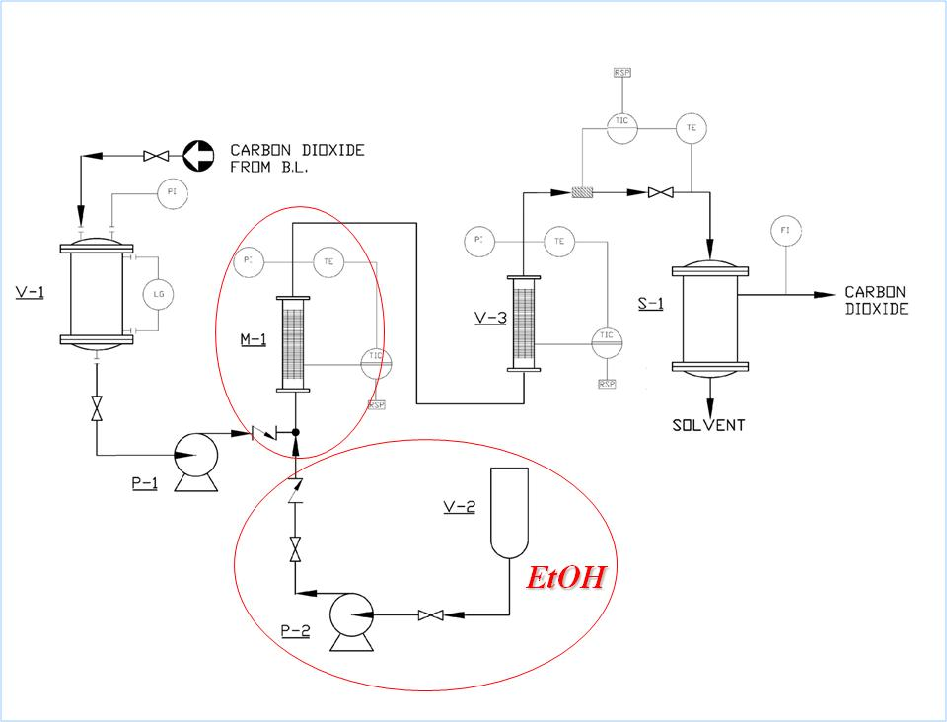

Figure 1: Plant modification performed to allow the use of SC-CO2 plus EtOH mixture as antisolvent

Then, the effect of polymer concentration and of SC-CO2/EtOH flow rates volume ratio were studied, changing PVDF-HFP concentrations in acetone from 10 to 20% w/w and performing the supercritical phase separation process at 200 bar and 45 °C for 3 h, using three SC-CO2/EtOH volume ratios: 99/1, 80/20 and 50/50. In this work, supercritical process operative conditions were fixed since they were optimized in previous works (Cardea et al., 2018; Reverchon and Cardea, 2006).

The first experimental evidence was that the solution of PVDF-HFP at 20% w/w in acetone, processed by SC-CO2 alone, produced a regular and microporous sample morphology with wrinkled and closed pore walls. These results are consistent with the ones obtained in the literature using the same operative conditions and polymer concentration (Cardea et al., 2018). Performing the experiments on PVDF-HFP 20% w/w in acetone and using SC-CO2/EtOH flow rates at a volume ratio of 99/1, a regular microporous morphology was observed as in the previous case; but, cell walls were characterized by a nanoporous sub-structure, as shown in Figure 2a. Changing the SC-CO2/EtOH flow rates volume ratio at 80/20, a so-called leafy morphology was obtained and cells disappeared, as reported in Figure 2b. The same morphology was observed also at a SC-CO2/EtOH flow rates volume ratio of 50/50; this last morphology was typical of the aerogels generated by the supercritical drying process (Cardea et al., 2009).

Reducing the PVDF-HFP concentration in the starting solution at 15 and 10% w/w, the same trend was observed: i.e., when the ethanol flow rate increased from 1 to 20% v/v with respect to the SC-CO2 flow rate, the samples morphology changed from microporous with nanoporous cell walls to completely nanoporous, as reported in Figure 3a-b and Figure 4a-b.

** **a** *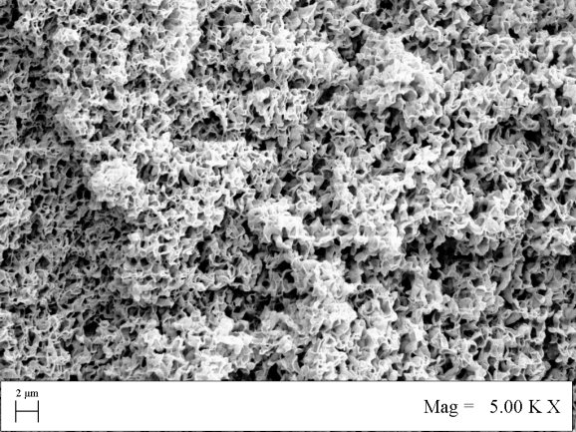* **b**

Figure 2: 20% w/w PVDF-HFP sample produced using a SC-CO2/EtOH flow rates volume ratio of: a) 99/1, b) 80/20

** a  b**

Figure 3: 15% w/w PVDF-HFP sample produced using a SC-CO2/EtOH volume ratio of: a) 99/1, b) 80/20

 **a**  **b**

Figure 4: 10% w/w PVDF-HFP sample produced using a SC-CO2/EtOH volume ratio of: a) 99/1, b) 80/20

These results demonstrated that this new process configuration, in which SC-CO2 and ethanol were fed together to the high-pressure vessel, probably induced an in-situ PVDF-HFP gelation during the process. In particular, when the ethanol flow rate was at least 20% v/v with respect to the SC-CO2 flow rate, during phase separation, also the gelation mechanism occurred, since ethanol behaves as a non-solvent with respect to the polymer. Operating in this manner, at the end of the process, a dried and nanostructured PVDF-HFP membrane was obtained, with the relevant advantage that the freezing/gelation step, generally used to induce the nanoporous structure formation after the addition of the non-solvent to the polymer solution (Cardea et al., 2009), was avoided.

Another interesting result is that for ethanol flow rate lower than 20% v/v, a microporous morphology was obtained as in the case of PVDF-HFP solution processed by SC-CO2 alone; but, using this procedure, the morphology was modified and improved, since also a nanoporous sub-structure on the cells walls was induced due to the ethanol presence. It is worthy to note that the simultaneous addition to the process of ethanol and SC-CO2, at the adopted operative conditions, favoured ethanol interaction with the polymer solution at nanoscale, due to the peculiarities of the mixture at supercritical conditions, such as negligible surface tension, that avoid sample collapse, and high diffusivity, that makes this process faster with respect to the traditional ones (NIPS and TIPS). This can be the reason why also for small ethanol amount in the system, a different morphology was obtained with respect to the one observed for PVDF-HFP samples processed using SC-CO2 alone (Reverchon and Cardea, 2006).

Since this trend was consistent for all the polymer concentrations tested in this work, it can be hypothesized that there is a critical ratio by volume between the SC-CO2 and EtOH flow rate that allows the gelation mechanism: i.e., when it was 99/1% v/v (SC-CO2/EtOH flow rate), the reduced amount of ethanol was only able to create a nanoporous sub-structure in the cell walls of the microporous membrane; whereas, when EtOH flow rate was at least 20% v/v of the SC-CO2 flow rate, an in-situ gelation was obtained and a completely nanoporous membrane morphology was produced, similar to the ones obtained in the supercritical gel drying process (Cardea et al., 2009).

The modification of structures morphology also affected their peculiarities; in particular, the ethanol presence during the process allowed an improvement of PVDF-HFP structures porosity and surface area, as reported in Table 1.

*Table 1:* Porosity and surface area for all the PVDF-HFP samples produced in this work

|  |  |  |  |  |  |  |
| --- | --- | --- | --- | --- | --- | --- |
| **SC-CO2/EtOH flow rate ratio, % v/v** | **PVDF-HFP 10% w/w** | | **PVDF-HFP 15% w/w** | | **PVDF-HFP 20% w/w** | |
| **Porosity, %** | **Surface area, m2/g** | **Porosity, %** | **Surface area, m2/g** | **Porosity, %** | **Surface area, m2/g** |
| 100/0 | 71 | 18.8 | 68 | 15.6 | 63 | 4.9 |
| 99/1 | 74 | 21.1 | 70 | 17.6 | 68 | 12.0 |
| 80/20 | 80 | 48.1 | 76 | 31.5 | 71 | 23.2 |
| 50/50 | 88 | 95.3 | 83 | 78.8 | 79 | 66.6 |

Increasing the EtOH content from 0 to 50% v/v, the porosity increased from 71 to 88% and surface area from 18.8 to 95.3 m2/g for PVDF-HFP 10% w/w sample; the porosity increased from 68 to 83% and surface area from 15.6 to 78.8 m2/g for PVDF-HFP 15% w/w sample; the porosity increased from 63 to 79% and surface area from 4.9 to 66.6 m2/g for PVDF-HFP 20% w/w sample. These interesting results confirmed the high versatility of the supercritical fluids assisted processes: modifying the process parameters (i.e., EtOH content), an increase of porosity larger than 20% and an increase of surface area larger than 500%, with respect to the PVDF-HFP sample obtained without EtOH, were obtained.

* 1. Conclusions and perspectives

In this work, a simplified PVDF-HFP membranes production method was successful adopted. In particular, depending on the ethanol content, it is possible to generate two different PVDF-HFP structure morphologies. The first one, obtained at low ethanol content (i.e., 1% v/v), allowed to generate microporous membranes characterized by nanoporous cells walls; the presence of low traces of ethanol slightly affected the SC-CO2 phase inversion process, overlapping a nanoporous morphology to the typical microporous one obtained for PVDF-HFP membranes. Increasing the amount of ethanol (i.e., larger than 20% v/v), the PVDF-HFP structure completely changed and an aerogel-like morphology (i.e., nanoporous) was generated, even if a gelation/freezing step was not performed. This result is very intriguing since it is the first time that this kind of morphology was obtained by a one-step procedure; for these reasons, this procedure can be a relevant alternative for the production of PVDF-HFP microporous and/or nanoporous filters at industrial scale.

In perspective, PVDF-HFP membranes will be tested on contaminated water, to verify they capability to entrap particles and the different performances related to the two morphologies can be determined in order to select the best filter solution.

References

Baldino L., Cardea S., Reverchon E., 2015, Antimicrobial membranes produced by supercritical assisted phase inversion, Chemical Engineering Transactions, 43, 121-126.

Cardea S., Baldino L., De Marco I., Reverchon E., 2014, Generation of loaded pmma scaffolds using supercritical CO2 assisted phase separation, Chemical Engineering Transactions, 38, 241-246.

Cardea S., Baldino L., Reverchon E., 2018, Comparative study of PVDF-HFP-curcumin porous structures produced by supercritical assisted processes, J Supercrit Fluids, 133, 270-277.

Cardea S., Gugliuzza A., Sessa M., Aceto M.C., Drioli E., Reverchon E., 2009, Supercritical gel drying: A powerful tool for tailoring symmetric porous PVDF-HFP membranes, ACS Applied Materials and Interfaces, 1, 171-180.

Daniel C., Longo S., Cardea S., Vitillo J.G., Guerra G., Monolithic nanoporous-crystalline aerogels based on PPO, RSC Adv, 2, 12011-12018.

Kang G.-d., Cao Y.-m., 2014, Application and modification of poly(vinylidene fluoride) (PVDF) membranes – A review, J Membr Sci, 463, 145–165.

Mansourizadeh A., Ismail A.F., Matsuura T., 2010, Effect of operating conditions on the physical and chemical CO2 absorption through the PVDF hollow fiber membrane contactor, J Membr Sci, 353, 192-200.

Nunes-Pereira J., Ribeiro S., Ribeiro C., Gombek C.J., Gama F.M., Gomes A.C., Patterson D.A., Lanceros-Méndez S., 2015, Poly(vinylidene fluoride) and copolymers as porous membranes for tissue engineering applications, Polymer Testing, 44, 234-241.

Reverchon E., Cardea S., Rapuano C., 2007, Formation of poly-vinyl-alcohol structures by supercritical CO2, Journal of Applied Polymer Science, 104, 3151-3160.

Reverchon E., Cardea S., 2006, PVDF−HFP Membrane Formation by Supercritical CO2 Processing: Elucidation of Formation Mechanisms, Ind Eng Chem Res, 45, 8939-8945.

Tao M., Xue L., Liu F., Jiang L., 2014, An intelligent superwetting PVDF membrane showing switchable transport performance for oil/water separation, Adv Mater, 26, 2943-2948.

Tsivintzelis I., Marras S.I., Zuburtikudis I., Panayiotou C., 2007, Porous poly (l-lactic acid) nanocomposite scaffolds prepared by phase inversion using supercritical CO2 as antisolvent, Polymer, 48, 6311-6318.

Yang X., Wang R., Shi L., Fane A.G., Debowski M., 2011, Performance improvement of PVDF hollow fiber-based membrane distillation process, J Membr Sci, 369, 437-447.