CHEMICAL ENGINEERING TRANSACTIONS  VOL. 73, 2019 | A publication of
The Italian Association
of Chemical Engineering
Online at www.aidic.it/cet
Guest Editors: Andrea D’Anna, Paolo Ciambelli, Carmelo Sunseri
Copyright © 2019, AIDIC Servizi S.r.l.
ISBN 978-88-95608-70-9; ISSN 2283-9216

Non-Thermal Plasma Technology for the Effective Regeneration Of Macroscopic Adsorbent Materials Used In The Removal Of Patent Blue V Dye From Aqueous Solutions
Giuseppina Iervolino, Olga Sacco, Vincenzo Vaiano*, Vincenzo Palma
Department of Industrial Engineering, University of Salerno, Via Giovanni Paolo II, 132, 84084 Fisciano (SA), Italy

In this work, two different commercial macroscopic adsorbent materials (Na-ZSM5 zeolite in spherical pellets and TiO₂ cylindrical pellets) has been tested in the removal of model organic food dyes (Patent blue V, E131) and they were regenerated using an innovative techniques based on non-thermal plasma process. The adsorption experiments were carried out using a pyrex cylindrical reactor and liquid samples were analyzed in continuous mode by spectrophotometric measurement at λ = 636 nm. The results demonstrated that these materials were able to remove Patent blue V dye, with removal efficiency equal to 80% for the zeolite and 95% for TiO₂ pellets after 400 min of treatment time. The adsorbent materials have been used for several cycles until their saturation. In particular, after seven adsorption cycles, the adsorbing capacity was reduced of about 60 and 20% for zeolite and TiO₂ pellets, respectively. Subsequently, the materials were regenerated by non-thermal plasma and reused in the adsorption system. The results evidenced that the regeneration by non-thermal plasma was able to induce the complete degradation of the absorbed organic substance and consequently restoring the initial adsorption capacity of both macroscopic adsorbent materials.
  - Introduction
Human, domestic and industrial activities require the use of a large amount of water. The direct consequence of this use is the production of wastewater. Therefore, it is necessary to purify the wastewater through processes able to remove the persistent contaminants that are among the main causes of problems in the aquatic ecosystem. In particular, dyes coming from textile and food industries are important pollutants in water effluents (Vaiano et al., 2016). Food dyes are one of the most widely used and dangerous additives in food industry (beverages, jelly sweets, candies, ice-cream, etc.). Approximately 10–20% of the dyes are lost during manufacturing process, resulting in large amounts in wastewater (Gao et al., 2011). The occurrence of food dyes residues in wastewater affects aquatic environment by colouring water and impeding light penetration. Moreover, they are suspected to cause carcinogenic effects, hypersensitivity reactions, and genotoxic effects on human health (Zhou et al., 2014). One of the food dyes most difficult to remove from wastewater and particularly subject to studies on the effects on human health is Patent blue V. It is a dark blue synthetic food dye and it has been banned in Australia, America and Norway since it can cause allergic reactions, with symptoms such as pruritus, skin rash, nausea and hypotension (Šafařı́k and Šafařı́ková, 2002). Furthermore, the release into the water environment of this dye causes serious environmental damage (Šafařı́k and Šafařı́ková, 2002), and for this reason, the removal of this dye is thus of primary concern and needs special attention (Bangash and Alam, 2006). Because of the low biodegradability of dyes, conventional biological treatment processes are not very effective in the removal of dyes from wastewater (Mafra et al., 2013, Li et al., 2017). Therefore, chemical and chemical-physical processes (e.g., coagulation, flocculation, adsorption, chemical oxidation) are typically used in food dyes wastewater treatment (De Caprariis et al., 2018). Adsorption is a widely used technology for wastewater purification. This process is based on the mass transfer of the contaminant: in this way the solid material (the adsorbent) can remove the dissolved contaminants present in the water by attracting them on its surface. Therefore, it involves the interphase accumulation of concentrated substances at a surface or at the interphase. This separation technique finds wide application in the removal of dye from aqueous media (Brahim et al., 2014). Consequently, materials such as activated charcoal, chitin, silica gel and natural clay have been used with great success (Bangash and Alam, 2006). However, commonly, the adsorbents materials lose their adsorbent proprieties and become themselves a contaminant. The most commonly used adsorbent is activated carbon due to its high specific surface area (Foo and Hameed, 2009, Cantarella et al., 2019). The major limitation of activated carbon is the lack of adsorption efficiency after regeneration (Gong et al., 2009) and that, once exhausted, the spent carbon may have to be handled as a hazardous waste when disposed of (Liu et al., 1996). For overcoming the disadvantages of the adsorption technique, various studies related to the regeneration of adsorbents have been conducted (Kulkarni and Kaware, 2014). The regeneration step is a very important aspect from economy and environmental point of view to be taken into account. The regeneration can reduce the need of new adsorbent and also reduce the problem of disposal of the spent adsorbent. Various regeneration methods have been used with different degrees of success (Wang et al., 2006) and different regeneration techniques are available including wet air oxidation (Shende and Mahajani, 2002), chemical (Mittal et al., 2009), thermal regeneration (San Miguel et al., 2001, Meshkat et al., 2019) or solvent treatment (Dutta et al., 2019)). Nevertheless, these techniques are normally limited either technically or economically. For example, some adsorbent materials can be regenerated by temperature and pressure swing adsorption (PSA) and then reused. However, the thermal desorption process requires additional energy in order to generate high-temperature gas or steam, and the PSA process requires a vacuum pump, which needs large power, to achieve a low-pressure flue gas; these require additional costs (Kuroki et al., 2009). An interesting alternative to the conventional regeneration methods is represented by non-thermal plasma based process. This technique has attracted growing interest of researchers due to the optimized energy consumption and cost-effectiveness (Sultana et al., 2015). Non-thermal plasma allows to obtain highly reactive species (Gupta et al., 2018) able to remove and degrade the organic substance adsorbed on the surface of the adsorbent material, restoring its initial capacity. The application of this technology for various purposes is already widely reported in the literature, including the treatment of surfaces and the regeneration of materials (Morent et al., 2008). Among the non-thermal plasma (NTP) technology, the dielectric barrier discharge (DBD) reactor is an example of NTP system characterized by the presence of one or more dielectric layers between electrodes (Aziz et al., 2019, Iervolino et al., 2019). DBD reactor has been efficiently used to modify/clean surfaces of materials, and may offer an interesting alternative for adsorbents regeneration (Qu et al., 2009). Therefore, the aim of this work was to evaluate the ability of NTP technology in the regeneration of zeolites and TiO₂ pellets, used for the adsorption of the Patent blue V (PB) from aqueous solutions. As a practical technique for industrial applications, repetitive operations of adsorption and non-thermal plasma regeneration of zeolites and TiO₂ pellets were conducted to demonstrate the effectiveness of the regeneration process.
  - Experimental
    - Adsorption tests
The commercial Na-ZSM5 zeolite in spherical pellets (ZEOcat Z-400, pellets size: 1.2-2 mm, SiO₂/Al₂O₃ ratio: 400) were provided by ZEOCHEM. The commercial TiO₂ pellets were providing by Sigma-Aldrich in a cylindrical shape (height: 6-10 mm and diameter: 3.2 mm). The adsorption tests were carried out with PB initial concentration equal to 2.5 mg L⁻¹ and ZEO or TiO₂ pellets amount equal to 20 g. The total volume of aqueous solution was 35 mL. The experiments were realized using a pyrex cylindrical reactor (I.D. = 2.6 cm; height = 9 cm). The continuous mixing of the aqueous solution was realized by external recirculation of wastewater through the use of a peristaltic pump (Watson-Marlow). Liquid samples were analyzed in continuous mode by spectrophotometric measurement at λ = 636 nm. The used instrument was a Perkin Elmer UV-Vis spectrophotometer. The analytical system is composed by a flow UV-Vis quartz cuvette and an additional external peristaltic pump (Gilson) for the recirculation of the liquid.
    - Non thermal plasma regeneration tests
The regeneration of the adsorbent material was performed through the action of non-thermal plasma technology (Figure 1) using a dielectric barrier discharge (DBD) reactor. In particular, the experiments were carried out in a cylindrical quartz reactor (length: 42 cm; ID: 2.42 cm; OD: 2.5 cm) equipped with two openings: one for the air inlet, and another for the outlet of the gas to be analyzed. The reactor consisted of two electrodes and a dielectric barrier. The dielectric was a quartz tube. The electrodes (two copper wires) were placed at a distance of about 1.25 cm. In particular, the inner electrode was housed in a quartz sheath placed in the centre of the reactor and the outer electrode was wrapped around the external surface of the quartz tube for a length of 8.3 cm. The tube, the inner and the outer electrodes were placed concentrically. The frequency and voltage of power supply were regulated by PVM500/DIDRIVE10 (UNLIMITED). Electric parameters were measured and recorded using a digital oscilloscope Tektronix TDS 3032 (300 MHz bandwidth, 2GSamples/s) and a high voltage probe Tektronix P6015A. The applied voltage was equal to 38 kV. The carrier frequency of sine wave was constant and equal to 20 kHz. The overall electrical consumption of the system was about 45 W. The discharge takes place at the interface between the gas (air flow rate: 60 NL h⁻¹) and the adsorbent material. The reactor was filled with the zeolite or TiO₂ pellets with an amount equal to 20 g. The CO₂ production in the gas phase was monitored by continuous gas analyzer (Uras 14, ABB).
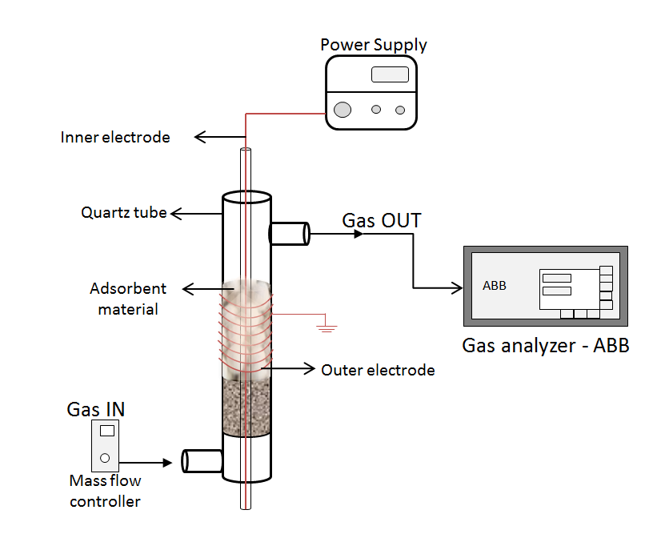
Figure 1: Experimental setup for non-thermal plasma regeneration process.
  - Results and Discussion
    - Patent blue V adsorption test
Figure 2 reports the results of adsorption tests carried out using ZEO (Figure 2a) and TiO₂ (Figure 2b) for seven reuse cycles. No cleaning or regenerating step was carried out on the used ZEO or TiO₂ pellets. After each reuse cycle, the treated solution has been discharged from the reactor and a fresh solution with the same initial patent blue concentration was fed for a new test adsorption. In the first cycle of adsorption, when the surface of both ZEO and TiO₂ pellets are free from the PB molecules, the pollutant removal was equal to 80% and 97% respectively, after 400 min of treatment time. Subsequently the first cycle, when a large number of molecules are already adsorbed on the surface of the adsorbent materials, the adsorption capacity substantially decreased until to reach a PB removal of only 20 % for ZEO and 80 % for TiO₂ after 400 min in the seven reuse cycles. This last result indicates that the ZEO and TiO₂ pellets have lost their initial adsorption capacity and a regenerative process is therefore needed for restoring the same initial efficiency in the removal of the target pollutant.
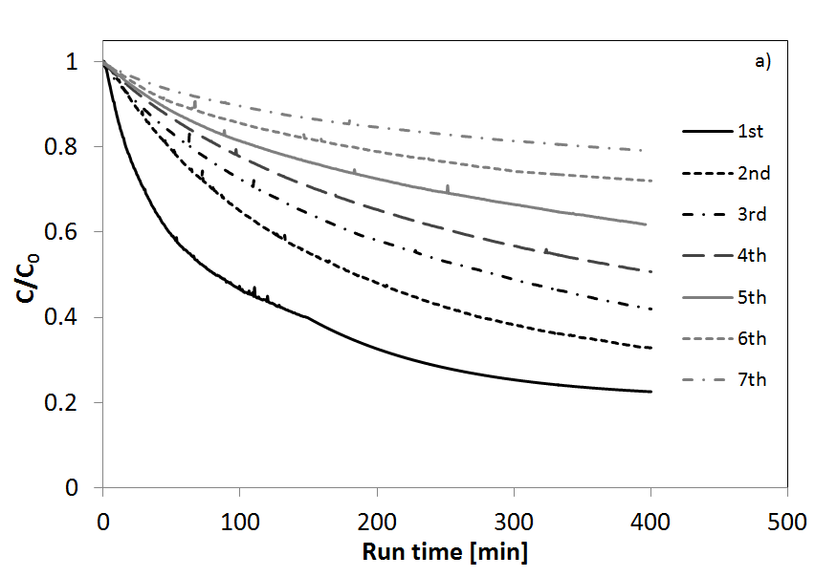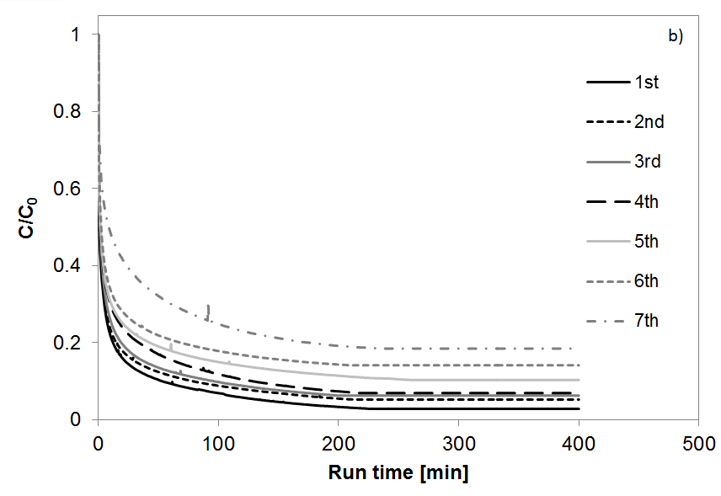

Figure 2: Adsorption reuse cycles using ZEO pellets (a) and using TiO₂ pellets (b).

    - Non thermal plasma regeneration results
In order to evaluate the efficiency of the regeneration process, a parameter monitored during the process was the CO₂ production. The analysis of CO₂ production allows to evaluate the effectiveness of the regeneration process since it is representative of the mineralization of the organic substance adsorbed on the surface of the used materials. Figures 3a and 3b show the CO₂ production during the application of non-thermal plasma on ZEO pellets and on TiO₂ pellets, respectively. For both materials it is possible to observe that the maximum CO₂ production is obtained after the first 5 minutes of treatment, confirming the immediate efficiency in the mineralization of PB by non-thermal plasma applications and therefore the regeneration of the adsorbent materials. The application of the electric discharge allows the formation of O₃ from O₂ present in the air. Ozone, an extremely reactive molecule, has the main function of degrading the PB molecules adsorbed on the material.

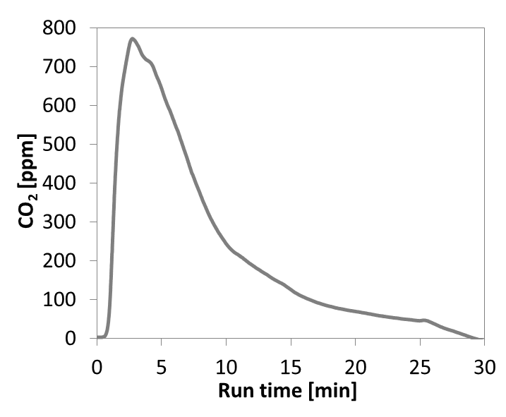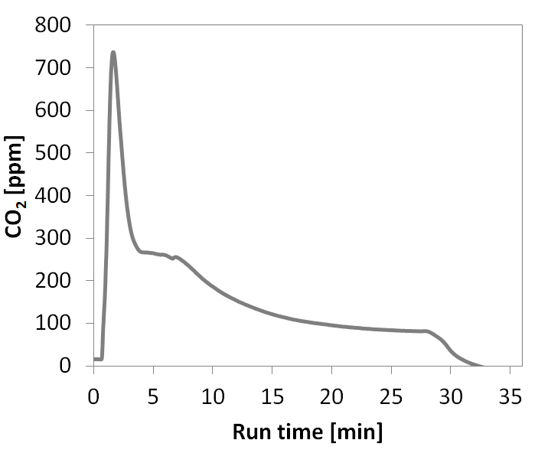
a)
b)
Figure 3: CO₂ production during the application of non-thermal plasma treatment for ZEO pellets (a) and TiO₂ pellets (b) regeneration.

In addition to the CO₂ production, the effectiveness of the non-thermal plasma process in the regeneration of the adsorbent materials is demonstrated by the recovery of the adsorbing properties.

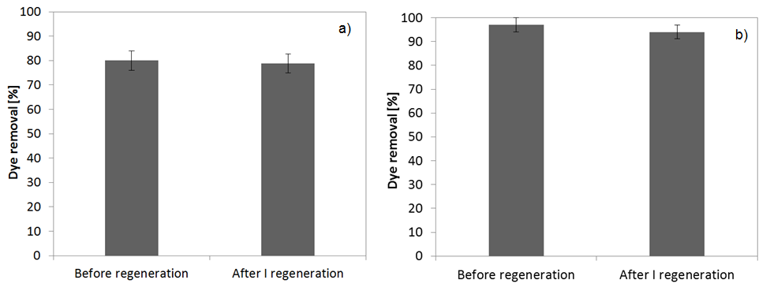
Figure 4: Dye removal on ZEO pellets (a) and TiO₂ pellets (b) before and after the first regeneration step.
Figure 4 reports the comparison between the amounts of dye removed with zeolites (Figure 4a) and TiO₂ pellets (Figure 4b) before the regeneration step and the amount of dye removed after the regeneration step. In particular for the ZEO pellets it is possible to observe that the dye removal before the regeneration step was equal to 80% and after the regeneration with non-thermal plasma process it was equal to about 79%. As for the zeolites, also in the case of TiO₂ pellets, the adsorption properties (97% of dye removal) are almost completely recovered after the regeneration process (95% of dye removal). It was also demonstrated that the non-thermal plasma based technology allows to obtain the regeneration of the adsorbent material without damaging their properties and structural characteristics, even after several regeneration cycles. Repetitive operations of dye adsorption and non-thermal plasma regeneration were conducted to demonstrate this ability. The results were reported in Figure 5. As it can be seen, the adsorption properties of the zeolites (Figures 5a) and TiO₂ pellets (Figure 5b) remains unchanged even after four regeneration cycles.

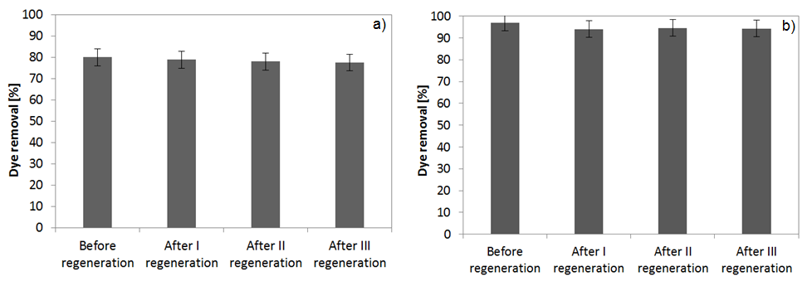
Figure 5: Dye removal on ZEO pellets (a) and TiO₂ pellets (b) before and after the different regeneration step.
  - Conclusions
In this work, two different commercial macroscopic adsorbent materials (Na-ZSM5 zeolite in spherical pellets and TiO₂ cylindrical pellets) has been tested in the removal of Patent blue V dye and they were regenerated using an innovative techniques based on non-thermal plasma process. The results have shown clearly that both the used macroscopic adsorbent materials are able to effectively remove the Patent blue V dye from water. However, their adsorption capacity substantially decreased until to reach only 20% and 80% of Patent blue V removal after 400 min in the seven reuse cycles for ZEO pellets and TiO₂ pellets, respectively. Using the non-thermal plasma based technology it was possible to regenerate, in a short time (after only 5 min), both the adsorbent materials. Therfore, it has been demonstrated that with the application of non-thermal plasma technology, the adsorbing capacities of zeolites and titania pellets have been completely restored, preserving the properties of the materials and their structural characteristics, also after repetitive operations of adsorption and non-thermal plasma regeneration.
References
Aziz, K. H. H., Miessner, H., Mahyar, A., Mueller, S., Kalass, D., Moeller, D. & Omer, K. M. 2019. Removal of dichloroacetic acid from aqueous solution using non-thermal plasma generated by dielectric barrier discharge and nano-pulse corona discharge. Separation and Purification Technology.
Bangash, F. K. & Alam, S. 2006. Kinetic of Patent Blue VF Adsorption from aqueous solution on activated bone charcoal. Journal of the Chinese Chemical Society, 53, 1091-1108.
Brahim, I. O., Belmedani, M., Belgacem, A., Hadoun, H. & Sadaoui, Z. 2014. Discoloration of azo dye solutions by adsorption on activated carbon prepared from the cryogenic grinding of used tires. Chemical Engineering Transactions, 38.
Cantarella, M., Gorrasi, G., Di Mauro, A., Scuderi, M., Nicotra, G., Fiorenza, R., Scirè, S., Scalisi, M. E., Brundo, M. V. & Privitera, V. 2019. Mechanical milling: a sustainable route to induce structural transformations in MoS 2 for applications in the treatment of contaminated water. Scientific reports, 9, 974.
De Caprariis, B., De Filippis, P., Petrucci, E. & Scarsella, M. 2018. Activated Biochars Used as Adsorbents for Dyes Removal. Chemical Engineering Transactions, 65, 103-108.
Dutta, T., Kim, T., Vellingiri, K., Tsang, D. C., Shon, J., Kim, K.-H. & Kumar, S. 2019. Recycling and regeneration of carbonaceous and porous materials through thermal or solvent treatment. Chemical Engineering Journal.
Foo, K. & Hameed, B. 2009. An overview of landfill leachate treatment via activated carbon adsorption process. Journal of hazardous materials, 171, 54-60.
Gao, J.-F., Zhang, Q., Wang, J.-H., Wu, X.-L., Wang, S.-Y. & Peng, Y.-Z. 2011. Contributions of functional groups and extracellular polymeric substances on the biosorption of dyes by aerobic granules. Bioresource technology, 102, 805-813.
Gong, J.-L., Wang, B., Zeng, G.-M., Yang, C.-P., Niu, C.-G., Niu, Q.-Y., Zhou, W.-J. & Liang, Y. 2009. Removal of cationic dyes from aqueous solution using magnetic multi-wall carbon nanotube nanocomposite as adsorbent. Journal of hazardous materials, 164, 1517-1522.
Gupta, T., Karki, S., Fournier, R. & Ayan, H. 2018. Mathematical modelling of the effects of plasma treatment on the diffusivity of biofilm. Applied Sciences, 8, 1729.
Iervolino, G., Vaiano, V. & Palma, V. 2019. Enhanced removal of water pollutants by dielectric barrier discharge non-thermal plasma reactor. Separation and Purification Technology, 215, 155-162.
Kulkarni, S. & Kaware, J. 2014. Regeneration and recovery in adsorption-a review. International Journal of Innovative Science, Engineering & Technology, 1, 61-64.
Kuroki, T., Fujioka, T., Kawabata, R., Okubo, M. & Yamamoto, T. 2009. Regeneration of honeycomb zeolite by nonthermal plasma desorption of toluene. IEEE Transactions on Industry Applications, 45, 10-15.
Li, H., Hou, J., Duan, L., Ji, C., Zhang, Y. & Chen, V. 2017. Graphene oxide-enzyme hybrid nanoflowers for efficient water soluble dye removal. Journal of hazardous materials, 338, 93-101.
Liu, J., Crittenden, J. C., Hand, D. W. & Perram, D. L. 1996. Regeneration of adsorbents using heterogeneous photocatalytic oxidation. Journal of Environmental Engineering, 122, 707-713.
Mafra, M., Igarashi-Mafra, L., Zuim, D., Vasques, É. & Ferreira, M. 2013. Adsorption of remazol brilliant blue on an orange peel adsorbent. Brazilian Journal of Chemical Engineering, 30, 657-665.
Meshkat, S. S., Rashidi, A., Dastgerdi, Z. H. & Esrafili, M. D. 2019. Efficient DBT removal from diesel oil by CVD synthesized N-doped graphene as a nanoadsorbent: Equilibrium, kinetic and DFT study. Ecotoxicology and environmental safety, 172, 89-96.
Mittal, A., Mittal, J., Malviya, A. & Gupta, V. 2009. Adsorptive removal of hazardous anionic dye “Congo red” from wastewater using waste materials and recovery by desorption. Journal of Colloid and Interface Science, 340, 16-26.
Morent, R., De Geyter, N., Verschuren, J., De Clerck, K., Kiekens, P. & Leys, C. 2008. Non-thermal plasma treatment of textiles. Surface and Coatings Technology, 202, 3427-3449.
Qu, G.-Z., Li, J., Wu, Y., Li, G.-F. & Li, D. 2009. Regeneration of acid orange 7-exhausted granular activated carbon with dielectric barrier discharge plasma. Chemical Engineering Journal, 146, 168-173.
Šafařı́k, I. & Šafařı́ková, M. 2002. Detection of low concentrations of malachite green and crystal violet in water. Water research, 36, 196-200.
San Miguel, G., Lambert, S. & Graham, N. 2001. The regeneration of field-spent granular-activated carbons. Water Research, 35, 2740-2748.
Shende, R. & Mahajani, V. 2002. Wet oxidative regeneration of activated carbon loaded with reactive dye. Waste Management, 22, 73-83.
Sultana, S., Vandenbroucke, A. M., Leys, C., De Geyter, N. & Morent, R. 2015. Abatement of VOCs with alternate adsorption and plasma-assisted regeneration: a review. Catalysts, 5, 718-746.
Vaiano, V., Iervolino, G., Sannino, D., Murcia, J. J., Hidalgo, M. C., Ciambelli, P. & Navío, J. A. 2016. Photocatalytic removal of patent blue V dye on Au-TiO2 and Pt-TiO2 catalysts. Applied Catalysis B: Environmental, 188, 134-146.
Wang, S., Li, H., Xie, S., Liu, S. & Xu, L. 2006. Physical and chemical regeneration of zeolitic adsorbents for dye removal in wastewater treatment. Chemosphere, 65, 82-87.
Zhou, Z., Lin, S., Yue, T. & Lee, T.-C. 2014. Adsorption of food dyes from aqueous solution by glutaraldehyde cross-linked magnetic chitosan nanoparticles. Journal of Food Engineering, 126, 133-141.

