CHEMICAL ENGINEERING TRANSACTIONS  VOL. 73, 2019 | A publication of
The Italian Association
of Chemical Engineering
Online at www.aidic.it/cet
Guest Editors: Andrea D’Anna, Paolo Ciambelli, Carmelo Sunseri
Copyright © 2019, AIDIC Servizi S.r.l.
ISBN 978-88-95608-70-9; ISSN 2283-9216

Photocatalytic Oxidation of Arsenite to Arsenate Using a Continuous Packed Bed Photoreactor
Giuseppina Iervolinoª, Vincenzo Vaiano^{a,}*, Mariantonietta Matarangoloª Luigi Rizzo^{b}
ª Department of Industrial Engineering, University of Salerno, Via Giovanni Paolo II, 132, 84084 Fisciano (SA), Italy
^{b} Department of Civil Engineering, University of Salerno, via Giovanni Paolo II, 132, 84084 Fisciano (SA) Italy
*vvaiano@unisa.it
The aim of this work was to evaluate the effectiveness of TiO₂ pellets for the photocatalytic oxidation of As(III) to As(V) under UV light with simultaneous adsorption of As(V) in a continuous packed bed photoreactor. In particular commercial cylindrical pellets of TiO₂ were used as photocatalyst. Experimental photocatalytic tests were carried out in a cylindrical pyrex photoreactor (irradiated by UV-LEDs) which operates in continuous mode in order to treat aqueous solution contaminated with arsenic at different initial As(III) concentration. Preliminary tests conducted in a batch configuration showed that TiO₂ pellets adsorb As(V) produced from the photoreaction, without leading to a deactivation of the active sites and evidencing that the As(V) produced is completely released into the solution. Moreover, TiO₂ pellets maintained an excellent photoactivity and durability after several cycles making it a very promising catalyst to be employed in continuous reactors for the photocatalytic treatment of water polluted by arsenic, obtaining 98% As(III) oxidation yield after only 15 min of UV-LEDs irradiation. Moreover, the use of a continuous packed bed reactor filled with the stable TiO₂ catalyst pellets irradiated by UV light allows to reach a steady state As(III) concentration without any deactivation phenomena. Finally, with 1 mg L⁻¹ As(III) initial concentration, no As(V) release was observed from TiO₂ surface during the irradiation time evidencing that the total arsenic removal could be achieved thanks to the photocatalytic properties and adsorption ability of the TiO₂ pellets.
  - Introduction
In many countries, such as Bangladesh, United States, Vietnam and Italy, the contamination of groundwater from arsenic has become a major problem because of the toxicity of this element (Wang and Wai, 2004). The contamination is mainly natural, of geological origin, but also anthropic activities such as the use of pesticides and the presence of industries can result in groundwater contamination. People are exposed to high levels of inorganic arsenic (i) through contaminated drinking water, (ii) by using contaminated water in food preparation as well as (iii) for food crops irrigation, (iv) by eating contaminated food and (v) smoking tobacco. Long-term exposure to inorganic arsenic can lead to chronic arsenic poisoning. Skin lesions and skin cancer are the most characteristic effects. For these reason and in order to minimize arsenic related health risks, the World Health Organization (WHO) set the limit of maximum arsenic concentration in drinking water as low as 10 μg L⁻¹ (Sun et al., 2017). The prevalent forms of inorganic arsenic naturally occurring in drinking water are As(III) and As(V). The concentrations and the ratios between As(III) and As(V) are highly variable and depend on the redox conditions present in the water and in the geological context (Cullen and Reimer, 1989). In groundwater As(III) is the predominant form of arsenic, which is more toxic and mobile than As(V) (Sharma and Sohn, 2009). As(III) has low affinity with mineral surfaces, while As(V) adsorbs easily to solid surfaces. Accordingly, a pre-oxidation step to transform As(III) to As(V) is necessary to achieve an optimal As(V) adsorption (Gómez Pastora et al., 2016). In the literature several methods have been reported for the oxidation of As(III) in As(V). They are mainly based on the use of conventional oxidants, such as chlorine, chlorine dioxide (ClO₂), chloramine (NH₂Cl), permanganate (MnO₄⁻) (Önnby et al., 2014). However, to avoid the formation of dangerous oxidation by-products and the presence of residuals in the treated water, photocatalysis can be a valid alternative. Recently, several studies have been performed on the application of photocatalysis for the removal of arsenic from drinking water mainly using UV light active TiO₂ or other semiconductors, such as Fe₃O₄ (Sun et al., 2017). In another paper, MoO_{x}/TiO₂ photocatalytst allowed to achieve the total oxidation of As(III) to As(V) in water without TiO₂ deactivation (Vaiano et al., 2016). TiO₂ and zero-valent iron under simulated sunlight (Xe lamp) were also investigated and photocatalytic oxidation of As(III) to As(V) was found to be strongly affected by pH, being the optimal result observed at pH=3 (Dutta et al., 2005). Also photocatalytic oxidation of As(III) to As(V) under visible light using Fe doped TiO₂ semiconductor was investigated and a complete oxidation was observed after only 30 min of irradiation time (Iervolino et al., 2018). Therefore, according to the literature, photocatalysis with TiO₂ based photocatalyst is effective in the oxidation of As(III) to As(V) (Zhang and Itoh, 2006). However, most of the studies available in scientific literature, deal with slurry reactors (Dutta et al., 2004), but. this experimental set-up would be quite hard to upscale. Therefore, to treat high flow rates and to make the photocatalyst easily removable at the end of the process, the synthesis of structured catalysts is becoming increasingly interesting research area for the scientific community. Accordingly, in this work the use of TiO₂ pellets was proposed for the removal of arsenic from drinking water. However, another limitation of the application of the photocatalytic process is represented by the absence of a proper reactor design and optimization because of the most studied photoreactors are in batch configuration (Sacco et al., 2018). Due to a more easy scale-up process, an interesting alternative is represented by reactors that can be operated in continuous mode (McCullagh et al., 2010). In particular, the use of micro-reactors allows the uniform irradiation of the whole solution volume and consequently the photocatalytic reactions can be substantially accelerated (from h/days for batch process to seconds/mins in continuous-flow) (Cambié et al., 2016). Moreover, micro-reactors can also improve mass transfer, due to the formation of a thin film of the aqueous solution over the catalyst surface, thus enabling an efficient penetration of UV radiation inside the core of the reactor (Sengupta et al., 2001). In this work a solution about the problem of drinking water contaminated by arsenic is proposed, using a continuous mode operated photoreactor, as well as exploiting the photocatalytic efficiency of TiO₂ pellets.
  - Experimental
    - Photocatalytic activity tests using batch reactor
The photocatalytic oxidation of As(III) to As(V) was preliminarily studied in a cylindrical batch photoreactor. TiO₂ commercial cylindrical pellets (size equal to 10 x 2.8 mm; anatase crystalline form, Sigma-Aldrich) were used during the photocatalytic tests. The amount of TiO₂ sample, used in the experimental tests, was equal to 4 g. UV-LEDs strip (LEDs nominal power: 12 W m⁻²; main emission: 365 nm) was used as light source and positioned around the external surface of the photoreactor. The system was left in dark conditions for 1 hour and then the reaction was started under UV light up to 3 h. The initial As(III) concentration was 5 mg L⁻¹ while the solution volume was 100 mL. During the photocatalytic test, liquid samples were collected at fixed time and analyzed. In particular, the As(V) concentration was analyzed by a spectrophotometric method based on the formation of molybdenum blue, which allows the evaluation of As(V) concentration at λ = 880 nm (Perkin Elmer UV-Vis spectrophotometer) (Vaiano et al., 2014). The concentration of the total arsenic was analyzed by preliminary oxidizing As(III) fraction through the addition of a KMnO₄ aqueous solution. In this way As(III) was totally oxidized to As(V) and then analyzed with the molybdenum blue method in both untreated and treated solutions (Vaiano et al., 2016). In particular the As(III) and As(V) concentrations were calculated using the following equations:

As_{tot} = As_{oxidized} − As_{reduced};

As(III) = As_{oxidized} − As_{untreated};

As(V) = As_{untreated} − As_{reduced};

    - Experimental tests using the continuous flow micro-reactor
A cylindrical pyrex reactor (ID = 1.3 cm, L_{TOT} = 10 cm and V_{TOT} = 7 mL), operating in continuous mode, was used for photocatalytic tests (Figure 1). The stock solutions containing the As(III) (at 5 and 1 mg L⁻¹ initial concentration) were prepared and collected in the feed tank (3 L). The feed tank was equipped with a magnetic stirrer to assure the complete homogenization of the stock solution. The arsenic solution was pumped from the feed tank to the continuous flow photo-reactor using a peristaltic pump (Watson Marlowe 120 s). The overall liquid stream is fed from the bottom of the reactor at 0.5 mL min⁻¹ flow rate. Then it passes through the catalytic bed and finally comes out from the top of the reactor, being conveyed in a tank where the treated solution was collected. The liquid samples to be analyzed were taken at the outlet of the continuous flow reactor. The total amount of TiO₂ pellets used in the experimental tests accounted for 4 g. The micro-reactor was irradiated with a UV-LEDs strip (nominal power: 12 W m⁻²; wavelength emission peak: 365 nm) positioned on the external surface of the cylindrical reactor.

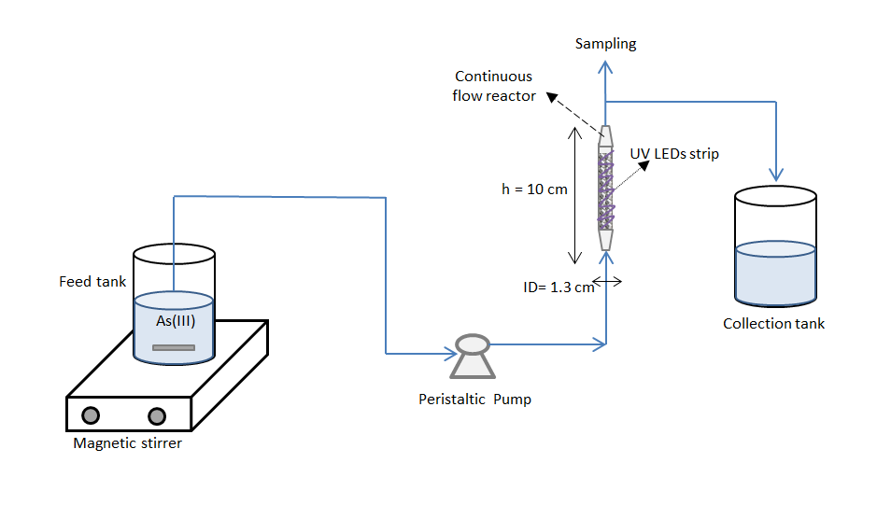
Figure 1: Experimental set-up apparatus using continuous flow reactor.
  - Results
    - Photocatalytic tests in batch
In order to evaluate the efficiency of TiO₂ pellets photocatalysts in batch conditions, the photocatalytic oxidation of As(III) to As(V) under UV light was evaluated. In particular, control tests were carried out in the presence of As(III) and irradiating the photoreactor with UV LEDs in the absence of the photocatalyst (photolysis reaction). Subsequently, this result was compared with the photocatalytic test. The behavior of the As(III) relative concentration (Figure 2a) and As(V) produced (Figure 2b) as a function of irradiation time is shown in Figure 2. The photolysis control test did not result in any oxidation activity. In presence of TiO₂ pellets an important decrease of the As(III) concentration was obtained. In particular, it is possible to observe that, after only 15 min of irradiation, 90% of As(III) was removed. The total As(III) removal was obtained after about 1 hour of treatment. It is important to underline that this result remains constant after 5 cycles of photocatalytic activity (Figure 2a). Figure 2b shows the formation of As(V) during the photocatalytic test. During the early minutes of irradiation, the As(V) was released in the solution. However, after 15 min, the As(V) obtained from the oxidation of the As(III) started to decrease due to the adsorption on TiO₂ pellets, thus ensuring the complete removal of the As(III) and As(V) present in solution after 120 min of treatment. Accordingly, TiO₂ pellets photocatalyst was effective in the simultaneous removal of As(III) and As(V) formed during the photocatalytic oxidation of As(III), and it was also proven to be reusable for several cycles, keeping its activity constant. In order to confirm the adsorption ability of TiO₂ pellets, experimental tests were carried out in the presence of only As(V) solution (initial concentration equal to 5 mg L⁻¹), in dark condition (Figure 3). In this case, TiO₂ pellets showed an important adsorbing property for As(V), being it removed by 87% after 60 min of treatment and 100% after 180 min, so confirming the literature results about the affinity of As(V) with the adsorbent materials (Pena et al., 2005). In addition, TiO₂ pellets were used for several cycles (without regeneration steps) and it was possible to note that, after 180 min, their activity remains constant also after four reuse cycles. These results demonstrate that the use of TiO₂ pellets allows to obtain two processes in a single step, the oxidation of As(III) in As (V) (Figure 2b) and the adsorption of As(V) to the photocatalyst, avoiding subsequent adsorption step, typically necessary for the complete removal of the As(V) from water (Iervolino et al., 2016).
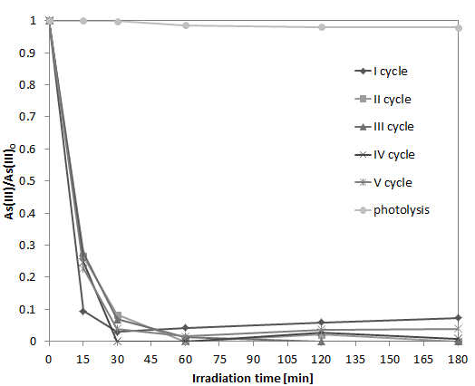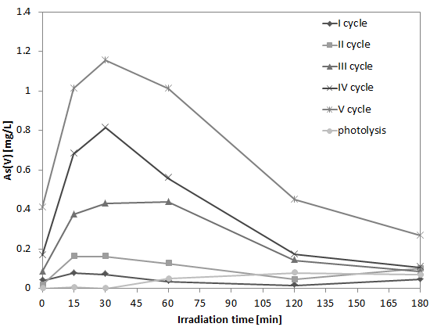
b)
a)
Figure 2: Behaviour of As(III) relative concentration in solution (a) and behaviour of As(V)concentration in solution (b) as a function of UV light irradiation time.
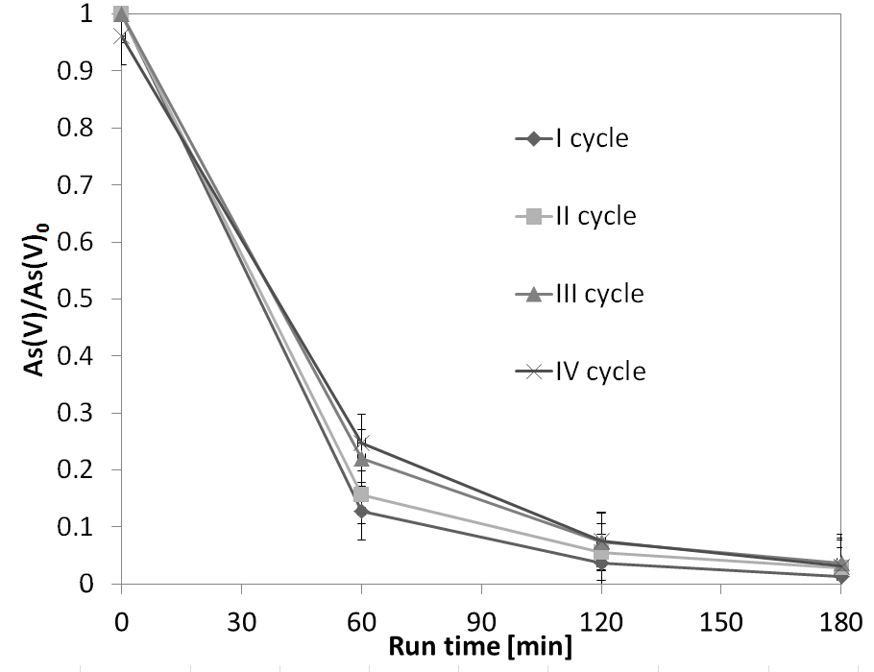
Figure 3: Behaviour of As(V) relative concentration in solution during dark adsorption experiment.

    - Photocatalytic tests in the continuous ﬂow reactor
The results of photocatalytic experiments performed in the continuous flow micro-reactor are reported in Figure 4. In particular, the graph shows the oxidation of As(III) to As(V) in the presence of UV LEDs and with an initial concentration of As(III) equal to 5 mg L⁻¹. It is possible to note that during the experiment, the TiO₂ pellets maintained their activity and the As(III) oxidation was equal to 80% in the steady state condition. The formation of As(V) released in solution increased up to about 2.5 mg L⁻¹, a significantly lower amount than the expected value (4 mg L⁻¹). In order to perform a test in almost real conditions, the same photocatalytic experiment was performed at lower initial As(III) concentrations (1 mg L⁻¹) (Figure 5). In this case it was possible to note that the As(III) was totally oxidized without any release of As(V) in the solution, indicating that the obtained As(V) was adsorbed on the TiO₂ pellets surface, confirming the results obtained under batch conditions (Figures 2 and 4) where the As(V) adsorption was observed for different reuse cycles. Therefore, the developed system could be able to guarantee the complete removal of the arsenic from water matrix, especially at very low As(III) initial concentration.
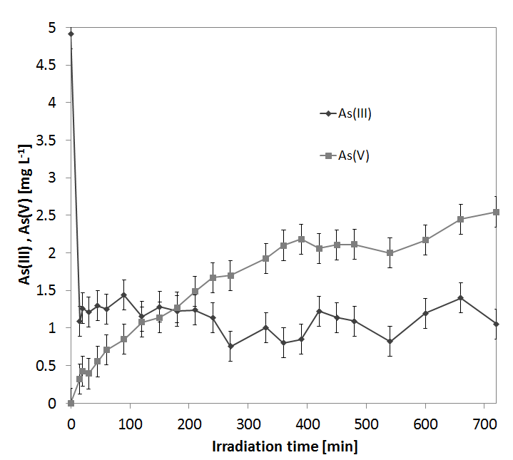
Figure 4: Behaviour of As(III) and As(V) concentration during the photocatalytic test. As(III) initial concentration: 5 mg L⁻¹.

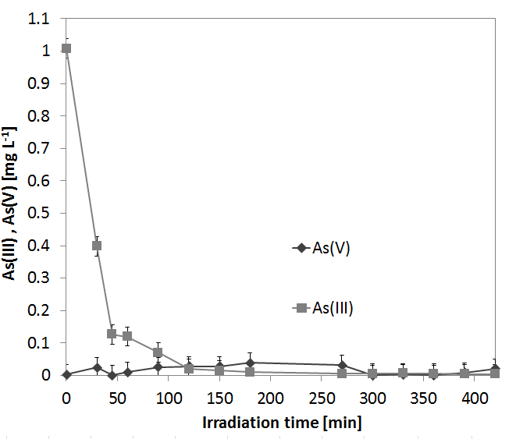
Figure 5: Behaviour of As(III) and As(V) concentration during the photocatalytic test. As(III) initial concentration: 1 mg L⁻¹.
  - Conclusions
The photocatalytic oxidation of As(III) to As(V) in mild conditions was investigated in the presence of TiO₂ pellets. The results from batch condition tests showed 90% of photocatalytic oxidation of As(III) under UV light, after only 15 min of irradiation. During the early minutes of the treatment, the As(V) was released into the solution. Subsequently, adsorption on TiO₂ pellets took place, ensuring the simultaneous and complete removal of the As(III) and As(V) from the aqueous solution. The continuous flow micro-reactor configuration confirmed the performances obtained under batch conditions, highlighting that, even in the presence of low As(III) concentrations (1 mg L⁻¹), the system was effective in the purification of arsenic contaminated water. Moreover, after several reuse cycles, TiO₂ pellets maintained an excellent photoactivity and durability making it a very promising catalyst to be employed in continuous reactors for the photocatalytic treatment of arsenic polluted water. The results showed in this work are extremely interesting and could be considered as a proof of concept for the scale up application of the photocatalytic oxidation systems to be used in the removal of arsenic form drinking water.
References
Cambié, D., Bottecchia, C., Straathof, N. J., Hessel, V. & Noel, T. 2016. Applications of continuous-flow photochemistry in organic synthesis, material science, and water treatment. Chemical reviews, 116, 10276-10341.
Cullen, W. R. & Reimer, K. J. 1989. Arsenic speciation in the environment. Chemical reviews, 89, 713-764.
Dutta, P. K., Pehkonen, S., Sharma, V. K. & Ray, A. K. 2005. Photocatalytic oxidation of arsenic (III): evidence of hydroxyl radicals. Environmental science & technology, 39, 1827-1834.
Dutta, P. K., Ray, A. K., Sharma, V. K. & Millero, F. J. 2004. Adsorption of arsenate and arsenite on titanium dioxide suspensions. Journal of Colloid and Interface Science, 278, 270-275.
Gómez Pastora, J., Bringas Elizalde, E. & Ortiz Uribe, I. 2016. Design of novel adsorption processes for the removal of arsenic from polluted groundwater employing functionalized magnetic nanoparticles. Chemical Engineering Transactions, 47, 1573-1578.
Iervolino, G., Vaiano, V. & Rizzo, L. 2018. Visible light active Fe-doped TiO2 for the oxidation of arsenite to arsenate in drinking water. Chemical Engineering Transactions, 70, 241-246.
Iervolino, G., Vaiano, V., Rizzo, L., Sarno, G., Farina, A. & Sannino, D. 2016. Removal of arsenic from drinking water by photo-catalytic oxidation on MoOx/TiO2 and adsorption on γ-Al2O3. Journal of Chemical Technology and Biotechnology, 91, 88-95.
McCullagh, C., Robertson, P. K., Adams, M., Pollard, P. M. & Mohammed, A. 2010. Development of a slurry continuous flow reactor for photocatalytic treatment of industrial waste water. Journal of Photochemistry and Photobiology A: Chemistry, 211, 42-46.
Önnby, L., Kumar, P. S., Sigfridsson, K. G., Wendt, O. F., Carlson, S. & Kirsebom, H. 2014. Improved arsenic (III) adsorption by Al2O3 nanoparticles and H2O2: evidence of oxidation to arsenic (V) from X-ray absorption spectroscopy. Chemosphere, 113, 151-157.
Pena, M. E., Korfiatis, G. P., Patel, M., Lippincott, L. & Meng, X. 2005. Adsorption of As(V) and As(III) by nanocrystalline titanium dioxide. Water Research, 39, 2327-2337.
Sacco, O., Matarangolo, M., Vaiano, V., Libralato, G., Guida, M., Lofrano, G. & Carotenuto, M. 2018. Crystal violet and toxicity removal by adsorption and simultaneous photocatalysis in a continuous flow micro-reactor. Science of The Total Environment, 644, 430-438.
Sengupta, T. K., Kabir, M. F. & Ray, A. K. 2001. A Taylor vortex photocatalytic reactor for water purification. Industrial & engineering chemistry research, 40, 5268-5281.
Sharma, V. K. & Sohn, M. 2009. Aquatic arsenic: toxicity, speciation, transformations, and remediation. Environment international, 35, 743-759.
Sun, T., Zhao, Z., Liang, Z., Liu, J., Shi, W. & Cui, F. 2017. Efficient As (III) removal by magnetic CuO-Fe3O4 nanoparticles through photo-oxidation and adsorption under light irradiation. Journal of colloid and interface science, 495, 168-177.
Vaiano, V., Iervolino, G., Sannino, D., Rizzo, L. & Sarno, G. 2016. MoOx/TiO2 immobilized on quartz support as structured catalyst for the photocatalytic oxidation of As(III) to As(V) in aqueous solutions. Chemical Engineering Research and Design, 109, 190-199.
Vaiano, V., Iervolino, G., Sannino, D., Rizzo, L., Sarno, G. & Farina, A. 2014. Enhanced photocatalytic oxidation of arsenite to arsenate in water solutions by a new catalyst based on MoOx supported on TiO2. Applied Catalysis B: Environmental, 160-161, 247-253.
Wang, J. S. & Wai, C. M. 2004. Arsenic in drinking water—a global environmental problem. Journal of chemical education, 81, 207.
Zhang, F.-S. & Itoh, H. 2006. Photocatalytic oxidation and removal of arsenite from water using slag-iron oxide-TiO2 adsorbent. Chemosphere, 65, 125-131.

