CHEMICAL ENGINEERING TRANSACTIONS  VOL. 73, 2019 | A publication of
The Italian Association
of Chemical Engineering
Online at www.aidic.it/cet
Guest Editors: Andrea D’Anna, Paolo Ciambelli, Carmelo Sunseri
Copyright © 2019, AIDIC Servizi S.r.l.
ISBN 978-88-95608-70-9; ISSN 2283-9216

Study of the Carbonyl Sulphide Hydrolysis Reaction in Liquid Phase
Vincenzo Palmaª, Vincenzo Vaianoª, Daniela Barba^{a,*}, Michele Colozzi^{b}, Emma Palo^{b}, Lucia Barbato^{b}, Simona Cortese^{b,} Marino Miccio^{b}
ªUniversity of Salerno, Department of Industrial Engineering, via Giovanni Paolo II, 132, Fisciano (SA), Italy
^{b}KT kinetics Technology, Viale Castello Della Magliana, 27, 00148, Rome, Italy
dbarba@unisa.it
The hydrolysis of carbonyl sulfide (COS) was studied in a gas‐liquid reactor at room temperature and ambient pressure in presence of alkanolamines, such as monoethanolamine (MEA), diethanolamine (DEA), methyldiethanolamine (MDEA) and diisopropylamine (DIPA). The activity and stability of the different amines was investigated at fixed COS inlet concentration and reaction volume. The highest removal efficiency of COS was obtained in presence of DEA aqueous solution (25 %), while the lowest COS conversion was observed with the tertiary amine MDEA (< 10 %). A greater COS removal was obtained in presence of the higher reaction volume (400 cm³) that was equal to 25 % for DEA and 26 % for DIPA, respectively. Finally, the evaluation of the kinetic constant for the COS hydrolysis reaction with DEA was performed.
  - Introduction
Carbonyl sulphide is an undesirable impurity in a variety of industrial gases. It is often present in minor amounts in petroleum refinery gases and in larger amounts in coal gasification product streams (Xinxue et al., 2005). In particular, COS and other sulfur compounds such as CS₂, SO₂ are produced in the thermal stage of the Claus process due to the simultaneous presence of hydrocarbons and sulfur compounds (Manenti et al., 2013). The complete removal of these compounds is strictly necessary due to the more stringent environmental regulations of the sulfur emission (Palma et al., 2018). The main processes developed for the removal of COS include hydrogenation, amine processes and gas-liquid phase hydrolysis (Svoronos et al., 2002).
In process industry, basic alkanolamine solutions are used frequently to remove acidic compounds such as H₂S, COS, and CO₂ (Littel et al., 1992). The common absorbents are primary, secondary and tertiary alkanolamines (Ernst and Chen, 1988, Magné-Drisch et al., 2016). In amine based processes, COS reacts readily with primary and secondary alkanolamines solvents to form stable thiocarbamates that are difficult to regenerate and may also contribute to operational problems that involve the decreasing of the plant life and also a reduction of the solution absorption capacity (Islam et al., 2010). However, tertiary alkanolamines, e.g. MDEA, do not form stable thiocarbamates, as observed for primary and secondary alkanolamine, due to the absence of the hydrogen atoms bounded to the nitrogen and has a low vapor pressure, high resistance to degradation and requires low energy absorption for the regeneration (Bassani et al., 2015). Despite abundant literature, only few works address the absorption kinetics for COS in secondary and tertiary alkanolamines (Hinderaker, 2000, Little et al., 1992).
The aim of this work is to study the COS hydrolysis reaction in liquid phase in presence of different alkanolamines aqueous solutions, in order to classify the best one in terms of removal efficiency of COS and low tendency to the deactivation.
The COS removal was quite low in presence of MDEA (< 10 %) with respect to the performance obtained with the other alkanolamines (~ 30 %). By varying the reaction volume of DEA and DIPA, a greater stability of time on stream was observed in presence of DEA solution.
  - Experimental
At this scope, it was designed and assembled a laboratory plant for the conduction of the experimental tests. The preliminary tests were carried out at fixed temperature (20 °C) in order to perform a screening of different types of alkanolamines (MEA, DEA, MDEA, DIPA). The influence of the alkanolamine solution volume and COS inlet concentration was also assessed.
The laboratory apparatus is schematized in Figure 1.
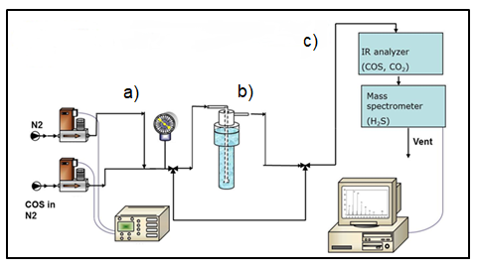
Figure 1: Scheme of the laboratory plant
The main units of the laboratory plant are: feed section (a), reaction section (b) and analysis section (c).
The feed section consists of a system of three-way valves that allows to send the stream feed (COS, N₂) to the reactor, or in by-pass position, to send the stream feed directly to the analysis.
Experimental tests were carried out in a quartz tubular reactor with 280 mm length and internal diameter of 300 mm. The feed stream is bubbled in the reactor that is located in a criostatic bath at temperature of 20 °C.
The analysis section is characterized by two analyzers: a FT-IR Multigas in continuous Nicolet Antaris IGS (Thermo Electron) for the COS, CO₂ and a quadrupole mass spectrometer for the H₂S, H₂O.
The activity tests were performed in the following operating conditions listed in Table 1:
Table 1 : Operating conditions of the activity tests
Pressure, atm | 1
Temperature, °C | 20
Total Flow Rate (Q), Ncm³/h | 30,000
COS inlet concentration (C₀), ppm | 150 – 1,000
Reaction Volume (V), cm³ | 100 - 400
Alkanolamine concentration in solution, wt % | 1
The activity measurement was evaluated by the COS conversion (xCOS) Eq(1).
$x COS\left(\%\right)=\frac{(z{COS}_{IN}-z{COS}_{OUT})}{z{COS}_{IN}}∙100$ (1)
where:
zCOS_{IN} : Inlet COS volumetric fraction [-]
zCOS_{OUT} : Outlet COS volumetric fraction [-]
  - Results
The influence of the different alkanolamines (MEA, DEA, MDEA, DIPA) on the COS removal efficiency is reported in Figure 2.
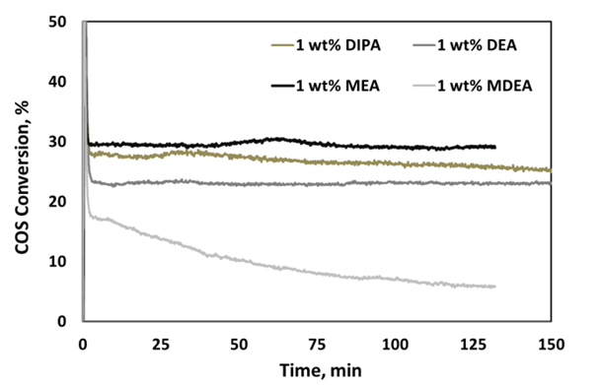
Figure 2: Influence of the type of alkanolamine (MEA, DEA, MDEA, DIPA) on the COS conversion (C₀= 1,000 ppm, V = 400 cm³)
The COS conversion decreases rather quickly in presence of MDEA, while it remains stable in presence of the other three alkanolamines. In particular, the steady state COS conversion was equal to 25 %, 27 % and 30 % for DEA, DIPA and MEA, respectively. An analysis of the gas phase did not show the presence of H₂S and CO₂, which are the main expected products of the COS hydrolysis reaction. This result could be explained considering that, H₂S and CO₂ have a very high solubility in aqueous solutions containing alkanolamines as confirmed also by literature (Dawodu et al., 1994). More precisely, CO₂ is solubilized as carbonic acid, while H₂S, splits primarily into H⁺ and HS that, in presence of water according to the reactions shown in equations Eq(2) and Eq(3).
$CO_{2}+H_{2}O= H^{+}+HCO_{3}^{-}$ (2)

$H_{2}S= H^{+}+HS^{-}$ (3)
Even if the highest COS conversion was obtained in presence of the MEA solution, it was not considered for the additional tests due to its high volatility and the formation of degradation products such as carbamates (Vaidya et al., 2009). The presence of these degradation products determines the reduction solution capacity, corrosion, foaming and fouling (Islam et al., 2010). For this reason, further investigations were performed considering DEA and DIPA.
The effect of the reaction volume on the COS conversion is shown in Figures 3 and 4 for DEA and DIPA, respectively. For both alkanolamine solutions, it is observed that a higher efficiency of the COS removal is obtained in presence of higher solution volume (400 cm³). In the case of the DEA solution, the COS conversion increases from 10 up to 24 % after 120 min of time on stream (Figure 3), while for DIPA, the final conversion was about 27 % (Figure 4).
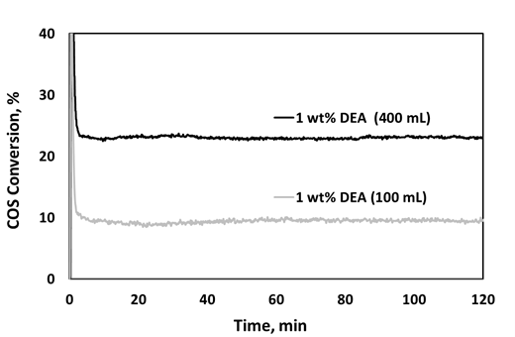
Figure 3: COS removal in DEA solution with reaction volumes of 100 and 400 cm³ (C₀= 1,000 ppm)
It is worthwhile to note that, when DIPA is used in the absorbing solution, the COS conversion is not stable during the test, showing a decreasing trend observable after about 30 min by the starting of the test.
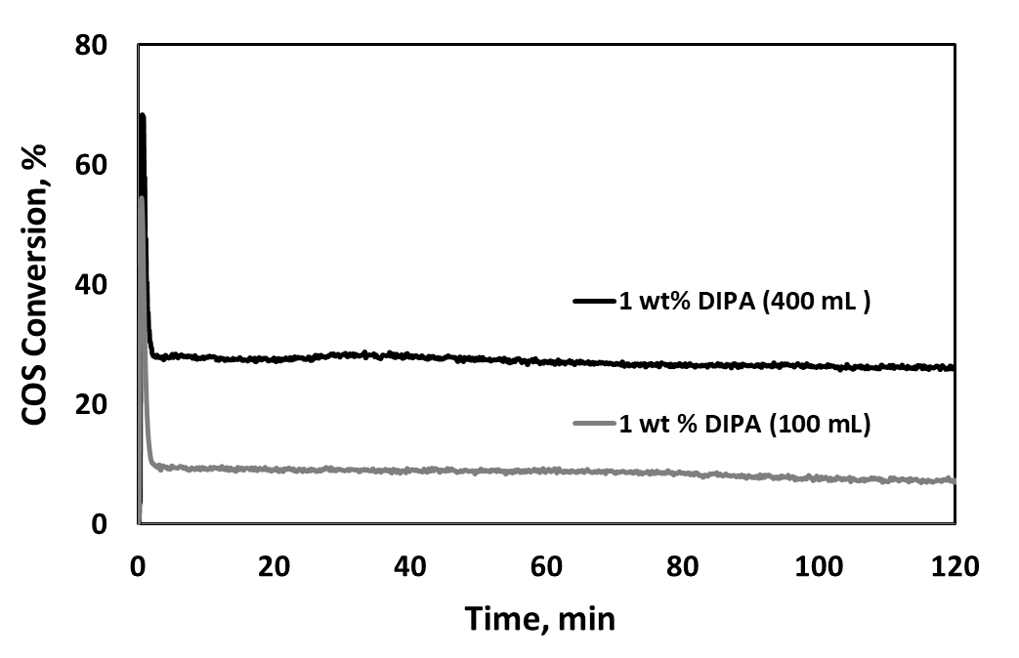
Figure 4: COS removal in DIPA solution with reaction volumes of 100 and 400 cm³ (C₀= 1,000 ppm)
Considering this observation, the influence of COS inlet concentration was investigated using DEA alkanolamine. The obtained results are shown in Figure 5.
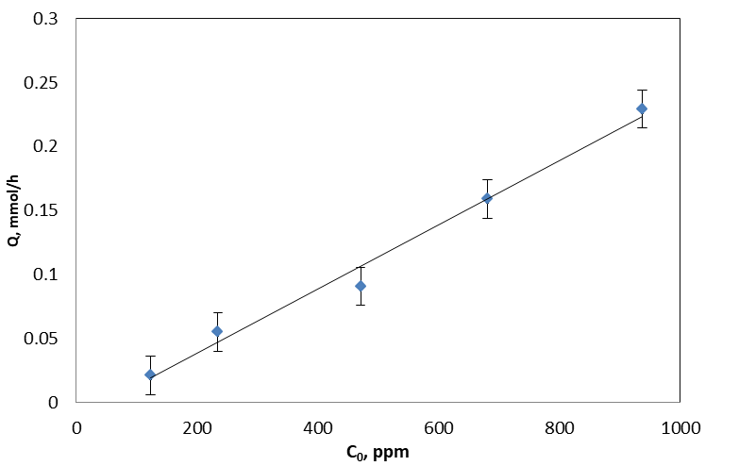
Figure 5: COS removal (Q, mmol/h) as function of the COS inlet concentration (C₀ = 150 -1000 ppm) in 1 wt% DEA solution, V = 100 cm³
The degree of COS removal grows linearly with the increasing of the COS inlet concentration. This behaviour could be indicative of the probable absence of limitations related to the mass transfer phenomena of COS molecules from the gas to the liquid phase and from the liquid-gas interface to the liquid bulk where the chemical reaction with alkanolamine occurs. In order to estimate the rate of the hydrolysis reaction for the different tested alkanolamines, the reactor was assumed as a CSTR reactor. The COS mass balance is reported in Eq(4):

$Q∙\left(C_{0}-C_{f }\right)-r∙V=0$ (4)

where:
Q = Total volumetric flow rate [Ncm³·h⁻¹]
C₀ = Inlet COS molar concentration [mol·cm⁻³]
C_{f} = Outlet COS molar concentration [mol·cm⁻³]
r = Hydrolysis Reaction rate, [mol·cm⁻³·h⁻¹]
V = Reaction volume [cm³]

The hydrolysis reaction rate was calculated in according to the following relationship Eq(5) and the obtained values are reported in Table 2.

$r=Q∙\frac{\left(C_{0}-C_{f }\right)}{V}$ (5)

Table 2 : Hydrolysis Reaction Rate of the amines (C₀=1000 ppm, V=400 cm³)
Amines | r, mol·cm³·h⁻¹
MEA | 1.0 ·10⁻⁶
DEA | 8.0 ·10⁻⁷
DIPA | 9.0 ·10⁻⁷
MDEA | 2.0 ·10⁻⁷
Very similar values of the hydrolysis reaction rates were obtained for MEA, DEA and DIPA. Based on the previous considerations regarding the use of MEA and DIPA, the kinetic constant was calculated only for DEA. According to the literature, the reaction of COS in DEA aqueous solutions is generally represented by the zwitterion mechanism Eq(6-7) (Amararene et al., 2004).
$COS+{(C_{2}H_{4}OH)}_{2}NH↔ {(C_{2}H_{4}OH)}_{2}NH^{+}COS^{-}$ (6)

${(C_{2}H_{4}OH)}_{2}NH^{+}COS^{-}+b→ {(C_{2}H_{4}OH)}_{2}NCOS^{-}{+ bH}^{+}$ (7)

The deprotonation reaction is considered as limiting step, implying the participation of a second molecule of DEA (b). Therefore, it was assumed that the reaction between COS and DEA aqueous solutions is irreversible and is of the first order with respect to COS and second order with respect to DEA concentration Eq(8):

$r=K_{COS-DEA}∙C_{COS}∙C_{DEA}^{2}$ (8)

Since all the reactions were studied with a large excess of alkanolamine over COS, a good pseudo-first order equation can be considered Eq(9):

$r=K_{app}∙C_{COS}$ (9)

and K_{app} can be therefore expressed by means of Eq(10):

$K_{app}=∙K_{COS-DEA}·C_{DEA}^{2}$ (10)

where:
K_{COS-DEA} = Kinetic constant [cm⁶·mol⁻² h⁻¹]
K_{app} = Apparent kinetic constant [h⁻¹]
C_{COS} = COS molar concentration in liquid phase [mol·cm⁻³]
C_{DEA} = DEA molar concentration in liquid phase [mol·cm⁻³]

The equilibrium of COS between gaseous and liquid phase can be described by Henry’s law Eq(11).

$P∙y_{COS}=H_{COS}∙x_{COS}$ (11)

where:
P = Total Pressure [atm]
y_{COS} = COS molar fraction in gas phase
x_{COS} = COS molar fraction in liquid phase
H_{COS} = Henry constant [atm]

Furthermore, being negligible the amine volume with respect to the water one (V_{H2O} = molar volume, cm³/mol), the COS molar concentration (C_{COS}) can be expressed according to the following equation Eq(12):

$x_{COS}= C_{COS}∙V_{H2O}$ (12)

Substituting the Eq(12) in Henry’s law Eq(11), the COS concentration can be so expressed Eq(13):

$C_{COS}=\frac{P∙y_{f}}{H∙V_{H2O}}$ (13)

By replacing the Eq(10) and Eq(13) into the Eq(4), the COS mass balance can be expressed as follows Eq(14):

$Q∙\left(C_{0}-C_{f }\right)-K_{app}∙\frac{P∙y_{f}}{H∙V_{H2O}}∙V=0$ (14)

Considering that COS must firstly dissolve in water in order to react with DEA, the value for Henry constant in the Eq(14) was approximated with that one related to COS in water and it is equal to 2190 atm (Perry and Green, 1999). Therefore the values of the apparent kinetic constant (K_{app}) and kinetic constant (K_{COS-DEA}) were respectively 39 h⁻¹ and 3900 cm⁶·mol⁻² h⁻¹.
  - Conclusions
The COS hydrolysis reaction in liquid phase was studied in presence of different alkanolamines (MEA, DEA, MDEA, DIPA) at ambient temperature. A laboratory plant was appropriately designed and assembled for the conduction of the experimental tests. From the screening of the alkanolamines, it was obtained a COS conversion of about 27 % for DIPA and DEA, while a low removal efficiency of COS was observed in presence of MDEA. The MEA has exhibited the highest removal efficiency of COS (30 %), but due to its low vapour pressure and the high degradation, it was not selected for further investigations. The decrease of the reaction volume from 400 to 100 cm³ has involved a decrease of the COS conversion up to 65 and 71 % for DIPA and DEA, respectively. Based on the obtained results, the DEA was the alkanolamine more appropriate to guarantee high stability and good reactivity towards COS. A possible future work could be the study of the COS hydrolysis in presence with aqueous solutions at higher DEA concentration in order to further increase the COS removal rate.
References
Amararene F., Bouallou C., 2004, Kinetics of Carbonyl Sulfide (COS) Absorption with Aqueous Solutions of Diethanolamine and Methyldiethanolamine, Industrial and Industrial Engineering Chemistry Research, 43 (19), 6136-6141.
Bassani A., Manenti F., Ranzia E., Lima N.N.M., Linan L.Z., 2015, Novel Coal Gasification Process: Improvement of Syngas Yield and Reduction of Emissions, Chemical Engineering Transactions, 43, 1483-1488.
Dawodu O.F., Meisen A.,1994, Mechanism and Kinetics of COS-Induced Diethanolamine Degradation, Industrial and Engineering Chemistry Research, 33, 480-487.
Ernst W.R., Chen M.S.K., 1988, Hydrolysis of Carbonyl Sulphide in a gas-liquid reactor, AIchE Journal, 34 (1), 158-162.
Hinderaker G., Sandall O. C., 2000, Absorption of carbonyl sulfide in aqueous diethanolamine, Chemical Engineering Science, 55, 5813-5818.
Islam M.S., Yusoff R., Ali B.S., 2010, Degradation Studies of Amines and Alkanolamines during CO₂ Absorption and Stripping system, Engineering e-Transaction, 5 (2), 97-109.
Littel R.J., Verstegg G.F., Van Swaaij W.P.M., 1992, Kinetics of COS with primary and secondary amines in aqueous solutions, AIchE Journal, 38 (2), 244-250.
Magné-Drisch J., Gazarian J., Gonnard S., Schweitzer J.M., Chiche D., Laborie G., Perdu G., 2016, COSWEETTM: A New Process to Reach Very High COS Specification on Natural Gas Treatment Combined with Selective H₂S, Removal Oil & Gas Science and Technology, 71, (3), 40.
Manenti F., Papasidero D., Ranzi E., 2013, Revised Kinetic Scheme for Thermal Furnace of Sulfur Recovery Units, Chemical Engineering Transactions, 11, 221-230.
Palma V., Barba D., Vaiano V., Colozzi M., Palo E., Barbato L., Cortese S., Miccio M., 2018, Catalytic Oxidative Decomposition of H₂S for Hydrogen Production, Chemical Engineering Transactions, 70, 325-330.
Perry R.B., Green D.W., 1999, Perry’s Chemical Engineers’ Handbook, Seventy Edition, McGraw Hill.
Svoronos P.D.N, Bruno T.J., 2002, Carbonyl Sulfide: A review of its chemistry and properties, Industrial and Engineering Chemistry Research, 41, 5321-5336.
Vaidya P.D., Kenig E.Y., 2009, Kinetics of Carbonyl Sulfide reaction with Alkanolamines: A review, Chemical Engineering Journal, 148, 207–211.
Xinxue L., Yingxin L., Xionghui W., 2005, Hydrolysis of Carbonyl Sulfide in binary mixture of Diethylene Glycol Diethyl Ether and Water, Chinese Journal of Chemical Engineering, 13 (2), 234-238.

