|  |  |
| --- | --- |
| cetlogo ***CHEMICAL ENGINEERING TRANSACTIONS***  ***VOL. 73, 2019*** | A publication of  aidiclogo_grande |
| The Italian Association  of Chemical Engineering  Online at www.aidic.it/cet |
| Guest Editors: Andrea D’Anna, Paolo Ciambelli, Carmelo Sunseri  Copyright © 2019, AIDIC Servizi S.r.l.  **ISBN** 978-88-95608-70-9; **ISSN** 2283-9216 | |

Immobilization of Horseradish Peroxidase on Fe3O4/Au\_GO Nanoparticles to Remove 4-Chlorophenols from Waste Water

Maria Sarnoa,b, Mariagrazia Iulianoa\*

aDepartment of Industrial Engineering, University of Salerno, Via Giovanni Paolo II ,132 - 84084 Fisciano (SA), Italy

bCentre NANO\_MATES, University of Salerno Via Giovanni Paolo II ,132 - 84084 Fisciano (SA), Italy

mariagraziaiuliano@outlook.it

Here we report the removal of 4-chlorophenols from waste water through the use of horseradish peroxidase (HRP) immobilized on Fe3O4/Au\_GO nanoparticles. The large amount of surface functional groups on the support, which is coated with citric acid molecules, enables rapid enzyme immobilization through electrostatic interactions. HRP have been immobilized through physical adsorption on Fe3O4/Au\_GO for 4-chlorophenols removal. The 4-chlorophenol degradation in presence of HRP immobilized on Fe3O4/Au\_GO was 98 % after 180 min and at room temperature, with a reusability after three cycle of 95 %.

* 1. Introduction

Aromatic compounds, such as: phenol-based compounds; aromatic amines; constitute one of the major classes of pollutants. Indeed, they are dangerous and persistent organic pollutants due to their high toxicity, carcinogenic, teratogenicity and mutagenic effects. They are found in the waste waters of a wide variety of industries, including plastics, pharmaceuticals, wood preservatives, pesticides, petrochemicals, of printing and dyeing materials (Zhang et al.,2009). Given, the great number of industrial waste waters containing chlorophenols, they are continuously monitored. Environmental legislation defines the maximum discharge limit in rivers as about 0.1 mg/L. On other hand, the concentrations of chlorophenols found in the effluents may vary from 100 to 1000 mg/l and their degradation is usually difficult (Cooper et al., 1996). For these reasons, different techniques such as physical adsorption, catalytic oxidation and biodegradation have been used for the removal of chlorophenols. The enzymatic treatment has been proposed by many researchers as a potential alternative to conventional methods. Biodegradation due to enzymatic action presents high specificity, selectivity and catalytic activity, mild reaction conditions and few by-products formation (Dong et al., 2014). Moreover, enzymes are less likely to be inhibited by substances which may be toxic for living organisms. Peroxidases, such as: horseradish peroxidase (HRP); lignin peroxidase (LiP); manganese peroxidase (MnP), etc, have been used for treatment of aqueous aromatic compounds. In particular, HRP can degrade chlorophenols (Hamid et al., 2009). This enzyme catalysed the oxidation of the phenol in presence of hydrogen peroxide to generate phenoxy radicals, which react with other substrate molecules to give oligomers or polymers that are much more insoluble in water compared to the original monomers (Dong et al., 2014;Laurenti et al., 2002).

The reactions can be simply summarized in the following equation:

|  |  |
| --- | --- |
| $$\text{2RH + }{\text{H}}_{\text{2}}{\text{O}}_{\text{2}}\text{→ 2}{\text{R}}^{\text{·}}\text{ + 2}{\text{H}}_{\text{2}}\text{O}$$ | (1) |

On another hand, the use of HRP is limited due to poor stability and process costs, and because of enzyme recovery and reuse are difficult. These disadvantages can be overcome by immobilizing the enzyme (Sarno et al., 2017a; Sarno et al 2019). Enzyme immobilization can enhance the reusability and reduce the operational process cost. Immobilized enzymes are often more stable with pH than free enzymes (Sharma et al., 2017). Nanomaterials can serve as promising supporting materials for immobilization, because of their specific surface area and effective enzyme loading (Feng et al., 2011). The literature presents different types of nanomaterials for enzyme immobilization. Examples of nanomaterials used for enzyme immobilization include: carbon nanotubes (CNTs); nanoparticles (NPs); magnetic nanoparticles (MNPs), nanocomposites; nanofibers; nanorods and mesoporous media (Andreescu et al., 2008). Graphene oxide (GO) (a graphene derivative) is a planar material with a large specific surface area. For this reason, it is a promising candidate for the enzyme immobilization. Graphene oxide contains a range of reactive oxygen functional groups on the surface (Zhang et al ., 2010; Chang et al., 2014), for this reason, can be easily modified and dispersed in water. On the other hand, graphene can be used as support for nanoparticles dispersion and stabilization (Jiang et al., 2011; Zhang et al., 2010; Sarno et al., 2016). Magnetic nanoparticles (MNPs) offer the additional advantages of: easy separation, just by applying a magnetic field; and, possible higher selectivity (Sharma et al., 2017). Herein, a simple one-step strategy was developed to obtain Fe3O4/Au\_GO nanoparticles, constituted of GO supporting flower like Fe3O4/Au NPs (pistil Au NPs and petals Fe3O4 NPs), by adding graphene oxide (GO) in an ethylene glycol solution of ferric chloride (FeCl3∙6H2O) and Gold(III) chloride trihydrate (HAuCl4·3H2O) precursors and in presence of citric acid surfactant. Fe3O4/Au nanoparticles deposition on the graphene oxide sheets and partial reduction of GO occurred simultaneously. The citric acid functionalized Fe3O4/Au\_GO nanoparticles, synthesized via a solvothermal process, can immobilize HRP to remove 4-chlorophenols in the presence of H2O2. The effects of coupling time and enzyme concentration on the immobilized efficiency were investigated. The effect of reaction time and the reusability on the removal of 4-chlorophenols were also evaluated.

* 1. Material and Method
     1. Synthesis Fe3O4/Au\_GO nanoparticles

The commercial graphene oxide (GO) was purchased from Graphene Supermarket. All the other chemicals were acquired from Sigma Aldrich.

Synthesis procedure, 75 mg of GO, Fe3Cl3·6 H2O (3 mmol), HAuCl4 (0.1 mmol), Urea (30 mmol) and citric acid (0.5 mmol) were dispersed in 30 ml of ethylene glycol. The mixture was ultra-sonicated for 5 min. Subsequently, the solution was transferred into a teflon-lined stainless steel autoclave and then heated at 200 °C for 4 h. After cooling down to room temperature the black material was washed with ethanol for several time and then dried at 60°C for 12 h to obtain Fe3O4/Au\_GO NPs.

* + 1. HRP Immobilization

Fe3O4/Au\_GO NPs (0.1 mg) and 1, 2, 4 mg of HRP in 10 ml of phosphate buffer pH =6 were mixed at 4°C for ~ 3 h. Finally, immobilized enzymes were separated by an external magnetic field. The nanoparticles with anchored HRP were gathered and rinsed three times with buffer phosphate (pH 6.0) to specifically remove non-attached enzymes. In order to determine the amount of enzyme loading, the residual enzyme in the collected supernatant was measured using UV/Visible spectroscopy. The immobilized enzyme was dispersed in the buffer and stored at 4°C for further measurements.

* + 1. Enzyme loading determination

The amount of immobilized enzyme on Fe3O4/Au\_GO was determined by subtracting the initial amount of enzyme from the amount of enzyme remaining in the supernatant. The concentration of unbound enzymes which were in the supernatant was determined with a calibration curve and then the amount of enzyme immobilized on Fe3O4/Au\_GO nanoparticles was obtained. In particular, the enzyme attachment percentage was calculated by Bradford method (Bradford, 1976)

* + 1. 4-Chlorophenol degradation

The removal efficiency is defined as the percentage of chlorophenol removed from solution under experiment conditions. The experiments were carried out in triplicate. Experiments were conducted in a stirred batch reactor of 25 ml total volume at 25°C. 0.1 mg/ml of HRP free and immobilized (Fe3O4/Au\_GO/HRP) solutions were added to an aqueous solution of 4-chlorophenol (4-CP) (10 mL, 0.4 mM). The mixture was vibrated at a speed of 200 r/min at 25 °C. After 30 min, to achieve adsorption-desorption equilibrium, the reaction was initiated by the addition of H2O2 (0.2, 0.4, 0.6 and 0.8 mM) and carried out for 180 min. At given time intervals, 2 mL aliquots of the reaction solution were removed and the MNPs were immediately recovered by magnetic separation. The concentration of 4-chlorophenol in the supernatant was determined with UV-visible spectrophotometry.

* + 1. Analytical method

4-Chlorophenol concentrations were measured by colorimetric method. Solutions of potassium ferricyanide (83.4 mM in 0.25 M sodium bicarbonate solution) and 4-aminoantipyrine (AAP) (20.8 mM in 0.25 M sodium bicarbonate solution) were prepared. Aliquots (800 µl) of the sample were placed in a spectrophotometer cuvette (1 ml) together with 100 µl AAP solution and 100 µl solutions of potassium ferricyanide. After few minutes to allow the color to develop fully, absorbance was measured at 510 nm against a blank. Absorbance values were transformed to 4-chlorophenol concentrations in the sample by using calibration curve (mg/ml of 4-Chlorophenol= 0,0195 \* Abs + 7E-05 R² = 0,9999).

* 1. Result and Discussion
     1. Characterization of Fe3O4/Au\_GO NPs

In Figure 1, the X-ray diffraction (XRD) pattern of the Fe3O4/Au\_GO nanoparticles is shown. The peaks of Fe3O4/Au\_GO nanoparticles are clearly visible in the XRD profile. The magnetite typical peaks at 30.6° (220), 35.0° (311), 54 (422), 57.6° (511) can be seen (Sarno et al., 2017a), together with the peaks at 38.5° (111), 44.7° (200), 65.2 °(220), 77.9 (311) and 82° (222) ascribed to Au positions (Sarno et al.,2019). On the other hand, the typical diffraction peak of GO at around 10.4°, corresponding to the (001) reflections of GO is absent. The absence of the typical peak of GO and the appearance of a weak peak at about 24° evidence the GO reduction (Sarno et al., 2017b). An estimation of the average crystalline size (D) of Fe3O4/Au\_GO nanoparticles can be made by using the well-known Scherrer equation, D = kλ/B cosθ. Scherrer equation applied at (311) peak of Fe3O4 and (220) peak of Au indicate 10.3 nm and 11.2 nm size, respectively. The equation applied at the other relevant diffraction peaks confirms the quasi-spherical nature of both components in the nanoparticles.

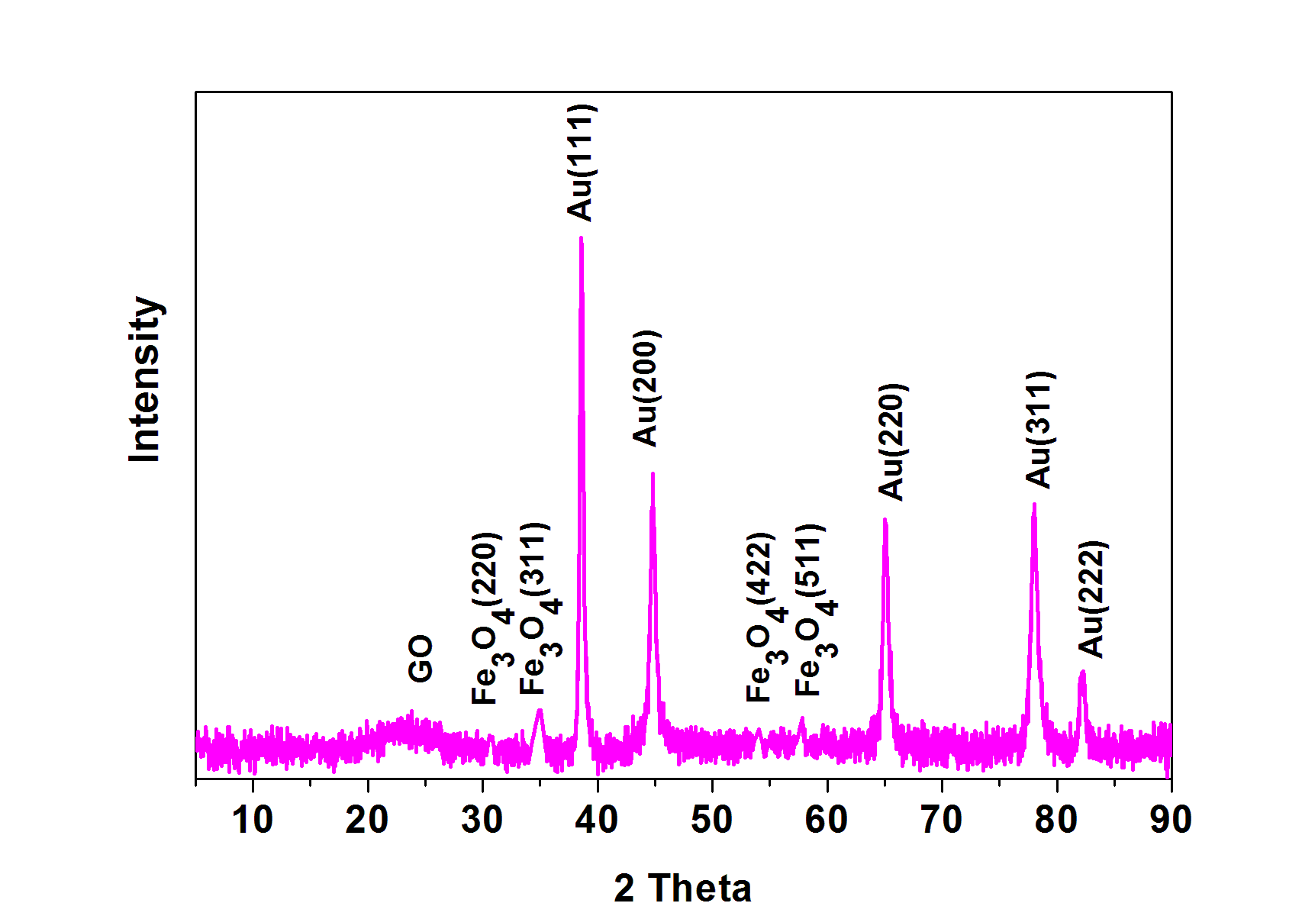

Figure 1: XRD spectrum of Fe3O4/Au\_GO NPs

SEM images, not shown here, evidence the flower-like morphology (Au NPs pistil and Fe3O4 NPs petals) of the nanoparticles. The elemental analysis performed under SEM-EDX (Table 1) evidences the presence of carbons, iron, oxygen and gold species, in the sample there are no impurities. Moreover, weight concentrations and the atomic ratios of the various components indicate a favored reduction for the gold precursor in the reaction conditions used, (see the precursors amounts in the experimental section). Indeed the reduction rate of Au+ ion is greater than that of formation of the Fe3O4. The basic concept of this one-step synthesis of the Fe3O4/Au\_GO composite is to take advantage of the difference in reduction potentials between the two soluble metal salts (EAu+/Au=+1.42 eV vs. the standard hydrogen electrode (SHE); EFe3+/Fe2+ =+0.77 eV vs. SHE). Taking into account the quantities of the species in question and the nanoparticles size three Fe3O4 petals for each Au pistil can be calculated.

The atomic ratio O/Fe = 1.59 at. suggests the formation of magnetite. On the other hand, the ratio O/Fe for magnetite is smaller and equal to 1.33, but additional oxygen can derive from the presence of oxygenated groups of graphene and from the oxygen of citric acid.

Table 1: Elemental analysis using EDX for Fe3O4/Au\_GO

|  |  |  |  |  |
| --- | --- | --- | --- | --- |
| **Element Number** | **Element Symbol** | **Element Name** | **Atomic Conc.** | **Weight Conc.** |
| 8 | O | Oxygen | 43.13 | 26.94 |
| 6 | C | Carbon | 29.86 | 13.99 |
| 26 | Fe | Iron | 27.01 | 59.06 |
| 79 | Au | Gold | 1.08 | 8.31 |

* + 1. Immobilization efficiency

Physical immobilization can be considered the simplest functionalization method employed in protein immobilization. In present study HRP was immobilized on Fe3O4/Au\_GO NPs by physical interaction. In particular, considering the isoelectric point of HRP (above pH 8), it is expected that a slightly acid pH would favor the electrostatic interaction between nanoparticles and enzyme. To better control the immobilization procedure, it is important to choose the optimum reaction time and enzyme concentration. Figure 2a shows the relative immobilization efficiency (%) of HRP in correspondence with the different reaction time.

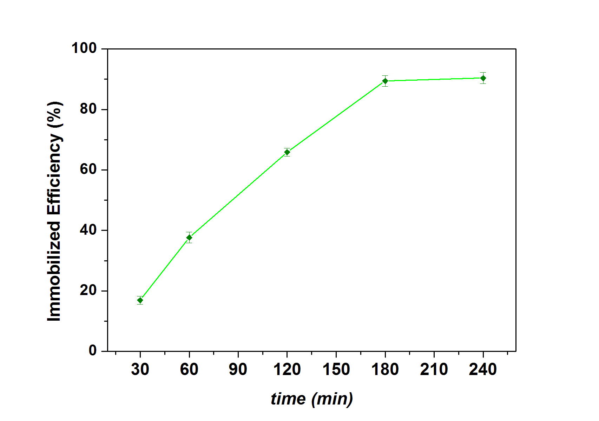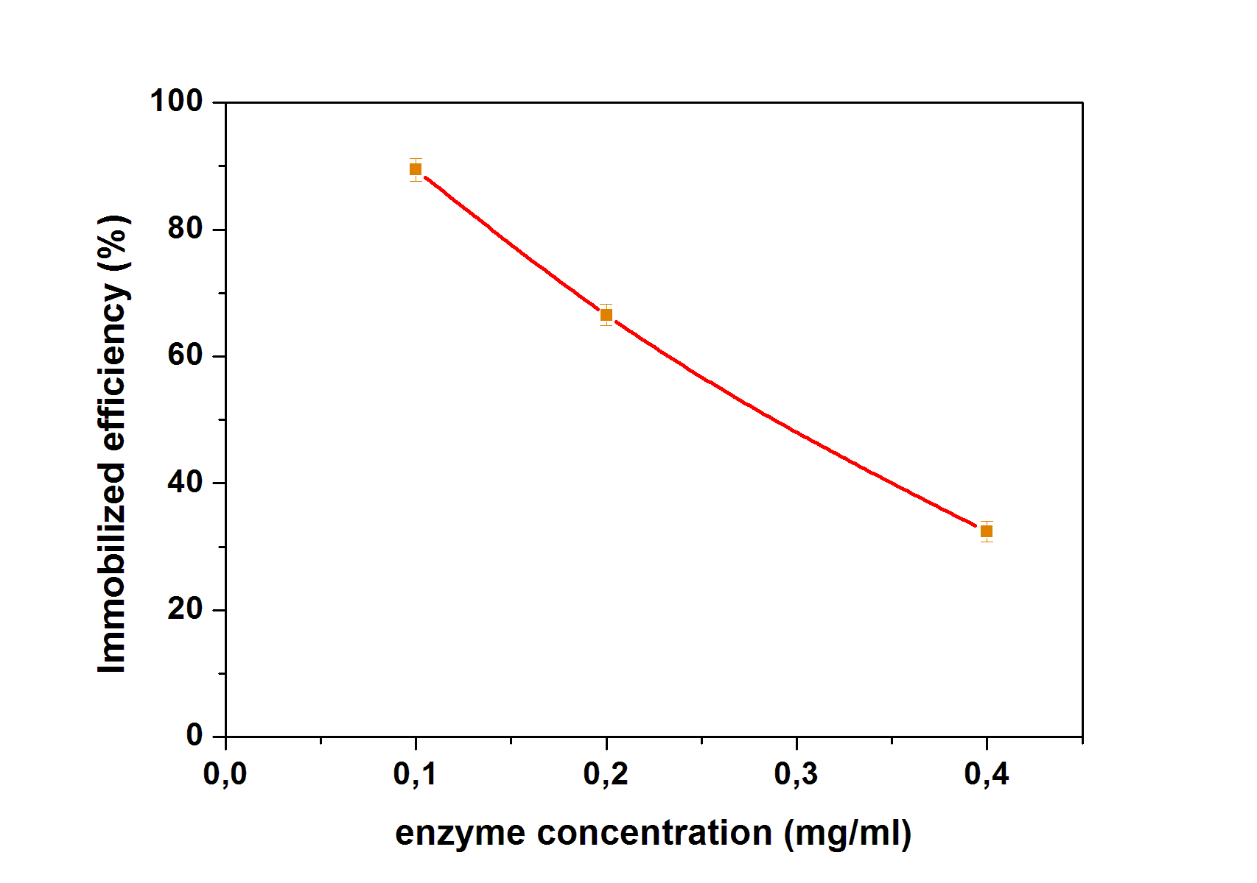

**a**

**b**

*Figure 2: Dependence of immobilization of HRP with time. Immobilization conditions: coupling temperature, 4 °C; coupling pH, 6; lipase concentration, 0.1 mg/ml; (a). Dependence of immobilization of HRP on enzyme concentration. Immobilization conditions: coupling temperature, 4 °C; coupling pH, 6; time, 3 h; (b). Each point represents the mean of two experiments ± S.E.*

The immobilization efficiency after 60 min was 40%, and achieves the maximum loading after180 min. The concentration of HRP in the immobilization batch significantly affects the enzyme immobilization efficiency, see Figure 2b. The optimum enzyme concentration results 0.1 mg/ml (Sarno et al., 2017).

* + 1. Effect of reaction time and H2O2 concentration

The co-substrate H2O2 activates the enzymatic reaction to produce peroxidase radical intermediates, which attack the chlorophenol compounds to form free radicals (Mohan et al., 2005). Optimization of the conditions for the removal of chlorophenols was performed using different concentrations of H2O2. Figure 3a shows that the removals of 4-chlorophenol increase significantly with increasing H2O2 concentration from 0.2 to 0.6 mM. When the H2O2 concentration is higher than 0.6 mM, the chlorophenol degradation efficiency gradually decrease.

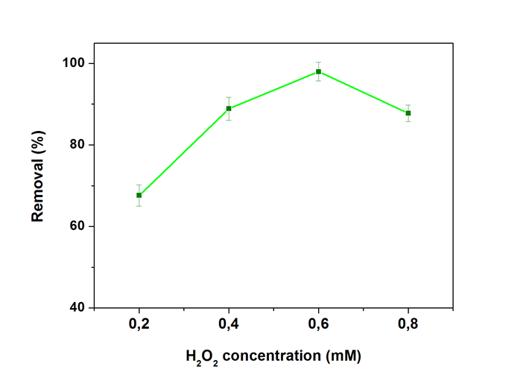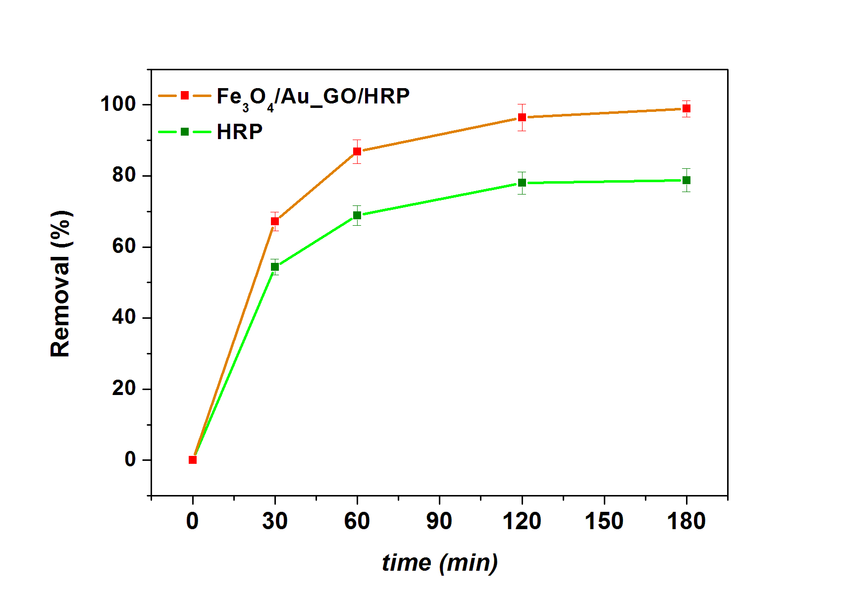

**a**

**b**

*Figure 3: Effect of H2O2 concentration on 4-chlorophenol degradation. Immobilization conditions: coupling temperature, 4 °C; coupling pH, 6; lipase concentration, 0.1 mg/ml; time, 3 h. Degradation test conditions: reaction temperature, 25 °C; catalyst concentration 0.1 mg/ml; reaction time 180 min; (a). Effect of time on 4-chlorophenol degradation. Immobilization conditions: coupling temperature, 4 °C; coupling pH, 6; lipase concentration, 0.1 mg/ml, time, 3 h. Degradation test conditions: reaction temperature, 25 °C; catalyst concentration 0.1 mg/ml; H2O2 concentration, 0.6 mM; (b). Each point represents the mean of three experiments ± S.E.*

[Figure](https://www.sciencedirect.com/science/article/pii/S1872206715608567#fig6) 3b shows the effect of time on the degradation of 4-chlorophenol using the immobilized HRP and free HRP. In the first 30 min, the degradation process, induced by immobilized HRP, was fast and reached a degradation percentage of about 67%. The contribution of immobilized HRP to 4-CP degradation was about 98% at 180 min. The degradation efficiency of free HRP is lowest than that of immobilized HRP, suggesting that free HRP is partially inactivated during the reaction, in particular, during the formation of the different free radical intermediates (Cheng et al., 2006). These results show the excellent performance of Fe3O4/Au\_GO as support to improve enzyme activity and protect the enzyme towards the inactivation of HRP during the reaction.

* + 1. UV-Vis Analysis

In Figure 4, as an example, the UV absorption spectra of 4-CP at different reaction times (from 0 to 180 min) is shown in the experimental condition reported in the figure caption. 4-chlorophenol presents strong absorption bands in the ultraviolet region with wavelengths at 225 and 280 nm (Taherian et al., 2013). These peaks gradually diminished with increasing reaction time. The slight increase in the absorbance, observed near 250 nm, can be attributed to the formation of intermediates, i.e. benzoquinones (Thorsten et al., 2013).

 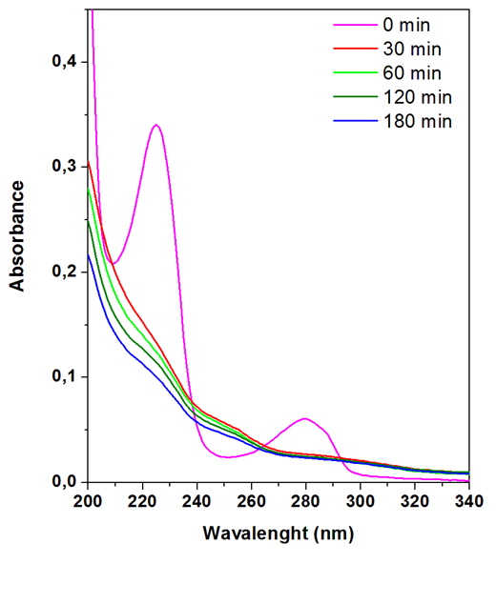

*Figure 4: The absorption spectra of the reactant solution monitored at selected time intervals (0, 30, 60, 120 and 180 min), obtained using ultraviolet-visible spectrophotometer. Degradation test conditions: reaction temperature, 25 °C; catalyst concentration 0.1 mg/ml, H2O2 concentration 0.6 mM.*

* + 1. Catalyst reusability

The reusability is also a key factor in 4-chlorophenol removal (see Figure 5). Compared with free enzyme, the immobilized enzyme can be easily separated from the reaction solution through an external magnetic field and reused. The immobilized HRP retains 95% of the initial activity for the first three cycles. The small gradual decrease can be attributed to the formation of free radicals, generated during enzymatic oxidation of the 4-chlorophenol, which would contribute to activity reduction in the next cycle (Cheng et al., 2006).

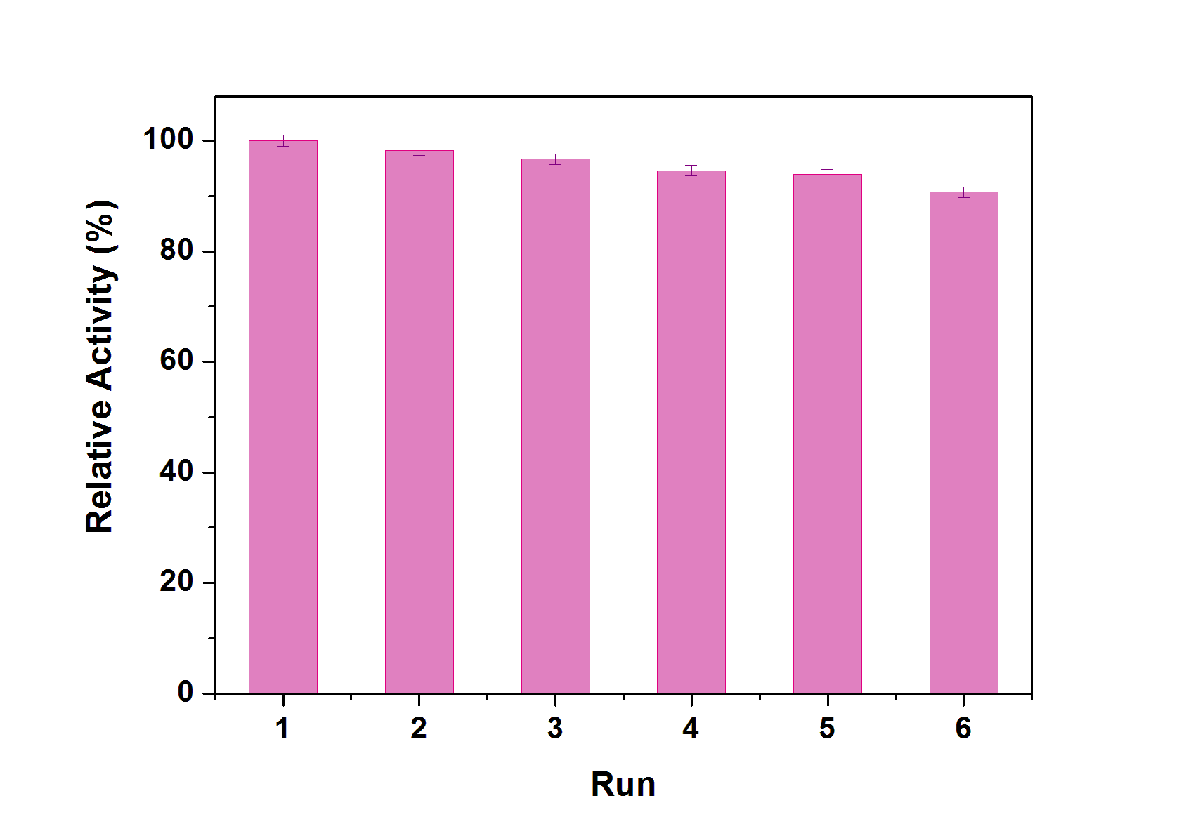

*Figure 5: Reused of immobilized HRP. Immobilization conditions: coupling temperature, 4 °C; coupling pH, 6; lipase concentration, 0.1 mg/ml; time, 3 h. Degradation test conditions: reaction temperature, 25 °C; catalyst concentration 0.1 mg/ml; H2O2 concentration, 0.6 mM, reaction time, 3 h. Each point represents the mean of three experiments ± S.E.*

* 1. Conclusions

Magnetic Fe3O4/Au\_GO NPs were synthesized using solvothermal method. HRP was successfully immobilized on the Fe3O4/Au\_GO via interaction between functional groups and the enzyme. The immobilized HRP was used as an enzymatic catalyst to activate H2O2 for degradation of 4-chlorophenol, with excellent activity and reusability.

Reference

Andreescu S., Njagi J. C., Ispas C., 2008, Nanostructured materials for enzyme immobilization and biosensors, in: V. Erokhin, M.K. Ram, O. Yavuz (Eds.), The New Frontiers of Organic and Composite Nanotechnology, Elsevier, Amsterdam, 355–394.

Chang Q., Tang H. Q., 2014, Immobilization of Horseradish Peroxidase on NH2-Modified Magnetic Fe3O4/SiO2 Particles and Its Application in Removal of 2,4-Dichlorophenol, Molecules ,19, 15768-1578.

Cheng J., Yu S. M., Zuo P., 2006, Horseradish peroxidase immobilized on aluminum-pillared interlayered clay for the catalytic oxidation of phenolic wastewater, Water Resources, 40, 283-290.

Cooper V. A., Nicell J. A.,1996, Removal of phenols from a foundry Wastewater using horseradish peroxidase, Water Resources, 30, 954-964.

Dong S. P., Mao L., Luo S. Q., Zhou L., Feng Y. P., Gao S. X., 2014, Comparison of lignin peroxidase and horseradish peroxidase for catalyzing the removal of nonylphenol from water, Environmental Science and Pollution Research, 21, 2358-2366.

Feng W., Ji P., 2011, Enzymes immobilized on carbon nanotubes Biotechnology Advances, 29,889–895.

Hamid M., Rehman K. U., 2009, Potential applications of peroxidase, Food Chemistry, 115, 1177-1186.

Hwang Y., Mines P. D., Jakobsen M. H., Andersen H. R., 2015, Simple colorimetric assay for dehalogenation reactivity of nanoscale zero-valent iron using 4-chlorophenol, Applied Catalysis B: Environmental, 166–167,18–24.

Jiang G. D., Lin Z. F., Chen C., Zhu L. H., Chang Q., Wang N., Wei W., Tang H. Q., 2011, TiO2 nanoparticles assembled on graphene oxide nanosheets with high photocatalytic activity for removal of pollutants, Carbon, 49, 2693-2701.

Laurenti E, Ghibaudi E, Todaro G, Pia Ferrari R., 2002, Enzymatic degradation of 2,6-dichlorophenol by horseradish peroxidase: UV–visible and mass spectrophotometric characterization of the reaction products, Journal of Inorganic Biochemistry, 92, 75-81.

M. Bradford, 1976, A rapid and sensitive method for the quantitation of microgram quantities of protein utilizing the principle of protein-dye binding, Journal Analytical Biochemistry, 72, 248–254.

Sarno M., Iuliano M., 2019, Highly active and stable Fe3O4/Au nanoparticles supporting lipase catalyst for biodiesel production from waste tomato, [Applied Surface Science](https://www.sciencedirect.com/science/journal/01694332), 474, 135-146.

Sarno M., Iuliano M., Polichetti M., Ciambelli P., 2017a High activity and selectivity immobilized lipase on Fe3O4 nanoparticles for banana flavour synthesis, Process Biochemistry, 56, 98-108.

Sarno M., Paciello L., Cirillo C. , Parascandola P. , Ciambelli P., 2016, Improvement of the Lipase Immobilization Procedure on Monodispersed Fe3O4 Magnetic Nanoparticles, Chemical Engineering Transactions 49, 121-126.

Sarno M., Scudieri C., Longo A., Ciambelli P., 2017b Graphene Oxide as a Novel Nanoplatform for Electrochemical Detection of Arsenic (III), Chemical Engineering Transactions, 60, 13-18.

Sharma A., Kumar A., Meena K.R., Rana S., Singh M., Kanwar S.S., 2017, Fabrication and functionalization of magnesium nanoparticle for lipase immobilization in n-propyle gallate synthesis, Journal of King Saud University – Science, 29, 536–546.

Taherian S. ,  Entezari M.H. ,  Ghows N., 2013, Sono-catalytic degradation and fast mineralization of p-chlorophenol: la0.7Sr0.3MnO3 as a nano-magnetic green catalyst, Ultrasonics Sonochemistry, 20, 1419–1427.

Thorsten W. M. S, Kleinermanns K., 2013, 1,4-Hydroquinone is a hydrogen reservoir for fuel cells and recyclable via photocatalytic water splitting, Open Journal Physical Chemistry, 3, 97–102.

Zhang F., Zheng B., Zhang J. L., Huang X. L., Liu H., Guo S. W., Zhang J. Y., 2010, Horseradish Peroxidase Immobilized on Graphene Oxide: Physical Properties and Applications in Phenolic Compound Removal, The Journal Physical Chemistry C, 114, 8469–8473.

Zhang J. B., Xu Z. Q., Chen H., Zong Y. R., 2009, Removal of 2,4-dichlorophenol by chitosan-immobilized laccase from Coriolus versicolor, Biochemical Engineering Journal, 45, 54-59.

Zhang J. L., Zhang F., Yang H. J., Huang X. L., Liu H., Zhang J. Y., Guo S. W., 2010, Graphene Oxide as a Matrix for Enzyme Immobilization, Langmuir, 26, 6083-6085.