CHEMICAL ENGINEERING TRANSACTIONS  VOL. 73, 2019 | A publication of
The Italian Association
of Chemical Engineering
Online at www.aidic.it/cet
Guest Editors: Andrea D’Anna, Paolo Ciambelli, Carmelo Sunseri
Copyright © 2019, AIDIC Servizi S.r.l.
ISBN 978-88-95608-70-9; ISSN 2283-9216

Hyper-Cross-Linked Polymer Loaded with Graphite Nanoplatelets for Supercapacitor Application
Maria Sarnoª, Rachele Castaldo^{b}, Eleonora Ponticorvo^{a,}*, Davide Scarpaª, Mariacristina Cocca^{b}, Veronica Ambrogi^{c}, Gennaro Gentile^{b}
a Department of Industrial Engineering and Centre NANO_MATES University of Salerno, Via Giovanni Paolo II ,132 - 84084 Fisciano (SA), Italy.
b Institute for Polymers, Composites and Biomaterials, National Research Council of Italy, Via Campi Flegrei 34, 80078 Pozzuoli, Italy.
c Department of Chemical, Materials and Production Engineering, University of Naples, Piazzale Tecchio 80, 80125 Napoli, Italy.
eponticorvo@unisa.it
Hyper-cross-linked (HCL) styrene-based resins filled with graphite nanoplatelets (GNP) at two different GNP concentrations were synthesized by means of a facile and efficient modified Davankov procedure. Firstly, the synthesized samples were broadly characterized by means of transmission electron microscopy (TEM) and thermogravimetric analysis (TG-DTG), and their BET surface areas were also evaluated. Afterwards, capacitance performance of the synthesized electrode materials was investigated by cyclic voltammetry in a 0.5 M H₂SO₄ solution at different scan rates, also exploring the effects of GNPs concentration. The synthesized materials showed high specific capacitances (C_{sp}) of 52.1 F/g and 60.4 F/g, values obtained with a concentration of the GNP fillers equal to 7.5 wt% and 10 %wt respectively. Moreover, the synthesized nanocomposites exhibited a high capacitance retention up to 97 % over 10000 cycles, thus confirming their excellent performances as robust EDLC electrode materials.
  - Introduction
Over the past few decades, supercapacitors have gained increasing attention as electrical energy storage (EES) systems complementary to batteries. Indeed, these devices can be adopted for a wide range of applications (e.g. power generation and transportation), being able to guarantee high power density, fast charge/discharge rates and long life cycles (Wang et al., 2007; Sarno et al., 2015; Sarno et al., 2016a). Among them, electrical double-layer capacitors (EDLCs) possess remarkable power densities in virtue of the mechanism by which they store electrical energy. In these devices, charges are accumulated on the electrode surfaces through the formation of a double layer of ions originated from the electrolyte. Formation of the electric double layer is very fast and highly reversible, requiring only physical adsorption and desorption of ions onto the electrode surface, therefore power densities related to this type of supercapacitors are remarkably high (Largeot et al., 2008; Trezza et al., 2008). However, although endowed with the aforementioned excellent features, the still low energy densities of EDLCs remain a main challenge in their development (Peng at al., 2005). In order to meet this challenge, highly accessible surface areas and high conductivity to promote charge transport and accumulation are the most required characteristics for EDLCs electrodes (Pandolfo et al., 2006). Typical EDLC electrodes showing these optimal characteristics are nanocarbons, such as activated carbon, carbon fiber, aerogel, graphite nanoplatelets (GNPs), etc. properly designed to expose a high surface area (Sarno et al., 2016b; Sarno et al., 2018a) to the electrolyte and EDLC formation (Yoshida et al., 1996) In particular, graphite nanoplatelets (GNPs), consisting of short stacks of graphene sheets, are promising candidates thanks to their capacity to exhibit peculiar two-dimensional characteristics, including good electronic behaviour, potential wide accessible surface area and high mechanical resistance (Chiam et al., 2018). Hyper-cross-linked (HCL) resins, composed of rigid molecular linkers, can enhance the GNP-based EDLCs performances. These versatile materials can be produced through a facile and cost-effective method and possess several remarkable characteristics, such as high chemical stability and large specific surface area (1000 – 1900 m²/g) with tunable pore size distribution (Tsyurupa et al., 2002; Woodward et al., 2014). Their porous structure can easily host nanofillers, embodied in the hyper-cross-linked matrix, which: preserves nano-dimensions, preventing nanoplatelets agglomeration; ensures homogeneous dispersion, reducing the required amount of active species; preserves the electrode against leaching phenomena (Castaldo et al., 2017a; Castaldo et al., 2017b). In particular, the aim of this paper was to load inside a HCL an EDLC high capacitive material, in order to obtain a stable, robust and reliable supercapacitor. Furthermore, HCLs porous structure, consisting of both meso- and micropores, contributes to the electrode accessibility and wettability, allowing active sites availability for ions adsorption during the electrolyte induced swelling (Hu et al., 2017).
In the following paper, hyper-cross-linked styrene-based resins filled with graphite nanoplatelets at different GNP concentrations were synthesized by means of a modified Davankov method. As explained in a previous work, this new synthetic approach is simpler, more efficient, and involves reduced amount of waste chemicals (Castaldo et al., 2017c). The as-synthesized materials were then widely characterized and tested as electrode materials for supercapacitors. The electrochemical performances of the samples were investigated by cyclic voltammetry tests in H₂SO₄ electrolyte solution and capacitance retention was evaluated. The effects of GNPs concentration on the electrochemical capacitance were also explored.
  - Experimental Section
    - Materials
Graphite nanoplatelets (GNP, grade M, average diameter 25 µm) were purchased from XG Sciences (Lansing, MI). Vinylbenzyl chloride (VBC, >95%, mixture of isomers, ∼70% meta + ∼30% para), p-divinylbenzene (DVB, 85%, meta isomer ∼10 wt %), 2,2’-azobis(2-methylproprionitrile) (AIBN, >98%), FeCl₃ (> 97%), were purchased by Sigma Aldrich (Milan, Italy), and used without further purifications.
    - Nanocomposite preparation
The hyper-crosslinked poly(divinylbenzene-co-vinylbenzyl chloride) based nanocomposites containing GNP were prepared through a two-step procedure. DVB and VBC (molar ratio 2:98) were mixed with different concentrations (7.5 and 10 wt %) of GNP (the obtained samples will be named GNP7.5-HPC and GNP10-HPC in the following). To ensure an effective nanofiller dispersion, the mixture was sonicated for 50 min with a 500 W tip sonicator at 25% power, with a 10 s/50 s ON/OFF cycle. Therefore, 0.5 phr of AIBN was added, and the mixture was kept under stirring at constant temperature (80°C) under nitrogen for 30 min. Polymerization was completed in an oven for 24 h at 80°C. For comparison, neat poly(divinylbenzene-co-vinylbenzyl chloride) was prepared similarly (HPC in the following).
The obtained nanocomposite and polymer precursors were repeatedly washed with methanol, acetone and diethyl ether, and then dried in a vacuum oven at 40 °C for 24 h (Castaldo et al., 2017c). For the synthesis of the hyper-cross-linked systems, the precursors were swollen in 1,2-dichloroethane for 2 h, then the systems were cooled to 0 °C by means of an ice/water bath. FeCl₃ was added, and stirring was continued for 2 h. After that, the reaction flask was heated to 80 °C and kept at this temperature for 18 h. The obtained hyper-cross-linked resin and nanocomposite were washed with methanol and dried in a vacuum oven at 40 °C.
    - Characterization methods
Bright field transmission electron microscopy (TEM) analysis was performed on the precursor nanocomposites by means of FEI Tecnai G12 Spirit Twin (LaB₆ source). TEM images were acquired through FEI Eagle 4k CCD camera. Specific surface area (SSA) and porosity of the hyper-cross-linked samples were determined by nitrogen adsorption measurements at 77 K, using a Micromeritics ASAP 2020 analyzer. Prior to the analysis all the samples were degassed at 120 °C under vacuum (P < 10−5 mbar); all the adsorption measurements were performed using high purity gases (>99.999%). Thermogravimetric analysis (TG-DTG) was carried out by using a SDTQ 600 Analyzer (TA Instruments) with a heating rate of 10 °C/min, from ambient temperature up to 1000 °C under air flow (Ciambelli et al., 2004).
Electrochemical tests to evaluate capacitance performances of the synthesized samples, in particular cyclic voltammetry (CV) tests, were carried out by means of an Autolab PGSTAT302N potentiostat. In detail, cyclic voltammetry measurements were run at different scan rates (10, 20, 50,100 and 150 mV/s) in the potential range 0.4 ÷ 0.8 V and in a 0.5 M H₂SO₄ electrolyte solution. Starting from the CV, the Eq(1) was used in order to evaluate the specific capacitance of the samples:
$${\text{C}}_{\text{sp} }\text{=}\frac{\int{\text{i}∙d\text{V}}}{\text{ΔV}∙\text{v} }$$ | (1)
ΔV is the potential range chosen, I is the current density, V is the potential, v is the CV scan rate.
Before performing the tests, 4 mg of synthesized material were dispersed into 80 μl of a 5 wt% Nafion solution, 200 μl of ethanol and 800 μL of water. The resulting mixture consists of a homogeneous suspension which, after being sonicated for 30 mins and then air-dried, was partially deposited dropwise onto a DRP-110 Screen Printed Electrode (SPE). SPE consists of a carbon working electrode, a platinum counter electrode and a silver reference electrode and were preferred over commonly used carbon electrodes thanks to their good characteristics (Rowley-Neale et al., 2015; Sarno et al., 2018b; Sarno et al., in press).
  - Results and discussion
Dispersion TEM micrograph of the GNP10-HPC precursor is reported in Figure 1. After the one-step synthesis approach, which allows to “freeze” the mixture during hyper-cross-linking process, graphite nanoplatelets results well dispersed in the polymer matrix. The lateral size of GNP is within the range 400 nm – 3.0 μm. Moreover, as shown in Fig. 1, GNP are well exfoliated within the DVB-VBC precursor.

Figure 1: TEM image of GNP10-HPC

By including GNP into the polymer matrix, a small reduction of the SSA and porosity of the system was registered, with no significant modifications of the pore size distributions. In particular, HPC resin, GNP7.5-HPC and GNP10-HPC nanocomposites showed BET specific surface areas (SSA) of ~1900 m²/g, ~1740 m²/g and ~1790 m²/g, respectively. TG-DTG profiles obtained under air flow are shown in Figure 2 for HPC and GNP loaded HPC. The TG-DTG profiles of HPC clearly exhibit a main weight loss in the range 290-540 °C. At this temperature the HCL resin is completely degraded, while GNP7.5-HPC and GNP10-HPC present a residual weight of about 9 % and 12 %, respectively (Ferrara et al., 2007). This residual weight, slightly higher than the nominal GNP content, can be ascribed to a slightly retarded degradation of the polymeric phase in the nanocomposites, due to the presence of the carbonaceous filler. CV curves of HPC resin, GNP7.5-HPC and GNP10-HPC prepared samples at different scan rates (10, 20, 50, 100 and 150 mV/s) were reported in Figure 3. As can be seen from the figure, HPC neat resin displays narrow curves. On the other hand, the nanocomposite materials show quasi-rectangular current–voltage response curves. No detectable redox peaks can be found in the chosen potential window, which indicates a nearly ideal capacitive behavior of the GNP7.5-HPC and GNP10-HPC electrodes (Wang et al., 2015; Du et al., 2009; Xia et al., 2009; Yoo et al., 2011; Zhu et al., 2010; Sarno et al., 2016c; Karandikar et al., 2012; Nishihara et al., 2012; Sarno et al., 2016d; Liu et al., 2010). Capacitances of 52.1 F/g and 60.4 F/g were obtained for GNP7.5-HPC and GNP10-HPC, respectively. Moreover, long-term cycling tests were carried out in 0.5 M H₂SO₄ over 10000 cycles at 150 mV/s, proving that 97 % of the initial capacitance was retained (Figure 4). The obtained encouraging results suggest the possibility to achieve even higher capacitances further by adding supercapacitive materials with redox properties. The loading of larger amounts of GNP will be subject of a future dedicated work.

Figure 2: TG/DTG curves of HPC, GNP7.5-HPC and GNP10-HPC

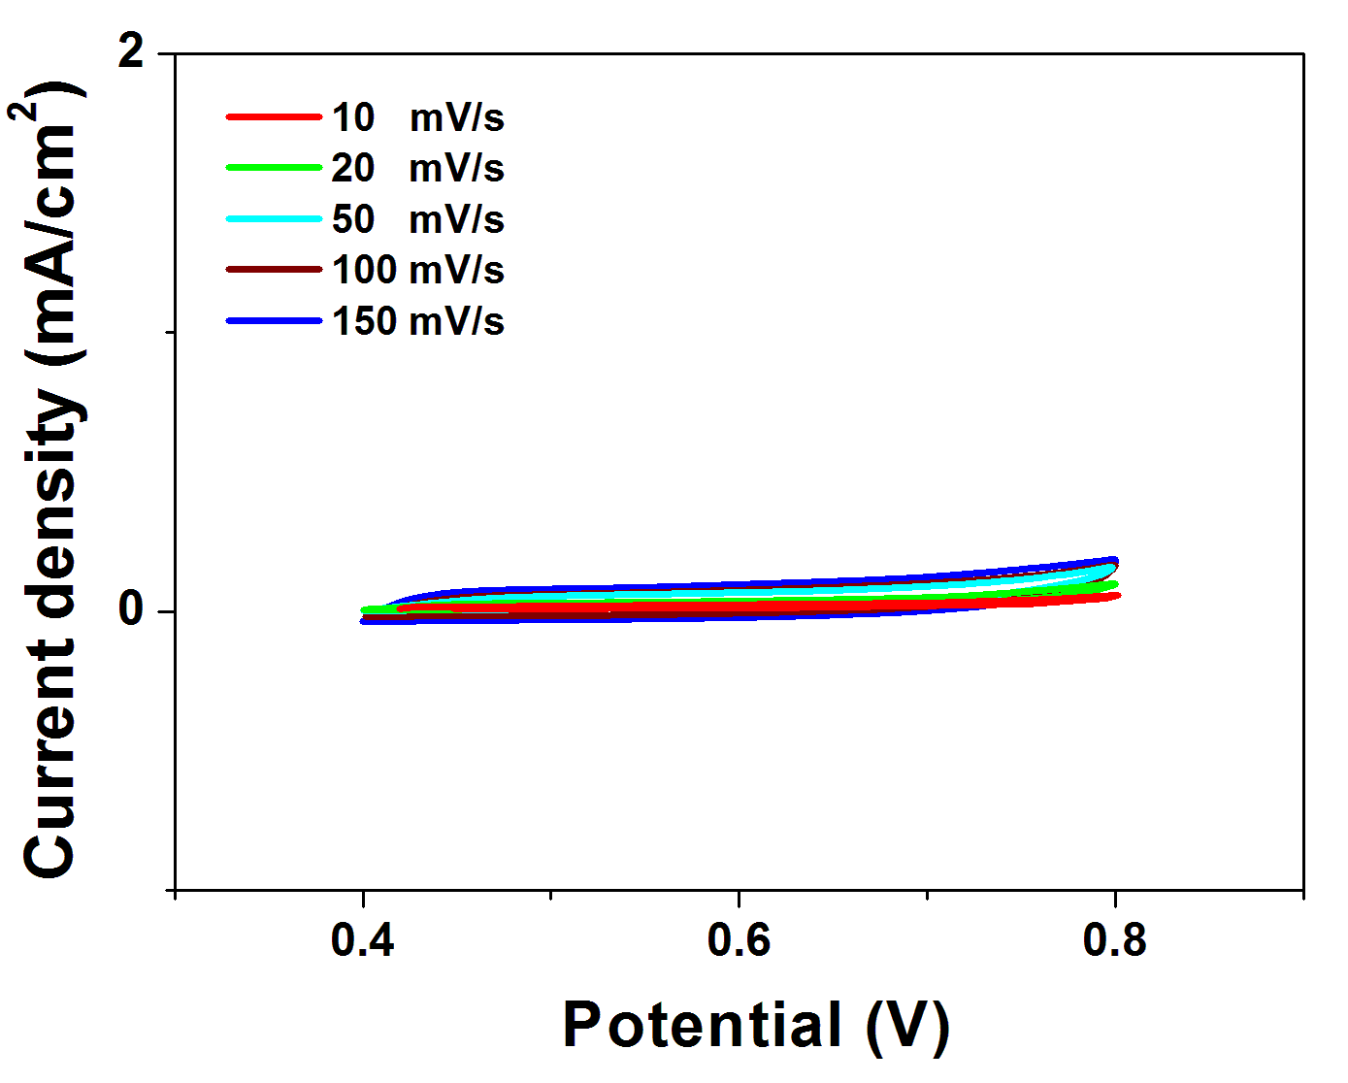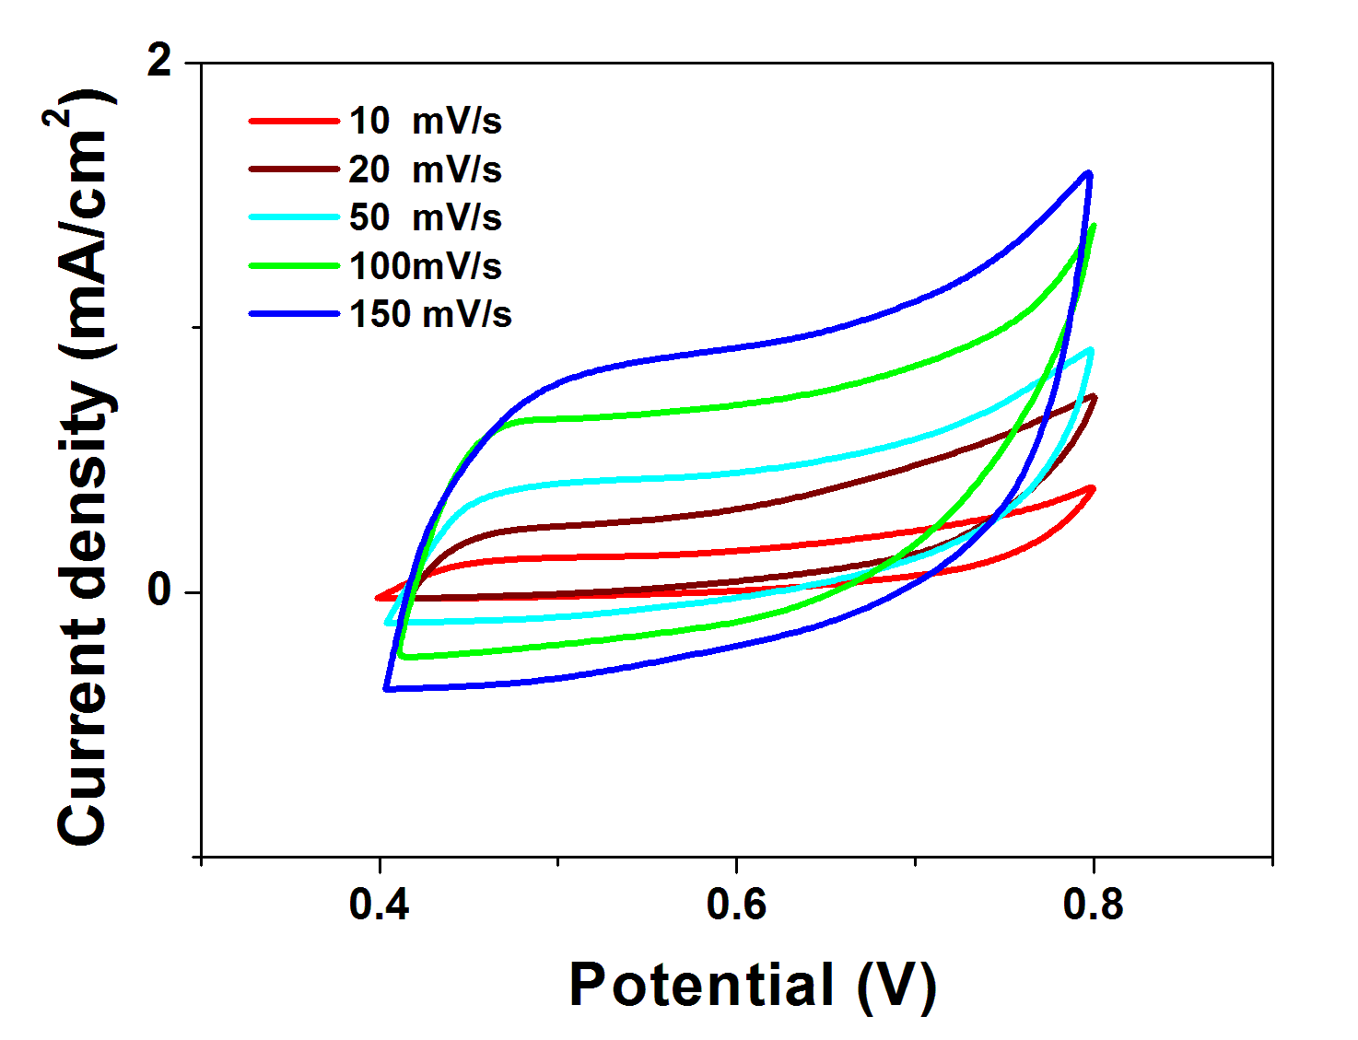
b
a
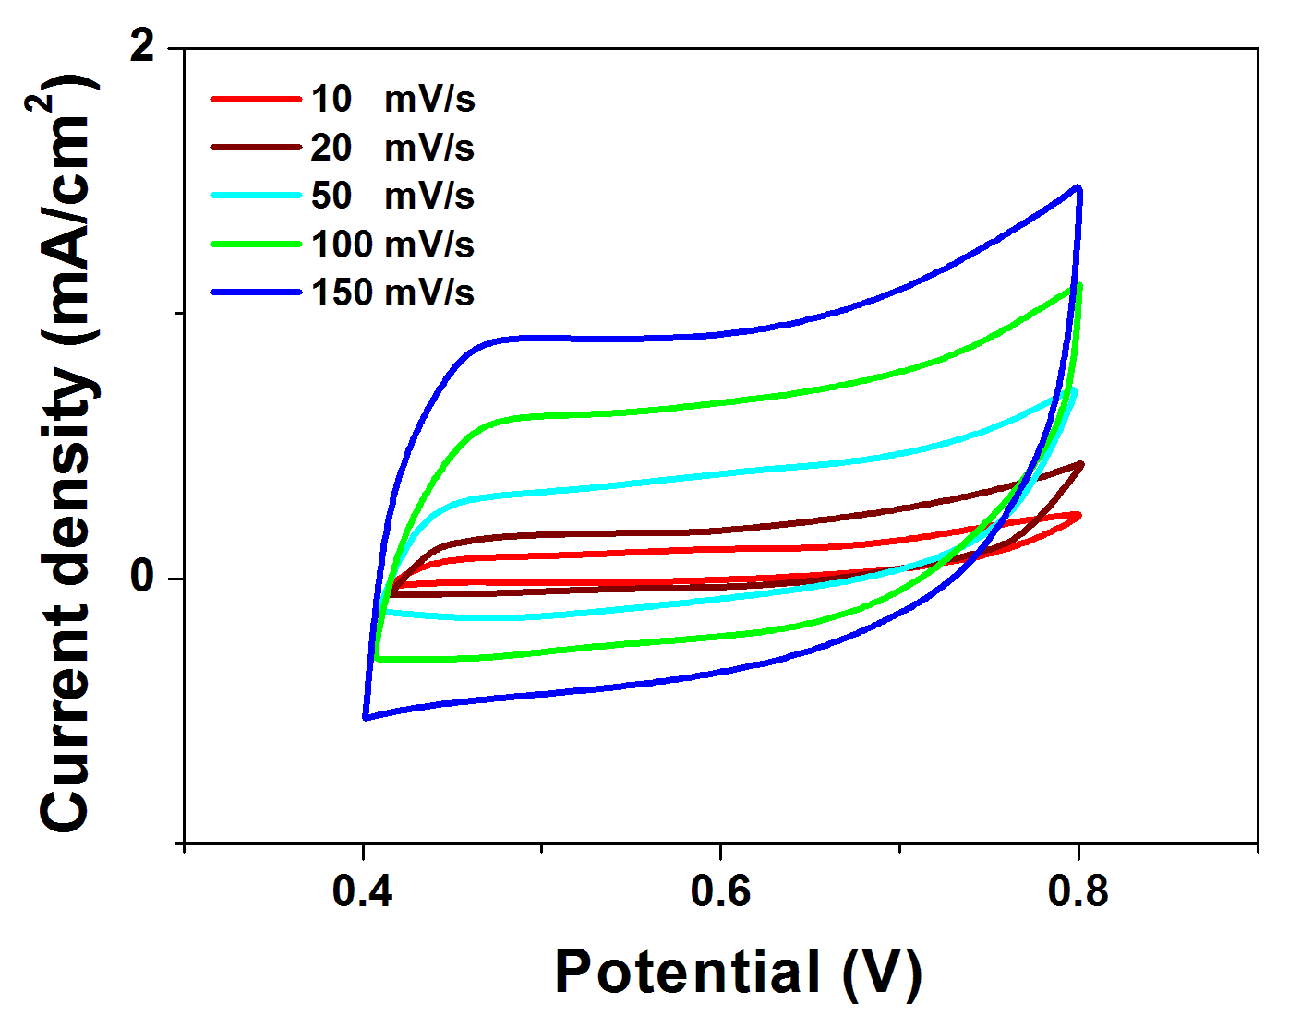
c
Figure 3: Cyclic voltammograms of HPC (a), GNP7.5-HPC (b) and GNP10-HPC (c) measured at different scan rates in a 0.5 M H₂SO₄

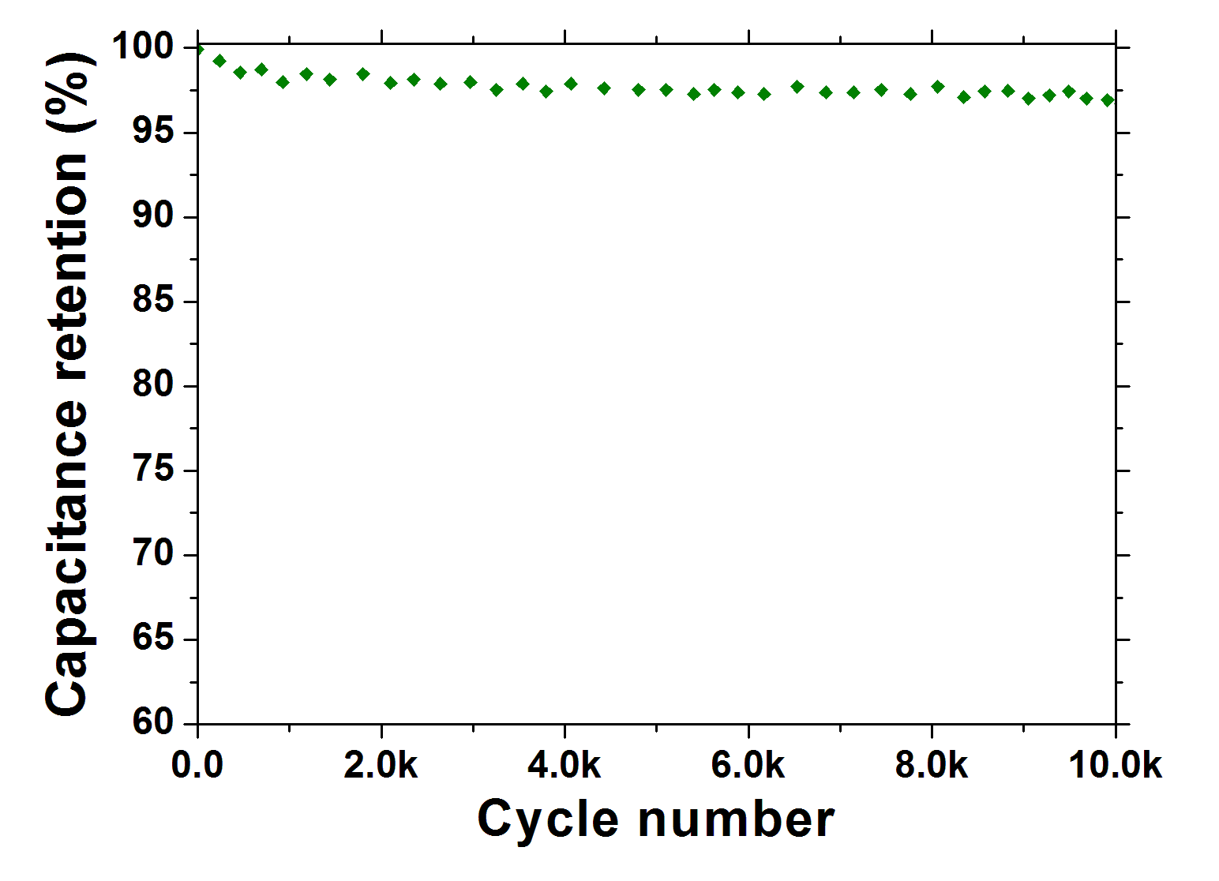
Figure 4: Capacitance retention as a function of cycle number for GNP10-HPC
  - Conclusions
In summary, a simple, and efficient modified Davankov procedure was adopted in order to synthesize hyper-cross-linked styrene-based resins filled with graphite nanoplatelets at 7.5 wt% and 10 wt% of GNP. TEM and TG-DTG analyses confirmed the formation of the aforementioned nanocomposite structure, which preserved the high surface area of the neat HCL resin without significant reduction of the hyper-cross-linked resin volume. Cyclic voltammograms, run at different scan rates in a 0.5 M H₂SO₄ solution, revealed that both nanocomposites exhibit quasi-rectangular current–voltage response curves without any detectable redox peaks in the analyzed potential window, which suggests a nearly ideal capacitive behavior. The HCLs meso- and microprous structure favors accessibility and wettability of the electrode active sites for ion adsorption throughout the electrolyte induced swelling. Moreover, the synthesized nanocomposites exhibited a very high capacitance retention, showing a high stability as well as excellent capacitive performance as robust EDLC electrode materials.
References
Castaldo R., Avolio R., Cocca M., Gentile G., Errico M.E., Avella M., Carfagna C., Ambrogi V., 2017b, Synthesis and adsorption study of hypercrosslinked styrene-based nanocomposites containing multi-walled carbon nanotubes, RSC Advances, 7, 6865-6874.
Castaldo R., Avolio R., Cocca M., Gentile G., Errico M.E., Avella M., Carfagna C., Ambrogi V., 2017c, A Versatile Synthetic Approach toward Hyper-Cross-Linked Styrene-Based Polymers and Nanocomposites, Macromolecules, 50, 4132-4143.
Castaldo R., Gentile G., Avella M., Carfagna C., Ambrogi V., 2017a, Microporous Hyper-Crosslinked Polystyrenes and Nanocomposites with High Adsorption Properties: A Review, Polymers, 9, 651-673.
Chiam S.L., Lim H.N., Hafiz S.M., Pandokumar A., Huang N.M., 2018, Electrochemical Performance of Supercapacitor with Stacked Copper Foils Coated with Graphene Nanoplatelets, Scientific Reports, 8, 3093.
Ciambelli P., Sannino D., Sarno M., Fonseca A., Nagy J.B., 2004, Hydrocarbon Decomposition in Alumina Membrane: An Effective Way to Produce Carbon Nanotubes Bundles, Journal of Nanoscience and Nanotechnology, 4, 779-787.
Du X., Wang C., Chen M., Jiao Y., Wang J., 2009, Electrochemical performances of nanoparticle Fe₃O₄/active carbon supercapacitor using KOH electrolyte solution, Journal of Physical Chemistry C, 113, 2643–2646.
Ferrara M., Neitzert H.-C., Sarno M., Gorrasi G., Sannino D., Vittoria V., Ciambelli P., 2007, Influence of the electrical field applied during thermal cycling on the conductivity of LLDPE/CNT composites, Physica E: Low-dimensional Systems and Nanostructures, 37, 66-71.
Hu W., Xie F., Li Y., Wu Z., Tian K., Wang M., Pan L., Li L., 2017, Hierarchically Porous Carbon Derived from PolyHIPE for Supercapacitor and Deionization Applications, Langmuir, 33, 13364-13375.
Karandikar P.B., Talange D.B., Mhaskar U.P., Bansal R., 2012, Development, modeling and characterization of aqueous metal oxide based supercapacitor, Energy, 40, 131-138.
Largeot C., Portet C., Chmiola J., Taberna P.L., Gogotsi Y., Simon P., 2008, Relation between the Ion Size and Pore Size for an Electric Double-Layer Capacitor, Journal of the American Chemical Society, 130, 2730-2731.
Liu C., Z. Yu, Neff D., Zhamu A., Jang B.Z., 2010, Graphene-based supercapacitor with an ultrahigh energy density, Nano Letters, 10, 4863-4868.
Lv W., Tang D.-M., He Y.-B., You C.-H., Shi Z.-Q., Chen X.-C., Chen C.-M., Hou P.-X., Liu C., Yang Q.-H., 2009, Low-temperature exfoliated graphenes: vacuum-promoted exfoliation and electrochemical energy storage, ACS nano, 3, 3730-3736.
Nishihara H., Kyotani T., 2012, Templated nanocarbons for energy storage, Advanced Materials, 24, 4473-4498.
Pandolfo A.G., Hollenkamp A.F., 2006, Carbon properties and their role in supercapacitors, Journal of Power Sources, 157, 11-27.
Peng Z., Lin J., Ye R., Samuel Errol L.G., Tour J.M., 2015, Flexible and Stackable Laser-Induced Graphene Supercapacitors, ACS Applied Materials & Interfaces, 7, 3414-3419.
Rowley-Neale S.J., Brownson D.A.C., Smith G.C., Sawtell D.A., Kelly P.J., Banks C.E., 2015, 2D nanosheet molybdenum disulphide (MoS₂) modified electrodes explored towards the hydrogen evolution reaction, Nanoscale, 7, 18152–18168.
Sarno M., Baldino L., Scudieri C., Cardea S., Ciambelli P., Reverchon E., 2016c, Supercritical CO₂ processing to improve the electrochemical properties of graphene oxide, The Journal Of Supercritical Fluids, 118 119–127.
Sarno M., Cirillo C., Ponticorvo E., Ciamblelli P., 2015, Sythesis and Characterization of FLG/Fe₃O₄ Nanohybrid Supercapacitor, Chemical Engineering Transactions, 43, 943-948.
Sarno M., Cirillo C., Scudieri C., Polichetti M., Ciambelli P., 2016d, Electrochemical Applications of Magnetic Core-Shell Graphene-Coated FeCo Nanoparticles, Industrial & Engineering Chemistry Research, 55, 3157-3166.
Sarno M., Ponticorvo E., 2018a, Cu-graphene nanostructures for low concentration CH₃SH removal, Chemical Engineering Transactions, 68, 487-492.
Sarno M., Ponticorvo E., 2018b, Continuous flow HER and MOR evaluation of a new Pt/Pd/Co nano electrocatalyst, Applied Surface Science, 459, 105-113.
Sarno M., Ponticorvo E., Cirillo C., 2016a, High surface area monodispersed Fe₃O₄ nanoparticles alone and on physical exfoliated graphite for improved supercapacitors, Journal of Physics and Chemistry of Solids, 99, 138-147.
Sarno M., Ponticorvo E., Scarpa D., in press, Ru and Os based new electrode for electrochemical flow supercapacitors, Chemical Engineering Journal, doi: 10.1016/j.cej.2018.09.211.
Sarno M., Troisi A., Scudieri C., Ciambelli P., 2016b, Synthesis and functionalization of carbon nanotubes and graphene based supercapacitor for arsenic removal and water desalination: A comparison, Chemical Engineering Transactions, 47, 319-324.
Trezza M., Prischepa S.L., Cirillo C., Fittipaldi R., Sarno M., Sannino D., Ciambelli P., Hesselberth M.B.S., Lazarouk S.K., Dolbik A.V., Borisenko V.E., Attanasio C., 2008, Superconducting properties of Nb thin films deposited on porous silicon templates, Journal of Applied Physics, 104, 083917.
Tsyurupa M.P., Davankov V.A., 2002, Hypercrosslinked polymers: Basic principle of preparing the new class of polymeric materials, Reactive and Functional Polymers, 53, 193-203.
Wang S., Wei T., Qi Z., 2007, Supercapacitor Energy Storage Technology and its Application in Renewable Energy Power Generation System, Proceedings of ISES World Congress, Vol.I-Vol.V, 2805-2809.
Wang Z., Liu C.J., 2015, Preparation and application of iron oxide/graphene based composites for electrochemical energy storage and energy conversion devices: current status and perspective, Nano Energy, 11, 277–293.
Woodward R.T., Stevens L.A., Dawson R., Vijavaraghavan M., Hasell T., Silverwood I.P., Ewing A.V., Ratvijitvech T., Exley J.D., Chong S.Y., Blanc F., Adams D.J., Kazarian S.G., Snape C.E., Drage T.C., Cooper A.I., 2014, Swellable, Water- and Acid-Tolerant Polymer Sponges for Chemoselective Carbon Dioxide Capture, Journal of the American Chemical Society, 136, 9028–9035.
Xia J., Chen F., Li J., Tao N., 2009, Measurement of the quantum capacitance of graphene, Nature Nanotechnology, 4, 505−509.
Yoo J.J., Balakrishnan K., Huang J., Meunier V., Sumpter B.G., Srivastava A., Conway M., Mohana Reddy A.L., Yu J., Vajtai R., 2011, Ultrathin Planar Graphene Supercapacitors, Nano Letters, 11, 1423−1427.
Yoshida A., Nonaka S., Aoki I., Nishino A., 1996, Electric double-layer capacitors with sheet-type polarizable electrodes and application of the capacitors, Journal of Power Sources, 60, 213-218.
Zhu Y., Stoller M.D., Cai W., Velamakanni A., Piner R.D., Chen D., Ruoff R.S., 2010, Exfoliation of Graphite Oxide in Propylene Carbonate and Thermal Reduction of the Resulting Graphene Oxide Platelets, ACS Nano, 4, 1227−1233.

