CHEMICAL ENGINEERINGTRANSACTIONS  VOL. 73, 2019 | A publication of
The Italian Association
of Chemical Engineering
Online at www.aidic.it/cet
Guest Editors:Andrea D’Anna, Paolo Ciambelli, Carmelo Sunseri
Copyright © 2019, AIDIC ServiziS.r.l.
ISBN978-88-95608-70-9;ISSN 2283-9216

Design of Novel Equipment Capable to Quickly Produce Efficient Nanomaterials for Use in Environmental and Sanitary Emergencies
Marco Stoller^{a*}, Srikanth Vuppala^{b}, Khley Cheng^{c}, Mamadou Traore^{c}, Angela Marchettiª, Andrei Kanaev^{c}, Agostina Chiavola^{d}
a Sapienza University of Rome, Dept. Of Chemical Materials Environmental Eng., Via Eudossiana 18, 00184 Rome, Italy
b Sapienza University of Rome, Dept. Of Astronautic and Elettrical and Energy Eng., Via Eudossiana 18, 00184 Rome, Italy
c CNRS, Université Paris Très, Lab.des Sciences des Procédés et des Matériaux, 93430 Ville Taneuse, France
d Sapienza University of Rome, Dept. Of Civil Buildings and Enviromental Eng. Via Eudossiana 18, 00184 Rome, Italy
marco.stoller@uniroma1.it
In emergency, to produce safe water, that is “potable water free from harmful microorganisms and substances even if it may have colour, odour or taste problem due to dissolved minerals”, applied methods should be immediately available to treat contaminated water, to reach at least a microbiological pollution in terms of bacteria concentration is maximum 10⁸ UFC/mL and a maximum concentration of As and COD are 0.1 mg/L and 20 mg/L, respectively. In this work, the treatment of contaminated water to use in environmental and sanitary emergency is performed by the production and employment of proper nanomaterials produced locally. The development of a novel equipment capable to produce quickly and continuously these specific nanomaterials is necessary. Therefore, it was suggested to perform continuous production of the materials by means of process intensification techniques such as the spinning disk reactor (SDR) or the T-mixer reactor (TMR), respectively.Both equipment performed well in producing the required nanomaterials. Concerning the efficiency of the produced materials to lead to safe water in case of emergency, three main parameters were considered: organic matter degradation, heavy metal elimination and anti-bacterial properties. The final results showed that the produced materials are capable to guarantee the required treatment, and it is suggested to use an SDR to produce ferromagnetic core silica shell Al₂O₃ and Zr/TiO₂ coated nanoparticles; the first capable to remove 59.6% of the organic matter, 59.5% of heavy metals and more than 99% of bacteria after 24h. Finally, the nanomaterial can be removed with ease from the water by magnets at 99.1%.
This appears to be very good in terms of ease of the emergency handling. Nowadays, the adopted procedure concerns only bacteria and coarse material removal, performed by addition of toxic chlorine. Since the bacteria content is not known, this requires time lasting “trial & error” procedures to adjust the right amount of added chlorine, since it should be sufficient to deactivate 99% of the bacteria but should not exceed specific residual concentration values due to high toxicity. The new approach suggested in this work permits the immediate use of nanomaterials for contaminated water treatment in emergency to a safe one.
  - Introduction
As soon as a disaster happens, one critical aspect is to provide access to safe water to the population, in order to avoid the spread out of diseases in the region (Gueye et al., 2016). Indeed, it should be considered that all local infrastructures such as transportation, distribution networks (water, energy) and hospitals are operating in critical conditions (Stoller et al., 2018); therefore, it is mandatory to avoid additional problems that would lead to overwhelm the surviving structures (Festag, 2014). Safe water is mostly not available due to the failure of the water distribution system and a wide spread contamination of all natural and conducted water sources by mixing of the streams exiting broken sewer piping systems and direct pollution from air (Stoller et al., 2013). Despite the population is perfectly aware about this situation, access to water is surely one of the first needs that pushes the people to desperately get some water from contaminated sources risking disease (Vilardi et al., 2018a). In order to limit the spread out of diseases in disaster areas, it appears mandatory to have available a set of technologies able to guarantee safe water access to the population and to provide these solutions in a very short amount of time (Stoller at al., 2016). One possibility is to ship to those regions a water supply (Di Palma et al., 2007). This solution is quite easy to organize and to accomplish, but generally it might not be sufficient. Another possibility is the employment of prebuild water treatment units to locally treat the polluted water to a safe quality grade one. Unfortunately, this strategy continues to have many drawbacks (Vilardi et al., 2018b). Although these units are relatively compact in size, their transportation to the disaster area requires some logistics involving air shipping, leading unavoidably to a delay in delivering. Moreover, these units are specific in removing target pollutants, that might be different from those appearing in the disaster area. Finally, these units, such as small reverse osmosis membrane plants, requires a sensible amount of energy that might be unavailable or requires additional equipment such as electric generators (Stoller et al., 2017a).
In this work a different strategy to approach the problem is suggested, that is to produce nanoparticles capable to remove unhealthy pollutants from contaminated water sources once employed (Vilardi et al., 2018c). The advantage of this approach is the possibility to store these materials in proper packaging upon their usage and to perform the transportation with ease to the specific area by airdrop (Chinh et al., 2019). Of course, the production of these nanomaterials requires equipment to be successfully produced, but it is not necessary to ship this equipment elsewhere. The employment of these nanomaterials to treat the contaminated water does not require additional logistics, chemicals and energy (Vilardi et al., 2017a). Generally speaking, the use of nanoparticles has been demonstrated to be suitable in other industrial sectors (Bavasso et al., 2016), besides the environmental one (Di Palma et al., 2015). In detail, in order to conveniently produce continuously nanomaterials at a suitable amount for this application, process intensified techniques were investigated, such as an SDR and a TMR, respectively. Both devices were used to produce suitable nanoparticles that are capable to eliminate a wide range of water contaminates of major concern such as organic matter, heavy metals and bacteria, reaching higher removal efficiencies in comparison with other processes (Vilardi et al., 2018d). Moreover, the core of these nanoparticles is ferromagnetic, permitting the recovery from the purified water by magnets allowing multiple reusage (Gomez Pastora et al., 2016). As a consequence, it is possible to treat a relatively high number of water sources for several days by means of the same amount of nanoparticles (Vilardi et al., 2018e). In particular, ferromagnetic core silica shell nanoparticles were coated by means of Al₂O₃ and Zr/TiO₂ solutions, respectively. Once produced, the performances of the developed materials were investigated on the degradation rate of methylene blue, As and staphylococcus aureus using a model solution representative of the simultaneous presence of organic matter, heavy metals and bacteria.
  - Experimental set-up
In this work, two process intensified devices were used to prepare the different materials.The first studied equipment was an SDR, well-known to be suitable for the development of more efficient and faster chemical synthesis leading to nanoparticles production (Stoller et al., 2017b). A typical scheme of an SDR is shown in Figure 1. The reactants are fed by injectors on the top surface of the rotating disk, whereas the product is withdrawn from the bottom (Di Palma and Verdone, 2009). SDR has been successfully used to produce titanium dioxide nanoparticles, hydroxyapatite nanoparticles and Ag nanoparticles (Stoller et al., 2017b). The resulting nanosize of the outcoming particles from the SDR are given by the achievement of local micromixing conditions (Vilardi, 2019): the rotation of the disk surface at high rotational speed (200- 6000 rpm, depending on the diameter of the disk) induces high centrifugal fields which allow the formation of a liquid film characterized by a thickness of 0.05-0.5 mm and characterized by the presence of sensible shear forces. Many studies have been performed to establish main operational parameters affecting the product size of the nanoparticles exiting the SDR (Vilardi et al., 2017b). The main advantage of the SDR is the mass transfer improvement followed by a significant reduction of the mixing time and the possibility to produce nanoparticles in continuous. Another benefit is the ease industrial scaling-up of the device. The second device was a TMR, that is basically a T shaped reactor (Figure 1). The adopted set-up consists of two pressurized tanks, in where the reactant solutions are stored. These tanks are connected to a T-mixer by two on-off electrical valves. The T-mixer consists of two small injection pipes, 1 mm in inner diameter, which are not coaxial but shifted each other in order to increase the micromixing trough a vortex effect. The outlet leg is a pipe 30 cm in length and 2 mm in inner diameter. The pipe diameters were chosen such that the same Re number in all sections of the T-mixer was attained. Some preliminary measurements with water were performed in order to determine the effect of the pressure in the reactant tanks on the outlet flow rate of the suspension and the relevant Re number (Vuppala et al., 2018).

Figure 1: Scheme of an SDR (left) and of a TMR (right - (a) side view (b) top view).
It has been already showed that SDR exhibits higher capacities and lower power consumption for continuous nanoparticles production if compared to TMR. The latter one is capable to achieve enhanced micromixing conditions, leading to the production of smaller sizes.
The ferromagnetic core silica shell nanoparticles (FM) were prepared by two steps. Firstly, Fe3O4 magnetic nanoparticles were synthesized using a SDR. Then, Fe3O4 particles were dispersed in distilled water, followed by the addition of C2H5OH (Sigma Aldrich). Tetraethyl orthosilicate (TEOS) was added drop-wise to the Fe3O4 particle suspension (Ochando-Pulido and Stoller, 2015).
Then an aqueous solution of NH3 (30 wt %) was added and the TEOS hydrolysis and condensation was allowed under overnight moderate stirring. The obtained FM particles were washed in a centrifuge using water/ethanol blends then distilled water. To end they were dried and calcinated at 450 °C for 30 min.
The two coating solutions were prepared by two different procedures:
- for the Al₂O₃ coating, 50ml of distilled water was drop wise added to 10g of aluminium isopropoxide in 50 ml of isopropanol under vigorous stirring conditions and after this sonicated for 5 min. The previously produced FM particles were put in contact with the coating solution under sonication for 10 min and the obtained material was then calcinated at 450 °C/ 30 min, hereafter called FMA;
- for the Zr/TiO₂ coating, on one side a solution of titanium (IV) isopropoxide, zirconium (IV) propoxide and n-propanol and on the other side a solution of water and n-propanol were prepared, respectively. These solutions were used for the chemical precipitation reaction for the TMR, operated at 4 bar with nitrogen. The previously produced FM particles were put in contact with the coating solution under sonication for 10 min and the obtained material was then calcinated from 50 °C to 500 °C by rate 2 °C/min and kept for 4 h, hereafter called FMZT.
  - Result and Discussion
As a first step, both materials were characterized by SEM and BET, EDS analysis of the materials. The obtaind results are reported in Figures 2 and 3, showing high purity of the produced materials (>99.9%) and a mean particle size of 20nm and 15nm and BET values of 199 m²/g and 79 m²/g for TMA and TMZT, respectively. On the left side of the figures 2 and 3 the SEM photos are reported, showing theat the mean size of the particles were below 25 nm, whereas on the right side the EDS spectra are reported. After the production of the two different materials, some tests were performed to check for organic and inorganic contaminants removal, in detail:
- For the organic matter reduction were added 3 g/l of nanoparticles to a 400ml of an aqueous solution of 7ppm of methylene blue (“MB”) in a 600ml Pyrex glass, aerated abundantly and irradiated by UV lamp of known wavelength and power output (365nm, 1 tube of 8W). Temperature in the reactor was not controlled but checked regularly. Without catalyst, no degradation is observed for 24h. Additional stirring will be provided by an impeller system to achieve proper suspension. Degradation of the dye is evaluated by absorbance for 30 min in dark condition (“dark1”), and degradation up to 3h under UV light, followed by another 30 minutes in dark condition (“dark2”).
- For arsenic removal batch tests were adopted. Atomic adsorption spectroscopy was used to determine the residual concentration of As in 400ml of solution adding 0.5 mg/l of As and 0.1 g/l of adsorbent material, with retention times up to 24h.
- For anti-bacterial properties check, tests will be performed by following the French Standard NF T 72-190, which states that a product is recognized bactericidal if it represents a reduction of 5 log. The first step is the preparation of a mother's bacterial suspension 108 UFC/mL, and to use this suspension to produce diluted ones in step of 10th. Staphylococcus aureus will be used as model bacteria. After checking some standards, samples of the nanomaterial will be put in contact with the bacterial colony and after 1h, the evaluation of the bactericidal consequences follows.
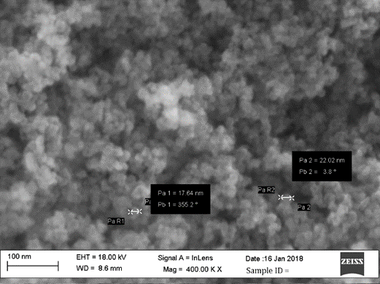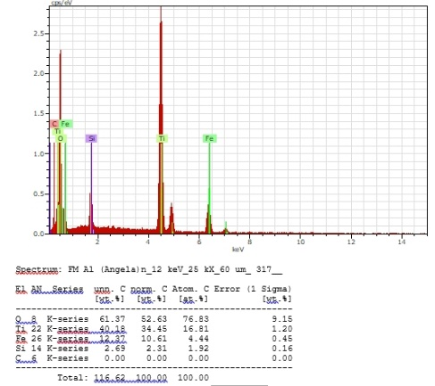
Figure 2: SEM of FMA sample.
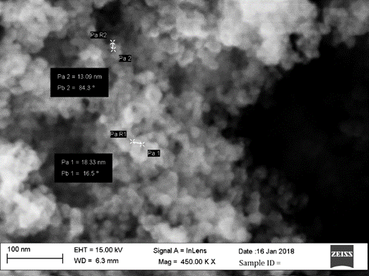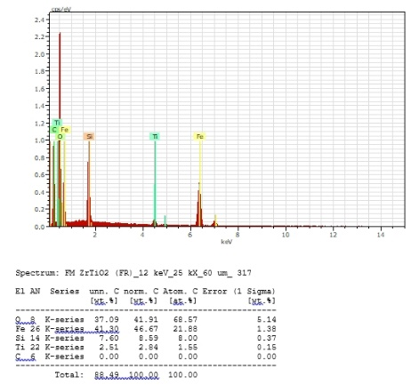
Figure 3: SEM of FMZT sample.
The obtained results of the performed experimental work are reported in Table 1.
Table 1: Results of laboratory tests.
 | FMA | FMZT
Removal of As from 0.5 mg/l As solution
As removal after 1h | 16.2% | N/A
As removal after 24h | 73.5% | 0.5%
Removal of organic matter from 7ppm MB solution
Dye removal after dark1 | 93.9% (24°C) | 94.7% (24°C)
Dye removal after 3h | 72.5% (29°C) | 90.8% (29°C)
Dye removal after dark2 | 78.0% (27°C) | 90.5% (27°C)
Antibacterial activity tests
Antibacterial efficiency | More than 99% | More than 99%
Removal of organic matter from 0.5 mg/l As, 7ppm MB solution simultaneously
After 1h | 15.1% As; 6.7% of MB | <0.1% As; 21.9% of MB
After 24h | 59.5% As; 14.8% of MB | <0.1% As; 59.6% of MB

Concerning As removal, it is noticeable that FMZT do not exhibit sensible adsorption capacities. This behaviour might be justified by a very low electrostatic affinity of As at the solution pH, equal to 6, that leads the particle surface to be negatively charged. In these conditions, the As species, usually present in the oxyanion forms (AsO₃³⁻), are not attracted (Tuutijärvi et al., 2012). Moreover, the limited surface area should be considered as an additional constraint to performance improvement. This is not the case for FMA, that exhibits satisfying removal capacities of As, up to 73.5% within 24h. Analogous results have been reported for other metals (Vilardi et al., 2019a) and for complex wastewaters treated by iron-based nanomaterials (Vilardi et al., 2019b).
Concerning MB removal, both materials exhibits interesting capacities in adsorbing this pollutant. Unfortunately, FMA is affected by a negative aspect, that is the increase of concentration of MB in the solution as soon as the light is put on in the photoreactor, starting from 93.9% in dark conditions reaching a final value of 72,5%. In other words, a desorption of 21.4% MB takes place. It should be considered that alumina due to its high band gap value is not capable to give rise to photocatalytic reactions in the operating conditions of these experiments (Pathania et al., 2016). Therefore, the purification action of FMA is limited to adsorption. With this insight, the observed results of partial desorption might be justified by increase of the sample temperature, given by the light source, in the reactor. The same effect to the same extent cannot be reported for FMZT, since this material exhibits photoactivity. In this case, even if some desorption of MB might take place due to temperature increases, the quick mineralization of the organic pollutant on FMZT strongly inhibits this mechanism (Chinh et al., 2018). Both materials qualify as anti-bacterial. Finally, performances sensibly change in presence of a mixture of As and MB, with an overall reduction of the pollutant elimination capabilities. In these conditions, each material suffers from competitive adsorption mechanisms, where As and MB will preferentially adsorb on TMA and TMZR, respectively. As a consequence, in this work it was not possible to identify one stand-alone material capable to completely purify the water samples. At the end, the nanomaterials were recovered by magnets from the samples at 99.1% in dry weight.
  - Conclusions
The advantages and disadvantages of the studied equipment capable to produce the nanomaterials used in this work are well known in literature. Both devices are capable to generate micro-mixing condition to produce nanoparticles at a high capacity rate and sufficient quantity to face emergency situations. The used nanomaterials, that is FMA and FMZT, are capable to remove 59.6% of the organic matter, 59.5% of heavy metals and more than 99% of bacteria after 24h. Moreover, the nanomaterial can be removed with ease from the water by magnets at 99.1%. In emergency situations, where it is mandatory to avoid the spread out of diseases even under unproper water usage by the population, the employment of these materials appears to meet this target: a contaminated water source can be treated by means of the proposed method if the microbiological pollution in terms of bacteria concentration is maximum 10⁸ UFC/mL and the maximum concentration of As and COD are 0.1 mg/L and 20.0 mg/L, respectively. The advantages of the proposed method are the ease of transportation to the disaster area of the packaged materials, no additional need of logistics, chemicals and energy, no required knowledge for the immediate application. This is not the case of conventional procedures which mostly target the elimination of bacteria and coarse material only, using gridding and addition of chlorine. This latter method permits to deactivate 99% of the bacteria but might rise a problem of toxicity if the concentration values exceed the specific residual ones. The use of ferromagnetic nanocores allows the recovery of the employed materials by magnetic filters, permitting the reuse and as a consequence a limited requirement on the needed amounts. Despite the satisfactory results obtained in this work, the Authors understand that the proposed technology is not a stand-alone technique, since requirements of additional basic pre-processing (cloth filtering, sedimentation, etc.) hold on. Finally, to further reduce the time of production future work should focus on the possibility to develop enhanced nanoparticles, using a combined Al₂O₃/Zr/TiO₂ coating solution produced by co-precipitation techniques. This could permit to increase the performances of the material, and to reduce to one single synthesis step the nanomaterial production.
References
Bavasso I., Vilardi G., Stoller M., Chianese A., Di Palma L., 2016, Perspectives in Nanotechnology Based Innovative Applications for The Environment, Chemical Engineering Transactions, 47, 55–60.
Chinh V.D., Broggi A., Di Palma L., Scarsella M., Speranza G., Vilardi G., Thang P.N., 2018, XPS Spectra Analysis of Ti2+, Ti3+ Ions and Dye Photodegradation Evaluation of Titania-Silica Mixed Oxide Nanoparticles, Journal of Electronic Materials, 47, 2215–2224.
Chinh V.D., Hung L.X., Di Palma L., Hanh V.T.H., Vilardi G., 2019, Effect of Carbon Nanotubes and Carbon Nanotubes/Gold Nanoparticles Composite on the Photocatalytic Activity of TiO₂ and TiO₂-SiO₂, Chemical Engineering and Technology, 42, 308-315.
Di Palma L., Ferrantelli P., Merli C., Petrucci E., Pitzolu I., 2007, Influence of soil organic matter on copper extraction from contaminated soil, Soil and Sediment Contamination, 16, 323-335.
Di Palma L., Verdone N., 2009, The effect of disk rotational speed on oxygen transfer in rotating biological contactors, Bioresource Technology, 100, 1467-1470.
Di Palma L., Medici F., Vilardi G., 2015, Artificial aggregate from non metallic automotive shredder residue, Chemical Engineering Transactions, 43, 1723-1728.
Festag A., 2014, Cooperative intelligent transport systems standards in Europe, IEEE communications magazine, 52(12), 166-172.
Gómez Pastora J., Bringas Elizalde E., Ortiz Uribe I., 2016, Design of novel adsorption processes for the removal of arsenic from polluted groundwater employing functionalized magnetic nanoparticles, Chemical Engineering Transactions, 47, 241-246.
Gueye M.T., Di Palma L., Allahverdeyeva G., Bavasso I., Petrucci E., Stoller M., Vilardi G., 2016, The influence of heavy metals and organic matter on hexavalent chromium reduction by nano zero valent iron in soil, Chemical Engineering Transactions, 47, 289-294.
Ochando-Pulido J. M., Stoller M., 2015, Kinetics and boundary flux optimization of integrated photocatalysis and ultrafiltration process for two-phase vegetation and olive washing wastewaters treatment, Chemical Engineering Journal, 279, 387-395.
Pathania D., Katwal R., Kaur H. 2016, Enhanced photocatalytic activity of electrochemically synthesized aluminum oxide nanoparticles, International Journal of Minerals, Metallurgy, and Materials, 23(3), 358-371.
Stoller M., Ochando-Pulido, J. M., Chianese A., 2013, Comparison of critical and threshold fluxes on ultrafiltration and nanofiltration by treating 2-phase or 3-phase olive mill wastewater, 32, 397-402.
Stoller M., Azizova G., Mammadova A., Vilardi G., Di Palma L., Chianese A., 2016, Treatment of Olive Oil Processing Wastewater by Ultrafiltration, Nanofiltration, Reverse Osmosis and Biofiltration, Chemical Engineering Transactions, 47, 409–414.
Stoller M., Ochando-Pulido J.M., Vilardi G., Vuppala S., Bravi M., Verdone N., Di Palma L., 2017a, Technical and economic impact of photocatalysis as a pretreatment process step in olive mill wastewater treatment by membranes, Chemical Engineering Transactions, 57, 1171-1176.
Stoller M., Vilardi G., Di Palma L., Chianese A., Morganti P., 2017b, Process intensification techniques for the production of nanoparticles for the cosmetic and pharmaceutical industry, Journal of Applied Cosmetology, 35 (1-2), 53-59.
Stoller M., Sacco O., Vilardi G., Ochando-Pulido J.M., Di Palma L., 2018, Technical–economic evaluation of chromium recovery from tannery wastewater streams by means of membrane processes, Desalination and Water Treatment, 127, 57-63.
Tuutijärvi T., Repo E., Vahala R., Sillanpää M., Chen G., 2012, Effect of competing anions on arsenate adsorption onto maghemite nanoparticles, Chinese Journal of Chemical Engineering, 20(3), 505-514.
Vilardi G., Di Palma L., Verdone N., 2017a, Competitive Reaction Modelling in Aqueous Systems: the Case of Contemporary Reduction of Dichromates and Nitrates by nZVI, Chemical Engineering Transactions, 60, 175–180.
Vilardi G., Stoller M., Verdone N., Di Palma L., 2017b, Production of nano Zero Valent Iron particles by means of a spinning disk reactor, Chemical Engineering Transactions, 57, 751–756.
Vilardi G., Rodriguez-Rodriguez J., Ochando-Pulido J.M., Verdone N., Martinez-Ferez A., Di Palma L., 2018a, Large Laboratory-Plant application for the treatment of a Tannery wastewater by Fenton oxidation: Fe(II) and nZVI catalysts comparison and kinetic modelling, Process Safety and Environmental Protection, 117, 629-638.
Vilardi G., Di Palma L., Verdone N., 2018b, On the critical use of zero valent iron nanoparticles and Fenton processes for the treatment of tannery wastewater, Journal of Water Process Engineering, 22C, 109–122.
Vilardi G., Ochando Pulido J.M., Verdone N., Stoller M., Di Palma L., 2018c, On the removal of Hexavalent Chromium by olive stones coated by iron-based nanoparticles: equilibrium study and Chromium recovery, Journal of Cleaner Production, 190, 200-210.
Vilardi G., Di Palma L., Verdone N., 2018d, Heavy metals adsorption by banana peels micro-powder. Equilibrium modeling by non-linear models, Chinese Journal of Chemical Engineering, 26, 455-464.
Vilardi G., Ochando Pulido J.M., Stoller M., Verdone N., Di Palma L., 2018e, Fenton oxidation and chromium recovery from tannery wastewater by means of iron-based coated biomass as heterogeneous catalyst in fixed-bed columns, Chemical Engineering Journal, 351, 1-11.
Vilardi G., 2019, Mathematical modelling of simultaneous nitrate and dissolved oxygen reduction by Cu-nZVI using a bi-component shrinking core model, Powder Technology, 343, 613-618.
Vilardi G., Di Palma L., Verdone N., 2019a, A physical-based interpretation of mechanism and kinetics of Cr(VI) reduction in aqueous solution by zero-valent iron nanoparticles, Chemosphere, 220, 590-599.
Vilardi G., Rodriguez-Rodriguez J., Ochando Pulido J.M., Di Palma L., Verdone N., 2019b, Fixed-bed reactor scale-up and modelling for Cr(VI) removal using nano iron-based coated biomass as packing material, Chemical Engineering Journal, 361, 990-998.
Vuppala S., Stoller M., Chiavola A., Kanaev A., Cheng K., 2018, Synthesis of core-shell nanoparticles for the removal of toxic pollutants in aqueous medium, Chemical Engineering Transactions, 70, 1819-1824.

