CHEMICAL ENGINEERING TRANSACTIONS  VOL. 73, 2019 | A publication of
The Italian Association
of Chemical Engineering
Online at www.aidic.it/cet
Guest Editors: Andrea D’Anna, Paolo Ciambelli, Carmelo Sunseri
Copyright © 2019, AIDIC Servizi S.r.l.
ISBN 978-88-95608-70-9; ISSN 2283-9216

The Effect of pH in Tannery Wastewater by Fenton vs. Heterogeneous Fenton Process
Javier Rodriguez-Rodriguez, Javier Miguel Ochando-Pulido*, Antonio Martinez-Ferez
University of Granada, Department of Chemical Engineering, Granada, Spain
jmochandop@ugr.es
The present study reports about the development of heterogeneous Fenton process by means of nano zero-valent iron particles (nZVI) as heterogeneous catalyst for the treatment of a synthetic tannery wastewater (STW). The experimental tests were conducted using a pilot Fenton plant for the investigation of the scale-up possibility of the treatment process, studying the influence of initial pH (varied in the range 3-7) and catalyst/oxidant ratio (Cat/Ox wt%) on the overall efficiency of the process. The target wastewater prepared in laboratory, was characterized by a high initial COD₀=1200 mg/L and the monitored parameters during the process were COD and hexavalent chromium (Cr(VI)) concentrations. Two different Cat/Ox ratios were tested (20 and 35%) whereas the H₂O₂ amount was fixed equal to 0.75*COD₀. The treatment process was performed for the first 2 h in batch, whereas the remaining 8 h were conducted in continuous. The optimal operating parameters (Cat/OX=35%, pH=3) allowed to reach a COD removal efficiency of 70% and a total Cr(VI) removal.
  - Introduction
Tannery wastewater still represents a serious issue, in particular in the Mediterranean Area (Vilardi et al., 2018a). Spain and Italy hold the most important industrial districts in Europe and their production covers more than 70% of total European leather production (Di Palma et al., 2018). Since the world annual leather production is 2110 Mm², about 35–45 km³ of tannery wastewater are generated every year, causing a severe environmental problem which may only grow in the future. Worldwide, chromium tanning process still represents the widest used process with respect to the vegetable one (Mella et al., 2015), because of its rapidity and feasibility, producing a more stable and workable leather (Vilardi et al., 2018b). The tanning process requires the use of trivalent chromium salts and other potentially toxic compounds, both organic and inorganic, leading to the generation of very polluted process waters (Vilardi et al., 2019a). Among the various toxic compounds traces of hexavalent chromium, Cr(VI), may also be detected (Vilardi et al., 2018c). Cr(VI) is a very toxic compound, considered carcinogenic and mutagenic (Gueye et al., 2016) and characterized by a remarkable solubility and mobility in the environment (Vilardi et al., 2018d). Various processes have been developed for the removal of heavy metals in complex wastewaters, such as photocatalysis (Stoller et al., 2017a), membrane treatments (Stoller et al., 2016) and biosorption (Vilardi et al., 2018e). Considering the high concentration of phenols and other organic material in tannery wastewaters, besides the presence of toxic metals, one of the most employed process for its treatment is represented by Fenton-like processes (Vilardi, 2019). Fenton processes are well-known within the scientific community because of their suitability to remove recalcitrant organic compounds in complex wastewaters (Hodaifa et al., 2013). The main advantages of Fenton process involve mild operative conditions (the process is usually performed at room temperature and atmospheric pressure) as well as low-cost and easily available reagents (Kang and Hwang, 2000). Conversely, acid environment and large hydrogen peroxide dosages are often necessary to reach appreciable treatment efficiencies (Babuponnusami and Muthukumar, 2014). The development of nanotechnology applied to environmental processes has allowed to foster classical processes through the use of limited quantities of active nano-catalysts (Bavasso et al., 2016). In particular, the use of iron-based nanoparticles in different sectors, such as the civil (Di Palma et al., 2015), the cosmetic (Stoller et al., 2017b) and the environmental one (Vilardi et al., 2017a) has been extensively studied in the last decade. Zero-valent iron nanoparticles are characterized by high active surface area and remarkable activity towards both organic and inorganic pollutants (Vilardi and Di Palma, 2017) and has also been investigated its possible use in heterogeneous Fenton processes (Vilardi, 2018). Therefore, the aim of this work was to investigate on the influence of pH and Catalyst/Oxidant weight ratio on the Chemical Oxygen Demand (COD) and Cr(VI) removal efficiency, treating a synthetic tannery wastewater in a pilot-scale Fenton plant sited in the laboratory of Granada University. Kinetic tests were performed once optimal pH and Cat/Ox weight ratio were found. The kinetic data were well fitted to a pseudo-nth order kinetic model (White and Verdone, 2000), using the non-linear Excel solver for the data modelling to avoid the errors due to the linearization procedure (Di Palma et al., 2003).
  - Materials and Methods
    - Materials and synthesis
All the reagents were purchased at analytical grade from Sigma Aldrich (Madrid). The solutions were prepared in deionized water. Selected amounts from stock solutions of the following reagents were used to produce synthetic tannery wastewaters (Vilardi et al., 2018a): tannic acid (5 g/L), NH₄Cl (1 g/L), K₂Cr₂O₇ (12.26 g L⁻¹), Cr₂(SO₄)₃ (1 g/L), Polyethylene glycol 300, CH₂O₂, NaHCO₃ (1 g/L), HCOONa (1 g/L), C₆H₆O (5 g L⁻¹). The STW was characterized in terms of COD (according to closed reflux colorimetric method (Federation, 2005)), pH (measured by a Crison pH-meter) Cr(III) concentration (using an Agilent 240 measuring total Cr), Total polyphenols (using the Folin-Ciocalteau method and expressing it as mg/L of Gallic Acid Equivalent (Hodaifa et al., 2013)) and Cr(VI) concentration (determined according dyphenylcarbazide method (Vilardi et al., 2019b)) and the measured values are reported in Table 1.

Table 1: STW main characteristics.
parameter | unit of measure | value
pH |  | 5
COD | mg/L | 1200
total polyphenols | mg GAE/L | 270
Cr(VI) | mg/L | 10
Cr(III) | mg/L | 20

The following reagents were used for the production of nZVI: FeSO₄·7H₂O, NaBH₄, N₂, following the procedure reported in previous paper, where also its characterization is reported (Vilardi et al., 2018f). In brief, the synthesis was carried out in a 500-mL flask where nitrogen (N₂) was purged during the entire preparation. The selected procedure consists of the preparation of 120 mL of a 0.16 M Fe²⁺ solution to which 120 mL of 0.38 M BH₄⁻ solution were added drop wise, using the optimal molar ratio among BH⁴⁻ and Fe²⁺ (Vilardi et al., 2017b). No buffer systems were used during the preparation. Reaction mixture was shaken vigorously for an hour, up to the gas evolution (hydrogen) ceased. The iron nano-catalyst was characterized by a mean size of 100 nm and by a bi-modal size distribution, with a second family of aggregated nanoparticles with a mean size of 250 nm, determined through dynamic light scattering method (Brookhaven).
    - Experimental set-up
Figure 1 displays the Fenton Pilot plant made of four units: oxidation, neutralization, separation and store unit.

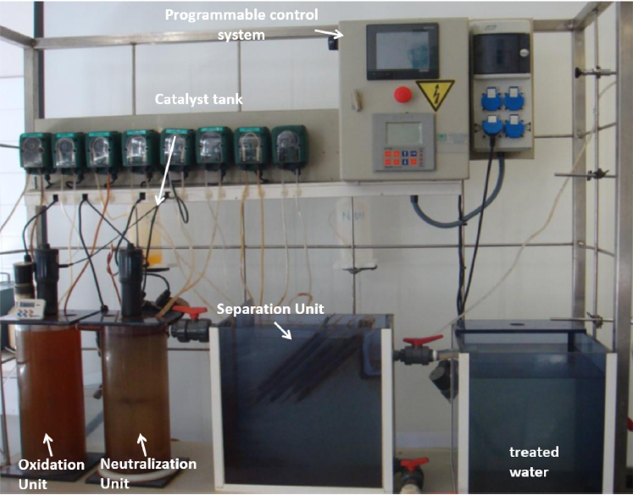
Figure 1: image of used pilot-scale treatment plant (Vilardi et al., 2018g).
Three impellers operating at 60 rpm constituted the stirring equipment, consisting of a three-bladed mixing propeller located at 0.05 m from the reactor bottom and others two turbines with four blades inclined 45° above were installed in the shaft. The diameter of each impeller was 0.05 m, the vertical distance between the impellers was 0.12 m. The oxidation step was performed in a continuous stirred tank reactor, with a diameter of 0.16 m, a height of 0.38 m and a volume of 7.4 L. The static liquid height was set to 0.36 m; the neutralization step was performed in a similar above mentioned reactor (volume = 7 L); the solid sedimentation step occurred in a lamellar settler with a capacity of 22 L; five storage tanks were adopted: (i) for STW (32 L of capacity), (ii) for the hydrogen peroxide (3 L of capacity), (iii) for the catalyst (3 L of capacity), (iv) for the NaOH solution (3 L of capacity) and (v) for the treated STW (50 L of capacity); the plant was also equipped by: 9 peristaltic pumps; pneumatic level sensors; programmable logic controller (PLC).Synthetic tannery wastewater passed from the oxidation unit to the neutralization one by overflow and then was sent from this latter to the sedimentation settler and then to the final treated water storage tank. The beginning of the experiments on continuous mode was performed after having reached steady state (asymptotic organic matter degradation) in the batch step (start-up stage). Experiments were performed continuously for 8 h cycles, taking samples regularly to assess the ability of the depuration process operating in continuous. The process started as batch stirred tank mode for 2 h, then the continuous mode began for additional 8 h. The monitored parameters during the process were COD (COD was determined by the closed reflux colorimetric method subsequently to the manganese oxide addition to remove residual hydrogen peroxide, which remained unreacted in the samples taken from the reactor during the treatment tests) and hexavalent chromium (Cr(VI)) concentrations. Two different Cat/Ox ratios were tested (20 and 35%) whereas the hydrogen peroxide amount was fixed equal to 0.75*COD₀. Six kinetic tests were performed varying the initial pH according to the following values: 3, 5 and 7. At the end of each test the nZVI were recovered, washed with H₂SO₄ 0.1 M solution and re-used until their completely de-activation. The COD kinetic data were fitted to a pseudo-nth order kinetic model, whose equation is reported below:
$${{COD}_{t}}^{n-1}=\frac{{COD}_{0}^{n-1}}{1+\left(n-1\right){COD}_{0}^{n-1}kt} (1)$$

where n is the reaction order and k (M^{1-n}/s) is the kinetic constant. The non-linear regression of experimental data was accomplished in excel environment, using the non linear solver of Excel (Microsoft) function in order to avoid the errors due to linearization (Vilardi et al., 2017c).
  - Results and Discussion
    - Optimal Cat/Ox ratio at different pH
Figure 2 displays the obtained COD removal efficiency values at 10 h of treatment, varying the Cat/Ox ratio and the initial pH.

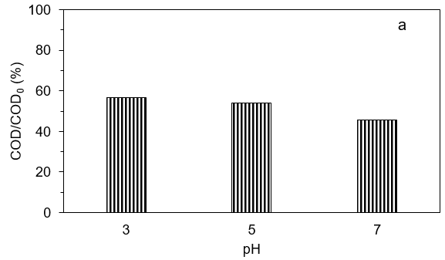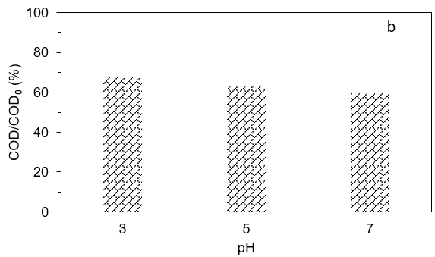

Figure 2: COD removal efficiency value obtained for Cat/Ox=20% (a) and Cat/Ox=35% (b) at different initial pH (temperature=25°C, COD₀=1200 mg/L, contact time=10 h).

As expected, at lower pH the COD removal efficiency increased. In fact, as reported also in previous work (Vilardi et al., 2018g), in very acid environment the production of radical species that oxidize the organic pollutant present in tannery wastewater is favoured. In particular, the mechanism of heterogeneous Fenton process can be represented by the following equations:
$$Fe\left(0\right)+H_{2}O_{2}+2H^{+}→Fe\left(II\right)+2H_{2}O (2)$$
$$Fe\left(II\right)+H_{2}O_{2}→Fe\left(III\right)+HO^{*}+OH^{-} (3)$$
At the same time, Cr(VI) species are reduced to Cr(III) species by Fe(0), according to eq.(4):
$$Fe\left(0\right)+Cr\left(VI\right)→Fe\left(III\right)+Cr\left(III\right) (4)$$

This was demonstrated by the final Cr(VI) concentration measured at 10 h, that, independently from the pH or Cat/Ox ratio, was always below the detection limit of the method (<0.005 mg/L). According to the obtained COD removal efficiency values reported in Figure 1, i.e. for Cat/Ox=20% the values for pH=3, 5 and 7 were 57, 54 and 46%, respectively, whereas for Cat/Ox=35% the values were 68, 63 and 59%, respectively, it was possible to state that the higher Cat/Ox ratio combined with the lower pH value led to the maximum treatment efficiency. These data are in line with those reported by Wang et al. (2014), that obtained a similar COD removal efficiency (55.87%) at higher pH, working on a real TW in batch and lab-scale. analogous results were reported in other studies where authors worked in batch mode, with lab-scale equipment and on synthetic TW (Schrank et al., 2005).
    - Kinetic tests and data modelling
Figure 2 shows the kinetic experimental data at different initial pH and Cat/Ox ratio values, with the fitted pseudo-nth order kinetic model.

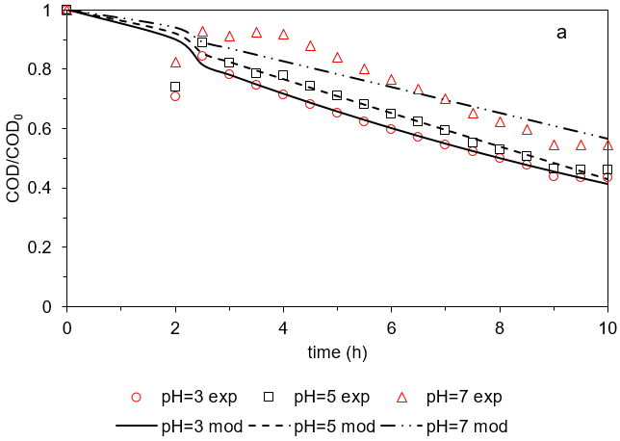

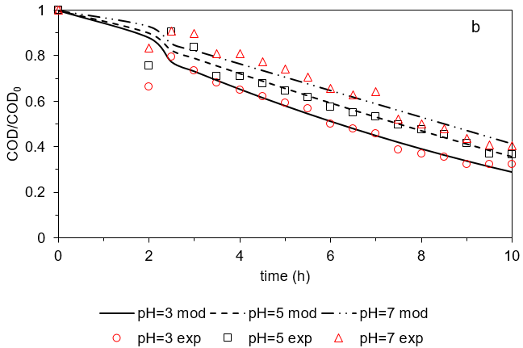
Figure 2: kinetic data obtained at different initial pH and Cat/Ox values (points) and pseudo-nth order kinetic model (lines) (Cat/Ox=20% figure a, Cat/Ox=35% figure b, contact time=10 h, temperature=25°C).

The pseudo-nth kinetic model was able to well describe the experimental data after the first two hours of batch mode. In fact, during the transition among batch and continuous mode, the addition of freshly prepared STW caused an initial increase in the COD value that cannot be well described by the model that reports only a reduction of the target parameter concentration. However, the regressed k and n values reported in Table 1 are in line with the expectations, since similar order of magnitude for the kinetic constant has been reported in previous studies regarding organic oxidation by Fenton-like process (Nakagawa et al., 2016).

Table 1: regressed k and n values.
Conditions | k (M^{1-n}/s) | n | R²
pH=3, Cat/Ox=20% | 0.013 | 0.78 | 0.986
pH=5, Cat/Ox=20% | 0.013 | 0.78 | 0.986
pH=7, Cat/Ox=20% | 0.013 | 0.78 | 0.981
pH=3, Cat/Ox=35% | 0.013 | 0.78 | 0.979
pH=3, Cat/Ox=35% | 0.013 | 0.78 | 0.992
pH=3, Cat/Ox=35% | 0.013 | 0.78 | 0.988

The used nZVI were recovered by magnetic separation and re-used in the same experiments, according to optimal operating conditions (pH=3 and Cat/Ox=35%). The COD removal efficiency obtained up to five cycles of use was almost equal to that obtained in the first experiment. In detail, the removal values at 10 h were: 67.4, 66.1, 65.5, 64.8 and 63.1%, respectively, whereas it dropped up to 51% after the sixth cycle of use, implying that the nZVI activity tended to strongly decrease after 5 cycles of use.
  - Conclusions
The nZVI particles were successfully used to develop a heterogeneous Fenton-like process, tested on a pilot scale Fenton plant to treat a synthetic tannery wastewater. The nanoparticles were characterized by a bimodal size with a mean size of 100 nm and were used as catalyst for the production of Fe(II) ions in aqueous medium. The influence of pH and the ratio between catalyst and oxidant has been studied monitoring both Cr(VI) concentration and COD of the polluted tannery solutions. The Cr(VI) concentration immediately decreased (after 1 h) below the detection limit of the determination method, independently from the initial pH and/or the initial catalyst/oxidant ratio. The optimal pH and Cat/Ox (% weight) ratio were 3 and 35%, respectively, leading to a COD removal efficiency of 68%. The initial oxidant amount (hydrogen peroxide) was fixed equal to 0.75*COD₀, according to a previous study. The kinetic experimental data were then successfully fitted to a pseudo-nth order kinetic model, obtained as regressed reaction order, n, a value of 0.78 and as regressed kinetic constant, k, a value of 0.013 M^{0.22}/s. In conclusion, the use of a heterogeneous nano-catalyst proved to be an efficient alternative to the classical iron sulphate salt, considering the higher COD removal efficiency values, reported in a previous work, and also the possibility to re-use the catalyst up to 5 times before its de-activation.
References
Babuponnusami A., Muthukumar K., 2014, A review on Fenton and improvements to the Fenton process for wastewater treatment, Journal of Environmental Chemical Engineering, 2, 557–572.
Bavasso I., Vilardi G., Stoller M., Chianese A., Di Palma L., 2016, Perspectives in Nanotechnology Based Innovative Applications for The Environment, Chemical Engineering Transactions, 47, 55-60.
Di Palma L., Merli C., Paris M., Petrucci E., 2003, A steady-state model for the evaluation of disk rotational speed influence on RBC kinetic: Model presentation, Bioresource Technology, 86, 193-200.
Di Palma L., Medici F., Vilardi G., 2015, Artificial aggregate from non metallic automotive shredder residue, Chemical Engineering Transactions, 43, 1723-1728.
Di Palma L., Verdone N., Vilardi G., 2018, Kinetic Modeling of Cr(VI) Reduction by nZVI in Soil: The Influence of Organic Matter and Manganese Oxide, Bulletin of Environmental Contamination and Toxicology, 101, 692-697.
Federation, W., 2005, Standard Methods for the Examination of Water and Wastewater, American Public Health Association (APHA), Washington, DC, USA.
Gueye M.T., Di Palma L., Allahverdeyeva G., Bavasso I., Petrucci E., Stoller M., Vilardi G., 2016, The influence of heavy metals and organic matter on hexavalent chromium reduction by nano zero valent iron in soil, Chemical Engineering Transactions, 47, 289-294.
Hodaifa G., Ochando-Pulido J.M., Rodriguez-Vives S., Martinez-Ferez A., 2013, Optimization of continuous reactor at pilot scale for olive-oil mill wastewater treatment by Fenton-like process, Chemical Engineering Journal, 220, 117–124.
Kang Y.W., Hwang K.-Y., 2000, Effects of reaction conditions on the oxidation efficiency in the Fenton process, Water Research, 34, 2786–2790.
Mella B., Glanert A.C., Gutterres M., 2015, Removal of chromium from tanning wastewater and its reuse. Process Safety and Environmental Protection, 95, 195–201.
Nakagawa H., Takagi S., Maekawa J., 2016, Fered-Fenton process for the degradation of 1,4-dioxane with an activated carbon electrode: a kinetic model including active radicals, Chemical Engineering Journal, 296, 398–405.
Stoller M., Azizova G., Mammadova A., Vilardi G., Di Palma L., Chianese A., 2016, Treatment of Olive Oil Processing Wastewater by Ultrafiltration, Nanofiltration, Reverse Osmosis and Biofiltration, Chemical Engineering Transactions, 47, 409–414.
Stoller M., Ochando-Pulido J.M., Vilardi G., Vuppala S., Bravi M., Verdone N., Di Palma L., 2017a, Technical and economic impact of photocatalysis as a pretreatment process step in olive mill wastewater treatment by membranes, Chemical Engineering Transactions, 57, 1171-1176.
Stoller M., Vilardi G., Di Palma L., Chianese A., Morganti P., 2017b, Process intensification techniques for the production of nanoparticles for the cosmetic and pharmaceutical industry, Journal of Applied Cosmetology, 35 (1-2), 53-59.
Vilardi G., Di Palma L., 2017, Kinetic Study of Nitrate Removal from Aqueous Solutions Using Copper-Coated Iron Nanoparticles, Bulletin of Environmental Contamination and Toxicology, 98 (3), 359-365.
Vilardi G., Verdone N., Di Palma L., 2017a, The influence of nitrate on the reduction of hexavalent chromium by zero-valent iron nanoparticles in polluted wastewater, Desalination and Water Treatment, 86, 252–258.
Vilardi G., Stoller M., Verdone N., Di Palma L., 2017b, Production of nano Zero Valent Iron particles by means of a spinning disk reactor, Chemical Engineering Transactions, 57, 751–756.
Vilardi G., Di Palma L., Verdone N., 2017c, Competitive Reaction Modelling in Aqueous Systems: the Case of Contemporary Reduction of Dichromates and Nitrates by nZVI, Chemical Engineering Transactions, 60, 175–180.
Vilardi G., 2018, Bimetallic nZVI-induced chemical denitrification modelling using the shrinking core model, Chemical Engineering Transactions, 70, 235-240.Vilardi G., Di Palma L., Verdone N., 2018a, On the critical use of zero valent iron nanoparticles and Fenton processes for the treatment of tannery wastewater, Journal of Water Process Engineering, 22C, 109–122.
Vilardi G., Ochando Pulido J.M., Stoller M., Verdone N., Di Palma L., 2018b, Fenton oxidation and chromium recovery from tannery wastewater by means of iron-based coated biomass as heterogeneous catalyst in fixed-bed columns, Chemical Engineering Journal, 351, 1-11.
Vilardi G., Ochando Pulido J.M., Verdone N., Stoller M., Di Palma L., 2018c, On the removal of Hexavalent Chromium by olive stones coated by iron-based nanoparticles: equilibrium study and Chromium recovery, Journal of Cleaner Production, 190, 200-210.
Vilardi G., Mpouras T., Dermatas D., Verdone N., Polydera A., Di Palma L., 2018d, Nanomaterials application for heavy metals recovery from polluted water: the combination of nano zero-valent iron and carbon nanotubes. Competitive adsorption non-linear modeling, Chemosphere, 201, 716-729.
Vilardi G., Di Palma L., Verdone N., 2018e, Heavy metals adsorption by banana peels micro-powder. Equilibrium modeling by non-linear models, Chinese Journal of Chemical Engineering, 26, 455-464.
Vilardi G., Sebastiani D., Miliziano S., Verdone N., Di Palma L., 2018f, Heterogeneous nZVI-induced Fenton oxidation process to enhance biodegradability of excavation by-products, Chemical Engineering Journal, 335, 309–320.
Vilardi G., Rodriguez-Rodriguez J., Ochando-Pulido J.M., Verdone N., Martinez-Ferez A., Di Palma L., 2018g, Large Laboratory-Plant application of a Tannery wastewater treatment by Fenton oxidation: Fe(II) and nZVI catalyst comparison and kinetic modelling, Process Safety and Environmental Protection, 117, 629-638.
Vilardi G., 2019, Mathematical modelling of simultaneous nitrate and dissolved oxygen reduction by Cu-nZVI using a bi-component shrinking core model, Powder Technology, 343, 613-618.
Vilardi G., Rodriguez-Rodriguez J., Ochando Pulido J.M., Di Palma L., Verdone N., 2019a, Fixed-bed reactor scale-up and modelling for Cr(VI) removal using nano iron-based coated biomass as packing material, Chemical Engineering Journal, 361, 990-998.
Vilardi G., Di Palma L., Verdone N., 2019b, A physical-based interpretation of mechanism and kinetics of Cr(VI) reduction in aqueous solution by zero-valent iron nanoparticles, Chemosphere, 220, 590-599.
Wang Y., Li W., Irini A., Su C., 2014, Removal of organic pollutants in tannery wastewater from wet-blue fur processing by integrated anoxic/oxic (A/O) and Fenton: process optimization, Chemical Engineering Journal, 252, 22–29.
White D. A., Verdone N., 2000, Numerical modelling of sedimentation processes, Chemical Engineering Science, 55, 2213-2222.

