CHEMICAL ENGINEERING TRANSACTIONS  VOL. 73, 2019 | A publication of
The Italian Association
of Chemical Engineering
Online at www.aidic.it/cet
Guest Editors: Andrea D’Anna, Paolo Ciambelli, Carmelo Sunseri
Copyright © 2019, AIDIC Servizi S.r.l.
ISBN 978-88-95608-70-9; ISSN 2283-9216

Steam Reforming of Model Compounds from Biomass Fermentation over Nanometric Ruthenium Modified Nickel-Lanthanum Perovskites Catalysts
Maria Paola Bracciale, Benedetta de Caprariis, Paolo De Filippis, Marco Scarsella*
Department of Chemical Engineering, Sapienza University of Rome, Via Eudossiana 18, 00184 Rome, Italy
marco.scarsella@uniroma1.it

Nanometric ruthenium-modified LaNiO₃ perovskites prepared by coprecipitation method in aqueous and non-aqueous solvents were tested as catalysts in the steam reforming of butanol, acetone and ethanol and their mixture, named ABE, usually produced by fermentation. ABE is potentially of great interest for hydrogen production, notwithstanding the strong tendency of this mixture of oxygenated compounds to produce coke in the steam reforming conditions. The tested catalyst showed high feed conversions with improved stability.
  - Introduction
The renewable production of hydrogen from sustainable resources such as biomass is becoming more and more attractive. In this context oxygenated compounds obtained from biomass fermentation constitute a very promising feedstock. Through fermentation of a wide variety of lignocellulosic materials it is possible to obtain a mixture of oxygenated compounds, principally ethanol, acetone and butanol (generally in a mass ratio butanol:acetone:ethanol of about 6:3:1) [Karimi et al., 2015]. The mixture, usually known with the acronym ABE (acetone-butanol-ethanol ), other than as biofuel, in blend with diesel and gasoline [Algayyim et al., 2018], can constitute a potential source of H₂, due to its high weight % of hydrogen content. Moreover this mixture is easy to handle and obviously such to assure a neutral carbon dioxide balance in the hydrogen production. Notwithstanding the use of the mixture of oxygenated compounds obtained from fermentation broths could be a very economical option, considering the cost of the separation processes necessary to obtain the single constituents, few studies are available on its reforming and also on reforming of butanol and acetone [Kumar et al., 2018]. For the steam reforming of these oxygenated compounds and their mixtures nickel and cobalt based catalysts are the most suggested [Yadav et al., 2018; Wang et al., 2016; Bizkarra et al., 2015; Cai et al. 2012; Roy et al., 2011], anyway the challenge of developing catalysts with a suitable resistance to deactivation by coke deposition is still open. In this context growing attention have received perovskite-type oxides (ABO3, where A = alkali, alkaline earth or rare-earth elements and B = transition metal). These oxides show high thermal stability and when subjected to reduction of the B-sites cations they produce nanometric particles with the transition metal highly dispersed at the surface of the support, thus increasing the catalytic activity and stability and providing unfavourable conditions to carbon deposition.
In the present work nanometric ruthenium-modified LaNiO3 perovskites were prepared by coprecipitation method in aqueous and non-aqueous solvents and characterized. The results of their use as catalysts for the steam reforming of model mixtures constituted of butanol, acetone and ethanol are presented. The tests were performed in a fixed bed reactor in a temperature range of 500-700 °C. The stability of the catalysts over time were also evaluated.
  - Experimental
    - Catalysts synthesis
Catalysts were prepared by coprecipitation method using two different solvents, water and a deep eutectic solvent (DES). Nickel nitrate hexahydrate (Sigma-Aldrich, purum p.a., ≥97.0), lanthanum nitrate hexahydrate (Fluka, puriss. p.a., ≥99.0%) and ruthenium nitrosyl nitrate (Sigma-Aldrich, diluted nitrate solution, 1.5 % Ru) were used as metals precursors.
In the water route, to a solution of the metal precursors in the stoichiometric ratio necessary to obtain the target perovskite was rapidly added, under intense stirring at room temperature, an equivalent volume of NaOH solution 3.2M. The obtained suspension was left under stirring at room temperature overnight, then was filtered, washed with water to neutrality, dried at 80 °C for 24h and finally the resultant solid was grinded and calcined at 750 °C for 6 hours under static air.
For the DES route was used as solvent a deep eutectic solvent constituted by choline chloride and urea in a 1:2 molar ratio. The procedure was the same as in the water route, but performed at a temperature of 80 °C to assure the low viscosity for the DES necessary for a correct mixing and homogeneity of the suspension.
Both LaNiO₃ and ruthenium-modified with 5%wt Ru (LaRu_{x}Ni_{1-x}O₃) catalysts were prepared in water and in DES. To evaluate the formation of the perovskite structure and the degree of crystallinity, X-ray diffraction (XRD) was performed on all the obtained samples. XRD patterns were obtained using a Philips Analytical PW1830 X-ray diffractometer, equipped with Cu Kα (1.54056 Å) radiation, in the 2θ range from 15 to 70° with a step size of 0.02° and a time for step of 3.5 sec. The data were collected with an acceleration voltage and applied current of 40 kV and 30 mA, respectively. X-ray microdiffractometer, Rigaku D-max-RAPID, using Cu-Kα radiation.
    - Experimental set-up
The laboratory set-up consisted in a stainless steel tube reactor (id= 10mm, h= 330 mm) with a support grid for the catalytic bed constituted by 0.1 g of catalyst diluted in 2 g of silicon dioxide. The reactor was heated by an external cable heater and controlled by a PLC.K-type thermocouples were used for temperature measurements. Deionized water and one between acetone (Sigma-Aldrich, ACS reagent, ≥99.5%), n-butanol (Sigma-Aldrich,
puriss. p.a., ≥99.5%), ethanol (Sigma-Aldrich , puriss., ≥99.8%) or a mixture of these three (A:B:E 0.27:0.43:0.30 molar ratio) were fed separately with two syringe pumps to the reactor, in the selected steam to carbon (S/C) ratio that is 3.8. N₂ was employed as carrier gas and was mixed with the reactants in a mixing valve before entering to an evaporator held at 230 °C to vaporize the feed before it entered to the reactor. The experimental set-up scheme is reported in [B. de Caprariis et al., 2017]. The laboratory set-up and the operative conditions used in the experimental tests are reported in Figure 1 and Table 1, respectively.
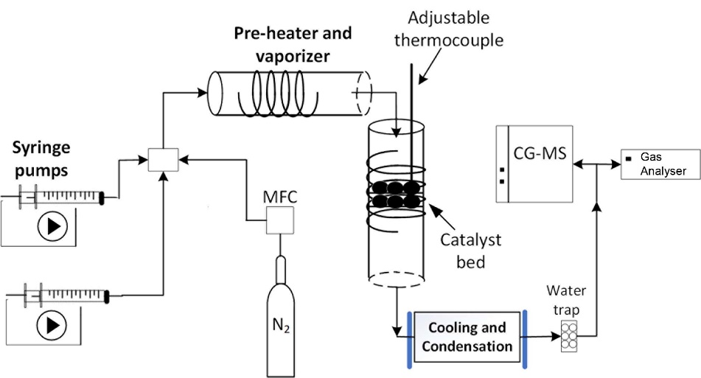

Figure 1: Experimental set-up
Table 1: Operative conditions used in the steam reforming tests.
 | Operative conditions |  | Operative conditions
Temperature (°C) | 500-700 | Catalyst bed volume (cm³) | 1
N2 flow rate (l/h) | 6.6 | Catalyst amount (g) | 0.1
Liquid feed flow rate (ml/h ) | 7.5 | S/C | 3.8
 |  | GHSV (h⁻¹) | 13703

At the reactor exit the condensable fraction (unreacted feed and condensable products) was separated and the gas sent to an online analyzer (Siemens Ultramat 23) for the CO, CO2 and CH4 . The hydrogen concentration was measured by a GC mass spectrometer (Hiden QGA).
Before the reforming tests catalysts were activated in situ at 750 °C using a hydrogen-nitrogen mixture with the following procedure: 1 h gas flow rate of 0.6 Nl min⁻¹ with a H₂/N₂ ratio of 0.15; 1 h gas flow rate of 0.4 Ni min⁻¹ with a H₂/N₂ ratio of 0.50.
The spent catalyst was recovered after the tests and the carbon deposition was determined gravimetrically by coke combustion.
  - Results and discussion
    - Catalysts characterization
Figure 2 reports the X-ray diffraction profiles of the prepared catalysts. The main phase present in all catalysts was the perovskite structure of LaNiO₃, as highlighted by the diffraction lines at 32°, 47° and 58°. Furthermore, the sample obtained by DES route shows reflections due to NiO and an additional spinel-type phase (La₂NiO₄). These latter have been reported as intermediate phases generated when the calcination temperature is not enough for the transformation into LaNiO₃ [Yang et al., 2016].

a) | b)
Figure 2: XRD pattern of catalysts synthetized in a) water, b) DES.
In the sample synthetized in water, the insertion of Ru did not affect the LaNiO₃ perovskite structure. In addition, the XRD pattern also shows the diffraction lines of NiO along with the lines of the hexagonal lanthanum oxycarbonate (La₂O₂CO₃) phase. It has been proposed that the La₂O₂CO₃ phase plays a key role in reducing carbon deposition [Yang et al., 2015]. For Ru substitution in the DES route whereas there are also reflection lines of LaOCl. No diffraction peaks corresponding to RuO₂ or metallic Ru were detected. The crystal sizes of the LaNiO₃ perovskite structure, calculated from the full width at half maximum (FWHM) of the most intense diffraction peak using Scherrer formula, are listed in Table 2. Upon Ru insertion, the particle sizes slightly increased.
Table 2: Crystallite size of the synthetized perovskite structures
Sample | Crystallite size of LaNiO₃ (nm)
LaNiO₃ H₂O | 16.09
LaNiO₃ + 5%Ru H₂O | 16.13
LaNiO₃ DES | 19.0
LaNiO₃ + 5%Ru DES | 19.7

    - ABE steam reforming tests
In the Figure 3 the results of the tests performed with the single compounds are reported in terms of carbon specie conversion which was calculated as:
$\%conv=\frac{F_{CO,out}+F_{CO2,out}+F_{CH4,out}+2*F_{C2H4,out}}{number of C* F_{i,in}}$ (1)
a) | b)
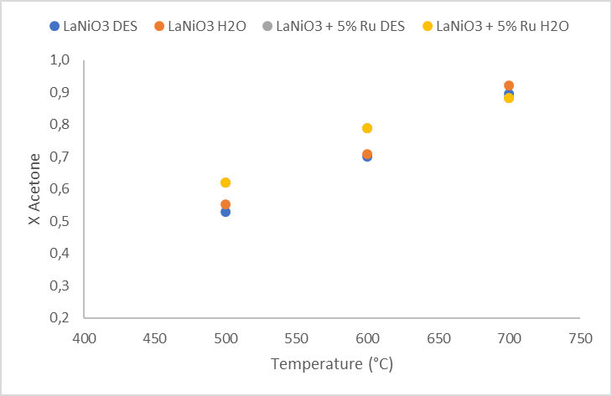 | 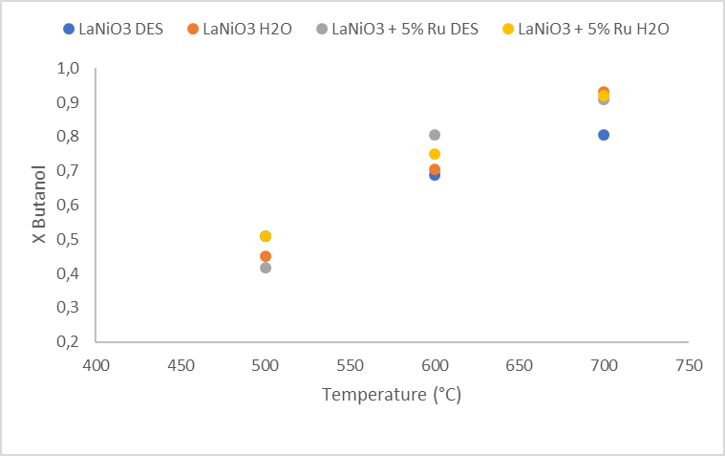
c)
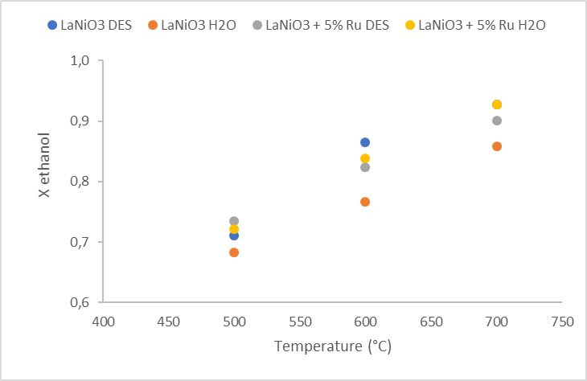
Figure 3: Carbon conversion as a function of temperature with the four prepared catalysts of a) acetone, b) butanol, c) ethanol.
In the investigated interval of temperatures, the conversions range between 0.4-0.95 for acetone and butanol and higher when ethanol is used as feed, in the range of 0.65-0.95. The catalysts with Ru give generally higher conversions and between them the catalyst synthetized in water seems to have the best performances especially at low temperature. In Figure 4 the carbon conversion of ABE and the hydrogen selectivity calculated as follow are reported.
$S_{H2}=\frac{F_{H2,out}}{F_{tot,out}}$ (2)

a) | b)
 | 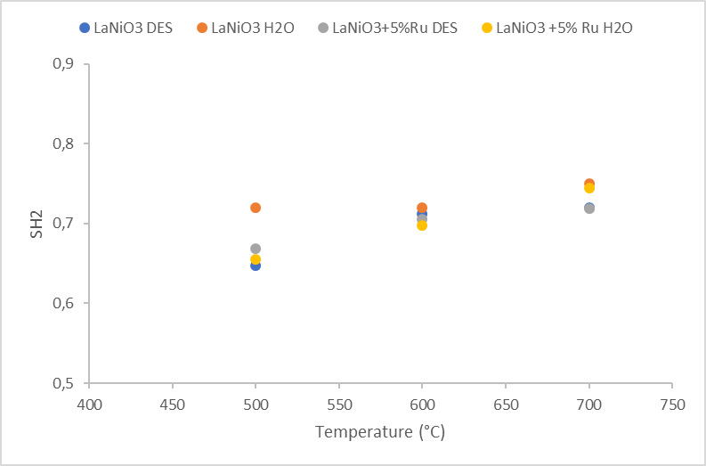

Figure 4: a) Carbon conversion as a function of temperature with the prepared catalysts of ABE, b) H₂ selectivity

The behavior is the same observed for the three single compounds, the catalysts containing 5 % of Ru have higher activity leading to major conversions. The values of conversion in the whole temperature range vary from 0.64, the lowest value obtained with the LaNiO3 synthetized in water and 0.97 that is the value obtained at 700 °C with the two catalysts with Ru. The values of hydrogen selectivity range between 0.64 and 0.75 and no considerable differences are observed changing the catalyst.
Looking at Table 3 and Table 4 where the gas composition is reported for the four catalysts in the entire temperature range, it can be noticed that the catalysts with Ru produce the minor amount of methane (Table 4) and between them the lowest is measured with the one synthetized in DES. As expected, the amount of methane decreases with the increase of temperature for all the tests since the methanation reaction becomes unfavored. Furthermore, with the LaNiO₃ + 5% Ru DES, the production of ethylene is the lowest meaning that also the coke amount on this catalyst should be low as confirmed by the data reported in Table 5.
Table 3: Gas composition N₂ free basis for LaNiO₃ DES and LaNiO₃ H₂O.
 | LaNiO3 DES |  |  | LaNiO3 H2O
T (°C) | 500 | 600 | 700 | 500 | 600 | 700
H2 % vol | 65.0 | 71.4 | 72.0 | 71.1 | 72.1 | 73.1
CO % vol | 6.1 | 6.7 | 7.9 | 5.1 | 6.7 | 7.4
CO2 %vol | 21.7 | 17.7 | 16.7 | 18.5 | 18.6 | 17.7
CH4 %vol | 3.5 | 2.5 | 1.8 | 2.8 | 2.0 | 1.6
C2H4 %vol | 3.7 | 1.7 | 1.6 | 2.5 | 0.6 | 0.2
Ntot (mol/s) | 3.88*10⁻⁵ | 5.31*10⁻⁵ | 6.49*10⁻⁵ | 5.98*10⁻⁵ | 6.46*10⁻⁵ | 7.13*10⁻⁵
Table 4:Gas composition N₂ free basis for LaNiO₃ DES + 5% Ru and LaNiO₃ H₂O + 5% Ru
 | LaNiO3 DES +5% Ru |  |  | LaNiO3 H2O +5% Ru
T (°C) | 500 | 600 | 700 | 500 | 600 | 700
H2 % vol | 66.7 | 70.5 | 71.8 | 65.5 | 68.7 | 70.9
CO % vol | 5.4 | 6.7 | 7.5 | 5.9 | 6.6 | 7.7
CO2 %vol | 25.3 | 21.3 | 19.8 | 25.7 | 22.5 | 19.8
CH4 %vol | 1.5 | 0.9 | 0.6 | 1.7 | 1.2 | 0.8
C2H4 %vol | 1.1 | 0.6 | 0.3 | 1.2 | 1.1 | 0.8
Ntot (mol/s) | 5.52*10⁻⁵ | 6.42*10⁻⁵ | 7.59*10⁻⁵ | 5.22*10⁻⁵ | 6.56*10⁻⁵ | 8.24*10⁻⁵
Table 5: Coke formed during the long duration tests
Sample | Coke %_{wt}
LaNiO3 H2O  LaNiO3 + 5%Ru H2O  LaNiO3 DES  LaNiO3 + 5%Ru DES | 8.54  0.04  7.39  1.67

The long duration steam reforming tests at 700 °C on ABE (Figure 5) show good performances for all the catalysts; the excellent stability for the catalysts containing 5% Ru has to be noted, as confirmed by their very low coke deposition tendency, reported in Table 5. The extremely low percentage of coke showed by the LaNiO₃ + 5% Ru H₂O confirms the function of the lanthanum oxycarbonate phase in reducing carbon deactivation by reaction with carbon deposited on the active sites [Aupretre et al., 2002; Yang et al., 2015].
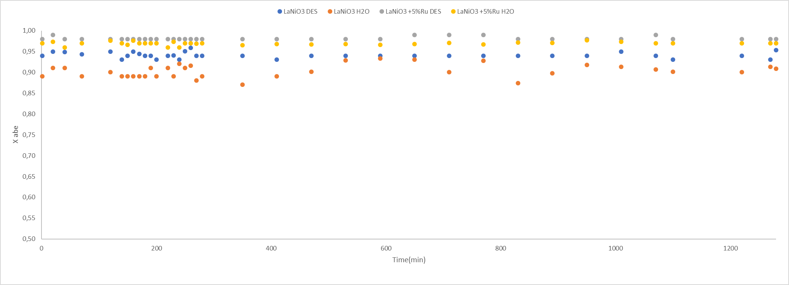

Figure 5: Conversion of ABE in the long duration tests for the four catalysts at 700 °C.
  - Conclusions
In this work nanometric ruthenium-modified LaNiO₃ perovskites were prepared by coprecipitation method in water and DES and the effects of the solvent and of the presence of Ru was evaluated in the steam reforming of mixtures constituted of butanol, acetone and ethanol, typically obtained through fermentation of lignocellulosic materials and notoriously hard to use as feed due to deactivation of the catalysts by coke deposition. All the catalysts show good performances in ABE steam refroming with conversion values ranging from 65-97% in the temperature interval tested. Furthermore, both the Ru-modified LaNiO₃ catalysts showed an improved stability in long duration tests, confirming the recognized catalytic characteristics of perovskite-type structures. This is particularly evident for the sample synthetized in water, with an ABE conversion higher than 96% and a weight percentage of carbon deposition of 0.04 at the end of the long duration test compared with 8.54 % for the corresponding catalyst without Ru.
References
Algayyima S.J.M., Wandelb A.P., Yusafa T., Hamawand I., 2018, Production and application of ABE as a biofuel. Renewable and Sustainable Energy Reviews 82, 1195–1214.
Aupretre F., Descorme C., Duprez D., 2002, Bio-ethanol catalytic steam reforming over supported metal catalysts. Catalysis Communications, 3, 263.
Bizkarra K., Barrio V.L., Yartu A., Requies J., Arias P.L., Cambra J.F., 2015, Hydrogen production from n-butanol over alumina and modified alumina nickel catalysts. International Journal of Hydrogen Energy, 40, 5272–5280.
Cai W., de la Piscina P.R., Homsa N., 2012, Hydrogen production from the steam reforming of bio-butanol over novel supported Co-based bimetallic catalysts. Bioresource Technology, 107, 482–486.
de Caprariis B., Bracciale M.P., De Filippis P., Hernandez A.D., Petrullo A., Scarsella M., 2017, Steam reforming of tar model compounds over ni supported on CeO2 and mayenite. Can. J. Chem. Eng., 95, 1745–1751.
Karimi K., Tabatabaei M., Sárvári Horváth I., Kumar R., 2015, Recent trends in acetone, butanol, and ethanol (ABE) production. Biofuel Research Journal, 8, 301–308.
Kumar B., Kumar S., Sinha S., Kumar S., 2018, Utilization of acetone-butanol-ethanol-water mixture obtained from biomass fermentation as renewable feedstock for hydrogen production via steam reforming: thermodynamic and energy analyses. Bioresource Technology, 261, 385–393.
Roy B., Sullivan H., Leclerc C.A., 2011 .Aqueous-phase reforming of n-BuOH over Ni/Al2O3 and Ni/CeO2 catalysts. Journal of Power Sources, 196, 10652–10657.
Scherrer P., 1912, Bestimmung der inneren Struktur und der Größe von Kolloidteilchen mittels Röntgenstrahlen, Chapter In: R Zsigmondy (Ed.), Kolloidchemie Ein Lehrbuch, Springer Berlin Heidelberg, Berlin, DE, 387–409.
Wang Y., Yang X., Wang Y., 2016, Catalytic performance of mesoporous MgO supported Ni catalyst in steam reforming of model compounds of biomass fermentation for hydrogen production. International Journal of Hydrogen Energy, 41, 17846–17857.
Yadav A.K., Vaidya P.D., 2018, Reaction kinetics of steam reforming of n-butanol over a Ni/hydrotalcite catalyst. Chem. Eng. Technol., 41 (5), 890–896.
Yang E-h., Noh Y-s., Ramesh S., Lim S.S., Moon D.J., 2015, The effect of promoters in La0.9M0.1Ni0.5Fe0.5O3 (M = Sr, Ca) perovskite catalysts on dry reforming of methane. Fuel Processing Technology, 134, 404–413.
Yang E-h., Moon D.J., 2016, Synthesis of LaNiO3 perovskite using an EDTA-cellulose method and comparison with the conventional Pechini method: application to steam CO2 reforming of methane. RSC Advances, 6 (114), 112885-112898.

