CHEMICAL ENGINEERING TRANSACTIONS  VOL. 73, 2019 | A publication of
The Italian Association
of Chemical Engineering
Online at www.aidic.it/cet
Guest Editors: Andrea D’Anna, Paolo Ciambelli, Carmelo Sunseri
Copyright © 2019, AIDIC Servizi S.r.l.
ISBN 978-88-95608-70-9; ISSN 2283-9216

Decolourization of Anionic Dye by Activated Carbon-Supported Nano-Zero Valent Iron (nZVI)
Nur Aishah Zarime, Wan Zuhari Wan Yaacob, Habibah Jamil
Geology Programme, Faculty of Science and Technology, Universiti Kebangsaan Malaysia, Malaysia
aishahzarime@gmail.com, drwzwy@gmail.com and bib@ukm.edu.my

This study investigates the capability of activated carbon-supported nano-zero valent iron (AC-nZVI) to remediate the anionic dye (Acid Orange II). The supported nanoparticles (AC-nZVI) were synthesized by using chemical reduction method of Ferric Chloride Tetrahydrate and Sodium Borohydride, NaBH4 solutions. The absorbents of nZVI and AC-nZVI were characterized by using Brunnaer–Emmett–Teller (BET) surface area, Field Emission Scanning Electron Microscopy (FESEM), X-Ray Diffraction (XRD) and X-ray Photoelectron Spectroscopy with Auger Electron Spectroscopy (XPS-AES). Batch Tests were also conducted to delineate the effectiveness of adsorbent materials in removing Acid Orange II. Batch tests involved of five effects including dose, initial concentration, pH, kinetic and temperature. In initial concentration effect, AC-nZVI exhibits larger adsorption capacity (4.41 mg/g) compared to activated carbon (1.82 mg/g) due to the dispersion of nZVI particles on activated carbon particles, consequently providing more sites for adsorption. The results also revealed that the supported nZVI can be an effective absorbent to remove anionic dye wastewater.
  - Introduction
Nano zero-valent iron (nZVI) has been commonly used in groundwater treatment and site remediation due to its higher reactivity (Chen et al. 2012; Vilardi et al. 2017; Bavasso et al. 2018). This nZVI use the concept of adsorption process, which is one of the most efficient methods in removing pollutants from wastewater. According to Shen et al. (2009), the advantages of adsorption process are inexpensive, simple in operation and no formation of sludge. However, nZVI itself has its own limitation that are easily agglomerate and sedimentation due to iron's magnetic attraction forces resulting in reducing its mobility (Busch et al. 2015). Modification on nZVI was proposed to reduce nZVI particles from agglomerated (Kakavandi et al. 2014; Busch et al. 2015). The main objective of the current study is to investigate the capability of activated carbon-supported nano-zero valent iron nanoparticles (AC-nZVI) to remediate the anionic dye (Acid Orange II). According to Shen et al. (2009), activated carbon is frequently used in wastewater treatment due to its large specific surface area, although it is a bit expensive to run.
  - Materials and Method
Materials used in this study are activated carbon and Acid Orange II supplied in solid state. Chemicals such as Ferric Chloride Tetrahydrate, FeCl₃.6H₂O (Acros organics, 99+%), Sodium Borohidrate, NaBH₄ (Acros organics, 98+%) and Ethanol C₂H₆O (Fisher Scientific, 99.4%) were used in this analysis.
2.1 Synthesizing Composite Nanoparticles
Composite nanoparticles were synthesized by using chemical reduction method (Yaacob and How, 2015). Ferric chloride solutions were prepared by mixing 4.38g ferric chloride tetrahydrate with 50 ml mixture of ethanol and deionized water (35ml ethanol + 15ml of deionized water). 4 g of activated carbon was added to ferric chloride solution and the mixture was shaken using ultrasonic shaker for 30 minutes. To produce NaBH₄ solutions, 6.091 g sodium borohydride was dissolved in 100 ml deionized water. The NaBH₄ solutions were then pipetted into ferric chloride solution on a magnetic stirrer. The mixture was stirred for 20 minutes after the last dropped of NaBH₄. The black particles of AC-nZVI were filtered and were washed three times with ethanol (50ml). Lastly, nanoparticles were oven dried at 50ºC for approximately 12 hours.
2.2 Batch Test
Batch Test studies were conducted to determine the effectiveness of absorbent materials in removing Acid Orange II. Batch tests involved of five effects including different doses (0.05 g to 1 g), concentrations (5 mg/L to 250 mg/L), pH values (pH 2 - pH 12), kinetics (0 min to 180 min) and temperatures (30ºC to 60 ºC). Each effect are performed three time replication under the same conditions and all the measured data are the average values for three replicates in each effects.
  - Results and Discussions
3.1 Brunnaer–Emmett–Teller (BET) surface area
Table 1 shows the result of Brunnaer–Emmett–Teller (BET) surface area for activated carbon and AC-nZVI. The results showed the activated carbon has higher surface area and pore volume (618.3522 m²/g, 0.3684 cm³/g; respectively) compared to AC-nZVI (157.3585 m²/g, 0.1104 cm³/g; respectively). The results indicated that pores in the activated carbon were filled with added nZVI particles (Zhu et al. 2009; Chen et al. 2012).
Table 1: Specific surface areas (BET) result for Activated Carbon and AC-nZVI
Sample | Activated Carbon | AC-nZVI
BET Surface Area (m²/g) | 618.3522 | 157.3585
Pore Volume (cm³/g) | 0.3684 | 0.1104
Pore Size (Å) | 23.8280 (2.3828 nm) | 28.0597 (2.8060 nm)
3.2 Field Emission Scanning Electron Microscopy (FESEM)
FESEM images with EDX spectrum of AC-nZVI are shown in Figure 1. The AC-nZVI has spherical shapes, ranging between 45.61 nm to 69.42 nm and were aggregated into a chain-like (Shi, et al., 2011; Kerkez et al., 2014) on activated carbon surface. The aggregation of nZVI was due its huge interface energy and magnetic property (Han et al., 2015). The EDX image and EDX spectrum in Figure 1(b) and Figure 1(c) contained intense peaks of Fe, C, O and Na. The elements of Fe, C, O and Na were originated from ferric chloride, sodium borohydride and activated carbon used to synthesize the AC-nZVI.
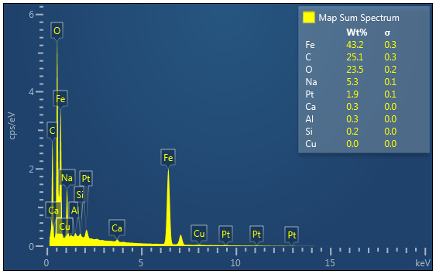
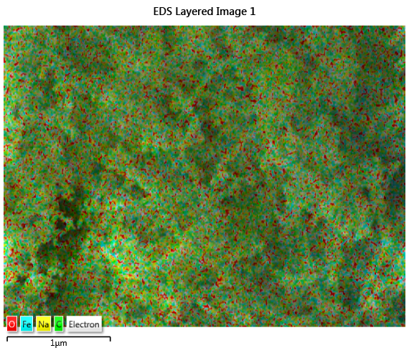
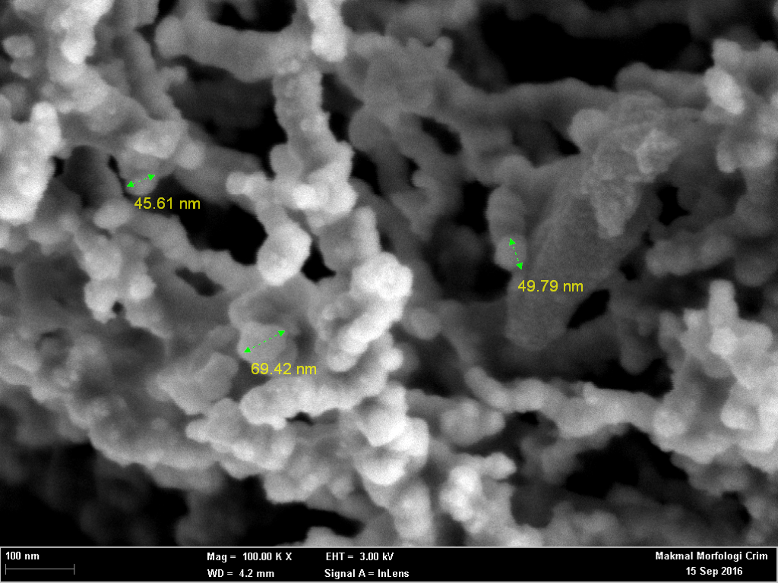
c

Figure 1: Field Emission Scanning Electron Microscopy (FESEM) results for AC-nZVI (a) Mag=100000X (b) EDX- image and (c) EDX spectrum
3.3 X-Ray Diffraction (XRD)
Figure 3 shows the XRD patterns of the activated carbon and AC-nZVI. The XRD pattern of activated carbon, graphite and carbon oxide were indicated at the peaks of 24.7° and 27°respectively. In AC-nZVI, small peak at 2θ = 44.9° corresponded to the formation of zero valent iron (Yaacob and How, 2015; Al-Dokheily and Sadoon, 2015).
3.4 X-ray Photoelectron Spectroscopy with Auger Electron Spectroscopy (XPS-AES)
Figure 3 shows the X-ray photoelectron spectroscopy and Auger Electron Spectroscopy (XPS-AES) spectrum of activated carbon and AC-nZVI. As displayed in Figure 1(a), only O and C were found on activated carbon surface while Na, Fe, O, C, and B were distributed on AC-nZVI surface. Na and B were expected to be present as NaBH₄ was used to synthesize AC-nZVI (Yaacob and How 2015). According to (Yaacob and How, 2015), the peaks at 719.7 eV (Fe0 2p1/2) corresponding to zero valent iron.

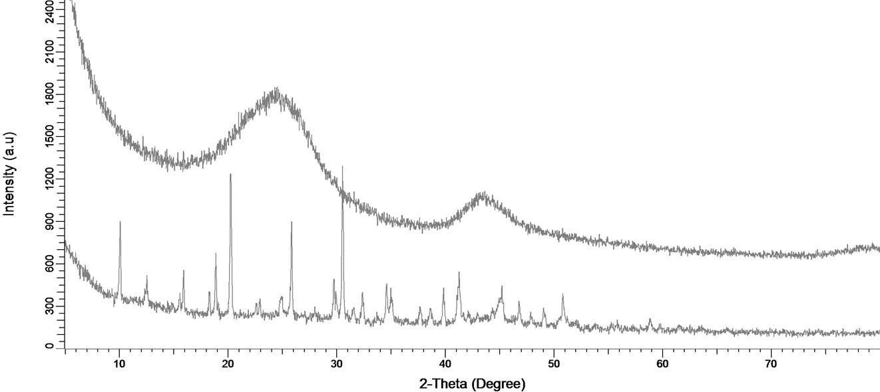
Carbon Oxide
Iron, Fe
Carbon Oxide
Graphite, C
AC-nZVI
Activated Carbon
Figure 2: X-ray Diffraction (XRD) images for AC and AC -nZVI
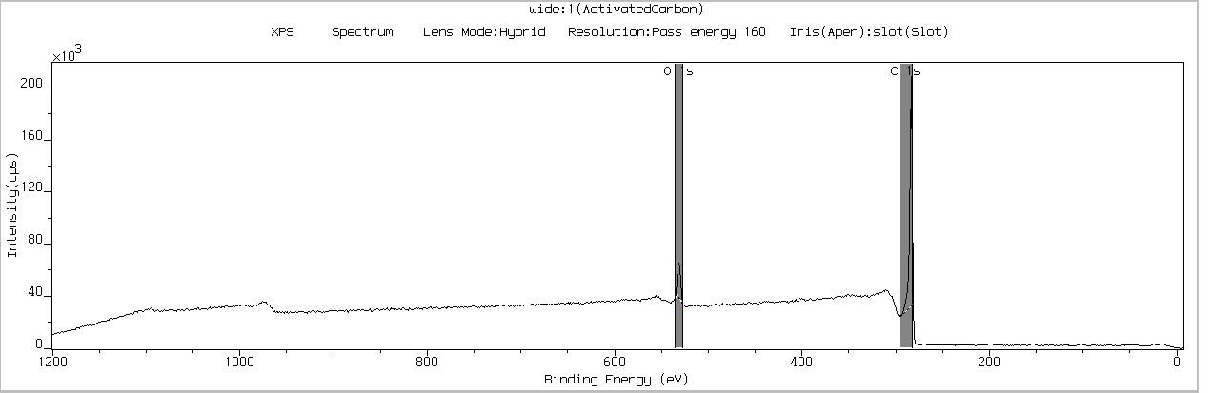
a
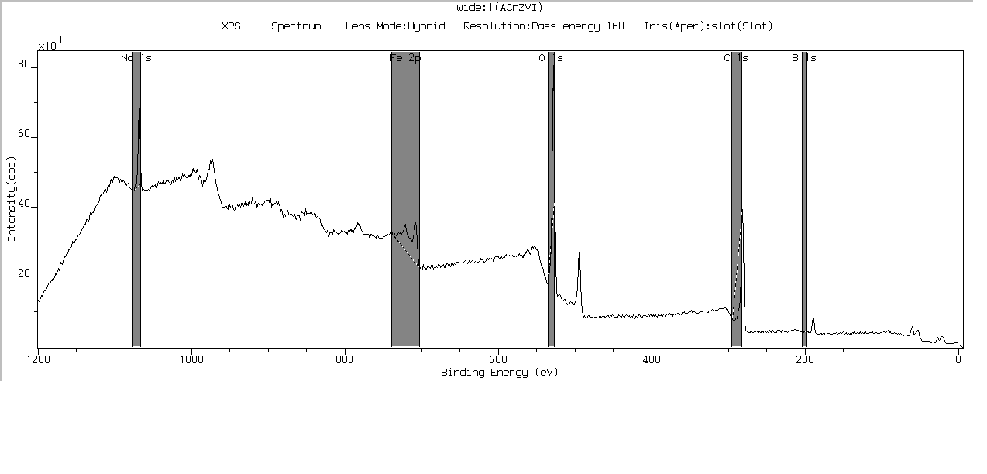
b
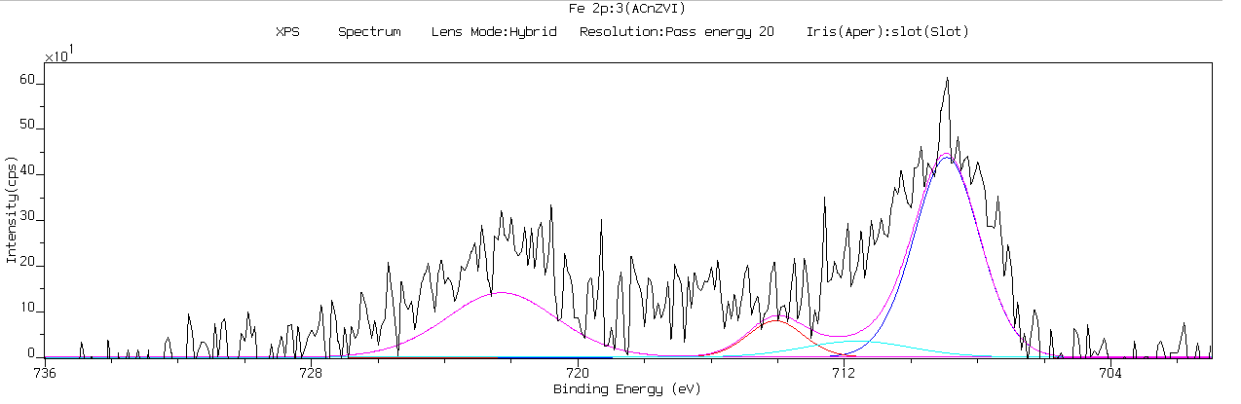
Fe 2p 2/3
Fe3O4
FeO
Fe 2p ½
Fe2O3
c
Figure 3: X-ray photoelectron spectroscopy and Auger Electron Spectroscopy (XPS-AES) result for (a) Activated Carbon, (b) AC-nZVI and (b) AC-nZVI of Fe 2p line
3.5 Batch Test
The sorption results of different dosages are presented in Figure 4(a). By using dye concentration of 50 ppm and pH values of pH=6, the results for both activated carbon and AC-nZVI showed the same trend and adsorption values. The adsorption capacity for both materials decreased with the increasing of adsorbent materials due to the overlapping of adsorption sites, thus giving the overcrowded adsorbent particles (Hefne et al., 2010). The adsorption values for both materials were also the same in all dosage values, showing that both materials had same capability to adsorb dye. Based on the paper reported by (Shen et al. 2009), activated carbon has higher adsorption capability in removing pollutant due to its large specific surface area. This study suggests of using high concentration of Acid Orange II in order to know the different of adsorption capacity between activated carbon and AC-nZVI.
d
c
b
a

e
Figure 4: Batch Test results of five factors (a) dose (b) initial concentration (c) pH (d) kinetic and (e) Temperature
The effect of initial concentrations on Acid Orange II are presented in Figure 4(b). The curve showed the adsorption capacity increased with the increasing of initial concentration until at one point it became constant although the initial concentration was increased due to surface particles was saturated with dye. In initial concentration effect, AC-nZVI exhibited larger adsorption capacity (4.41 mg/g) compared to activated carbon (1.82 mg/g) due to the dispersion of nZVI particles on activated carbon particles, consequently providing more sites for adsorption. Figure 4(c) and 4(d) illustrate the effect of pH and kinetic study of Acid Orange II on activated carbon and AC-nZVI. Both graphs were constant suggesting that the adsorption capacity was not affected by pH values and shaking time. The effect of temperature on the adsorption capacity of Acid Orange II on Gr and Gr-nZVI is illustrated in Figure 4(e). It can be observed that adsorption capacity of Acid Orange II was increased with the increasing of temperature. The same results reported by Reddy et al. (2012). For the AC-nZVI curved, it showed constant adsorption capacity values, and this showing that temperature did not give any significant effect on AC-nZVI particles. However, AC-nZVI showed higher adsorption capacity compared to activated carbon. This was due to AC-nZVI provided both mineral and nZVI particles surfaces for greater adsorption sites compared to activated carbon itself. The findings suggest the stability of AC-nZVI towards temperature effects and proven as better materials for water treatment in the natural environment.
  - Conclusions
This study concludes that AC-nZVI was successfully synthesized using chemical reduction method. The characterization of composite nanoparticles was performed using BET surface area, FESEM, XRD and XPS-AES. Through BET surface area, the pores in the activated carbon were filled with added nZVI particles. The FESEM analysis shows the AC-nZVI has spherical shapes, ranging between 45.61 nm to 69.42 nm and were aggregated into a chain-like on activated carbon surface. In XRD pattern, the AC-nZVI shows small peak at 2θ = 44.9° where it was corresponded to the formation of zero valent iron. In Batch test results, only effects of initial concentration and temperature showed a significant difference between activated carbon and AC-nZVI in adsorbing dye. Other effects such as dose, pH and kinetic effects did not give any significant difference since activated carbon has their own capability in remediates dye.
Acknowledgments
Authors acknowledged the use of instruments in Centre for Research & Instrumentation Management (CRIM), UKM with a financial support from Ministry of Education. Authors also wish to thank Geology Program, Faculty of Science and Technology, Universiti Kebangsaan Malaysia (UKM), Malaysia for their technical supports.
References
Al-Dokheily M.E., Abd Al-Baqr J.S., 2015, Synthesis of Iron Nanoparticles and Applications in the Removal of Heavy Metals from Aqueous Solutions, Chemical and Process Engineering Research, 34.
Bavasso I., Verdone N., Di Palma L., 2018, Cr(VI) Removal by Green-Synthetized Iron-Based Nanoparticles: Effect of Cr(VI) Concentration and pH Condition on Adsorption Process, Chemical Engineering Transactions, 70, 469-474.
Busch J., Meißner T., Potthoff A., Bleyl S., Georgi A., Mackenzie K., Trabitzsch R., Werban U., Oswald S. E., 2015, A Field Investigation on Transport of Carbon-Supported Nanoscale Zero-Valent Iron (nZVI) in Groundwater, Journal of Contaminant Hydrology,181, 59–68.
Chen Z.X., Cheng Y., Chen Z., Megharaj., Naidu., 2012, Kaolin-Supported Nanoscale Zero-Valent Iron for Removing Cationic Dye-Crystal Violet in Aqueous Solution, Nanotechnology for Sustainable Development, First Edition, 189–96.
Han L., Xue S., Zhao S., Yan J., Qian L., Chen M., 2015, Biochar Supported Nanoscale Iron Particles for the Efficient Removal of Methyl Orange Dye in Aqueous Solutions, PLoS ONE 10 (7): 1–15.
Hefne J.A., Mekhemer W.K., Alandis N.M., Aldayel O.A., Alajyan T., 2010, Removal of Silver ( I ) from Aqueous Solutions by Natural Bentonite, JKAU, 22 (1): 155–76.
How H.K., Yaacob W.Z.W, 2015, Synthesis and Characterization of Marine Clay-Supported Nano Zero Valent Iron, American Journal of Environmental Sciences, 11(2):115–24.
Kakavandi B., Kalantary R.R., Farzadkia M., Mahvi A.H., Esrafili A., Azari A., Yari A.R., Javid A.B., 2014, Enhanced Chromium (VI) Removal Using Activated Carbon Modified by Zero Valent Iron and Silver Bimetallic Nanoparticles, Journal of Environmental Health Science & Engineering, 12 (1): 115.
Kerkez D.V., Tomašević D.D., Kozma G., Bečelić-Tomin M.R, Prica M.D., Rončević S.D, Kukovecz Á, Dalmacija B.D., Kónya Z., 2014, Three Different Clay-Supported Nanoscale Zero-Valent Iron Materials for Industrial Azo Dye Degradation: A Comparative Study, Journal of the Taiwan Institute of Chemical Engineers, 45 (5): 2451–61.
Reddy M.C.S, Sivaramakrishna L, Reddy A.V., 2012, The Use of an Agricultural Waste Material, Jujuba Seeds for the Removal of Anionic Dye (Congo Red) from Aqueous Medium, Journal of Hazardous Materials, 203–204: 118–27.
Shen D., Fan J., Zhou W., Gao B., Yue Q., Kang Q, 2009, Adsorption Kinetics and Isotherm of Anionic Dyes onto Organo-Bentonite from Single and Multisolute Systems, Journal of Hazardous Materials, 172 (1): 99–107.
Shi L., Zhang X., Chen Z., 2011, Removal of Chromium (VI) from Wastewater Using Bentonite-Supported Nanoscale Zero-Valent Iron, Water Research, 45 (2): 886–92.
Vilardi G., Di Palma L, Verdone N., 2017, Competitive reaction modelling in aqueous systems: The case of contemporary reduction of dichromates and nitrates by nZVI, Chemical Engineering Transactions, 60, 175-180.
Zhu H., Jia Y., Wu X, Wang H., 2009, Removal of Arsenic from Water by Supported Nano Zero-Valent Iron on Activated Carbon, Journal of Hazardous Materials, 172 (2–3):1591–96.

