CHEMICAL ENGINEERING TRANSACTIONS  VOL. 74, 2019 | A publication of
The Italian Association
of Chemical Engineering
Online at www.aidic.it/cet
Guest Editors: Andrea D’Anna, Paolo Ciambelli, Carmelo Sunseri
Copyright © 2019, AIDIC Servizi S.r.l.
ISBN 978-88-95608-71-9; ISSN 2283-9216

Contribution to Copper Elimination Study by Adsorption on Double-Layered Hydroxides HDL

Nadjet Taoualit^{a,}*, Khalida Boutemak^{b}, Zoubida Chemat-Djenni^{b}, Salaheddine Aoudj^{c}, Nabila Touatiª, Wiame Abdelliª

ª Laboratoire des applications énergétiques de l’hydrogène. Département de génie des procédés, Faculté de Technologie. Université de Blida1, Blida, Algérie
^{b}Laboratoire d’Analyse Fonctionnelle des Procédés Chimiques. Département de génie des procédés, Faculté de Technologie. Université de Blida1, Blida, Algérie
^{c}Laboratoire de Génie Chimique. Département de génie des procédés. Université de Blida1, Blida, Algérie

The present work is a contribution to copper removal study by adsorption on Double-Layered Hydroxides Co-Cr-HDL prepared by co-precipitation method at pH of 10.
Characterization of the solid was performed by both FTIR and DRX techniques.
The kinetic study and the determination of adsorption isotherms were carried out in a batch system at room temperature to evaluate the effect of the adsorbent-adsorbate contact time, the adsorbate initial concentration, the solution pH and the adsorbent mass on the retention of copper and the adsorption capacity of the synthesized HDL.
Retention of copper reached 50 % on 0.05 g of HDL during 6 hours of contact at the pH of synthesized aqueous solution.
Experimental kinetic data have been well described by the pseudo-second-order model and adsorption equilibrium can be represented by the Langmuir model which gives us information on the nature and the texture of the solid surface which would be homogeneous, with sites energetically identical, able to receive the copper ions in monolayer, without interaction between the adsorbed chemical species.

- Introduction
With the rapid development of modern industry, the contamination of environment has become increasingly serious, where many industrial wastes have cruelly polluted the natural environment that was in adequacy with human habitation in the past. Discharges of organic and metallic pollutants into environment remain a serious problem in many countries, facing many industries such as mining, hydrometallurgy, pulp and paper, petrochemicals, refining, fertilizers, electroplating, surface treatments, etc.
Surface treatment industry generates complex discharges because they contain pollutants of diverse natures according to the manufacturing processes used, which are susceptible to interactions and whose separative collection is not always feasible (Agence de l'eau Rhône-Méditerranée-Corse, 1998).
The main liquid waste from surface treatments baths such as baths of pickling, of degreasing, of treatment and of rinsing contain surface treatment metals such as Copper, Nickel, Chromium, Cadmium, Zinc, ... (Beaux, 1997).
Concentrated baths discharge into the environment can cause accidental pollution. This often results in the mortality of species whose specific lethal dose is reached (Khyati and Messafi, 2004; Muiras et al., 1995).
It is in the plant, aquatic and micro-organisms world that copper has a truly remarkable toxicity. The use of copper for pesticide purposes has led to a dramatic enrichment of certain environments. The toxicity of copper does not depend only of its total concentration in the environment, but that the physicochemical and biological variables had to be integrated in the estimation of the real impact of a contamination on the living. They are principally the solvated form $Cu{(H_{2}O)}_{n}^{2+}$ and the small organic complexes able to cross the cell membranes which are the most bioavailable. Any factor capable of modifying the abundance of these labile species is susceptible to increase or decrease the toxicity of copper. The pH, the redox potential (Eh), and the composition and concentration of the solutes (ie the activity of all the ions in the aqueous phase) are from this point of view determining parameters, on which it is possible to intervene to mitigate the effect of a contamination (Taoualit, 2018).
Chronic exposure to copper is the cause of WILSON disease, characterized by hepatic cirrhosis, brain damage, demyelination, renal involvement, and copper deposition in the cornea (Leóna and Guzmánb, 2007). Different disorders have been described as a consequence of copper accumulation in animals and humans. Acute copper intoxication causes severe gastroenteritis characterized by abdominal pain, diarrhea, anorexia, dehydration and shock. Prolonged exposure to copper can cause irritation of the nose, mouth, and eyes and causes headaches, upset stomach, dizziness, vomiting, and diarrhea. Intentionally, high doses of copper can cause liver and kidney damage (Kermiche and Djerad, 2011; Taoualit et al., 2017).
For the elimination of the potential for environmental disturbance in a perspective of sustainable development, depollution of water and recovery of industrial waste are important objectives for both industrialized and developing countries. To achieve this, treatment technologies must be developed, permitting thus to preserve the environment.
For both economic and ecological reasons, finding clean processes that not only prevent toxic releases to nature but also ensure their recycling is a necessity.
Many techniques of depollution are developed in recent years including chemical precipitation processes, flocculation, ion exchange, electrolysis, membrane processes and adsorption.
In this study, the adsorption process was applied to the retention of copper from effluents of surface treatment discharges using the Layered Double Hydroxides LDH (Co-Cr-HDL) as adsorbent prepared by the co-precipitation method at constant pH. LDH have been of great interest since a few years due to their electrochemical properties (Deroy and Besse, 1989; Guerlou-Demourgues and Delmas,1994) or anion exchange and their use in heterogeneous catalysis.
HDL, also called anionic clays (Vaysse, 2011) are little abundant materials in the natural state, but easily synthesizable in the laboratory which requires a simple titration assembly, with an inexpensive and available material, and also allows us better control of the composition of the reaction medium and gives well crystallized products (Taoualit et al., 2015).
The structure is constituted by a stack of brucite-type sheets ${[M_{1-y}^{II} L_{y}^{III} {(OH)}_{2}]}^{y+}{[X^{n}]}_{y/n}{[H_{2}O]}_{z}$ with common stops, as shown in figure 1. The partial substitution of the trivalent cations M (III) for the divalent cations L (II) generates an excess of positive charge on the sheets. The charge density being proportional to the ratio $y=\frac{n\left(M^{III}\right) }{n\left(M^{III} + L^{II}\right)}$. In order to ensure the overall electrical neutrality, anionic species $(X^{n-})$ are then intercalated in the interlayer space in conjunction with water molecules, the cohesion of the structure results, on the one hand, from electrostatic interactions between the oxygenated metal sheets and the anions and on the other hand from a hydrogen bonding network established between the water molecule and the interlamellar anions hydroxides of the sheets (Géraud, 2006).
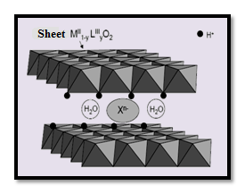
Fig.1 : Schematic representation of a LDH phase structure ((Géraud, 2006)

The application of adsorption based on the use of layered double hydroxides has been recognized as one of the most effective technologies for the removal of organic compounds such as dyes (Bouraada et al., 2014 ; Benselka-Hadj Abdelkader et al., 2011). But few works on their use for the adsorption of metals are cited (Lahkale et al., 2014 ; Perrin et al., 2010).
- Experimental study
  - Materials and methods
In this work, all the reagents and products used were not purified prior to use. NaOH (97%), HCl (98%) were purchased from Biochem Chemopharma and Na₂CO₃ (99.5 -100%) from Panreac. Co(Cl₂) 6H₂O (99-100%) purchased from Riedel-de-Haën and Cr(Cl₃) 6H₂O (98%) were purchased from Merck, AgNO₃ (99.8%) was purchased from Biochem Chemopharma.
  - Preparation of Co-Cr-HDL
Co-Cr-HDL was prepared by co-precipitation method at constant pH by titrating 100 mL of Co(Cl₂) and Cr(Cl₃) mixture solution, defined by a molar ratio y equal to 2 with 100 mL of Na₂CO₃ solution 1M and NaOH 2M at room temperature under strong agitation during about 90 minutes while the pH was maintaining constant equal to 10. When the precipitation reaction was completed, the resulting gel was refluxed at 60°C for 15 hours to allow crystal growth. Once the heat treatment achieved, the product was filtered and washed several times with distilled water until complete elimination of excess ions on the solid (Cl⁻, Na⁺), then dried in an oven at 70°C over one night. Obtained product was in the form of a sinterable solid then it was ground using an agate mortar to give a very fine white powder. Thereafter, the solid was calcined in a furnace at temperature of 600°C with an air inlet for 4hours, and a temperature rise of $5°C. \min^{-1}$. Obtained solid was then characterized by different physico-chemical techniques such as X-ray diffraction, infrared spectroscopy FTIR and the point of zero charge Pzc.
Several studies have shown that [20, Wiame] calcined HDL (HDLc) have remarkable and higher adsorptions than non-calcined phases. For this reason, calcined HDL at 600° was used for copper adsorption.
  - Preparation and dosage of Copper solutions
Copper stock solution of $1g. L^{-1}$ was prepared by dissolving a given amount of CuSO₄ in distilled water. Other solutions at different concentrations were obtained by successive dilutions. The initial pH was adjusted with dilute solutions of HCl (0.1M) and/or NaOH (0.1M).
The residual copper in the aqueous solution was analyzed by atomic absorption spectrophotometry with flame (Analytik Jena s5) at appropriate copper wavelength
λ = 324.8 nm. The copper adsorption capacity, the adsorbed quantity and the removal efficiency (E %) of copper on Co-Cr-HDL were calculated from equations 1, 2 and 3 :
$$Q_{t}=\frac{C_{0}-C_{t}}{m} ×V$$ | (1)
$$Q_{e}=\frac{C_{0}-C_{e}}{m} ×V$$ | (2)
$E(\%)=\frac{C_{0}-C_{t}}{C_{0}} ×100$ | (3)
Where $Q_{t} (mg.g^{-1})$ is the copper ions amount adsorbed at time t (min), $Q_{e} (mg.g^{-1})$ represents the amount of adsorbed metal at equilibrium per unit mass of solid, $C_{0}(mg.L^{-1})$, $C_{t}(mg.L^{-1})$ and $C_{e}(mg.L^{-1})$ are respectively the initial, the final concentration of copper (at time 0 and t) and at equilibrium in the aqueous solution, V is the aqueous solution volume (mL) and m (g) represents the amount of the adsorbent Co-Cr-HDL.
  - Adsorption kinetic studies of copper on synthesized HDLs
The adsorption tests on Co-Cr-HDL were carried out in batch system using 250 mL glass bottles closed with a stopper and covered with aluminum paper, all containing a known Co-Cr-HDL mass to which was added separately a volume of 100 mL of Copper aqueous solution at fixed initial concentration and a constant pH. The assembly was placed under horizontal stirring on an oscillating table at room temperature during 24 hours.
Samples were thus taken at different time intervals ranging from 0 to 24 h of contact. After filtration, the adsorbates were analyzed directly by atomic absorption spectrophotometer at the wavelength $λ=324.8 nm$.
The copper adsorption kinetics were obtained by plotting the curve $Qe = f (t)$, (Eq.2). Various steps and operating conditions have also been adopted. The first step consisted to determine optimum copper removal efficiencies as well as equilibrium time. The evaluation of copper removal efficiency is followed by E% (Eq.3). The follow steps were to record the effect of successively, adsorbent mass, contact time, copper initial concentration and of aqueous solution pH.
- Results and Discussion
  - Characterization
X-ray diffraction
Obtained diffractogram of Co-Cr-LDH is represented on figure 2. The general appearance of the spectrum is typical of hydrotalcite-type compounds (Bouda, 2013). Indeed, this characteristic is represented by the existence of intense and symmetrical peaks at low values ​​of $2ϑ$ and less intense and generally asymmetric peaks at higher angular values.
The first peak at $2ϑ≈11°<30°$ has been indexed as d₀₀₃ and corresponds to d₀₀₃ = 5 A°. This basic reflection corresponds to the inter-sheet space. It makes it possible to calculate the parameter of the mesh c with c = 3d₀₀₃.
The second characteristic peak at the higher $2ϑ$ values ​​was indexed as d₁₁₀ and corresponds to d₁₁₀ = 1.82A°. This basic reflection corresponds to the intermetallic distance a, with a = 2d₁₁₀. The cell parameters are $c=15 A°$ and $a=3.64 A°$. These values ​​are in agreement with those found in the literature (Benselka-Hadj Abdelkader et al., 2011; Lahkale et al., 2014; El Mouhalhal et al., 2003).
Co-Cr-HDL matrix is ​​of crystalline form.

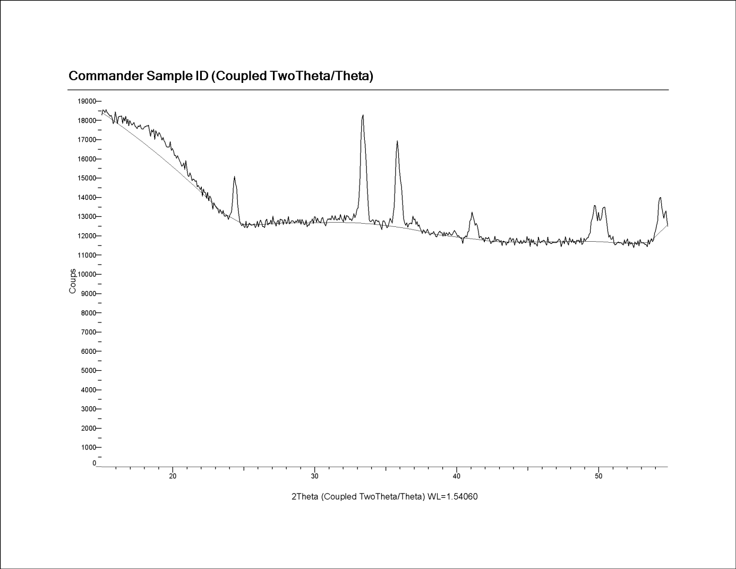
Fig. 2 : X-Diffractogram of Co-Cr-HDL

Spectroscopy IR
FTIR spectrum of Co-Cr-LDH sample was obtained on a Perkin Elmer apparatus in the range 4000-400 cm⁻¹ and represented on figure 3. The study by IR spectroscopy (Figure 3) confirms the obtention of HDL by the appearance of all the expected bands (Segni, 2005; Chebli, 2016 ; Ferreira et al., 2004 ; Lu et al., 2016).
The FTIR spectrum of Co-Cr-LDH is typical of layer double hydroxides and agrees well with the typical results obtained and found in literature (Lu et al., 2016 ; Ray L. Frost et al., 2005; Bouhent, 2011 ;Garcia-Sosa et al., 2015).
Indeed, the broad band at 3463 cm⁻¹ is attributed to the hydroxide groups (OH⁻) present in the layer and of water molecules intercalated and /or absorbed. The vibration band in the vicinity of 2500 cm⁻¹, can be attributed to the deformation of the OH⁻ molecules. The band at 1637 cm⁻¹ is assigned to the angular deformation of H₂O molecule, the vibration band at 1381 cm⁻¹ which corresponds to the antisymmetric elongation of the inter-lamellar carbonates CO₃²-. At low wave number (672 and 436 cm⁻¹) bands are respectively due to the M-O and O-M-O vibrations of prepared Co-Cr-HDL sheet (M represents the divalent or trivalent metal, here Co or Cr).
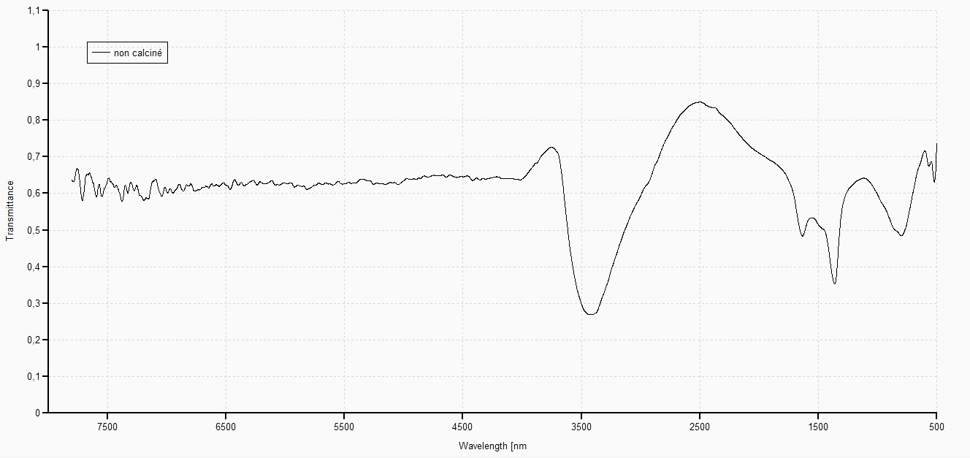
Fig. 3 : FTIR spectrum of Fe-Al-LDH

3.2. Adsorption of Copper on Co-Cr-HDL study
Effect of Co-Cr-HDL mass
The retention of copper increases from 0 to 51% when the Co-Cr-HDL mass varies from 0 to 0.05 g. For higher masses, a state of pseudo-equilibrium is reached (Fig. 4). A higher value of the solid has no influence on the retention of the copper species. This behavior results probably because the number of active sites available is all the greater as the mass is great (0.05 g), which favors the adsorption of a large quantity of copper.

Effect of contact time
the adsorption of copper ions consists of two steps (Fig.5). The first one being more or less rapid corresponding to the occupation of the anionic clay active sites by the copper during about 6 hours. The second step is slower, it corresponds to the equilibrium and stability of the adsorption. pH of the solution is that of the solution initially prepared.

Fig. 4 : Effect of Co-Cr-HDL mass on Copper removal
Fig. 5 : Adsorption kinetic of Copper on Co-Cr-HDL according to contact time

Effect of pH
Obtained results (Figure 6) show that at pH <5, adsorbed copper regularly increases to become optimal at a pH of 5 and then decrease as the pH increases. Copper is mainly in its ionic form Cu²⁺ in such a pH. Addition of H⁺ ions to lower the pH, leads to the neutralization of the OH⁻ ions released by the HDL structure (Ait Ichou et al., 2014; Aider, 2015), which leads us to suppose that it is probably due to electrostatic interactions between Cu²⁺ and the Co-Cr-HDL synthesized carbonate ions, which favors the adsorption of copper in an acid medium. The carbonate ions that are released due to calcination are very difficult to exchange (Bouda, 2013). A pH of 5 is then considered optimal for the adsorption of copper on the calcined Co-Cr-HDL clay.
Effect of initial concentration
Increase of initial concentration causes a decrease in the Copper adsorbed quantity. High removal efficiencies are obtained for an initial concentration of 10 mg. L-1.
Modeling of isotherms and kinetics of copper adsorption on Co-Cr-HDL
Application of the pseudo-second-model and pseudo-first-model to Copper adsorption reveals that the experimental kinetic data have been well described by the pseudo-second-order model with R² = 1.
On the other hand, the linear forms of Langmuir, Freundlich and Temkin equations were employed to describe the equilibrium data. The performance of each form was judged through the correlation coefficients R² (Table1)

Fig. 6 : Influence of pH on adsorbed quantity of Copper
Fig. 7 : influence of Copper initial concentration on its adsorption

Table1 : Langmuir, Freundlich and Temkin isotherm parameters for Copper retention at T=25°C and pH=5
Langmuir |  |  | Freundlich |  |  | Temkin
Q_{m} (mg/g) | b (L.mg⁻¹) | R² | 1/n | k_{f} | R² | A | B | R²
9.434 | 2.23 x10⁻² | 0.987 | 12.5 | 0.883 | 0.743 | 4.7169 | 0.212 | 0.749

- Conclusion
In the present work, the synthesis of Co-Cr-HDL calcined clay by the co-precipitation method has been carried out to apply it in the adsorption of copper in aqueous solution resulting from surface treatment discharges.
Obtained results showed that the synthesized anionic clay corresponds to a hydrotalcite compound with good crystallinity and has the property to be able to regenerate after calcination and formation of mixed oxides. The retention of copper reached 50 % on 0.05 g of HDL during 6 hours of contact at the pH of synthesized aqueous solution.
Experimental kinetic data have been well described by the pseudo-second-order model and adsorption equilibrium can be represented by the Langmuir model which gives us information on the nature and the texture of the solid surface which would be homogeneous, with sites energetically identical, able to receive the copper ions in monolayer, without interaction between the adsorbed chemical species. Obtained results demonstrate the immense potential of HDLs as adsorbents for toxic metal ions remediation in polluted waters and wastewaters. LDH can be suitable for the treatment of charged effluents containing species that are harmful to the environment such as surface treatment baths (electroplating, metallurgy, copper plating, etc.), wastewater from olive mills which are heavily loaded with terms of organic matter, ... since the technique is economically feasible requiring a simple titration assembly, and an inexpensive and available material in the laboratory.

References
Agence de l'eau Rhône-Méditerranée-Corse, 1998, Traitement de surfaces, Epuration des eaux. SITS = Syndicat général des industries de matériels et procédés pour les traitements de surfaces. - Bibliogr. p. 272. Glossaire.
Aider, N.,2015, Etude des matériaux mésoporeux appliqués à la réaction de knoevenagel, Doctorat thesis, University of Tizi-Ouzou, Algeria.
Ait Ichou, A., Abali, M., Chiban, M., Carja, G., Zerbet, M., Eddaoudi, E., Sinan, F., 2014, Development and characterization of synthetic clay LDH type and their application on the adsorption of Cu²⁺ions, J. Mater. Environ. Sci. 5 (S2), 2444-2448.
Benselka-Hadj Abdelkader, N., Bentouami, A., Derriche, Z., Bettahar, N., Charles de Ménorval, L., 2011, Synthesis and characterization of Mg-Fe Layer Double Hydroxides and its application on adsorption of Orange G from aqueous solution, Chemical Engineering Journal, 169, 231–238.
Beaux, J.F., 1997, l’Environnement, Nathan.
Bouda, A., 2013, Master thesis, University of Blida1, Algeria
Bouhent, M.M., 2011, Synthèse et Modification des LDH (Layered Double Hydroxides) : Application à la rétention de polluants. Doctoral thesis, University of Oran, Algeria.
Bouraada, M., Bessaha, H., Charles de Ménorval, L., 2014, Removal of Evans Blue and Yellow Thiazole dyes from aqueous solution by Mg-Al-CO₃ Layered Double Hydroxides as anion-exchanger, Mediterr. J. Chem., 3(3).
Chebli, D., Bouguettoucha, A., Reffas, A., Tiar, C., Boutahala, M., Gulyas, H., Amrane, A., 2016, Removal of the anionic dye Biebrich scarlet from water by adsorption to calcined and non-calcined Mg–Al Layered Double Hydroxides, Desalination and Water Treatment, Volume 57, Issue 46.
Deroy, A., and Besse, J.P., 1989, Solid state Ionics, 35, 35.
Géraud, E., 2006, Élaboration et caractérisation de matrices Hydroxydes Doubles Lamellaires Macroporeuses, Doctoral thesis, University of Blaise Pascal, France.
El Mouhalhal, N., Zhouri, E., Rahal, M., EL-Hajbi, A., 2003, Synthesis, Characterization of Lamellar Double Hydroxide [ZnCrSO₄] and vibratory study of the sulfate anion between the sheets, Phys. Chem. News, 10, 112-118.
Ferreira, O.P., L Alves, O., Gouveia, D.X., Souza Filho, A.G., J. AC de Paiva, Filho, J.M., 2004, Thermal decomposition and structural reconstruction effect on Mg–Fe-based Hydrotalcite compounds, Journal of Solid State Chemistry, Volume 177, 3058–3069.
García-Sosa, I., Cabral-Prieto, A., Nava, N., Navarrete, J., Olguín, M.T., Luis Escobar, López-Castañares, R., Olea-Cardoso, O., 2015, Sorption of Chromium (VI) by Mg/Fe Hydrotalcite type compunds. Hyperfine Interact, 232: 67.
Guerlou-Demourgues, L. and Delmas, C., 1994, Effect of Iron on the Electrochemical Properties of the Nickel Hydroxyde Electrode, Journal of the Electrochemical Society, Vol. 141, N°3, 713-717.
Kermiche, M. and Djerad, S., 2011, Facilitated transport of copper through bulk liquid membrane containing di-2ethylhexyl phosphoric acid, Desalination and Water Treatment 36 (1-3), 261-269.
Khyati, A., Messafi, A., 2004, Traitement des rejets liquides émanant des industries de traitements de surfaces et leur réutilisation dans les circuits des chaînes selon le principe : rejet zéro.
Lahkale, R., Sadik, R., Sabbar, E., 2014, Removal of trivalent chromium from tannery effluent by calcined Layered Double Hydroxide. J. Mater. Environ. Sci., 5 (S2), 2403-2408.
Leóna, G., Guzmánb, M. A., 2007, Facilitated transport of copper through bulk liquid membranes containing different carriers: compared kinetic study, Desalination 223, 330–336.
Lu, Z., Qian, L., Xu, W., Tian, Y., Jiang, M., Li, Y., Sun, X., Duan, X., 2016, Dehydrated Layered double hydroxides: Alcohothermal synthesis and oxygen evolution activity. Nano., Res., 9: 3152-3161.
Muiras, J.M., Sutter, B., Guillais J.C., 1995, Traitement de surface: Techniques de reduction de déchets, published by CETIM: Centre Technique des Industries Mécaniques (CETIM).
Perrin, L., Bourgois, J., Laforest, V., 2010, Cr (VI) trapping by polymetallic Hydroxide Sludge, Colloquium Water, Waste and Sustainable Development, March 28–31, Alexandri
Segni, R., 2005, Caractérisation structurale, propriétés d’échange et stabilité de matériaux de type Hydrocalumite [Ca₂M(OH)₆]+[X^{n} _{1/n.} xH₂O]⁻ avec M=Al, Fe, et Sc et X=SO₄, CrO₄ , V2O7 et SiO3. Theoretical and/or physical chemistry, University of Blaise Pascal-Clermont-Ferrand II, France.
Ray L. Frost, Anthony W. Musumeci, Jocelyn Bouzaid, Moses O. Adebajo, Wayde N. Martens and J. Theo Kloprogge, 2005, Intercalation of Hydrotalcites with Hexacyanoferrate (II) and (III) – a Thermo Raman spectroscopic study. Journal of Solid State Chemistry, 178, 1940-1948.
Taoualit, N., 2018, Doctorat thesis, University of Blida1, Algeria.
Taoualit, N., Abidat, I., Hadj-Boussaad, D.E., 2017, Separation of copper and zinc from aqueous solution using liquid-membrane-gel (LMG) containing trioctylphosphine Oxide TOPO as carrier, International Journal of Computational and Experimental Science and Engineering (IJCESEN), Vol. 3, N°.1, 1-6.
Taoualit, N., Chemat, Z., Hadj-Boussaad, D.E., 2015, Batch kinetic, Isotherm and Thermodynamic Studies of copper (II) removal from wastewater using HDL as adsorbent, International Journal of Chemical and molecular engineering, Vol. 2, N°.12.
Vaysse, C., 2001, Caractérisation structural d’hydroxydes doubles lamellaires contenant des anions oxometallates (Mo, W) ou acrylate intercales, Matériaux. Doctorat thesis, University of Sciences and Technologies, Bordeaux I, France.

