CHEMICAL ENGINEERING TRANSACTIONS  VOL. 74, 2019 | A publication of
The Italian Association
of Chemical Engineering
Online at www.aidic.it/cet
Guest Editors: Andrea D’Anna, Paolo Ciambelli, Carmelo Sunseri
Copyright © 2019, AIDIC Servizi S.r.l.
ISBN 978-88-95608-71-9; ISSN 2283-9216

Equilibirum, Kinetic and Thermodynamic Study of Green Malachite and Rhodamine-B Dyes Sorption on Olive Pomace
Khalida Boutemak^{a,c,}*, Nadjet Taoualit^{b} , Benamar Cheknane^{c}, Ouarda Laslouni^{d} ,Sohaib Djeddouª, Khadidja Medaoudª, Isaac Mazouniª, Salaheddine Aoudj^{e}
ªLaboratoire d’Analyse Fonctionnelle des Procédés Chimiques, Département de Génie des Procédés, Faculté de Technologie, Université de Blida1, Route de Soumaa, Blida, 09000, Algérie.

^{b}Laboratiore des applications énergétiques et l’hydrogène, Département de Génie des Procédés, Faculté de Technologie, Université de Blida1, Route de Soumaa, Blida, 09000, Algérie.

^{c}Laboratoire de Chimie Physique des Interfaces des Matériaux Appliqués à l'Environnement. Université de Blida 1, BP 270, 09000 Blida, Algérie.

^{d} Département de physique, Université de Blida1, Route de Soumaa, 09000 Blida, Algérie.

^{e}Laboratoire de Génie Chimique, Département de Génie des Procédés, Faculté de Technologie, Université de Blida1, Route de Soumaa, Blida, 09000, Algérie.

kboutemak@yahoo.fr
The present work aims to study the Green malachite dye and Rhodamine-B sorption on olives pomace, solid waste of olive oil industry product. Batch experiments were carried out to determine the effect of various factors such as adsorbent dose (w), initial pH and contact time (t) on adsorption process. Kinetic data were well described by the pseudo second-order model. Langmuir isotherms described the process of dyestuffs sorption on olive pomace.Thermodynamic parameters revealed that the sorption process nature was endothermic.
  - Introduction
Dyes are widely used in printing, food, cosmetic and clinical industries but especially in the textile industries for their chemical stability and ease of synthesis and variety of colors. However, these dyes are the source of pollution once evacuated into the environment. Worldwide production of dyes is estimated at more than 800 000 tons per year (Ben Mansour et al., 2011). The textile industry consumes large quantities of water. PETRINIC et al., (Sbai and Loukili, 2015; Petrinic et al., 2007) reported that it is in the order of 200 L of water per kg of finished textile product, thus generating high-load liquid discharges of various types of pollutants that may be toxic.
These produce harmful effects on the environment such as eutrophication of rivers and stagnant water, under-oxygenation of microorganisms responsible for the degradation of organic matter, increase of turbidity and appearance of bad tastes, bacterial proliferation, pestilential odors and abnormal colorations (Belhadji and Moumeni, 2016), in addition, their persistence and bioaccumulation, because synthetic organic dyes are compounds that cannot be purified by natural biological degradation (Belhadji and Moumeni, 2016; Pagga and Brown, 1986).
Various physicochemical treatments (adsorption, nanofiltration coagulation/flocculation, precipitation, reverse osmosis, membrane filtration, electrochemical oxidation and biological process) have been used for the removal of dyes from industrial effluents (Ben Mansour et al., 2011). The adsorption process is one of the most methods used for dyes removal from wastewaters because of its efficiency, the simplicity of design and operation ability. This method requires the choice of an adsorbent that has good characteristics such as : a high specific surface and availability. Activated carbon is considered the most effective and commonly used adsorbent (powder or granular form) because of its large surface area, microporous structure, high adsorption capacity but its use is limited due to its high cost; moreover, its regeneration and reuse makes it costlier (Inyinbor et al., 2016; Rajesh et al., 2010). This has led to search for low cost adsorbent. Consequently, extensive researches focused on concurrent and alternatives processes using natural waste materials of biological origin often little or poorly valued such as agricultural materials and by-products of some industries due to their availability and low costs. Olive pomace is a solid residue obtained from olive oil industry. Chemically, olive pomace consists of fiber (as cellulose), lignin and polyphenolic compounds. It contains many polyvalent functional groups (e.g. hydroxylic groups), anionic and cationic functional groups (Abdounasser et al., 2016).

This present study aimed to the evaluation of by product solid waste of olive oil industry without chemical modification as low-cost effective adsorbent to remove respectively Malachite Green (MG) and Rhodamine-B (RhB) dyes from aqueous solution in batch experiment. The physicochemical characteristics, functional groups analysis and surface morphology of the adsorbent werestudied. Kinetic, isotherms and thermodynamic studies of the sorption of biomaterial were investigated.
  - Materials and Methods
    - Preparation of Olive Pomace biosorbent
Firstly, olive pomace was washed with water and then it was exhausted with hexane to remove the residual oil. Secondly, the obtained raw material was washed with abundant water and dried in an oven at 110 ° C overnight. The dried material was then crushed and sieved.
    - Characterization of the biosorbent
The moisture content, ash content, bulk density, porosity, pH, pH_{pzc} were determined. Structural analysis was carried out using a Fourier transform infrared spectrophotometer (FT-IR), (Perkin Elmer Corp) and the surface morphological of the biosorbent was observed using scanning electron microscopy (SEM), (JSM60-63 LV).
    - Adsorbates
The appropriate wavelengths of Malachite green, MG (CI name: Basic green 4 (BG4), chemical formula C₂₃ H₂₅ N₂Cl, molecular weight 364 g. mole⁻¹) and Rhodamine B, Rh-B (CI name: Basic violet 10, Chemical formula: C₂₈H₃₁N₂O₃Cl, Molecular weight: 479 g. mole⁻¹) were obtained using the Spectrophotometer model Shimadzu 170 UV/visible. The chemical structure of MG and Rh-B are shown in figure 1 and figure 2.
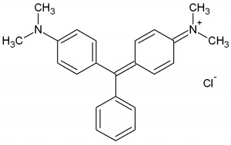
Figure 1: Chemical structure of Malachite green (MG)
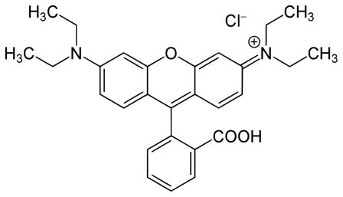
Figure 2: Chemical structure of Rhodamine-B (Rh-B)
    - Experimental
Batch experiments were carried out in 250 mL brown glass erlenmeyer flasks containing 100 mL of dye solution (MG solution and Rh-B solution separatly). An appropriate amount of biomass was added to the dye solution. The flasks were shaken at a constant speed of 200 rpm on a horizontal shaker (EDMUND BÜHLER GMBH SM-30). After adsorption, the samples were filtered with Wathman filter paper and the filtrate was analysed for the residual dye concentration of MG or Rh-B using UV-spectrophotometer (Shimadzu, Model UV 1800) at λ_{max} (MG) = 618 nm and λ_{max} (Rh-B) = 553 nm, respectively.
The amount of adsorbed dye at equilibrium, Q_{e} (mg.g⁻¹) was calculated using the following equation (Equation1):

$$Qe=\frac{C_{0}-C_{e}}{m} ×V (1)$$

Where C₀ and C_{e} (mg.L⁻¹) are the concentration of dye at intial and equilibrium, respectively. V(L) , is the aqueous solution volume and m(g) is the mass of used dry sorbent used.
The percentage removal is calculated using Equation2:

$$R (\%)=\frac{C_{0}-C_{e}}{C_{0}} ×100 (2)$$
The effect of various parameters such as adsorbent particles sizes: d₁˂0.1mm, 0.1˂d₂˂ 0.5 mm, pH (03-10), initial dye concentration (10, 40, 50, 60, 70 ,100 mg. L⁻¹), contact time (5mn-24H) and adsorption temperature (20 - 55°C) were investigated.
  - Results and Discussion
    - Adsorbent characterization
The morphology of olive pomace is presented in figure 3. The surface of olive pomace was observed to have large open pores.

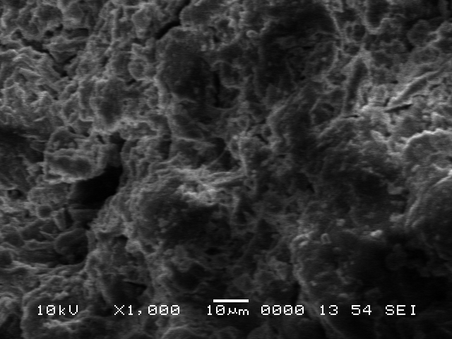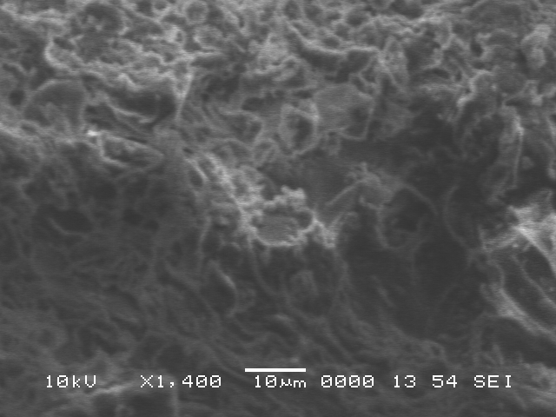
Figure 3: Surface morphology of olive pomaces before dye adsorption
Table 1 summarizes the different obtained characteristic parameters of the biosorbent.
Table 1: Characteristic of the biosorbent
Parameters | Value
Moisture content (%) | 2.65
Ash content (%) | 4.74
Bulk density | 0.59
Porosity | 0.51
pH | 5.4
pHPzc | 7

The functional groups of the adsorbent were established using FTIR (Figure 4). The peak at 3342 cm⁻¹ indicate the presence of hydroxyl groups, the peak at 2921cm⁻¹ corresponds to stretching of the C-H bonds of the methyl and methylene groups. The peak at 1640 cm⁻¹ represents –NH₂ groups. The peak at1422 cm⁻¹ corresponds to C-H stretching vibrations, CH₃ bending. The peaks 1253 cm⁻¹ and 1070 cm⁻¹ correspond to C-N and C-OH stretching vibrations respectively (Li et al., 2015; Inyinbor et al., 2016). The presence of these bands on the biomass surface contributed on dyes adsorption (Lin et al., 2011; Nwabanne et al., 2015).
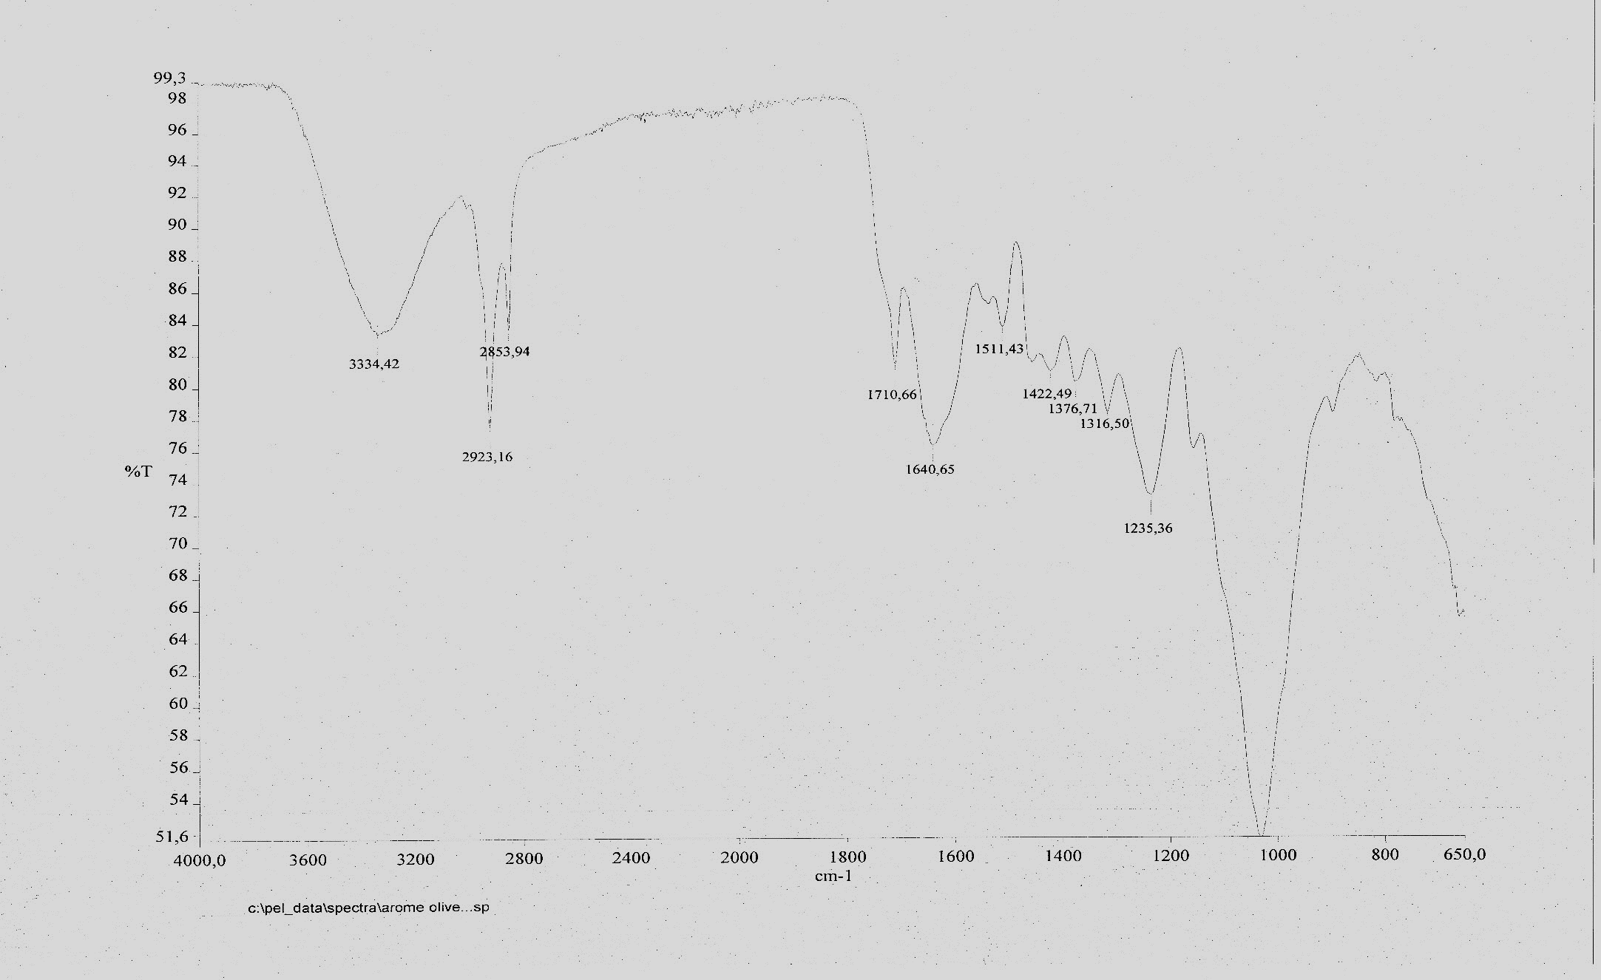
Figure 4: The FTIR spectra of olive pomace powder
    - Parametric study of the adsorption
Effect of biosorbent particles size
In this study, the effect of biosorbent particle size on the MG and Rh-B adsorption was investigated within size range of d₁˂0.1mm, 0.2 ˂d₂˂ 0.5 mm (figure 5) in order to determine the optimum diameter for MG and Rh-B dyes adsorption. The better adsorption was observed with lower particle size (diameter lower than 0.1mm). Smaller particles sizes give large surface area, which ensuing a high capacity and removal adsorption. Subsequently, d˂0.1mm was used in all adsorption experiments.
Figure 5: Effect of particles size on the biosorption of MG and Rh-B, (C₀= 50mg.L⁻¹)
Effect of aqueous solution pH
The pH of the solution influence significantly on adsorption process, it determines the surface charge of adsorbent and the state of adsorbent the effect of the solution pH on the MG and Rh-B adsorption onto olive pomace biomass was investigated.
The initial dye concentration, adsorbent dose, contact time and temperature were fixed at 50mg.L⁻¹, 0.5 g, 120mn and 293°K, respectively. The point of zero charge (pH_{pzc}) is defined as the solution pH at which the net surface charge of the adsorbent particle is zero. The Knowledge of pH_{PZC} permits to visualize the ionization of functional groups and their interaction with dyes solutions (Kooh et al., 2016). The pH_{pzc} of olive pomace biomass was determined to be at 7.
At solution pH higher than pH_{pzc}, strong electrostatic interactions could occur between positive dye charges and adsorbent negative surface charges.
Dye molecules mainly interact with the adsorbent by electrostatic interaction, hydrophobic-hydrophobic interaction and hydrogen bonding (Kooh et al., 2016). The effect of pH on the adsorption of MG and Rh-B by the biomass is presented in figure 6. As shown, the equilibrium sorption capacity for MG and Rh-B within pH range 3-12 was different. For MG, the equilibrium sorption capacity the amount adsorbed of dye reached the maximum at pH 5.4 and increased. At solution pH higher than pH_{pzc}, the adsorbent surface is negatively charged positively charged dye cation through electrostatic attraction.

Figure 6 : Effect of pH on adsorption of VM and Rh-B
Effect of initial dye concentration
The effect of the initial dye concentration on the biosorption of MG and Rh-B were investigated. As shown in figure 7, equilibrium sorption capacity of biomass increase with increasing initial dye concentration.
(a)
(b)

Figure 7 : Effect of initial dye concentration on the biosorption of MG (a) and Rh-B (b)
    - Biosorption kinetics
In order to investigate the adsorption processes of MG and Rh-B on olive pomace biomass, the pseudo-first order model and the pseudo-second-order one were used to test experimental data.
Table 2: Kinetic model for MG and Rh-B biosorption on olive pomace biomass
Adsorbate | Pseudo-first kinetic model |  |  | Pseudo-second kinetic model
 | Qe | K₁ | R² | Qe | K₂ | R²
MG | 9.89 | 1.88 | 0.998 | 3.15 | 7.75 | 0.9999
Rh-B | 9.55 | 2.87 | 0.999 | 3.10 | 6.50 | 0.9999

Experimental kinetics results (Table 2) show that pseudo second-order kinetic model gives the best correlation for the biosorption process of MG and Rh-B on olive pomace biomass.
    - Biosorption isotherms
Biosorption isotherms were investigated using Freundlich and Langmuir model (the respective expressions are in table 3) for determination of adsorption equilibrium characteristics of this biosorption process. According to correlation coefficient R², obtained data are well described by the Freundlich model (Table 3).
Table 3: Kinetic model for MG and Rh-B biosorption on olive pomace biomass
 | Parameter | MG | Rh-B
Freundlich model | K (mg^{1-n}L^{n}g⁻¹) | 4.07 | 1.00
 | N | 1.34 | 0.69
 | R² | 0.92 | 0.92
Langmuir model | Q_{max} (mg.g⁻¹) | 574.23 | 49.83
 | k (L.g⁻¹) | 0.01 | 0.01
 | R² | 0.85 | 0.89

    - Biosorption thermodynamics
Thermodynamic parameters relating to the adsorption process, Gibbs free energy ΔG, enthalpy ΔH and entropy ΔS were calculated using the following equations:
$$ΔG=-RT Lnk \left(3\right)$$
$$ΔG=ΔH-TΔS \left(4\right)$$

Obtained negative value of ΔG and positive values of ΔH and ΔS (Table 4) reveal an endothermic and spontaneous sorption of MG and Rh-B on olive pomace biomass.
The positive value of ΔS indicates the increased randomness in the system of the solid/solution interface during the adsorption of MG and Rh-B.
Table 4: Thermodynamics values of MG and Rh-B biosorption on olive pomace biomass
Adsorbates | ∆H°  kcal/mol | ∆S°  Cal/mol | ∆G°  Cal/k.mol
 |  |  | 298 °K | 308 °K | 328 °K
MG | 14.283 | 51.6 | -1093.56 | -1609.56 | -2641.56
Rh-B | 11.072 | 36.42 | 218.9 | -145.3 | -873.7

  - Conclusions
The present study illustrates that the waste recovered from oleicole industry could be used as effective biosorbent for the removal of MG and Rh-B dyes from aqueous solutions with percentage removal of 98% and 95%, respectively. The applicability of the Freundlich model indicates that MG and Rh-B sorption process onto biomass was more described by good correlation coefficients (R²=0.92). Kinetics studies show that MG and Rh-B adsorption process followed pseudo-second order kinetics model. Additionally, thermodynamic study has shown that sorption process on olive pomace biomass is spontaneous and endothermic.
References
Abdounasser, O.,.Maali, M.S., Maha, M.A., Huwaydah, A.I., Beaj, W., 2016. Olive pomace as an abunadant low-costadsorbent for nitrate removal from aquous solution. Journal of Environmental science 1: 10-19.
Belhadji, H., and Moumeni O., 2016. Étude des performances épuratoires d’une station d’épuration des eaux usées de l’industrie textile: cas de la STEP de Sebdou. Master thesis, Tlemcen University, Algeria.

Ben Mansour, H., Boughzala, O., Dridi, D., Barillier, D., Chekir-Ghedira, L., Mosrati, R., 2011. Les colorants textiles sources de contamination de l’eau: CRIBLAGE de la toxicité et des méthodes de traitement, Revue des sciences de l'eau, 24, N°3, 209-238. DOI:10.7202/1006453ar
Brown, M.A., and Devito, S.C., 1993. Predicting azo dye toxicity, Crit. Rev. Environ. Sci. Technol. 23, 249-324.
Inyinbor, A.A., Adekola, F.A., Olatunji, G.A., 2016. Kinetics,isotherms and thermodynamic modeling of liquid phase adsorption of Rhodamine B dye onto Raphia hookerie fruit epicarp. Water Resources and Industry 15: 14-27
Ganesh, R., 1992. Fate of azo dye in sludges, Doctorat Thesis, Chimie, Virginia Polytechnic Institute and State University, Blacksburg, VA, USA, 193 p.
Kooh M.R.R., Dahri M.K.,Lim L.B.L.2016.The removal of rhodamine B dye from aquous solution using equisetifolia needle as adsorbent.Cogent, Environmental Science 2: 1140553.
Lin, Y.,He, X.,Han, G.,Tian, Q.,Hu, W.2011. Removal of crystal violet from aqueous solution using powdered mycelial biomass of Ceriporia lacerata P2. Journal of Environnemental Sciences 23:2055-2062.
Pagga U. and Brown, D., 1986. The degradation of dyestuffs part II : behaviour of dyestuffs in aerobic biodegradation tests, Chemosphere; 15; 479-491. DOI :10.1016/0045-6535(86)90542-4
Li Q., Tang X., Sun Y., Wang Y., Long Y., Jiang J., Xu H., 2015. Removal of Rhodamine B from wastewater by modified Volvariella volvacea; batch and colum study. RSC Advances 5: 25337-25347.
Petrinic, I., Andersen, N. P. R., Sostar-Turk, S., Le Marechal, A. M., 2007. The removal of reactive dye printing compounds using nanofiltration, Dyes Pigments, 74(3), 512-518.
Sbai G., and Loukili, M., 2015. La décoloration des rejets liquides de textile (noir de soufre) par voie électrochimique, Afrique SCIENCE 11(1), 102 – 111.
Rajesh, Kannan R., Rajasimman, M., Rajamohan, N., Sivaprakash, B., 2010. Equilibrium and Kinetics Studies on Sorptionof malachite Green using Hydrilla Verticillata Biomass. International Journal of Environmental Research 4: 817-824.

