CHEMICAL ENGINEERING TRANSACTIONS  VOL. 73, 2019 | A publication of
The Italian Association
of Chemical Engineering
Online at www.aidic.it/cet
Guest Editors: Andrea D’Anna, Paolo Ciambelli, Carmelo Sunseri
Copyright © 2019, AIDIC Servizi S.r.l.
ISBN 978-88-95608-70-9; ISSN 2283-9216

Fabrication of Nanostructured Ni-Co Electrodes for Hydrogen and Oxygen Evolution Reaction in Water-Alkaline Electrolyzer
Fabrizio Ganci*, Valentino Cusumano, Carmelo Sunseri, Rosalinda Inguanta
Laboratorio Chimica Fisica Applicata, DIID- Dipartimento dell'Innovazione Industriale e Digitale, Ingegneria Chimica, Gestionale, Informatica, Meccanica, Università di Palermo, Viale delle Scienze, Bdg. 6, 90128 Palermo
fabrizio.ganci@unipa.it
Template electrosynthesis is a facile and cheap approach for obtaining nanostructures with very high surface area. This fabrication method has been used to produce electrodes for different applications, among which the electrolysis. In previous works, Ni and IrO₂ nanostructured electrodes were tested for hydrogen evolution reaction (HER) and oxygen evolution reaction (OER) in alkaline solution, respectively, without and with addition of Pd nanoparticles.
In this work, Ni-Co alloy electrodes were fabricated by the same method, starting from a bath containing a mixture of Ni and Co. After fabrication of the nanostructures and template dissolution, electrodes were characterized by EDS and SEM. The results show that i) alloy deposition is possible by this method, and ii) alloy is richer in Co compared to the composition of the bath employed for deposition. In order to evaluate the electrocatalytic properties of Ni-Co electrode, electrochemical tests were performed and the results were compared with pure Ni and Co electrodes. The tests were conducted through either cyclic or linear sweep voltammetry in 30% w/w KOH aqueous solution at room temperature. For the HER, pure Ni electrode was found to be more performing. Whereas, with regard to the OER, performance of the nanostructured Ni-Co electrodes show an improvement more than 20% in terms of electrocatalysis, in comparison with pure Ni and Co electrodes.
  - Introduction
The rapid development of electricity generation from renewable sources, such as wind and sun, is causing problems in the management of the electricity grid. The exploitation of non-programmable energy sources produces instability in the distribution of power and a non-optimal operative conditions for the power grid that would require regular production according with the load diagram. In order to continue the transition from the current power generation plants to renewable ones, it is necessary to undertake energy storage strategies. Among the various technologies for storing electric energy, batteries (Insinga et al., 2017) and electrochemical hydrogen are the most promising.One of the causes that limits the use of hydrogen as a storing medium is the high energy demand for producing it. The thermodynamic value inclusive of the entropy increase is 37.52 Wh g⁻¹ to which the HER and OER dissipative contributions have to be added. For this reason, great research efforts are focused on finding solutions to decrease the energy expenditure of the electrolysers. In particular, it is looking for nanostructured materials with high surface area and simultaneously with high catalytic properties. In the field of the electrolysers, the alkaline ones are the most mature technology and potentially more interesting because they do not require expensive materials. In fact, the most used materials are those of the Fe group, especially Ni and Co. Lupi et al. (2009) electrodeposited on aluminum net various composition of Ni-Co alloys, which showed excellent performances for the HER with about 35-39% Ni. Ullal et Hedge (2014) studied the electrocatalytic behaviors of nanocrystalline Ni-Fe coating deposited on copper electrode for HER and OER. Elias et al. (2015) synthetized and characterized Ni-W alloy coatings with various compositions. They found that Ni-W alloy with low W concentration (about 0.95 wt.%) was favoring OER, while a higher W concentration (about 12.49 wt. %) was favoring HER. In previous works, Ni nanostructured electrodes were fabricated by template electrosynthesis and they were tested in alkaline solution for HER (Ganci et al., 2017) while IrO₂ was tested for OER (Battaglia et al., 2014), both without and with addition of Pd nanoparticles. These electrodes showed good resistance to corrosion and good electrocatalytic properties.
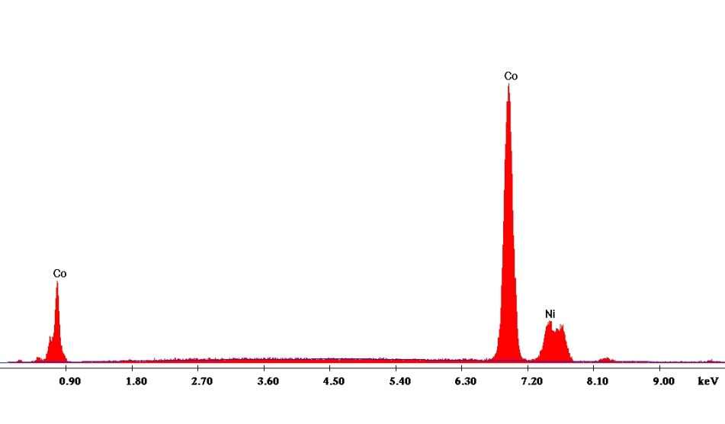 Figure 1: EDS spectrum of Ni-Co NWs.

In this work, nanostructured Ni-Co alloy electrode has been fabricated by electrodeposition in template. Chemical composition and morphology were determined by EDS and SEM analyses. The electrochemical characterization was carried out in 30% w/w KOH aqueous solution at room temperature by cyclic voltammetry (CV) and linear sweep voltammetry, comparing the result with nanostructured electrodes of pure Ni and Co. The results showed that Ni-Co alloy works better especially for OER, with an improvement in electrocatalytic activity of over 20%. The relevance and novelty of the work consists in the electrodeposition of a Ni-Co in a confined ambient such as the nanochannels of a template. As known, both electrochemical standard potentials and overvoltage for deposition of Ni and Co are different. In addition, the mass transport through the nanochannels is strongly inhibited by the highly frequent collision with the walls. For all this, it is of primary importance to investigate the possibility to electrodeposit such alloy, before to do a long-term study as an electrocatalyst for water splitting process. Therefore, the electrochemical characterization is valuable as suitability tests of the electrodeposited Ni-Co nanostructured alloy.
  - Experimental
Whatman polycarbonate membrane was employed as a template for Ni, Co, and Ni-Co nanowires (NWs) fabrication. The fabrication procedure for the NWs fabrication is the same described in Ganci et al. (2017) and Ganci et al. (2018a). The Ni deposition bath was a Watts bath (300 g/L Nickel Sulphate Hexahydrate, 45 g/L Nickel Chloride, 45 g/L Boric Acid) at pH 3. The Co deposition bath was composed by 300 g/L Cobalt Sulfate Heptahydrate, 45 g/L Cobalt Chloride and 45 g/L Boric Acid at pH 3. The Ni-Co deposition bath was a mixture of the previous two: two parts of Ni bath and one of Co bath.
After deposition, template was chemically dissolved in dichloromethane at room temperature. The operation was repeated 4 times to guarantee the total removal of the polycarbonate. At the end, NWs conformal to the template were obtained, well adherent to the current collector.
Electrodeposition and electrochemical characterization were performed using a Cell Test System (Solartron, Mod. 1470 E). Data were recorded by a desk computer via MultiStat Software (Mod. UBS147010ES). Morphology was investigated using a FEG-ESEM microscope (model: QUANTA 200 by FEI), equipped with Energy Dispersive Spectroscopy (EDS) probe.

Table 1: Ni and Co atomic concentration of deposition bath, of electrodeposited current collector (CC), and NWs.
Element | Bath | CC | NWs
Ni | 67% | 20.82% | 14.94%
Co | 33% | 79.18% | 85.06%
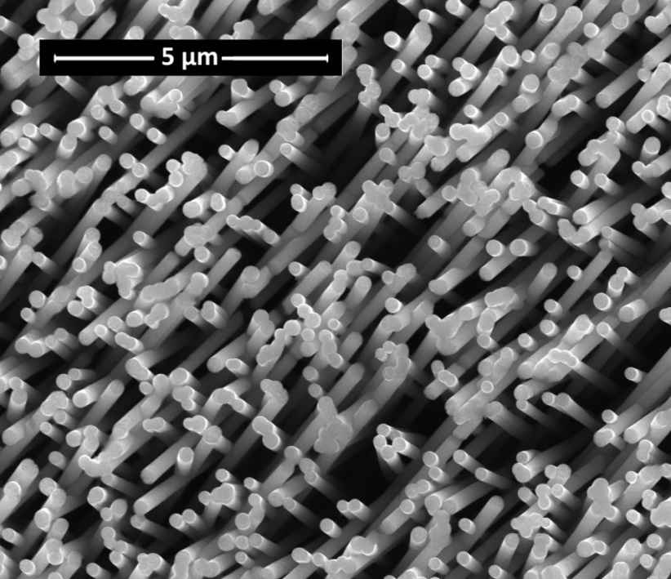
Figure 2: SEM image of Ni-Co NWs.
  - Results and Discussion
The novelty of the NWs fabrication procedure consists in the use of a concentrated solution of Ni and Co. Specifically, for the fabrication of this electrode, the composition of the solution is shown in Table 1. Once the template was dissolved, EDS characterization was performed on both current collector (CC) and NWs. Figure 1 shows the typical EDS spectrum of the NWs, in which both cobalt and nickel peaks are present. Table 1 evidences that Co concentration in the NWs is higher than the that of Ni, despite the lower Co concentration in the solution deposition. Also for CC, the Co atomic composition is higher than that of solution, while for the NWs the increase is 52.06%. This apparent anomaly is reported in the literature by Burzynska et Rudnik (2000). Furthermore, the difference in composition between the CC and the NWs is due to the different procedure of electrodeposition (Schweckandt and Aguirre, 2015). This alloy composition (5.69 atomic ratio Co/Ni) has proved to be succesfull for electrochemical water splitting. (see below)
In order to assess the structural integrity of the nanostructures, a SEM analysis was performed. Figure 2 shows the NWs morphology. The nanostructures have a cylindrical shape due to the template morphology, with average diameter of about 220-250 nm and length of about 5-6 µm. Moreover, they show a smooth surface without irregularities and with uniform composition throughout their length indicating the formation of Ni-Co alloy. It is also clear from both SEM and EDS analysis that the template was completely dissolved, because C peak was not detected. After the chemical and morphological characterization, an electrochemical characterization of the Ni-Co NWs was performed. In Figure 3, the first, third and fifth voltammetry cycles are plotted. The potential has been scanned from -0.033 V to 1.267 V vs. RHE (Reference Hydrogen Electrode) at 0.005 Vs⁻¹ for 5 times. CV was conducted in 30% w/w KOH aqueous solution at room temperature. The red line shows the first cycle. From -0.033 V to 1.267 V vs. RHE, there are three peaks: the first one at a potential of 0.35 V, the second one at 0.96 V, and the last one at 1.02 V. They are due to Co oxidation from Co (0) to Co (II), from Co (II) to Co (III), and from Ni(II) to Ni(III), respectively (Perez-Alonso et al., 2015). On the reverse scan, a wave appears at 0.9 V. It is due both to the reduction of Co (III) to Co (II) and of Ni(III) to Ni(II). The blue and green lines represent the third and fifth cycles, respectively. They have the same peaks of the first cycle, except for the oxidation peak of Co (0). This is due to the irreversibility of this oxidation. In fact, there is no further reduction peak at lower potential of 0.35 V vs. RHE.
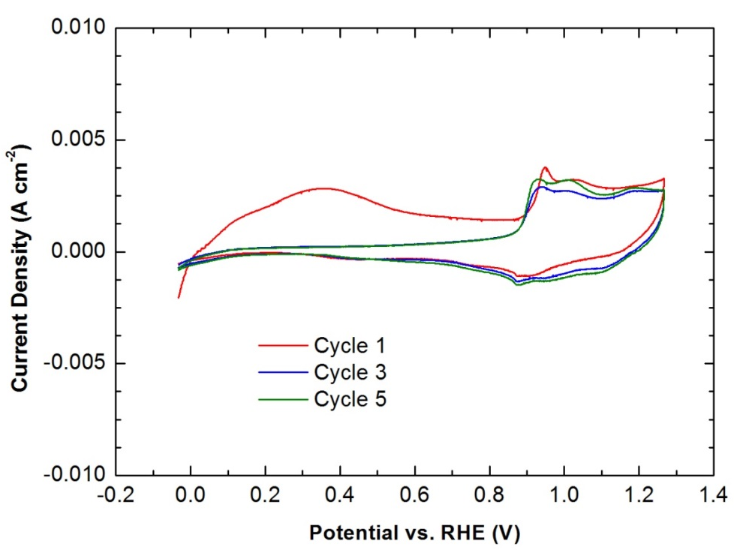
Figure 3: First, third and fifth cycle of cyclic voltammetry of a Ni-Co electrode (85.06% Co) conducted at a scan rate 5 mVs⁻⁻¹, in 30% w/w KOH aqueous solution at room temperature.
In order to evaluate the Ni-Co electrocatalytic performance both for HER and OER, quasi steady-state polarization (QSSP) tests were performed. The results were compared with pure Ni and pure Co electrodes having identical morphology. QSSPs were conducted in 30% w/w KOH aqueous solution at room temperature for both cathodic and anodic reaction. For the cathodic reaction, the potential was scanned from 0.1 V to -0.9 V vs RHE at 0.1667 mVs⁻¹. For the anodic reaction, the potential was scanned from 1.1 V to 2.1 V vs RHE at 0.1667 mVs⁻¹. Figures 4 and 5 show the logarithmic dependence of the overpotential on the absolute value of current density for all the electrodes. The experimental curves were fitted (dashed line) by the Tafel equation
$$η = a+b*log i$$ | (1)
The values of a and b are reported in Table 2 for both HER and OER. a is related to the exchange current density, while b indicates the slope of the curve in the graph, which evidences the irreversibility of the charge transfer reaction. The more this parameter is low in absolute value, the better is the electrode electrocatalysis towards the reaction. For HER, the Ni NWs show the best performance with -0.119 Vdec⁻¹; while the Ni-Co NWs electrode has a trend similar to that of pure Co, with -0.133 and -0.135 Vdec⁻¹ respectively. This is probably due to the composition of the electrode that is more unbalanced towards the Co, suggesting the possibility of improving the performance of the alloy by increasing the percentage of Ni in the alloy.
Instead, the Ni-Co alloy shows better electrocatalytic performance for OER because its b is 0.091 Vdec⁻¹, that is less than that of pure Ni and pure Co. In practice, the employment of Ni-Co electrode for OER guarantees an improvement of about 20% in the electrocatalytic performance in comparison with pure Ni and Co, in otherwise identical conditions. These results are preliminary because the prevalent interest was in showing the possible fabrication of Ni-Co alloy electrodes through template electrosynthesis. Future works will analyze the fabrication of Ni-Co alloys electrodes with different compositions and their electrocatalytic properties.
Table 2: Parameter value of the curves plotted in Figures 4 and 5 matched by Tafel equation for HER and OER.
Electrode | HER a (V) | HER b (Vdec⁻¹) | OER a (V) | OER b (Vdec⁻¹)
Ni NWs | -0.511 | -0.119 | 1.774 | 0.102
Co NWs | -0.568 | -0.135 | 1.816 | 0.104
Ni-Co NWs | -0.571 | -0.133 | 1.700 | 0.091

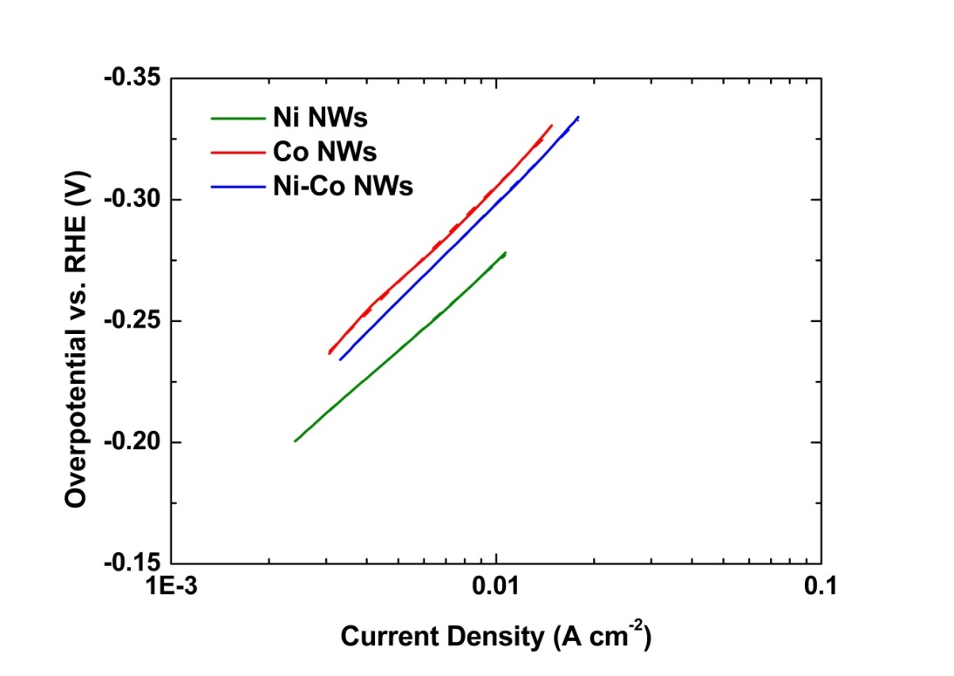
Figure 4: Cathodic QSSP for HER in 30% w/w KOH aqueous solution at room temperature.
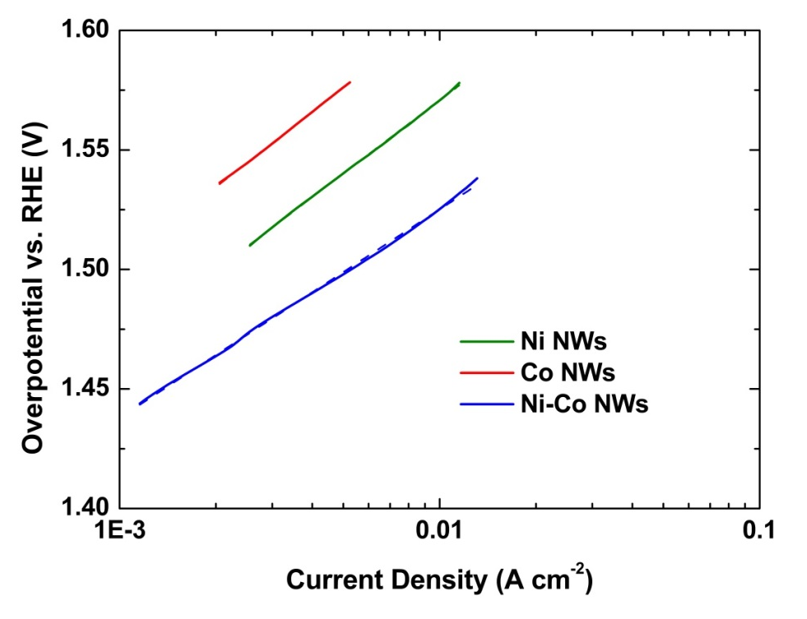
Figure 5: Anodic QSSP for OER in 30% w/w KOH aqueous solution at room temperature.
  - Conclusions
In this work, a Ni-Co alloy nanostructured electrode was fabricated by a template electrosynthesis method.
The method used for the manufacture, which is simple and cheap, has also proved effective for the deposition of the alloy. After the fabrication, the electrode has been characterized chemically and morphologically with EDS and SEM analyses. The electrochemical and electrocatalytic behavior of the Ni-Co NWs electrode was investigated by CV and QSSP. In 30% w/w KOH aqueous solution, the behavior was studied both as a cathode and as an anode of an alkaline electrolyzer. The results of these analyses were compared with electrodes of pure Ni and Co having the same morphology.
The Ni-Co NWs electrode showed the best results for OER with an overpotential of 0.091 Vdec⁻¹, improving the performance of pure electrodes by 20%. Instead, as far as HER is concerned, the best electrode is Ni NWs, probably due to an excessive concentration of Co in the alloy, which is a metal with low electrocatalytic features for HER. For this reason, further work is in progress aimed to fabricate and test Ni-Co alloy electrodes with different composition in order to find the best composition for assembling the alkaline electrolyzer with one-type electrode able to work as a cathode and an anode.
References
Battaglia M., Inguanta R., Piazza S., Sunseri C., 2014, Fabrication and characterization of nanostructured Ni-IrO2 electrodes for water electrolysis, International Journal of Hydrogen Energy, Elsevier, 39, 16797–16805.
Burzyńska L., Rudnik E., 2000, The influence of electrolysis parameters on the composition and morphology of Co–Ni alloys, Hydrometallurgy, 54, 2–3, 133-149.
Elias L., Scott K., Hedge C. A., 2015, Electrolytic Synthesis and Characterization of Electrocatalytic Ni-W Alloy, Journal of Materials Engineering and Performance, CrossMark, 24, 4182-4191.
Ganci F., Inguanta R., Piazza S., Sunseri C., Lombardo S., 2017, Fabrication and Characterization of Nanostructured Ni and Pd Electrodes for Hydrogen Evolution Reaction (HER) in Water Alkaline Electrolyzer, Chemical Engineering Transaction, vol. 57, 1591-1596.
Ganci F., Lombardo S., Sunseri C., Inguanta R., 2018a, Nanostructured electrodes for hydrogen production in alkaline electrolyzer, Renewable Energy, Elsevier, 123, 117-124.
Insinga M. G., Moncada A., Oliveri R. L., Ganci F., Piazza S., Sunseri C., Inguanta R., 2017, Nanostructured Pb Electrode for Innovative Lead-acid Battery, Chemical Engineering Transaction, vol. 60, 49-54.
Lupi C., Dell’Era A., Pasquali M., 2009, Nickel–cobalt electrodeposited alloys for hydrogen evolution in alkaline media, International Journal of Hydrogen Energy, Elsevier, 34, 2101-2106.
Perez-Alonso F. J., Adan C., Rojas S., Pena M. A., Fierro J. L. G., 2015, Ni-Co electrodes prepared by electroless-plating deposition. A study of their electrocatalytic activity for the hydrogen and oxygen evolution reactions, International Journal of Hydrogen Energy, Elsevier, 40, 51-61.
Schweckandt D. S., Aguirre M. C., 2015, Electrodeposition of Ni-Co alloys. Determination of properties to be used as coins, Procedia Materials Science, 8, 91-100.
Ullal Y., Hedge A. C., 2014, Electrodeposition and electro-catalytic study of nanocrystalline Ni-Fe alloy, International Journal of Hydrogen Energy, Elsevier, 39, 10485-10492.

