CHEMICAL ENGINEERING TRANSACTIONS  VOL. 73, 2019 | A publication of
The Italian Association
of Chemical Engineering
Online at www.aidic.it/cet
Guest Editors: Andrea D’Anna, Paolo Ciambelli, Carmelo Sunseri
Copyright © 2019, AIDIC Servizi S.r.l.
ISBN 978-88-95608-70-9; ISSN 2283-9216

Gelled Electrolyte for Nanostructured Lead-acid Battery
Maria Grazia Insinga*, Andrea Derelitto, Simone Pisana, Roberto Luigi Oliveri, Carmelo Sunseri, Rosalinda Inguanta
Applied Physics Chemistry Laboratory, Department of Industrial and Digital Innovation (DIID) - Chemical, Management, Computer, Mechanical Engineering, University of Palermo, Viale delle Scienze - 90128 Palermo (Italy)
mariagraziainsinga@gmail.com
In recent years, the storage of energy produced by renewable sources has become a topic of great interest. Lead-acid batteries are widely used in this field, in particular those based on VRLA (Valve-Regulated-Lead Acid) technology, in which the electrolyte is immobilized inside the battery. In this paper, the use of a hydrogel as an electrolyte was considered. Hydrogel can be described as a three-dimensional network of a hydrophilic polymer that can absorb large amounts of water (or aqueous solutions) without dissolving. Pb and PbO₂ nanostructured electrodes were used in the battery that used hydrogel as an electrolyte. Two different types of hydrogels were synthesised, both based on PVA that is a biodegradable, biocompatible, non-toxic, and non-carcinogenic polymer. The first one was obtained through physical gelling, the second one was obtained using borax (sodium tetraborate decahydrate) as a cross-linking agent. Preliminary tests of nanostructured lead-acid batteries using both types of hydrogels as an electrolyte were conducted for 100 cycles at 1C. The physically gelled hydrogel gave the best results in terms of efficiency, likely, owing to its greater absorption capacity. It was also verified that the recombination of the gases evolved during the charge phase (hydrogen and oxygen) takes place inside the battery itself. This is the major advantage of the gelled electrolyte in comparison with the liquid one.
  - Introduction
Polymeric gel electrolytes are often swollen polymer networks, so they possess both the cohesive properties of solids and the properties of the liquids from the point of view of diffusive transport. Thanks to this dual behaviour, gel electrolytes can be used in a wide variety of electrochemical devices. However, their mechanical strength is quite low; for this reason various additives are often used to improve their mechanical stability. In 1975, Feuillade and Perche (1975) produced gel with a high ionic conductivity (similar to that of the liquid electrolytes) by adding an aprotic solution containing alkali metal salts to the polymeric matrices. In the present work, PVA-based hydrogels were made to be used as gel electrolytes in lead-acid battery assembled with nanostructured electrodes. PVA hydrogel preparation, using the freeze-thaw technique, was first reported by Peppas (1975). In his work, aqueous solutions of PVA (between 2.5 and 15% weight/volume) were frozen at -20 °C and then thawed at room temperature. The crystallites formed after this procedure have been characterized by measurements of the turbidity of PVA samples. It has been observed that crystallinity increases with the duration of freezing, instead, during thawing, the crystallite size initially increases and then decreases. This may be due to the breaking of the crystalline structure. After the work by Peppas, numerous researches have been conducted on the production of hydrogels through this technique and on their characterization. For example, Nambu (1984) has introduced the use of these hydrogels for biomedical applications. His fabrication technique consisted in freezing a PVA solution at temperatures below -3 °C and then evaporating the water under vacuum. Yokoyama et al. (1986) examined the hydrogels produced by the Nambu method using X-ray diffraction, scanning electron microscope (SEM), and optical microscope. Three phases simultaneously present were identified: an aqueous phase with a low concentration of PVA, an amorphous phase and a crystalline one, which limits the movement of the amorphous chains of PVA.
The crystallization of the PVA hydrogels was discussed in detail by Bunn (1948). PVA chains form small sized ordered regions (crystallites) randomly distributed into an amorphous polymeric matrix. Stereoregularity greatly influences PVA's ability to crystallize: Harris et al. (1966) observed that stereoregularity does not increase crystallisation. In particular, isotactic PVA is less crystalline than syndiotactic, while atactic PVA is the form that exhibits crystallinity (Hallensleben, 2000). Several methods have been studied for crystallization of PVA, most of which involve heating leading to crystallite formation. The degree of crystallinity, as well as size of the crystallites, depend on the conditions under which drying takes place.
  - Experimental
2.1 Preparation of hydrogels and nanostructured electrodes
The hydrogels to be used in lead-acid battery assembled with nanostructured electrodes are based on PVA and were prepared by two different techniques. The first one consists in the fabrication of a gel through a "physical gelling", while the second one consists in the preparation of the gel through a "chemical gelling" process. The first step of the preparation of both hydrogels consists in the preparation of a 10% (w/v) PVA aqueous solution. For accelerating the dissolution of the PVA, a magnetic stirring was used and the temperature was raised to 80 °C. Two hours were necessary for getting the complete dissolution of the PVA. In order to produce the hydrogel by "physical" cross-linking method, the solution was cooled to room temperature, then it was kept at -20 °C for 24 h during which the hydrogel was formed, which was stabilized at room temperature for further 24 h. The second type of hydrogel was produced by using borax (sodium tetraborate decahydrate,$({Na}_{2}B_{4}O_{7}∙10H_{2}O$) as a cross-linking agent. Initially, an aqueous PVA solution and 4% (w/v) borax aqueous solution were prepared. Since borax is very soluble in water, the solution has been prepared at room temperature under stirring for 1 hour. Then 10 ml of H₂O-PVA solution were mixed with 600 μl of H₂O-borax solution. As the two solutions were mixed, the borate ions B(OH)₄⁻ reacted with the hydroxyl groups of the PVA generating weak transversal bonds between the polymer chains with the formation of a viscous and elastic hydrogel. For the sake of simplicity, in the following, the two types of hydrogel will be identified as physical hydrogel and borax hydrogel. Both the types of hydrogels were dried in an oven for 24 hours, at temperature of 40 °C, and then were ground to dust. Tests of swelling of the hydrogel powders were conducted in 5 M sulfuric acid (the electrolyte used in the lead acid battery) to evaluate their absorption capacity. It has been found that 1 g of physical hydrogel absorbs 2.95 g of acid, while 1 g of borax hydrogel can absorb 1.7 g. Of course, this difference results in different performance of the battery. The experimental details for obtaining nanostructured electrodes were described in a previous work (Inguanta et al., 2013). Nanowire array was electrodeposited inside the channels of a polycarbonate membrane acting as a template, which was chemically dissolved at the end of the growth of Pb or PbO₂ nanowires. A layer of the same material of the nanostructures acting as a current collector and support of the nanowires was deposited on a surface of the template.
2.2 Performance tests
The lab cell simulating a lead acid battery was assembled with nanostructured PbO2 and Pb electrodes separated by a layer of hydrogel acting as an electrolyte and a separator for avoiding short circuit. The PbO2 capacity was lower than that of Pb, like commercial battery. Usually, the negative electrode is the weak component of the lead acid battery owing to its trend to hard sulphation. Before testing the battery, the nanostructured electrodes were dipped in 5 M sulfuric acid in order to soak the porous mass. To find the influence of the immersion time on the battery performance, the electrodes were immersed for different times from 24 hours to five days. After extraction from the sulfuric acid, additional acid was poured on the electrodes. Finally, one surface of both PbO2 and Pb electrodes was spread by the hydrogel powder, which immediately swelled up owing to absorption of sulfuric acid. In this way, the electrolyte, in the form of swollen hydrogel, adhered perfectly to the two electrodes, which were coupled in a zero gap configuration. The experimental details for electrochemical tests were reported elsewhere (Insinga et al. 2017). Nanostructured electrode capacity was determined through gravimetric measurements. Only the nanostructures were considered as an active material, therefore only their weight was considered for evaluating the electrode capacity. Specific tests revealed that the layer of either Pb or PbO2 supporting the nanowires did not contribute to the electrode capacity. All tests were conducted at a constant current of 1C and room temperature, with a cut-off potential of 1.2 V. Since the Pb and PbO2 electrodes have different capacity, the 1C-rate was referred to the PbO2 mass. Besides, the discharge time was set at 90% of 3600 s, so that a part of Pb and PbO2 remained unconverted. This is beneficial for the negative electrode, because its real C-rate is a little less than 1C, which is evaluated according to the mass of PbO2. In such a way, the total sulphation of the electrodes on cycling is avoided.
2.3 Characterization of the materials
All the materials fabricated in the present work were characterized by Scanning Electron Microscopy (SEM) and X-ray diffraction (XRD). A Field Emission Gun Environmental Scanning Electron Microscope (FEI Quanta 200 FEG-ESEM) was employed for morphological analysis while solid-state characterization was performed through a RIGAKU X-ray diffractometer (model: D-MAX 25600 HK). X-ray diffraction patterns were obtained in the 2θ range from 10° to 100° with a sampling width of 0.004° and a scan speed of 3 deg/min, using Ni-filtered Cu Kα radiation (λ= 1.54 Å). Diffraction peaks were identified by comparison with ICDD database (International Centre for Diffraction Data 2007)
  - Results and discussion
After drying of the gelled PVA, SEM analysis revealed an average grain size of 1.82 mm and 1.064 mm for the borax and physical hydrogel, respectively. Figure 1 shows the SEM images of the two types of hydrogel, and evidence that the borax hydrogel is more compact than the physical one, so that it is less suitable to absorb 5 M sulfuric acid. Therefore, the different swelling behaviour of the two types of hydrogel can be attributed to their more or less compact structure. The PVA powder used to produce the hydrogels was initially characterized by XRD to determine its crystallinity. The XRD patterns were compared with those of the two types of hydrogel before and after their use in a cell simulating a lead-acid battery. Figure 2 shows that the XRD pattern of no gelled PVA has three characteristic peaks (2θ = 13.5°, 2θ = 19.8°, 2θ = 22.5°) that correspond to the crystalline regions of the PVA. The peaks agree with the findings by Seong et al. (2017). The most relevant results showed in Figure 2a are: i) the invariance of the crystallinity after the physical gelling process, and ii) the appearance of a wave in place of the peaks at 2θ = 19.8°, 2θ = 22.5° indicating some modification of the physical hydrogel under cycling.
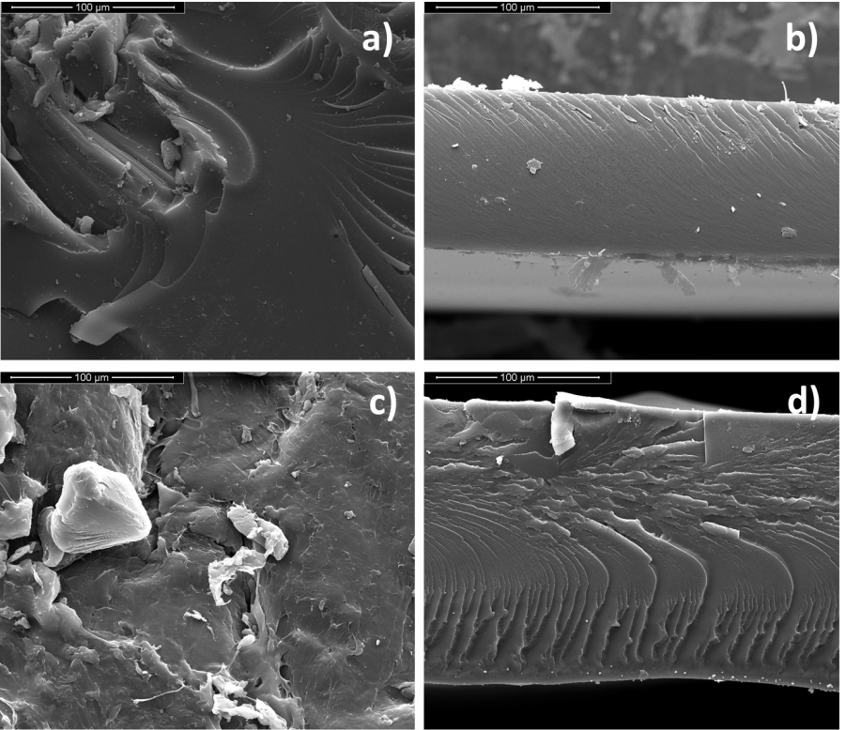
Figure 1: a) powder, and b) section view of borax gelled PVA; c) powder, and d) section view of physically gelled PVA.
On the contrary, the borax hydrogel appears more amorphous than the no gelled PVA. Such a structural change is evidenced in Figure 2b by the enlargement of the band at 2θ=13.5° and the sharp weakening of the peak at 2θ=19.8°. Besides, Figure 2b shows that XRD pattern of the hydrogel has the same trend of the no gelled PVA, therefore, the hydrogel has not incorporated borax. This conclusion is also supported by the absence of the most intense peak of the borax at 2θ = 34.882°. Also the borax hydrogel became more amorphous under cycling like the physical hydrogel. This behaviour can be attributed to the absorption of the free sulfuric acid which was added to the cell as a reservoir of electrolyte. This is a crucial aspect for guaranteeing long life of the gelled electrolyte and correct working of the battery. Water is consumed during overcharging, even if it is restored like in commercial battery equipped with gelled electrolyte. Since the total water loss under cycling cannot be exactly evaluated in advance, it is a precautionary approach to add free 5M sulphuric acid in order to replenish the lost water. The major risk associated with water loss is the progressive drying of the hydrogels with their permanent damage, and consequent out of service of the battery. Another significant feature of the hydrogels is their chemical inertness evidenced in the present work by the absence of any incorporation of Pb and PbO₂ in the hydrogels at the end of cycling. The first charging of the cell was conducted step-wise (Moncada et al. 2014, Insinga M.G. et al. 2017) so as to prevent any initial sharp increase of the voltage which might permanently damage the cell all along. A cut-off voltage of 1.2 V has also been set, while this parameter is between 1.3 and 1.7 V in commercial battery. The cut-off voltage of 1.2 V along with cycling rate of 1C are highly stressing conditions for commercial battery, which cannot sustain such conditions because fast permanent sulphation occurs. On the contrary, the nanostructured battery can sustain these cycling conditions without shortening the lifetime (Moncada et al. 2014, Moncada et al. 2015, Insinga M.G. et al. 2017).
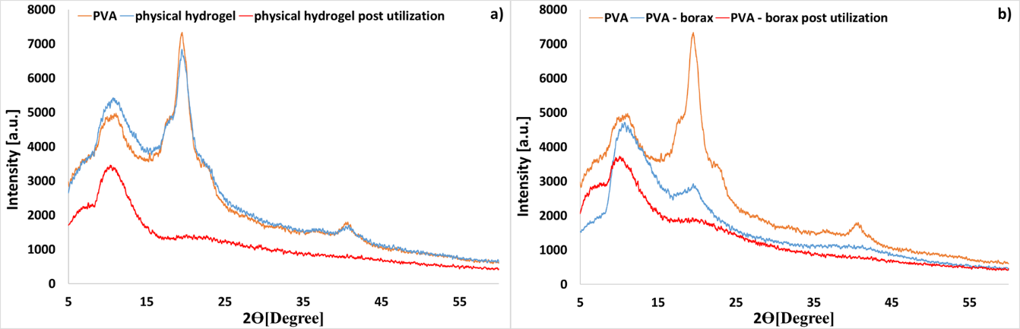
Figure 2: a) XRD pattern of PVA powder compared with physical hydrogel powder before and after its use as an electrolyte; b) XRD pattern of PVA powder compared with borax gelled powder before and after its use as an electrolyte
Figure 3 shows the cycling efficiency and specific drained charge as a function of the number of cycles when the two types of hydrogel are employed as electrolytes.
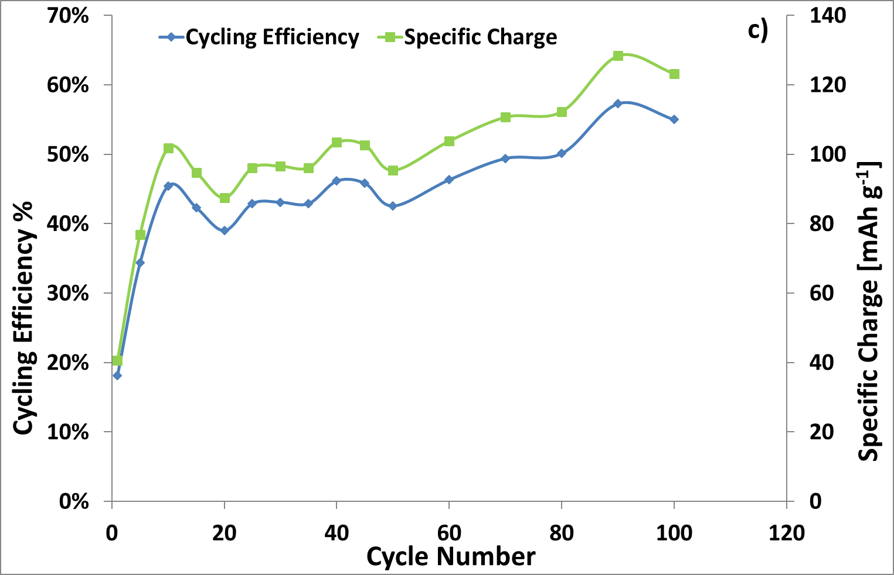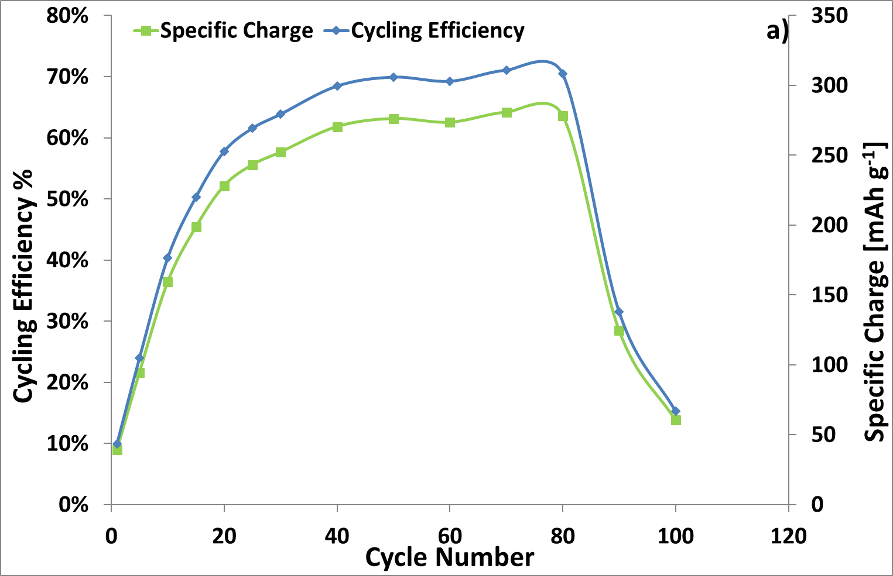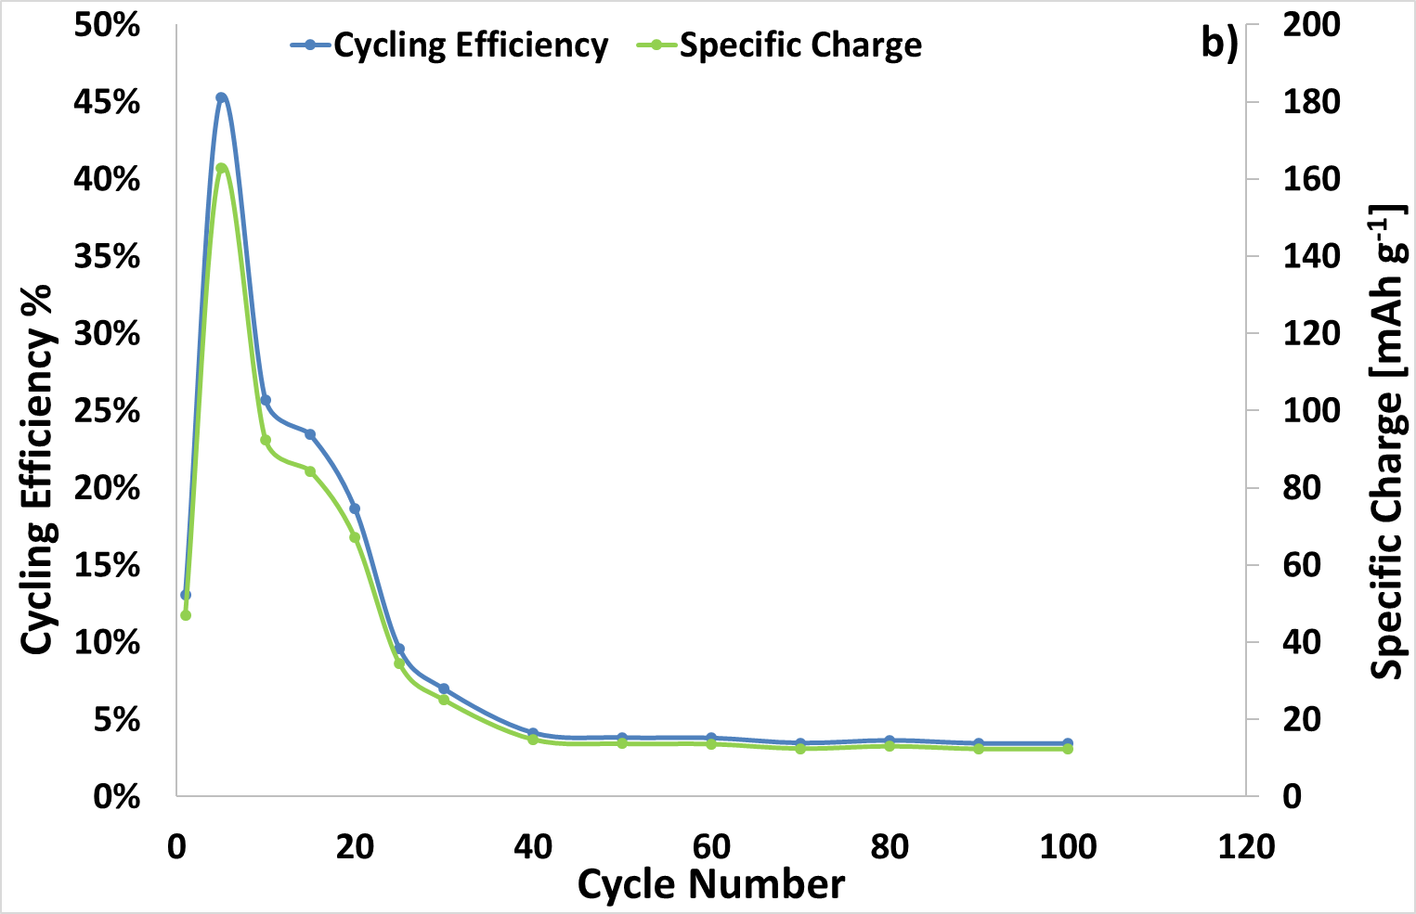 Figure 3 Cycling efficiency and electrical charge drained vs. cycle number at 1C and room temperature for a cell with: a) physical hydrogel; b) borax hydrogel; c) liquid electrolyte. Before cycling, electrode was held for 5 days in 5 M H₂SO₄
For comparison, the same curves are shown when liquid electrolyte was used (Figure 3c). The curves of Figure 3 show, first of all, a significant difference when liquid electrolyte is replaced by the gelled one. In addition, it is evident that physical hydrogel guarantees better performance than the borax one. In particular, the battery equipped with the physical hydrogel achieved efficiency of about 70% from 40th to 80th cycle followed by fast decay, while the battery with borax hydrogel achieved the maximum efficiency of about 45% in the initial cycles, followed by a very fast decay. The different behaviour under cycling of the two hydrogels can be attributed to the higher amount of acid absorbed by the physical hydrogel. The rapid falling-off of the battery performance at low cycle number is due to a progressive hydrogel deterioration under cycling. The most probable decay of the battery may be due to an unfinished design of the cell, where a progressive flow down of the hydrogels occurs because the electrodes are not permanently blocked in the initial zero-gap configuration. Under cycling, electrodes can move each other with consequent loss of the zero-gap configuration. The electrodes are vertically assembled, therefore, when the distance between them increases, the hydrogel layer can freely flow down leaving the superior part of the electrode uncovered, which, consequently, stops to work. In practice, tiny, little motions of the electrodes from the zero-gap assembly favour the slow dropping down of the hydrogel with consequent shortening of the lifetime of the battery. If this is the likely cause of decay of the battery, it can be solved by modifying the design of the. More research activity is in progress aimed to improve the time life of battery equipped with PVA physically gelled, because the challenge appears of great value in comparison with battery using a liquid electrolyte. Figure 3 also evidences that the physically gelled electrolyte shows a more favourable behaviour than a battery with liquid electrolyte. The weak point is the short lifetime, which can be extended by improving the cell design. Figure 4 shows the charge/discharge curves of cells equipped with physical and borax hydrogels. The comparison between Figure 4a and b confirm the poor performance of the cell with borax hydrogel evidenced by the decreasing of the drained charge from the 40th cycle onwards. Therefore, the stored energy that can be used is irrelevant. On the contrary, far better performance is shown by the cell equipped with physical hydrogel.
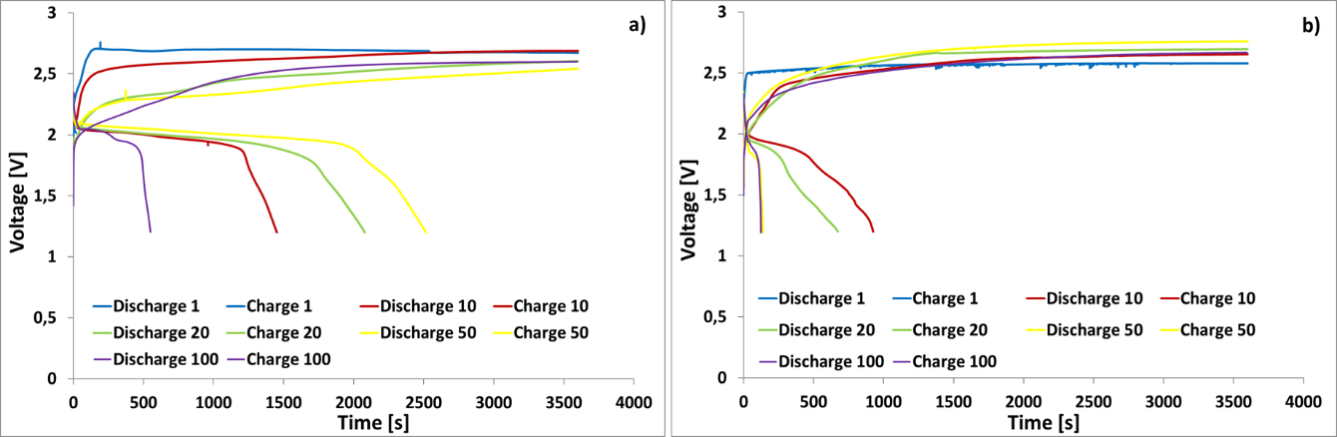
Figure 4: Charge/Discharge curves at 1C and room temperature of a battery with: a) physical hydrogel; b) borax hydrogel.
At the end of the cycling, the Pb and PbO₂ electrodes that had worked with either physical or borax hydrogel were analysed by SEM (Figure 5) to evaluate how their morphology had changed as a result of cyclization. Figure 5 shows that under cycling the original nanowires has been lost, replaced by particles that guarantee high porosity.
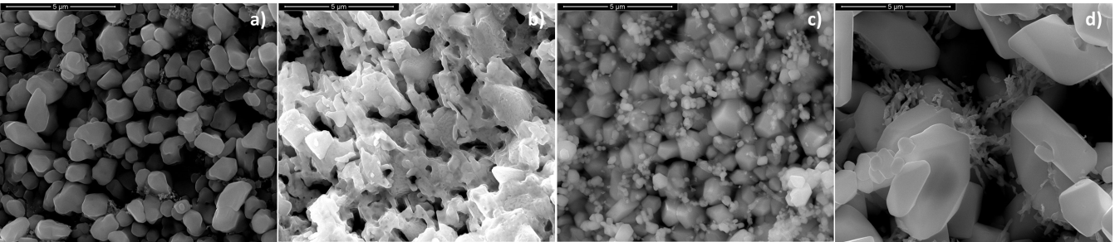
Figure 5: a) and b): SEM images of Pb and PbO₂ electrodes, respectively, cycled in contact with physical hydrogel. c) and d) SEM images of Pb and PbO₂ electrodes, respectively, cycled in contact with physical hydrogel. Cyclization was conducted at 1C and room temperature.
The morphology change is not due to the presence of the hydrogel, because identical modification has been observed in Pb and PbO₂ cycled in no gelled electrolyte (Moncada et al. 2014, Moncada et al. 2015, Insinga M.G. et al. 2017). The capability of the battery with gelled electrolyte to restore the water split in oxygen and hydrogen during charging was also investigated. A gas meter coupled with the cell was used to check gas production under charging. It was found the practical absence of gas production, so that battery with gelled electrolyte avoids water consume under cycling that is one of the principal disadvantages of the commercial lead-acid battery with liquid electrolyte.
  - Conclusion
Two different types of hydrogels were fabricated starting from an aqueous solution of PVA. One type of hydrogel was obtained by physical cross-linking at -20 °C, while the other one was obtained by using an aqueous borax solution as cross-linking agent. Both hydrogels were used as an electrolyte in a cell simulating a lead-acid battery. The cell was equipped with nanostructured Pb and PbO₂ electrodes, and was cycled at a rate of 1C for 100 cycles. The cell equipped with the borax hydrogel showed acceptable performance only in the initial cycles while the cell equipped with a physical hydrogel showed excellent performance in terms of drained charge and energy efficiency, which reached a value over 70%. The difference between the two hydrogels can be due to the low capacity of the borax hydrogel to absorb 5M sulfuric acid. The weak point of the battery with nanostructured electrodes in contact with gelled electrolyte is the very short lifetime. The longer lifetime was found when physical hydrogel was used. In any case, the maximum cycle number at 1C was 100 with an efficiency of about 70% from 40th to 100th cycle. After 100 cycles both efficiency and drained charge decayed. For electrodes in contact with borax hydrogel a shorter lifetime was found. In both cases, the short lifetime is due to a not optimised cell design, so that the hydrogels can flow down because the elctrodes are not definitely blocked in the zero gap configuration. Another significant finding is the absence of gas evolution because the gas recombines like in the commercial battery with gelled electrolyte. Further work is in progress for improving the cell design and testing the cell at higher C-rate as 10C.
References
Bunn, C.W., 1948, Crystal Structure of Polyvinyl Alcohol. Nature, 161, 929-930
Feuillade G., Perche P., 1975, Ion-conductive macromolecular gels and membranes for solid lithium cells, J. Appl. Electrochem., 5, 63-69
Harris H.E., Kenney J.F., Willcockson G.W., Chiang R., Friedlander H.N., 1966, Structure–property relationships of poly(vinyl alcohol). II. The influence of molecular regularity on the crystallization–dissolution temperature relationships of poly(vinyl alcohol), Polym Sci., 4, 665-677
Hallensleben M.L., 2000, Ullmann's Encyclopedia of Industrial Chemistry: Polyvinyl Compounds, Others, Wiley-VCH, Weinheim, Germany
Inguanta R., Randazzo S., Moncada A., Mistretta M.C., Piazza S., Sunseri C., 2013, Growth and Electrochemical Performance of Lead and Lead Oxide Nanowire Arrays as Electrodes for Lead-Acid Batteries, Chemical Engineering Transactions, 32, 2227-2232
Insinga M.G., Moncada A., Oliveri R.L., Ganci F., Piazza S., Sunseri C., Inguanta R., 2017, Nanostructured Pb electrode for innovative lead-acid battery, Chemical Engineering Transactions, 60, 49-54
International Centre for Diffraction Data, 2007, Newtown Square, PA, U.S.A.
Moncada A., Mistretta M.C., Randazzo S., Piazza S., Sunseri C., Inguanta R., 2014, High-performance of PbO₂ nanowire electrodes for lead-acid battery, Journal Power Sources, 256, 72-79
Moncada, A., Piazza, S., Sunseri, C., Inguanta, R., 2015, Recent improvements in PbO₂ nanowire electrodes for lead-acid battery, Journal of Power Sources, 275, 181-188
Nambu M., 1984, Freeze-dried poly(vinyl alchool) gel, US Patent 4,472,542
Peppas N.A., 1975, Turbidimetric studies of aqueous poly(vinyl alcohol) solutions, Macromol. Chem. and Pysics, 176, 3433-3440
Seong B. Y. , Sung H. Y. , Joon S. L. , Jong W. K., Jeong H. Y., 2017, Surface Properties of a Novel Poly(vinyl alcohol) Film Prepared by Heterogeneous Saponification of Poly(vinyl acetate) Film, Polymers MDPI, 9, 493.
Yokoyama F, Masada I, Shimamura K, Ikawa T, Monobe K.,1986, Morphology and structure of highly elastic poly(vinyl alcohol) hydrogel prepared by repeated freezing-and-melting, Colloid Polym Sci, 264, 595-601

