CHEMICAL ENGINEERING TRANSACTIONS  VOL. 73, 2019 | A publication of
The Italian Association
of Chemical Engineering
Online at www.aidic.it/cet
Guest Editors: Andrea D’Anna, Paolo Ciambelli, Carmelo Sunseri
Copyright © 2019, AIDIC Servizi S.r.l.
ISBN 978-88-95608-70-9; ISSN 2283-9216

Enzymatic Monolith Continuous Microreactors for the Synthesis of Xylooligosaccharides By Controlled Hydrolysis of Xylans
Domenico Pirozzi*ª, Antonio Aronneª, Dario Carusoª, Maria Abagnaleª, Gaetano Zuccaroª, Abu Yousuf^{c}, Ciro Florio^{d}, Annabella Tramice^{b}
ªDipartimento di Ingegneria Chimica, dei Materiali e della Produzione Industriale (DICMAPI) Università Federico II di Napoli, P.le Tecchio, 80, 80125 Napoli, Italia
^{b}Institute of Biomolecular Chemistry, National Research Council, Via Campi Flegrei, 34, Pozzuoli 80078, Naples, Italy.
^{c} Department of Chemical Engineering & Polymer Science, Shahjalal University of Science and Technology, Sylhet-3114, Bangladesh
^{d} University of Naples “Parthenope”, Department of Science and Technology (DiST), Laboratory of Biochemistry and Microbiology. Centro Direzionale di Napoli, ISOLA C4, 80133 Napoli, Italia
dpirozzi@unina.it

Immobilized enzymes are increasingly used in enzymatic microreactors, to encourage applications in different fields: food industry, medical diagnostics, organic synthesis, drug discovery, biosensors. As a matter of facts, microfluidic systems offer many advantages over conventional packed-bed bioreactors, such as higher efficiency, feasibility of multi-enzyme systems, higher mechanical stability, reduced amounts of reagents required [Pirozzi et al., 2016].
In this study β-1,4-xylan obtained from hemicelluloses was used to obtain xylo-oligosaccharides (XOS), the only nutraceutical that can be produced from lignocellulosic biomass. XOS are considered non-digestible food ingredients, and their prebiotic effect of XOS on Bifidobacterium and Lactobacillus species has been recently demonstrated [Aachary et al., 2011; Broekaert et al., 2011; Nacos et al., 2006; Samanta et al, 2015; Vazquez]et al., 2000]. In addition XOS are stable at wide range of pH (2.5–8.0) and temperature (100 °C), they can stimulate the selective growth of the gut microflora, reduce the blood glucose and cholesterol, reduce the pro-carcinogenic enzymes in gastrointestinal tract, and enhance the mineral absorption from large intestine [Aachary et al., 2011; Broekaert et al., 2011; Nacos et al., 2006; Samanta et al, 2015; Vazquez]et al., 2000].
In this view, sol-gel methods were used for the physical entrapment of xylanase from T. lanuginosus. Due to the mild conditions usually adopted for the gel synthesis, enzymes could be added to the initial mixture of precursors and so entrapped within monolithic porous layers in capillary tubes [Pirozzi et al., 2016].
A suitable combination of sol-gel precursors was found for the simultaneous improvement of the monolith adhesion to the tubing internal surfaces and of the catalytic properties of the entrapped enzymes. Specific attention was devoted to the determination of operating conditions suitable to enhance enzyme stability as well as selectivity in terms of XOS produced.
  - Introduction
The growth of innovative processes to transform lignocellulosic biomasses into high-value fine chemicals, pure polymers or their derivatives is of critical importance to avoid the possible negative effects on agricultural markets or the competition for land between food and non-food crops [de Jong et al., 2015; Fiorentino et al., 2010; Pirozzi et al., 2015; Scheidel et al., 2012; Zhou et al., 2011]. Despite this, the hemicellulose has been considered the bottleneck for the industrial exploitation of lignocellulosic materials, due to the fact that it has been only partially exploited [Finore et al., 2016; Lama et al., 2014]. β-1,4-Xylan is one of the main component of hemicelluloses and also the second most abundant polymer in nature. It can be used to get noteworthy bio-molecules, such as xylo-oligosaccharides (XOS). Their increasing industrial interest is mainly due to the fact that they can work as selective prebiotics for the gut microflora [Aachary et al., 2011; Broekaert et al., 2011; Nacos et al., 2006; Samanta et al, 2015; Vazquez]et al., 2000].
The enzymatic way is the best one to obtain all these features, and in particular endo-1,4-β-xylanase is the central enzyme implicated in the xylan degradation [Ashikin et al., 2017; Chapla et al., 2012; Immerzeel et al., 2014; Mohd Sukri et al., 2017; Muzard et al., 2009; Tramice et al., 2009].
ese features, and in particular endo-1,4-β-xylanase is the central enzyme implicated in the xylan degradation [Ashikin et al., 2017; Chapla et al., 2012; Immerzeel et al., 2014; Mohd Sukri et al., 2017; Muzard et al., 2009; Tramice et al., 2009]. This enzyme is of increasing industrial interest, from energy generation to paper manufacture, and hence its immobilization has been intensely considered, because it is necessary to improve enzymatic stability versus inactivating factors, in addition to obtain an easier separation from the products.
Enzymes immobilization in microreactors provides significant advantages over the conventional immobilization methods. As a matter of facts, reacting systems developed in microreactors offer many advantages compared to conventional reactors, such as higher surface/volume ratios, providing a larger surface area for enzyme immobilization, higher flexibility in fabrication into various geometries, shorter diffusion path lengths to reduce diffusional resistances, reduced backpressure in comparison to packed-bed reactors, controllable porosity, to obtain increased mass transfer, due to convective flow through micro-interstices within the monolith, higher mechanical stability in comparison to conventional packed-bed bioreactors, the development of a multi-enzyme system, by separate immobilization of enzymes in different compartments of the monolith, so that intermediates produced in a compartment can be used as subtrates in the following ones. In addition, microreactors enable environmentally friendly processes, so that reduced amounts of reagents can be used. Consequently, a rising number of industrial applications is being developed for microreactors in different fields, such as food industry, medical diagnostics, organic synthesis, drug discovery or biosensors, so it is immediately clear that this technique enables the development of a stable support and promotes the action of the trapped enzyme.
In this view, sol-gel methods were used for the physical entrapment of xylanase from T. Lanuginosus in siloxane matrices. Capillary micro-bioreactors are of attracting increasing interest also because they do not require specialized micro-fabrication techniques. In particular, the formation of a sol-gel monolithic porous layer within the capillary tubes is a promising procedure and due to the mild conditions usually adopted for the gel synthesis, enzymes could be added to the initial mixture of precursors and so physically entrapped within the monoliths, with no denaturation of the enzyme itself, while this drawback often occurs when covalent bondings take place.
Different enzymes of great industrial interest were immobilized within the matrix according to the sol-gel procedure: Lipase from Candida rugosa, Carbonic Anhydrase from bovine erythrocytes, Acetylcholinesterase from Electrophorus electricus, Laccase from Trametes versicolor and Xylanase from Termomyces lanuginosous. A suitable combination of the sol-gel precursors was found, for the simultaneous improvement of the monolith adhesion to the tubing internal surfaces and of the catalytic properties of the entrapped enzymes.
The aim of this paper is to submit different entrapment procedures for xylanases from Thermomyces lanuginosus in microstructured sol-gel matrices; the structures and catalytic properties of these new biocatalysts were investigated in term of xylanase catalytic properties and then as valuable enzymatic systems for a more effective and eco-friendly hydrolysis of hemicellulose.
This is the first model of not-covalent immobilization of xylanase into sol–gel matrices made of alkoxysilanes precursors. These enzymatic matrices were used either in “in-batch” or “in-continuous” bio-processes and in this last case by developing a suitable reactor. Several xylan hydrolyses reactions were carried out in different experimental conditions and compared each other.
  - Material and Method
    - Material
Xylanase from Thermomyces lanuginosus (TL, 2500 U/g), methyltrimethoxysilane, Si(OCH3)3CH3, (MTMS) tetramethoxysilane, Si(OCH3)4 (TMOS) and Xylan from birchwood were acquired from Sigma Aldrich and used without further purification. Silica gel and reverse-phase silica gel and TLC silica gel plates were from E. Merck (Darmstadt, Germany). Compounds on TLC plates were visualized by charring with α-naphthol reagent. Protein concentration was determined by the method of Bradford (M. M. Bradford, Anal. Biochem., 1976, 72, 248–254) using bovine serum albumin (BSA) as standard. Connectors and frits for the microreactors were provided by IDEX HEALTH & SCIENCE. TLC solvent system: \ (A): EtOAc/AcOH/2-propanol/HCOOH/H₂O, 25:10:5:1:15 by vol.
    - Method
The entrapment of Xylanase from T. lanuginosous (TL) in sol-gel matrices was achieved two different procedures [Pirozzi et al., 2016].

Single Step sol-gel procedure (SS_{D}, SS_{L}) for batch processes
Two identical samples were prepared observing the following procedure: 25 mg of TL (62.5 U), 0.725 mL of bidistilled H₂O, 2.38 mL of MTMS, 0.618 mL of TMOS (molar ratio of MTMS:TMOS=4:1), 6.75 mL of 100 mM phosphate buffer (pH 7.5) and 0.0313 mL of 40 mM HCl were mixed in a flask (200 rpm). Gelation is allowed to proceed at room temperature, and it occurred in no later than 5 min. The gelled systems were kept for 24 h at room temperature, and afterwards one of them lyophilized for a suitable time (1 day at least) and the other one desiccated in an incubator shaker (Infors HT Minitron) at 30 °C to constant weight. In both cases, the hardened gels were manually ground, giving a fine powder. TL-SS_{D} and TL-SS_{L} enzymatic matrices were so ready to be used.

Single Step sol-gel procedure (CSS_{L}) for continuous processes
In accordance with the same SS route adopted for batch processes and preserving the molar ratio between the siloxane precursors, the sol-gel mixture was prepared at a room temperature in glass vial mixing 40 mg of TL , 0.145 mL of bidistilled H₂O, 0.475 mL of MTMS, 0.124 mL of TMOS, 1.35 mL of 100 mM phosphate buffer pH 7.5, 0.00625 mL of HCl 40 mM. This milk-like gel-solution was rapidly poured in a Teflon tube previously connected to a syringe; in 30 min the solution inside the teflon tube became gel, turning from sol/transparent/liquid phase to gel/white/milk-like phase; the tube was then cut in smaller tubes (each one 8 cm long) and freeze-dried for a night. These tubes were used for setting proper micro-reactors able to perform enzymatic continuous tests.

Micro-reactors set-up
Xylanase-silica-immobilized into Teflon tubes (8 cm long, 1.9 mm internal diameter, with 5 mg of immobilized TL xylanase) is used for the micro-bioreactor assembling. This apparatus was put at 34 °C and it was connected to a peristaltic pump (Minipulse 3-Gilson) to assure xylane solution constant flow rate during the whole experimental time.
For each experiment, a preliminary washing with phosphate buffer of the system was accomplished to quantify the amount of released protein, according to the Bradford assay [Bradford., 1976].
  - Enzymatic processes
    - The batch route for bioconversion
Xylan degradation was selected as test reaction and diverse reactions were realized, testing the new sol-gel biocatalysts (TL-SS_{D} and TL-SS_{L}), just got as reported in the previous sections and compared to the free-xylanase (TL) enzymatic process.
The new biocatalysts TL-SS_{D} and TL-SS_{L} were tested in xylan hydrolysis (1.5 mL of 1 % (w/v) xylan solution in 50 mM buffer phosphate pH 7) under magnetic stirring at 34 °C and checked by TLC analyses (solvent systems A), preserving the donor/enzyme ratio but modifying the reaction time, according to the data reported in the Table 1. Reactions were monitored by TLC (system solvent A). In addition, the xylan hydrolysis was measured in terms of xylose equivalent.
Table 1: Batch-mode reactions with free and immobilized xylanase
enzyme | T [°C] | d/e ratio | Xylose equivalent  After 24 h [%]
Free TL | 34 | 6.6 | 33.2
SS_{D} TL  SS_{L} TL | 34  34 | 6.6  6.6 | 16.6  32.5

    - The continuous route for bioconversion
Continuous xylan degradation were realized using the micro-reactor system, made up as reported in section 2.2, at a constant flow rate of 2 mL/h, preserving the operative parameters to allow the comparison between batch and continuous processes.
After 24 h, the first collection of the obtained solution at the end of the piping was analyzed via TLC, then a second collection was done after 3 h, followed by a third collection of 6h; the last one was of 6 h. For each test, collected fractions were analyzed by TLC (system solvent A).
    - Scanning electron microscopy (SEM)
Enzymatic matrices TL-SS_{D} and TL-SS_{L} were prepared and fixed onto the grid, vacuum-coated with gold for 90 s and examined for morphology using an Inspect S FEI environmental scanning electron microscope (ESEM) instrument, to be aware of how the enzyme rearranged its conformation when entrapped.
  - Results and discussion
The new biocatalysts obtained according to the SS route, TL-SS_{D} and TL-SS_{L}, described in section 2.2, were used in the enzymatic hydrolysis of xylan for the production of xilo-oligosaccharides (XOS), that are of great industial interest. This entrapment procedure was a suitable optimization of the enzyme entrapment in sol-gel matrices methods recently studied by Pirozzi and co-workers [Pirozzi et al., 2016].
These enzymatic matrices were investigated for structural analysis as reported in the following sections, in addition to batch and continuous processes.
    - Characterization of sol-gel matrices: Scanning Electron Microscopy (SEM)
In order to study the morphology of TL-SS_{D} and TL-SS_{L} matrices, SEM images were collected to understand the enzyme reorganization within the matrices and the potential differences compared to the enzyme-free matrix. From Figure 1 is clear that there is a remarkable difference comparing the enzyme-free sol-gel matrix (TLfree-SS_{L}) and the enzyme-trapped ones (TL-SS_{D} and TL-SS_{L}): the first one shows a very closed structure, with extremely narrow interstices between each drop emerging on the surface, whereas for TL-SS_{D} and TL-SS_{L} is not like this, rather several large pores are located into the structures, and so the reagent xylan solution could evidently pass through them and join with trapped-enzyme.
It is evident from the Figure 1 that the enzyme significantly alter the sol-gel matrix configuration, forcing the rearrangement of the polymeric structure according to its own requirements.
In particular, comparing TL-SS_{D} and TL-SS_{L}, it seems that no specific dissimilarities are present, in fact in both cases the polymeric structure seems to be the same with numerous analogous characteristics, as the presence of various interstices. However, focusing the attention on the two trapped-enzyme matrices, and in particular on TL-SS_{D}, an accumulation of biomaterial is present within the siloxane polymer structure, as shown in Figure 2, and additionally each droplet is not well-defined and not totally separated from the nearby ones, whereas these two aspects are absent in the TL-SS_{L}.
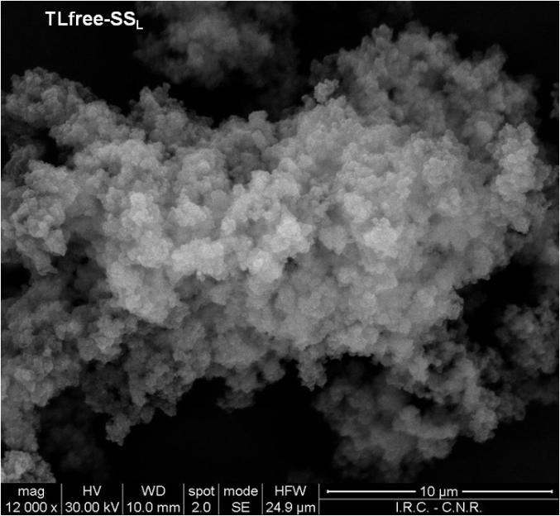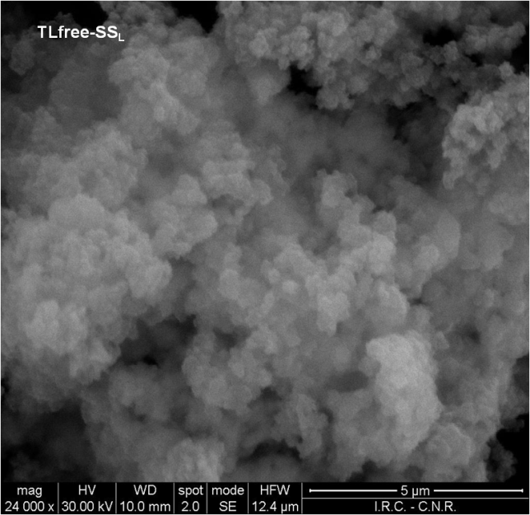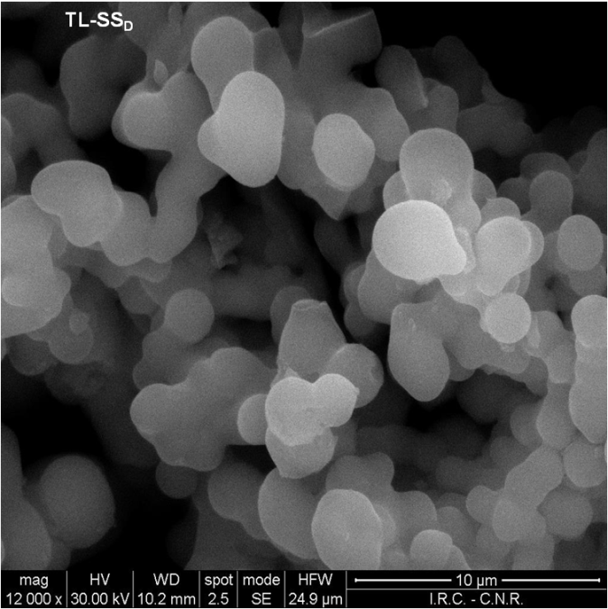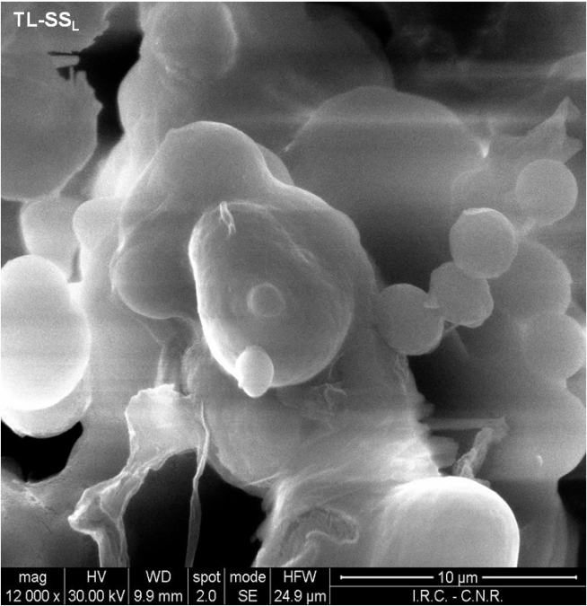
Figure 1: SEM images for TLfree-SS_{L}(12000x and 10 µm, 24000x and 5 µm), TL-SS_{D} and TL-SS_{L} (12000x and 10 µm)
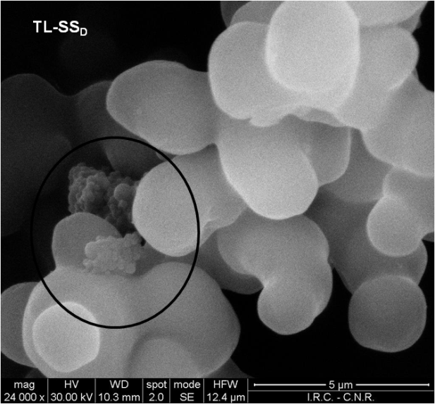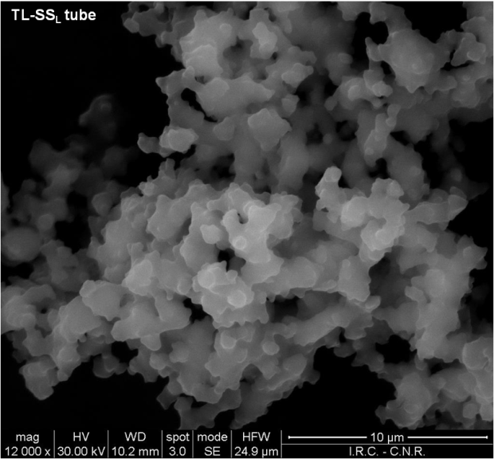
Figure 2: SEM image for TL-SS_{D} (24000x and 5 µm) and TL-SS_{L}tube (12000x and 10 µm)
    - Batch catalytic tests
The activity of the biocatalysts obtained according to the sol-gel procedure described in section 2.2, TL-SS_{D} and TL-SSL, was compared to that of free xylanase TL, to investigate the differences between free and trapped enzyme, choosing xylan from Birchwood hydrolyses as test reaction.
Reactions were monitored by TLC, and as it is clear from the Figure 3, hydrolyses realized by using the two matrices reminded a reduced reaction kinetic for TL-SS_{D}, while in the case of TL-SS_{L} the kinetic behaviour was similar to the processes with the free enzyme.
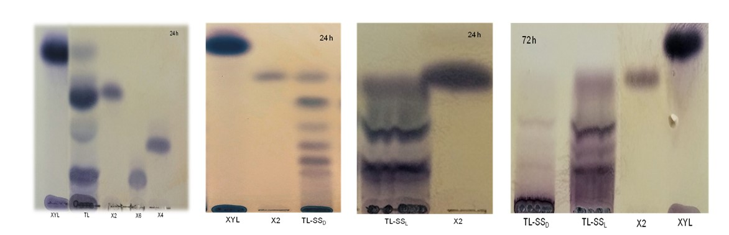Figure 3: TLC for enzymatic hydrolysis of xylan in presence of free-TL (24 h),TL-SS_{D} (24 and 72 h) and TL-SS_{L} (24 and 72 h).
In particular, xylan hydrolysis by TL-SS_{D} enzymatic matrix was evaluated in two different reaction time and compared to similar processes involving TL-SS_{L}. In any case, the oligosaccharidic material production resulted noticeable at all investigated times – 24 h and 72 h – in the case of TL-SS_{L} used as biocatalyst in the catalytic degradation of xylan (Figure 3). Moreover, TLC analyses of these processes indicated that in all cases, xylobiose, xylotriose and xylo-oligosaccharises with an rf similar to xylopentaose and xylohexaose resulted the most copious hydrolysis end products: TL-SS_{L} enzymatic matrix showed an hydrolytic capability similar to the free TL xylanase. On the contrary, with enzymatic digestions via TL-SS_{D} matrix a marked reduction of xylanase activity was recorded. Table 1 (last column) reports the conversion in terms of xylose equivalent. The results reported in the Table 1 indicate that lyophilisation is the best method for enzyme dehydration. The biocatalyst obtained by lyophilisation display a catalytic activity very similar to that of the free xylanase.
    - Continuous catalytic tests
Previous batch enzymatic experiments confirmed the better performances of biocatalysts obtained by single step procedure and lyophilisation as drying method. Consequently, micro-reactors for continuous degradation of xylan were assembled as reported in section 2.2, entrapping xylanase from Themomyces lanuginosus directly inside the Teflon tubes, following the Single Step sol-gel procedure (CSS_{L}), SEM analyses of the enzymatic matrices recovered from Teflon tubes showed a different morphology of monolith TL-CSS_{L}-tube in comparison with TL-SS_{L}, as showed in Figure 3, in which a more porous structure with smaller aggregates is clearly visible. The solution at the end of the piping was analyzed in terms of xylose equivalents, showing a level of xylose equivalents of about 18%. This value remained virtually constant for about 40 h.
  - Conclusions
According to the collected results, the degradation of xylan is feasible in order to obtain xylo-oligosaccharides. The reaction is best performed with TL-SS_{L} than TL-SS_{D}. Continuous microreactors resulted to be the most efficient configuration for the degradation, in comparison to the batch processes.
In this way, changing the amount of Thermomyces lanuginosus xylanase entrapped as TL-CSS_{L} in microreactors for continuous experiments or as TL-SS_{L} for batch tests, it is possible to degrade xylans and/or hemicellulose fractions from many waste sources to produce xylo-oligosaccharidic mixtures with the desired polymerization degree.
Reference
Aachary A.A., Prapulla S.G., 2011, Xylooligosaccharides (XOS) as an Emerging Prebiotic: Microbial Synthesis, Utilization, Structural Characterization, Bioactive Properties, and Applications, Comprehensive Reviews in Food Science and Food Safety, Vol. 10, 2-16.
Ashikin N., Wahab N., Illias R., Fuzu S., 2017, Comparison of Thermostable Xylanase Production by Escherichia coli Immobilised onto Different Nanoparticles, Chem. Eng. Transact., 56, 1825-1830.
Bradford M.M., 1976, A rapid and sensitive method for the quantitation of microgram quantities of protein utilizing the principle of protein-dye binding, Anal. Biochem., 72 (1976) 248-254 .
Chapla D., Pandit P., Shah S., 2012, Production of xylooligosaccharides from corncob xylan by fungal xylanase and their utilization by probiotics, Bioresource Technology, Vol. 115, 215–221.
de Jong E., Jungmeier G. (2015), Biorefinery Concepts in Comparison to Petrochemical Refineries, in “Industrial Biorefineries and White Biotechnology”, Elsevier, Amsterdam.
Finore I., Poli A., Di Donato P., Lama L., Trincone A., Fagnano M., Mori M., Nicolaus B., Tramice A., 2016, Hemicellulose extract from Cynara cardunculus: a source of value-added biomolecules produced by xylanolytic thermozymes, Green Chem., Vol. 18, 2460-2472.
Fiorentino N., Impagliazzo A., Ventorino V., Pepe O., Piccolo A., Fagnano M., 2010, Biomass accumulation and heavy metal uptake of Giant reed on polluted soil in southern Italy. Journal of biotechnology, Vol. 150(S1), 261.
Immerzeel P., Falck P., Galbe M., Adlercreutz P., Nordberg Karlsson E., Stålbrand H., 2014, Extraction of water-soluble xylan from wheat bran and utilization of enzymatically produced xylooligosaccharides by Lactobacillus, Bifidobacterium and Weissella spp., LWT - Food Science and Technology, Vol. 56, 321-327.
Lama L., Tramice A., Finore I., Anzelmo G., Calandrelli V., Pagnotta E., Tommonaro G., Poli A., Di Donato ., Nicolaus B., Fagnano M., Mori M., Impagliazzo A., Trincone A., 2014, Degradative actions of microbial xylanolytic activities on hemicelluloses from rhizome of Arundo donax, AMB Express, Vol. 4, 55, www.amb-express.com/content/4/1/55
Mohd Sukri S.S., Abdul Munaim M.S., 2017, Combination of Entrapment and Covalent Binding Techniques for Xylanase Immobilisation on Alginate Beads: Screening Process Parameters, Chem. Eng. Transact., Vol. 56, 169–174.
Muzard M., Aubry N., Plantier-Royon R., O’Donohue M., Remond C., 2009, Evaluation of the transglycosylation activities of a GH 39 b-D-xylosidase for the synthesis of xylose-based glycosides, J. Mol. Catal. B Enzym., Vol. 58, 1–5.
Nacos M.K., Katapodis P., Pappas C., Daferera D., Tarantilis P.A., Christakopoulos P., Polissiou M., 2006. Kenaf xylan–a source of biologically active acidic oligosaccharides. Carbohydr. Polym., Vol. 66, pp. 126–134.
Pirozzi D., Fiorentino N., Impagliazzo A., Sannino F., Yousuf A., Zuccaro G., Fagnano M., 2015, Lipid production from Arundo donax grown under different agronomical conditions, Renewable Energy, Vol. 77, 456-462.
Pirozzi D., Abagnale M., Minieri L., Pernice P., Aronne A., 2016, In-situ sol-gel modification strategies to develop a monolith continuous microreactor for enzymatic green reactions, Chemical Engineering Journal, Vol. 306, 1010-1016..
Samanta A.C., Jayapal N., Jayaram C., Roy S., Kolte A.P., Senani S., Sridhar M., 2015, Xylooligosaccharides as prebiotics from agricultural by-products: Production and applications, Bioactive Carbohydrates and Dietary Fibre, Vol. 5, 62 – 71.
Scheidel A., Sorman A.H., 2012, Energy transitions and the global land rush: Ultimate drivers and persistent consequences, Global Environmental Change, Vol. 22(3), 588-595.
Tramice A., Melck D., Virno A., Randazzo A., Motta A., Trincone A., 2009, Enzymatic synthesis and 3-D structure of anti-proliferative acidic (MeGlcUA) xylotetrasaccharide, Journal of Molecular Catalysis B: Enzymatic 61, 129–135.
Vazquez M.J., Alonso J.L., Dominguez H., Parajo J.C., 2000, Xylooligosaccharides: manufacture and applications, Trends in Food Science & Technology, Vol. 11, 387–393.
Zhou C. H., X. Xia X., Lin C. X., Tong D. S., Beltramini J., 2011,Catalytic conversion of lignocellulosic biomass to fine chemicals and fuels, Chem. Soc. Rev., Vol. 40, 5588-5617

