CHEMICAL ENGINEERING TRANSACTIONS  VOL. 73, 2019 | A publication of
The Italian Association
of Chemical Engineering
Online at www.aidic.it/cet
Guest Editors: Andrea D’Anna, Paolo Ciambelli, Carmelo Sunseri
Copyright © 2019, AIDIC Servizi S.r.l.
ISBN 978-88-95608-70-9; ISSN 2283-9216

Nano-CeO₂ Coating on Aluminum Foam Carriers for Structured Catalysts Preparation
Vincenzo Palma, Marco Martino*, Livia Truda
University of Salerno, Department of Industrial Engineering, Via Giovanni Paolo II 132, 84084 Fisciano (SA), Italy
mamartino@unisa.it
This paper reports the results of a study on the preparation of structured catalysts by chemical conversion coating. The ceria coating was realized by reacting suitably pre-treated aluminum structures with an oxidizing solution of cerium chloride; the obtained samples were characterized by means of several analytical techniques to evaluate the coverage percentage, the surface morphology and the surface chemical structure. A preliminary screening on the reactivity of the system, to find the better operative conditions, was carried out on square plates in order to realize a suitable plating bath for the preparation of a structured catalyst, made up of aluminium foam carrier. The obtained catalyst was loaded with platinum as active phase and tested in water gas shift reaction for hydrogen production.
  - Introduction
The water gas shift reaction plays a crucial role in the hydrogen production process, because it can be considered the first purification step of syngas, as it allows to reduce to less than 0.3 % the percentage of carbon monoxide, extremely harmful for the membranes (Tocci et al., 2006). Therefore, the configuration of the water gas shift reactor has recently been the subject of numerous studies, with the aim of carrying out a process intensification (Palma et al., 2018 c). Among the different alternatives, today structured catalytic reactors, characterized by a structured catalyst, are considered a valuable solution with respect to the packed bed reactors based on different particle shapes such as spheres, cylinders, rings, flat disc pellets or crushed material of a certain sieve fraction (Eigenberger, 2008). Structured catalysts, in fact, present several advantages especially for what concerns transport phenomena (Tronconi, 1997), such as heat (Palma et al., 2015) and mass transfer (Palma et al., 2018 b). Aluminum foam based structured catalysts have been extensively studied as ideal candidates for the water gas shift process intensification (Palma, Pisano, Martino, 2017); the high thermal conductivity of the structured carriers is strategic for the intensification of processes based on exothermic reaction, moreover the structured carriers allow to realize specific geometrical configurations. Furthermore the catalytic formulations play a crucial role in the realization of single stage water gas shift process; noble metals over high reducible supports seem to be the most suitable one for this scope (Palma and Martino, 2017). Structured catalysts are normally obtained by washcoating a carrier (Palma and Martino, 2018) with a primer such as alumina (Visconti, 2012), that makes compatible the active formulation with the inert carrier and allows to increase the surface area of the carrier. Alumina is an excellent primer but unfortunately is not inert towards the most reactions, for example towards water gas shift reaction (Palma et al., 2018 a), moreover, the washcoating procedure is cumbersome and expensive, making the possibility to realize a coating with the lonely active components an extremely attractive topic. In this sense, it could be strategic to realize a ceria-based catalyst by means of a ceria coating on aluminum carriers for the preparation structured catalysts. Many coating techniques are available (Meille, 2006), among them, chemical conversion coating (Sánchez-Amaya et al., 2012) can be considered a simple and effective method to obtain resistant (Wang et al. 2004) and uniform protective layers on metallic surfaces. In this contest, many studies on the resistance of cerium-based conversion layers on aluminum alloys were published (Debalà et al., 2001). Plating aluminum with cerium oxide arises as an alternative to chrome plating, as a response to the toxicity problems (Tang et al., 2011), associated to the use of chrome plating baths. At the beginning of the eighties, Hinton et al. (1984) reported that cerous chloride is able to reduce the corrosion rate of aluminum alloys; since then a multitude of works have been published on the set-up of the method, however most of them are based on electrodeposition (Balasubramanian et al., 1999). Anyway, electrodeposition presents a series of disadvantages, such as process costs and non-uniform plating, on the contrary, chemical conversion (Bethencourt et al., 2004) seems to be a simple, inexpensive and easily achievable process. The purpose of this article is to show that it is possible to use an aluminum protection technique (plating with cerium oxide), as a preparation method for structured catalyst employed in the water gas shift reaction. With this aim we report our results on the preparation of structured catalyst obtained by chemical conversion coating of ceria on open cell aluminum foam. The first phase of the work was focused on the set up of the method; a series of preparation parameters were investigated, such as the bath temperature, the reaction time and the pH of the bath. The experiments were carried out on square aluminum plates, to make easy the evaluation of the coating by surface analysis. The second phase of the work was devoted to the preparation of an open cell aluminum foam structured catalyst, and to the evaluation on the performance in water gas shift reaction.
  - Experimental

  - Materials
The aluminum square plates were provided by Officina Elettromeccanica Elena Mormile, aluminum foam was provided by ERG Materials and Aerospace; cerium(III) chloride heptahydrate 99 % (CeCl₃•7H₂O), hydrogen peroxide 35 %, hydrochloric acid 36.5-38.0 %, nitric acid 70 %, sodium hydroxide and acetone were provided by Sigma-Aldrich, tetrammineplatinum (II) nitrate 99 %, was provided by Strem Chemicals, bidistilled water provided by Titolchimica S.p.A.
  - Chemical coating procedure and catalyst preparation
The aluminum square plates were previously treated to prepare the surface to the chemical coating procedure. The samples were firstly degreased with acetone, then etched with sodium hydroxide solution (5 wt %) for 1 minute, finally treated with nitric acid solution (35 wt %) for 1 minute. After each treatment the aluminum structure was washed with distilled water and, at the end of the pre-treatments, it was immersed in the solution for the coating deposition (plating bath) (Andreeva et al., 2014).
The plating bath was composed by CeCl₃•7H₂O, H₂O₂ 35 wt % and water, in a weight ratio 1/3/75, acidified with HCl (pH=1-3). The treatment was repeated from 1 to 3 times from 10 minutes to 4 hours, and the resulting structure was dried at 393 K for 2 hours.
The structured catalyst was prepared by applying the previous plating procedure (pH=1, 323 K, 2 cycles of 4 hours), to the aluminum foam (40 PPI, 10-12 % relative density); after each cycle it was dried at 393 K for 2 hours and calcined at 723 K for 3 hours. It was reached a ceria surface loading equal to 47.71 wt %. The resulting plated foam was then loaded with platinum by impregnation with a solution of tetrammineplatinum (II) nitrate, dried at 393 K for 2 hours and calcined at 723 K for 3 hours, to obtain the desired platinum loading (0,12 wt% with respect the weight of the structured catalyst).
  - Characterization techniques
The B.E.T. specific surface areas measurements were obtained with a Costech Sorptometer 1040 (Costech International). The good coating resistance to mechanical stress was evaluated by ultrasound adherence test with an ultrasonic bath CP104 (EIA S.p.A.). The catalysts were dipped in petroleum ether at 298 K and submitted to ultrasound obtained setting the 60 % of rated power of the equipment, for six cycles of five minutes. The XRD diffractograms were obtained a Brucker D8 Advance, with a Cu Kα radiation source (35 kV; 40 mA) in the 2θ range 20-80 °, (Stp= 737; Stp size=0.0814; t/Stp 0.5 s). The crystallite dimensions were calculated from the diffractograms by applying the Scherrer equation. The coating coverage was checked by means of ARL QUANT'X ED-XRF spectrometer (Thermo Scientific, while the structural features evaluated with Raman spectroscopy by an inVia Raman Microscope (Renishaw), equipped with a 514 nmAr ion laser operating at 25 mW. Samples morphology was observed by a Field Emission Scanning Electron Microscope (FE-SEM, mod. LEO 1525, Carl Zeiss SMT AG, Oberkochen, Germany). The H₂-TPR experiments were performed, before the activity tests, with a reducing stream of 500 Ncc/min containing 5 vol% of H₂ in N₂, in the temperature range of 300-725 K, an heating rate of 10 K/min.
  - Activity tests
The activity tests were carried out at atmospheric pressure, in the temperature range of 520-630 K, with a reaction mixture of 4 % CO, 20 % H₂O and 76 % N₂, in a stainless steel tubular reactor with an internal diameter of 17 mm and 83 mm long, at a WHSV of 125 g_{CO}/g_{Pt}*h⁻¹. The reaction product composition on dry basis was monitored through an ABB system equipped with the non-dispersive infrared analyser Uras 14 for CO, CO₂ and CH₄ and a thermal conductivity detector Caldos 17 for H₂.
  - Results and discussion

  - Operating conditions screening
First of all, it was carried out a preliminary screening to find the optimal operating conditions for the coating by a plating bath, by evaluating some critical process parameters, such as pH, time of reaction, number of cycles and bath temperature (see table 1), in terms of CeO2 weight percentage of the aluminum surface, by mean of XRF analysis. For this screening, aluminum square plates (identified as Al_n, were n=1-7) were used. From the data, a clear trend is obtained: higher acidity, prolonged treatment times and higher temperatures favour the coverage and therefore the ceria loading achievable. In Figure 1 the hypothesized reaction pathway and the pictures of the aluminum squares in the plating phases were reported. The reaction takes place few seconds after the dip of the aluminum structures in the bath making gaseous bubbles. After the first hour, gaseous bubbles formation decreases rapidly and within the four hours it ends. These observations can be better understood, if correlated with the reaction pathway proposed by (Arnott et al.1989).
Table 1. XRF evaluation of reaction parameters (pH, reaction time and temperature, number of cycles)
Sample | pH | Time | Cycles | Temperature | Surface weight CeO₂ (%)
Al_1 | 3 | 10 min | 1 | 298 K | 6
Al_2 | 3 | 2 h | 1 | 298 K | 10
Al_3 | 3 | 4 h | 1 | 298 K | 13
Al_4 | 1 | 2 h | 1 | 298 K | 20
Al_5 | 1 | 4 h | 1 | 323 K | 24
Al_6 | 1 | 4 h | 2 | 323 K | 50
Al_7 | 1 | 4 h | 3 | 323 K | 80
In the first step of the process, at the anodic site of the aluminum surface, there happens the dissolution of the metal surface and evolution of oxygen, whereas at the cathodic site, the reduction of oxygen or hydrogen peroxide induces an increase of the local pH. This increase of pH value gives rise to the formation of cerium hydroxide that react with the aluminum surface to form the characteristic brick red cerium oxide/hydroxide layer. The subsequent drying generates the yellow layer of cerium oxide.
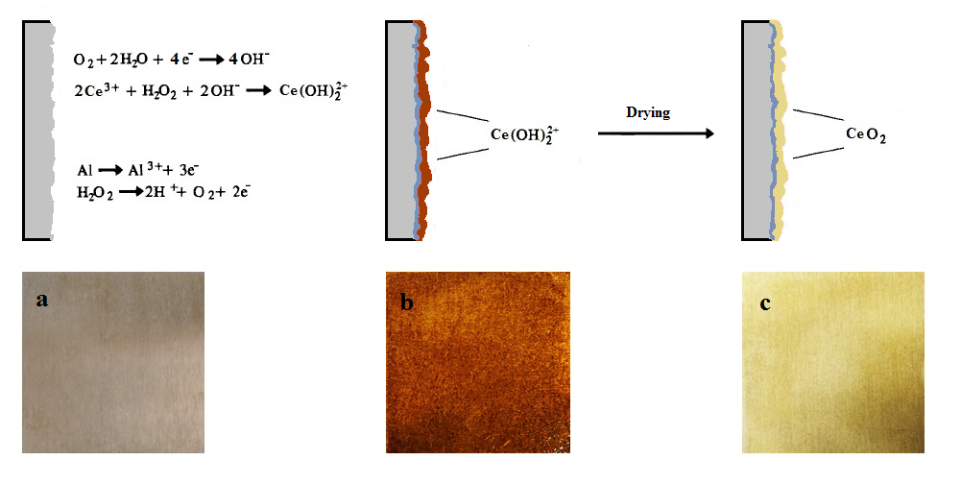
Figure 1. Reaction pathway (top) and pictures of aluminum square as it is (a, after plating (b) and after drying (c)
The deactivation is due to both a rapid decomposition of hydrogen peroxide and a contemporary increasing of the pH value of the bath, for this reason multiple cycles are required to reach higher surface coverage grade. The plated aluminum square were characterized by means of Raman, SEM analysis and ultrasound adherence test. In Figure 2 the Raman spectrum (a) and the SEM image (b) of Al_7 were reported. The Raman spectrum essentially showed two peaks, the F_{2g} mode at 480 cm⁻¹ of ceria fluorite structure type, and a broad peak at 620 cm⁻¹, attributed to the vibrations induced by the presence of oxygen vacancies. It is interesting to note that the vibration frequency of the F_{2g} mode, which is normally located in pure ceria at 464 cm⁻¹, suggesting a change in lattice parameters due to the strong interaction with aluminum surface. The SEM image (Figure 2 b) highlighted the nanometric structure of the ceria coating on the aluminum surface. With the intent to evaluate the mechanical resistance of the coating, the Al_7 sample was subjected to the ultrasound adherence test. The sample was immersed in petroleum ether and sonicated for 15 minutes, showing weight losses lower than 1 wt %. Looking forward, ceria nanoparticle coating via plating bath procedure represents an attractive solution to realize a ceria nanocoating on metallic surface for catalytic processes (Ho et al., 2018), overcoming the use of a binder between the carrier and the chemical support.
  - Catalyst characterization and catalytic evaluation
In Table 2 the surface areas, the crystallite sizes and the hydrogen uptake in TPR experiment, for plated foam (CeF40) and catalysed plated foam (PtCeF40), were reported. B.E.T. measurements highlighted the increase of the surface area of the foam support, due to the ceria loading, while the platinum loading did not any effect. The XRD diffractograms of CeF40 and PtCeF40 showed the typical peaks of ceria fluorite-type structure, moreover PtCeF40 diffractogram showed the presence of the peaks of metal platinum. The crystallite sizes were calculated by applying the Scherrer equation to the (111) crystal planes.
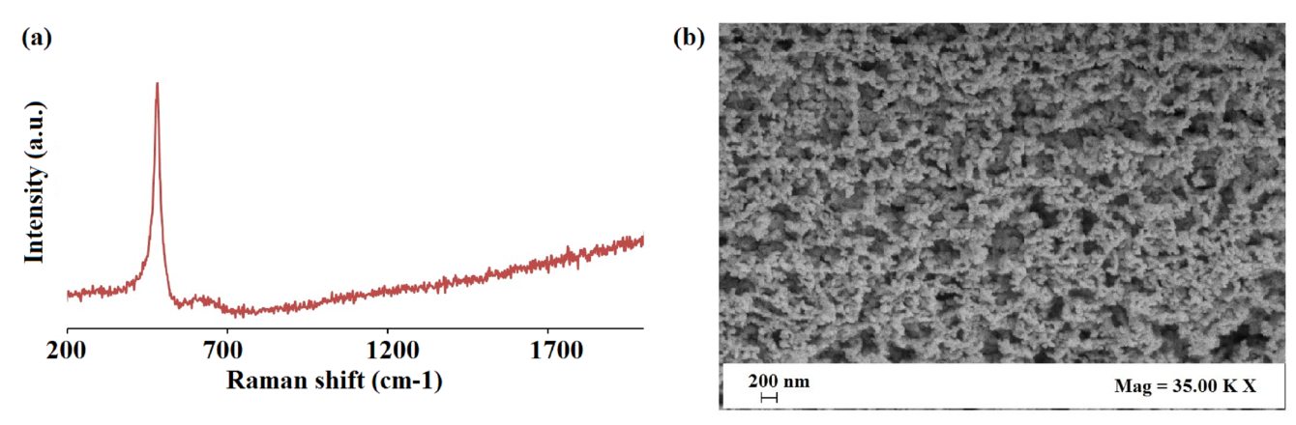
Figure 2. Raman spectra (a) and SEM image of Al_7 surface (b).
The H₂-TPR profile (Figure 3 b) showed a large band centred over 600 K, no peaks attributable to PtO_{x} species were identified, by confirming the XRD results. In this catalyst platinum persists as a metallic species even in a non-reducing environment, probably because it can be considered as segregated specie or, alternatively because of a contact with the aluminum foam. The consumption of hydrogen, during the TPR experiment, was attributed to the reduction of surface ceria, through the spillover effect (Prins, 2012) from platinum to ceria, demonstrated by a considerably lower reduction temperature compared to that reported for the ceria alone.
Table 2: Surface area, crystallite sizes and hydrogen consumption in H₂-TPR experiment
Sample | S_{B.E.T.} (m²/g) | H₂ chemisorbed  (mmol/g_{cat}) | Crystallite Size (nm)
 |  |  | CeO₂ (111) | Pt (111)
F40 | <1 | - | - | -
CeF40 | 8.0 | - | 8 | -
PtCeF40 | 7.9 | 0.24 | 8 | 22
The catalytic performances were evaluated in terms of CO conversion ($X_{CO})$, calculated as the ratio between reacted and supplied moles, and selectivity to hydrogen, calculated as ratio between hydrogen moles produced and reacted moles of carbon monoxide.
$$X_{CO}=\frac{n_{CO, in}-n_{CO,out}}{n_{CO, in}}$$ | (1)
$$S_{H_{2}}=\frac{n_{H_{2}}}{n_{CO, in}-n_{CO,out}}$$ | (2)

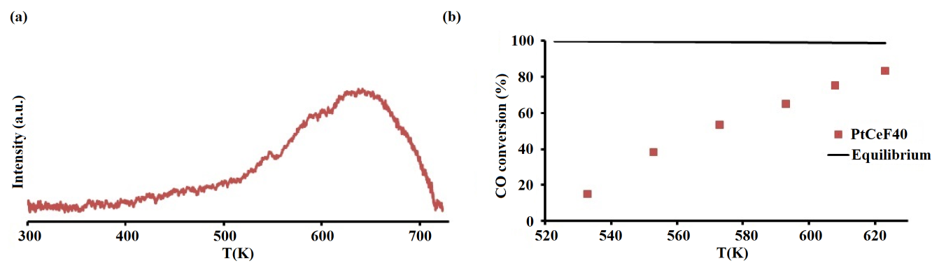
Figure 3. H_{2 uptake}-TPR profile (a) and CO conversion (b) as function of the temperature for PtCeF40 catalyst.
The PtCeF40 catalyst showed good performance in the evaluated temperature range (520 K – 620 K), the CO conversion exceeded 50 % for temperatures above 560 K, even if it never reached the equilibrium conversion. At lower temperature the catalysts was still active even if by allowing very low CO conversion values, at 530 K the reached value was only 10 %. Anyways, these results are extremely interesting considering the high space velocity used, moreover no methanation reaction was detected at any reaction temperature, highlighting the excellent selectivity to hydrogen that was higher than 98 % into all the investigated temperature range (Palma et al., 2018 c). After the activity test, the weight loss of the catalyst was checked. By results, any loss was not recorded by confirming the excellent coating adherence on the carrier able to hold out at such high temperature too.
  - Conclusions
An alternative method for the preparation of aluminum foam based structured catalysts has been developed and implemented for the water gas shift reaction. The proposed method has been developed on the basis of studies on the plating of the aluminum with cerium oxide, as an alternative to the chromium plating. The preliminary tests, carried out on aluminum squares allowed to set up the plating operating conditions. The results showed that an increase of the reaction temperature, a decrease of pH of the plating bath and more reaction cycles, are able to guarantee a good cerium oxide coating loading. The ultrasound adherence tests highlighted the mechanical resistance of the coating, the SEM images showed the formation of a nanometric ceria coating. This operating procedure was used for the preparation of a structured aluminium foam catalyst. This carrier was firstly coated into the setted up plating bath for a cerium oxide coating and then impregnated into an aqueous solution of tetrammineplatinum (II) nitrate for platinum deposition. The catalyst was characterized by XRD analysis demonstrating the nanometric particle dimensions of ceria and of metallic platinum, the TPR experiments confirmed the advent of an extensive spillover effect ascribable to a good cerium oxide coating with the absence of peaks related to platinum oxide. The activity tests showed that a structured catalyst prepared in such way is able to assure a good CO conversion and hydrogen selectivity at high space velocity.
Acknowledgments
This work has received funding from the European Union’s Horizon 2020 research and innovation programme, under the Marie Skłodowska-Curie grant agreement (No. 734561). The authors wish to thankfully acknowledge Mariarosa Scognamiglio (Department of Industrial Engineering, University of Salerno) for SEM analysis.
References
Andreeva R.A., Stoyanova E.A., Tsanev A.S., Stefanov P.K., Stoychev D.S., 2014, Protective ability of cerium-containing conversion films on aluminium, Transactions of the IMF, 92, 203 – 211.
Arnott D.R., Hinton B R.W., Ryan N. E., Cationic-Film-Forming Inhibitors for the Protection of the AA 7075 Aluminum Alloy Against Corrosion in Aqueous Chloride Solution, Corrosion, 45, 12 – 18.
Balasubramanian M., Melendres C.A., Mansour A.N., 1999, An X-ray absorption study of the local structure of cerium in electrochemically deposited thin films, Thin Solid Films, 347, 178 – 183.
Bethencourt M., Botana F.J., Cano M.J., Marcos M., 2004, Advanced generation of green conversion coatings for aluminium alloys, Applied Surface Science, 238, 278 – 281.
Eigenberger G., 2008, Catalytic fixed-bed reactors, Chapter In: Ertl G., Knözinger H., Schüth F., Weitkamp J., (Ed), Handbook of heterogeneous catalysis, vol. 10. Wiley-VCH Verlag GmbH & Co. KGaA, Weinheim (DE) 2075 – 2106.
Dabalà M., Armelao L., Buchberger A., Calliari I., 2001, Cerium-based conversion layers on aluminum alloys, Applied Surface Science, 172, 312 – 322.
Hinton B.R.W., Arnott D.R., Ryan N.E., 1984, Inhibition of aluminum alloy corrosion by cerous cations, Metals Forum, 7, 211 – 217.
Meille V., 2006, Review on methods to deposit catalysts on structured surfaces, Applied Catalysis A: General, 315, 1 – 17.
Ho P.H., Ambrosetti M., Groppi G., Tronconi E., Jaroszewicz J., Ospitali F., Rodríguez-Castellón E., Fornasari G., Vaccari A., Benito P., 2018, One-step electrodeposition of Pd–CeO₂ on high pore density foams for environmental catalytic processes, Catalysis Science & Technology, 8, 4678 – 4689.
Hughes A.E., Taylor R.J., Hinton B.R.W., 1995, Wilson L., XPS and SEM Characterization of Hydrated Cerium Oxide Conversion Coatings, Surface and Interface Analysis, 23, 540 – 550.
Palma V., Pisano D., Martino M., Ricca A., Ciambelli P., 2015, High Thermal Conductivity Structured Carriers for Catalytic Processes Intensification, Chemical Engineering Transactions, 43, 2047 – 2052.
Palma V., Pisano D., Martino M., 2017, The influence of the textural properties of aluminum foams as catalyst carriers for water gas shift process, International Journal of Hydrogen Energy, 42, 23517 – 23525.
Palma V., Martino M., 2017, Pt-Re Based Catalysts for the Realization of a Single Stage Water Gas Shift Process, Chemical Engineering Transactions, 57, 1657 – 1662.
Palma V., Pisano D., Martino M., 2018 a, Structured noble metal-based catalysts for the WGS process intensification, International Journal of Hydrogen Energy, 43, 11745 – 11754.
Palma V., Pisano D., Martino M., 2018 b, CFD modeling of the influence of carrier thermal conductivity for structured catalysts in the WGS reaction, Chemical Engineering Science, 178, 1 – 11.
Palma V., Pisano D., Martino M., 2018 c, Comparative Study Between Aluminum Monolith and Foam as Carriers for The Intensification of The CO Water Gas Shift Process, Catalysts, 8, 489.
Palma V., Martino M., 2018, Aluminum Foam based Catalysts for the CO-WGS Reaction, Chemical Engineering Transactions, 70, 1225 – 1230.
Prins R., 2012, Hydrogen spillover. Facts and fiction. Chemical Reviews 112, 2714 – 2738.
Sánchez-Amaya J.M., Blanco G., Garcia-Garcia F.J., Bethencourt M., Botana F.J., 2012, XPS and AES analyses of cerium conversion coatings generated on AA5083 by thermal activation, Surface & Coatings Technology 213, 105 – 116.
Tang J., Han Z., Zuo Y., Tang Y., 2011, A corrosion resistant cerium oxide based coating on aluminum alloy 2024 prepared by brush plating, Applied Surface Science, 257, 2806 – 2812.
Tocci, E.; Pullumbi, P., 2006, Molecular simulation of realistic membrane models of alkylated PEEK membranes, Molecular Simulation, 32, 145 – 154.
Tronconi E., 1997, Interaction between chemical kinetics and transport phenomena in monolithic catalysts, Catalysis Today, 34, 421 – 427.
Visconti C.G., 2012, Alumina: A Key-Component of Structured Catalysts for Process Intensification, Transactions of the Indian Ceramic Society, 71, 123 – 136.
Wang C., Jiang F., Wang F., 2004, Cerium Chemical Conversion Coating for Aluminum Alloy 2024-T3 and Its Corrosion Resistance, Corrosion, 60, 237 – 243.

